Mushroom Classification

***Wireframe Documentation***

Userpage

We have divided Mushroom Classification model userpage into Two Sections: -

1. First thing is the user can see the features of mushroom accordingly.

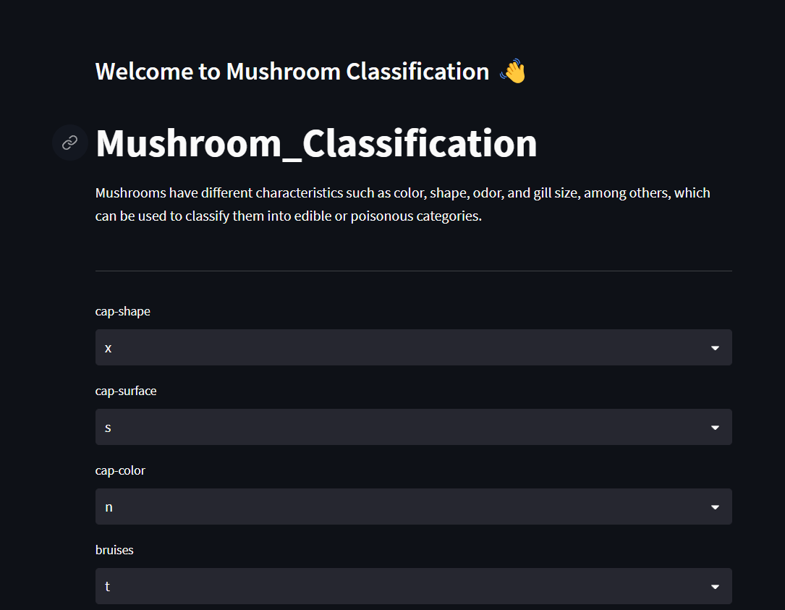

1. 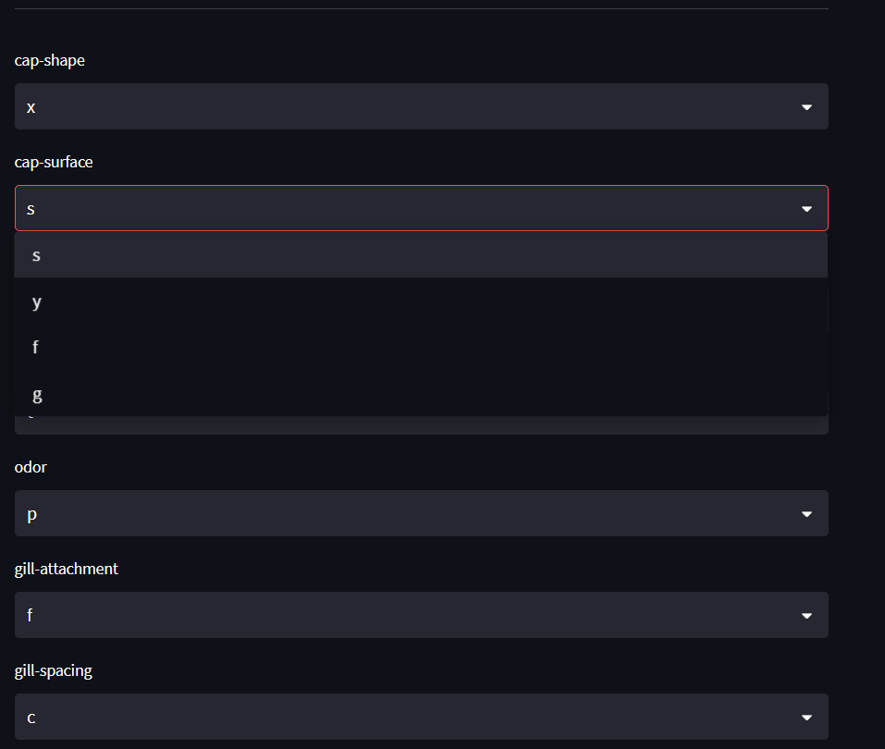User can fill the features of mushroom accordingly.
2. 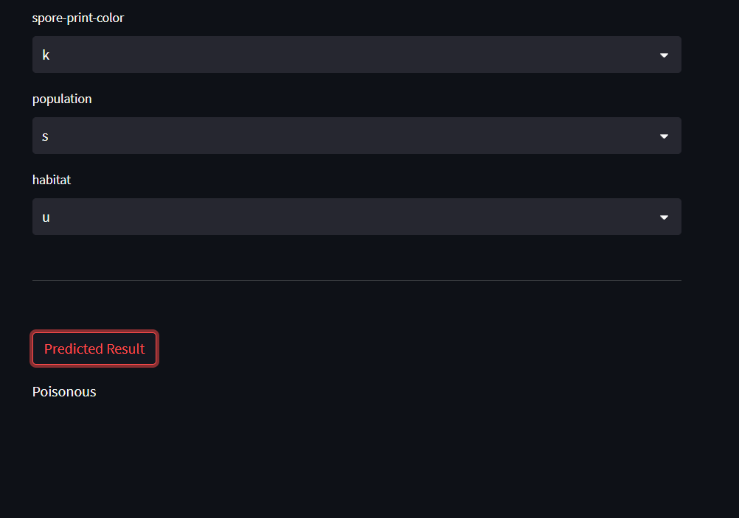The pretrained logistic Regression Model will take decision as per the input features. Afterwards ,it will provide the result of mushroom , i.e whether it is edible or poisonous.