Forecasting Sport and Physical Activity
Across London's 32 Boroughs
A demography-driven forecasting framework built on eight years
of the Sport England Active Lives Adult Survey
Prepared for a London-based non-profit sports organisation
Comprehensive Technical and Findings Report
135,497 respondents · 32 boroughs · eight annual waves, 2015–16 to 2022–23

5. Methodology

5.1 Why a conventional forecasting model is inappropriate
The intuitive approach — constructing a borough-by-year table and fitting a time-series or gradient-boosted model to it — fails here for a structural reason. Thirty-two boroughs across eight years yields 256 observations, three of them disrupted by the pandemic, with roughly 500 survey respondents standing behind each borough-year cell. Asking any model to learn temporal dynamics from such a table is asking it to learn noise, and no amount of regularisation compensates for a sample that small. The forecasting burden must be moved off the machine-learning model.
The sections I would actually edit
Definitely:
- Abstract
- Chapter 1 model-selection paragraph
- Chapter 2 model-selection paragraph
- Chapter 2 §2.5
- Chapter 3 modelling framework / §3.7
- Chapter 4 §4.2.1
- Chapter 4 §4.2.2
- Chapter 4 §4.2.3 + Table 4.2
- Chapter 4 figure titles/references
- Chapter 4 critical discussion
- Chapter 5.1
- Chapter 5.2
Probably don't touch:
- Chapter 1 objectives
- rest of Chapter 1
- most of Chapter 2
- data/methodology sections unrelated to model choice
- Chapter 4.3 forecast findings
- general limitations
- most of the conclusion

5.2 The architecture
The framework expresses each forecast as the product of a stable propensity surface and a projected population, plus a small behavioural adjustment:
Forecast = who is active (learned from 135,497 people) × how the population is changing + a behavioural trend
The three components are matched to what each is suited to estimate:
- The propensity model learns the relationship between a person's characteristics and their activity band. This is what a large cross-sectional survey is excellent for: 135,497 observations produce a stable, reliable estimate. Crucially, this model is time-free — it never extrapolates in time.
- The population projection carries the forecast forward. Each borough's demographic composition is projected from its trajectory across the eight observed waves, using the survey's own population-calibrated weights, with each borough's trend shrunk toward the London-wide trend so that no borough extrapolates to an implausible composition.
- The behavioural trend is the only extrapolated quantity: the London-level tendency for people of a given type to become more or less active over time, estimated with the pandemic waves handled separately.
The decisive advantage of this design is decomposition. Every projected change separates into a composition effect — the population changed — and a behaviour effect — people of a given type changed. These have entirely different policy responses, and no single blended forecast can distinguish them.

5.3 The propensity model
Activity is modelled as an ordered outcome — Inactive, Fairly Active, Active — using a cumulative-logit ordinal regression, which respects the natural ordering of the three bands. The predictors are the individual's age band, gender, ethnicity, socio-economic classification, education, disability status and body-mass-index group, together with borough identity. The model is fitted with survey weights so that its estimates are population-representative.
An alternative — gradient-boosted trees (LightGBM) — was tested head-to-head as a benchmark, to establish whether a more flexible method would materially improve accuracy.

5.4 Model selection
Both models were evaluated on a wave held out entirely from training. Their performance was near-identical:
Model | Discrimination (AUC) | Weighted accuracy | Borough correlation
No-features baseline | 0.500 | 0.643 | —
Ordinal logistic regression (selected) | 0.704 | 0.671 | 0.90
Gradient boosting (LightGBM) | 0.707 | 0.674 | 0.90

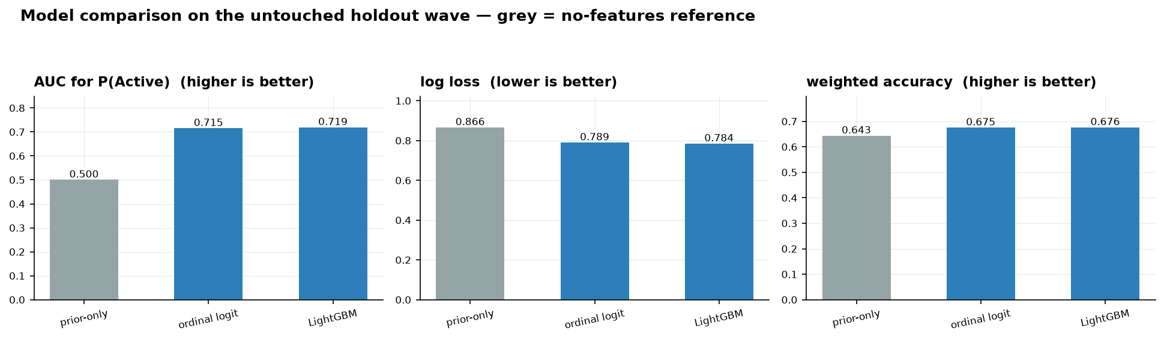
Figure 5.1. Comparison of the two models against a no-features baseline on the held-out wave.
The gradient-boosting model gained 0.003 in discrimination — not a meaningful advantage — so the ordinal logistic regression was selected. It extrapolates more sensibly when projected populations are pushed through it, its coefficients are directly interpretable, and it is substantially easier to defend. Testing a more complex method and reporting honestly that it did not help is a stronger methodological position than adopting it unexamined.

5.5 Individual-level accuracy in context
An AUC of 0.70 and 67% classification accuracy are modest at the individual level, and this is expected rather than a deficiency. Whether a specific person meets the 150-minute threshold in a given week depends on their occupation, injuries, motivation and even the weather — none of which a survey captures. For population-level forecasting, which aggregates many individual probabilities, a discrimination of 0.70 is a genuinely useful signal. An expectation of near-perfect individual prediction would misunderstand what is predictable in this domain.

5.6 Guarding against overfitting
Several independent checks establish that the model is not overfitting.
- The data were split temporally: trained on waves 1–6, tuned on wave 7, and tested on the untouched wave 8.
- Performance on the untouched wave equalled or exceeded performance on the tuning wave — the opposite of the signature of overfitting.
- Results were insensitive to the strength of regularisation, confirming the model operates far from the overfitting regime.
- The model carries roughly 1,270 observations per estimated parameter.
The most demanding test is leave-one-borough-out. Each borough was predicted by a model trained without ever seeing it. Accuracy was essentially unchanged — a borough correlation of 0.898, against 0.900 for boroughs the model had seen. This proves the model learned a transferable relationship between characteristics and activity, rather than memorising each borough's level, and it is precisely this property that licenses using the model to forecast populations that do not yet exist.
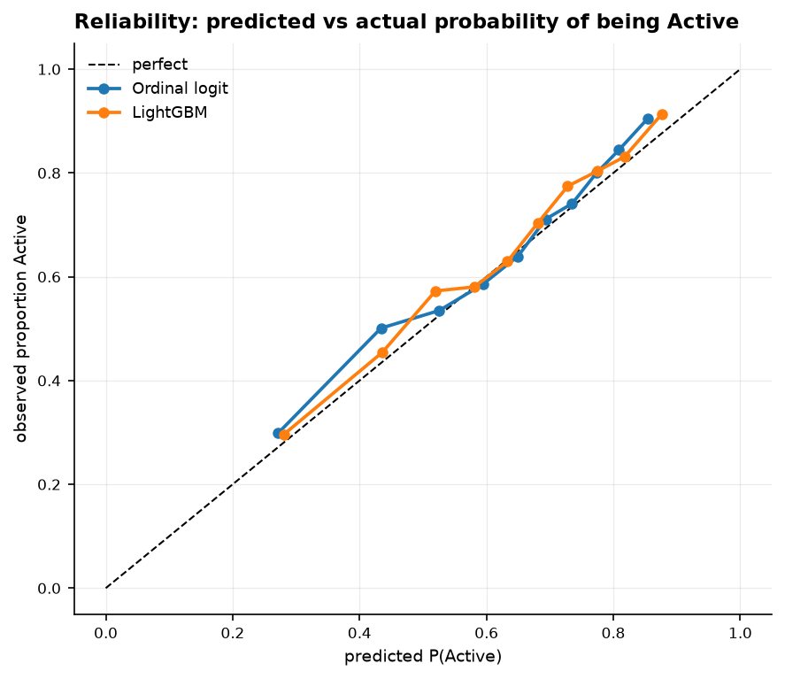
Figure 5.2. Reliability of predicted probabilities: predicted against observed probability of being Active. Both models track the diagonal closely, so the probabilities the forecast aggregates are honest.

6. Composition versus place
Before forecasting, one question must be settled: when boroughs differ in activity, is it because of who lives there or because of the place itself? Only the first responds to population change, so the answer determines what a demographic forecast can and cannot do.

6.1 The ablation
Three models were compared on the held-out wave: one using only demographics, one using only borough identity, and one using both. The demographic-only model was additionally evaluated leave-one-borough-out, to test whether composition generalises to boroughs never seen.
Model | Share of between-borough spread reproduced
Demographics only | 48%
Borough identity only | 86%
Demographics and borough together | 88%
Demographics only, on boroughs never seen in training | 47%

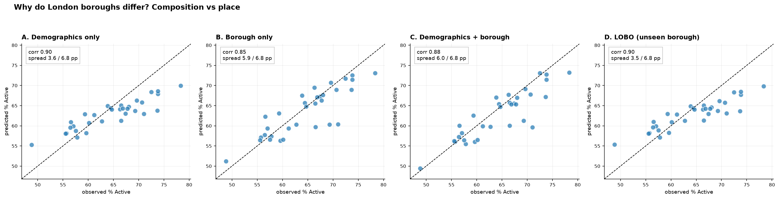
Figure 6.1. Predicted against observed borough activity under each model. Points on the diagonal indicate the model reproduces real differences between boroughs.
Roughly half of the difference between boroughs is compositional and half is not. The final row is the decisive validation: the demographic model predicts a borough it has never encountered as accurately as one it trained on, which is what makes demographic forecasting legitimate.

6.2 Place amplifies composition
A subtler feature of the same result carries strategic weight. The demographic-only model ranks boroughs almost perfectly — a correlation of 0.90 — but understates the magnitude of the differences by about half. Place effects therefore do not offset composition; they amplify it. Boroughs whose populations predict lower activity also tend to have place characteristics that depress activity further. Disadvantage compounds: the least advantaged boroughs are penalised twice, once by their demography and once by their environment.
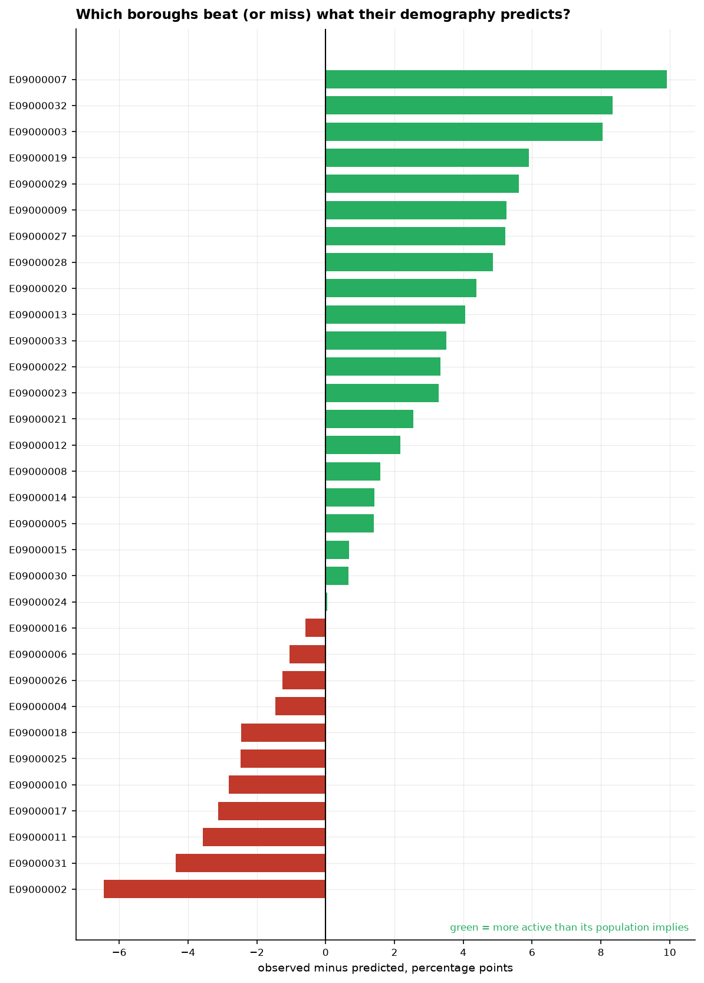
Figure 6.2. Boroughs ranked by how far they beat or miss the activity their demography predicts. A positive residual marks a borough more active than its population implies — a candidate for study of what it does differently.

6.3 The provision gradient
Repeating the composition–place decomposition across fifteen distinct behaviours produced the project's clearest strategic finding.
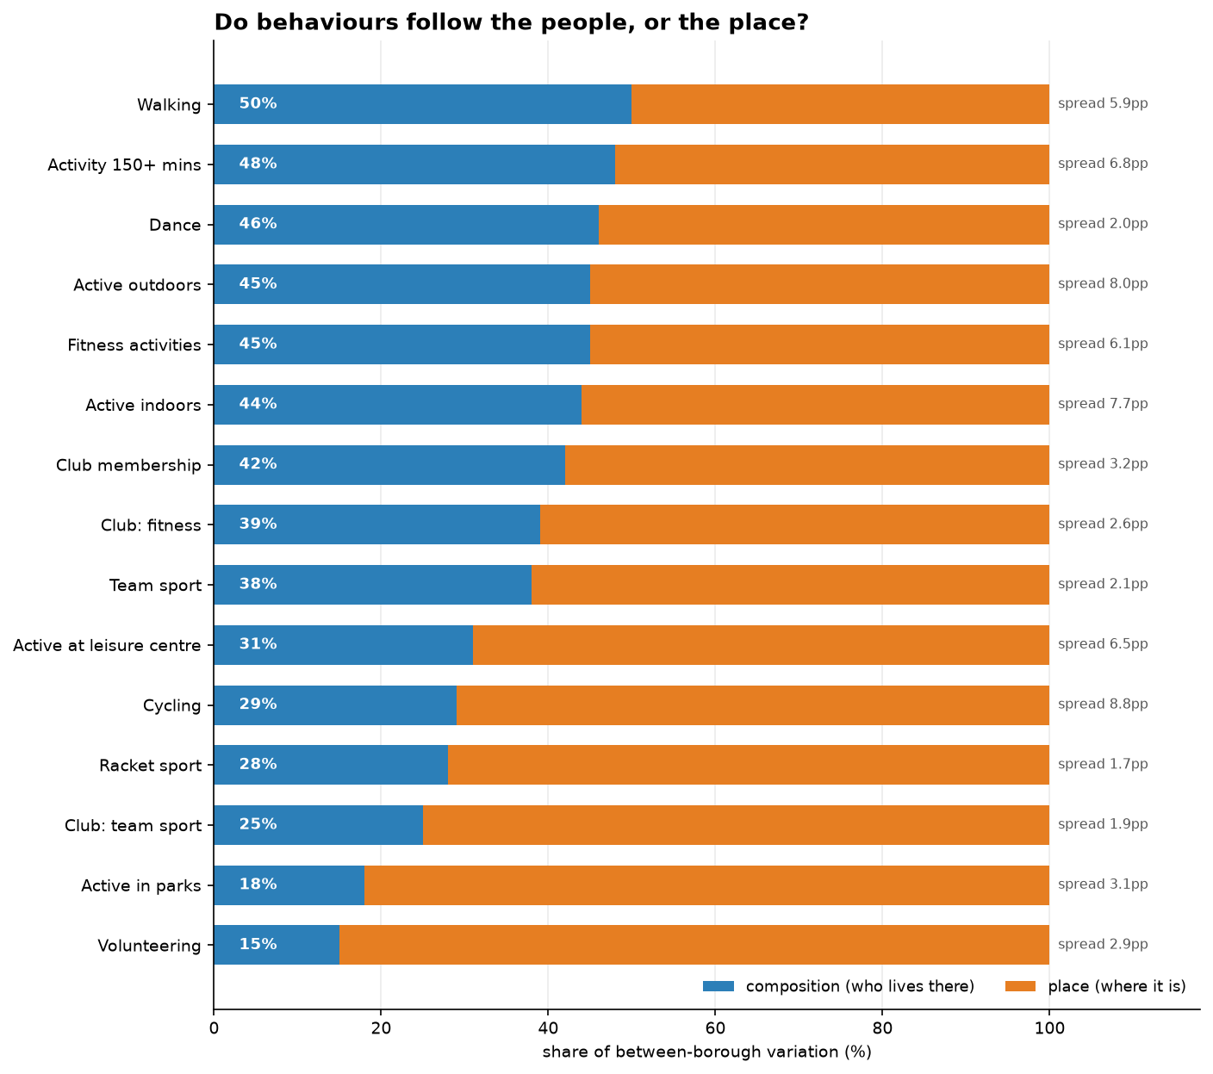
Figure 6.3. The share of between-borough variation explained by demographics, for each behaviour.
Follows the people (composition) |  | Follows the place (provision)
Walking | 50% | Volunteering | 15%
Overall activity | 48% | Park use | 18%
Dance | 46% | Team-sport club | 25%
Outdoor activity | 45% | Racket sport | 28%
Fitness activities | 45% | Cycling | 29%
Indoor activity | 44% | Leisure-centre use | 31%

The ordering is not arbitrary: the more a behaviour depends on provision, the less demography explains it. Walking requires only a pavement and tracks the population closely. Cycling requires lanes and secure storage. Park use requires parks. Racket and team sports require courts and clubs. Volunteering requires organisations to volunteer for. The implication for the commissioning organisation is direct: the behaviours least predictable from demographics are precisely those most open to influence through investment — and cycling, the behaviour with the widest borough gap in the entire dataset, is 71% attributable to place.

7. The forecasting engine
The engine assembles the components of Section 5 into borough-level and London-level projections with quantified uncertainty. Its procedure, and the decomposition it yields, are described here; the results by brief area follow in Sections 8 to 11.

7.1 Procedure
- The propensity model is fitted on all eight waves combined — the whole dataset — having been validated on held-out data first. Fitting on everything at the deployment stage yields the most stable estimate; discarding a wave would only add noise.
- Predicted activity probabilities are computed for every borough × age × gender × ethnicity cell.
- Each borough's demographic composition is projected forward from its eight observed waves, on the logit scale, with each borough's trend shrunk halfway toward the London trend to prevent implausible extrapolation.
- Projected populations are scored through the propensity surface and the borough intercepts, and the behavioural trend is added.
- Each projected change is decomposed into a composition effect and a behaviour effect.
- Uncertainty is quantified by a weighted bootstrap, refitting the whole procedure on resampled data to produce 90% intervals.
A built-in reconciliation check confirms that the modelled baseline reproduces the last observed value before any projection is trusted; the forecast begins where the data ends, within a fraction of a percentage point.

7.2 Observed, and projected — a note on interpretation
Every time-series figure in this report distinguishes observed survey years from model projections explicitly. Observed points are joined by a solid line and drawn with filled markers; the projection is drawn as a dashed line with open markers, beginning at a marked "last observed year" divider. The solid line connects real survey observations and involves no interpolation between years — there are no interpolated values anywhere in the analysis, because every survey year is a genuine data point. The distinction between what is measured and what is modelled is therefore visible on the face of each chart.

7.3 Horizon and scenarios
Forecasts are reported with intervals over a three-year horizon. The brief's ten-year horizon is addressed through labelled scenarios rather than a single projected line, because an eight-point series with no strong trend cannot support a decade-long point forecast without implying precision that does not exist. Three scenarios bound the long-run picture: composition only (behaviour frozen, demographic change alone), trend continues (recent behavioural improvement persists), and trend reverts (a pandemic-scale setback recurs). The spread between them is the honest statement of long-run uncertainty.

8. Overall participation
This section answers the brief's first area: forecasts of overall activity and club membership, London-wide and by borough, and the factors that reduce available free time.

8.1 The headline trend: stable but polarising
Across eight years the share of Londoners meeting the guideline moved within a narrow band, from 63.5% to 64.3%, with a pandemic dip and a full subsequent recovery. The stable headline conceals a consistent movement beneath it: the partially active band declined in almost every wave, from 12.3% to 10.1%, while the inactive share edged up from 24.2% to 25.5%.
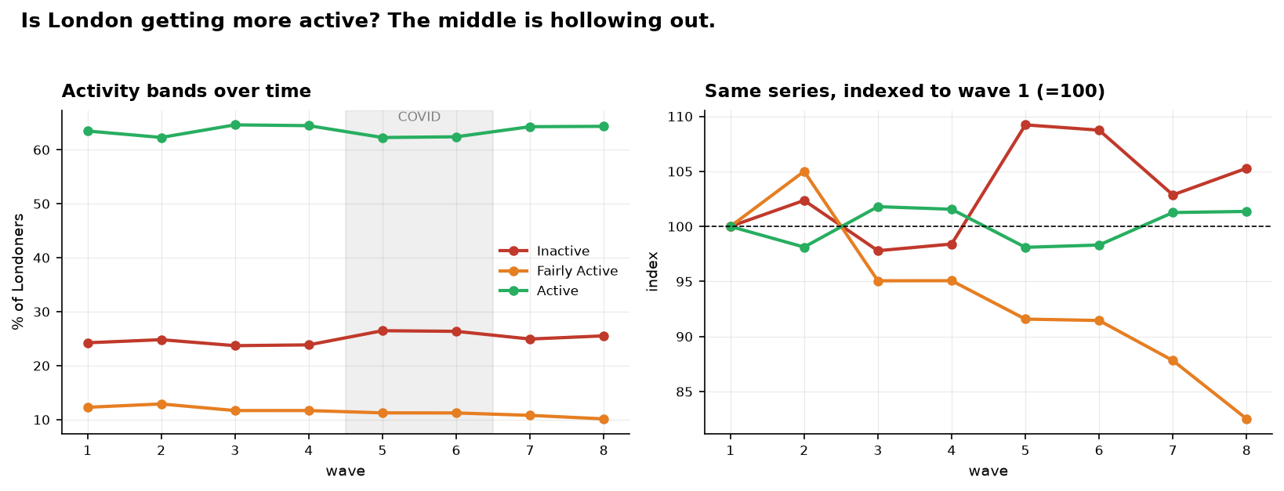
Figure 8.1. Activity bands over eight years. The right-hand panel, indexed to the first wave, makes the decline in the partially active group visible.
Label: Forecast. The strategic significance is that the partially active are the group closest to the guideline, and therefore the least costly to move across it. That group has contracted by nearly a fifth in eight years — a hollowing of the middle rather than a shift of the whole distribution.

8.2 London-level forecast
Overall activity is projected to reach 64.7% by 2025–26, from 64.4% today. This near-flat headline resolves into two opposing forces of comparable size.
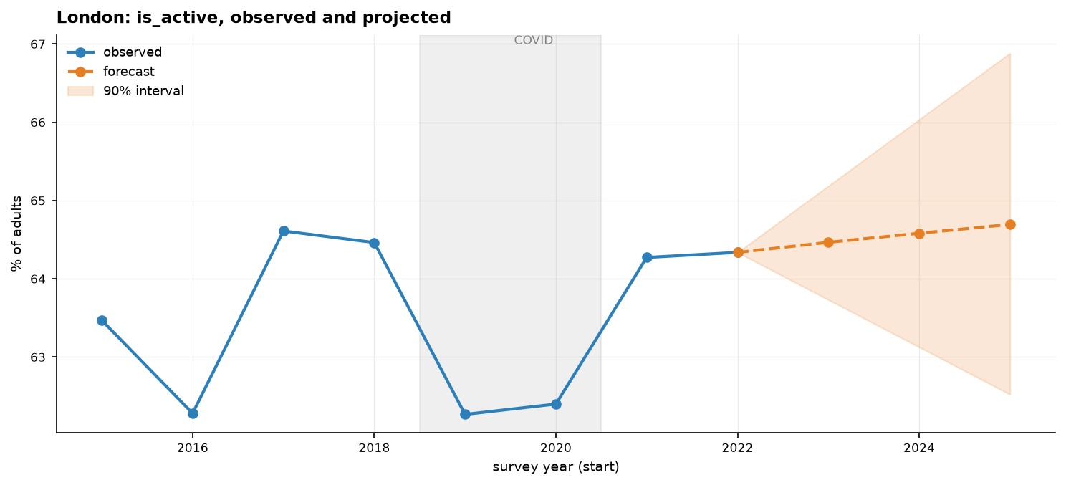
Figure 8.2. Observed and projected activity for London, with a 90% confidence band. The solid line is observed survey data; the dashed line is the model projection, beginning at the last observed year.
Component | Effect by 2025–26 | Interpretation
Composition | −0.37 points | London's ageing population pulls activity down
Behaviour | +0.69 points | People of a given type are becoming more active
Net | +0.32 points | Stability produced by two real trends cancelling

This is the central analytical result of the forecast. A conventional model would report the number as "roughly flat" and stop. Decomposing it shows that the stability is a coincidence of two genuine trends cancelling, not a settled equilibrium — and that if behavioural improvement stalls, the demographic headwind takes over. The stability is more fragile than the flat line suggests.

8.3 Borough forecasts
Every borough is forecast individually with a 90% interval. The gap between the most and least active boroughs — Wandsworth at roughly 75% and Barking and Dagenham at roughly 51% — is around 24 points, and it does not narrow across the projection; the intervals of the extremes do not overlap. Every borough shows a negative composition effect, ranging from near zero to about −0.9 points: London's demographic change is a headwind everywhere, varying only in strength.
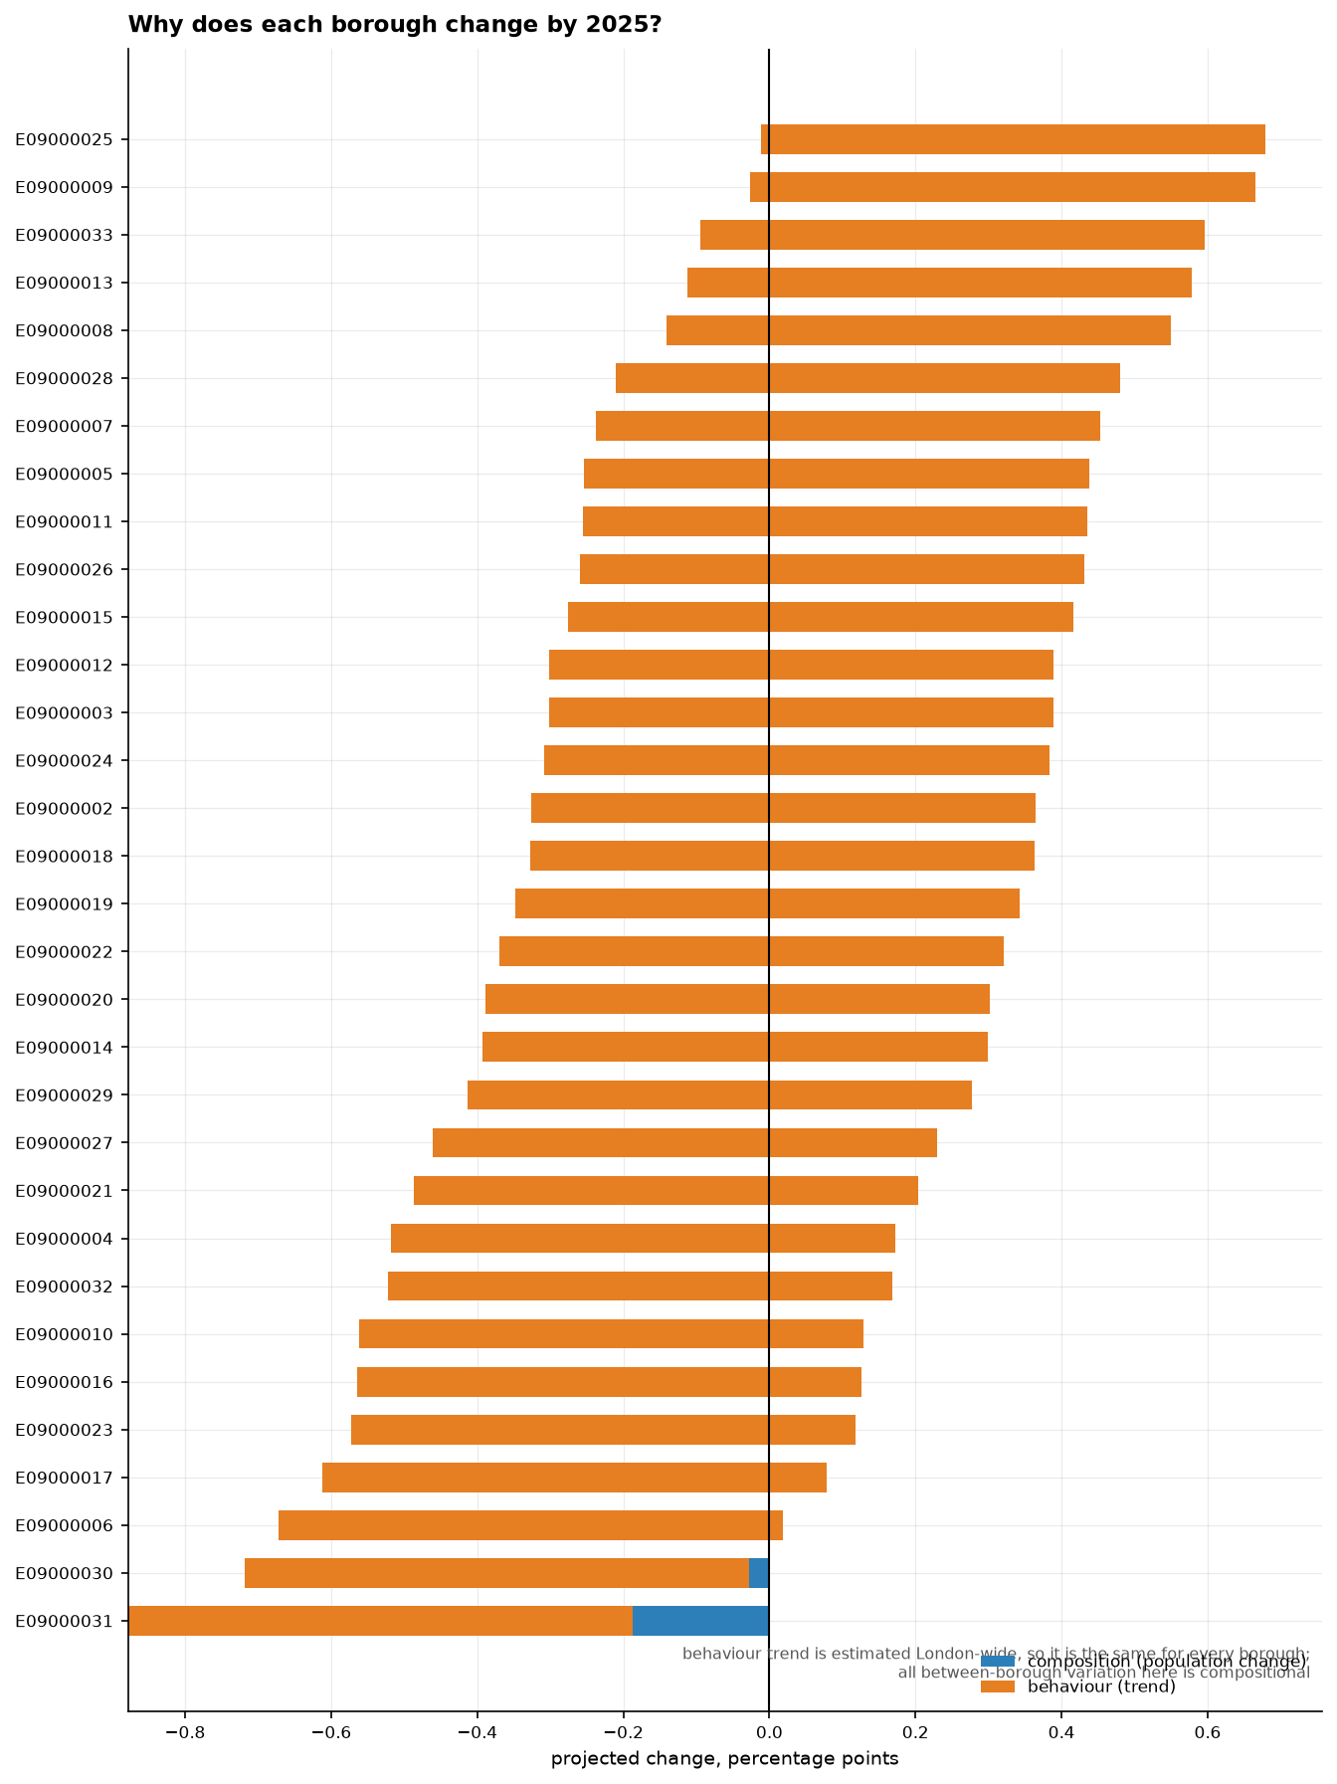
Figure 8.3. Each borough's projected change, split into population change and behavioural trend. The behavioural trend is estimated London-wide and is therefore common to all boroughs, so the between-borough variation shown here is compositional.

8.4 Activity-specific and club-membership forecasts
The same engine forecasts each activity type and each club type. Club membership is rising overall, led by team sports; fitness and gym membership is the single category still declining after the pandemic. Among activities, walking and active travel dominate participation. The activity series most disrupted by the pandemic — team sports and active travel — swing widely and are treated as directional rather than precise, a caution their wide intervals make explicit.
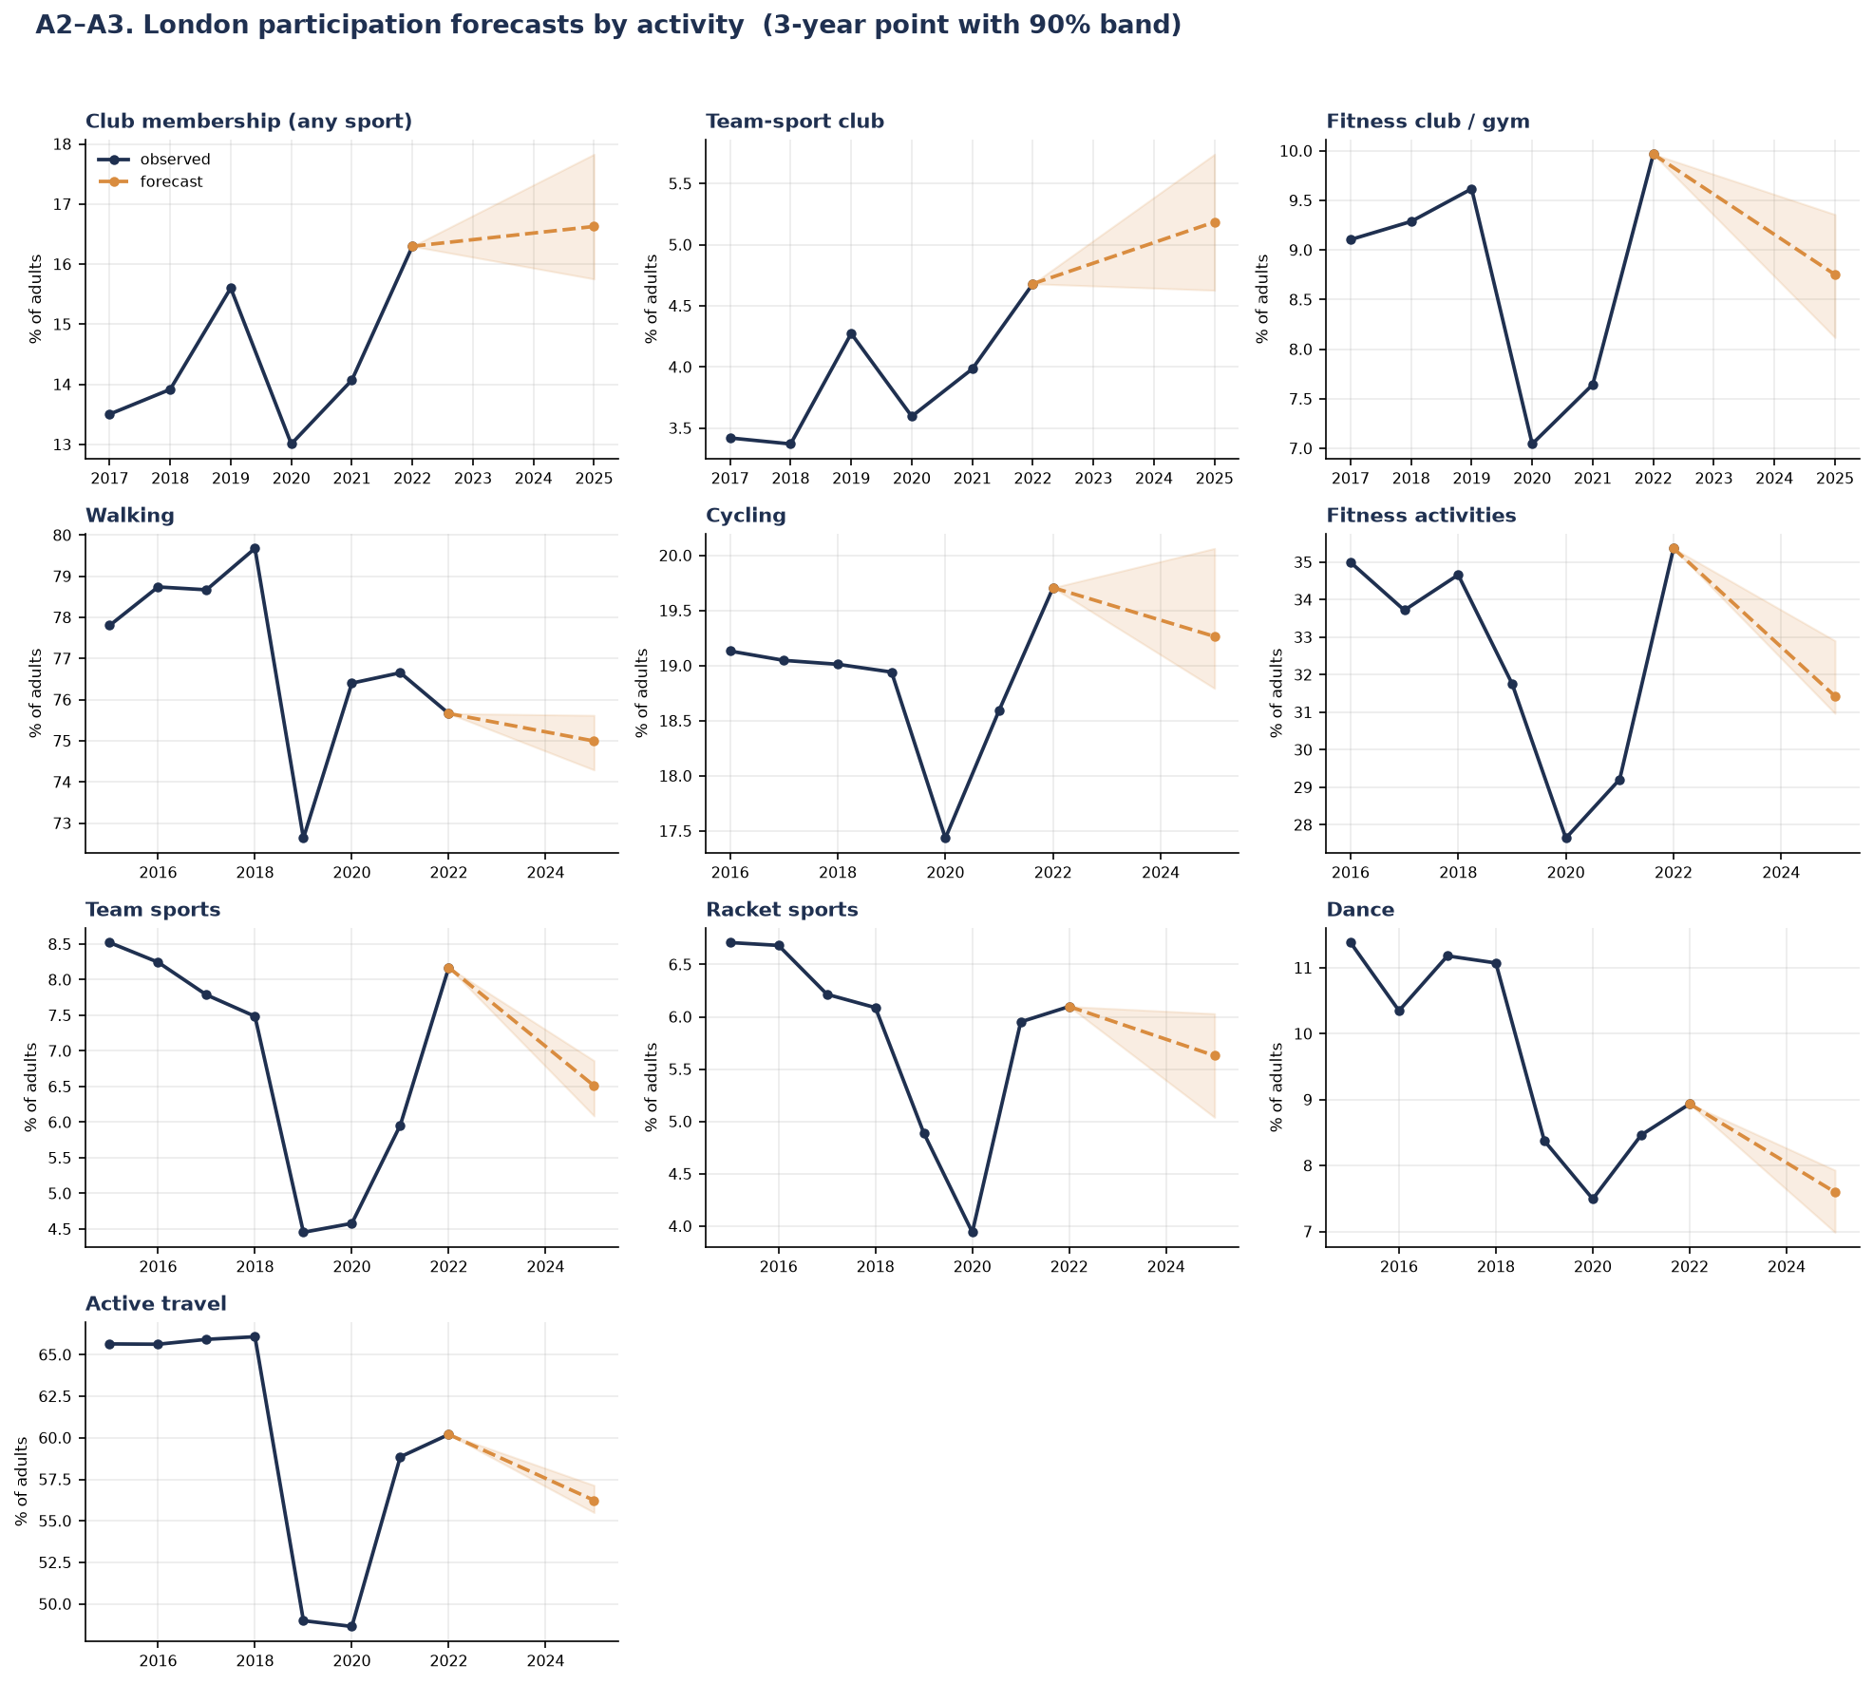
Figure 8.4. London participation forecasts by activity, three-year point with 90% band. Solid lines are observed survey years, dashed lines with open markers are projections. Label: Forecast.
Over ten years, each activity is given a scenario range rather than a point, for the reasons set out in Section 7.3.
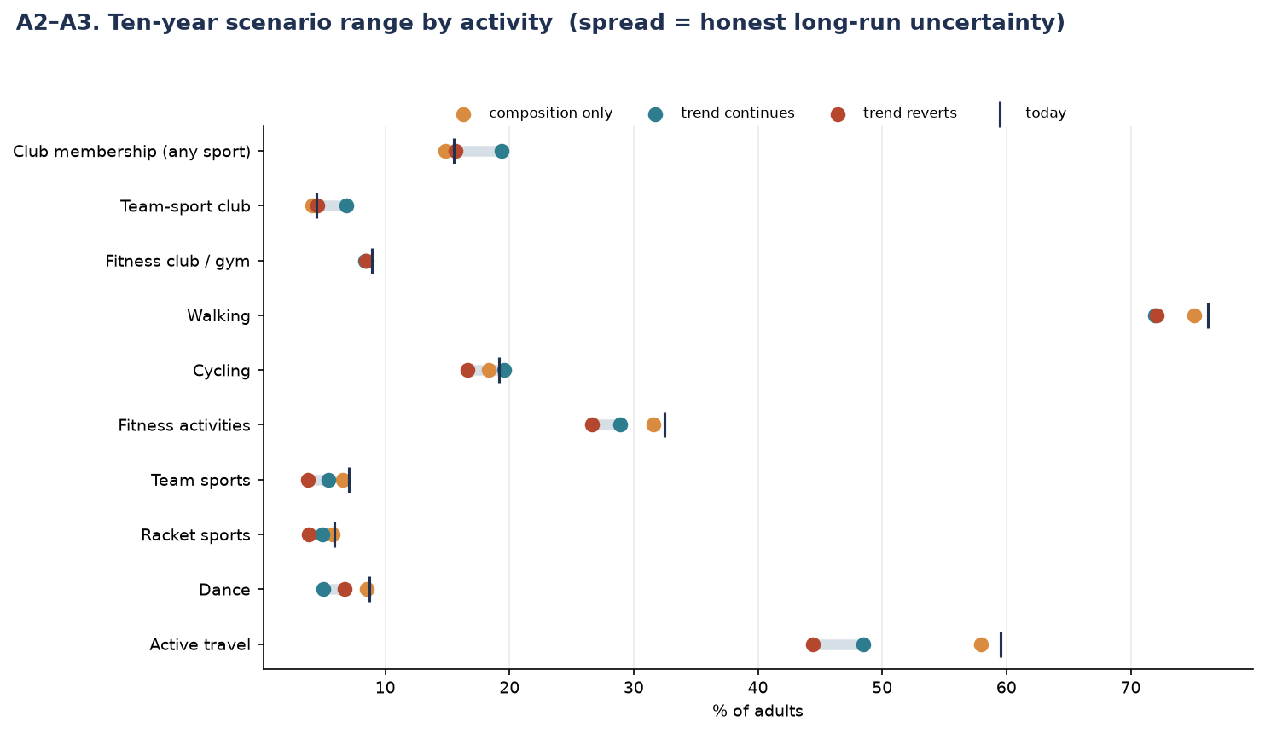
Figure 8.5. Ten-year scenario ranges by activity. The spread between scenarios is the honest statement of long-run uncertainty.

8.5 Factors reducing free time
Label: Description. The free-time questions appear in the final wave only, so this is a snapshot and cannot be forecast. Respondents reporting long working hours are markedly less active than those who do not — a time-poverty signal that connects directly to the decline in structured, facility-based activity documented in Section 8.4.
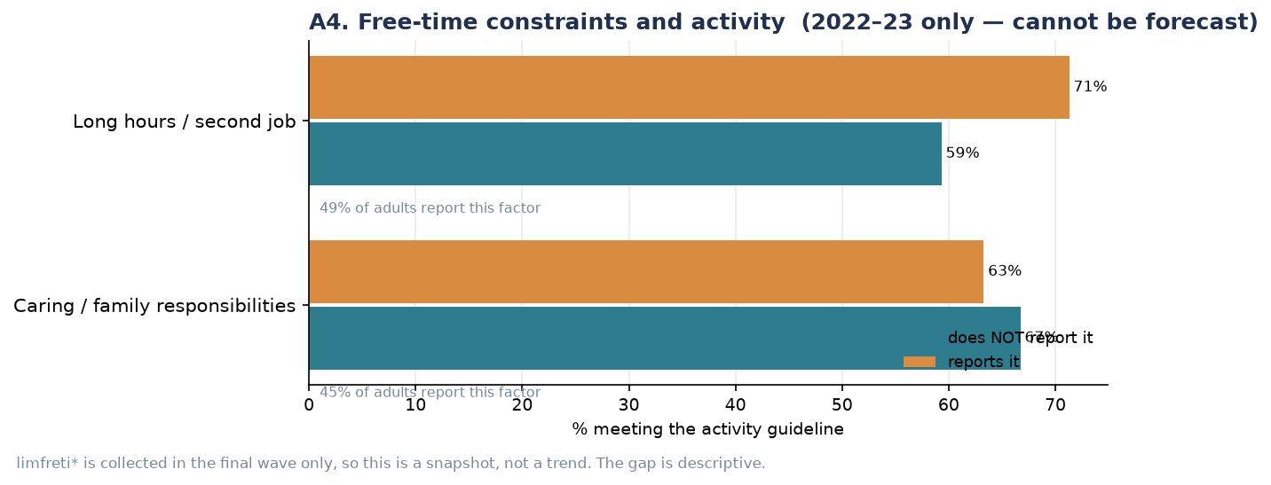
Figure 8.6. Activity by reported free-time constraint, 2022–23 only. Described, not forecast.

9. Demographic insights
This section answers the brief's second area: participation and forecasts by demographic group, the activities each group favours, and participation among people with health conditions.

9.1 Who is active
The socio-economic gradient is the strongest single pattern in the data — wider than age or ethnicity. The highest socio-economic group is 74% active against 47% for the lowest, a 27-point gap. Age spans 70% among the youngest to 52% among the oldest; ethnicity runs from around 70% for White groups to around 54% for Black and Asian groups; inner London is more active than outer, and men slightly more than women.
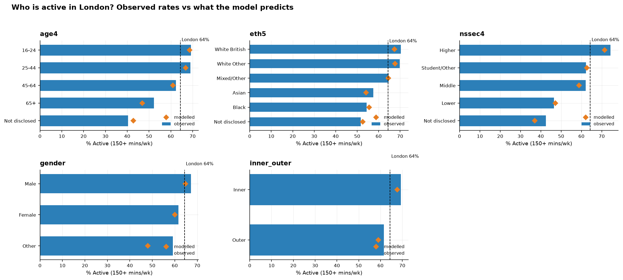
Figure 9.1. Observed activity by demographic group (bars) against the model's predictions (diamonds). The dashed line marks the London average.
That inner London is more active than outer runs counter to a simple deprivation account, since inner London contains many of the capital's most deprived areas; the composition–place analysis of Section 6 explains why place effects, not composition alone, drive this.

9.2 Forecasts by group
Each demographic group is forecast forward, calibrated so that its baseline equals its observed rate: the model supplies the change, and the data supplies the level, so the forecast reads on the scale that people recognise. The gradients persist through the projection.
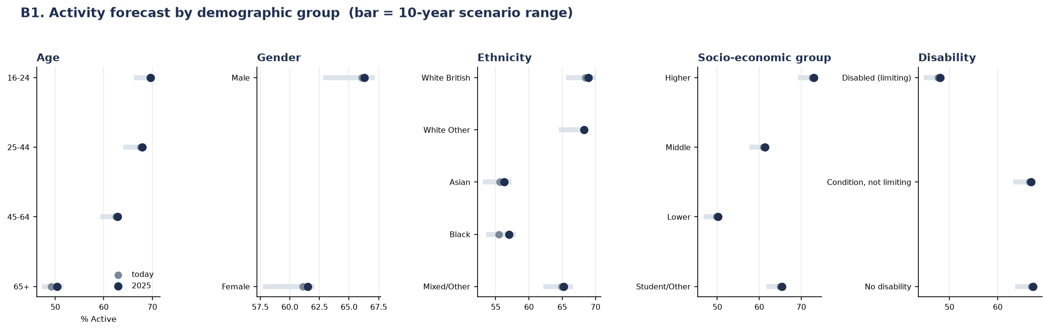
Figure 9.2. Activity forecast by demographic group; the bar shows the ten-year scenario range. Label: Forecast.
The 65-and-over group is the clearest illustration of the demographic headwind. It is the least active group and it barely moves on its own — but London is ageing into it, and that shift is the mechanism behind the −0.37-point composition effect at London level. For groups that are themselves projection dimensions (age, gender, ethnicity) the forecast is direct; for the others (socio-economic group, disability) the group's propensity is scaled to its observed activity ratio, a transparent approximation stated here so it is not over-interpreted.

9.3 Preferred activities by group
Walking is the top activity for every single demographic group. It is the universal entry point and the behaviour most tied to demographics. The socio-economic gap is not uniform across activities: it concentrates in the facility-dependent ones — higher groups do considerably more fitness and cycling — which are precisely the activities that Section 6 showed depend on provision. The demographic story and the provision story meet here.
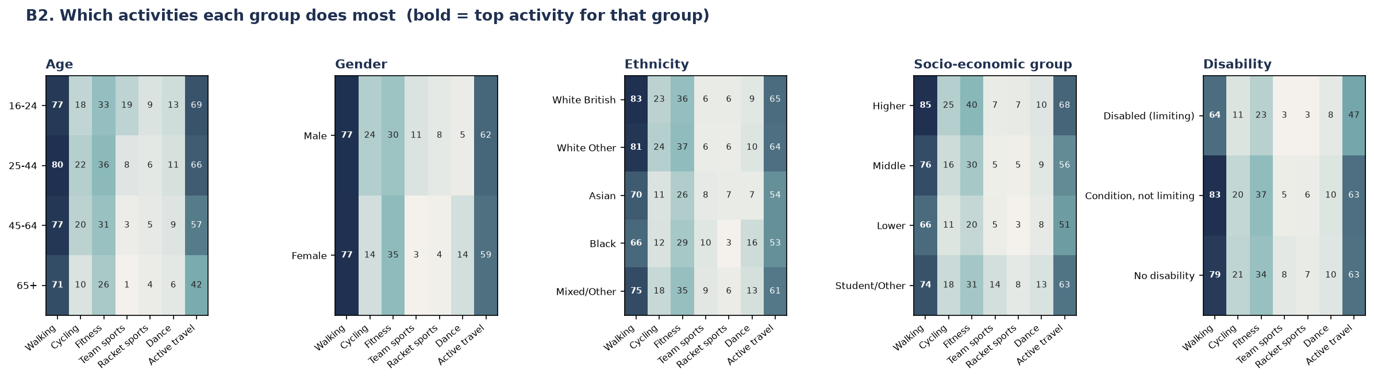
Figure 9.3. Which activities each group does most; the top activity for each group is emphasised.

9.4 Within-borough demographic detail
Label: Pooled description. A single borough-by-demographic cell contains around six respondents in a given wave, too few to report, so all waves are pooled and thin cells are suppressed. The age gradient holds inside every borough, but the level varies so widely that a young person in a deprived outer borough can be less active than an older person in an affluent one — place and demography compounding, again.
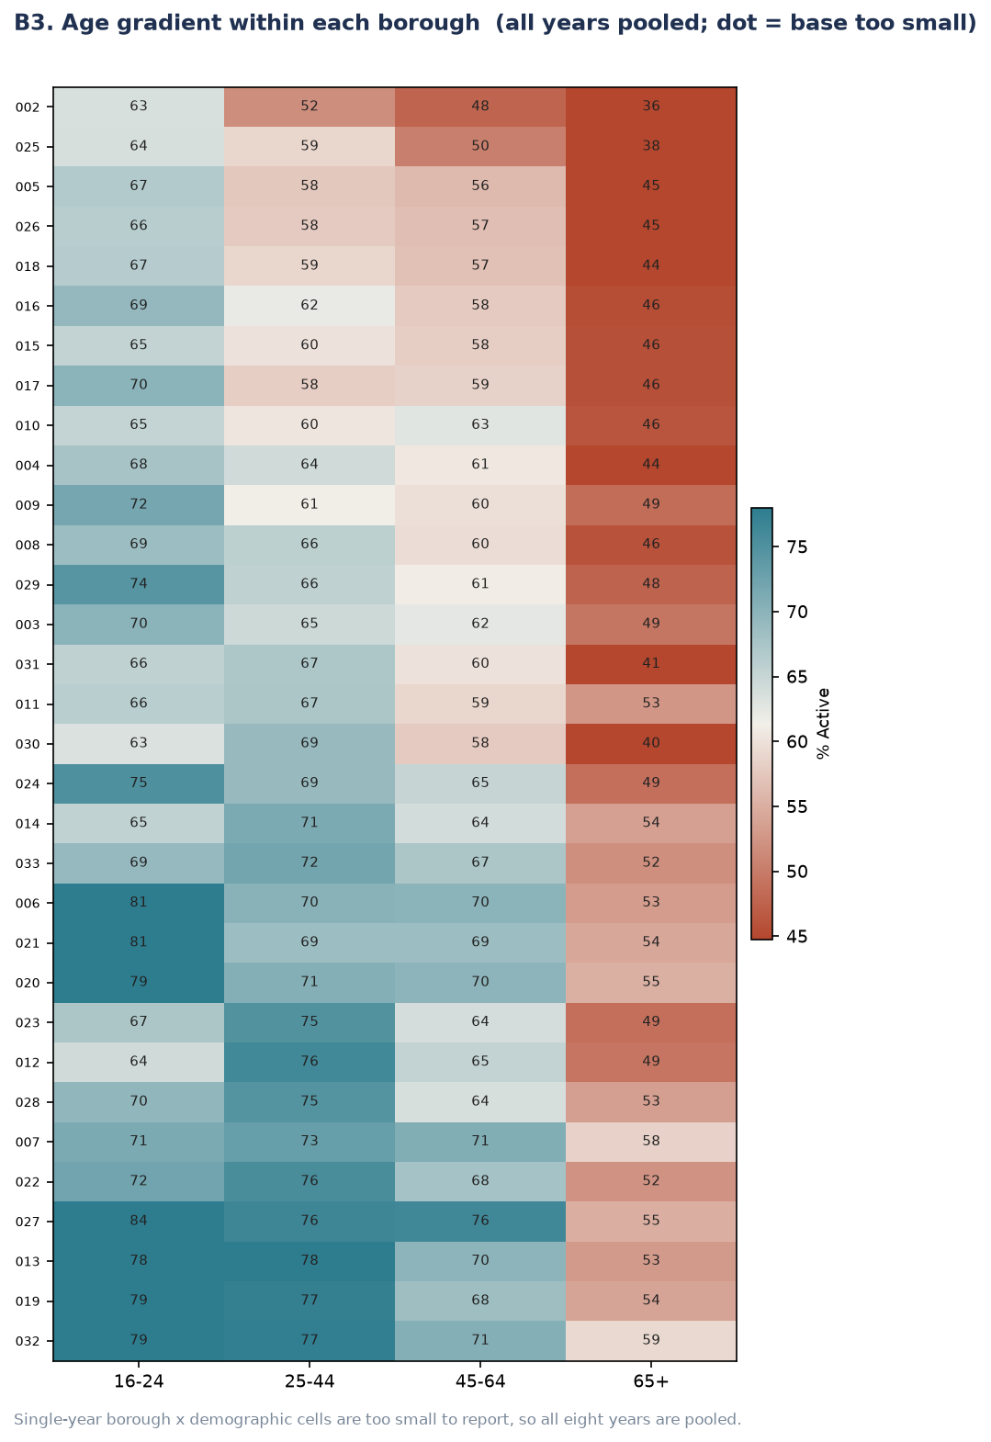
Figure 9.4. Age gradient within each borough, all waves pooled; a dot marks cells too small to report.

9.5 Participation and health conditions
Label: Description. Self-rated health is collected only from 2018–19, so it is described rather than forecast. The gradient is the steepest single relationship in the entire dataset — from 76% active at very good health to 20% at very bad, a 56-point span — and both long-term physical conditions and mental-health conditions show substantial gaps. The relationship is bidirectional: poor health reduces activity, and inactivity worsens health. It is therefore reported as association, not one-directional cause.
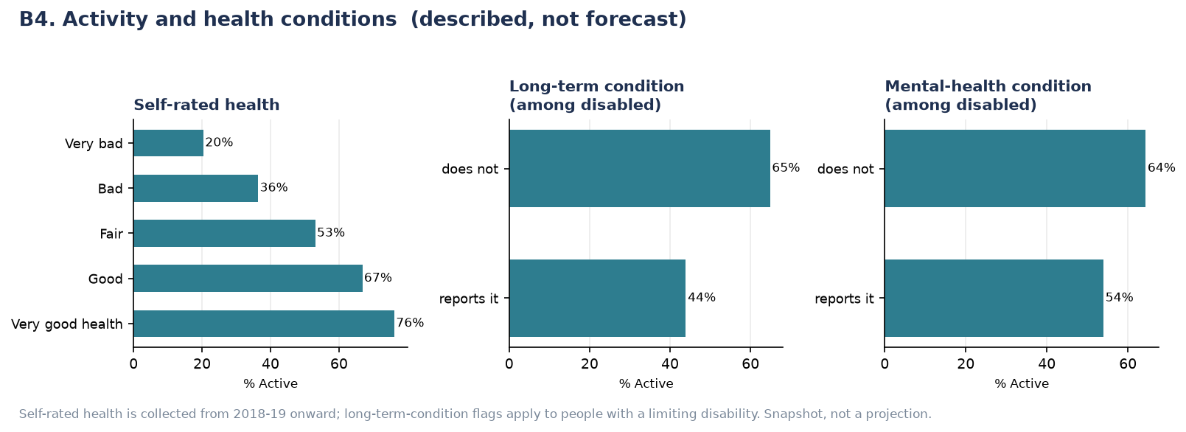
Figure 9.5. Activity by self-rated health and by long-term condition. Described, not forecast.

10. Indoor versus outdoor activity
This section answers the brief's third area: the balance of indoor and outdoor activity, its variation by activity level, and its relationship with inner/outer London and socio-economic group. The setting questions are asked of a rotating subsample of roughly a third of respondents, so this section is largely description, with a single caveated London-level projection.

10.1 The balance over time
Outdoor activity dominates throughout — roughly 65 to 72% — and indoor activity sits well below it, at 29 to 41%. The pandemic hit indoor activity hardest and its recovery was only partial: activity shifted outdoors and has not fully returned. Label: Forecast, with a wide interval reflecting the subsample.
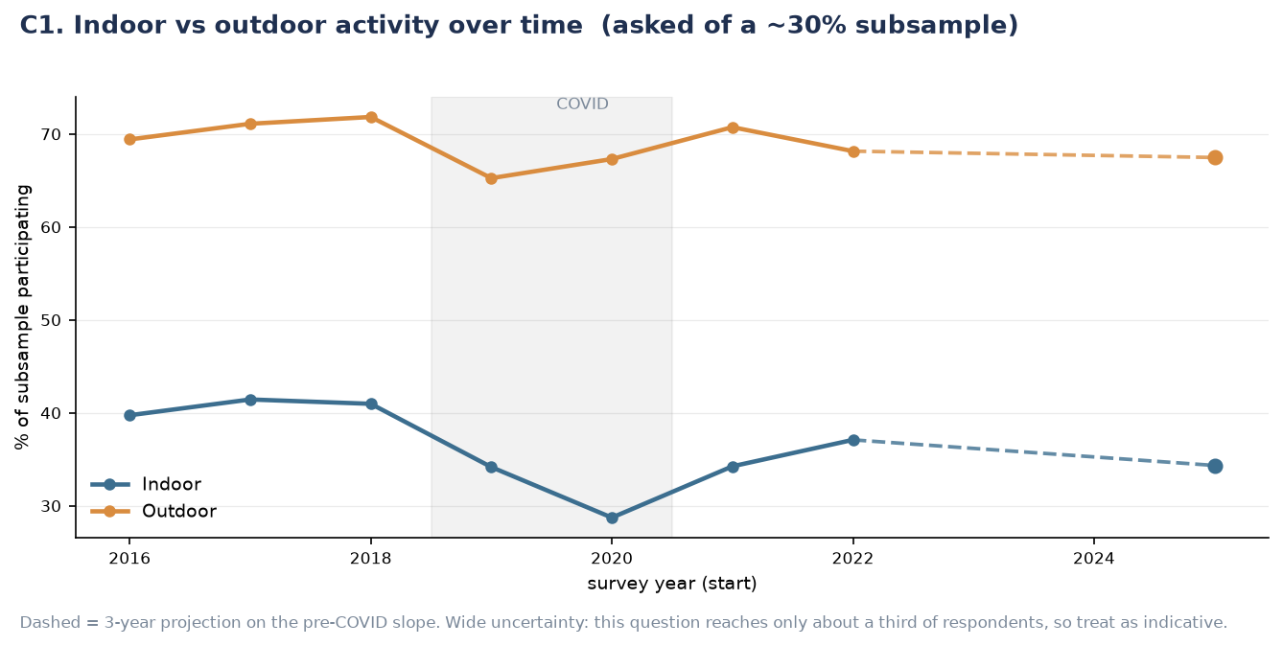
Figure 10.1. Indoor and outdoor participation over time, on the subsample. Solid lines are observed survey years; dashed lines with open markers are indicative projections.

10.2 Setting by activity level
Label: Description. Active people skew outdoor, and the street or road is overwhelmingly where activity happens — far ahead of leisure centres, parks or countryside. Leisure centres serve the already-committed: the Active use them roughly twice as much as the partially active. The low share of park-based activity reframes the picture as one of walkability and active travel rather than parks.
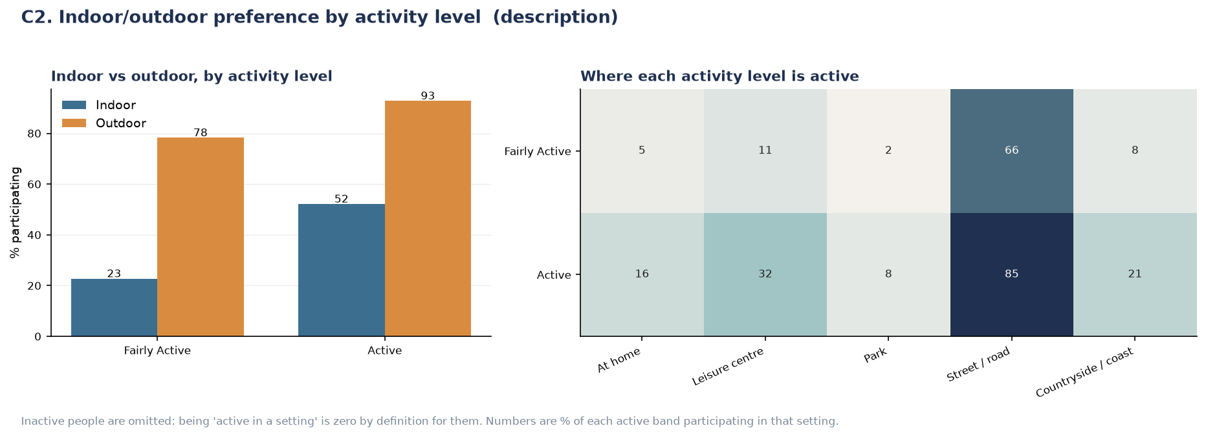
Figure 10.2. Indoor/outdoor split and specific settings, by activity level. Inactive respondents are omitted, being zero by definition.

10.3 Inner versus outer London by socio-economic group
Label: Description. Inner London leads on both indoor and outdoor activity for nearly every socio-economic group, and the widest gap is in affluent outdoor activity — consistent with walkable, high-amenity inner boroughs benefiting those able to afford to live in them. This is the exact relationship the brief names, and it decomposes the inner-London advantage by setting and by class.
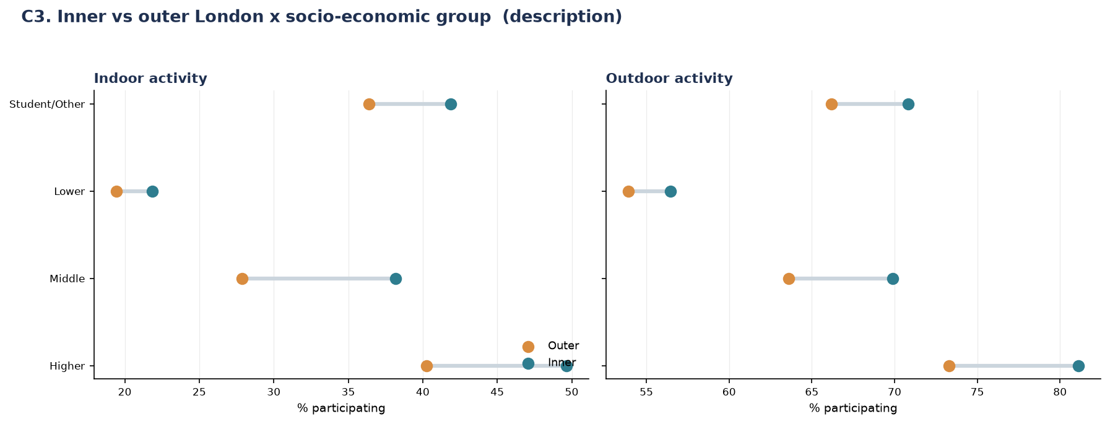
Figure 10.3. Inner versus outer London by socio-economic group, indoor and outdoor.

11. Volunteering in sport
This section answers the brief's fourth area. Volunteering is the most constrained target in the project: demographics explain only about 15% of the variation between boroughs, the borough correlation is near zero, and the question base changed twice during the series. It is therefore reported as description at London and demographic level; a borough forecast is not supportable, and stating that plainly is the honest result.

11.1 Who volunteers
Label: Description. Volunteering runs at about 18% and is youth-driven — the reverse of activity, where the young are most active but here also volunteer most, at 25% among 16–24s. Men volunteer more than women (21% against 15%), there is a modest socio-economic gradient, and — unusually — the picture is fairly even across ethnicity and disability, a more equitable pattern than activity itself.
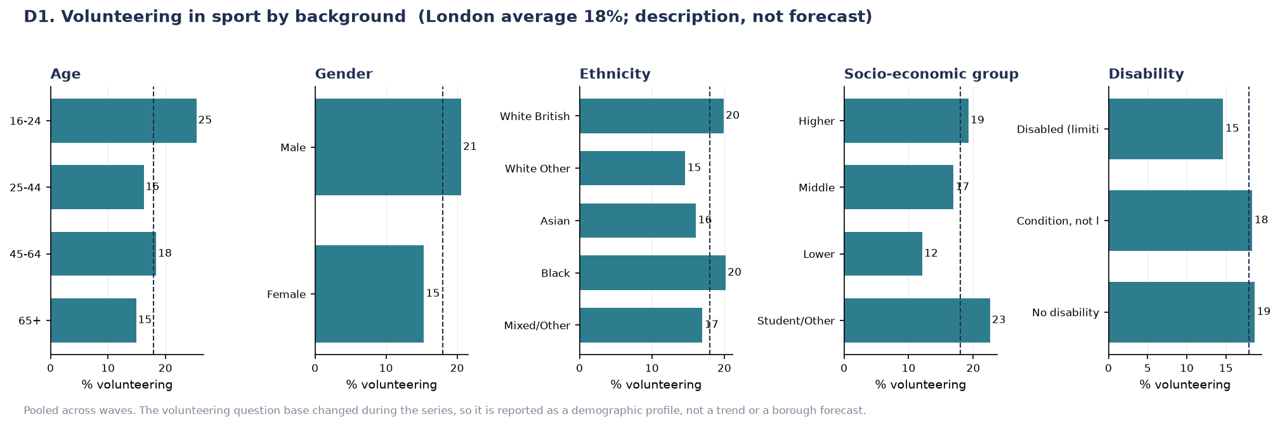
Figure 11.1. Volunteering in sport by background, pooled across waves. Described, not forecast.

11.2 Roles by demographic group
Label: Description. Organising and administration is the backbone role for almost every group. The young break the pattern toward hands-on roles — stewarding and coaching — and there is a clear gender split: men coach nearly twice as often as women and officiate more, while women concentrate in organising and support. This is a directly actionable finding for how volunteers are recruited and developed.
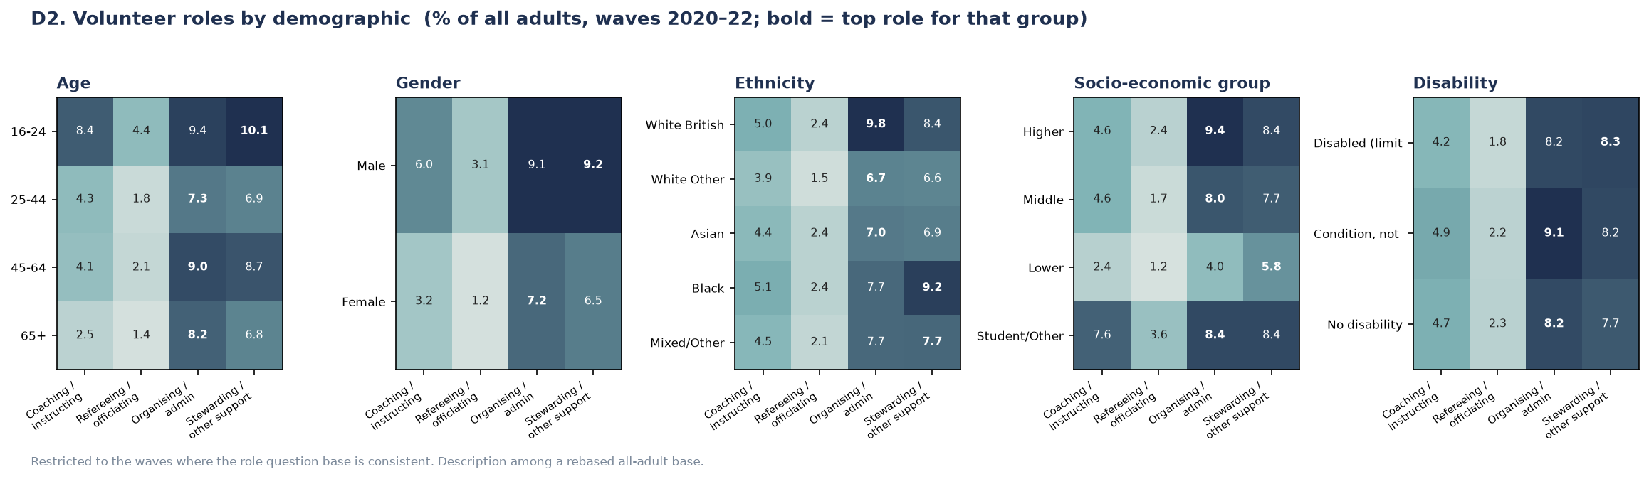
Figure 11.2. Volunteer roles by demographic group, waves 2020–22; the top role for each group is emphasised.

12. Coverage of the brief
The table below maps every sub-question in the brief to the way it is answered and its honesty label. Every line has either a forecast or a stated reason it cannot be forecast.
Brief sub-question | Delivered as | Label
Overall activity, London and boroughs, ten years | 64.7% by 2025–26; all 32 boroughs with intervals; ten-year scenarios | Forecast
Activity-specific participation, ten years | Seven activities, London-level, with scenario ranges | Forecast
Club membership, ten years | Overall, team-sport and fitness clubs | Forecast
Factors reducing free time | Snapshot; long hours associated with lower activity | Description
Group forecasts and preferred activities | All five demographic dimensions; walking universal | Forecast
Activity by demographic within borough | Pooled age gradient per borough | Pooled
Participation and health conditions | 56-point span by self-rated health | Description
Indoor/outdoor balance, ten years | Outdoor dominant; indoor took a lasting hit | Forecast (wide)
Setting by activity level | Street-led; leisure centres serve the committed | Description
Inner/outer × activity × socio-economic | Inner leads; widest gap in affluent outdoor | Description
Volunteering by background | 18% average; youth- and male-skewed | Description
Volunteer roles by demographic | Organising dominant; clear gender split | Description

Nothing in the brief is left unanswered, and nothing is forced past what the data supports.

13. What the framework enables
Beyond the specific figures, the project delivers a set of standing capabilities.
Capability | What it supports
Borough forecasts with confidence intervals | Planning and target-setting that separates real change from sampling noise
Composition–behaviour decomposition | Distinguishing demographic pressure, which must be absorbed, from behavioural change, which can be influenced
The provision gradient across behaviours | Prioritising investment toward behaviours that respond to provision rather than to population
Borough performance against demographic expectation | Identifying boroughs that outperform their population, and asking what they do differently
Full demographic profiles | Targeting the groups furthest from the guideline, quantified
A reproducible, extensible pipeline | Refreshing every figure when a new survey year is published, with no code changes

14. Limitations
Each limitation is stated plainly, because each affects how the results should be used.
- The survey is not a panel. No individual is followed over time, so the analysis describes how the population changes, not how particular people change over their lives.
- The behavioural trend rests on six usable years. Two waves are excluded as pandemic-affected. Over three years this is a small correction; over ten it is the least robust element in the analysis, which is precisely why the ten-year horizon is presented as scenarios rather than a point forecast. Each future year of data strengthens it.
- The place effect is measured, not explained. The analysis establishes that roughly half of between-borough variation is not compositional, but not what causes it. Section 15 sets out how this could be closed.
- Several questions are single-year or subsample. Free-time constraints (one wave), indoor/outdoor settings (a rotating third of respondents) and volunteering (a base that changed twice) are limited by how the survey collected them — hence their description labels.
- Borough-by-demographic detail is thin. Around six respondents populate a typical borough–demographic cell in a single wave, so such detail is reported only pooled across waves, with thin cells suppressed.
- Group forecasts for non-projected dimensions are approximate. Socio-economic and disability groups are not dimensions of the population projection, so their forecasts scale the group's propensity by its observed activity ratio — a transparent approximation rather than a full projection.

15. Recommended next step
The strongest available extension is to explain the place effect. The analysis produces, for every borough, a residual — the amount by which it beats or misses the activity its population predicts (Figure 6.2). That residual is a ready-made dependent variable, and it can be tested against external data the survey does not contain:
Priority | External data | Question it would answer
1 | Cycling infrastructure by borough | Does cycleway provision explain the widest borough gap in the dataset?
2 | Sports-facility supply per head | Does facility density explain leisure-centre use and club membership?
3 | Green-space coverage | Does park provision explain park-based activity?
4 | Official population projections | Can the composition layer be improved with formal cohort projections?

One constraint should be stated in advance: this analysis has 32 data points. That supports three or four explanatory variables at most, and yields descriptive rather than causal results. A finding that facility supply does not explain the residual would still be a useful and publishable result. This extension is severable: the project is complete and defensible without it.

16. Conclusion
The project delivers a complete, validated and reproducible forecasting framework for sport and physical activity across London's 32 boroughs, answering every area of the commissioning brief at the level the data can honestly support. Its central methodological contribution is to carry the forecast with demographic projection rather than with temporal extrapolation, which is both more defensible on eight noisy years and more informative, because it separates demographic pressure from behavioural change.
Its central substantive finding is the provision gradient: the behaviours least explained by who lives where are exactly those most open to influence through investment. Combined with the decomposition of London's flat headline into two opposing forces, and the persistent 24-point inequality between boroughs, this gives the commissioning organisation not merely a set of numbers but a diagnosis — of where change will happen on its own, where it will not, and where investment can most plausibly move the outcome.

Appendix A. The analytical pipeline
The analysis runs end-to-end from the raw survey files. Every stage prints validation output, and every figure regenerates automatically.
Stage | Purpose
Dictionary parsing | Reads all eight dictionaries; extracts variable definitions and geographic lookups
Wave profiling | Compares variable availability across waves; flags structural breaks
Harmonisation | Applies recoding, missing-value rules and geographic mapping; builds the individual file
Cell-panel construction | Aggregates to the reporting grain with sample sizes and reliability measures
Feasibility screening | Tests whether each behaviour has enough signal for borough-level analysis
Propensity modelling | Fits and compares models; produces diagnostic figures
Composition–place decomposition | Separates composition from place across behaviours
Forecasting | Produces projections, decomposition and scenarios with intervals
Stage runners (A–D) | Apply the engine and descriptions across the four brief areas
Visualisation | Produces exploratory and prediction figures

Three automatic checks guard every run: the activity classification must match Sport England's published grouping; the aggregated cell panel must reconcile exactly with the individual file; and every forecast must begin at the last observed value. A run that fails any of these halts or flags rather than producing a silently incorrect result.

Appendix B. Extensibility to future years
The pipeline is built to accept future survey releases indefinitely. Adding a new annual file and re-running extends the wave numbering and the year-to-wave mapping automatically, with no code changes, through the mid-2030s. This was verified by constructing a twelve-wave dataset and confirming that the forecasting engine advanced its baseline and horizon without modification.
Three properties of this extensibility are worth noting. First, a new year's file must be structurally similar; if the survey renames a column or changes a question's routing, the feasibility diagnostic flags it automatically, though the fix requires a human decision — as it did for the four defects in Section 4.4. Second, each new year needs its own dictionary for the geography mapping. Third, and most valuably, the framework improves as it ages: each additional non-pandemic year firms up the behavioural trend, which is the weakest element of the current model, so the long-run scenarios become progressively less speculative. The deliverable is therefore a standing capability that strengthens with each survey release, not a one-off analysis.

Appendix C. Glossary of key terms
Term | Meaning
Active / Fairly Active / Inactive | The three activity bands: 150+, 30–149, and 0–29 weekly moderate-equivalent minutes
Composition effect | The part of a projected change attributable to the population's demographic mix changing
Behaviour effect | The part attributable to people of a given type changing their activity over time
Propensity model | The time-free model relating a person's characteristics to their activity band
Provision gradient | The finding that the more a behaviour depends on facilities or infrastructure, the less demography explains its geography
Leave-one-borough-out | A validation predicting each borough from a model trained without it
AUC | Area under the ROC curve; a measure of a model's ability to rank cases, where 0.5 is chance
Residual (borough) | How far a borough's observed activity exceeds or falls short of what its demography predicts

Yes — and this is an important distinction. “Time-free” does NOT mean your data has no years. Your data absolutely has years: 2015–16 through 2022–23.
What it means is that the propensity model itself does not use year as a mechanism for predicting future activity.
Think of your framework as two separate parts
Your data has:
2015–16 → 2016–17 → ... → 2022–23
But you deliberately separate:
1. Who someone is → how likely they are to be Active
This is your ordinal logistic propensity model.
For example, it learns relationships such as:
Age + gender + ethnicity + socioeconomic group + disability + borough → probability of being Active
So it estimates something like:
A person with characteristics X has a 70% probability of being Active.
The model is learning this relationship from the historical survey data, but it is not saying “activity increases by X% every year.”

2. What changes in the future → handled separately
Your forecasting framework then introduces time through:
- projected demographic composition, and
- the behavioural trend $δ_{t}$.
That's why your equation is:
$${\hat{r}}_{b,t}=\sum_{c}{s_{b,c,t}}p_{b,c}+δ_{t}$$
Here:
- $s_{b,c,t}$changes with time → projected population composition
- $p_{b,c}$is the propensity estimated from the ordinal logistic model
- $δ_{t}$changes with time → behavioural trend
So time is absolutely present in the forecasting framework.
It just isn't directly modelled inside $p_{b,c}$.

A simple example
Suppose the model learns from the historical data that:
16–24-year-olds have a relatively high probability of being Active.
Your population projection then says:
In the future, the proportion of 16–24-year-olds changes.
The forecast changes because the population composition changed.
Separately, your behavioural term says:
Even after accounting for who lives in London, activity has been changing by approximately +0.23 percentage points per year during the non-pandemic period.
So the forecast also changes because of behavioural trend.
The ordinal logistic model itself isn't extrapolating:
2022 → 2023 → 2024 → 2025...
in the way an ARIMA or time-series model would.

So is your current wording correct?
Your current report says:
“The propensity model is treated as time-free, meaning that it does not itself predict future time periods. Instead, future change is introduced through the projected population composition and behavioural trend.”
Yes, the underlying idea is correct, but I agree that “time-free” can sound confusing, especially because your dataset obviously contains a time dimension.
I would actually change the wording to make it clearer and more academic.
I recommend replacing it with:
“The propensity model does not directly model temporal trends or extrapolate activity into future survey years. Instead, time-dependent changes are introduced separately through the projected population composition and behavioural trend.”
This is much clearer than “time-free.”
And then your limitation in Chapter 5 would become:
“The propensity model does not directly model temporal trends or extrapolate activity into future survey years, which is what makes the approach workable but also fixes an assumption in place.”
Although I'd make that sentence even cleaner when we get to 5.3.
So don't worry — we're not saying your model ignores the years. We're saying it doesn't use year as a direct predictor of future activity. That separation is actually one of the central ideas of your forecasting framework.

