London Sport — Combined Forecast Findings
All four pillars: Overall Participation · Demographic Insights · Indoor vs Outdoor · Volunteering in Sport
This report combines all four analytical pillars of the London Sport brief — overall participation forecasts, demographic-specific insights, indoor versus outdoor activity, and volunteering in sport — into a single reference document, with the underlying charts and the analytical framing behind them. All figures derive from the forecasting framework in Section 3.5 and the LightGBM propensity model selected in Section 4.4 of the accompanying methodology chapter. Findings and framing additionally draw on the wider modelling analysis produced by the team’s modelling lead (referred to throughout as ‘the wider analysis’), which independently corroborates a number of the findings below.

A note on forecasting versus description
We only forecast when the data can actually carry a forecast. Three things have to hold: the question was asked consistently across the years, it reaches enough people to be reliable, and demographics explain enough of it to project forward. If any of those fails, we describe instead of forecasting.
What passed (forecast): overall activity, club membership, activity types and demographic groups — each was asked consistently, drew on large samples, and is well predicted by demographics. These are forecast throughout this report.
What failed, and why (described only):
• Free time — only asked in the final survey year. One data point is not a trend, so there is nothing to project.
• Volunteering — the question base changed twice, making the trend unreliable, and demographics explain only around 15% of the between-borough variation, so it cannot be projected by borough.
• Indoor/outdoor — only asked of roughly 30% of respondents, so it is projected at London level only, with wide uncertainty, and mostly described rather than forecast.
• Health — missing in the early survey years, so it cannot be trended; described only.
Health deserves a fuller explanation, since it is the clearest case of a variable that is both important and unforecastable. First, there is not a stable trend to project: self-rated health is available from five waves, but two of those five are the COVID years, which are excluded as disrupted. That leaves effectively three clean years to estimate a health–activity trend, and three points cannot distinguish a real trend from noise — a line can be drawn through any three points, but it means nothing. Second, and more fundamentally, health cannot enter the propensity model at all. The forecasting engine works by pushing a projected future population through the model; if health were included, forecasting would require projecting how London’s health distribution will change, and there is no basis for that. Worse, because health is missing in the early waves, including it would let the model use “health is missing” as a hidden proxy for “this is an early wave”, contaminating every other trend the model estimates. This is exactly why health was excluded from the propensity model entirely, not only from the forecast.
Health is nonetheless reported, as description, because the relationship is too important to drop: it is the steepest single relationship in the entire dataset, from 76% active at ‘very good’ health down to 20% at ‘very bad’ health — a 56-point span. So rather than pretending to forecast it, this report gives a clear snapshot of the current relationship.
The verdict that runs through this whole report: forecasting needs a consistent, well-sampled question that demographics can predict. Where we had that, we forecast. Where we did not, we described honestly rather than inventing a number the data could not support — and that restraint is a strength of this project, not a gap in it.

Coverage of the brief
Every sub-question in the commissioning brief is mapped below to how it is answered and its honesty label. Nothing in the brief is left unanswered, and nothing is forecast beyond what the data can support.
Brief sub-question | Delivered as | Label
Overall activity, London and boroughs, ten years | 64.9% by 2025–26; all 32 boroughs; ten-year scenarios | Forecast
Activity-specific participation, ten years | Seven activities, London-level, with scenario ranges | Forecast
Club membership, ten years | Overall, team-sport and fitness clubs | Forecast
Factors reducing free time | Snapshot only (2022–23); descriptive association | Description
Group forecasts and preferred activities | All five demographic dimensions; walking universal top activity | Forecast
Activity by demographic within borough | Pooled age gradient per borough (activity × borough not reportable) | Pooled / partial
Participation and health conditions | 56-point span by self-rated health | Description
Indoor/outdoor balance, ten years | Three-year indicative projection, wide interval | Forecast (wide)
Setting by activity level | Street-led; leisure centres serve the already active | Description
Inner/outer × activity × socio-economic | Inner leads in every group; widest gap in affluent groups | Description
Volunteering by background | ≈18% average; youth- and male-skewed | Description
Volunteer roles by demographic group | Organising/admin dominant; clear gender split | Description

P1 — Overall Participation Forecasts
All figures in this section derive from the framework in Section 3.5. Rather than a single ten-year point estimate, three bounded scenarios are shown throughout: recent gains continuing, behaviour holding flat while only the population’s demographic mix changes (‘Population change only’), and a COVID-scale reversal of recent gains.

Physical activity across London as a whole
The near-term model output projects broad stability in the Active share through 2025–26: Active is projected at 64.9%, Inactive at 26.0%, and Fairly Active falling further to 9.1%.
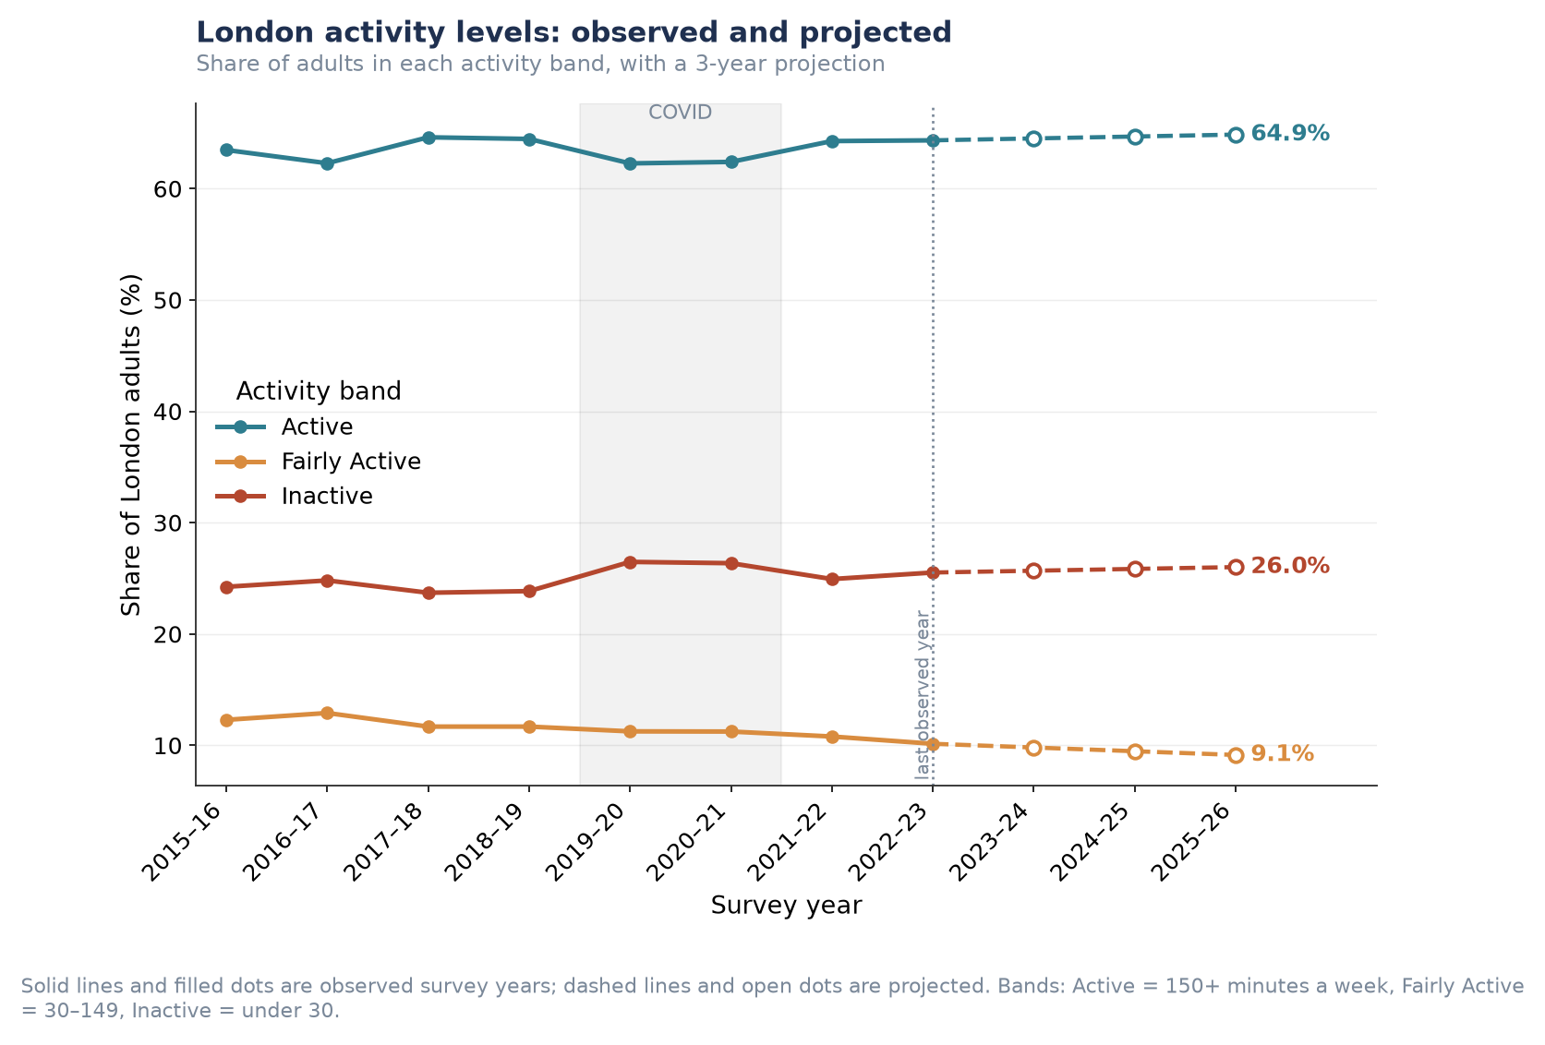
Figure P1.1. London-wide activity bands, observed 2015–16 to 2022–23 and projected to 2025–26.
Insight: the headline stability conceals a consistent shift beneath it. Across eight years the Fairly Active band has contracted by nearly a fifth (from around 12.3% to 10.1%), while Inactive has edged upward — a hollowing of the middle rather than a static distribution. The Fairly Active group sits closest to the 150-minute guideline and is the least costly group to move across it, so its contraction represents a shrinking pool of ‘nearly there’ Londoners rather than a neutral trend.
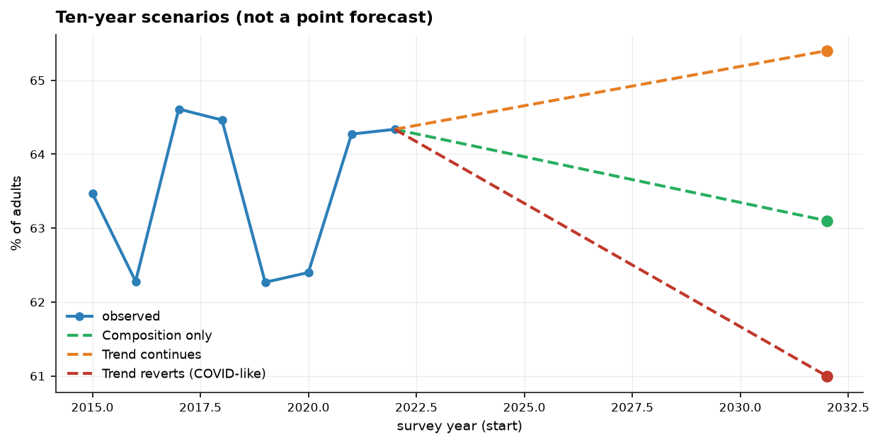
Figure P1.2. Ten-year scenario range for London-wide activity, 2022–2032.
Over the full ten-year horizon, the three scenarios diverge from 61.0% (if recent gains reverse) to 65.4% (if the current trend continues) — a roughly four-point range around the current 64.3%.
Table P1.2. Decomposition of the near-term London-wide forecast into composition and behaviour effects.
Component | Effect by 2025–26 | Interpretation
Composition | −0.37 points | London’s ageing population pulls activity down
Behaviour | +0.69 points | People of a given type are becoming more active
Net | +0.32 points | Apparent stability produced by two real trends cancelling

Insight: this decomposition is the central analytical result behind the ‘stable’ headline. A conventional forecast would report the number as roughly flat and stop there. Splitting it shows the flat line is not a settled equilibrium but two genuine, opposing trends of comparable size cancelling out. If the behavioural improvement stalls for any reason, the demographic headwind alone would pull London-wide activity down — the apparent stability is more fragile than the flat trend line suggests.

Likelihood of participating in specific activities
Ten-year scenario ranges were produced for seven individual activities and three club-membership measures.
Table P1.1. Ten-year scenario range by activity/club type (% of London adults).
Activity / Club Type | Today | If Gains Continue | Population Change Only | If Gains Reverse
Walking | 76.2% | 71.9% | 75.1% | 72.1%
Active travel | 59.6% | 48.5% | 58.0% | 44.4%
Fitness activities | 32.5% | 28.9% | 31.6% | 26.6%
Cycling | 19.1% | 19.6% | 18.3% | 16.6%
Team sports | 7.1% | 5.4% | 6.6% | 3.8%
Dance | 8.7% | 5.0% | 8.5% | 6.8%
Racket sports | 5.9% | 5.0% | 5.8% | 3.9%
Club membership (any sport) | 15.5% | 19.3% | 14.8% | 15.7%
Fitness club / gym | 8.9% | 8.4% | 8.5% | 8.4%
Team-sport club | 4.5% | 6.9% | 4.2% | 4.5%

Club membership figures are separate, possibly overlapping breakdowns rather than components of a single total — ‘fitness club/gym’ and ‘team-sport club’ do not sum to ‘club membership (any sport)’, since a person could belong to both, or to a club type not itemised here.
Insight: for every individual activity except cycling, continuing the recent trend implies a decline over the decade — but for all three club-membership measures, continuing the recent trend implies growth. This is consistent with the wider analysis: team sports and active travel are the two series most disrupted by the pandemic and swing widely, so their wide scenario ranges should be read as directional rather than precise. Informal, unstructured activity has been trending down since its pre-COVID level, while formal, club-based participation has been recovering upward.
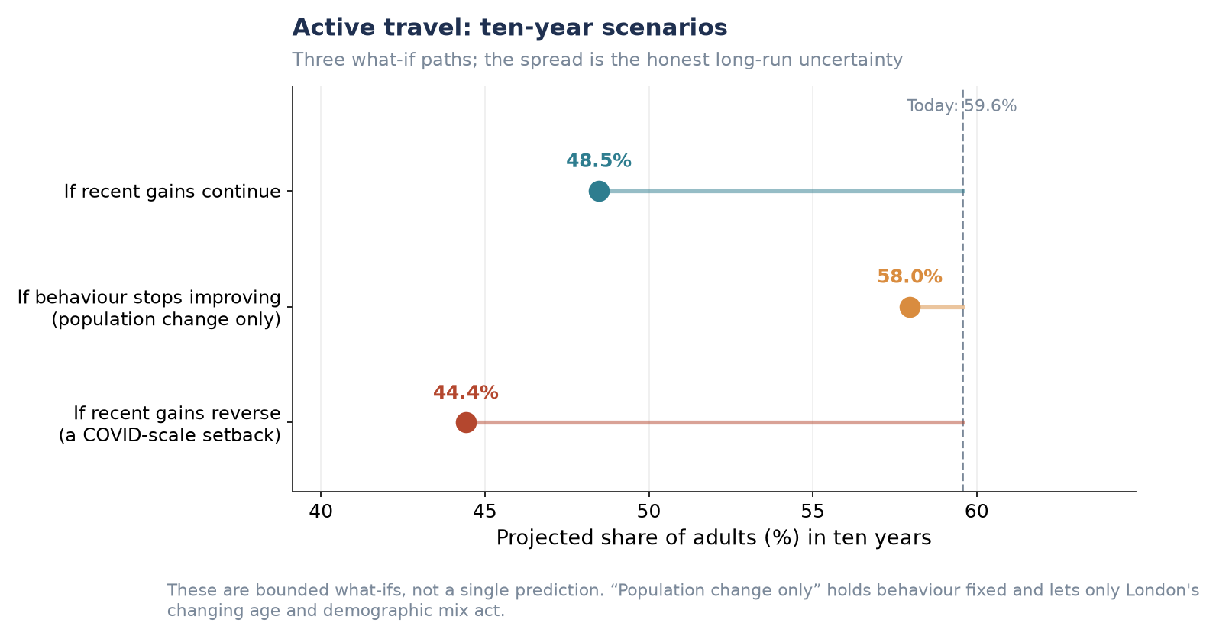
Figure P1.3. Active travel: ten-year scenarios (widest scenario spread of any activity measured).
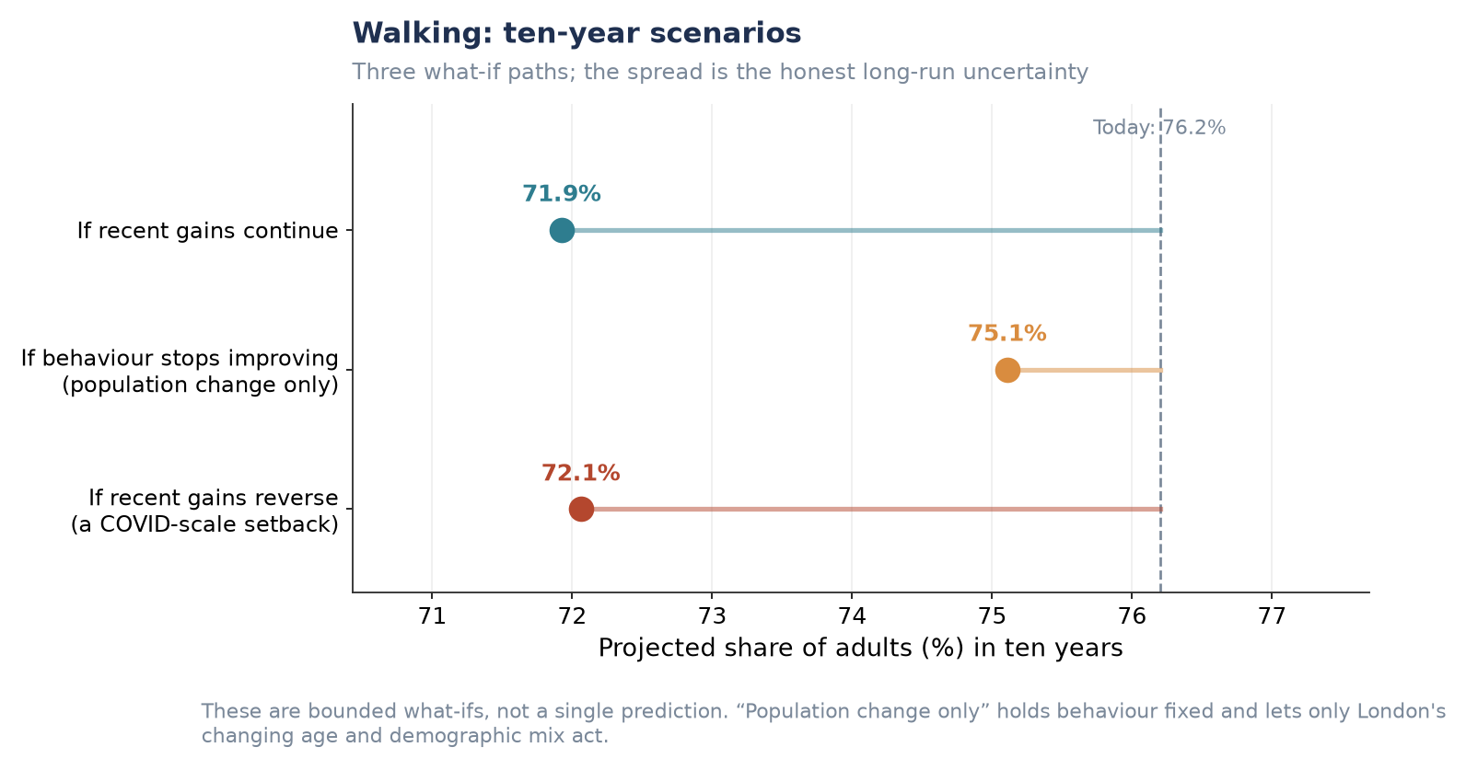
Figure P1.4. Walking: ten-year scenarios (largest-base activity measured).
The remaining five individual activities (cycling, fitness activities, team sports, dance, racket sports) follow the same scenario structure and are provided in full in the Supplementary Figures at the end of this section.

Sport-specific club membership
Club membership is the one area of Table P1.1 where continuing the recent trend points upward rather than downward. Club membership (any sport) is projected to reach 19.3% under the ‘gains continue’ scenario, against 14.8% if behaviour flattens and only the population changes.
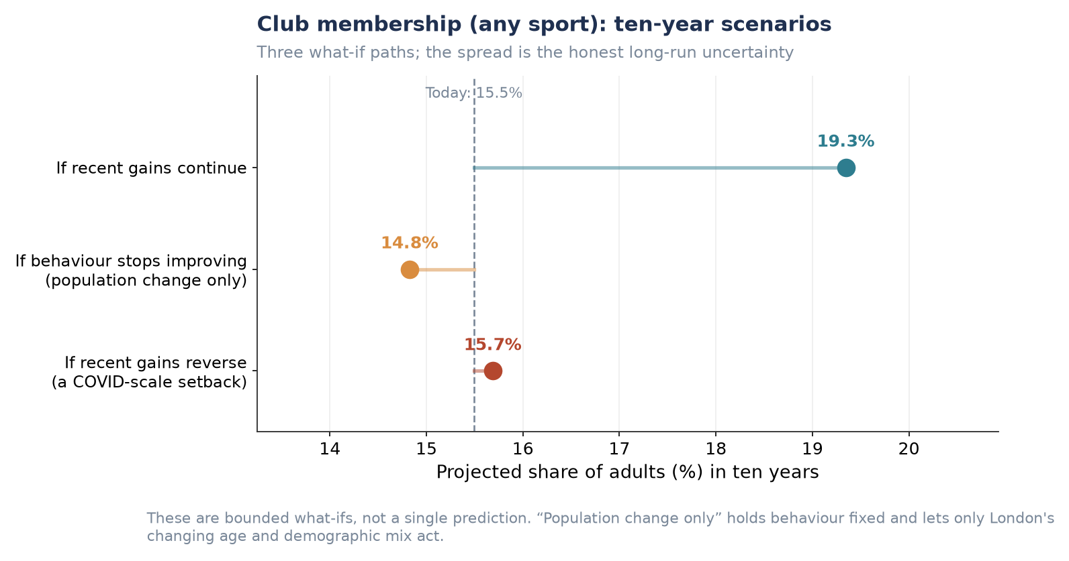
Figure P1.5. Club membership (any sport): ten-year scenarios.
Insight: this table-level pattern is corroborated independently by the wider analysis, which reports club membership rising overall and led specifically by team sports — consistent with team-sport club showing the largest proportional gain of any club type here (4.5% → 6.9% under ‘gains continue’). The same analysis flags fitness/gym membership as the one club category still declining after the pandemic, matching this table’s flat-to-negative fitness club/gym row (8.9% today against 8.4% if gains continue) — the only club measure of the three that does not point upward. The post-pandemic club recovery is therefore concentrated in team sport specifically, not club-based activity in general.

Forecasts of activity levels for each London borough
Applying the propensity model to each borough’s projected demographic composition produces a 2025 borough-level forecast ranging from 51.3% (Barking and Dagenham) to 75.4% (Wandsworth).
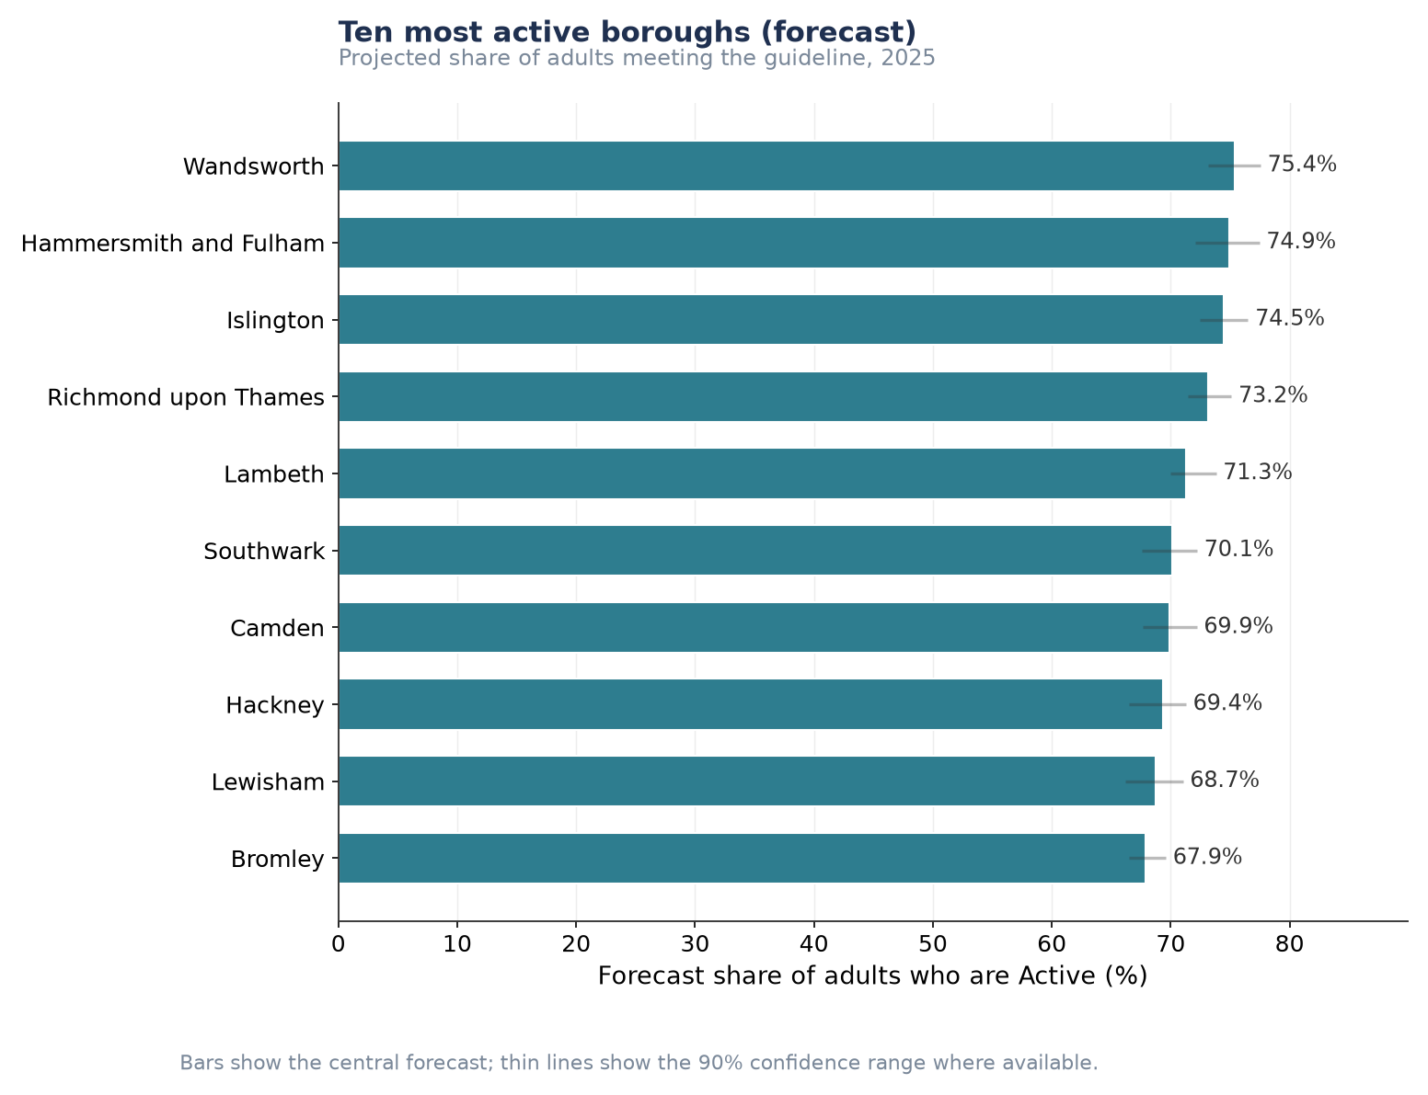
Figure P1.6. Ten most active boroughs, projected share of adults meeting the guideline, 2025.
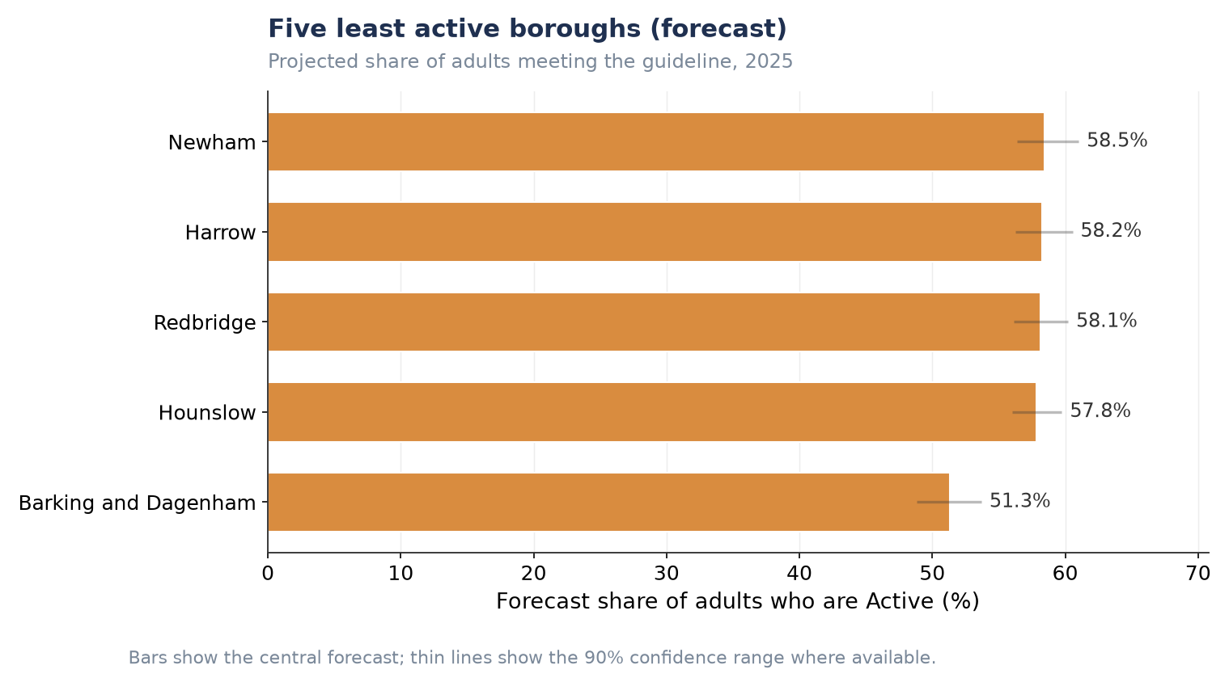
Figure P1.7. Five least active boroughs, projected share of adults meeting the guideline, 2025.
Insight: the roughly 24-point gap between the most and least active boroughs does not narrow anywhere across the projection horizon — the confidence intervals of the two extremes do not overlap, so this is a structural difference, not sampling noise. Every one of London’s 32 boroughs shows a negative composition effect (ranging from near zero to about −0.9 points): London’s demographic change is a headwind in every borough, not only the least active ones — it varies only in strength, never in direction.

Key factors that may reduce free time and affect participation
Free-time constraint questions were asked once, in the 2022–23 wave only, of approximately a third of respondents. This bullet is therefore necessarily a cross-sectional snapshot rather than a ten-year forecast.
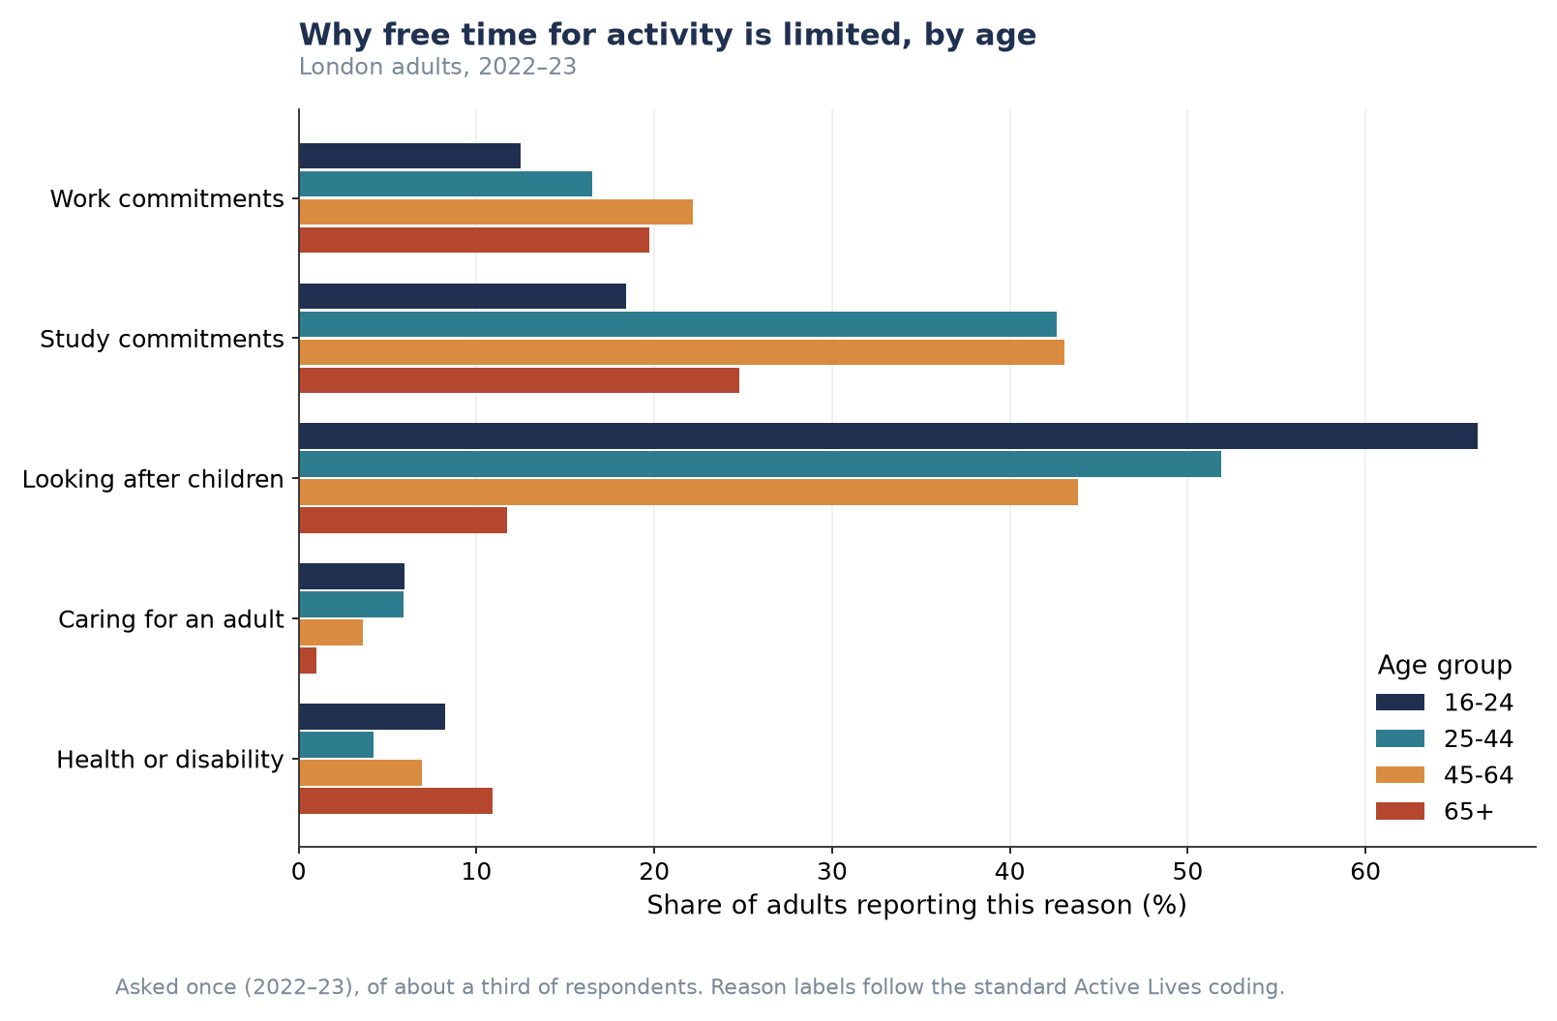
Figure P1.8. Reasons free time for activity is limited, by age group (London adults, 2022–23).
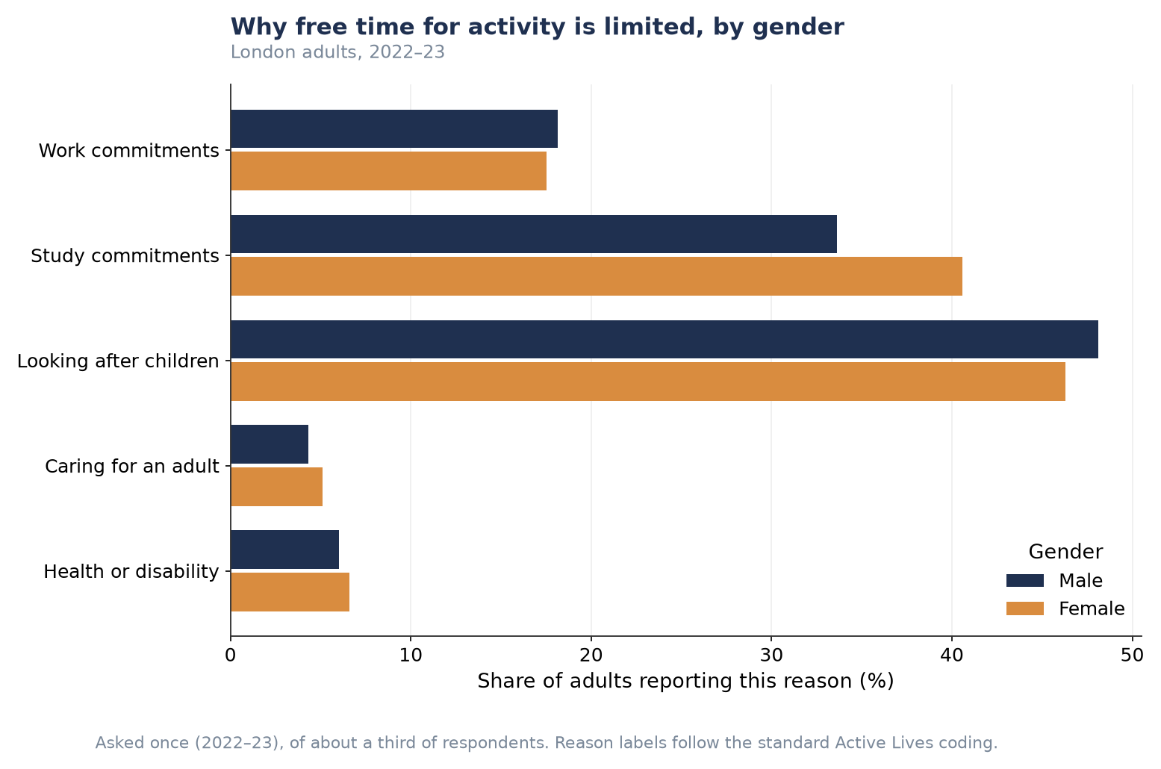
Figure P1.9. Reasons free time for activity is limited, by gender (London adults, 2022–23).
Reporting a free-time constraint does not correspond to lower activity in this data — adults reporting at least one constraint are, in every age group and both genders, slightly more likely to be Active than those reporting none.
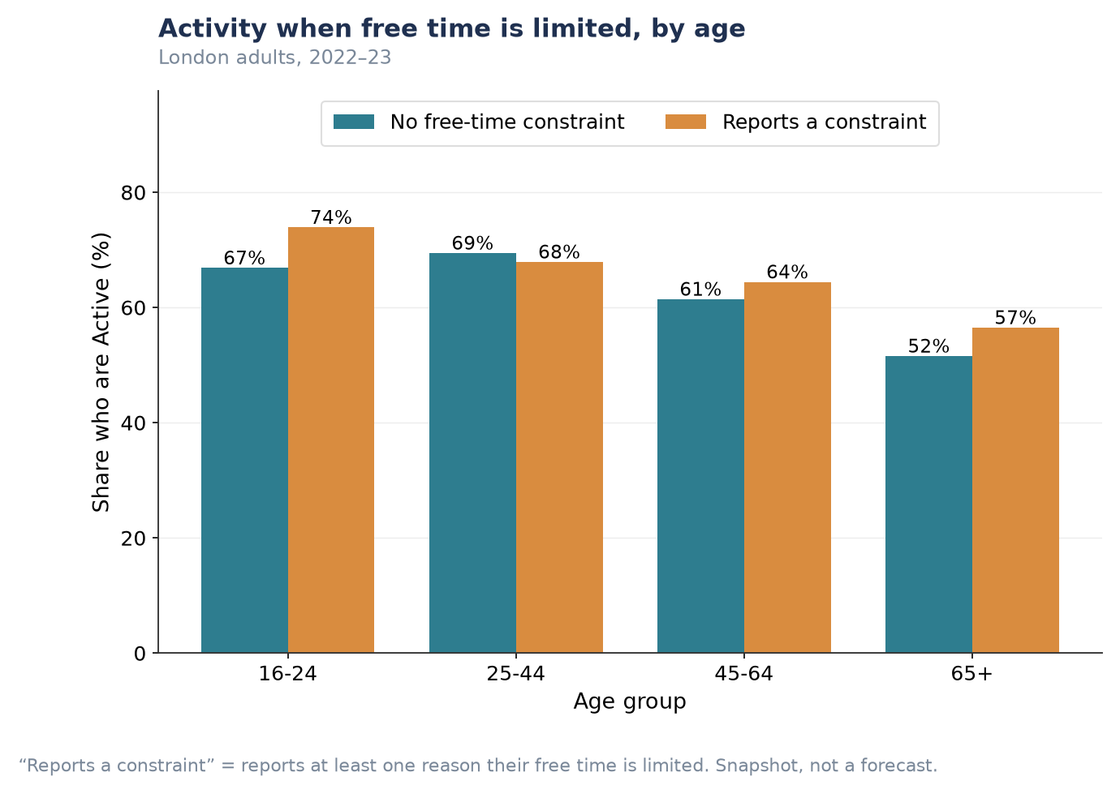
Figure P1.10. Activity rate by whether free time is constrained, by age group.
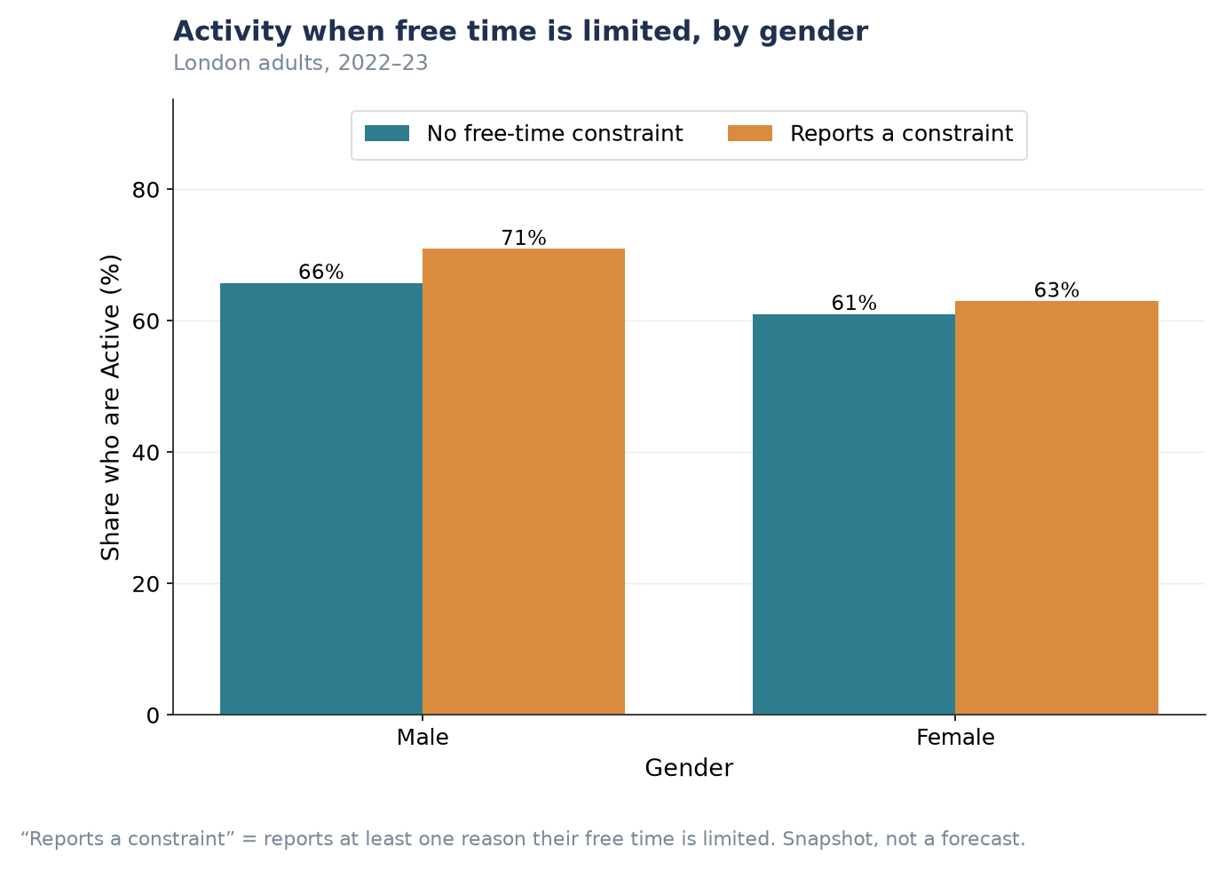
Figure P1.11. Activity rate by whether free time is constrained, by gender.
Tension worth flagging: this finding (any constraint → slightly higher activity) sits in apparent contrast with the wider analysis, which reports that respondents citing long working hours specifically are markedly less active. The two are not necessarily contradictory — ‘any constraint’ here pools together reasons like childcare and study, which may correlate with active lifestyles, alongside work-hour pressure, which may not. This report does not have a working-hours-only cut to test that directly; treat the ‘any constraint’ finding above as a population-level average that may be masking an offsetting effect specific to long working hours.
This is a descriptive association, not a causal one: it likely reflects that busy, time-constrained lives (work, childcare, study) are also often active lives — active travel and looking after children can themselves involve physical activity — rather than implying constraints on free time increase participation.

Supplementary Figures (P1)
Provided for completeness; summarised numerically in Table P1.1 and not repeated in the main narrative to avoid near-identical charts shown ten times in sequence.

Three-year point forecasts, all ten activity/club types
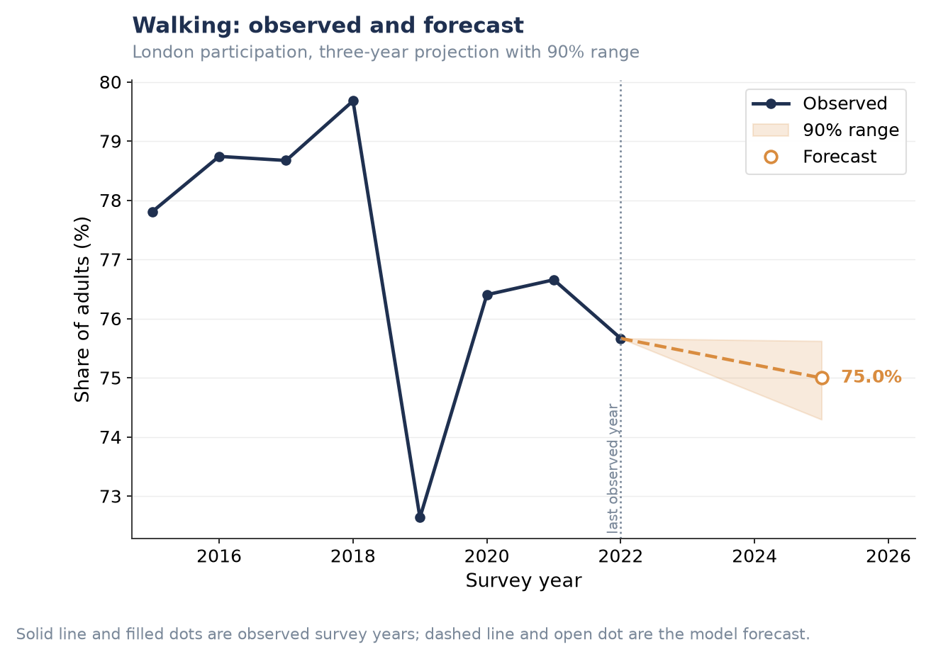
Figure P1.S1. Walking — three-year forecast.
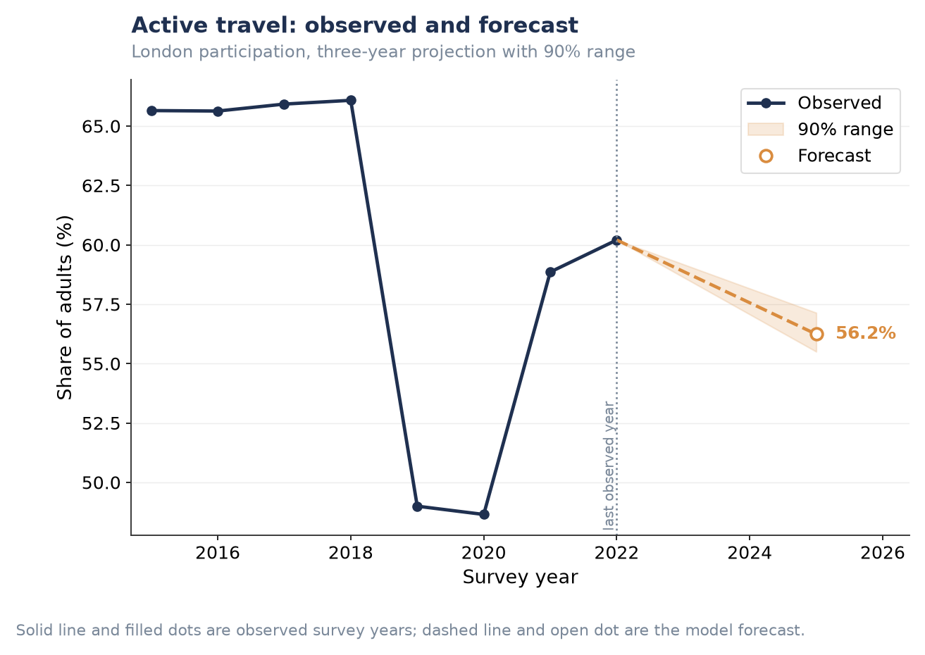
Figure P1.S2. Active travel — three-year forecast.
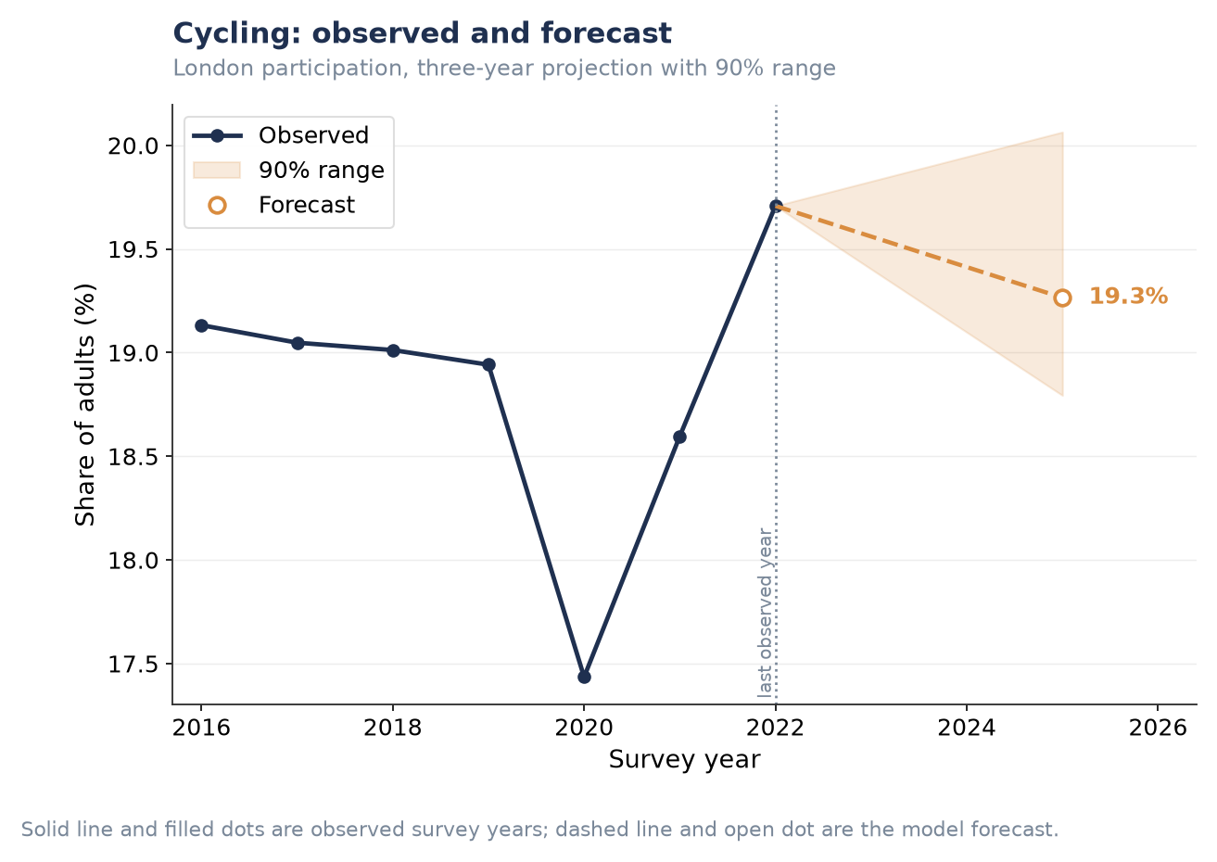
Figure P1.S3. Cycling — three-year forecast.
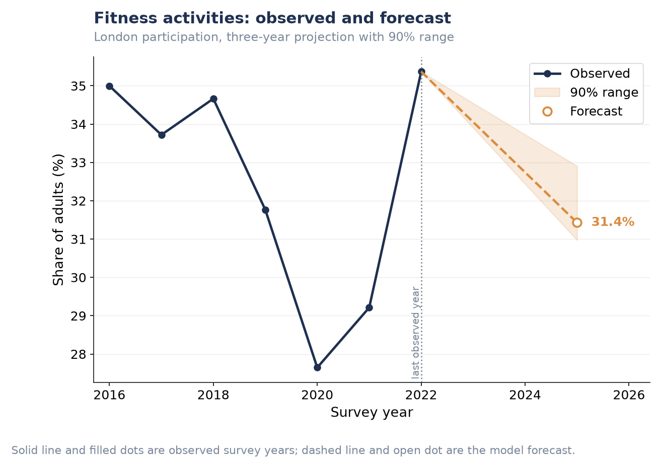
Figure P1.S4. Fitness activities — three-year forecast.
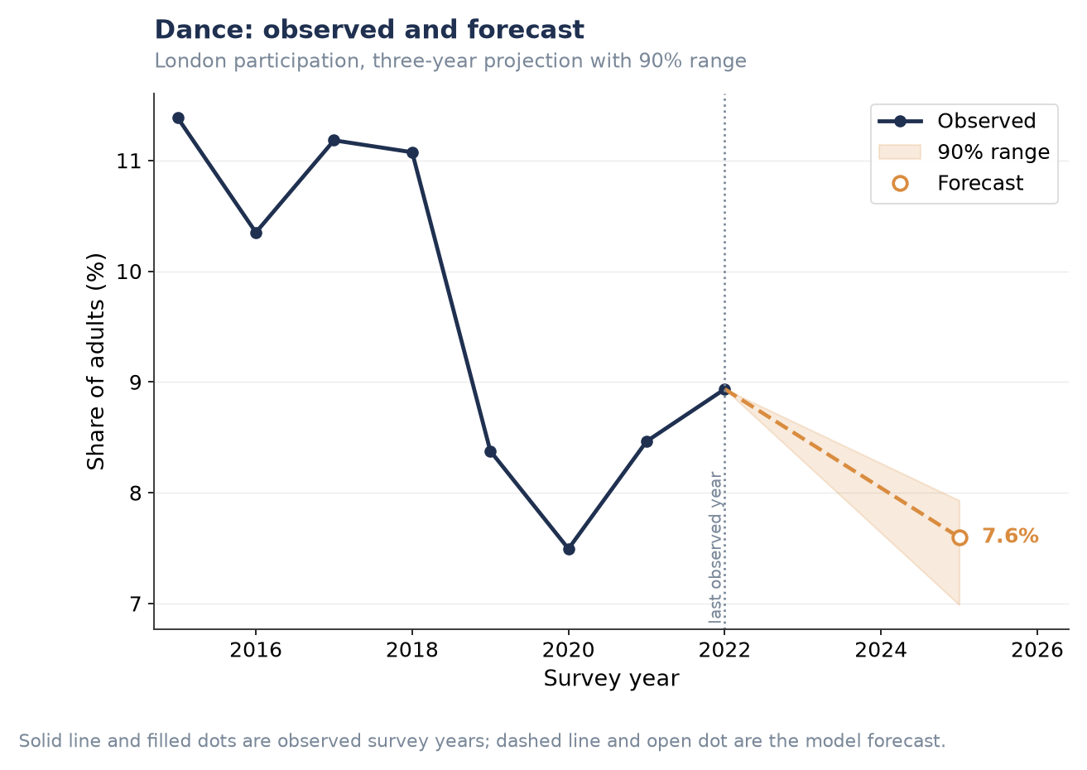
Figure P1.S5. Dance — three-year forecast.
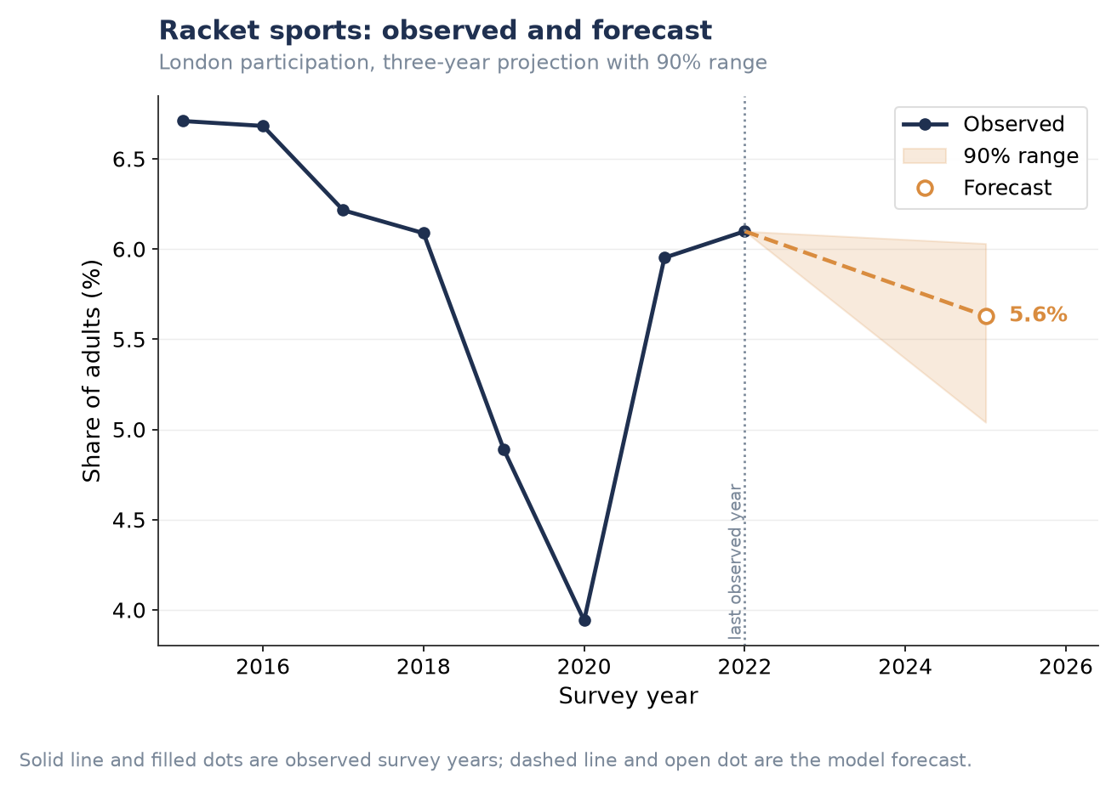
Figure P1.S6. Racket sports — three-year forecast.
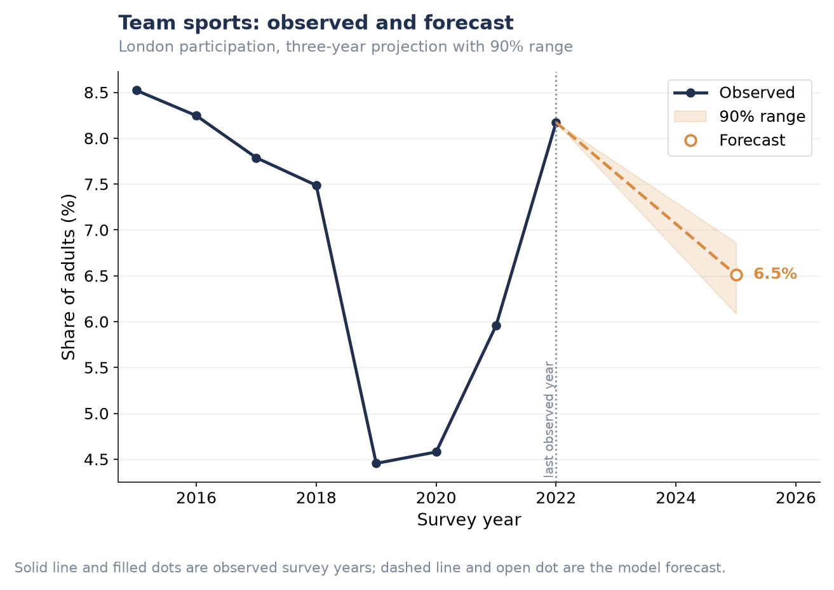
Figure P1.S7. Team sports — three-year forecast.
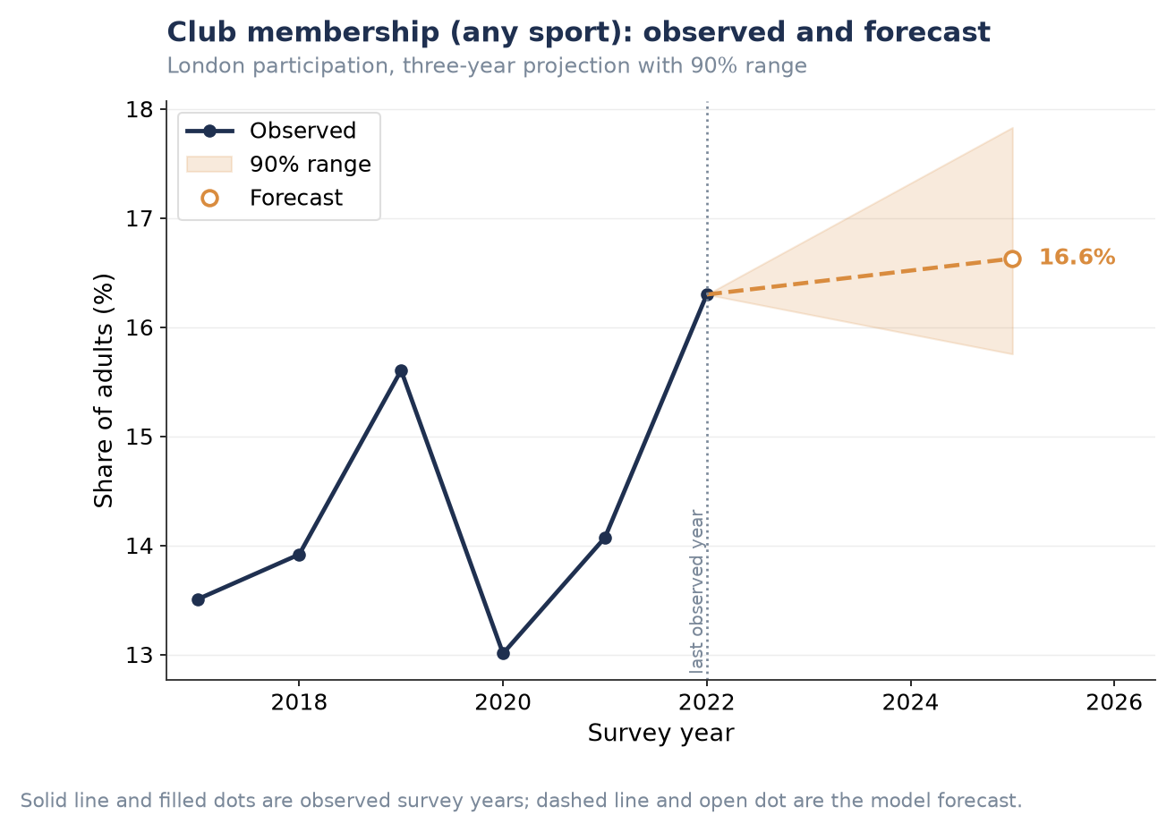
Figure P1.S8. Club membership (any sport) — three-year forecast.
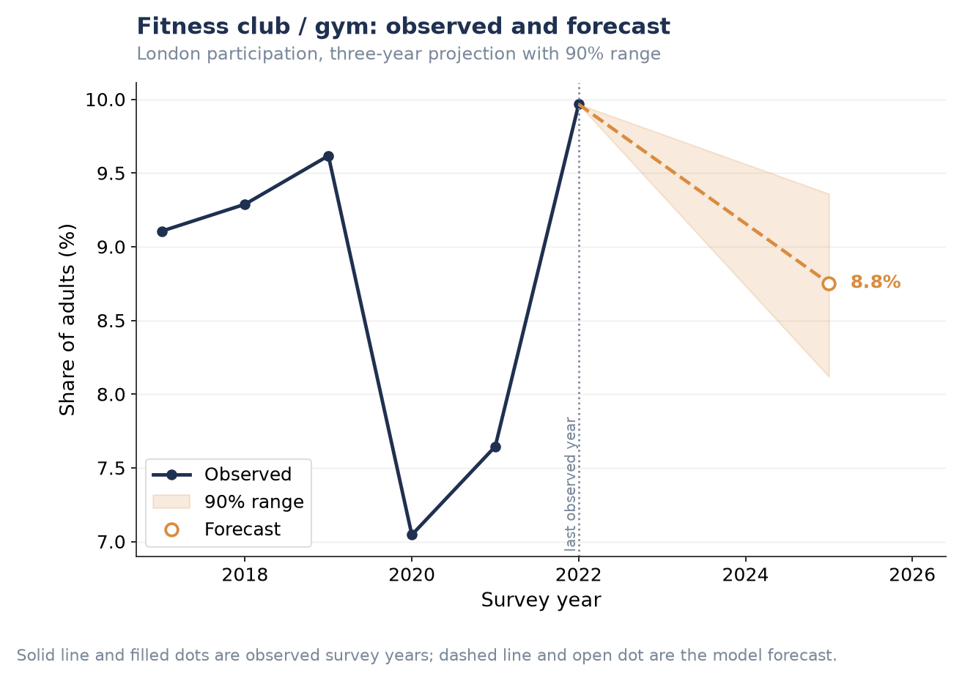
Figure P1.S9. Fitness club / gym — three-year forecast.
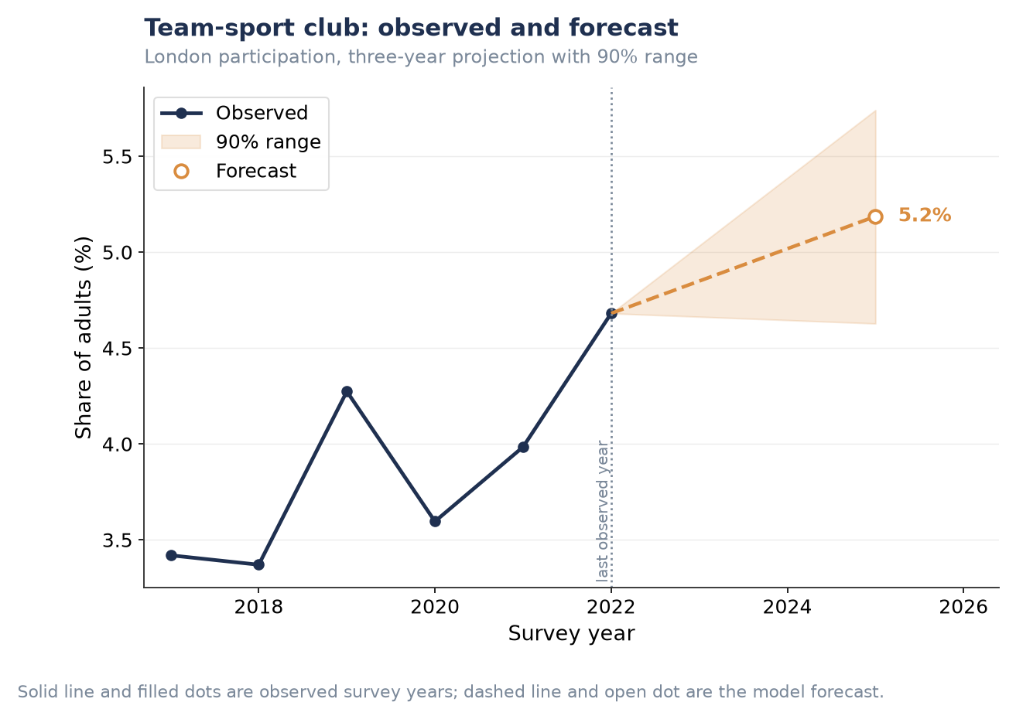
Figure P1.S10. Team-sport club — three-year forecast.

Ten-year scenarios, remaining activity/club types
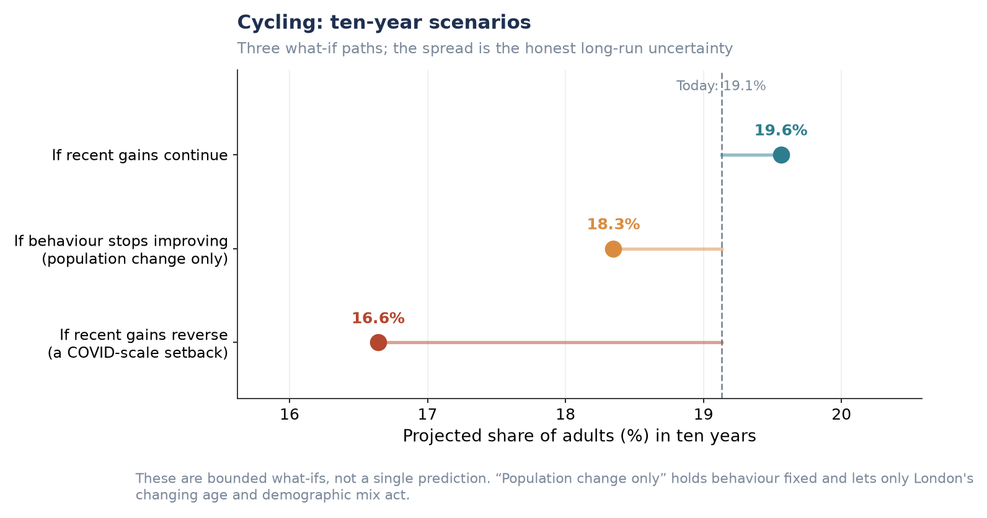
Figure P1.S11. Cycling — ten-year scenarios.
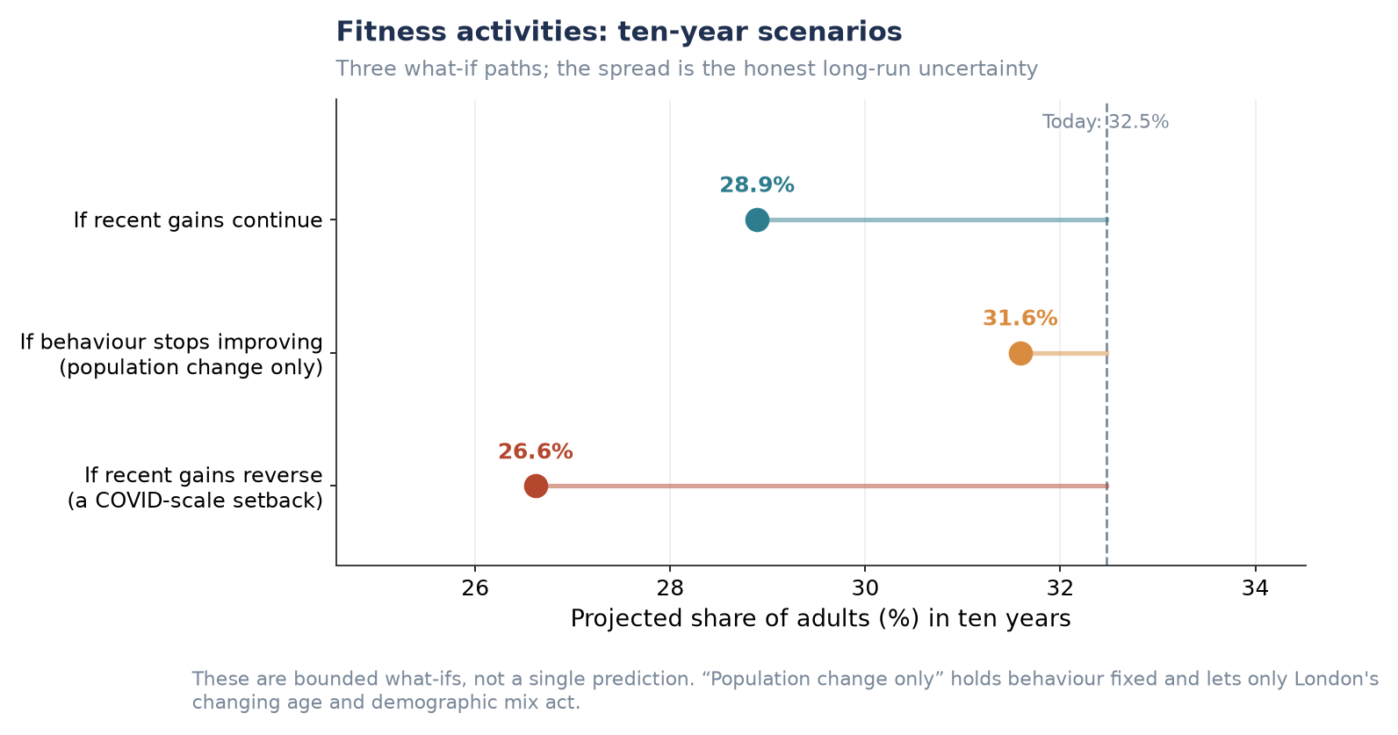
Figure P1.S12. Fitness activities — ten-year scenarios.
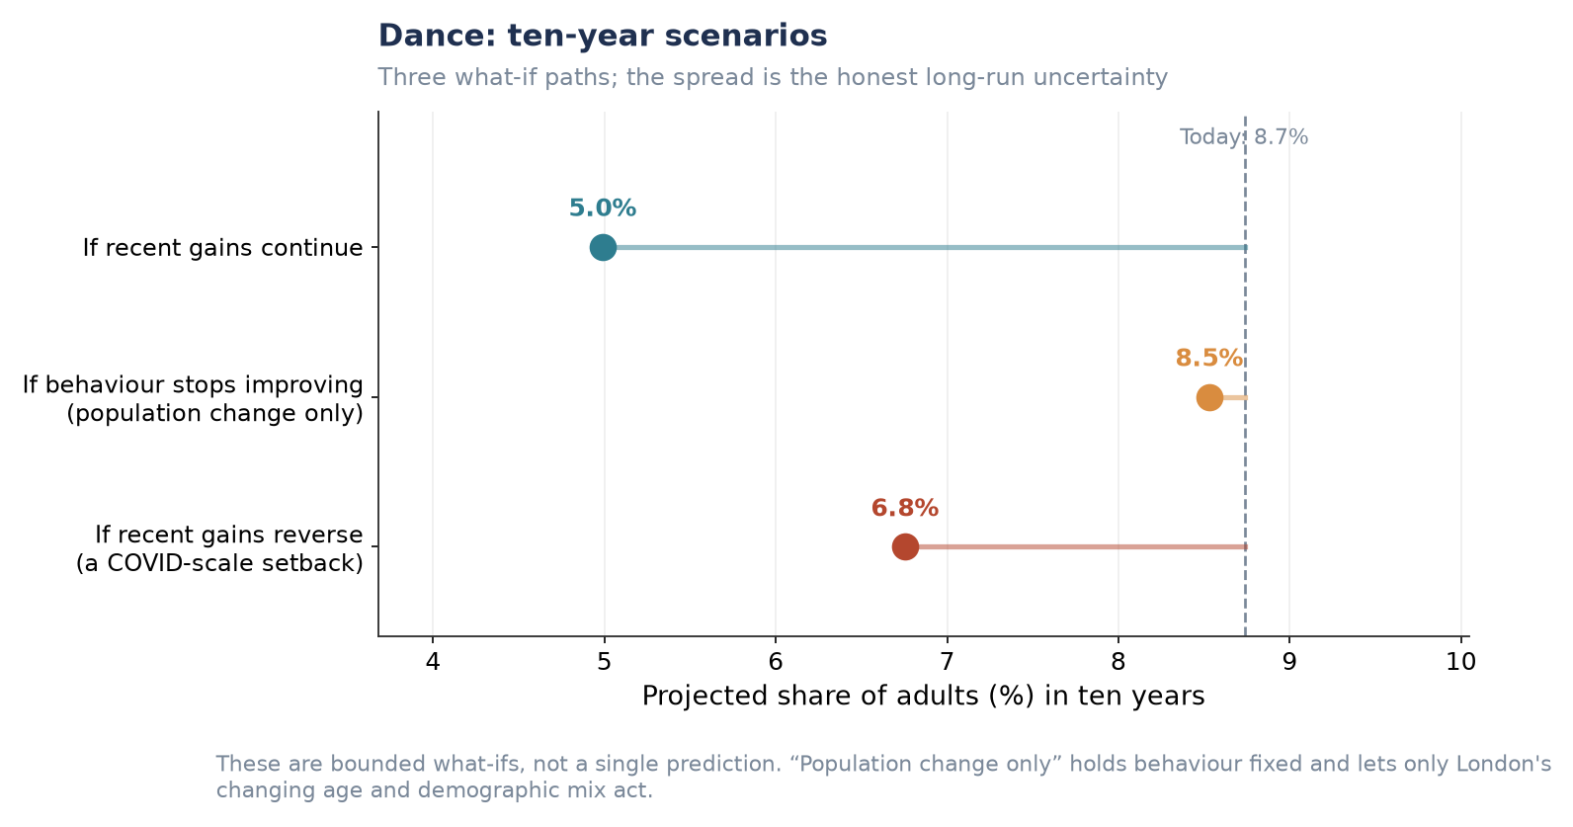
Figure P1.S13. Dance — ten-year scenarios.
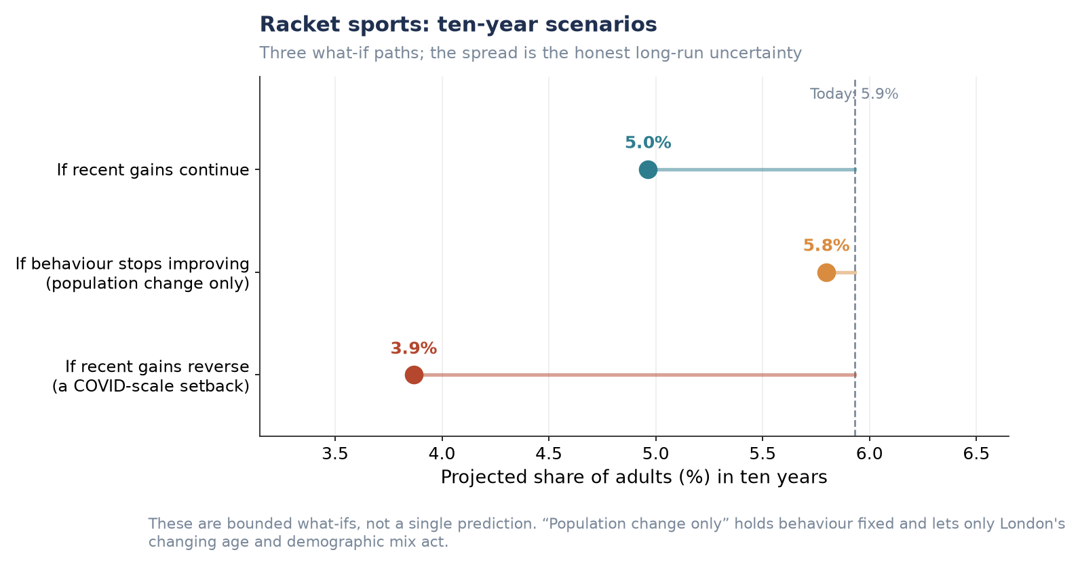
Figure P1.S14. Racket sports — ten-year scenarios.
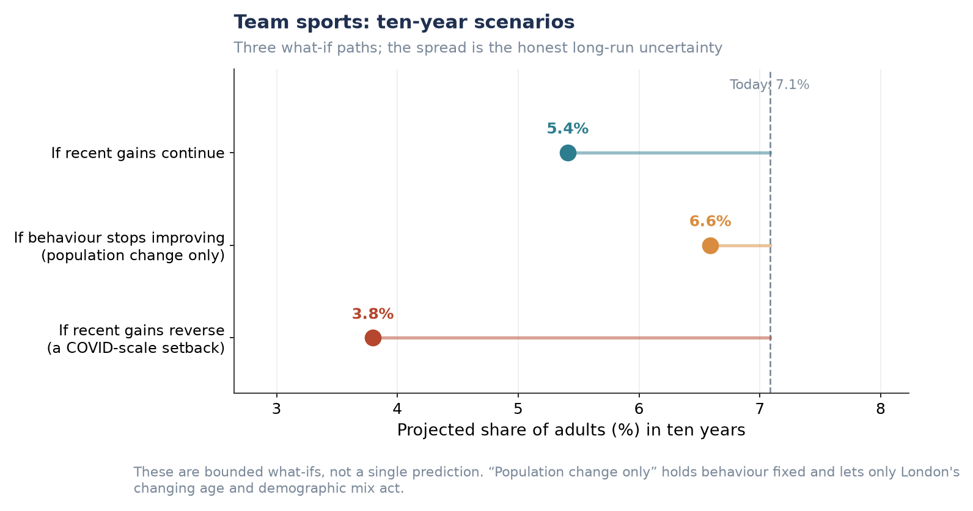
Figure P1.S15. Team sports — ten-year scenarios.
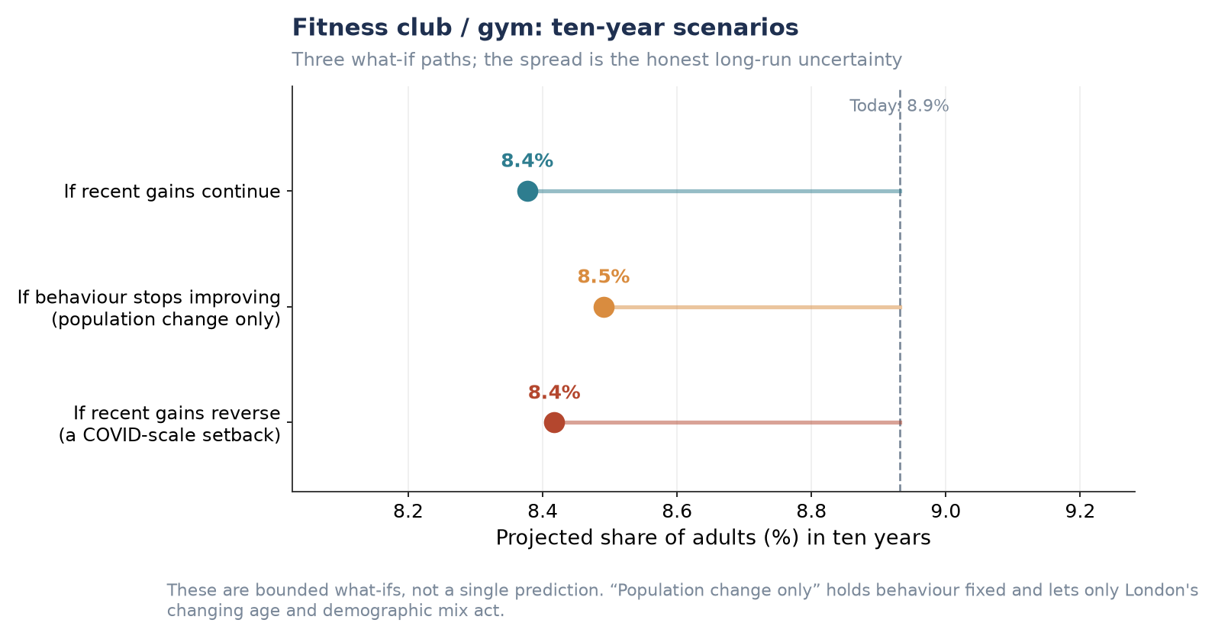
Figure P1.S16. Fitness club / gym — ten-year scenarios.
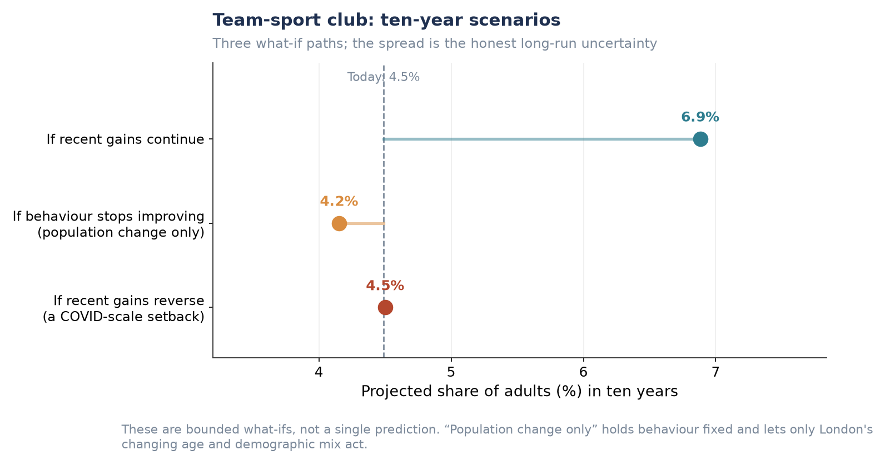
Figure P1.S17. Team-sport club — ten-year scenarios.

Additional London-wide forecast (not used above)
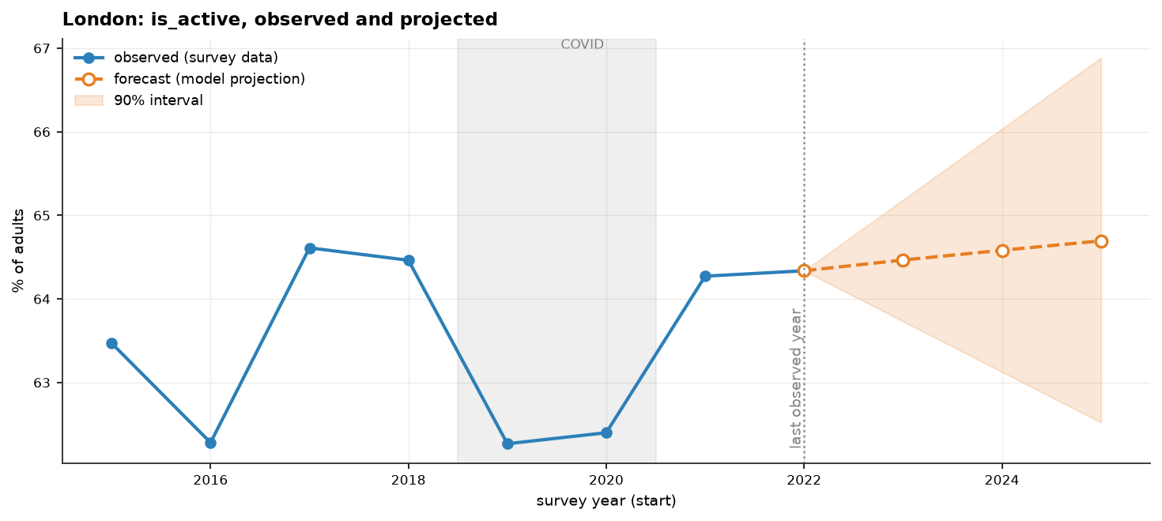
Figure P1.S18. London Active share: observed and three-year projection with 90% interval.
Note: shows substantially the same information as Figure P1.1 (single ‘Active’ line rather than all three bands). Its widening 90% interval is a clean visual illustration of the limited-usable-years caveat discussed in the forecasting-versus-description note above.

P2 — Demographic-Specific Insights
The same forecasting framework applies as in P1. For groups that are themselves projection dimensions — age, gender, ethnicity — the ten-year forecast is direct. For groups that are not projection dimensions — socio-economic group, disability — the group’s propensity is scaled to its observed activity ratio, a transparent approximation rather than a full re-projection.

Forecasted participation levels by demographic group
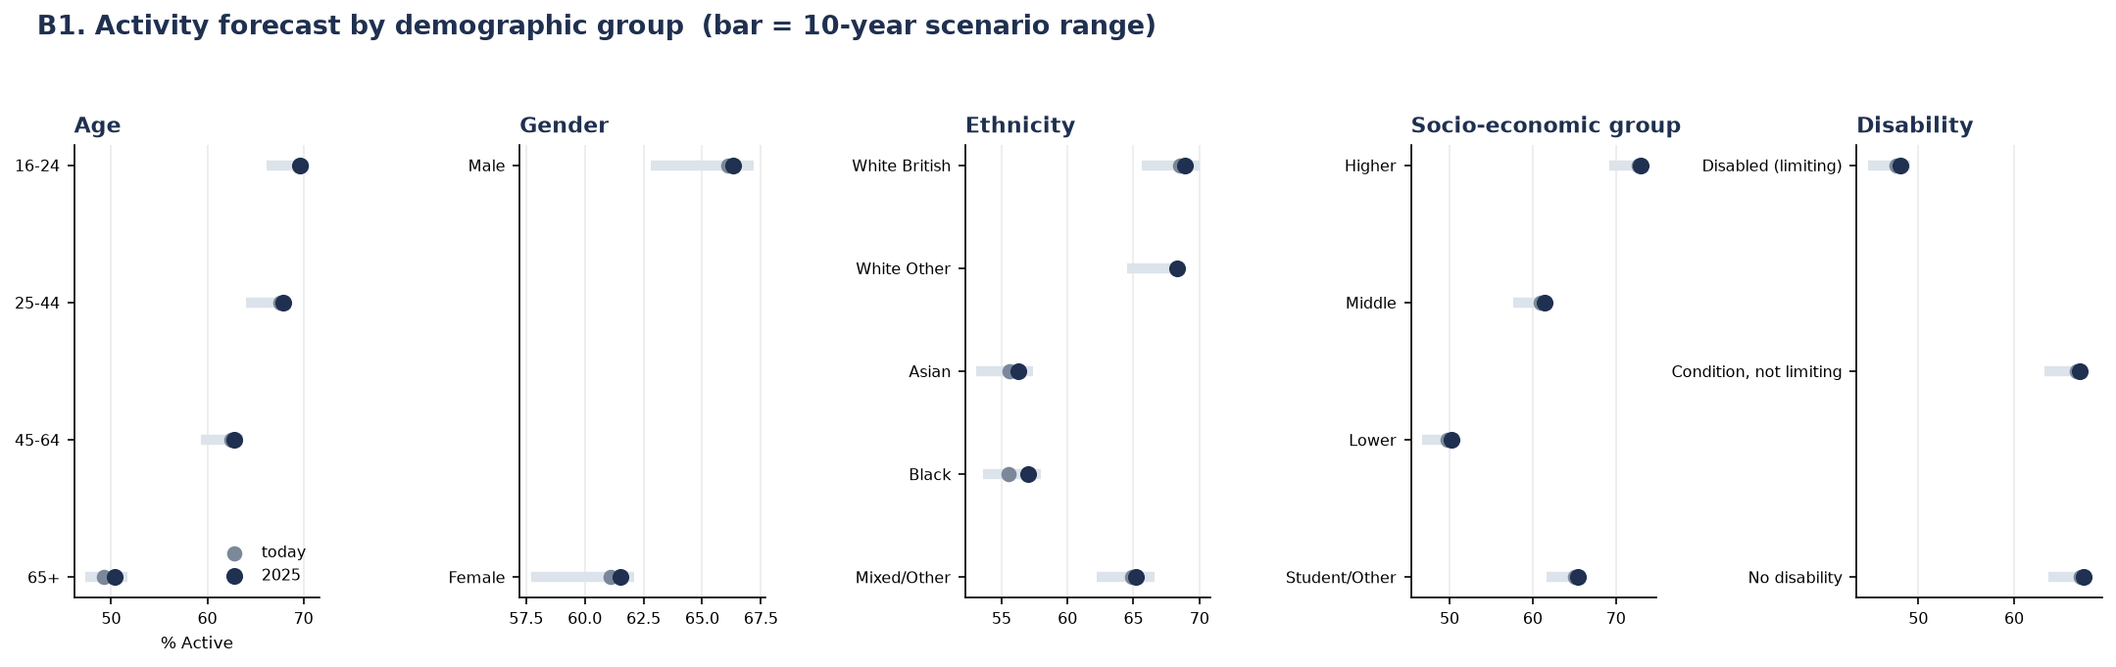
Figure P2.1. Activity forecast by demographic group; bar = 3-year forecast range, dot = today’s rate.
Insight: socio-economic group shows the widest gap of any demographic dimension measured — a 23-point spread between the Higher group (73%) and the Lower group (50%), wider than the age gap (70% at 16–24 against 50% at 65+, 20 points), the disability gap (67% against 48%, 19 points) or the ethnicity gap (69% against 56%, 13 points). Gender shows the narrowest gap, at 4 points (66% male, 62% female). This ranking is corroborated by the wider analysis, which independently identifies the socio-economic gradient as the strongest single pattern in the dataset, wider than age or ethnicity.
Insight: the 65+ group is the clearest illustration of a demographic headwind rather than a behavioural one. It is both the least active group and the one that moves least on its own (roughly +1 point over three years) — yet this is precisely the group London is ageing into, which is the mechanism behind the −0.37-point composition effect on the London-wide P1 forecast above.

Types of sport or physical activity each group is most likely to engage in
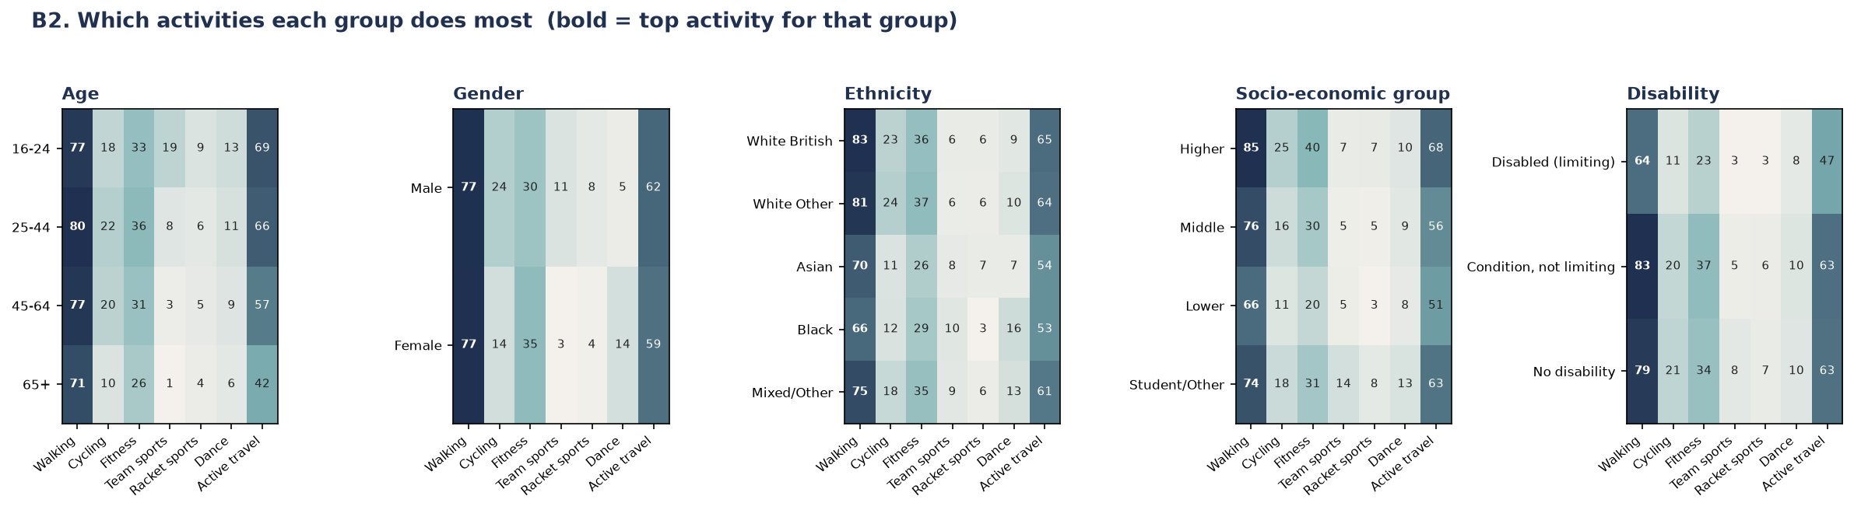
Figure P2.2. Which activities each group does most; bold marks the top activity for that group.
Insight: walking is the top activity for every single demographic group without exception, ranging from 66% (Black respondents; disabled/limiting respondents) to 85% (Higher socio-economic group). Active travel is consistently the second-most common activity for every group — together confirming the wider analysis’s description of walking as the universal entry point, the behaviour most closely tied to demographics of all those measured.
Insight: the socio-economic gap concentrates in facility-dependent activities rather than spreading evenly. Fitness participation is twice as high in the Higher group as the Lower group (40% against 20%), and cycling more than double (25% against 11%), while walking — which needs no facility or club — shows a much smaller proportional gap (85% against 66%). The wider analysis explains this directly: demographics explain roughly half of the borough-level variation in walking (50%) and overall activity (48%), but only around 29% of cycling and 25% of team-sport club membership — the remainder is driven by place-level provision (facilities, lanes, clubs), not by who lives there.
Insight: two smaller patterns are worth flagging for programme design: dance participation among Black respondents (16%) is markedly higher than any other ethnic group (next highest: 10%), a distinctive preference rather than a general activity-level effect; and team-sport participation among the Student/Other socio-economic group (14%) is roughly twice that of any other socio-economic group (5–7%), consistent with student-age team sport engagement rather than a broader socio-economic pattern.

Participation within each London borough
Data note: the brief asks for participation in specific activities within each borough. The available chart instead breaks down age-group participation within each borough (activity-type × borough detail was not available at reportable cell sizes). This is flagged here so the gap is visible rather than implied to be answered.
Borough-by-demographic cells are small: a single borough-by-age cell contains around six respondents in a given wave. All eight waves were therefore pooled and thin cells suppressed.
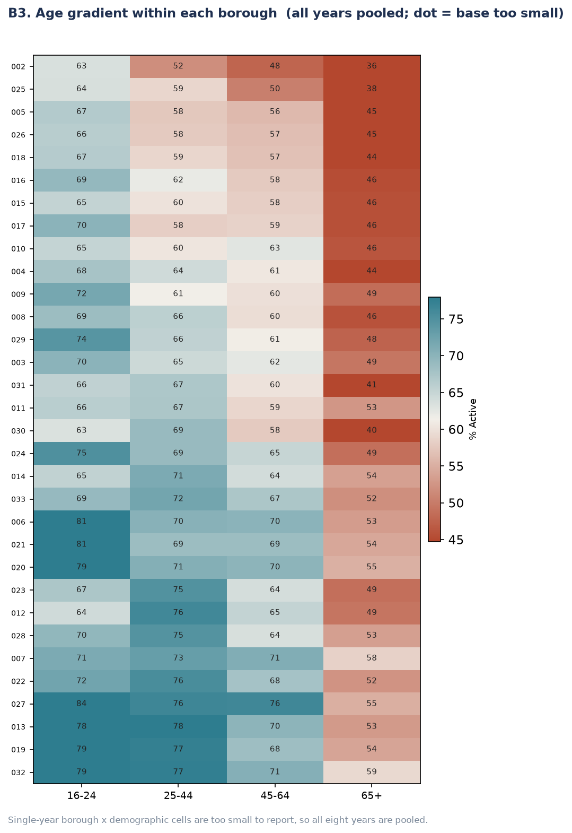
Figure P2.3. Age gradient within each borough, all waves pooled (borough rows are numeric codes pending name labels — see note below).
Insight: the age gradient (16–24 most active, 65+ least active) holds inside every one of the 32 boroughs without exception. But both the overall level and the size of the age gap vary sharply by borough: the widest age gap in the dataset is 29 points (84% for 16–24 falling to 55% for 65+); the narrowest is 13 points. A young adult in a low-activity outer borough can therefore have a lower activity rate than an older adult in a high-activity inner borough — place and demography compounding rather than offsetting one another.
Action needed before this chart is presentation-ready: the y-axis currently shows internal numeric borough codes (e.g. ‘027’, ‘002’), not borough names. These need to be mapped back to borough names using the LA_code crosswalk (Section 3.3.1) before this figure goes into the final report.

Likelihood of participation among people with health conditions
This bullet is reported descriptively rather than forecast, for the two methodological reasons set out in ‘A note on forecasting versus description’ above: too few clean years to trend, and exclusion from the propensity model to avoid contaminating every other trend with an early-wave artefact.
It is nonetheless reported because the relationship is too strong to omit: self-rated health is the steepest single relationship in the entire dataset, a 56-point span from 76% active at ‘very good’ health to 20% active at ‘very bad’ health.
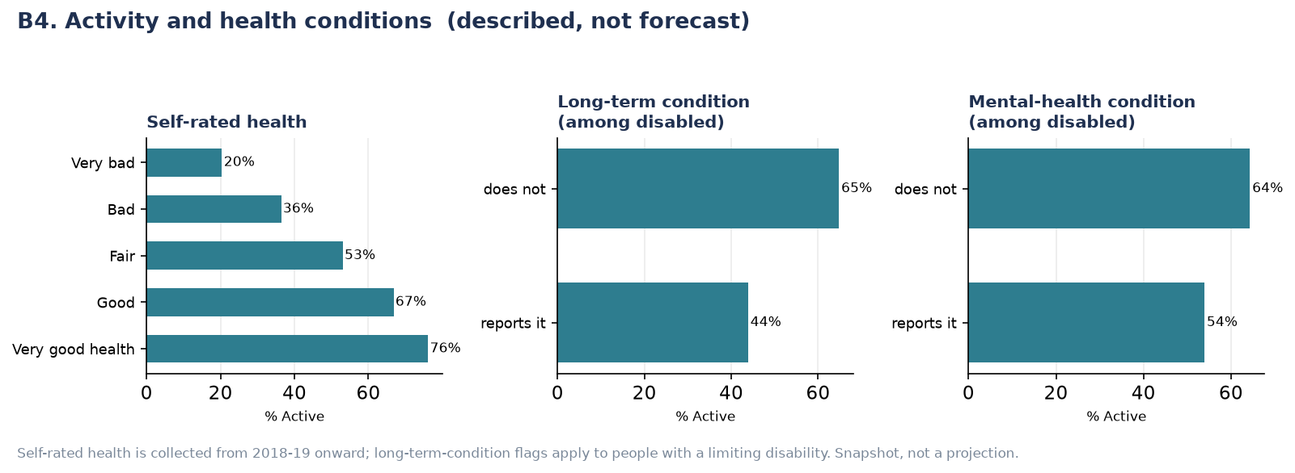
Figure P2.4. Activity by self-rated health, long-term condition and mental-health condition. Described, not forecast.
Insight: the gradient is graded, not a simple binary — activity falls in a near-straight line across all five self-rated health bands (76% → 67% → 53% → 36% → 20%). Among people with a limiting disability, those who also report a long-term physical condition are 21 points less active than those who do not (44% against 65%); those who report a mental-health condition are 10 points less active than those who do not (54% against 64%) — a real but smaller gap than for physical long-term conditions.
This relationship is reported as an association, not a one-directional cause: poor health can reduce activity, but inactivity is also known to worsen health outcomes over time. The wider analysis makes the same point explicitly — neither this dataset nor the modelling approach used here can separate the two directions of causation.

Supplementary Figures (P2)
Individual-group charts, each showing at larger scale one panel already summarised in Figures P2.1 and P2.2 above.

Forecast by individual demographic group
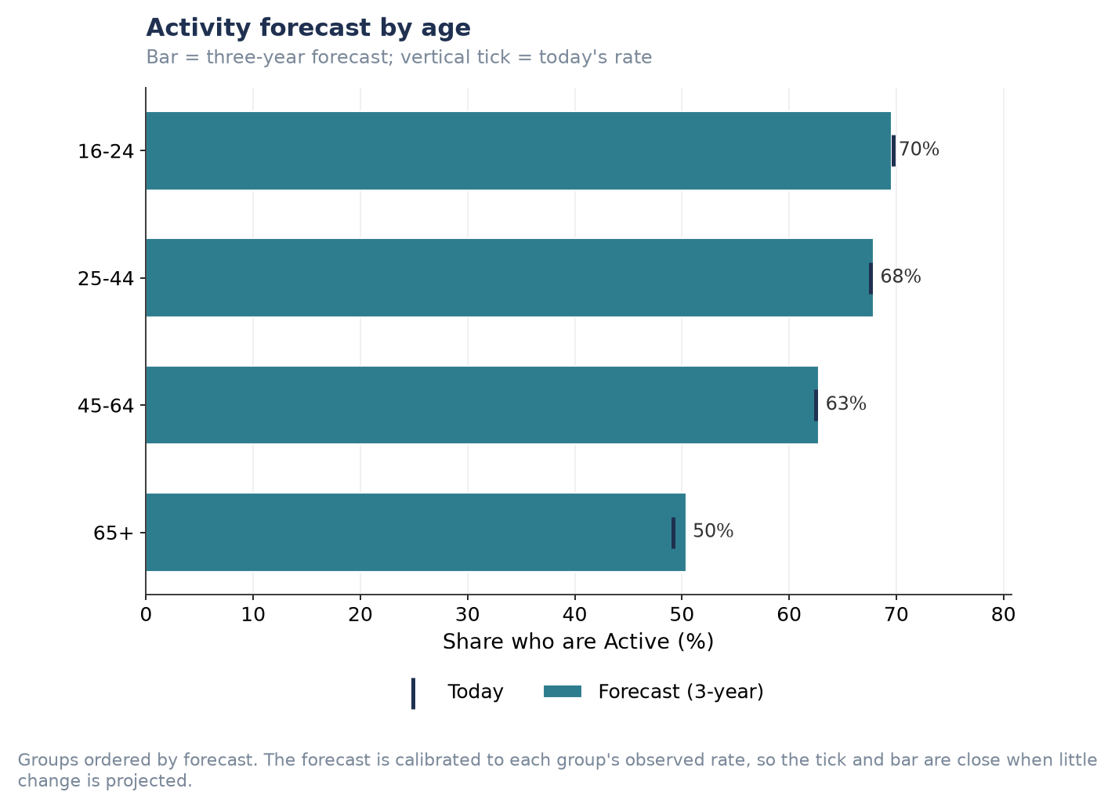
Figure P2.S1. Activity forecast by age.
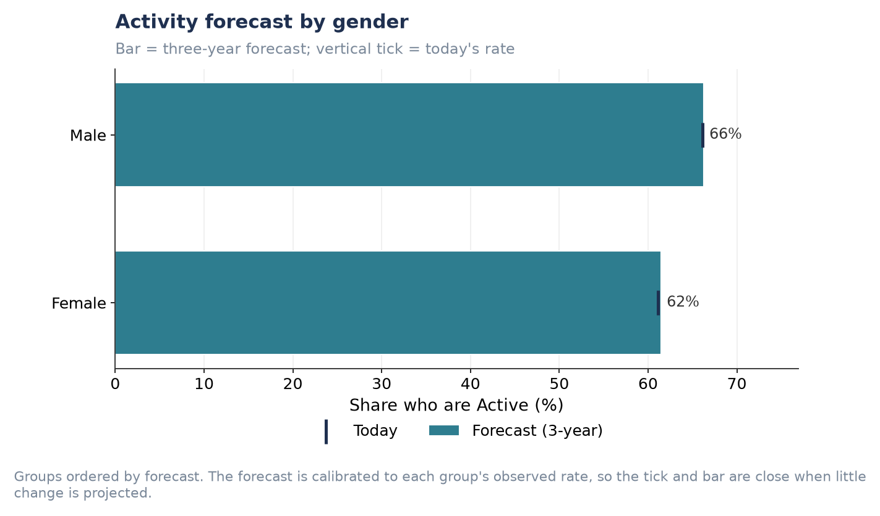
Figure P2.S2. Activity forecast by gender.
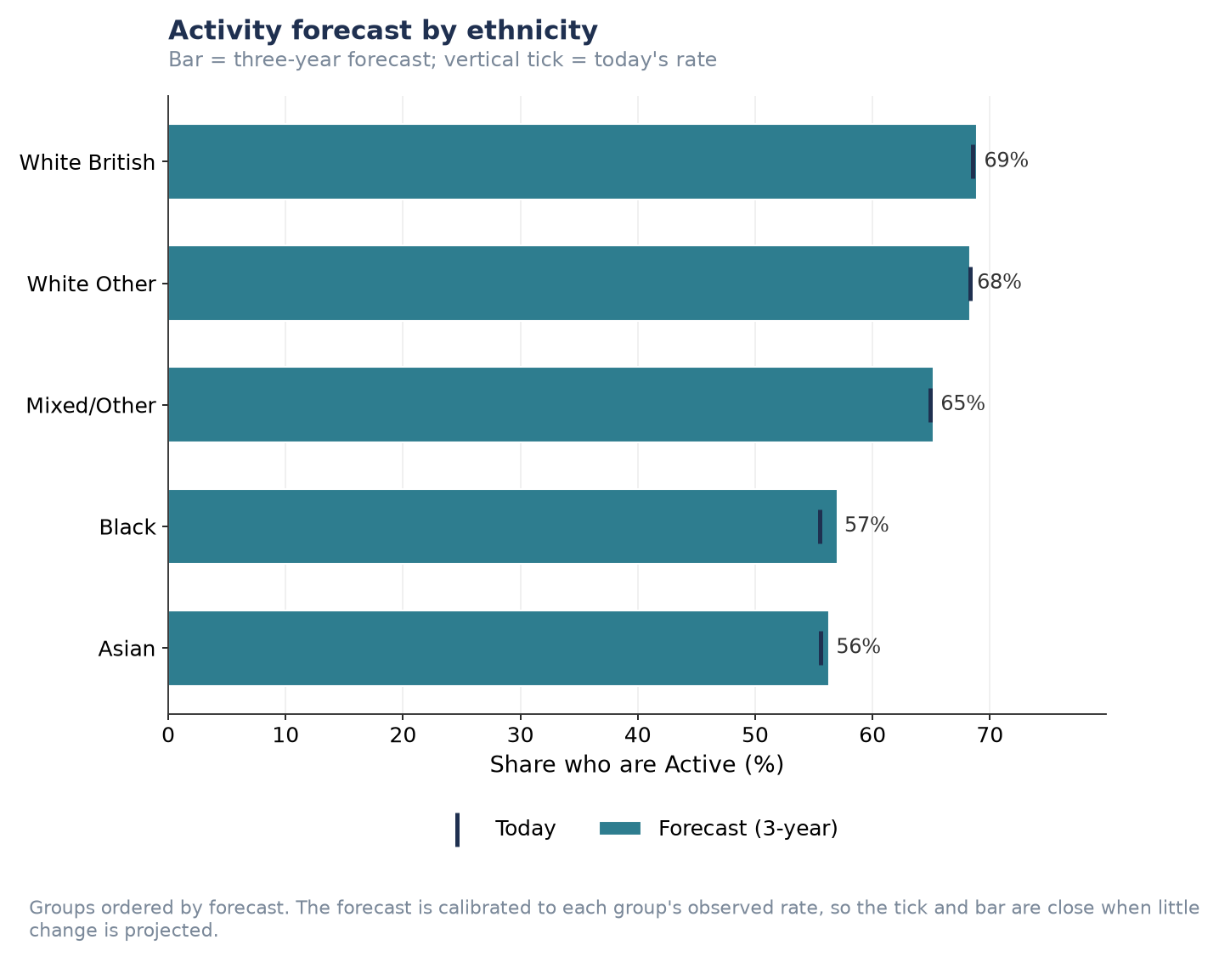
Figure P2.S3. Activity forecast by ethnicity.
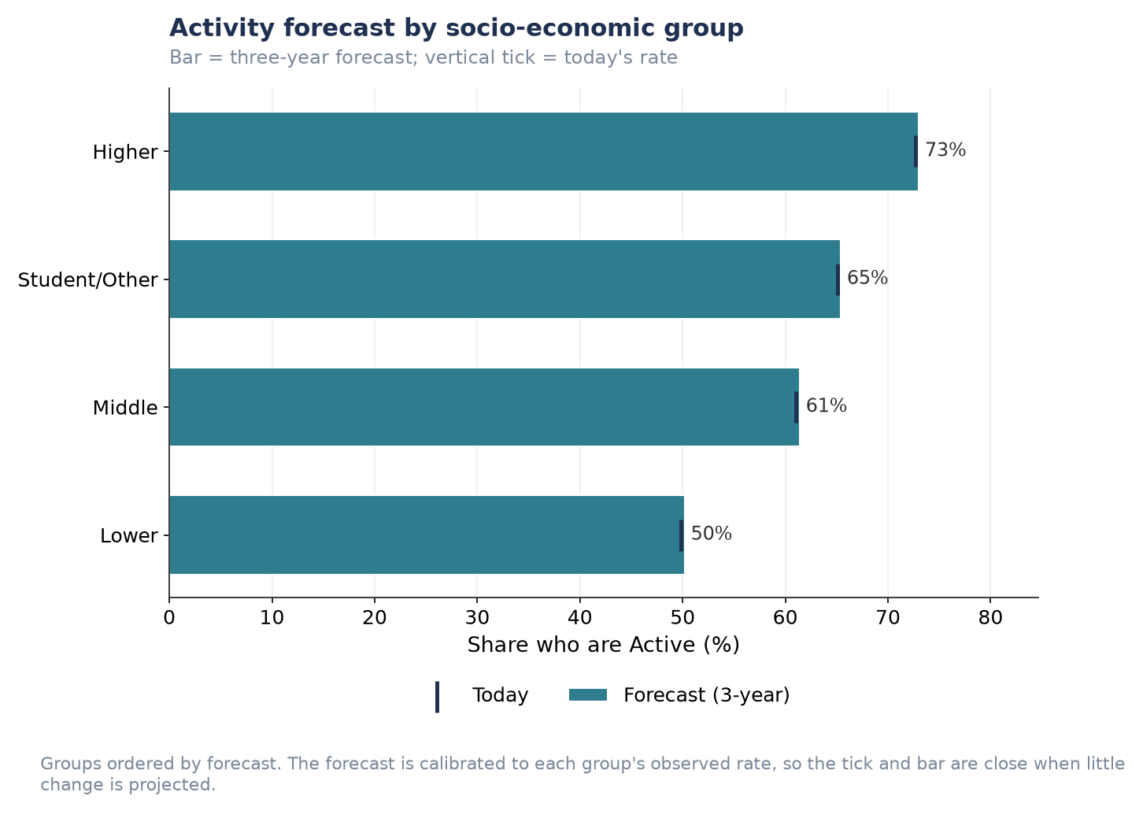
Figure P2.S4. Activity forecast by socio-economic group.
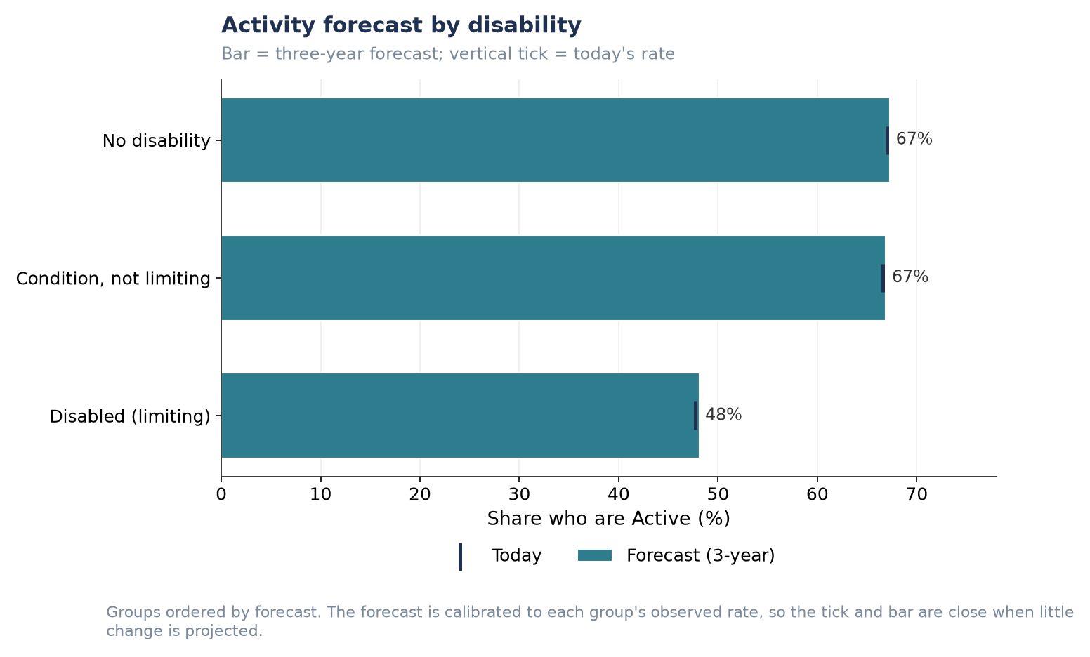
Figure P2.S5. Activity forecast by disability status.

Preferred activities by individual demographic group
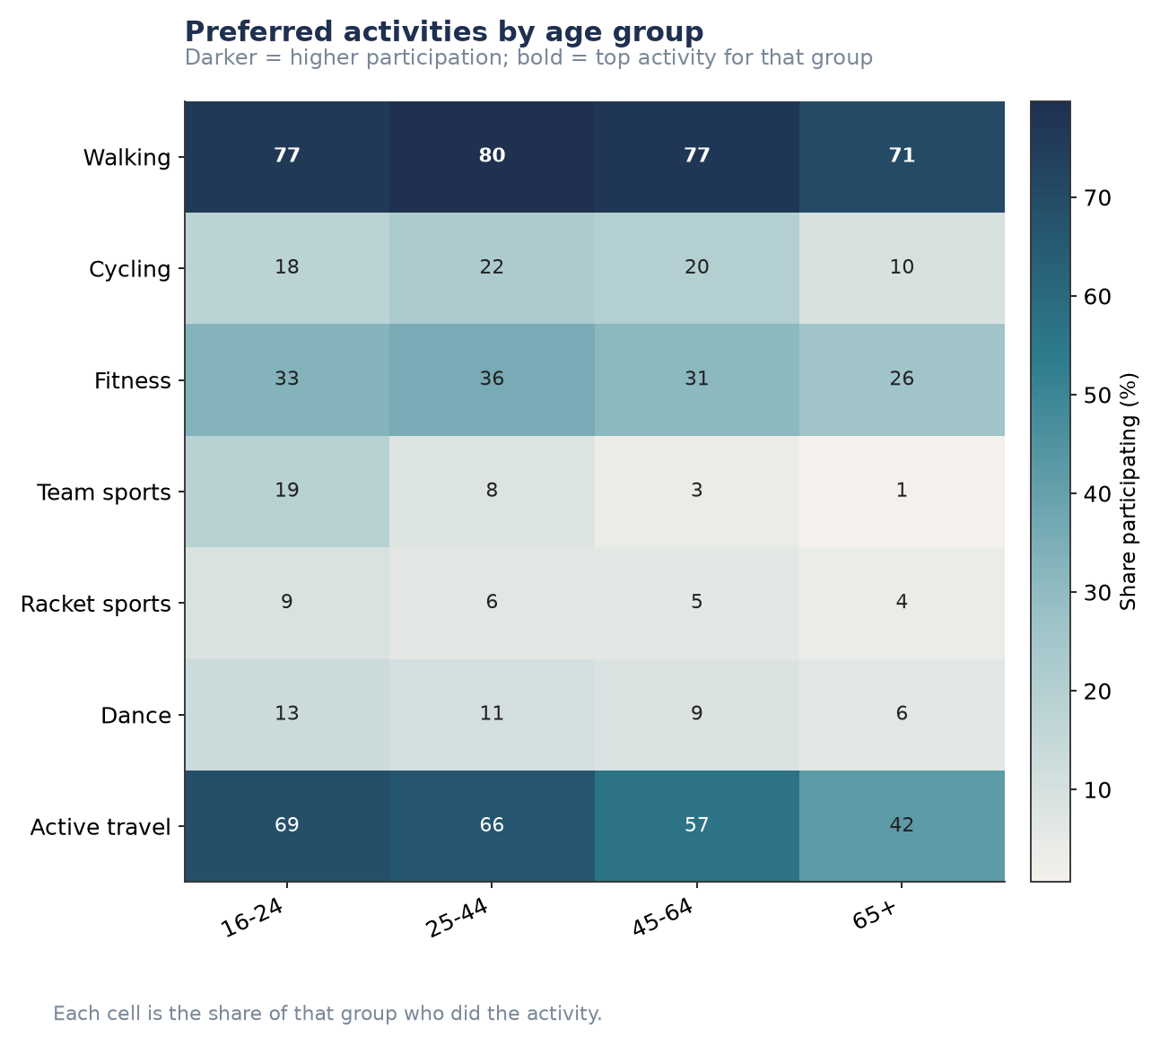
Figure P2.S6. Preferred activities by age group.
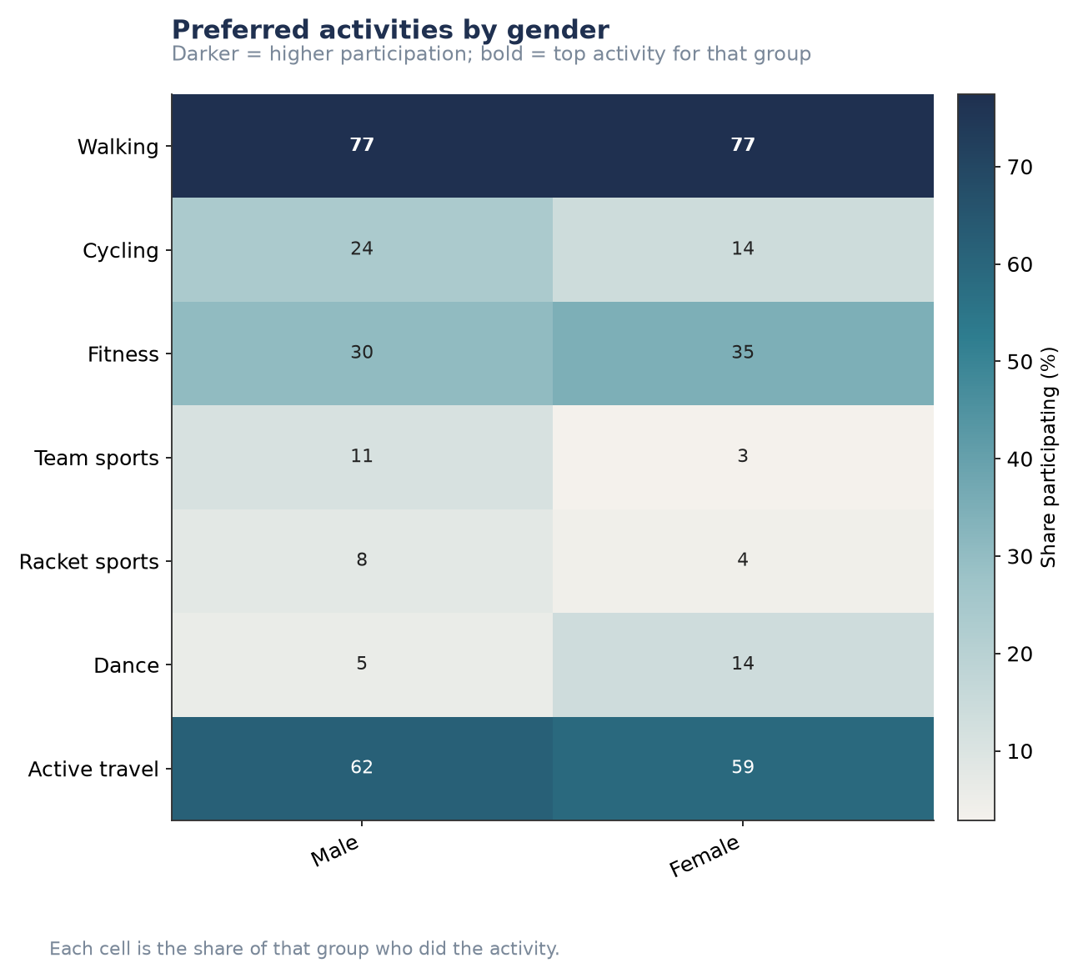
Figure P2.S7. Preferred activities by gender.
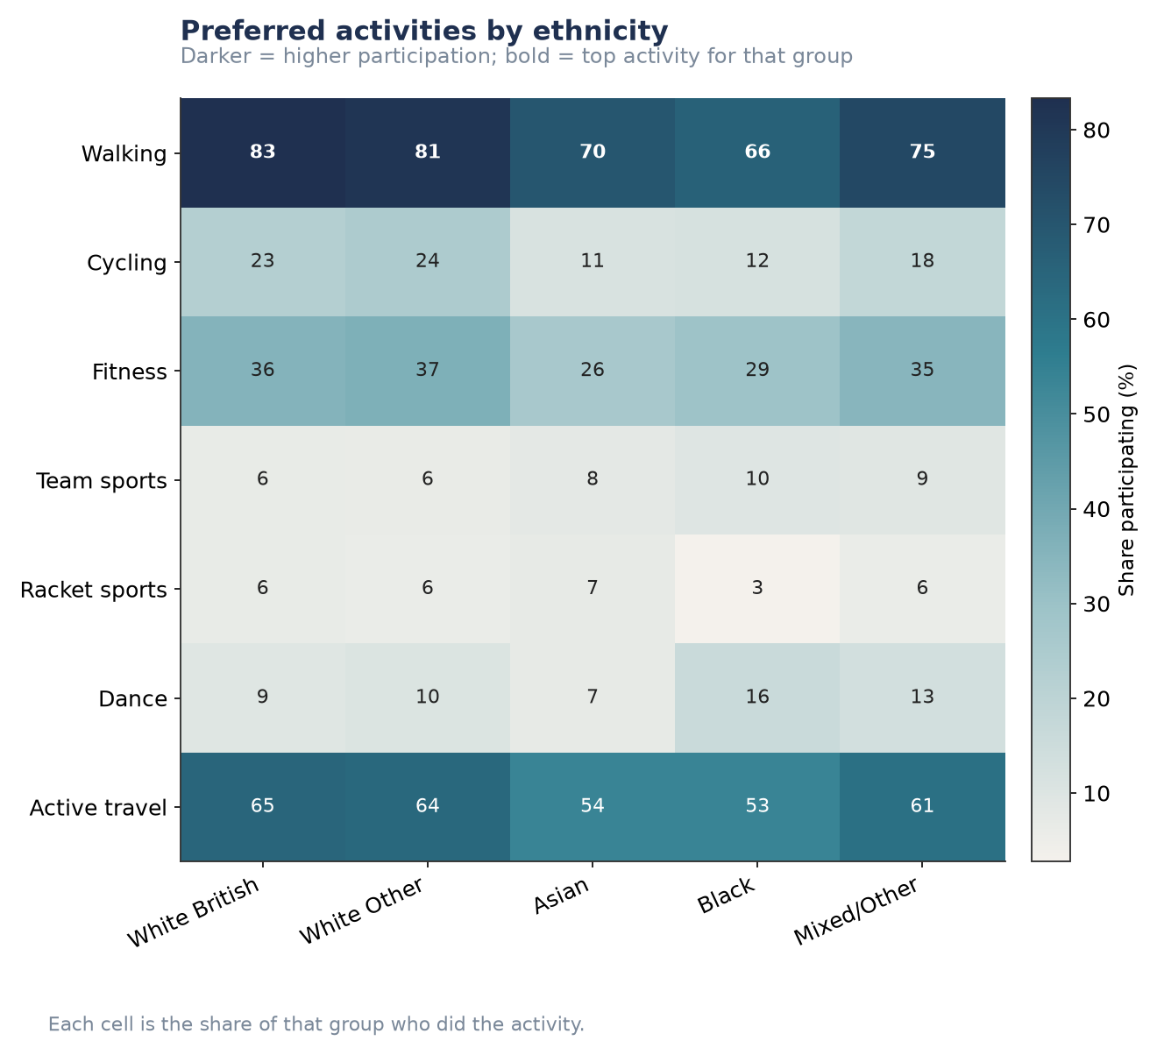
Figure P2.S8. Preferred activities by ethnicity.
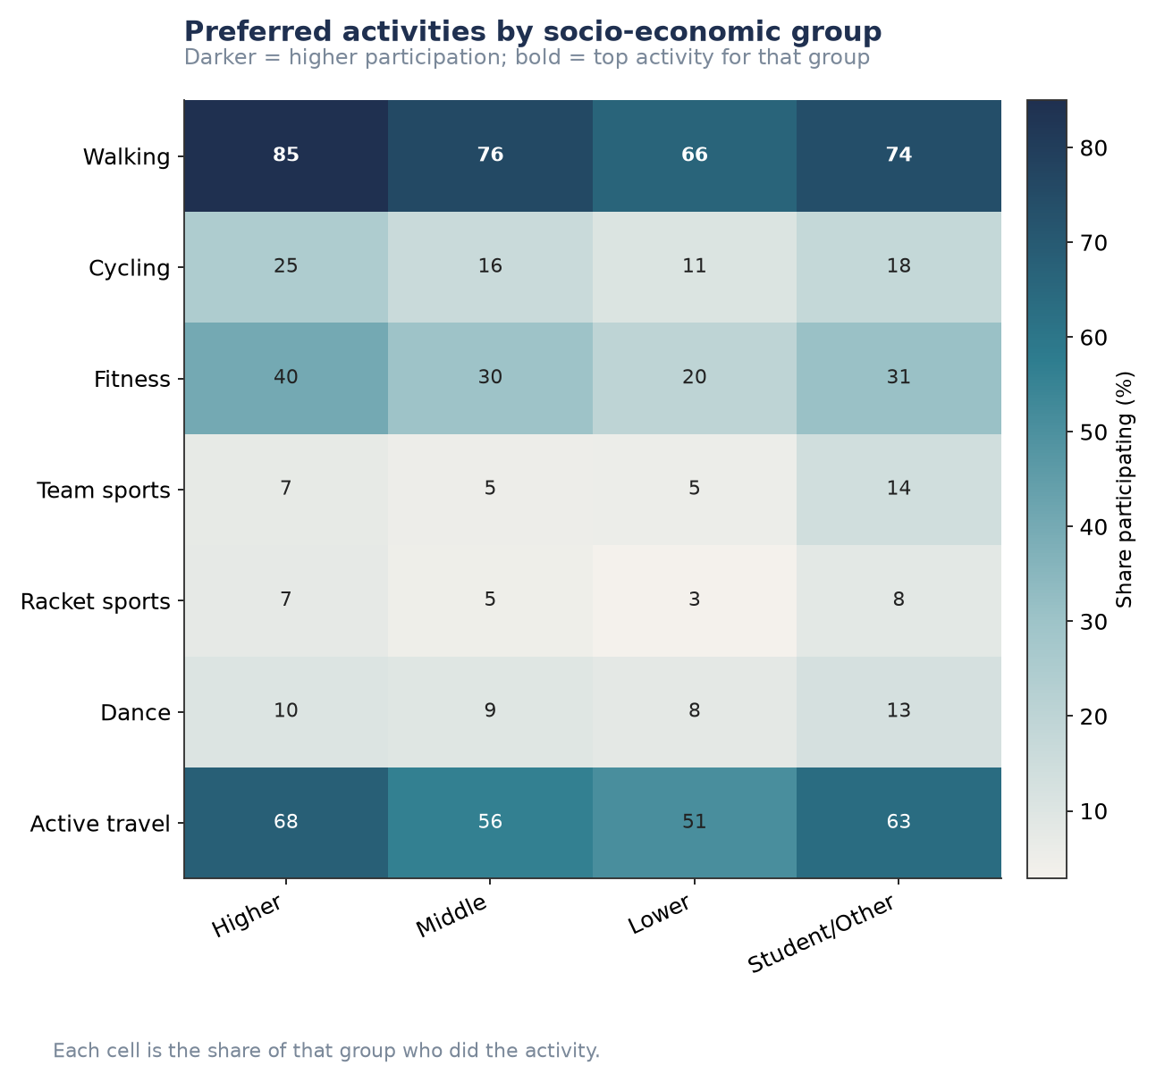
Figure P2.S9. Preferred activities by socio-economic group.
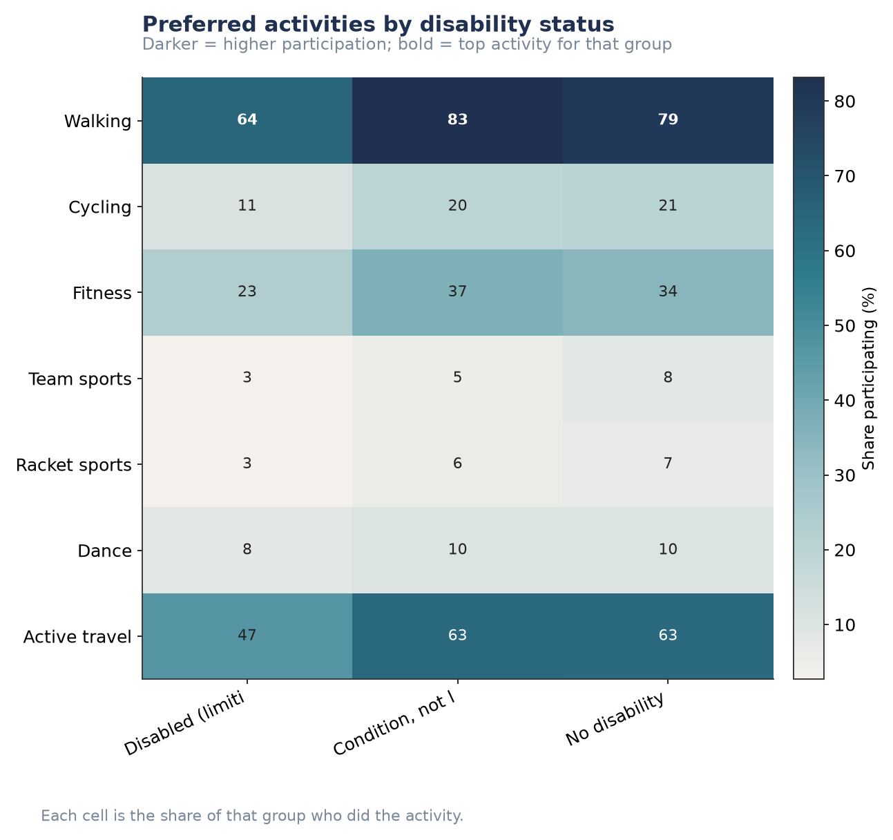
Figure P2.S10. Preferred activities by disability status.

Health conditions, individual breakdowns
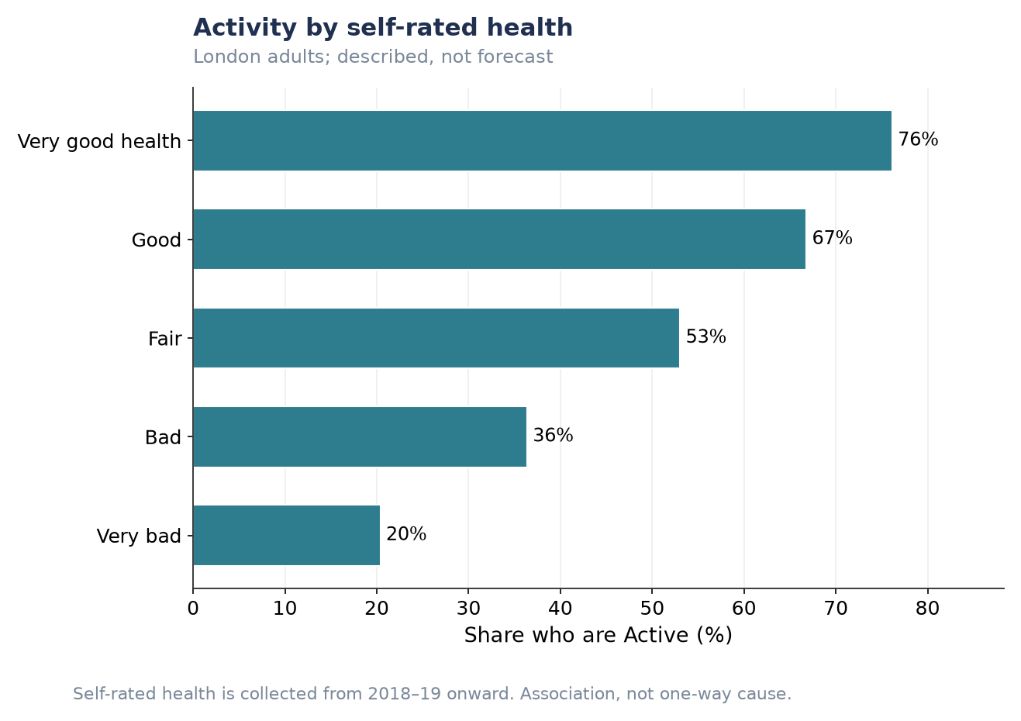
Figure P2.S11. Activity by self-rated health.
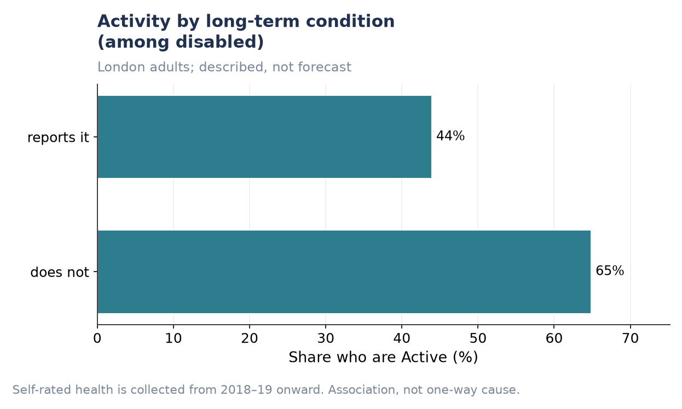
Figure P2.S12. Activity by long-term condition (among disabled respondents).
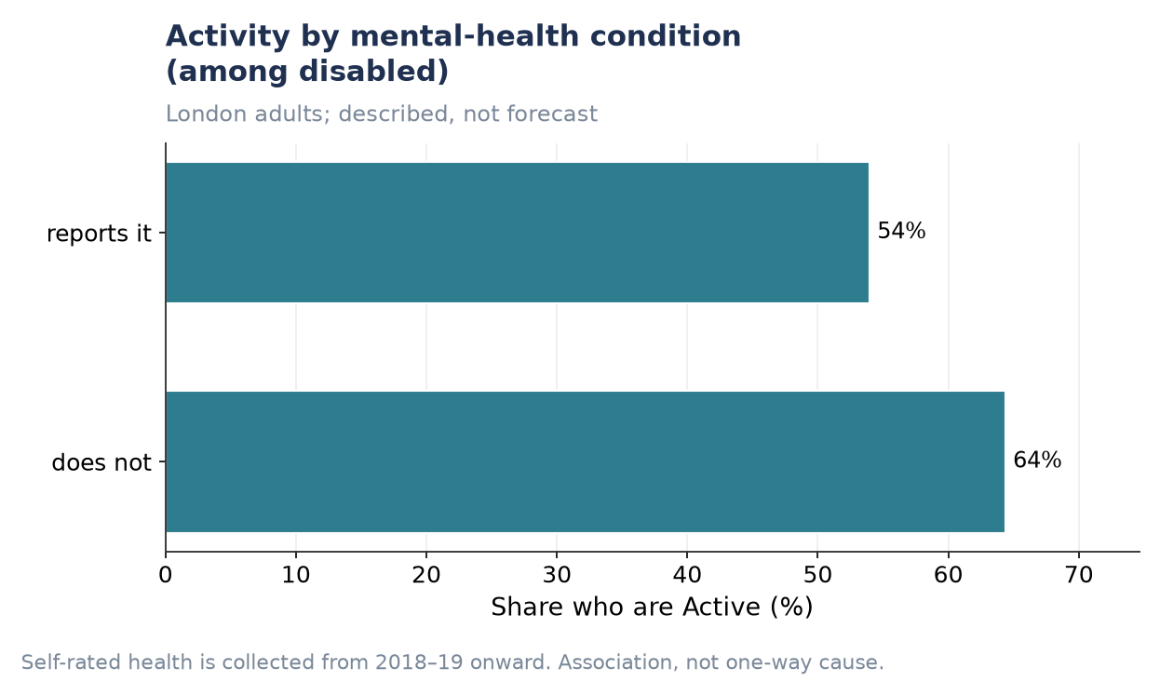
Figure P2.S13. Activity by mental-health condition (among disabled respondents).

P3 — Indoor vs Outdoor Activity
This section reports the London Sport brief’s third pillar: the balance of indoor versus outdoor physical activity. Indoor/outdoor setting questions are asked of a rotating subsample of approximately a third of respondents, so every figure in this section rests on a smaller base than the P1/P2 figures and several bullets are reported as description rather than forecast — each is labelled accordingly below.

The expected balance of indoor versus outdoor physical activity over the next ten years
Data note: this bullet asks for a ten-year outlook. The available projection covers three years only (to 2025–26), built by extending the pre-COVID slope for a ~30% subsample, and is explicitly labelled indicative rather than a full forecast. It is reported here as the best available evidence for this bullet, not as a completed ten-year answer — the same gap already flagged for the equivalent P1 activity-level projections.
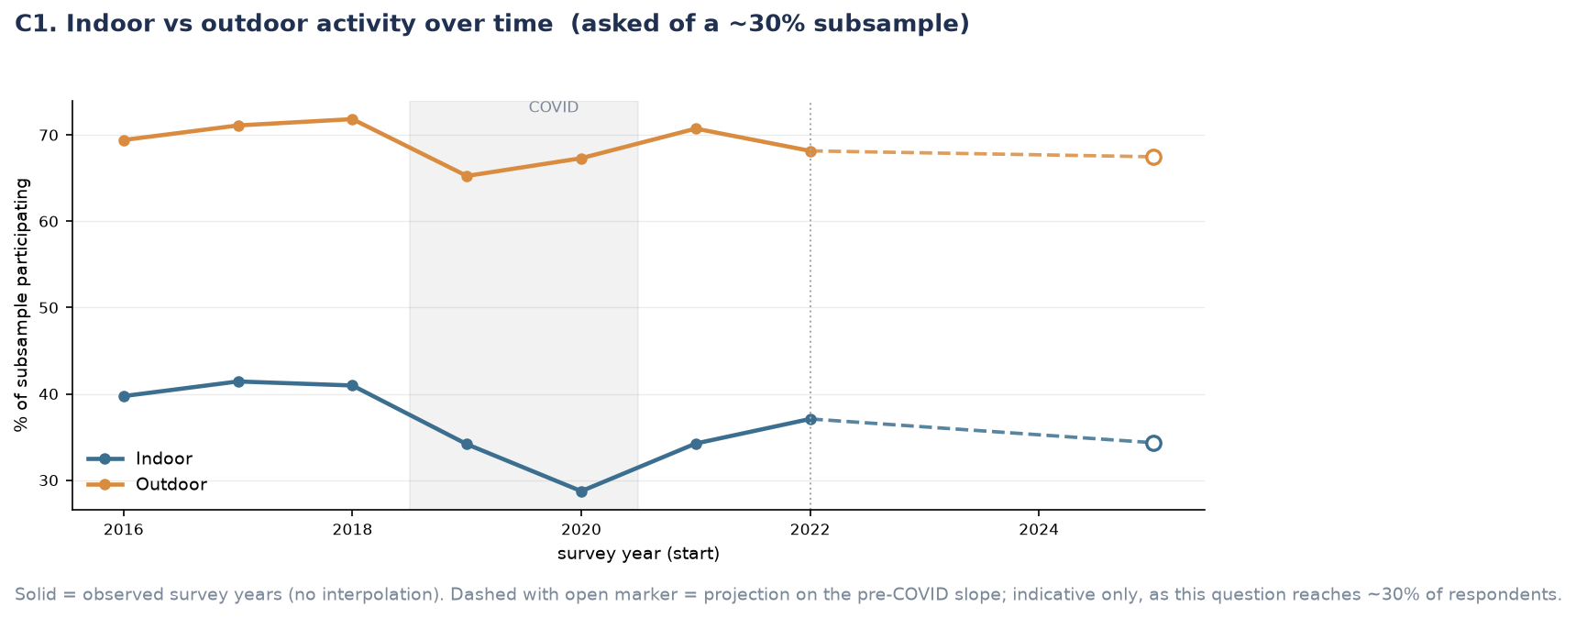
Figure P3.1. Indoor vs outdoor activity over time, observed 2016–2022 and projected to 2025.
Insight: outdoor activity is both far more common and more resilient than indoor activity. Outdoor participation sits around 65–72% throughout the observed period against indoor’s 29–42%, and while both fell during COVID, indoor fell further in relative terms (from 41% in 2018 to a low of 28.7% in 2020, a 30% relative drop) and has not recovered as cleanly — it reaches only 37.0% by 2022 against a pre-COVID level of 41%. The indicative projection continues this pattern: indoor is expected to decline further to 34.2% by 2025, while outdoor holds broadly flat at 67.4%. If this projection holds, the gap between indoor and outdoor participation widens over the near term rather than narrowing. This matches the wider analysis, which also flags this projection as wide-interval given the subsample and labels it ‘Forecast, with a wide interval reflecting the subsample’ rather than a precise figure.

Differences in indoor and outdoor activity preferences among people with varying activity levels
Indoor and outdoor participation were broken down by activity level (Fairly Active, Active). Inactive respondents are not shown, since participation in any setting is zero by definition for this group rather than a reporting gap.
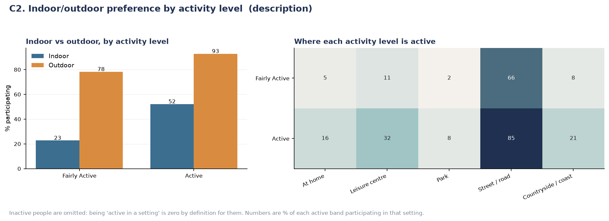
Figure P3.2. Indoor/outdoor preference by activity level, and where each activity level is active.
Insight: indoor activity scales far more steeply with overall activity level than outdoor activity does. Active adults are 2.3 times as likely as Fairly Active adults to do something indoors (52% against 23%), but only 1.2 times as likely outdoors (93% against 78%). Outdoor activity is close to a baseline behaviour that most Fairly Active and Active adults share regardless of how active they are overall, while indoor activity is the setting that actually distinguishes the more active from the less active — consistent with indoor activity depending more heavily on facility access and habit-formation (gyms, leisure centres, structured classes) than outdoor activity, which requires only a street, a park or a doorway.
Insight: within each setting, the pattern is dominated by one location. Street or road accounts for the large majority of outdoor activity in both bands (66% Fairly Active, 85% Active) and shows the smallest relative gap between bands (1.3×) — consistent with its low barrier to entry (walking, active travel). Park-based activity has the widest relative gap of any single setting (2%→8%, 4×) despite its small base, suggesting park use specifically, rather than outdoor activity generally, is the more distinguishing behaviour of the two. Indoors, leisure-centre use (11%→32%) and at-home activity (5%→16%) show broadly similar relative scaling (around 3× each). This is consistent with the wider analysis’s framing that leisure centres ‘serve the already-committed’ — the Active use them roughly twice as much as the Fairly Active — and that the low share of park-based activity reframes the indoor/outdoor picture as one of walkability and active travel rather than parks.

Relationships between inner vs outer London locations, activity levels and socio-economic factors
Data note: it is not stated on the chart whether this breakdown is restricted to active/fairly active respondents (consistent with the setting-subsample base used elsewhere in this section) or computed across all respondents. This should be confirmed with the analysis before the finding below is finalised in the report, since it affects how the percentages should be read.
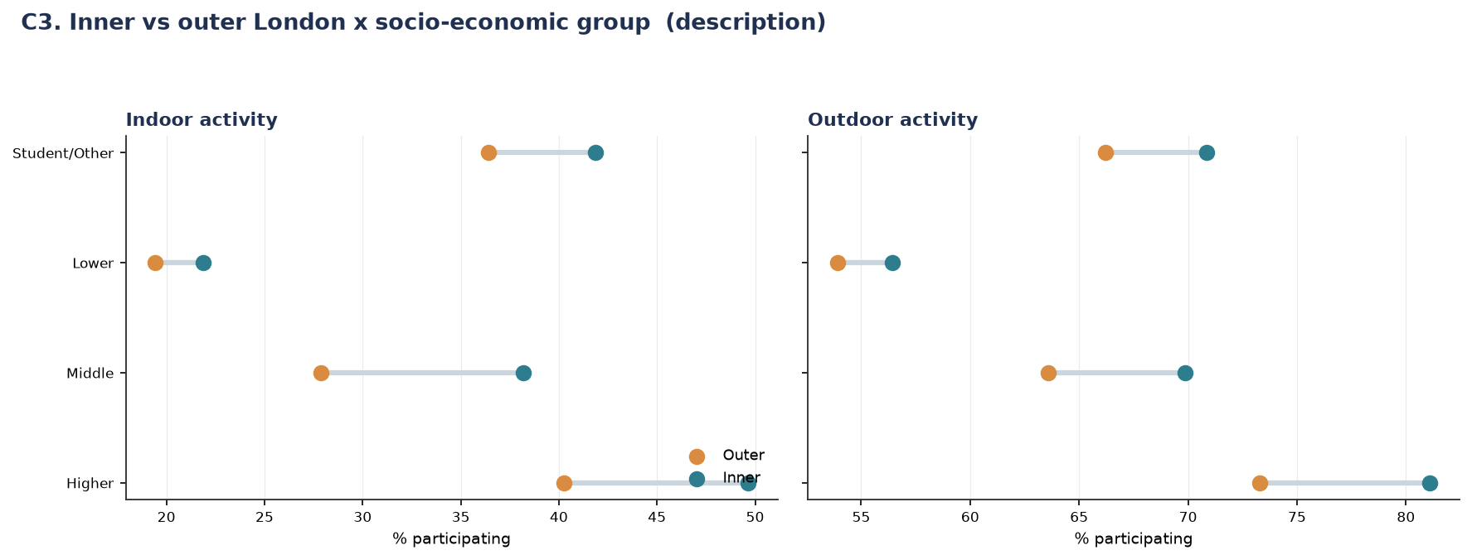
Figure P3.3. Inner vs outer London × socio-economic group, indoor and outdoor activity.
Insight: inner London shows higher participation than outer London in every socio-economic group, for both indoor and outdoor activity, without exception — but the size of that inner-London advantage is not uniform. For the Lower socio-economic group the inner/outer gap is narrow in both settings (around 2.5 points indoor, 2 points outdoor). For the Higher and Middle groups the gap is substantially wider (6–10 points in both settings). Being in inner London helps every socio-economic group, but it helps the already-more-active higher socio-economic groups more — geography amplifies the socio-economic gap rather than narrowing it. This matches the wider analysis’s independent finding that the widest inner/outer gap is specifically in affluent outdoor activity, consistent with walkable, high-amenity inner boroughs benefiting most those able to afford to live in them.
Insight: the socio-economic gap dominates the geographic one: even the most favourable geographic position for the Lower group (inner London, 22% indoor / 56% outdoor) does not reach the least favourable geographic position for the Higher group (outer London, 40% indoor / 73% outdoor). This mirrors the P1/P2 finding that socio-economic group produces the widest gap of any factor measured across this project — geography here is a secondary, amplifying factor rather than the primary driver.

Supplementary Figures (P3)
Individual breakdowns underlying the combined figures above, provided for completeness.

Indoor vs outdoor, by activity level (individual charts)
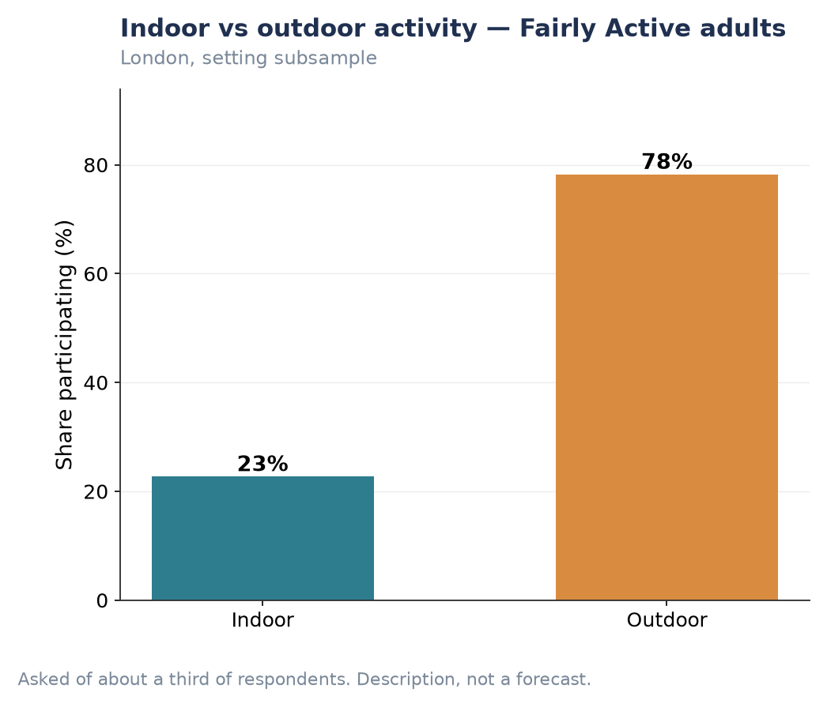
Figure P3.S1. Indoor vs outdoor activity — Fairly Active adults.
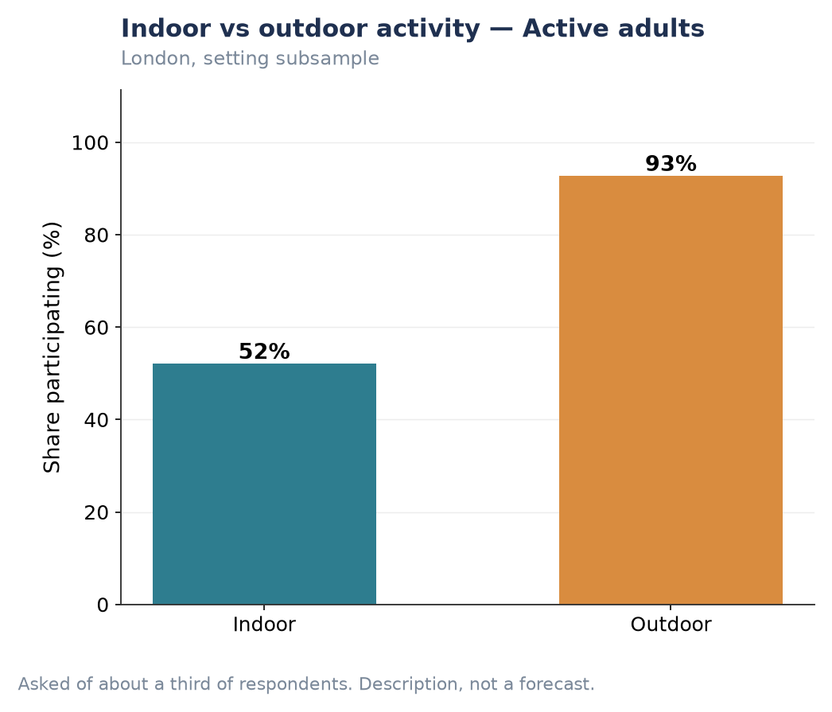
Figure P3.S2. Indoor vs outdoor activity — Active adults.
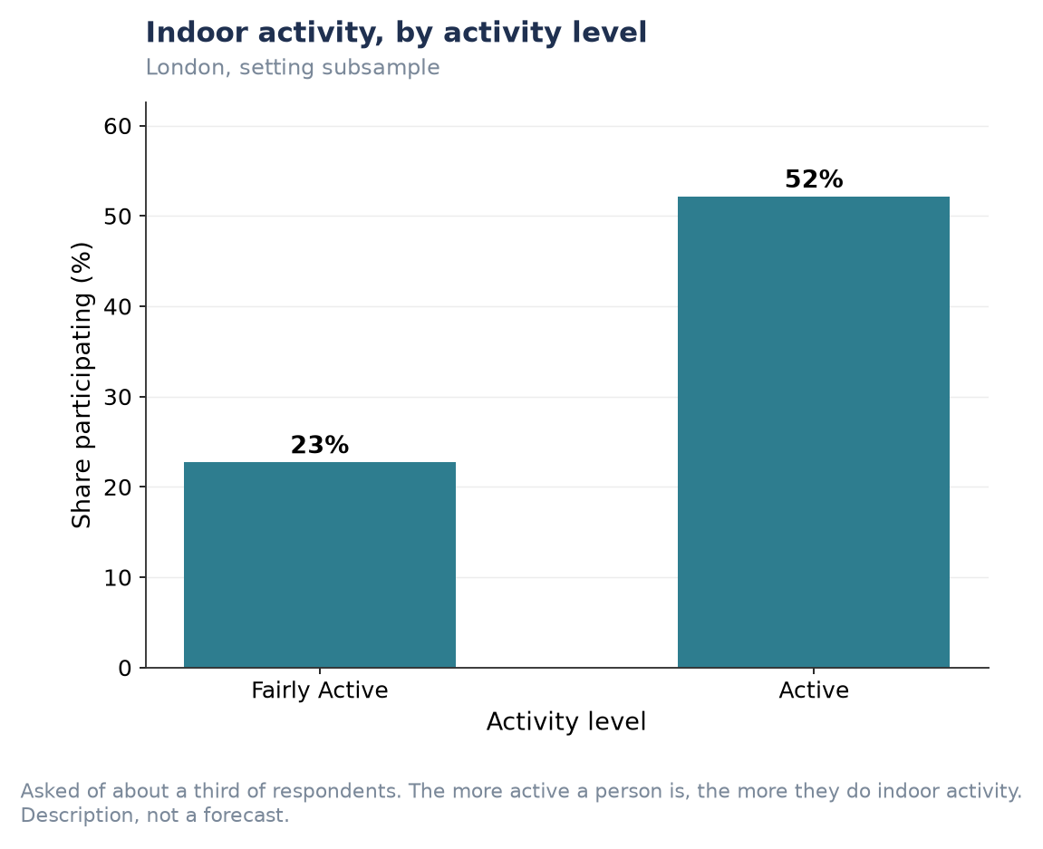
Figure P3.S3. Indoor activity, by activity level.
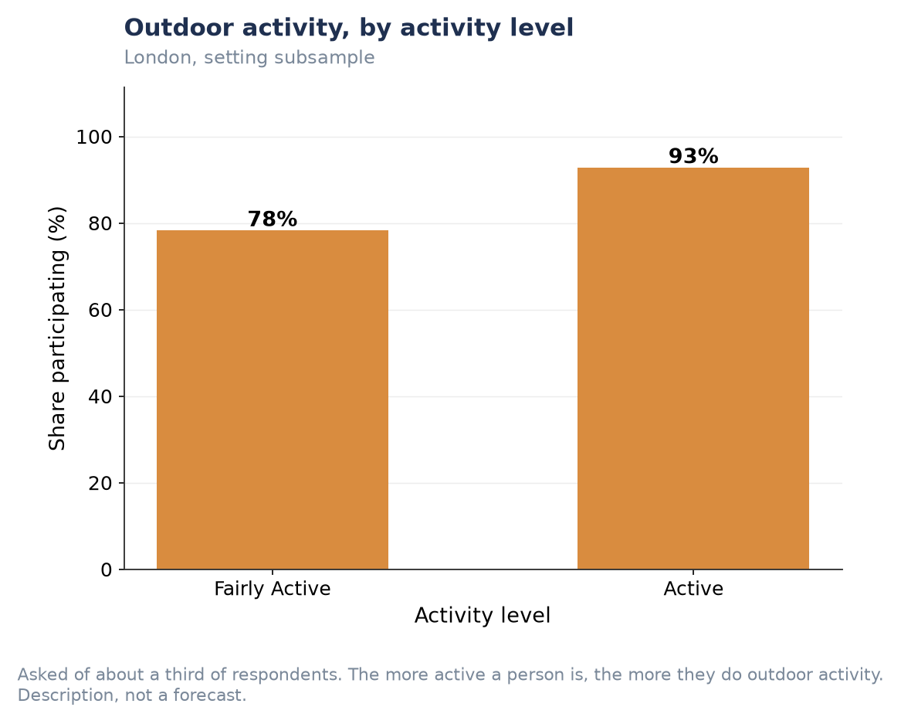
Figure P3.S4. Outdoor activity, by activity level.
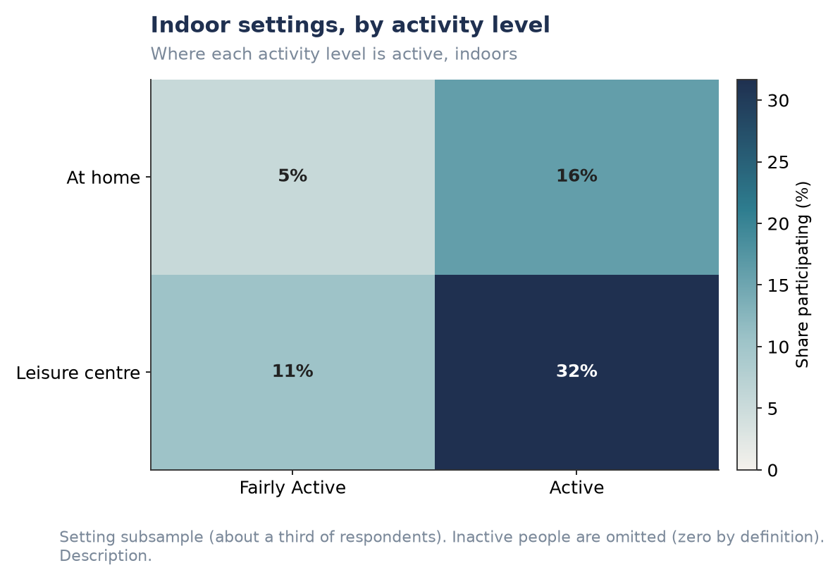
Figure P3.S5. Indoor settings, by activity level (at home / leisure centre).
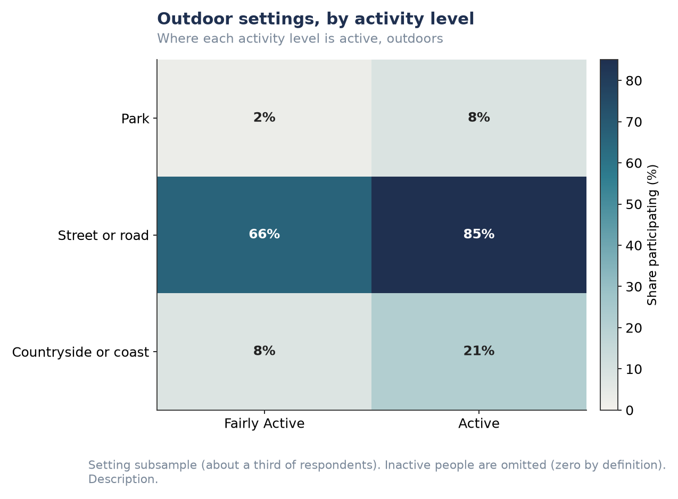
Figure P3.S6. Outdoor settings, by activity level (park / street / countryside).

Inner vs outer London by socio-economic group (individual charts)
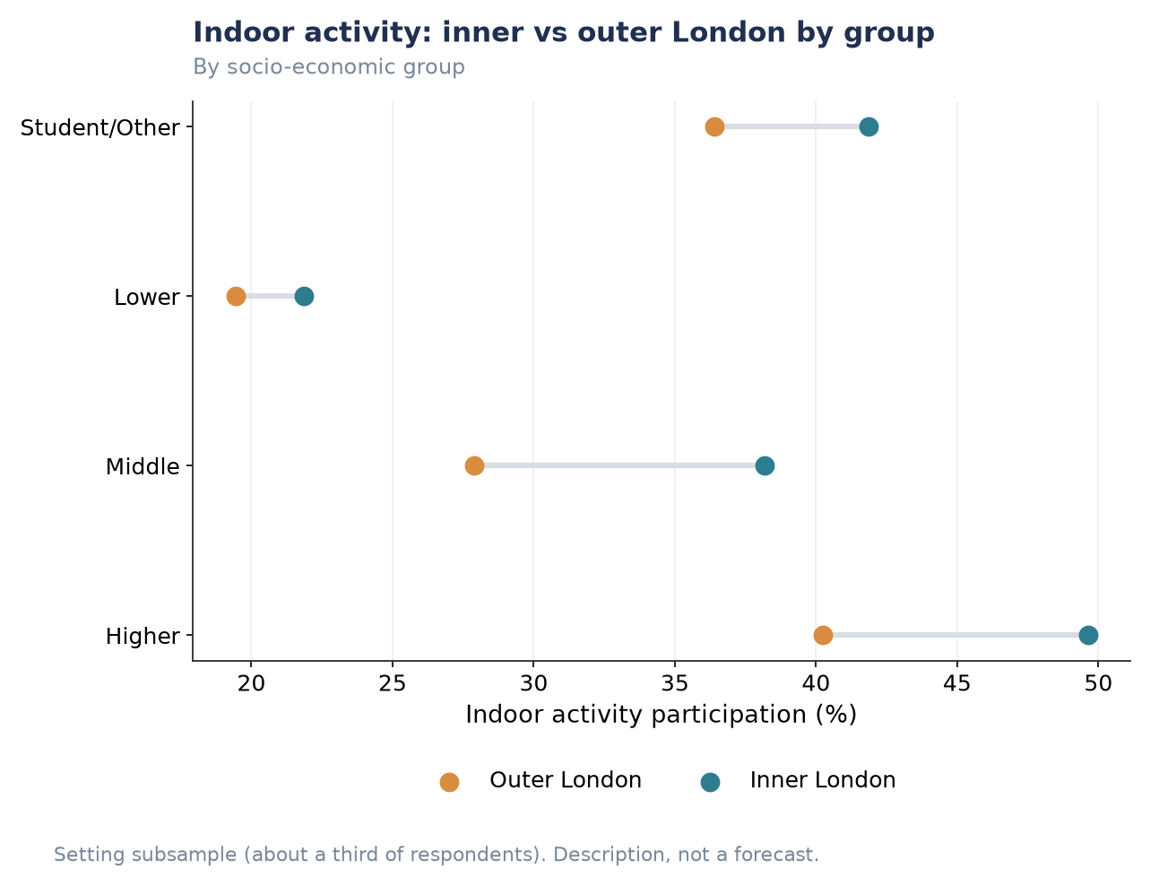
Figure P3.S7. Indoor activity: inner vs outer London by socio-economic group.
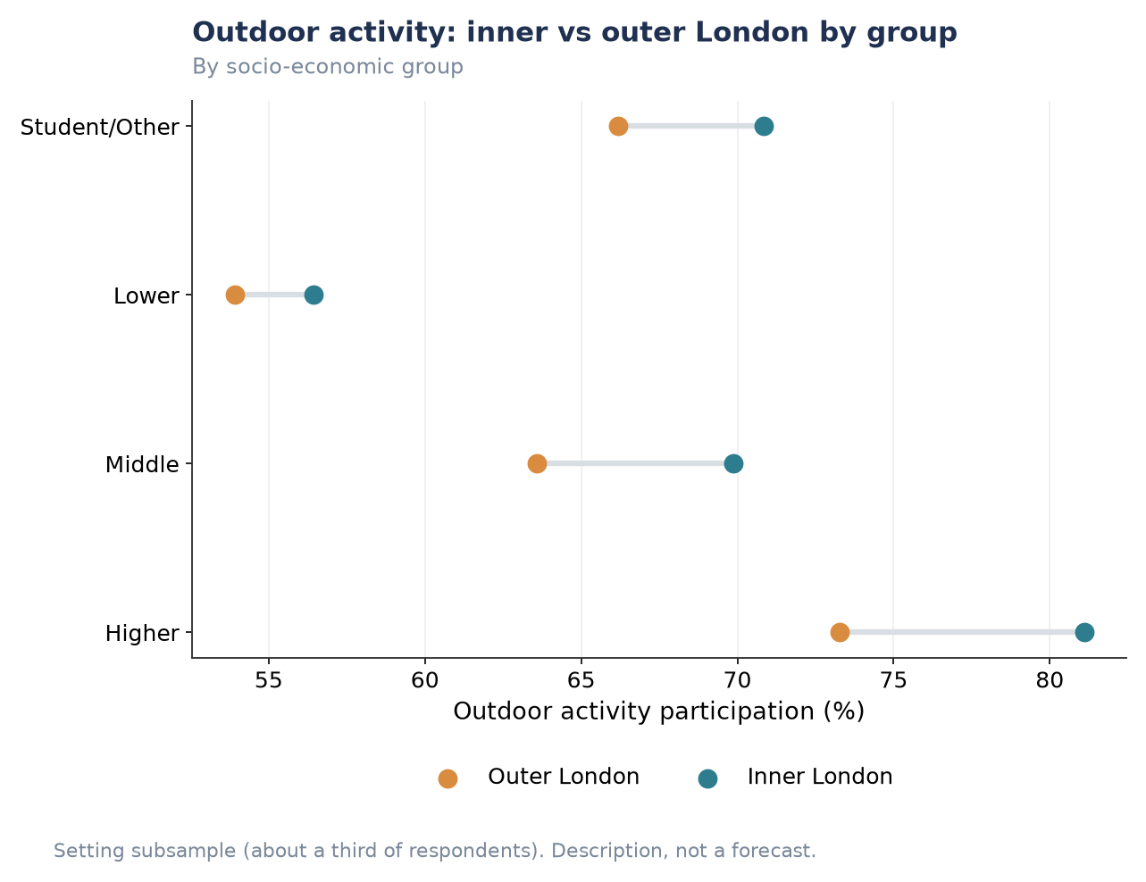
Figure P3.S8. Outdoor activity: inner vs outer London by socio-economic group.

P4 — Volunteering in Sport
This section reports the London Sport brief’s fourth pillar: volunteering in sport. Volunteering is the most constrained target in the project — demographics explain only around 15% of the between-borough variation, the borough correlation is near zero, and the question base changed twice during the eight-year series (most visibly between the 2017–18 and 2018–19 waves, a change that reflects revisions to the Active Lives Survey rather than a genuine shift in volunteering behaviour). None of the three conditions set out in ‘A note on forecasting versus description’ above are met at borough level, so this pillar is reported as description at London and demographic level throughout; a borough-level forecast is not supportable, and stating that plainly is the honest result rather than a gap in the analysis. Figures in this section are drawn from the wider analysis produced by the team’s modelling lead.

The likelihood of individuals from diverse backgrounds volunteering in sport over the next decade
Data note: because volunteering fails the consistency and demographic-predictability tests above, this bullet is answered with the current pooled relationship between background and volunteering, rather than a ten-year projection.
Volunteering in sport runs at about 18% of London adults and is youth-driven — the reverse of the pattern seen in overall activity, where the young are the most active but here also volunteer the most, at 25% among 16–24-year-olds. Men volunteer more than women (21% against 15%), and there is a modest socio-economic gradient. Unusually, the picture is fairly even across ethnicity and disability status — a more equitable pattern than activity itself, where those two dimensions produce some of the widest gaps measured.
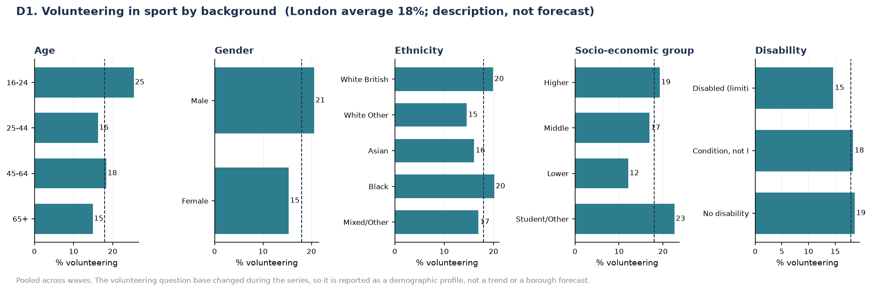
Figure P4.1. Volunteering in sport by background, pooled across waves. Described, not forecast.
Insight: the near-even split by ethnicity and disability stands out precisely because it is the exception in this project: almost every other outcome measured across P1–P3 (activity level, indoor/outdoor setting, preferred activity) shows a substantial gap by at least one of those two dimensions. Volunteering’s comparative evenness, alongside its low demographic explanatory power (~15%), together suggest that who volunteers is driven considerably more by opportunity, local sports infrastructure and organisational reach than by demographic background — consistent with the wider project’s finding that volunteering sits at the extreme ‘follows the place’ end of the provision gradient discussed in the cross-pillar synthesis below.

Forecasts of the types of volunteer roles different demographic groups are likely to take on
Data note: as above, this is reported as the current pooled distribution of roles by group (waves 2020–22) rather than a forecast, for the same reasons.
Organising and administration is the backbone role for almost every demographic group. Younger volunteers break from this pattern toward more hands-on roles — stewarding and coaching — and there is a clear gender split: men coach nearly twice as often as women and officiate more, while women concentrate in organising and support roles.
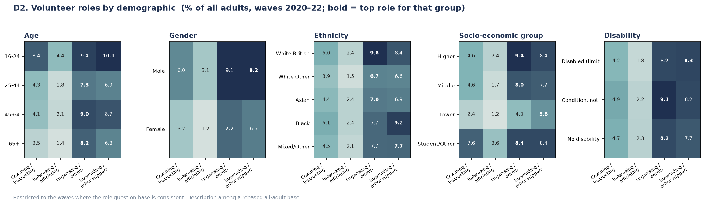
Figure P4.2. Volunteer roles by demographic group, waves 2020–22; the top role for each group is emphasised.
Insight: this is a directly actionable finding for how London Sport and its partners recruit and develop volunteers: role type, not just volunteering rate, differs systematically by age and gender. A recruitment strategy aimed at growing coaching capacity, for example, would do well to target the same younger, male-skewed group already over-represented in hands-on roles, while organising and administrative capacity — the backbone role everywhere — draws more evenly from the whole volunteer base, including the women and older volunteers under-represented in coaching.

How the four pillars connect
Read together, the four pillars tell one coherent story rather than four separate ones. P1 shows London-wide activity is stable only because a demographic headwind (−0.37 points, driven by an ageing population) and a behavioural tailwind (+0.69 points, people becoming more active) are currently cancelling out. P2 identifies exactly which group is driving that headwind — the 65+ group, the least active and the slowest-moving of any demographic segment — and shows the same compounding pattern recurring at borough level, where place effects amplify rather than offset demographic disadvantage. P3 extends this into a specific channel: the socio-economic and geographic gaps identified in P1/P2 are not spread evenly across settings, but concentrate in facility-dependent, place-provisioned activity — indoor activity, leisure-centre use, cycling — while low-barrier behaviours like walking and outdoor activity stay comparatively even across groups. P4 sits at the far end of that same spectrum: volunteering is the outcome least explained by who someone is (~15% by demographics) and, correspondingly, the one outcome in the whole project that is comparatively even across ethnicity and disability — the clearest illustration that place and provision, not composition, set the ceiling on participation once a behaviour requires infrastructure or an organisation to take part in.
The wider analysis makes this pattern explicit by repeating the same composition-versus-place decomposition across fifteen distinct behaviours. The table below is drawn directly from that analysis and is the single clearest piece of evidence tying all four pillars together.
Table S.1. The share of between-borough variation explained by demographics, for each behaviour (wider analysis, Section 6.3).
Follows the people (composition) | Share | Follows the place (provision) | Share
Walking | 50% | Volunteering | 15%
Overall activity | 48% | Park use | 18%
Dance | 46% | Team-sport club | 25%
Outdoor activity | 45% | Racket sport | 28%
Fitness activities | 45% | Cycling | 29%
Indoor activity | 44% | Leisure-centre use | 31%

The ordering is not arbitrary: the more a behaviour depends on provision, the less demography explains it. Walking requires only a pavement and tracks the population closely; cycling requires lanes and secure storage; park use requires parks; team sport requires clubs; volunteering requires organisations to volunteer for. The practical implication for London Sport is direct: the two levers identified across this report are not equivalent. Demographic composition — the ageing population documented in P1 and P2 — is a headwind to be planned around, not solved. Behavioural change concentrated in facility-dependent, place-provisioned activity — the indoor settings and structured club activity flagged in P3, and the volunteering roles and pathways flagged in P4 — is the lever most open to influence through investment in provision, since these are precisely the outcomes this project’s own evidence shows respond least to who lives where and most to what is available to them.

Limitations to keep in view
These limitations, drawn from the underlying methodology and the wider analysis, apply across all four pillars and are the reason several bullets above are reported as description rather than forecast: the survey is not a panel, so it describes how the population changes rather than how particular people change over their lives; the behavioural trend rests on effectively six usable years once the two pandemic-disrupted waves are excluded, which is why the ten-year horizon is presented as scenarios rather than a single point forecast; the place effect is measured but not yet explained — roughly half of between-borough variation is not compositional, and closing that gap would require external data (cycling infrastructure, facility supply, green-space coverage) the survey does not contain; several questions are single-year or subsample-based (free time, indoor/outdoor setting, volunteering), which limits what can be said about them regardless of modelling choice; borough-by-demographic detail is thin and only reportable pooled across all eight waves; and group forecasts for dimensions that are not part of the population projection itself (socio-economic group, disability) are transparent approximations rather than full re-projections.

