P1 — Overall Participation Forecasts
This section reports the London Sport brief's first pillar: overall participation forecasts. All figures below derive from the forecasting framework set out in Section 3.5 and the LightGBM propensity model selected in Section 4.4 — individual-level propensities combined with a projected demographic composition and an estimated behavioural trend, decomposed into composition and behaviour effects. Rather than a single point estimate for the ten-year horizon, three bounded scenarios are shown throughout: recent gains continuing, behaviour holding flat while only the population's demographic mix changes ('Population change only'), and a COVID-scale reversal of recent gains. This reflects genuine long-run uncertainty rather than false precision (Section 4.5).

Physical activity across London as a whole
The near-term model output projects broad stability in the Active share through 2025–26, alongside the continued erosion of the Fairly Active band identified in the EDA (Section 3.4): Active is projected at 64.9%, Inactive at 26.0%, and Fairly Active falling further to 9.1%.
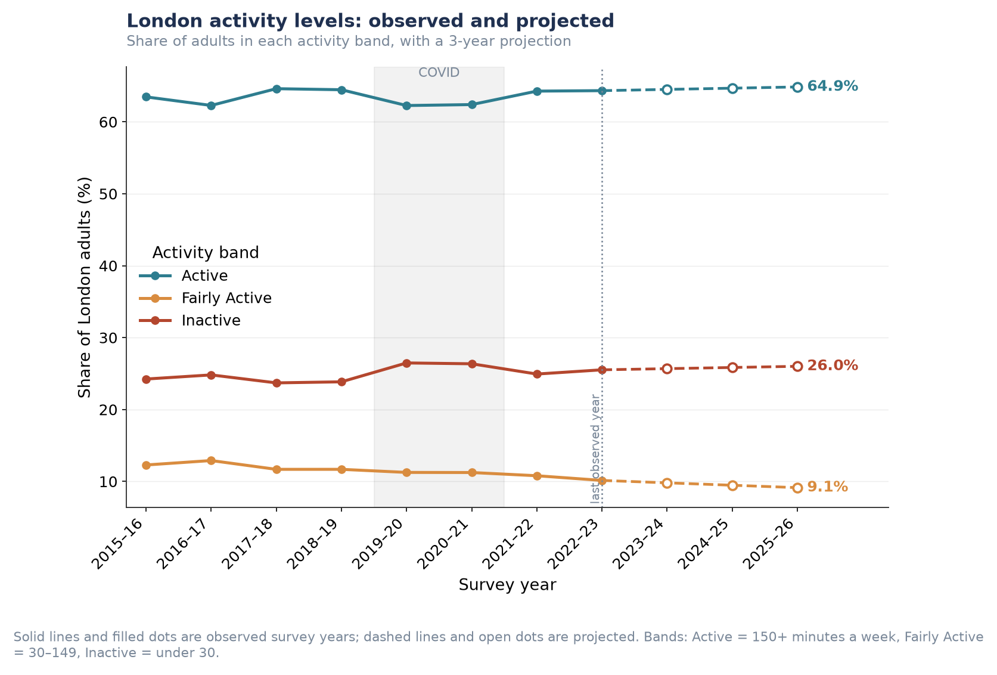
Figure P1.1. London-wide activity bands, observed 2015–16 to 2022–23 and projected to 2025–26.
Over the full ten-year horizon, the three scenarios diverge from 61.0% (if recent gains reverse) to 65.4% (if the current trend continues) — a roughly four-point range around the current 64.3%. This spread is the decomposition from Section 3.5 made visible: the 'Population change only' path isolates the effect of London's changing demographic mix alone, holding behaviour fixed.
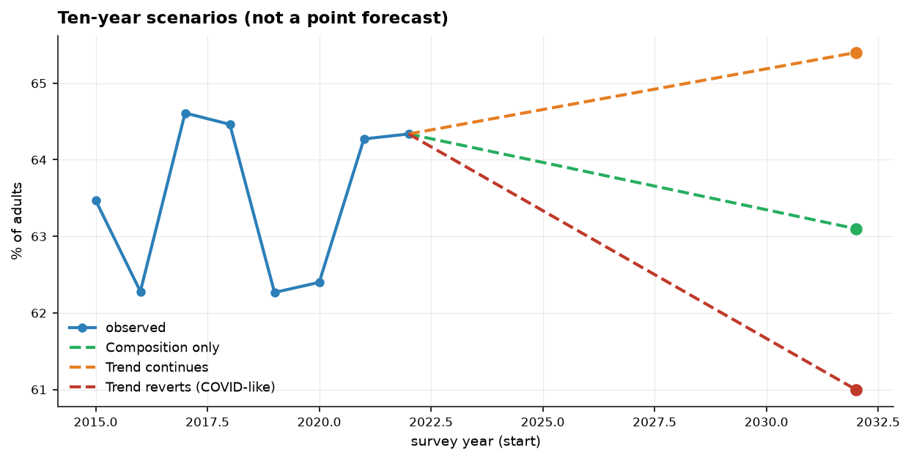
Figure P1.2. Ten-year scenario range for London-wide activity, 2022–2032.

Likelihood of participating in specific activities
Ten-year scenario ranges were produced for seven individual activities and three club-membership measures. Table P1.1 reports the central figure for each scenario; the two most illustrative are shown as figures below, with the remaining eight in the Supplementary Figures at the end of this section.
Table P1.1. Ten-year scenario range by activity/club type (% of London adults).
Activity / Club Type | Today | If Gains Continue | Population Change Only | If Gains Reverse
Walking | 76.2% | 71.9% | 75.1% | 72.1%
Active travel | 59.6% | 48.5% | 58.0% | 44.4%
Fitness activities | 32.5% | 28.9% | 31.6% | 26.6%
Cycling | 19.1% | 19.6% | 18.3% | 16.6%
Team sports | 7.1% | 5.4% | 6.6% | 3.8%
Dance | 8.7% | 5.0% | 8.5% | 6.8%
Racket sports | 5.9% | 5.0% | 5.8% | 3.9%
Club membership (any sport) | 15.5% | 19.3% | 14.8% | 15.7%
Fitness club / gym | 8.9% | 8.4% | 8.5% | 8.4%
Team-sport club | 4.5% | 6.9% | 4.2% | 4.5%

Club membership figures are separate, possibly overlapping breakdowns rather than components of a single total — 'fitness club/gym' and 'team-sport club' do not sum to 'club membership (any sport)', since a person could belong to both, or to a club type not itemised here.
A consistent pattern emerges across the 'if recent gains continue' column: for every individual activity except cycling, continuing the recent trend implies a decline over the decade — but for all three club-membership measures, continuing the recent trend implies growth. This suggests informal, unstructured activity (walking, dance, casual team sport) has been trending down since its pre-COVID level, while formal, club-based participation has been recovering upward. This divergence is directly relevant to the club-membership bullet below.
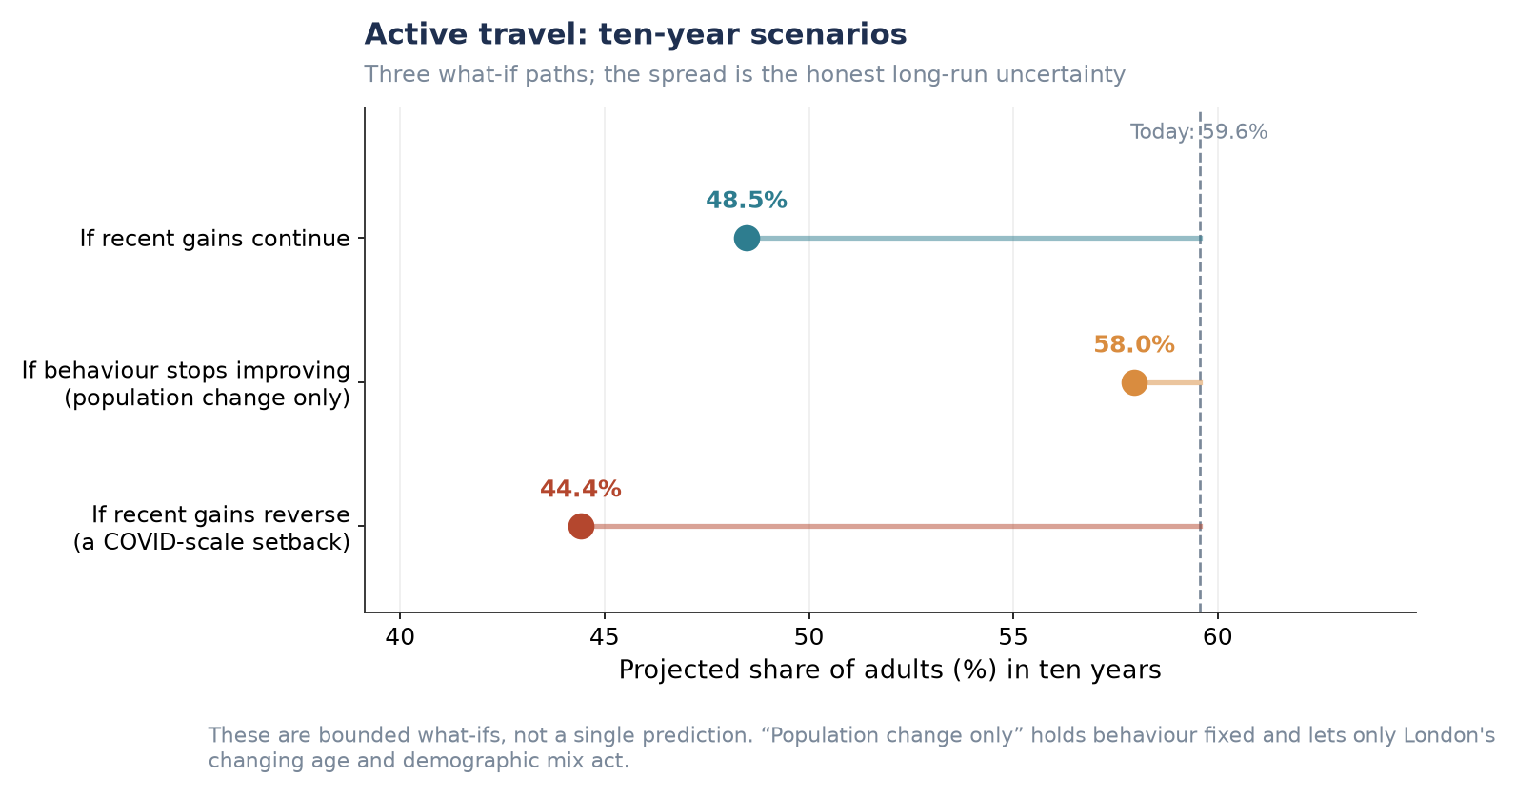
Figure P1.3. Active travel: ten-year scenarios (widest scenario spread of any activity measured).
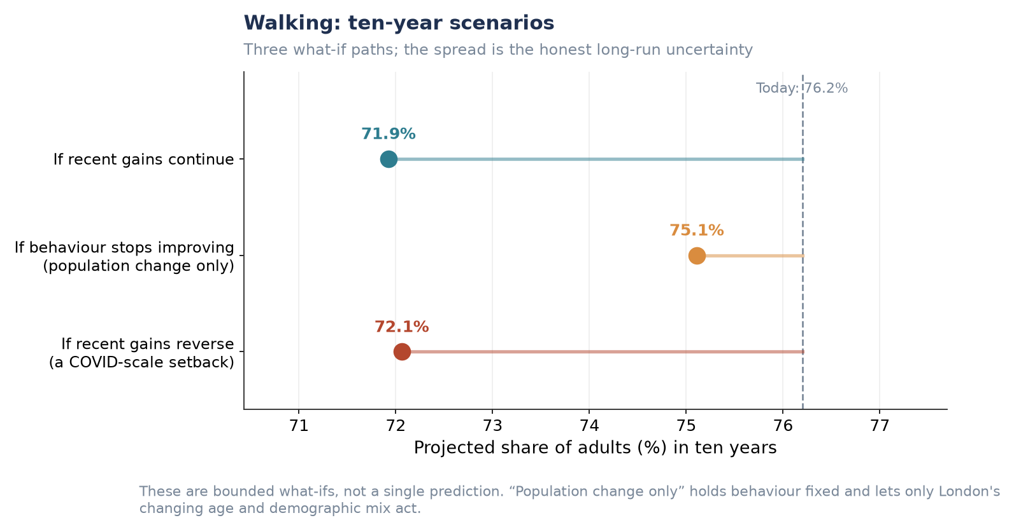
Figure P1.4. Walking: ten-year scenarios (largest-base activity measured).
The remaining five individual activities (cycling, fitness activities, team sports, dance, racket sports) follow the same scenario structure and are provided in full in the Supplementary Figures below.

Sport-specific club membership
Club membership is the one area of Table P1.1 where continuing the recent trend points upward rather than downward. Club membership (any sport) is projected to reach 19.3% under the 'gains continue' scenario, against 14.8% if behaviour flattens and only the population changes — a wider and more favourable scenario range than almost any individual activity measured.
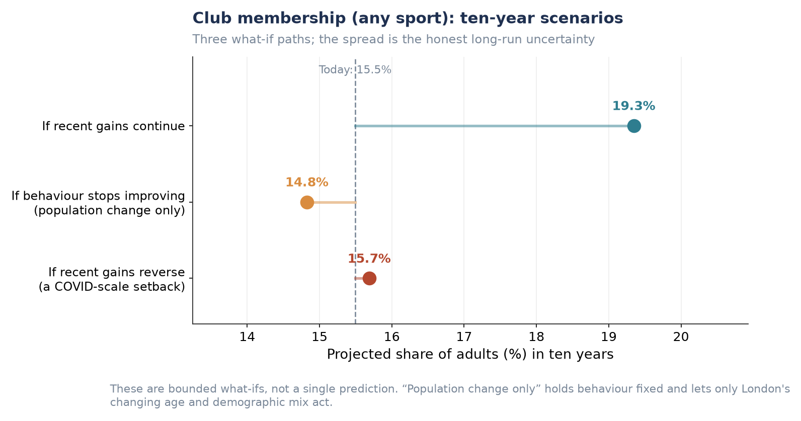
Figure P1.5. Club membership (any sport): ten-year scenarios.
Fitness club/gym and team-sport club membership (Table P1.1) show more modest movement individually, but both sit within the same general recovery pattern as overall club membership, reinforcing that the post-pandemic rebound in participation has been concentrated in structured, club-based settings rather than informal activity.

Forecasts of activity levels for each London borough
Applying the propensity model to each borough's projected demographic composition produces a 2025 borough-level forecast ranging from 51.3% (Barking and Dagenham) to 75.4% (Wandsworth) — a spread consistent with the borough variation already established in the EDA (Section 3.4). Boroughs in inner south-west and central London remain projected to lead; outer east and north-east London boroughs remain projected to lag.
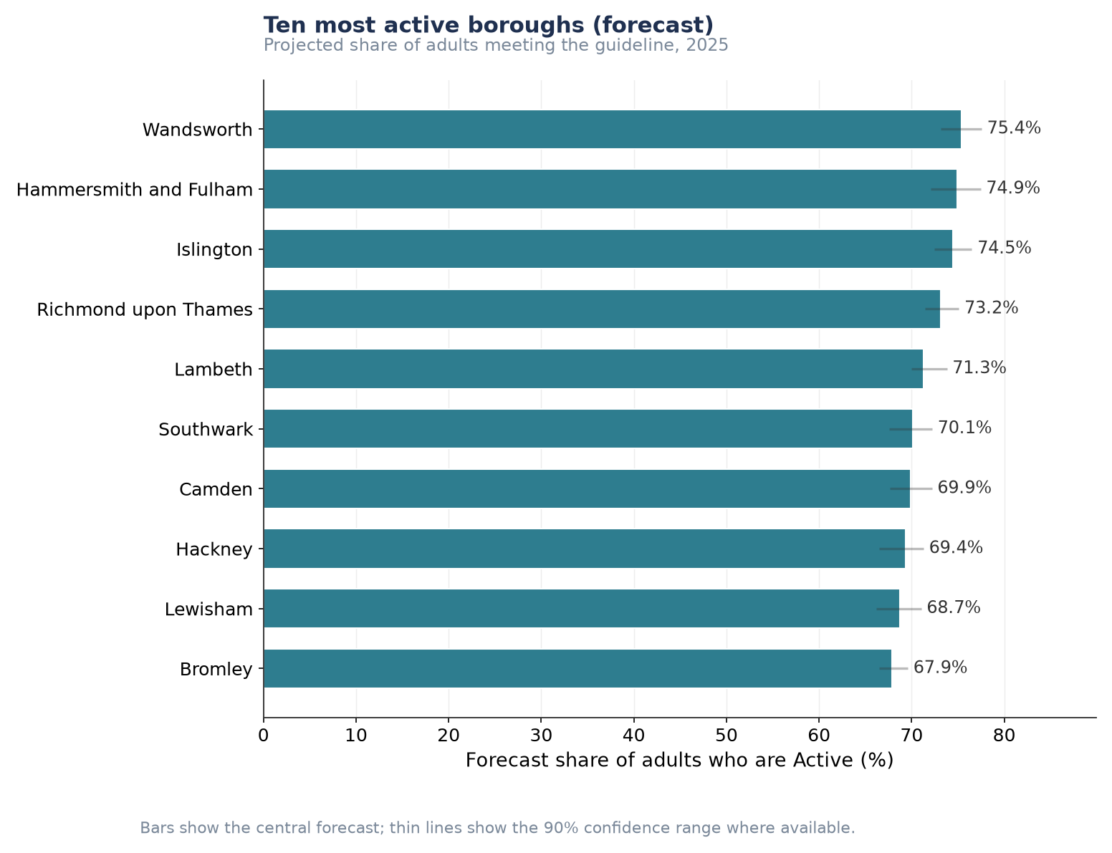
Figure P1.6. Ten most active boroughs, projected share of adults meeting the guideline, 2025.
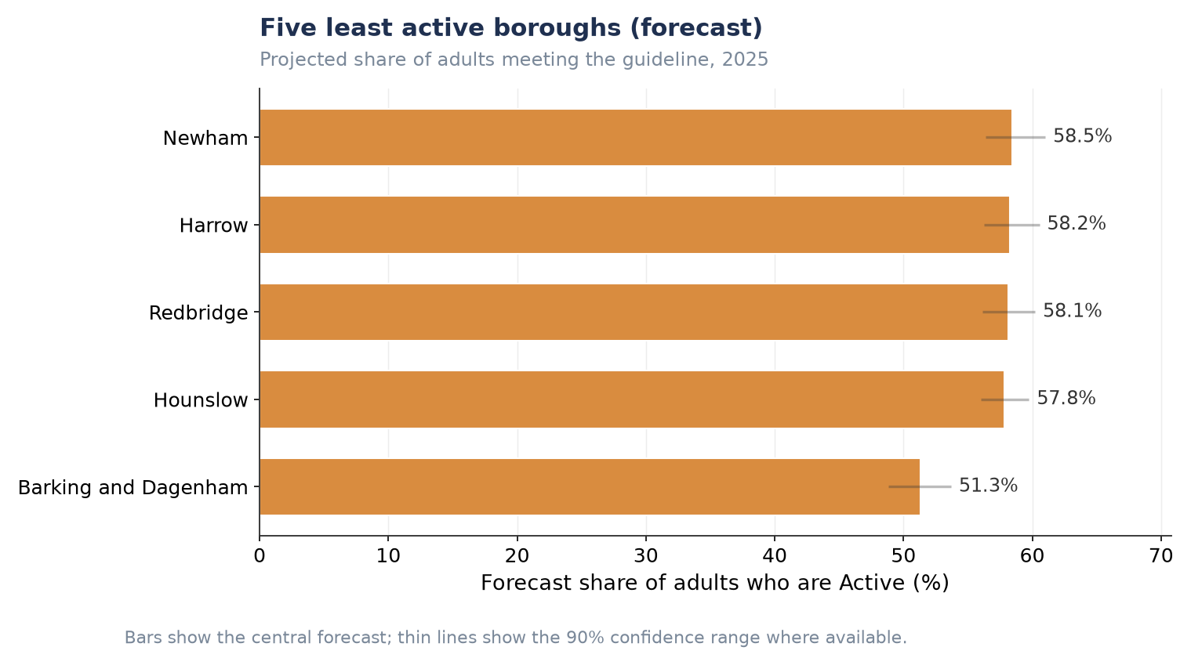
Figure P1.7. Five least active boroughs, projected share of adults meeting the guideline, 2025.
Barking and Dagenham's projected 51.3% sits noticeably below the next-lowest borough (Hounslow, 57.8%), a gap consistent with its position as an outlier in the underlying EDA (Section 3.4) rather than a modelling artefact.

Key factors that may reduce free time and affect participation
Free-time constraint questions were asked once, in the 2022–23 wave only, of approximately a third of respondents. This bullet is therefore necessarily a cross-sectional snapshot rather than a ten-year forecast; no trend or projection is available for this measure.
Looking after children is the most commonly reported constraint for adults aged 16–24 (66%) and 25–44 (52%), while work and study commitments dominate for the youngest and middle age groups respectively. Health or disability becomes a more prominent constraint from age 45 onwards, consistent with the demographic patterns established in Section 3.4.
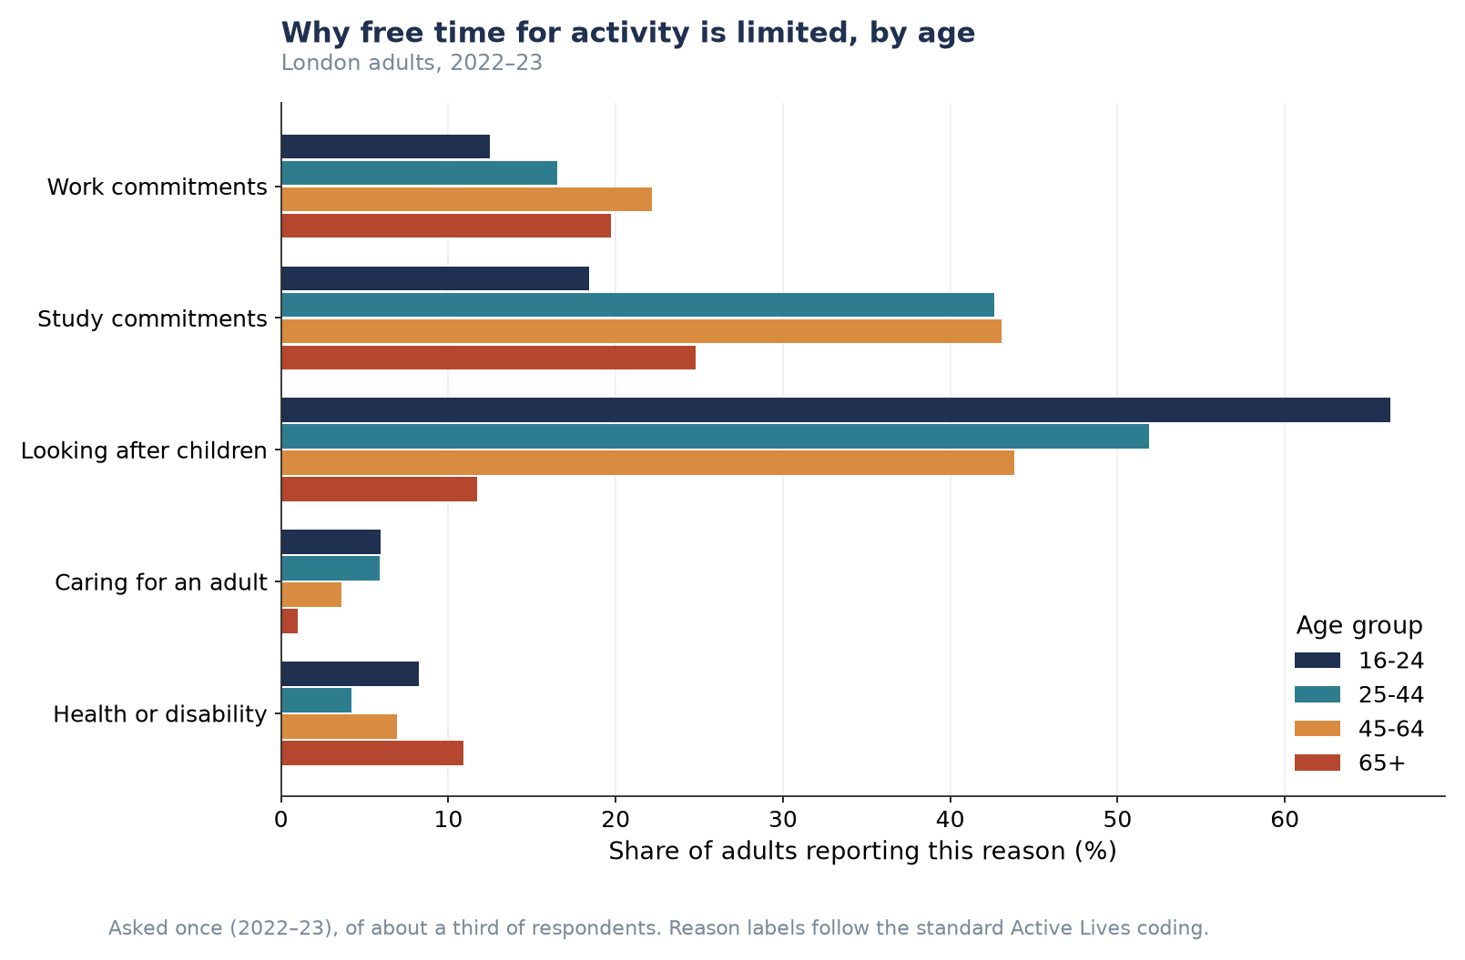
Figure P1.8. Reasons free time for activity is limited, by age group (London adults, 2022–23).
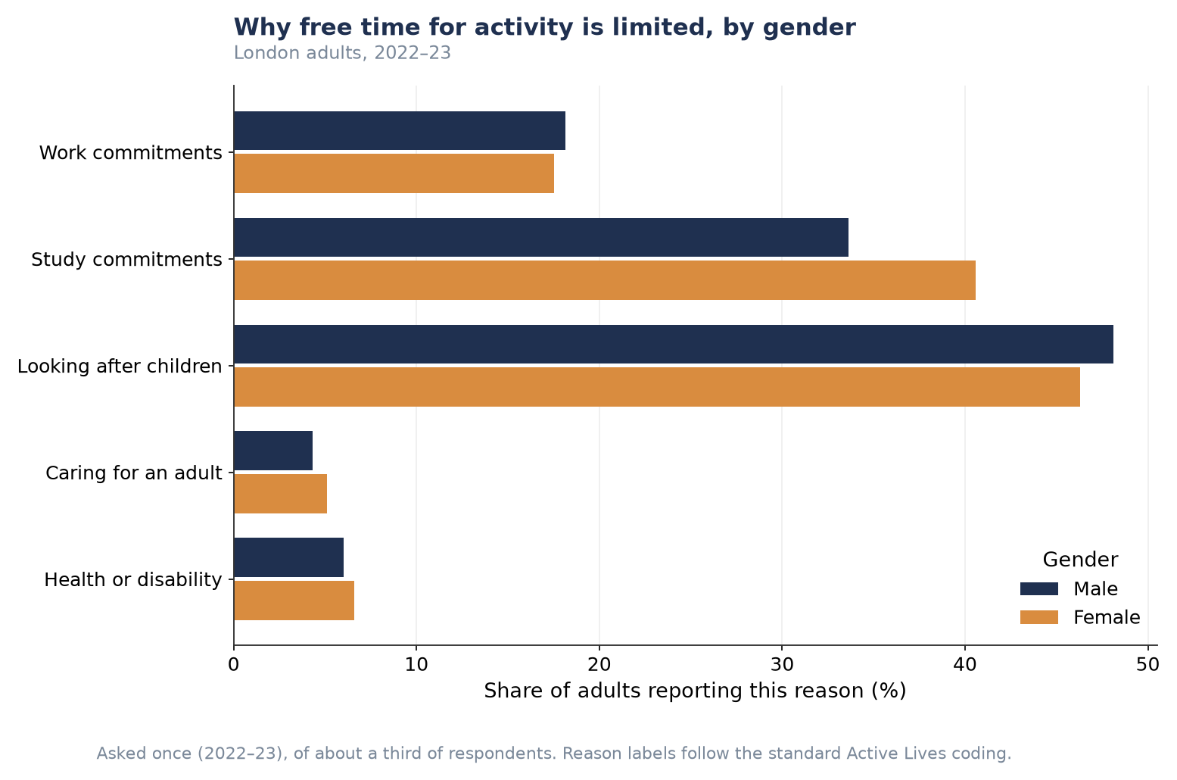
Figure P1.9. Reasons free time for activity is limited, by gender (London adults, 2022–23).
Reporting a free-time constraint does not correspond to lower activity — if anything, the opposite holds. Adults who report at least one constraint on their free time are, in every age group and both genders, slightly more likely to be Active than those who report no constraint at all. The gap is largest for 16–24-year-olds (74% against 67%) and persists, at a smaller margin, across every other group shown.
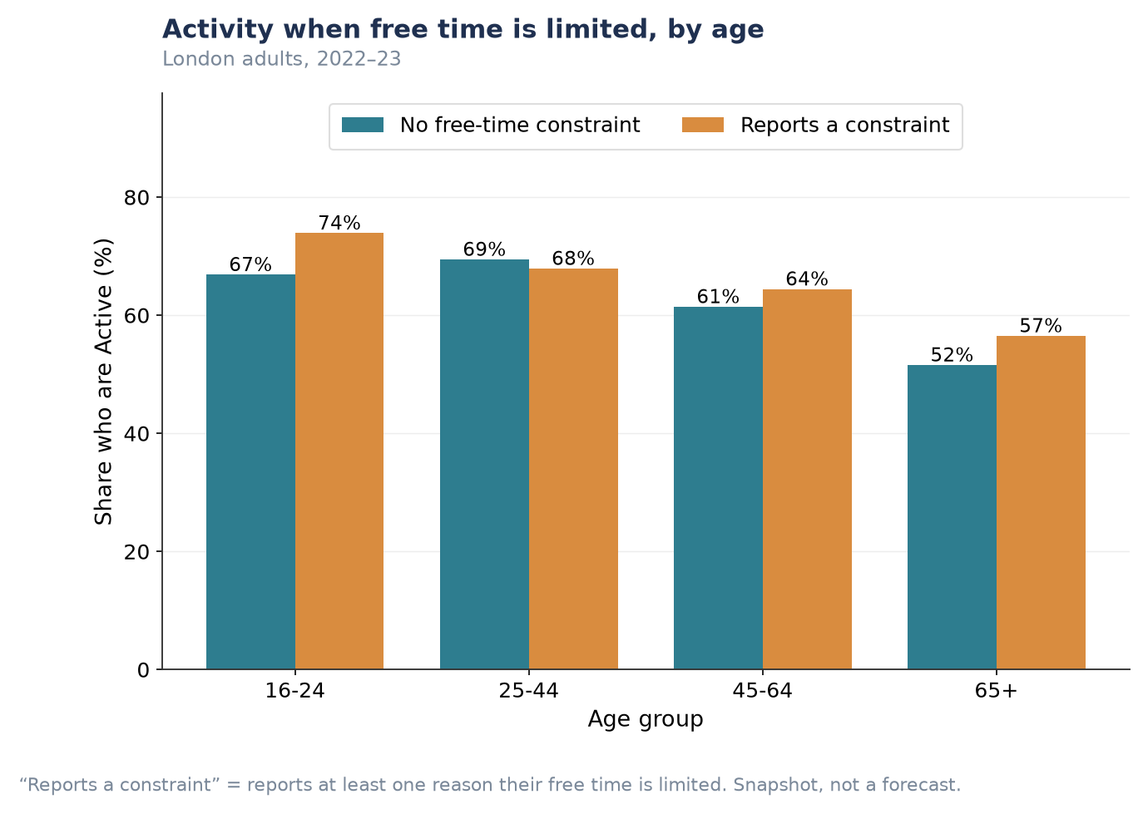
Figure P1.10. Activity rate by whether free time is constrained, by age group.
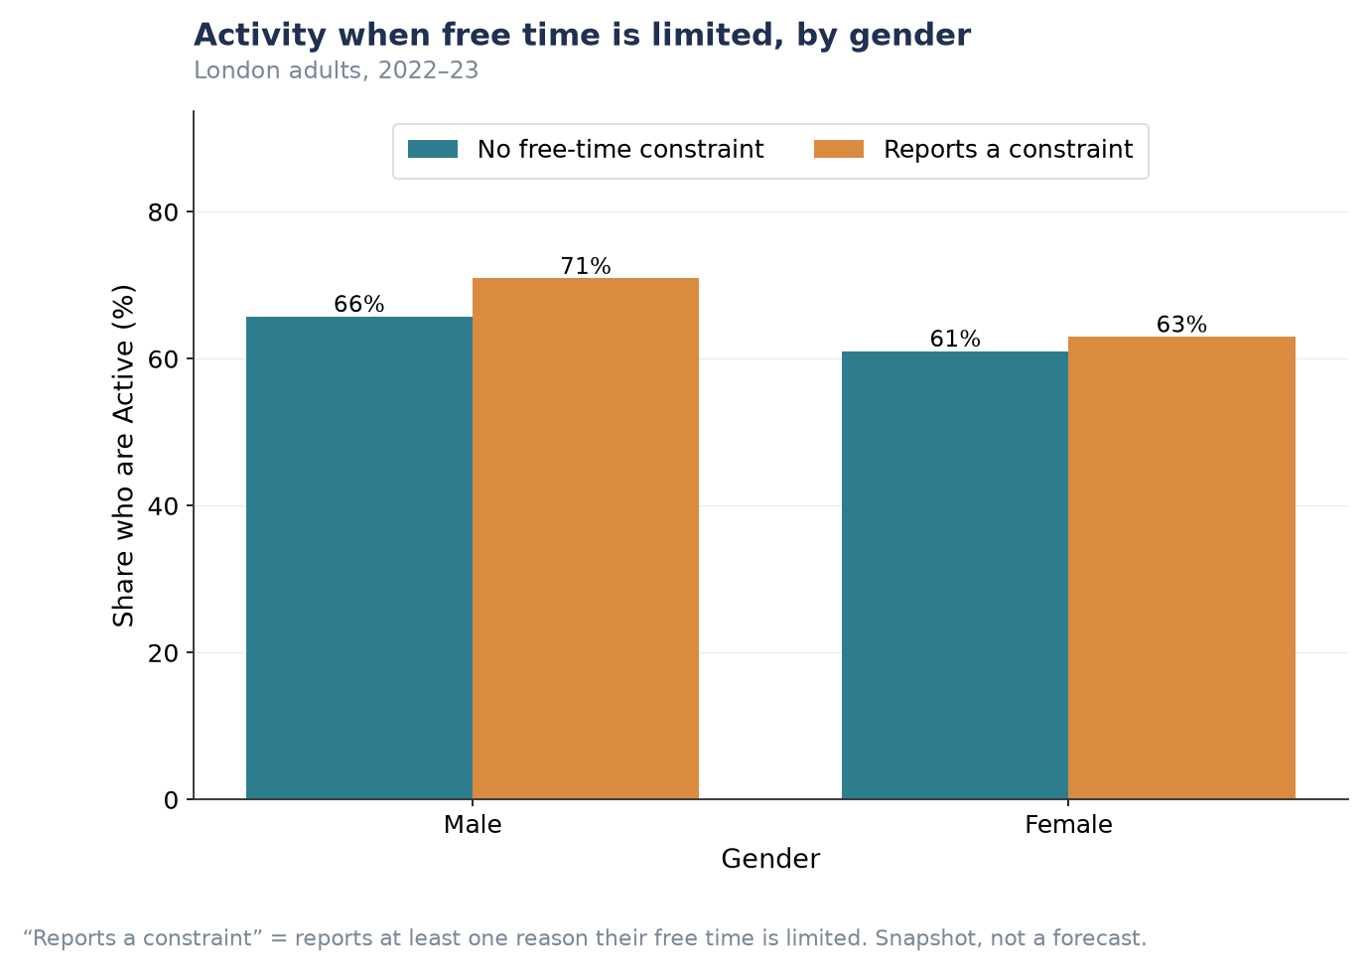
Figure P1.11. Activity rate by whether free time is constrained, by gender.
This is a descriptive association, not a causal one: it likely reflects that busy, time-constrained lives (work, childcare, study) are also often active lives — for example, active travel and looking after children can themselves involve physical activity — rather than implying that constraints on free time increase participation.

Supplementary Figures
The figures below are provided for completeness. They follow the same structure as the headline figures above and are summarised numerically in Table P1.1; they are not repeated in the main narrative to avoid showing near-identical scenario charts ten times in sequence.

Three-year point forecasts, all ten activity/club types
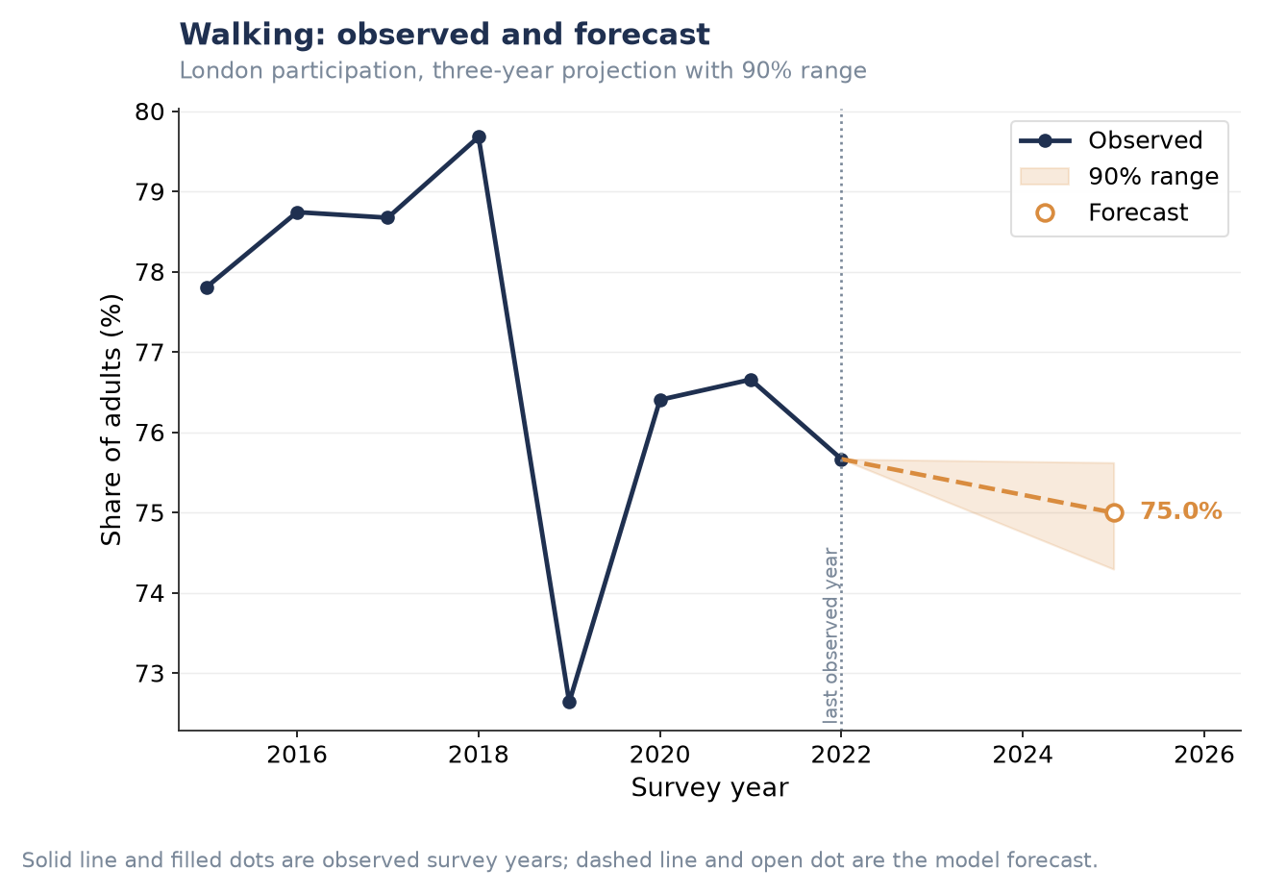
Figure P1.S1. Walking — three-year forecast.
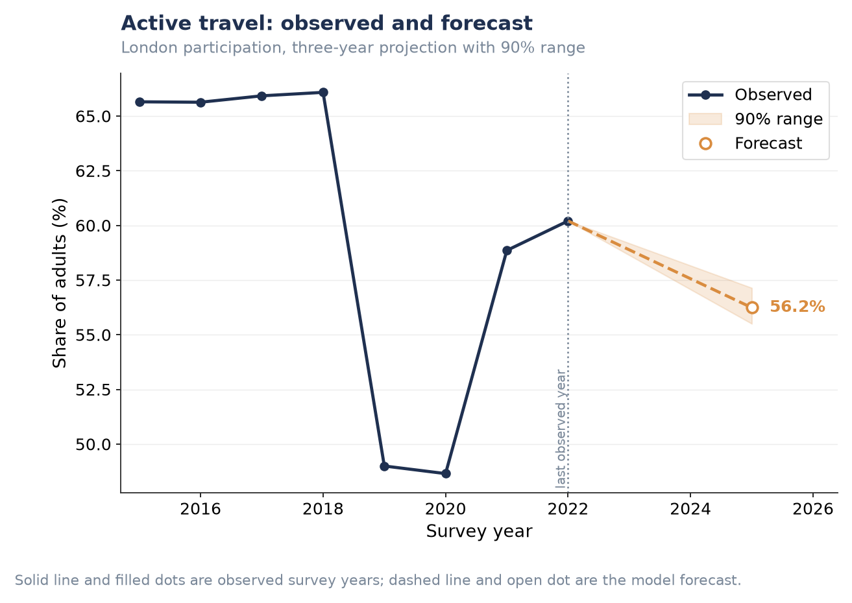
Figure P1.S2. Active travel — three-year forecast.
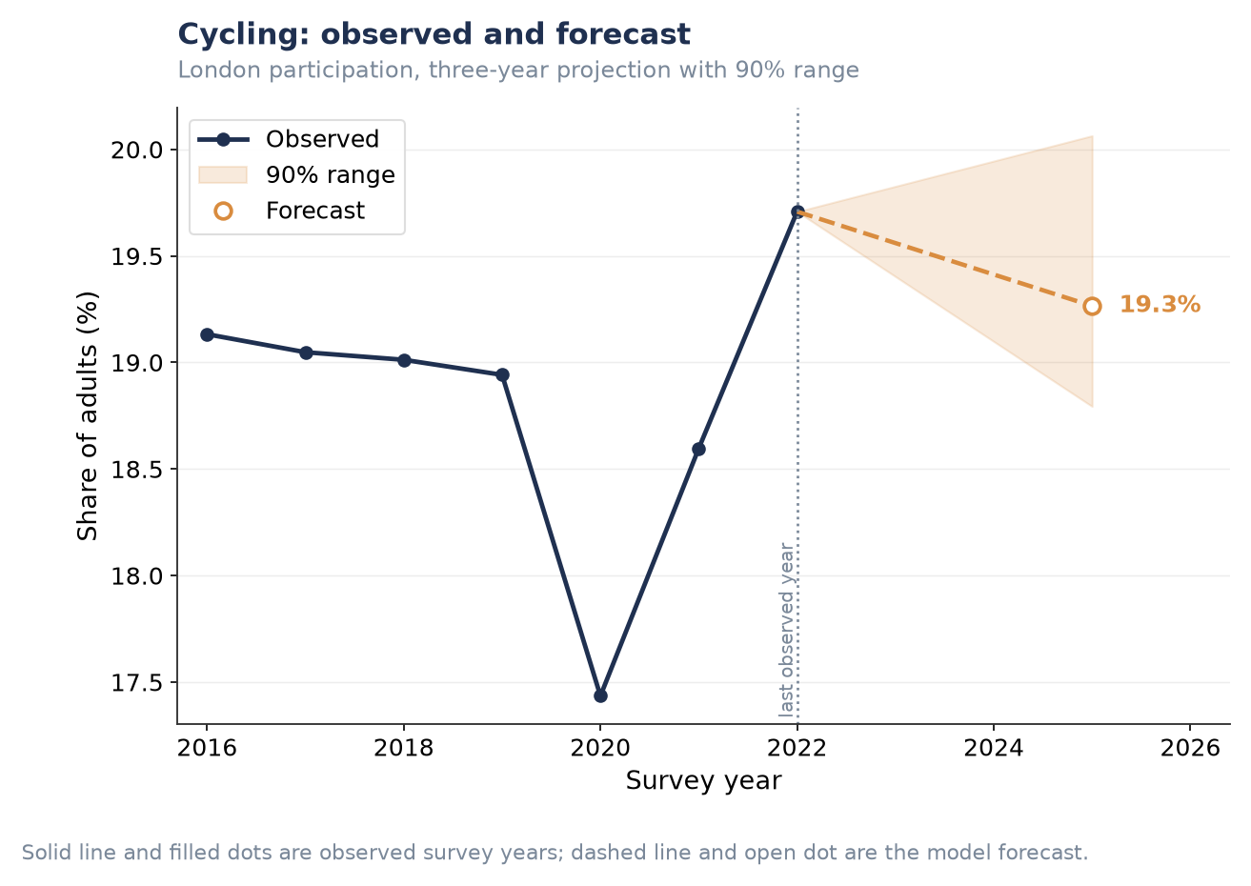
Figure P1.S3. Cycling — three-year forecast.
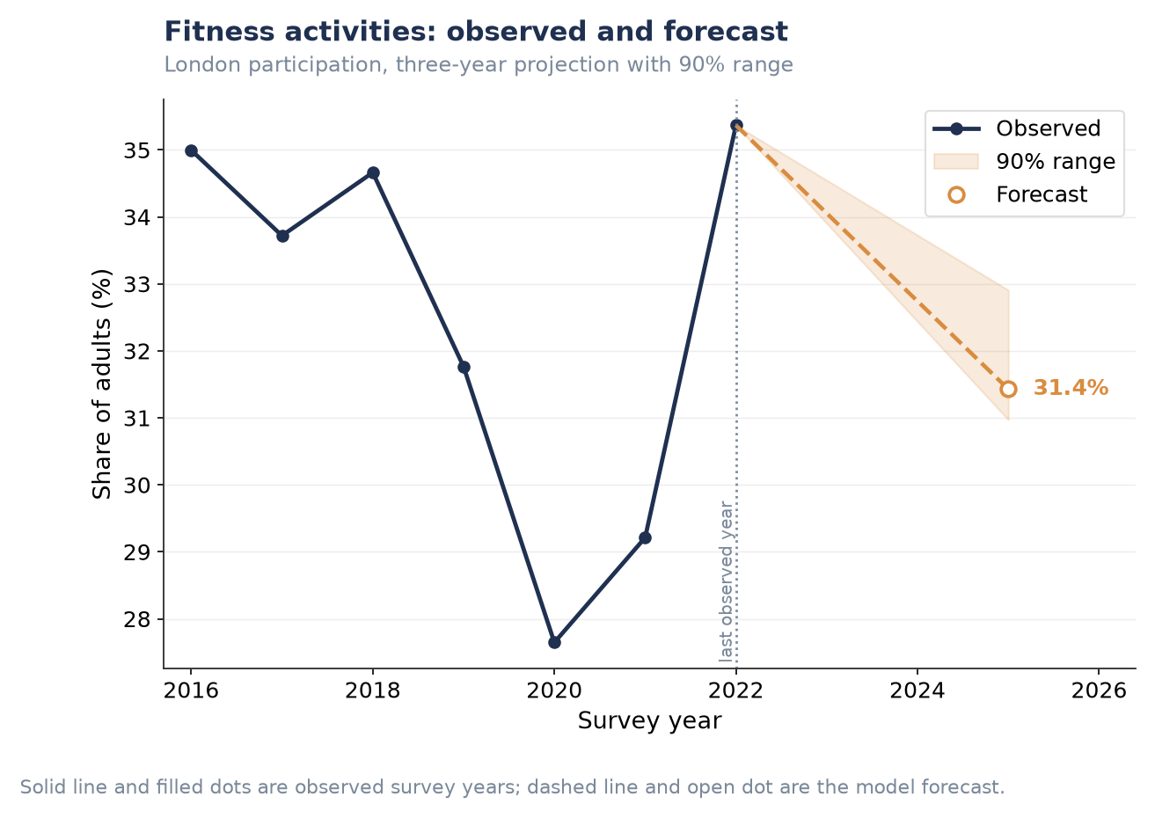
Figure P1.S4. Fitness activities — three-year forecast.
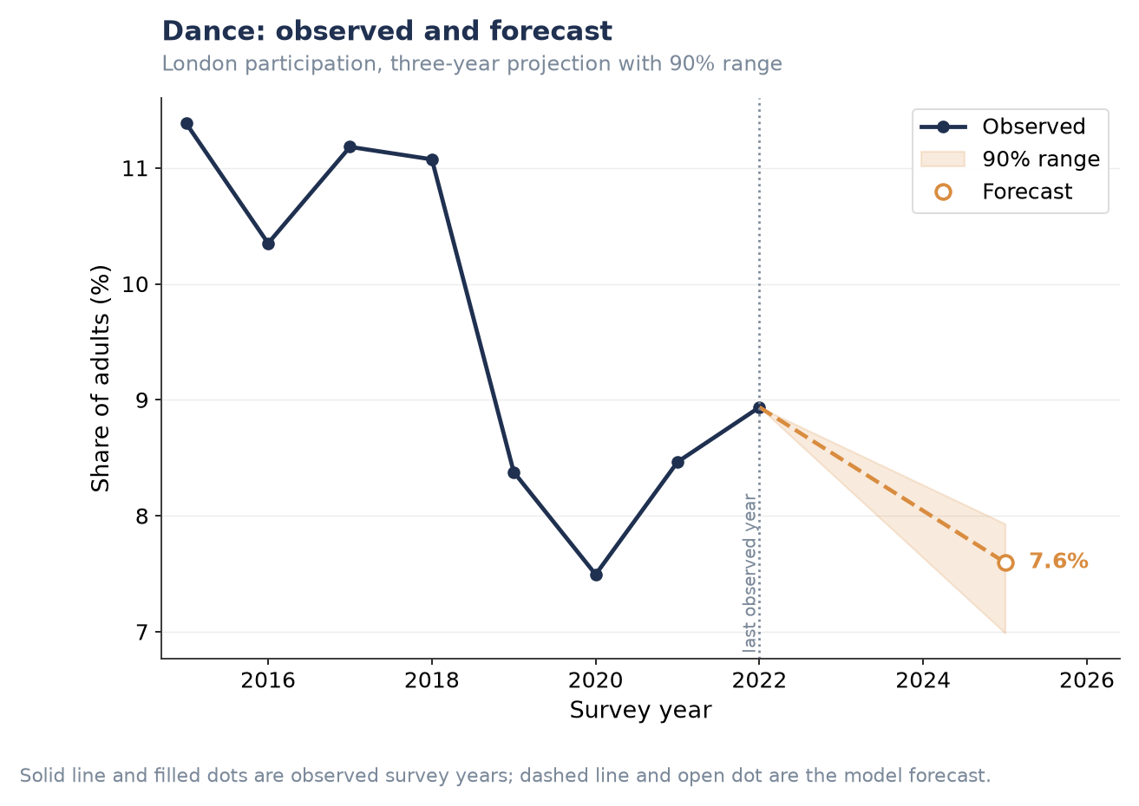
Figure P1.S5. Dance — three-year forecast.
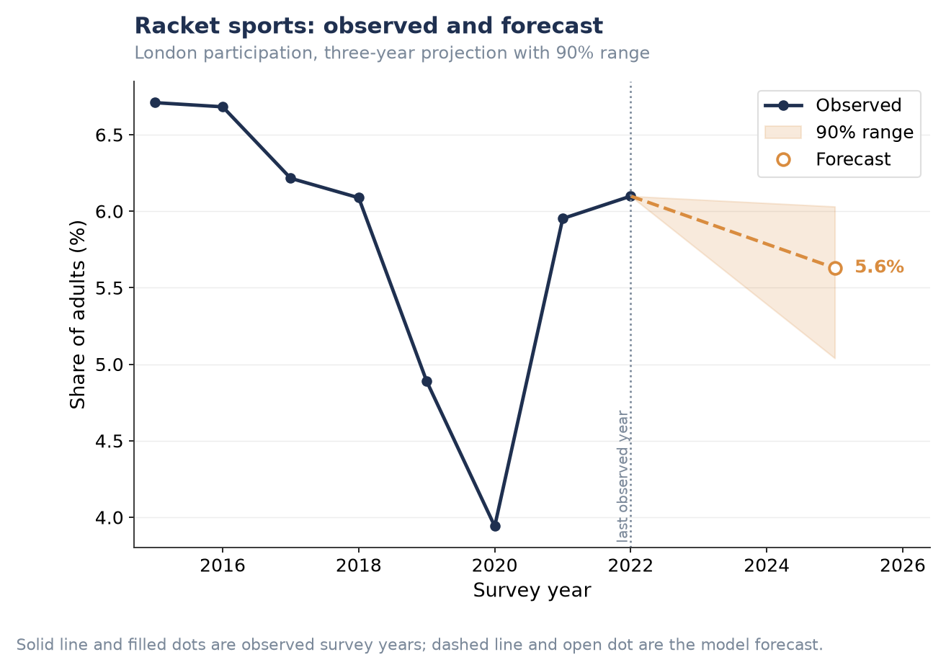
Figure P1.S6. Racket sports — three-year forecast.
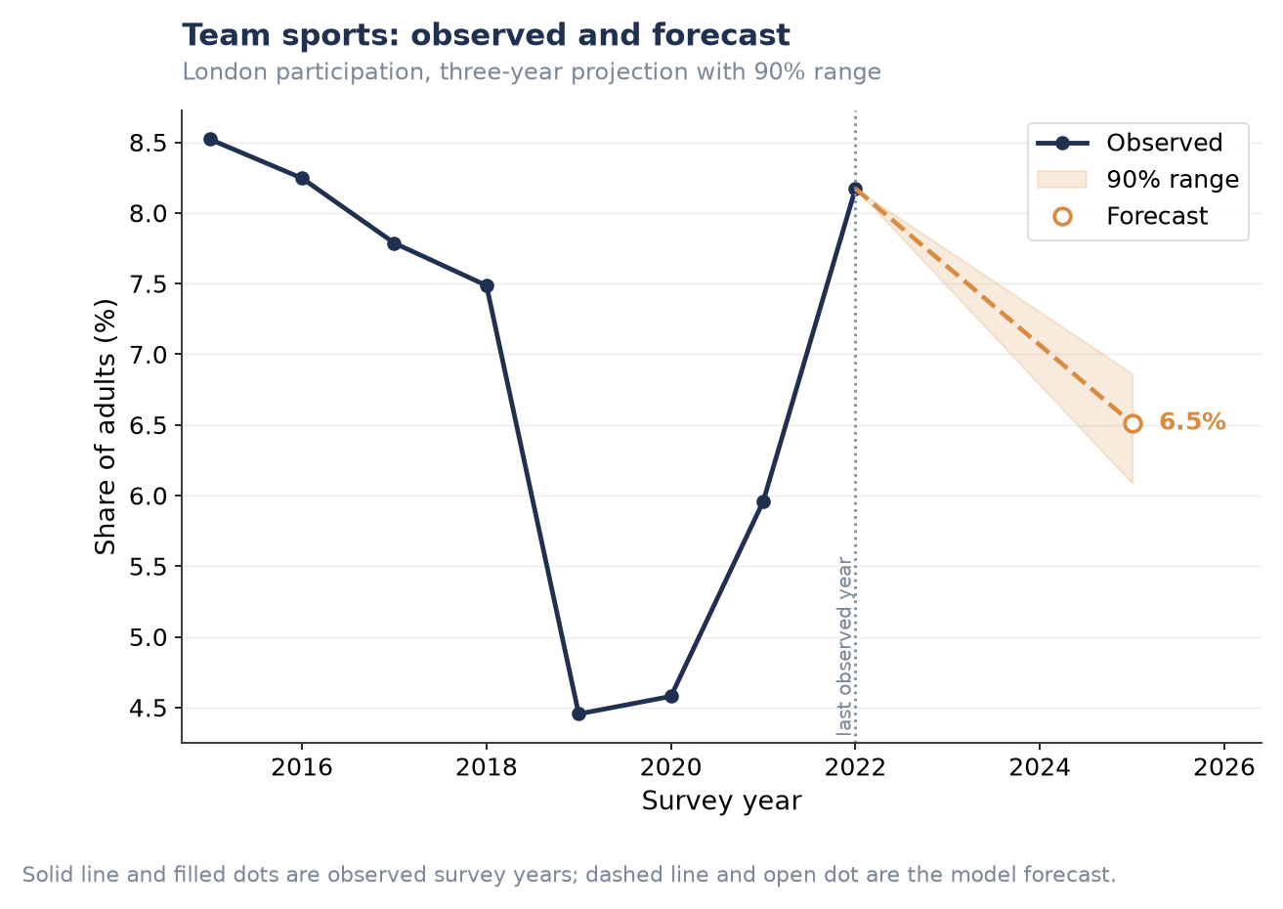
Figure P1.S7. Team sports — three-year forecast.
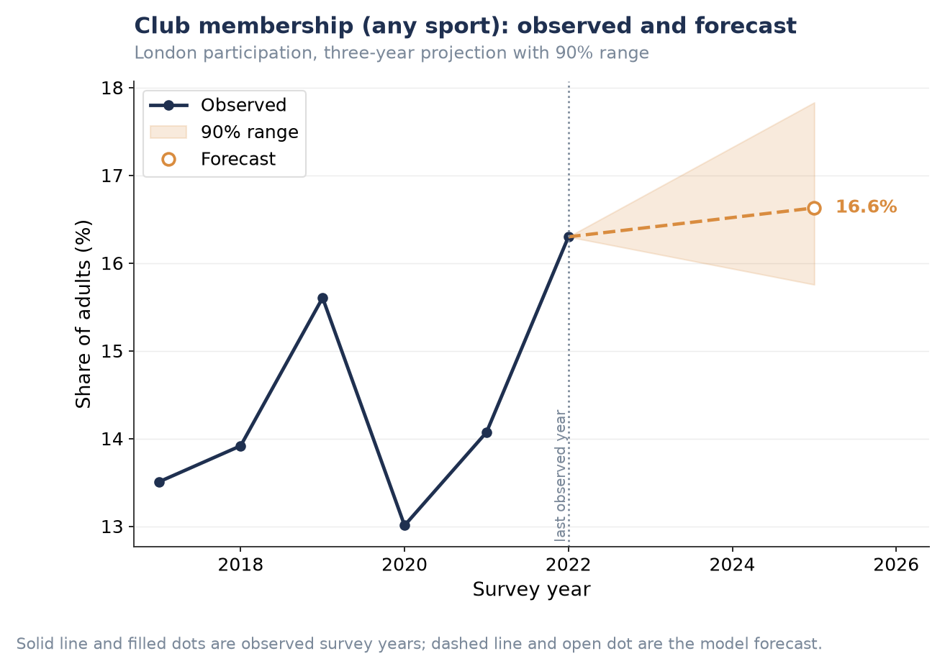
Figure P1.S8. Club membership (any sport) — three-year forecast.
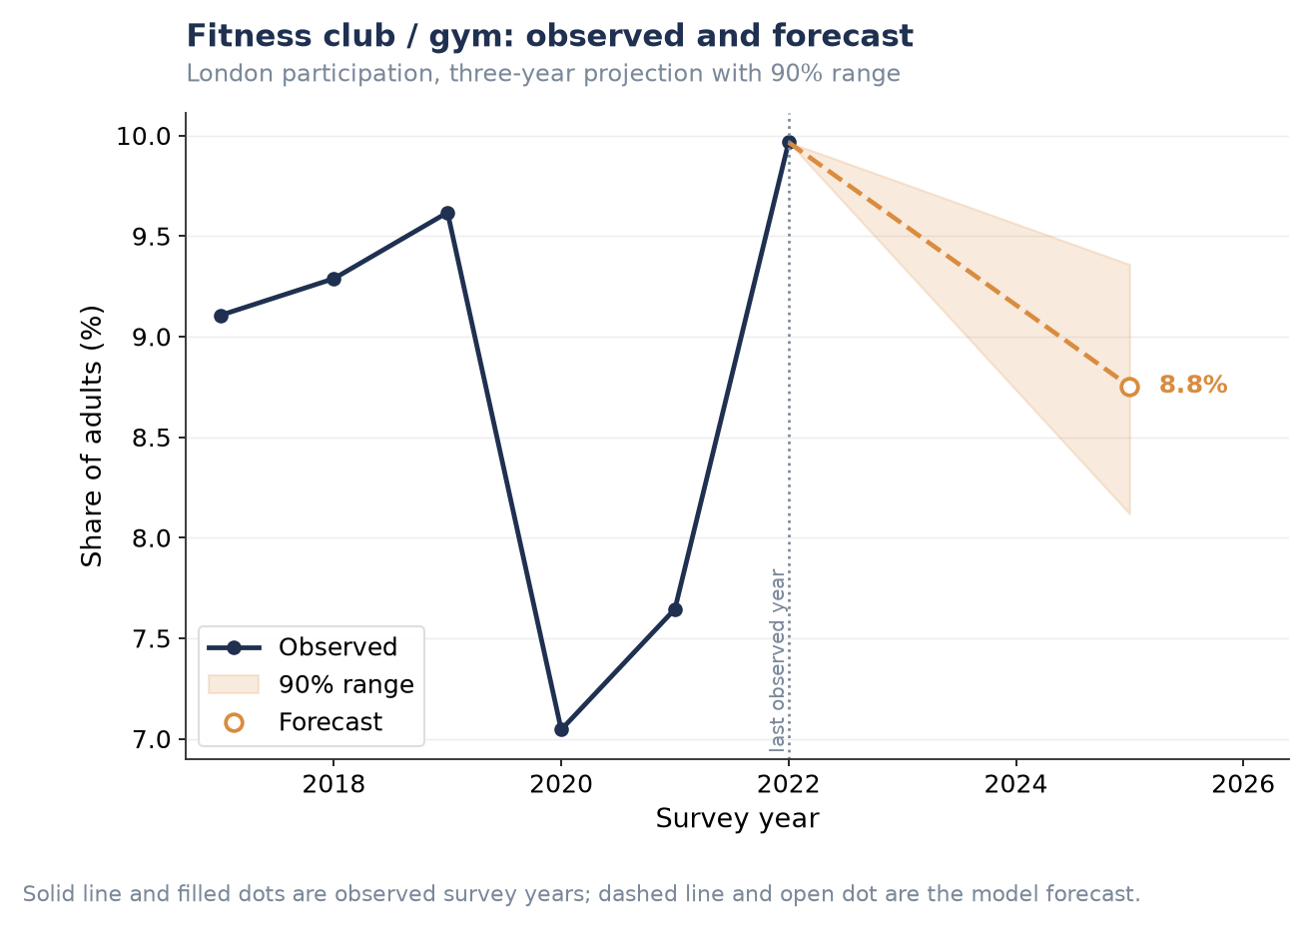
Figure P1.S9. Fitness club / gym — three-year forecast.
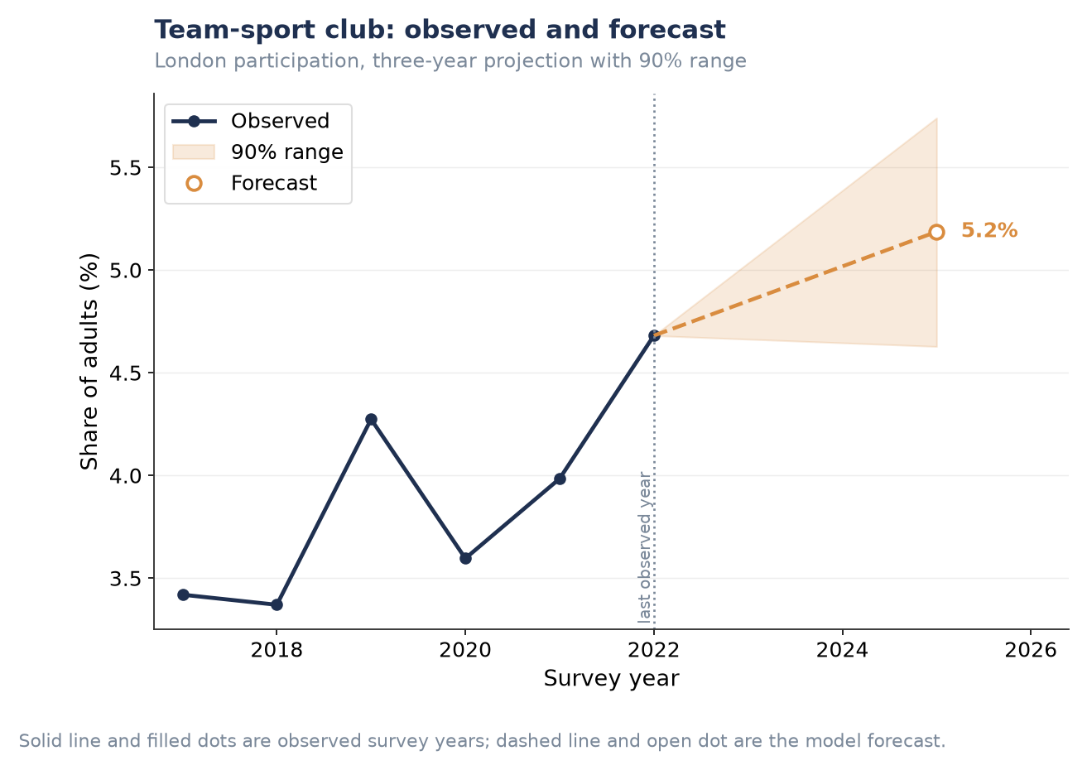
Figure P1.S10. Team-sport club — three-year forecast.

Ten-year scenarios, remaining activity/club types
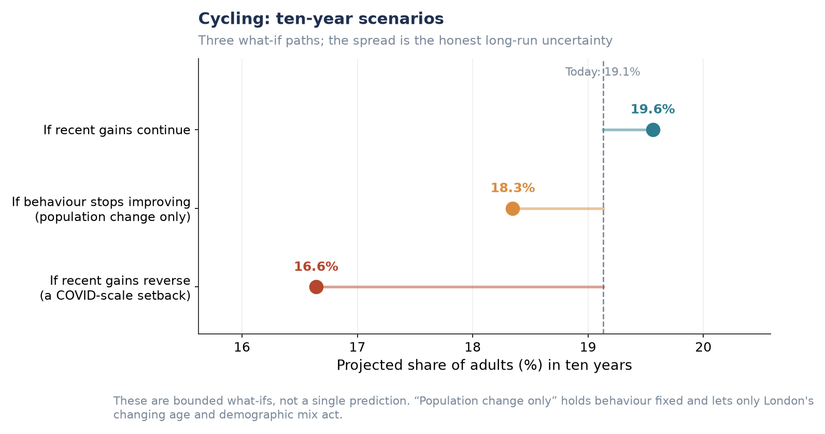
Figure P1.S11. Cycling — ten-year scenarios.
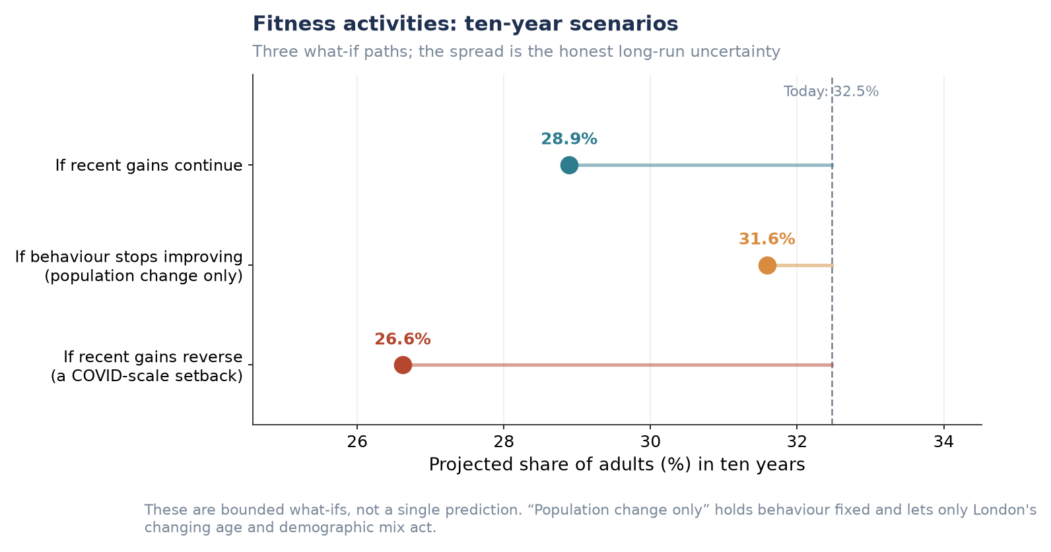
Figure P1.S12. Fitness activities — ten-year scenarios.
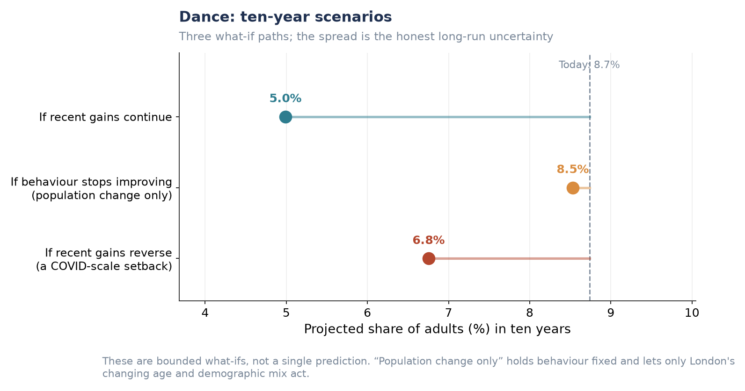
Figure P1.S13. Dance — ten-year scenarios.
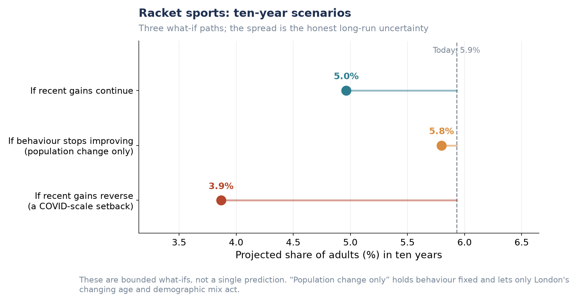
Figure P1.S14. Racket sports — ten-year scenarios.
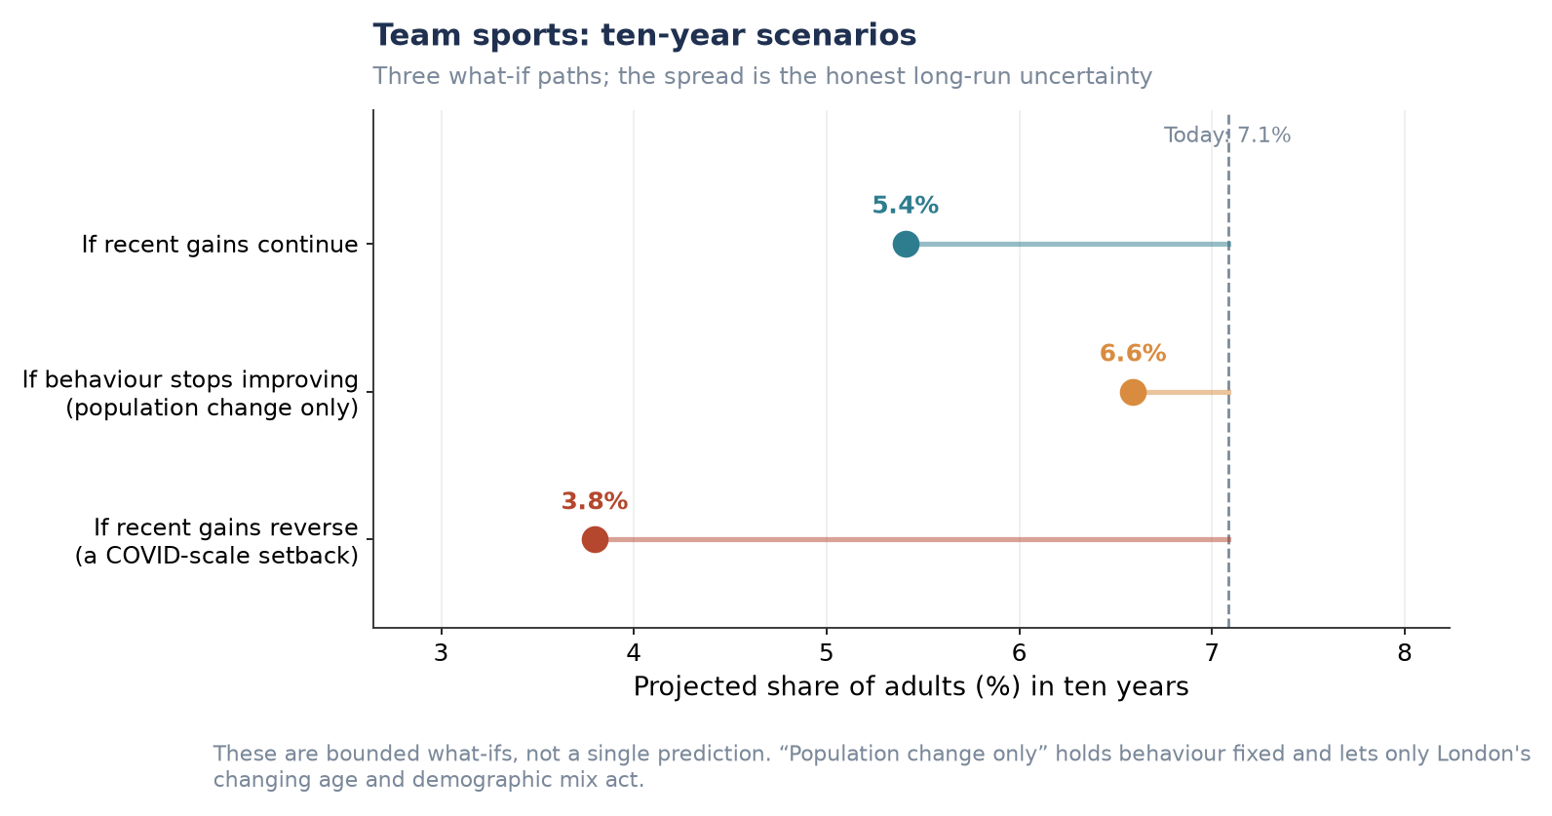
Figure P1.S15. Team sports — ten-year scenarios.
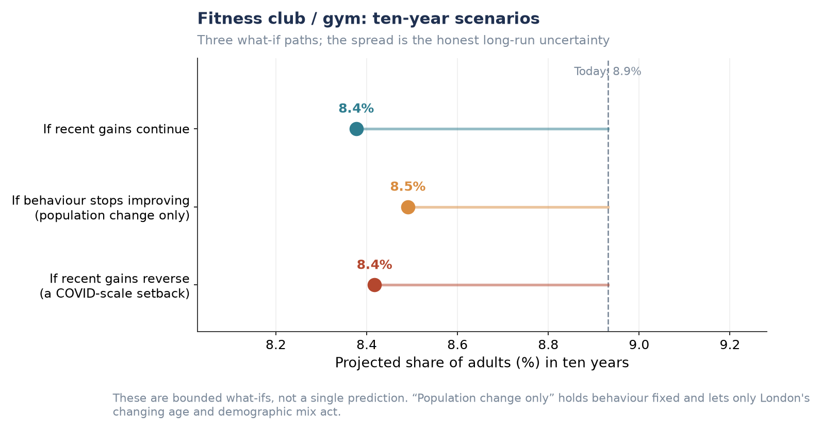
Figure P1.S16. Fitness club / gym — ten-year scenarios.
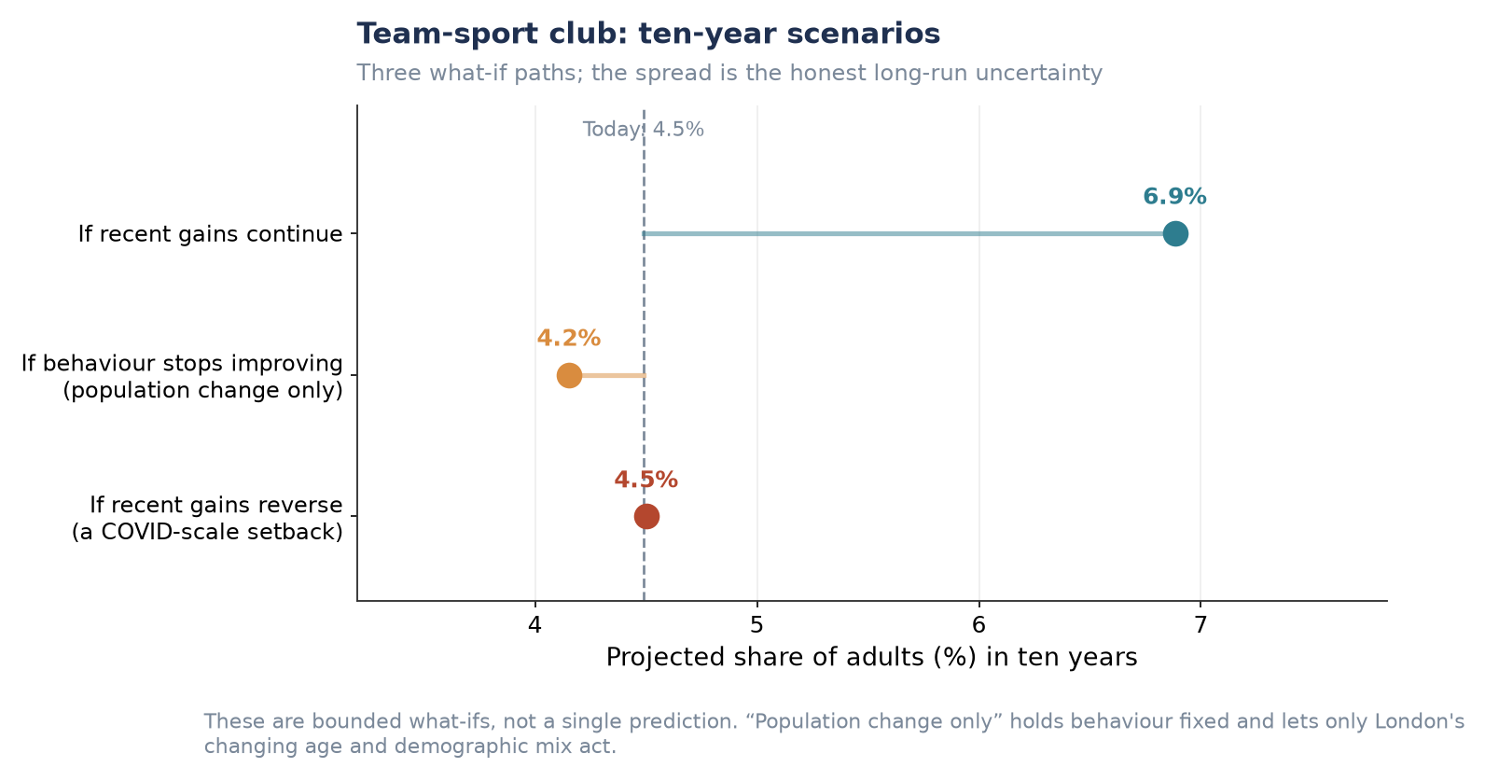
Figure P1.S17. Team-sport club — ten-year scenarios.

Additional London-wide forecast (not used above)
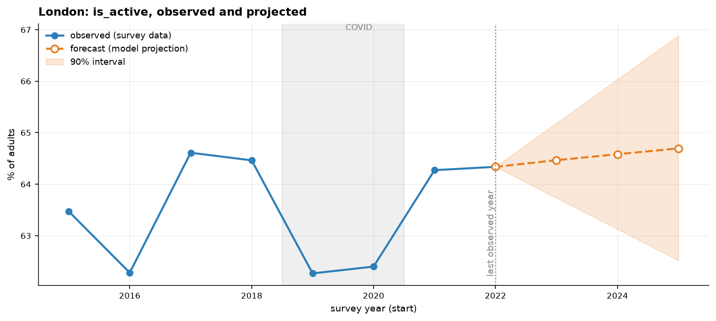
Figure P1.S18. London Active share: observed and three-year projection with 90% interval.
Note: this chart shows substantially the same information as Figure P1.1 (single 'Active' line rather than all three bands) and was not used in the main narrative for that reason. Its widening 90% interval is a clean visual illustration of the 'six genuinely usable years' caveat in Section 4.5 (Limitations) — consider placing it there instead if a figure is needed for that discussion.

