London Sport 2 — Forecast Findings: P1 Overall Participation & P2 Demographic Insights
This report combines the project's first two analytical pillars — overall participation forecasts and demographic-specific insights — into a single reference document, with the underlying charts and the analytical framing behind them. All figures derive from the forecasting framework in Section 3.5 and the LightGBM propensity model selected in Section 4.4. Findings and framing in this report additionally draw on the wider modelling analysis (comprehensive report, team), referenced throughout as 'the wider analysis'.
Table 0.1. Coverage of the brief — P1 and P2 only.
Brief sub-question | Delivered as | Label
Overall activity, London and boroughs, ten years | 64.7% by 2025–26; all 32 boroughs with intervals; ten-year scenarios | Forecast
Activity-specific participation, ten years | Seven activities, London-level, with scenario ranges | Forecast
Club membership, ten years | Overall, team-sport and fitness clubs | Forecast
Factors reducing free time | Snapshot only (2022–23); descriptive association, not a forecast | Description
Group forecasts and preferred activities | All five demographic dimensions; walking universal top activity | Forecast
Activity by demographic within borough | Pooled age gradient per borough (activity-type detail not available at reportable cell sizes) | Pooled / partial
Participation and health conditions | 56-point span by self-rated health | Description

Every row above has either a forecast or a stated methodological reason it is reported as description instead — nothing is silently omitted, and nothing is forecast beyond what the data can support.

P1 — Overall Participation Forecasts
All figures in this section derive from the framework in Section 3.5. Rather than a single ten-year point estimate, three bounded scenarios are shown throughout: recent gains continuing, behaviour holding flat while only the population's demographic mix changes ('Population change only'), and a COVID-scale reversal of recent gains.

Physical activity across London as a whole
The near-term model output projects broad stability in the Active share through 2025–26: Active is projected at 64.9%, Inactive at 26.0%, and Fairly Active falling further to 9.1%.
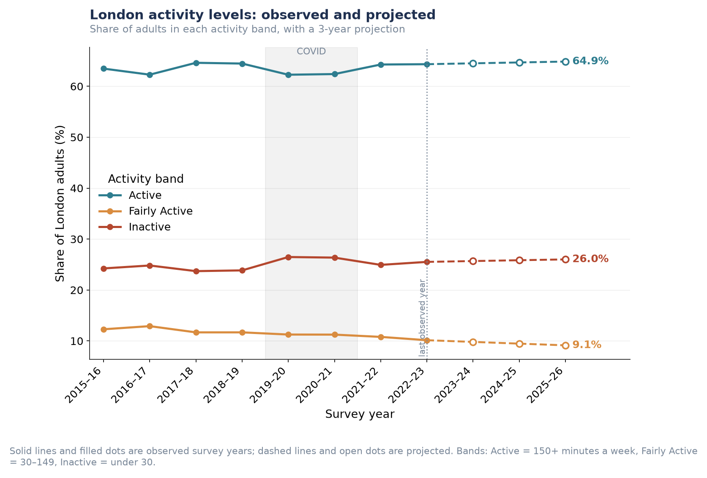
Figure P1.1. London-wide activity bands, observed 2015–16 to 2022–23 and projected to 2025–26.
Insight: the headline stability conceals a consistent shift beneath it. Across eight years the Fairly Active band has contracted by nearly a fifth (from around 12.3% to 10.1%), while Inactive has edged upward — a hollowing of the middle rather than a static distribution. This matters strategically: the Fairly Active group sits closest to the 150-minute guideline and is the least costly group to move across it, so its contraction represents a shrinking pool of 'nearly there' Londoners rather than a neutral trend.
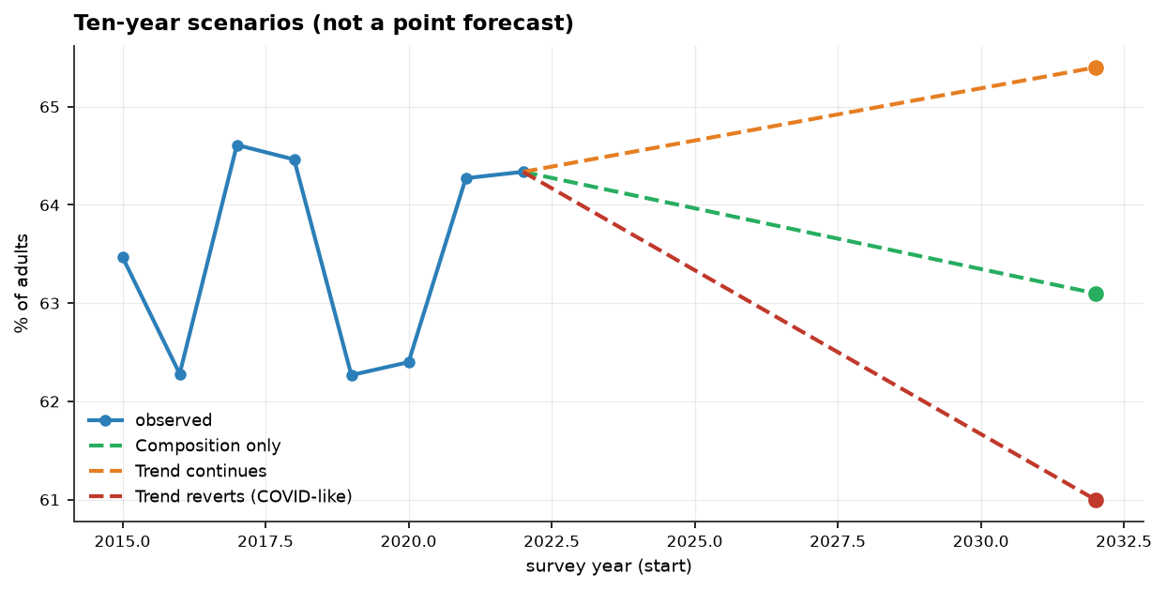
Figure P1.2. Ten-year scenario range for London-wide activity, 2022–2032.
Over the full ten-year horizon, the three scenarios diverge from 61.0% (if recent gains reverse) to 65.4% (if the current trend continues) — a roughly four-point range around the current 64.3%.
Table P1.2. Decomposition of the near-term London-wide forecast into composition and behaviour effects.
Component | Effect by 2025–26 | Interpretation
Composition | −0.37 points | London's ageing population pulls activity down
Behaviour | +0.69 points | People of a given type are becoming more active
Net | +0.32 points | Apparent stability produced by two real trends cancelling

Insight: this decomposition is the central analytical result behind the 'stable' headline. A conventional forecast would report the number as roughly flat and stop there. Splitting it shows the flat line is not a settled equilibrium but two genuine, opposing trends of comparable size cancelling out — a demographic headwind of −0.37 points against a behavioural tailwind of +0.69 points. If the behavioural improvement stalls for any reason, the demographic headwind alone would pull London-wide activity down; the apparent stability is more fragile than the flat trend line suggests.

Likelihood of participating in specific activities
Ten-year scenario ranges were produced for seven individual activities and three club-membership measures.
Table P1.1. Ten-year scenario range by activity/club type (% of London adults).
Activity / Club Type | Today | If Gains Continue | Population Change Only | If Gains Reverse
Walking | 76.2% | 71.9% | 75.1% | 72.1%
Active travel | 59.6% | 48.5% | 58.0% | 44.4%
Fitness activities | 32.5% | 28.9% | 31.6% | 26.6%
Cycling | 19.1% | 19.6% | 18.3% | 16.6%
Team sports | 7.1% | 5.4% | 6.6% | 3.8%
Dance | 8.7% | 5.0% | 8.5% | 6.8%
Racket sports | 5.9% | 5.0% | 5.8% | 3.9%
Club membership (any sport) | 15.5% | 19.3% | 14.8% | 15.7%
Fitness club / gym | 8.9% | 8.4% | 8.5% | 8.4%
Team-sport club | 4.5% | 6.9% | 4.2% | 4.5%

Club membership figures are separate, possibly overlapping breakdowns rather than components of a single total — 'fitness club/gym' and 'team-sport club' do not sum to 'club membership (any sport)'.
Insight: for every individual activity except cycling, continuing the recent trend implies a decline over the decade — but for all three club-membership measures, continuing the recent trend implies growth. This is consistent with the wider analysis: team sports and active travel are the two series most disrupted by the pandemic and swing widely, and their wide scenario ranges should be read as directional rather than precise. Informal, unstructured activity has been trending down since its pre-COVID level, while formal, club-based participation has been recovering upward.
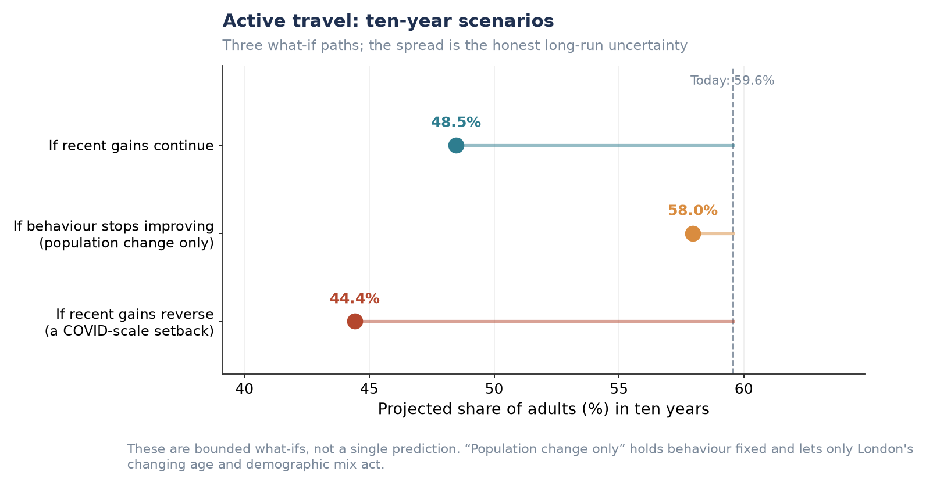
Figure P1.3. Active travel: ten-year scenarios (widest scenario spread of any activity measured).
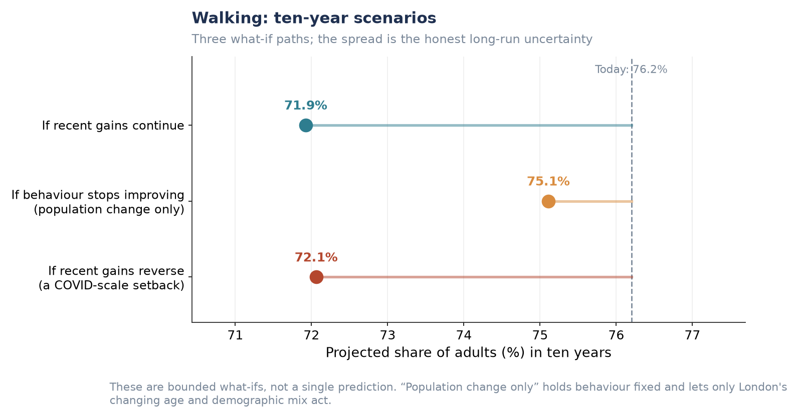
Figure P1.4. Walking: ten-year scenarios (largest-base activity measured).
The remaining five individual activities (cycling, fitness activities, team sports, dance, racket sports) follow the same scenario structure and are provided in full in the Supplementary Figures at the end of this section.

Sport-specific club membership
Club membership is the one area of Table P1.1 where continuing the recent trend points upward rather than downward. Club membership (any sport) is projected to reach 19.3% under the 'gains continue' scenario, against 14.8% if behaviour flattens and only the population changes.
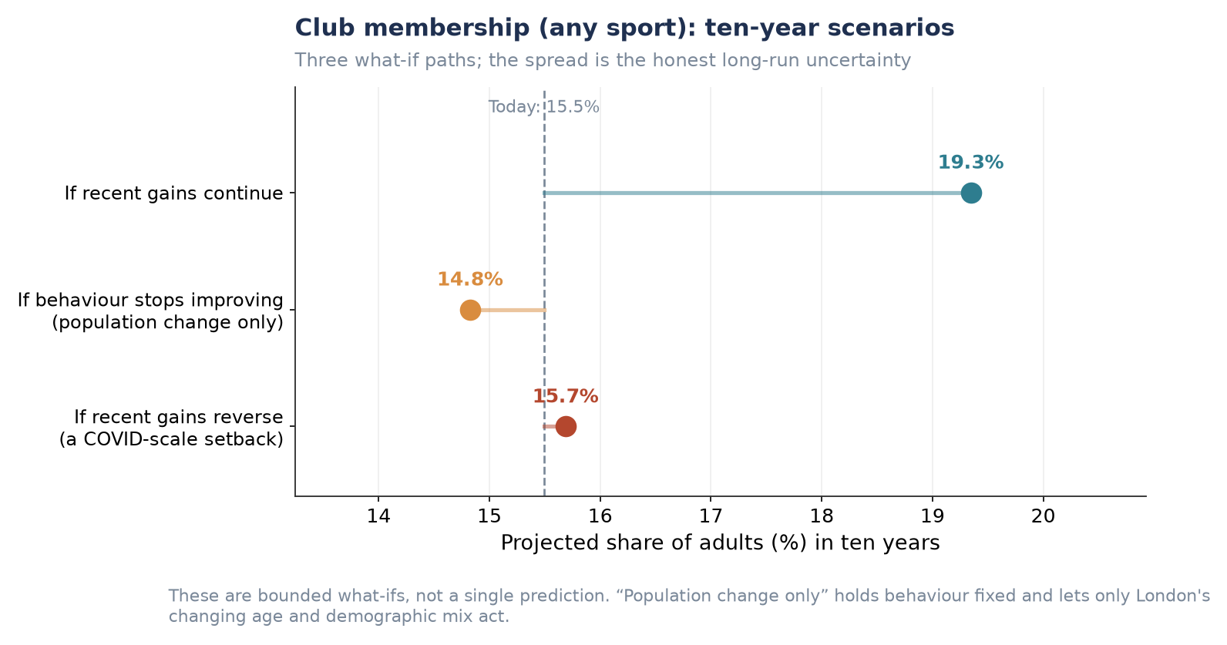
Figure P1.5. Club membership (any sport): ten-year scenarios.
Insight: this table-level pattern is corroborated independently by the wider analysis, which reports club membership rising overall and led specifically by team sports — consistent with team-sport club showing the largest proportional gain of any club type here (4.5% → 6.9% under 'gains continue'). The same analysis flags fitness/gym membership as the one club category still declining after the pandemic, which matches this table's fitness club/gym row showing a flat-to-negative scenario range (8.9% today against 8.4% if gains continue) — the only club measure of the three that does not point upward. The post-pandemic club recovery is therefore concentrated in team sport specifically, not club-based activity in general.

Forecasts of activity levels for each London borough
Applying the propensity model to each borough's projected demographic composition produces a 2025 borough-level forecast ranging from 51.3% (Barking and Dagenham) to 75.4% (Wandsworth).
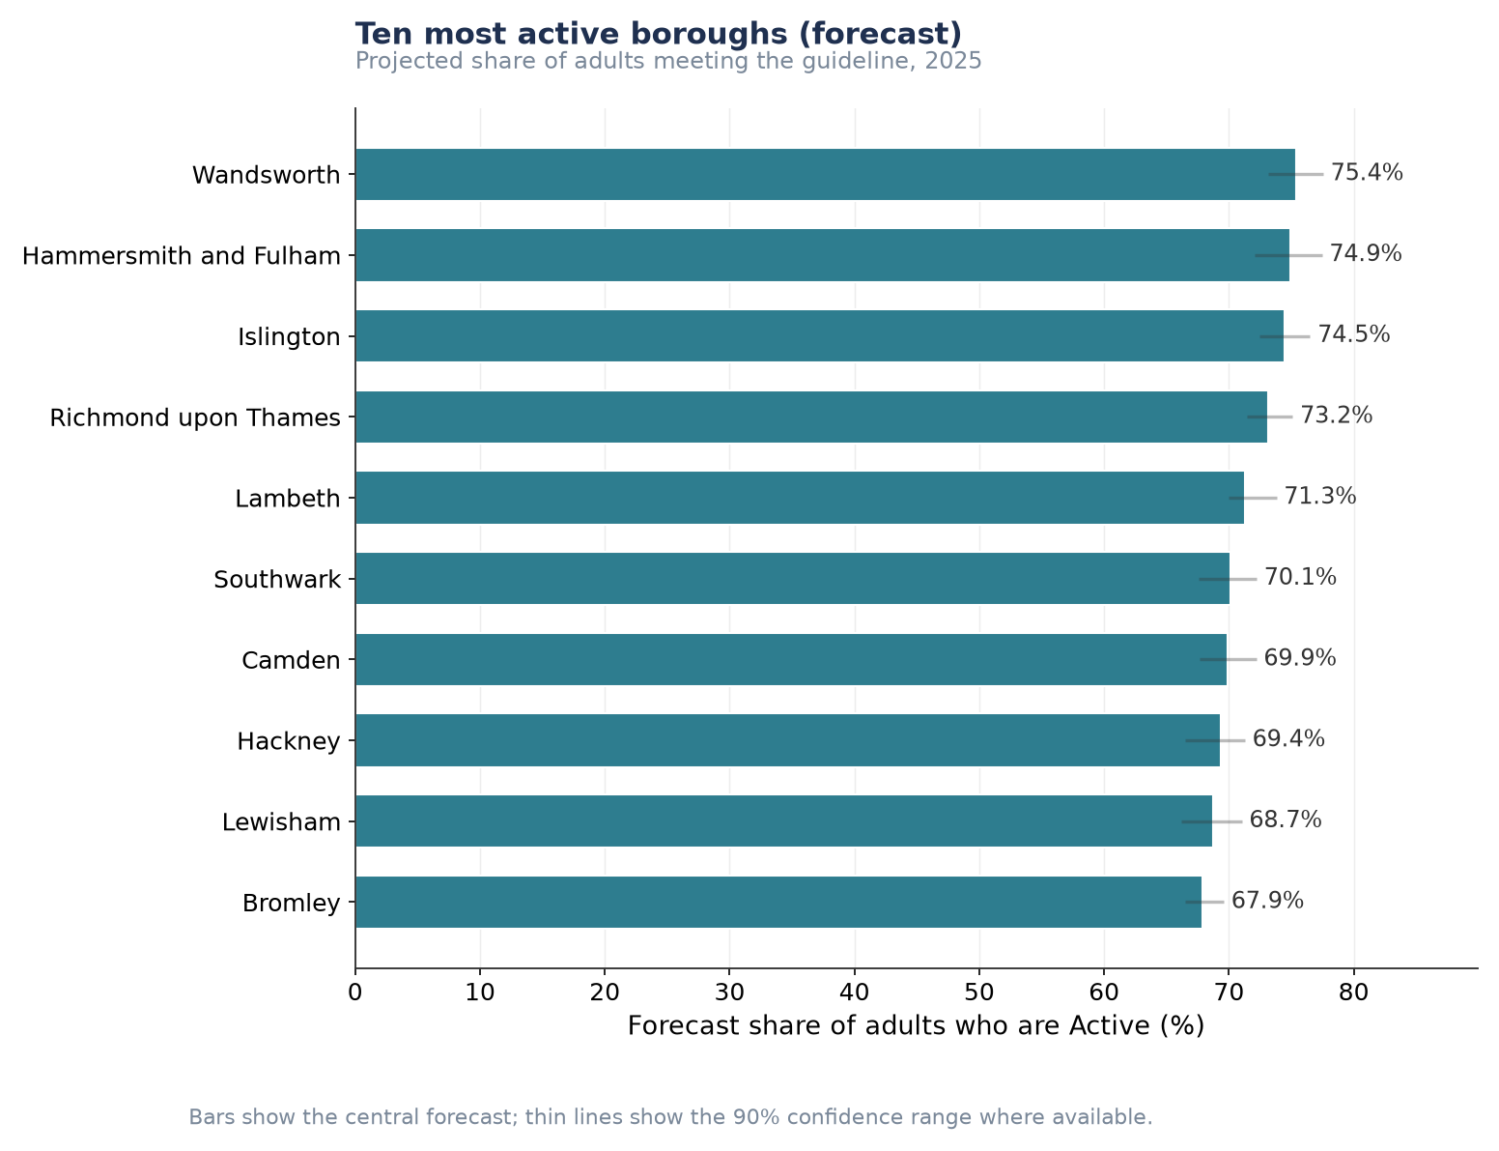
Figure P1.6. Ten most active boroughs, projected share of adults meeting the guideline, 2025.
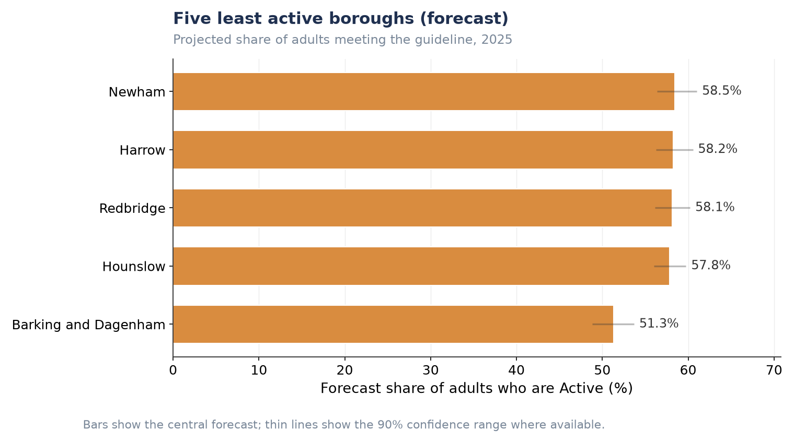
Figure P1.7. Five least active boroughs, projected share of adults meeting the guideline, 2025.
Insight: the roughly 24-point gap between the most and least active boroughs does not narrow anywhere across the projection horizon — the confidence intervals of the two extremes do not overlap, so this is a structural difference, not sampling noise. Every one of London's 32 boroughs shows a negative composition effect (ranging from near zero to about −0.9 points): London's demographic change is a headwind in every borough, not only the least active ones — it varies only in strength, never in direction. This means no borough is demographically insulated from the citywide ageing pressure identified above; some simply face a smaller version of the same headwind.

Key factors that may reduce free time and affect participation
Free-time constraint questions were asked once, in the 2022–23 wave only, of approximately a third of respondents. This bullet is therefore necessarily a cross-sectional snapshot rather than a ten-year forecast.
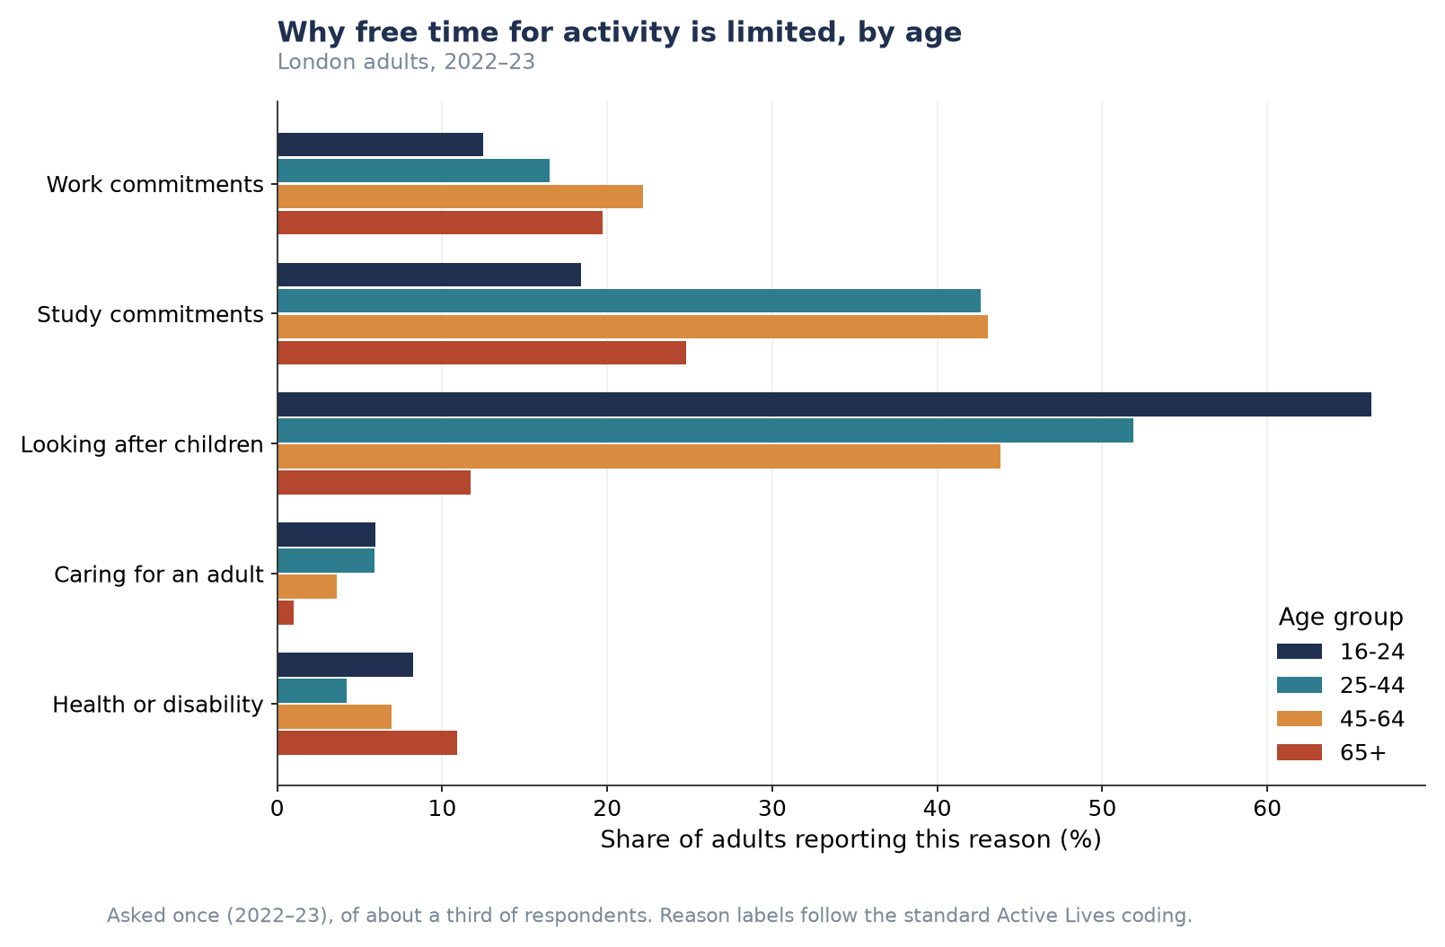
Figure P1.8. Reasons free time for activity is limited, by age group (London adults, 2022–23).
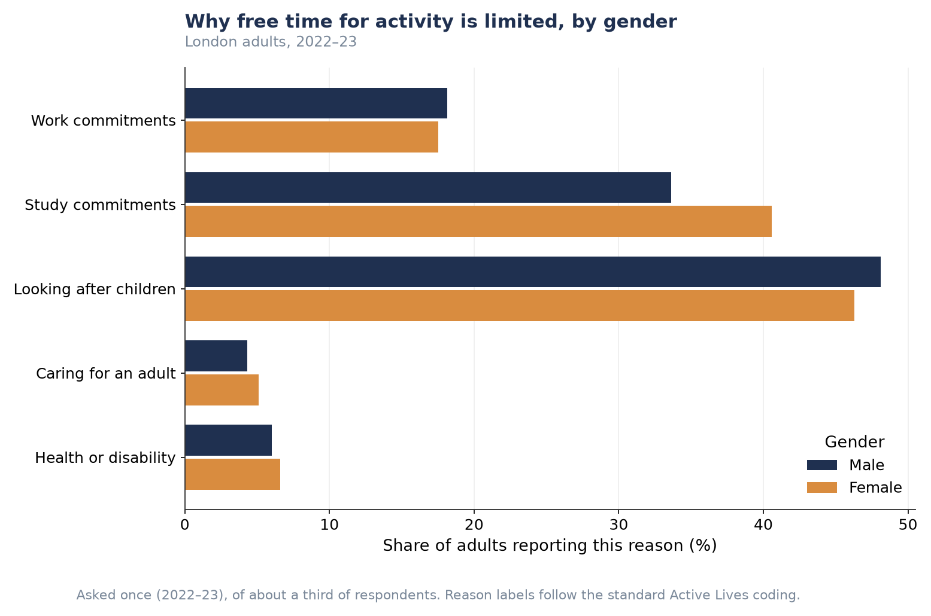
Figure P1.9. Reasons free time for activity is limited, by gender (London adults, 2022–23).
Reporting a free-time constraint does not correspond to lower activity in this data — adults reporting at least one constraint are, in every age group and both genders, slightly more likely to be Active than those reporting none.
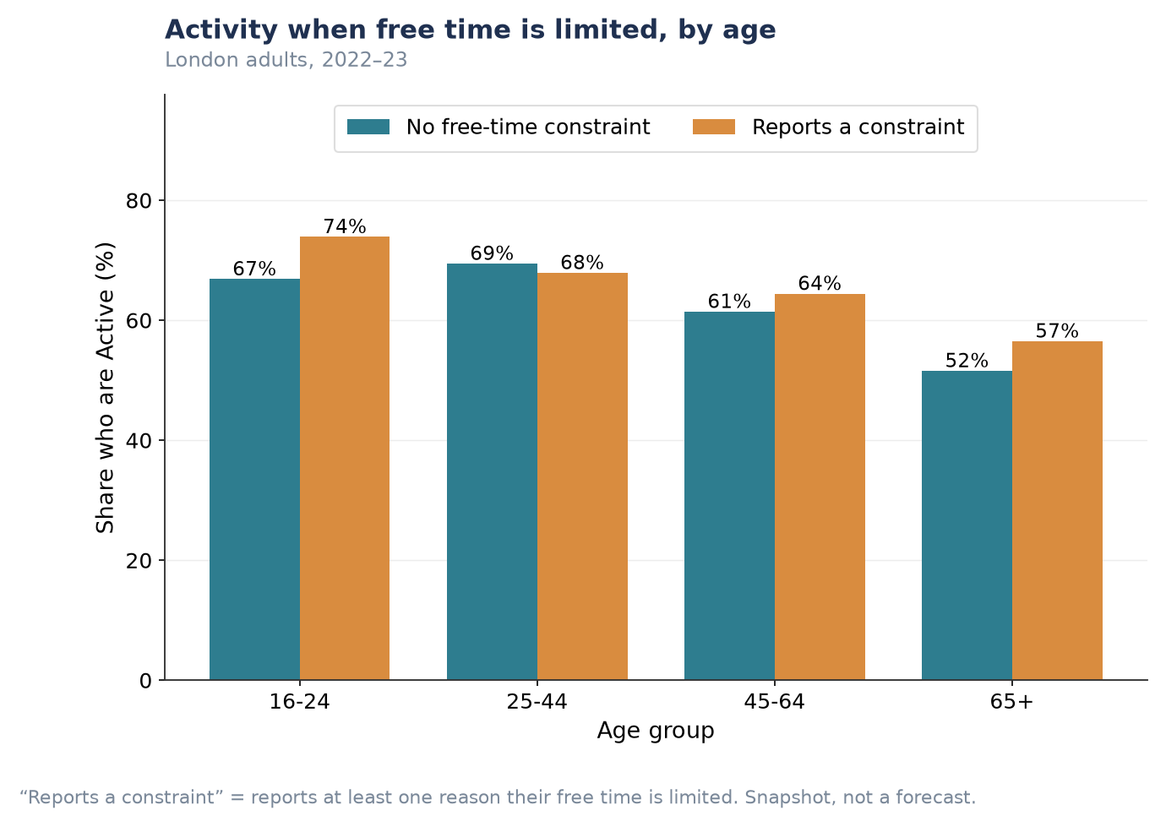
Figure P1.10. Activity rate by whether free time is constrained, by age group.
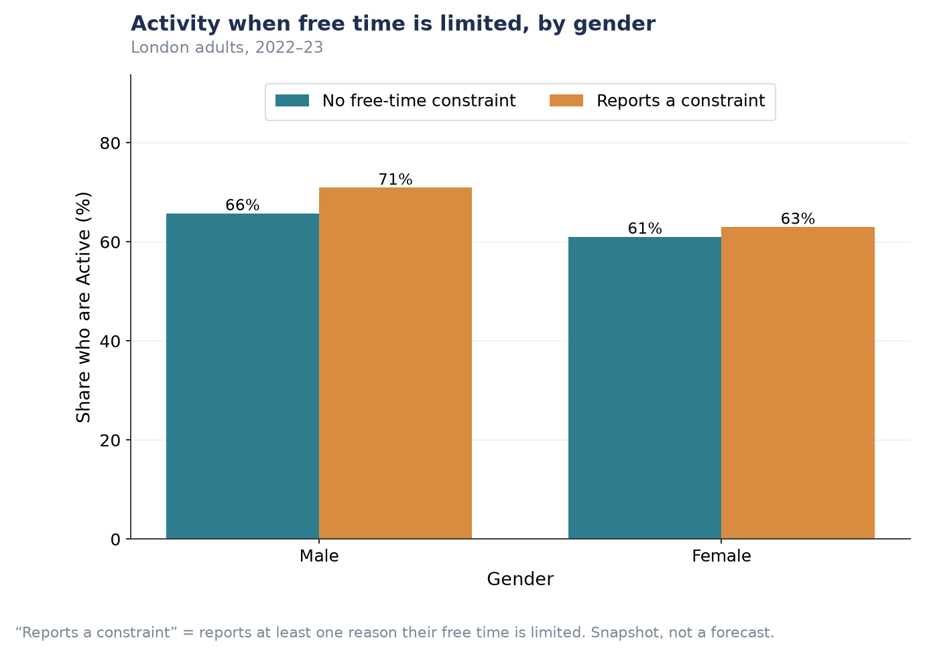
Figure P1.11. Activity rate by whether free time is constrained, by gender.
Tension worth flagging: this finding (any constraint → slightly higher activity) sits in apparent contrast with the wider analysis, which reports that respondents citing long working hours specifically are markedly less active. The two are not necessarily contradictory — 'any constraint' here pools together reasons like childcare and study, which may correlate with active lifestyles, alongside work-hour pressure, which may not. This report does not have a working-hours-only cut to test that directly; treat the 'any constraint' finding above as a population-level average that may be masking an offsetting effect specific to long working hours.
This is a descriptive association, not a causal one: it likely reflects that busy, time-constrained lives (work, childcare, study) are also often active lives — active travel and looking after children can themselves involve physical activity — rather than implying constraints on free time increase participation.

Supplementary Figures (P1)
Provided for completeness; summarised numerically in Table P1.1 and not repeated in the main narrative to avoid near-identical charts shown ten times in sequence.

Three-year point forecasts, all ten activity/club types
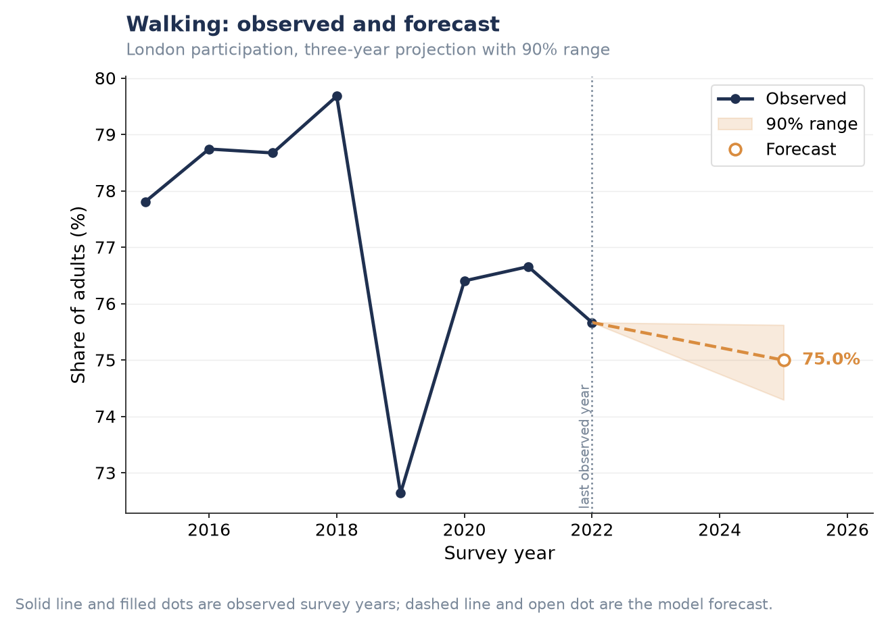
Figure P1.S1. Walking — three-year forecast.
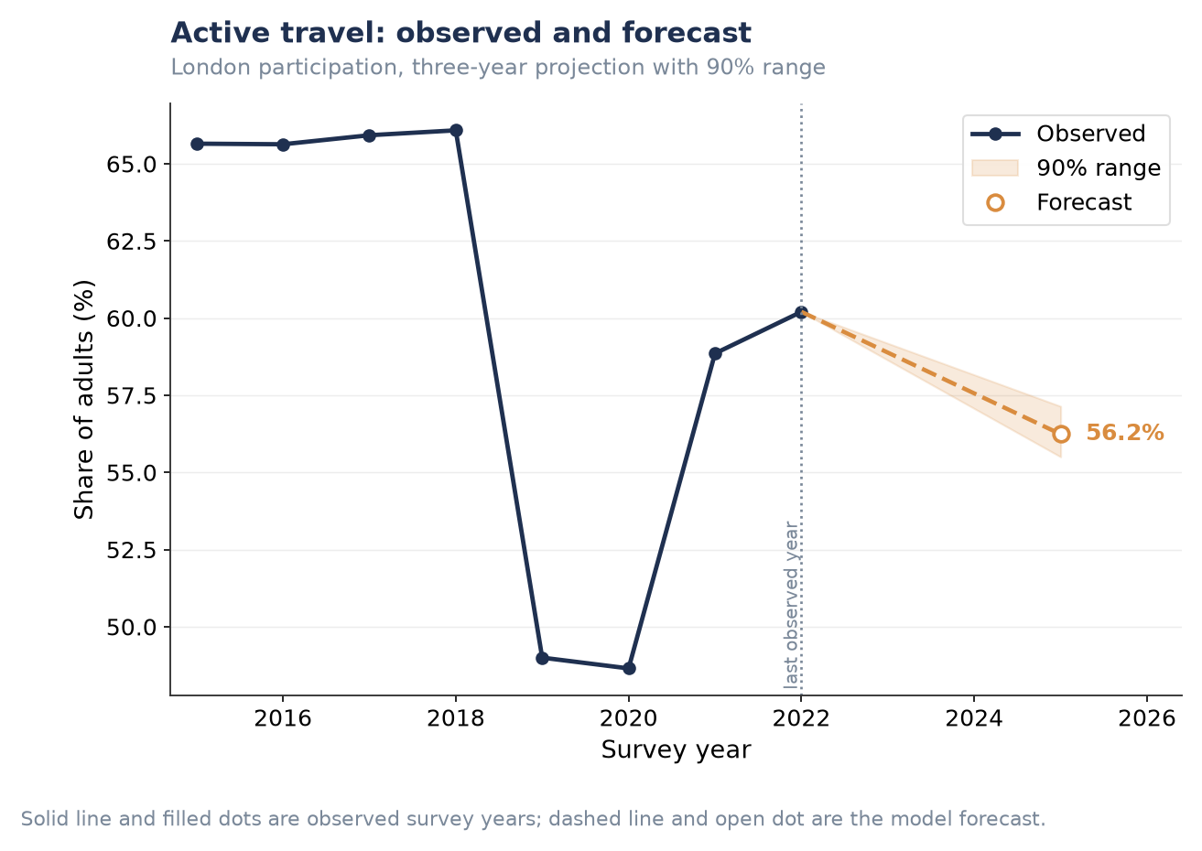
Figure P1.S2. Active travel — three-year forecast.
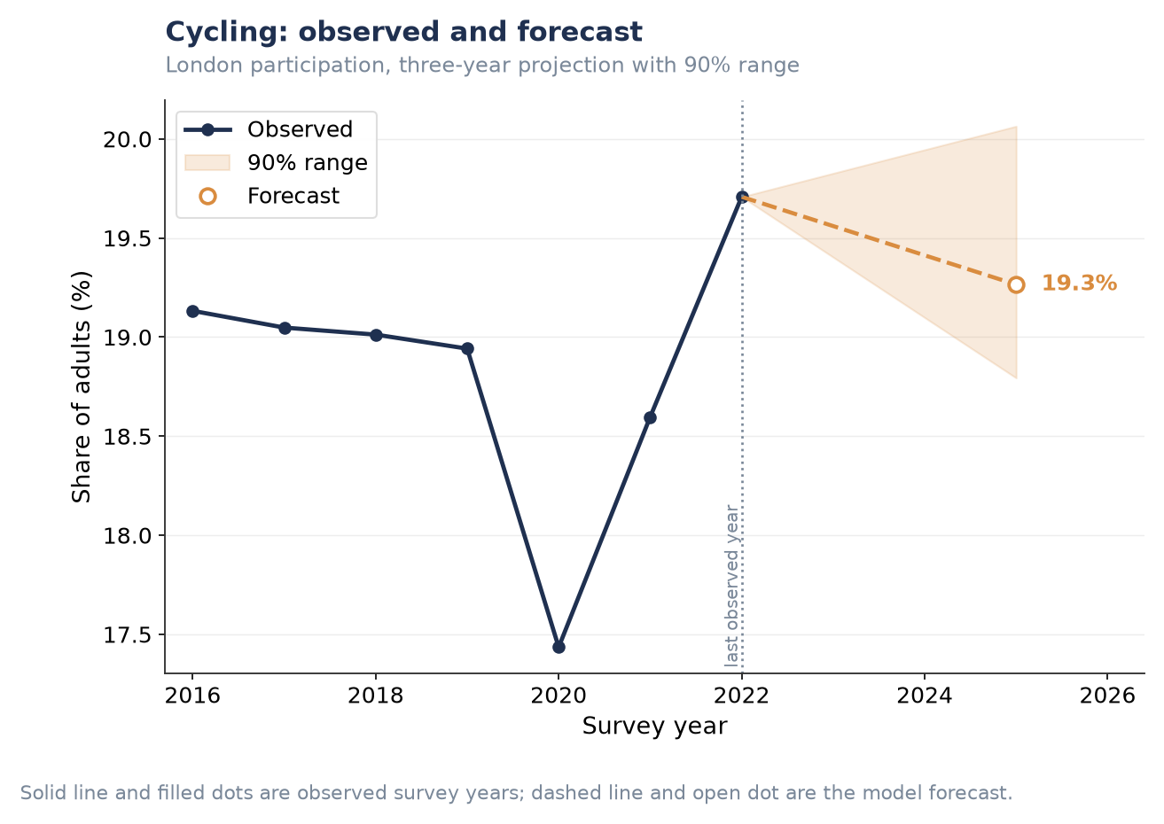
Figure P1.S3. Cycling — three-year forecast.
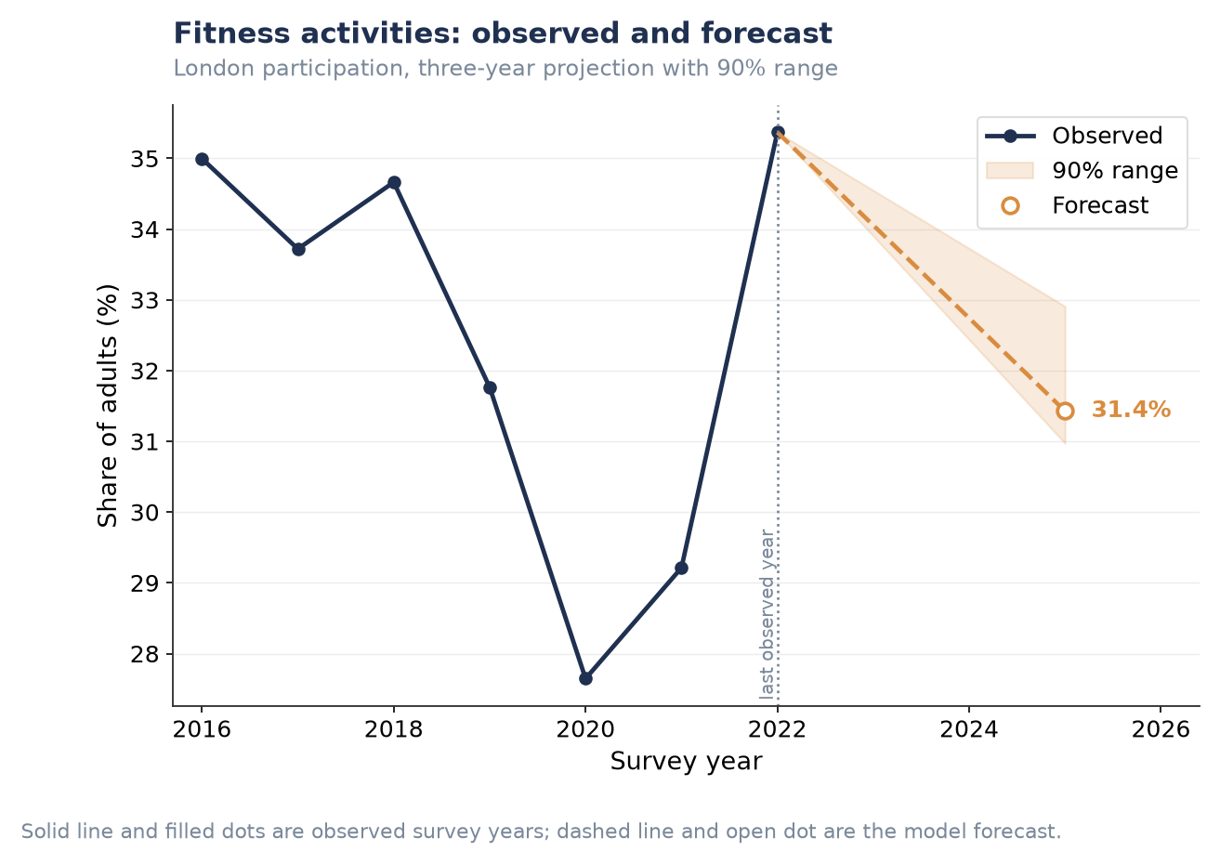
Figure P1.S4. Fitness activities — three-year forecast.
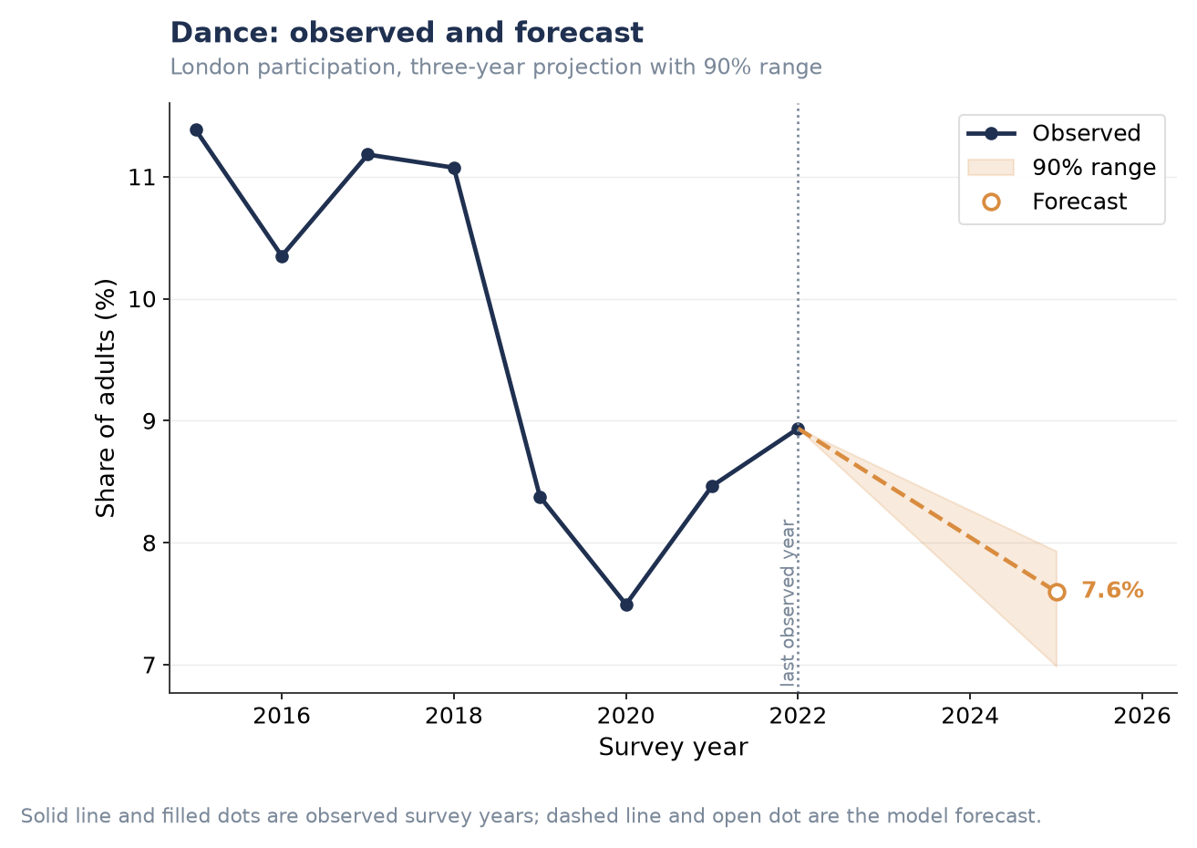
Figure P1.S5. Dance — three-year forecast.
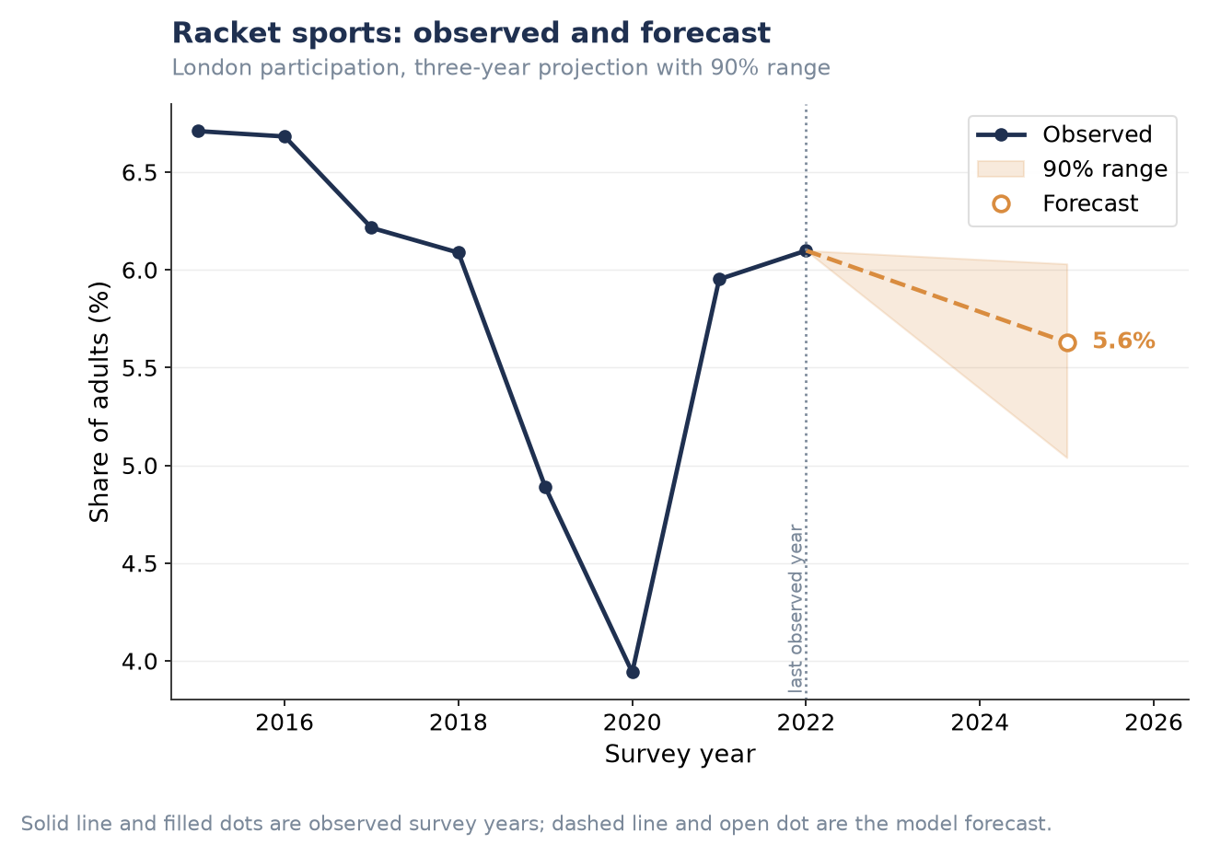
Figure P1.S6. Racket sports — three-year forecast.
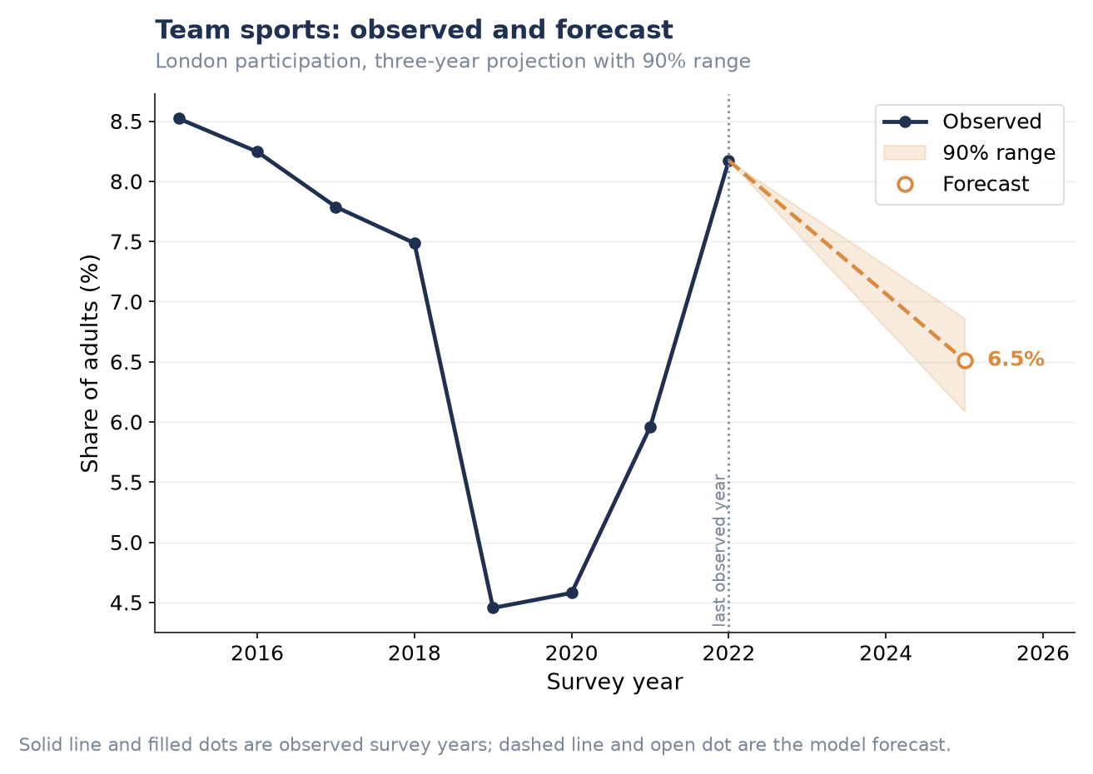
Figure P1.S7. Team sports — three-year forecast.
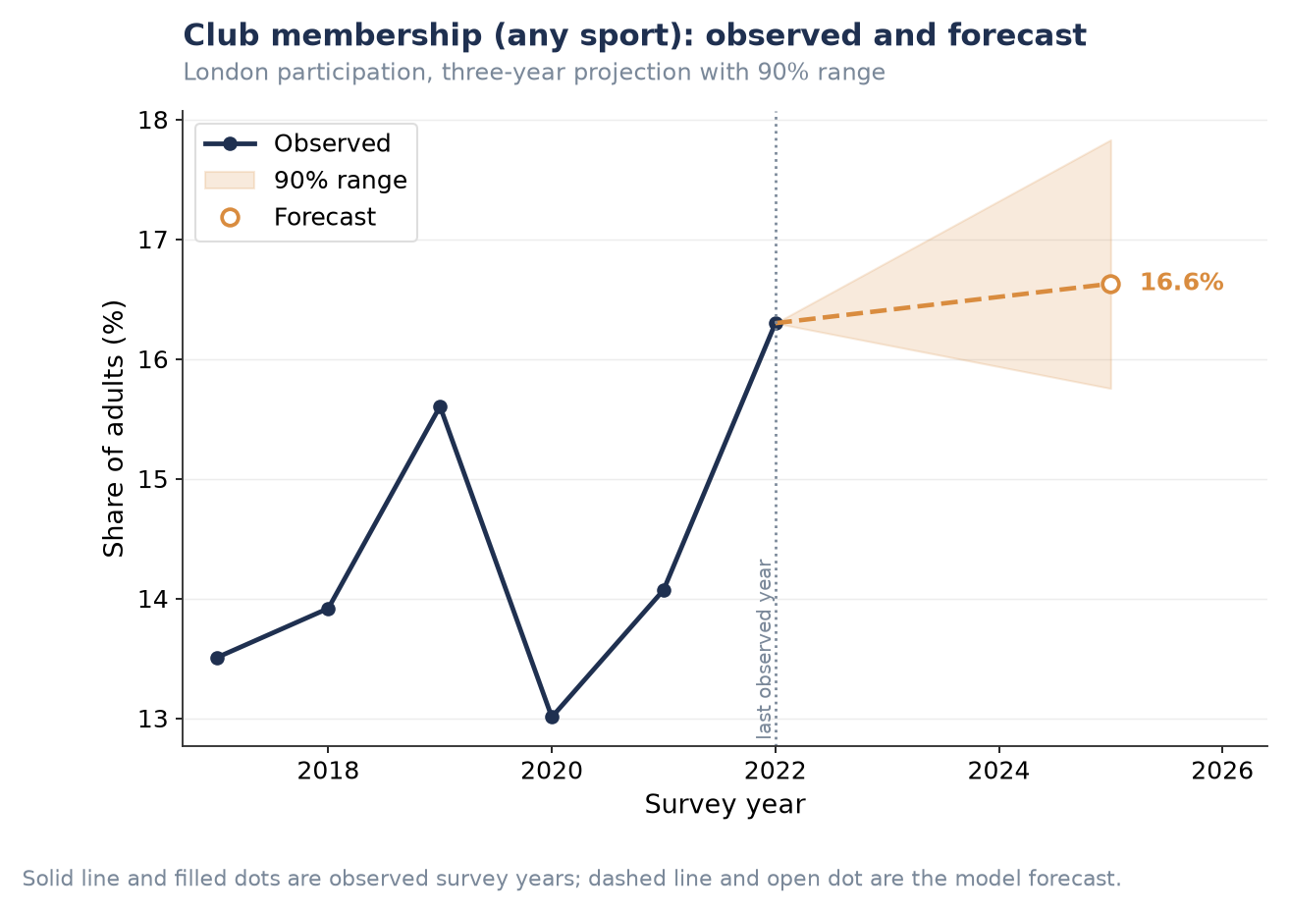
Figure P1.S8. Club membership (any sport) — three-year forecast.
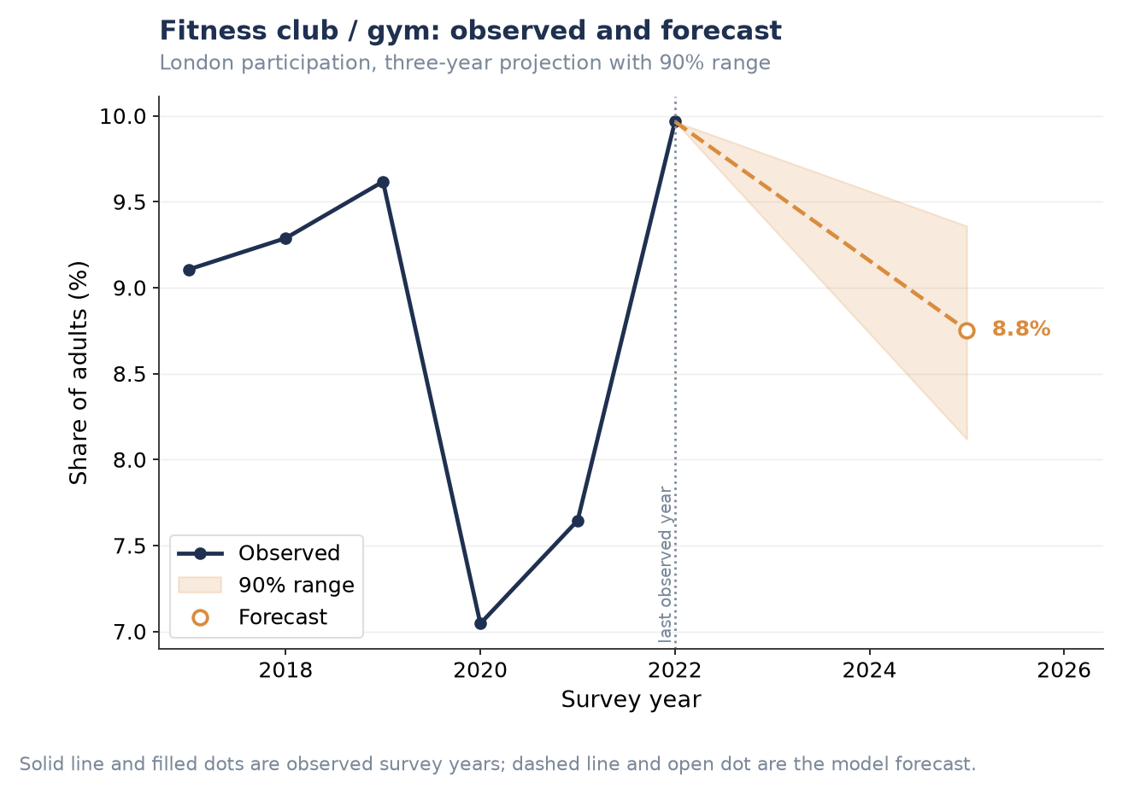
Figure P1.S9. Fitness club / gym — three-year forecast.
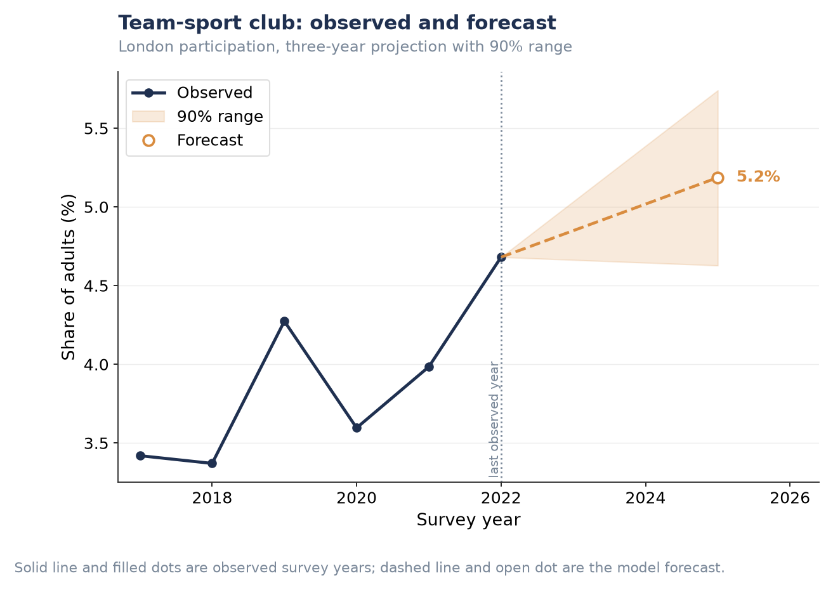
Figure P1.S10. Team-sport club — three-year forecast.

Ten-year scenarios, remaining activity/club types
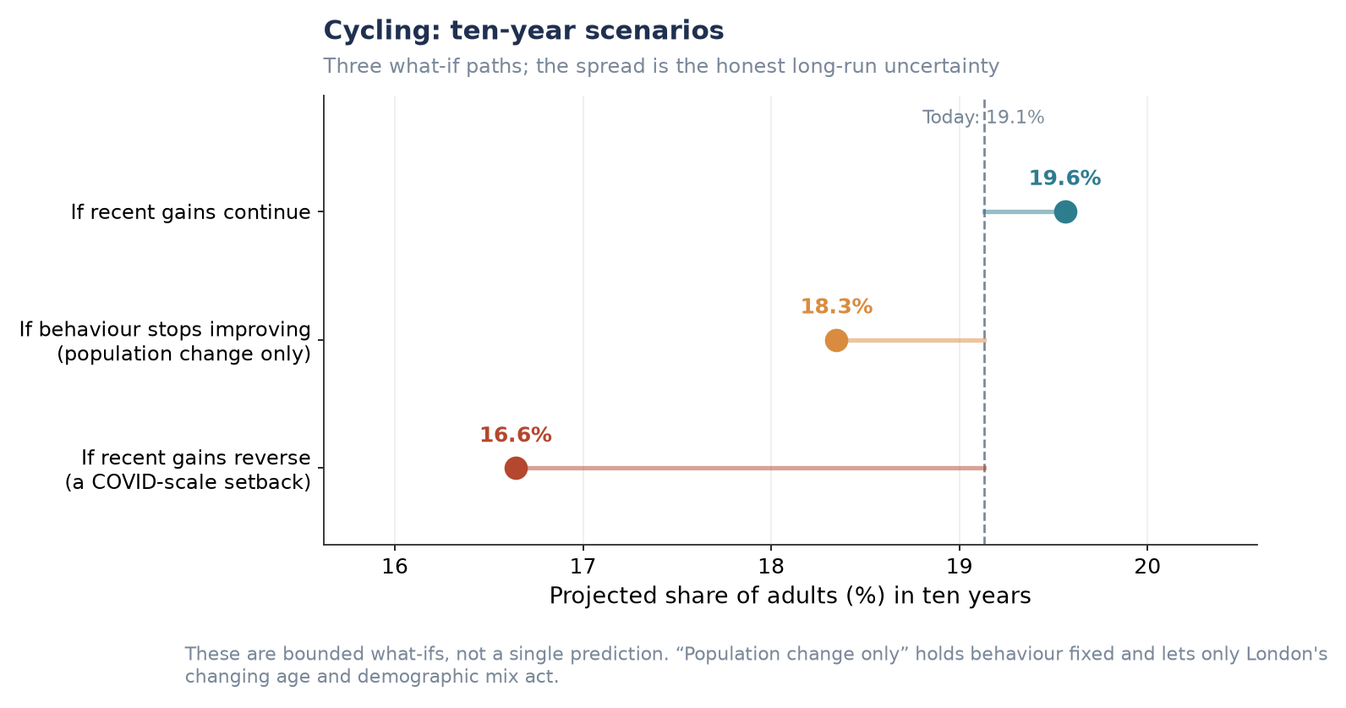
Figure P1.S11. Cycling — ten-year scenarios.
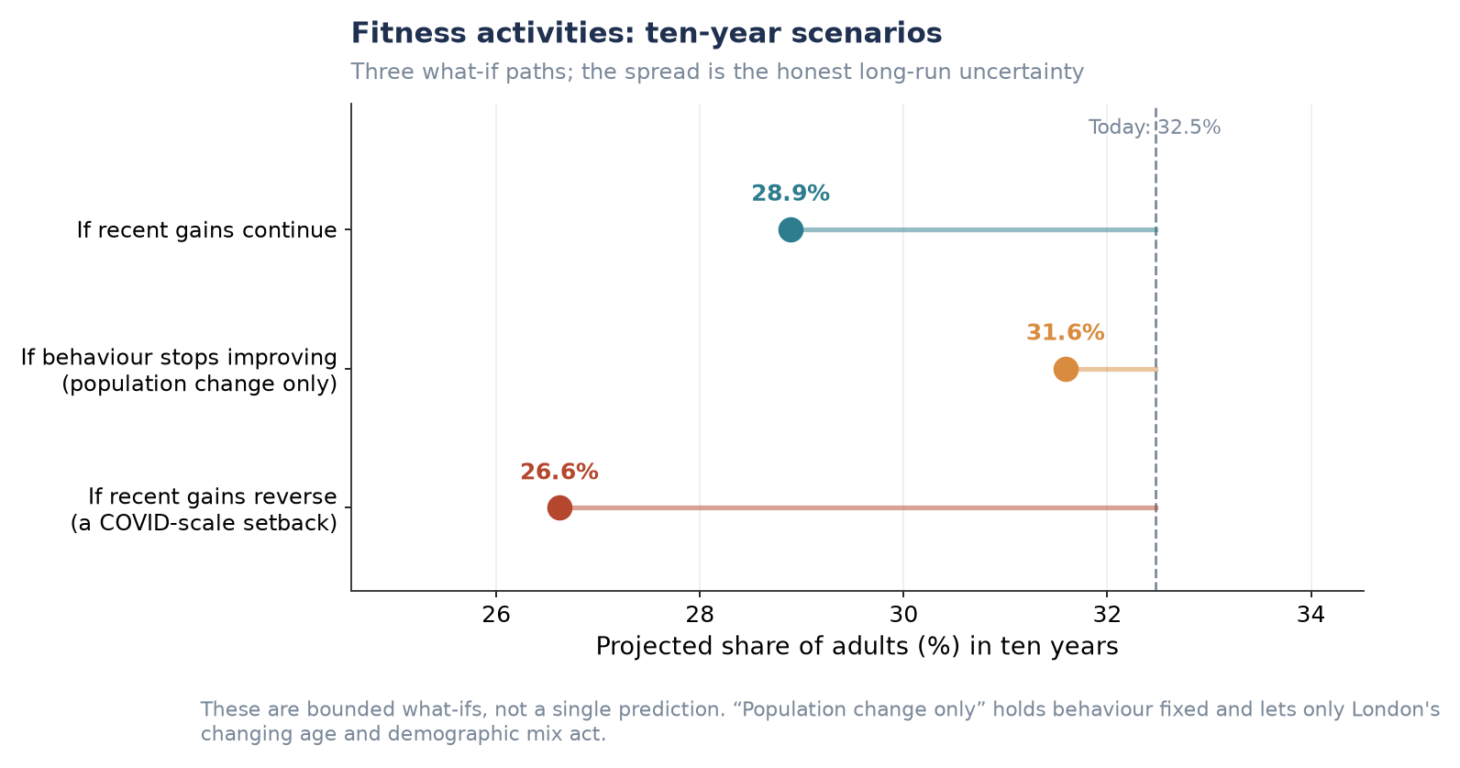
Figure P1.S12. Fitness activities — ten-year scenarios.
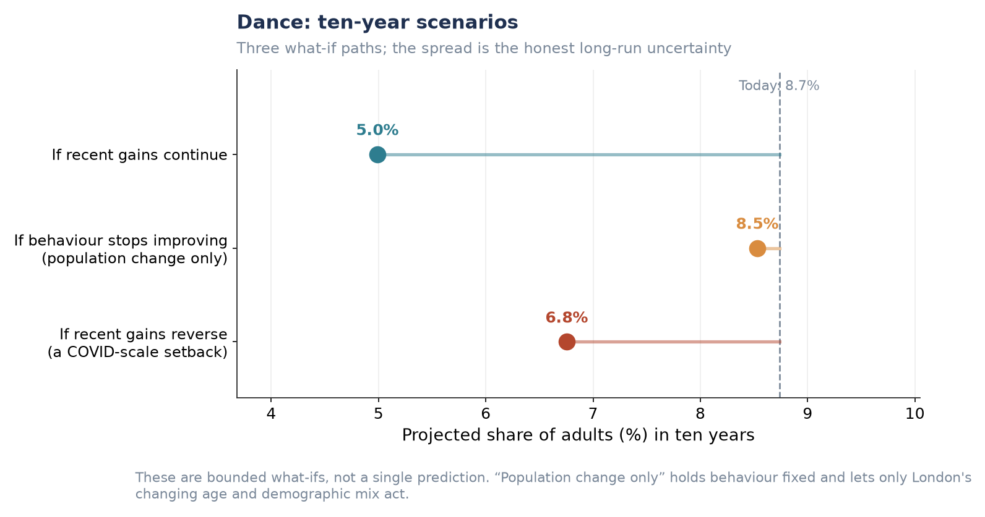
Figure P1.S13. Dance — ten-year scenarios.
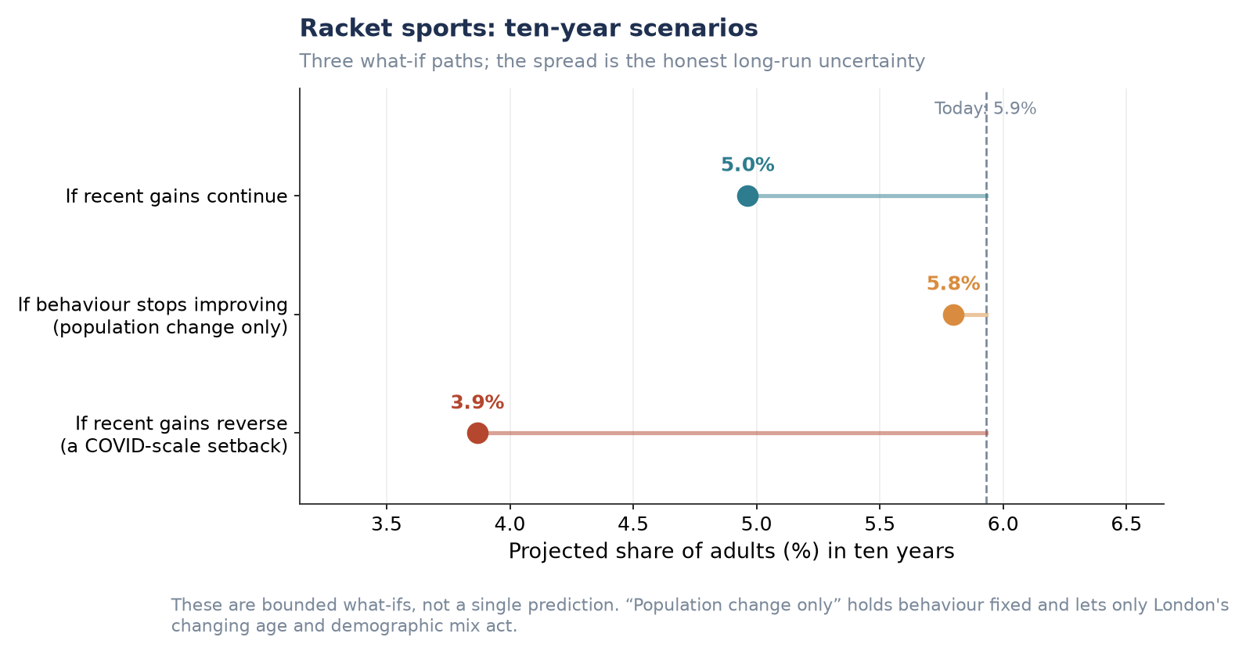
Figure P1.S14. Racket sports — ten-year scenarios.
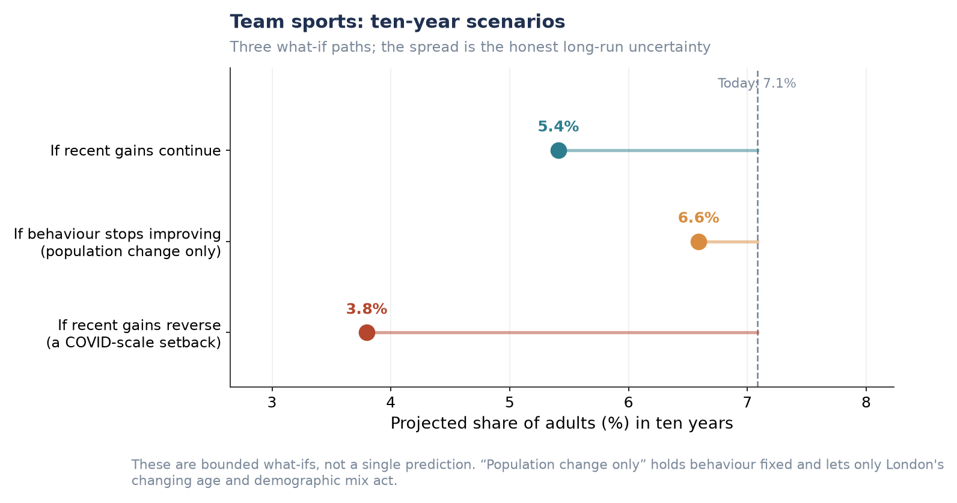
Figure P1.S15. Team sports — ten-year scenarios.
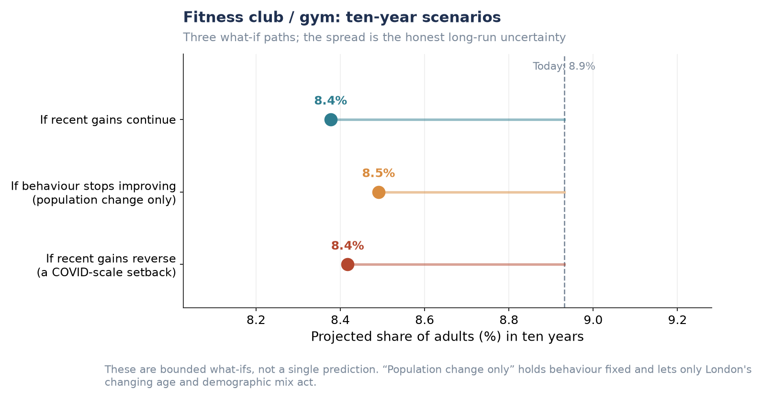
Figure P1.S16. Fitness club / gym — ten-year scenarios.
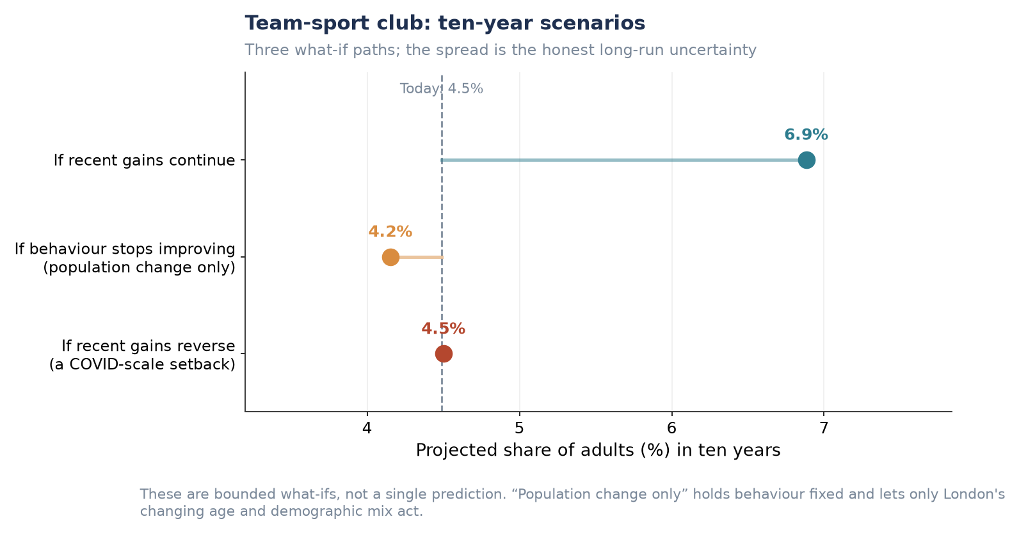
Figure P1.S17. Team-sport club — ten-year scenarios.

Additional London-wide forecast (not used above)
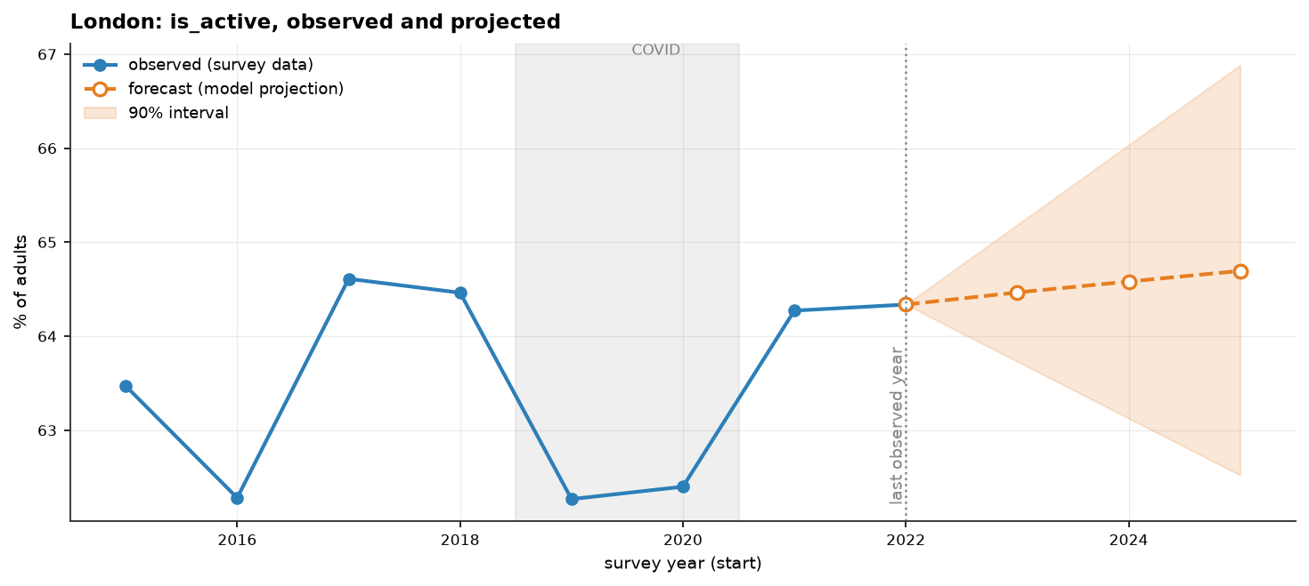
Figure P1.S18. London Active share: observed and three-year projection with 90% interval.
Note: shows substantially the same information as Figure P1.1 (single 'Active' line rather than all three bands). Its widening 90% interval is a clean visual illustration of the limited-usable-years caveat in Section 4.5 (Limitations) — consider placing it there instead.

P2 — Demographic-Specific Insights
The same forecasting framework applies as in P1. For groups that are themselves projection dimensions — age, gender, ethnicity — the ten-year forecast is direct. For groups that are not projection dimensions — socio-economic group, disability — the group's propensity is scaled to its observed activity ratio, a transparent approximation rather than a full re-projection.

Forecasted participation levels by demographic group
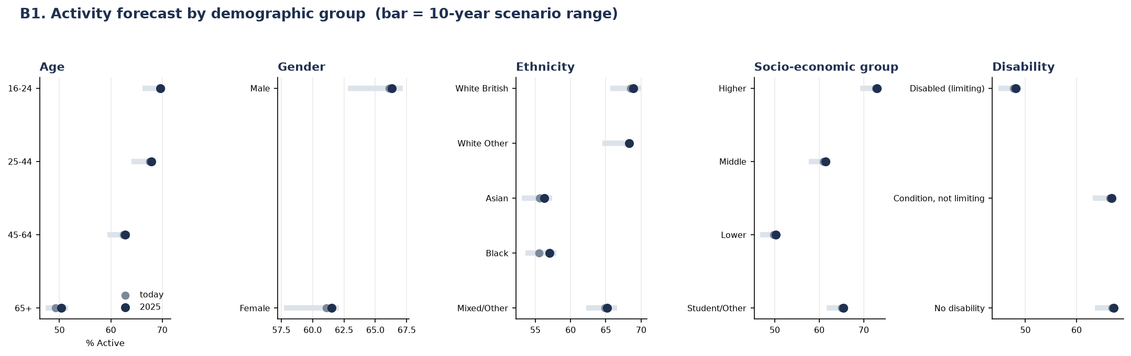
Figure P2.1. Activity forecast by demographic group; bar = 3-year forecast range, dot = today's rate.
Insight: socio-economic group shows the widest gap of any demographic dimension measured — a 23-point spread between the Higher group (73%) and the Lower group (50%), wider than the age gap (70% at 16–24 against 50% at 65+, 20 points), the disability gap (67% against 48%, 19 points) or the ethnicity gap (69% against 56%, 13 points). Gender shows the narrowest gap, at 4 points (66% male, 62% female). This ranking is corroborated by the wider analysis, which independently identifies the socio-economic gradient as the strongest single pattern in the dataset, wider than age or ethnicity.
Insight: the 65+ group is the clearest illustration of a demographic headwind rather than a behavioural one. It is both the least active group and the one that moves least on its own (roughly +1 point over three years) — yet this is precisely the group London is ageing into, which is the mechanism behind the −0.37-point composition effect on the London-wide P1 forecast above. The demographic and behavioural stories connect directly here: P1's 'fragile stability' finding is, at the individual level, this group's stagnation multiplied across a growing share of the population.

Types of sport or physical activity each group is most likely to engage in
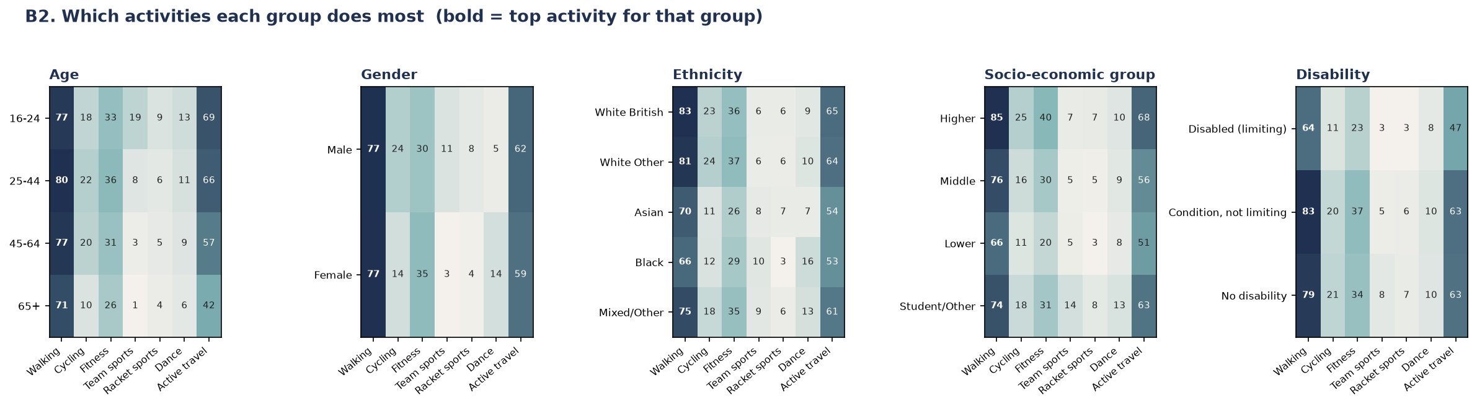
Figure P2.2. Which activities each group does most; bold marks the top activity for that group.
Insight: walking is the top activity for every single demographic group without exception, ranging from 66% (Black respondents; disabled/limiting respondents) to 85% (Higher socio-economic group). Active travel is consistently the second-most common activity for every group — together confirming the wider analysis's description of walking as the universal entry point, the behaviour most closely tied to demographics of all those measured.
Insight: the socio-economic gap concentrates in facility-dependent activities rather than spreading evenly. Fitness participation is twice as high in the Higher group as the Lower group (40% against 20%), and cycling more than double (25% against 11%), while walking — which needs no facility or club — shows a much smaller proportional gap (85% against 66%). The wider analysis explains this directly: repeating the composition–place decomposition across fifteen behaviours shows demographics explain roughly half of the borough-level variation in walking (50%) and overall activity (48%), but only around 29% of cycling and 25% of team-sport club membership — the remainder is driven by place-level provision (facilities, lanes, clubs), not by who lives there. The behaviours least predictable from demographics are, by this logic, precisely the ones most open to influence through investment.
Insight: two smaller patterns are worth flagging for programme design: dance participation among Black respondents (16%) is markedly higher than any other ethnic group (next highest: 10%), a distinctive preference rather than a general activity-level effect; and team-sport participation among the Student/Other socio-economic group (14%) is roughly twice that of any other socio-economic group (5–7%), consistent with student-age team sport engagement rather than a broader socio-economic pattern.

Participation within each London borough
Data note: the brief asks for participation in specific activities within each borough. The available chart instead breaks down age-group participation within each borough (activity-type × borough detail was not available at reportable cell sizes). This is flagged here so the gap is visible rather than implied to be answered.
Borough-by-demographic cells are small: a single borough-by-age cell contains around six respondents in a given survey wave. All eight waves were therefore pooled and thin cells suppressed.
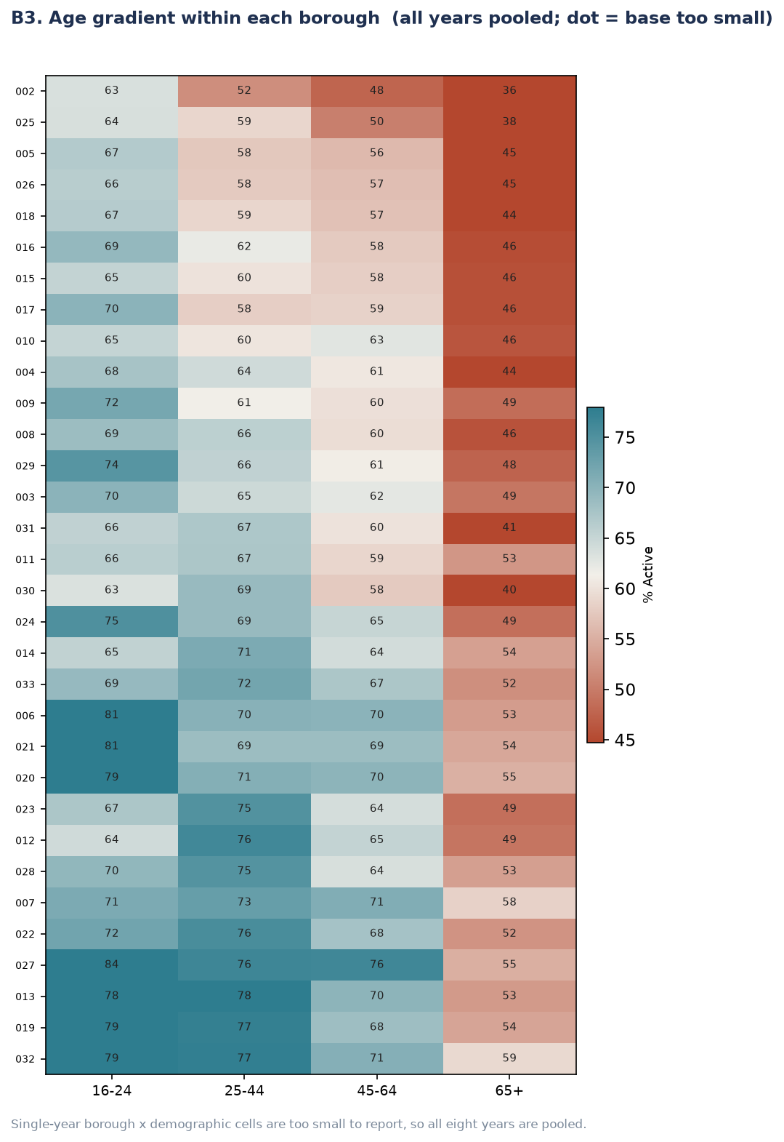
Figure P2.3. Age gradient within each borough, all waves pooled (borough rows are numeric codes pending name labels — see note below).
Insight: the age gradient (16–24 most active, 65+ least active) holds inside every one of the 32 boroughs without exception. But both the overall level and the size of the age gap vary sharply by borough: the widest age gap in the dataset is 29 points (84% for 16–24 falling to 55% for 65+); the narrowest is 13 points. A young adult in a low-activity outer borough can therefore have a lower activity rate than an older adult in a high-activity inner borough — place and demography compounding rather than offsetting one another, and directly consistent with the P1 borough finding that place effects amplify composition rather than cancel it out.
Action needed before this chart is presentation-ready: the y-axis currently shows internal numeric borough codes (e.g. ‘027’, ‘002’), not borough names. These need to be mapped back to borough names using the LA_code crosswalk (Section 3.3.1) before this figure goes into the final report.

Likelihood of participation among people with health conditions
This bullet is reported descriptively rather than forecast, for two methodological reasons rather than a data-availability oversight alone.
- A stable trend cannot be estimated. Self-rated health is available from 2018–19 onwards — five waves — but two of those five (2019–20 and 2020–21) are COVID-disrupted and are excluded as unrepresentative. That leaves three clean years, which cannot reliably distinguish a genuine trend from noise.
- Health cannot be added to the propensity model. Forecasting requires pushing a projected future population through the model, and London's future health distribution cannot be projected from this data. Health is also missing entirely from the three earliest waves; filling those gaps would let the model learn 'health is missing' as a proxy for 'this is an early wave', contaminating every other trend. This is why health was excluded from the propensity model entirely, not only from the forecast.
It is nonetheless reported because the relationship is too strong to omit: self-rated health is the steepest single relationship in the entire dataset, a 56-point span from 76% active at 'very good' health to 20% active at 'very bad' health.
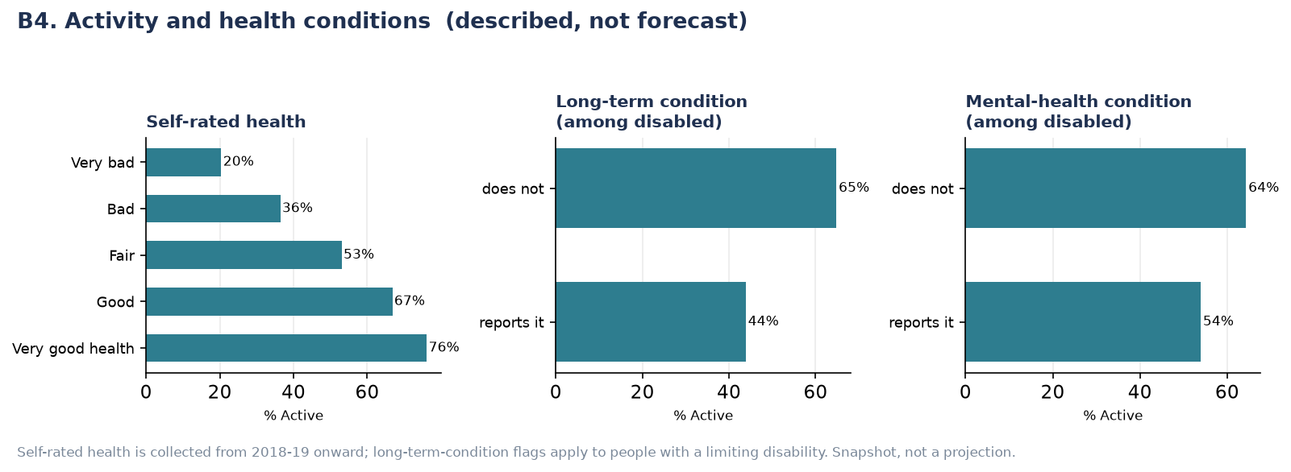
Figure P2.4. Activity by self-rated health, long-term condition and mental-health condition. Described, not forecast.
Insight: the gradient is graded, not a simple binary — activity falls in a near-straight line across all five self-rated health bands (76% → 67% → 53% → 36% → 20%). Among people with a limiting disability, those who also report a long-term physical condition are 21 points less active than those who do not (44% against 65%); those who report a mental-health condition are 10 points less active than those who do not (54% against 64%) — a real but smaller gap than for physical long-term conditions.
This relationship is reported as an association, not a one-directional cause: poor health can reduce activity, but inactivity is also known to worsen health outcomes over time. The wider analysis makes the same point explicitly — neither this dataset nor the modelling approach used here can separate the two directions of causation.

Supplementary Figures (P2)
Individual-group charts, each showing at larger scale one panel already summarised in Figures P2.1 and P2.2 above.

Forecast by individual demographic group
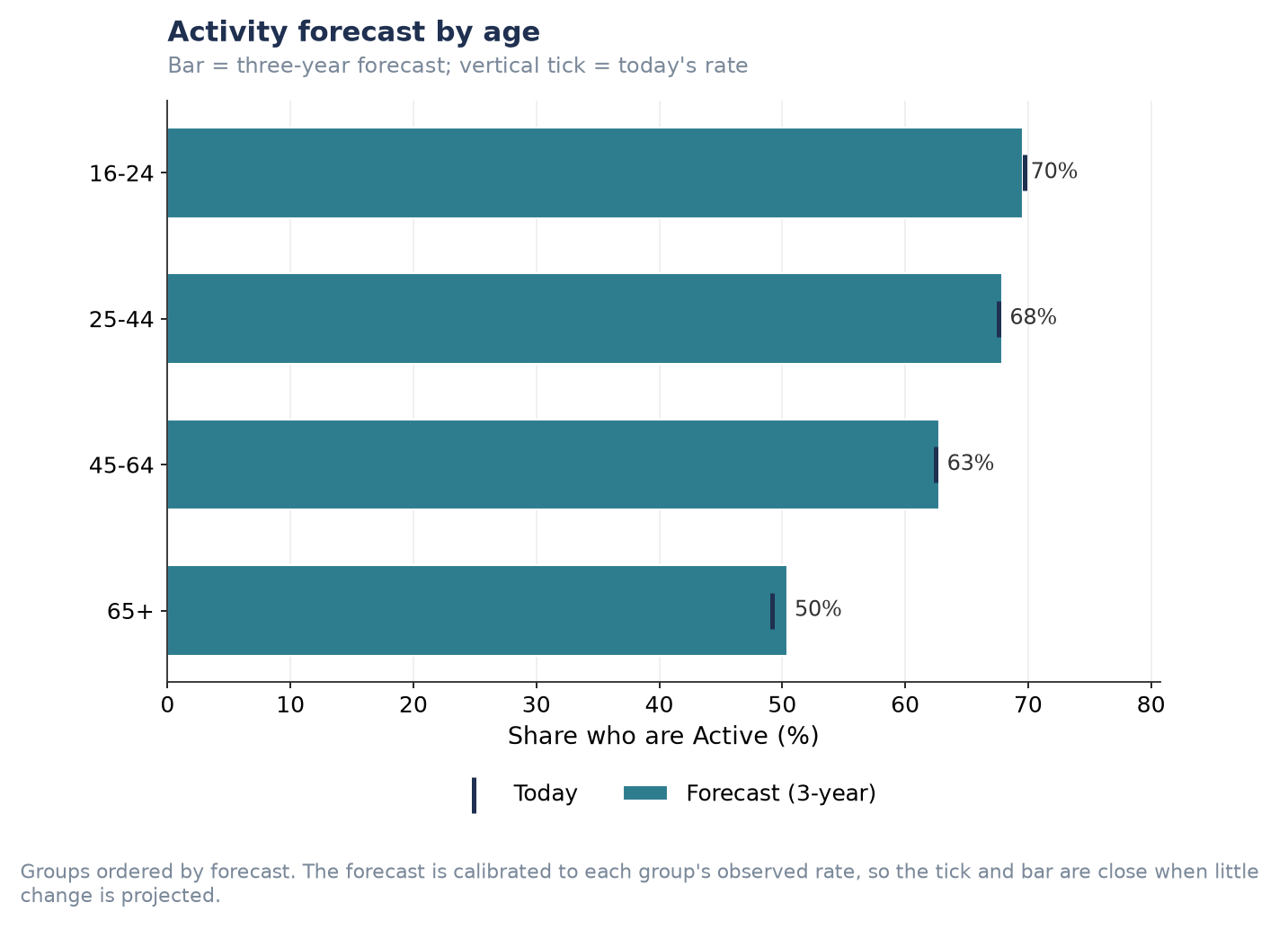
Figure P2.S1. Activity forecast by age.
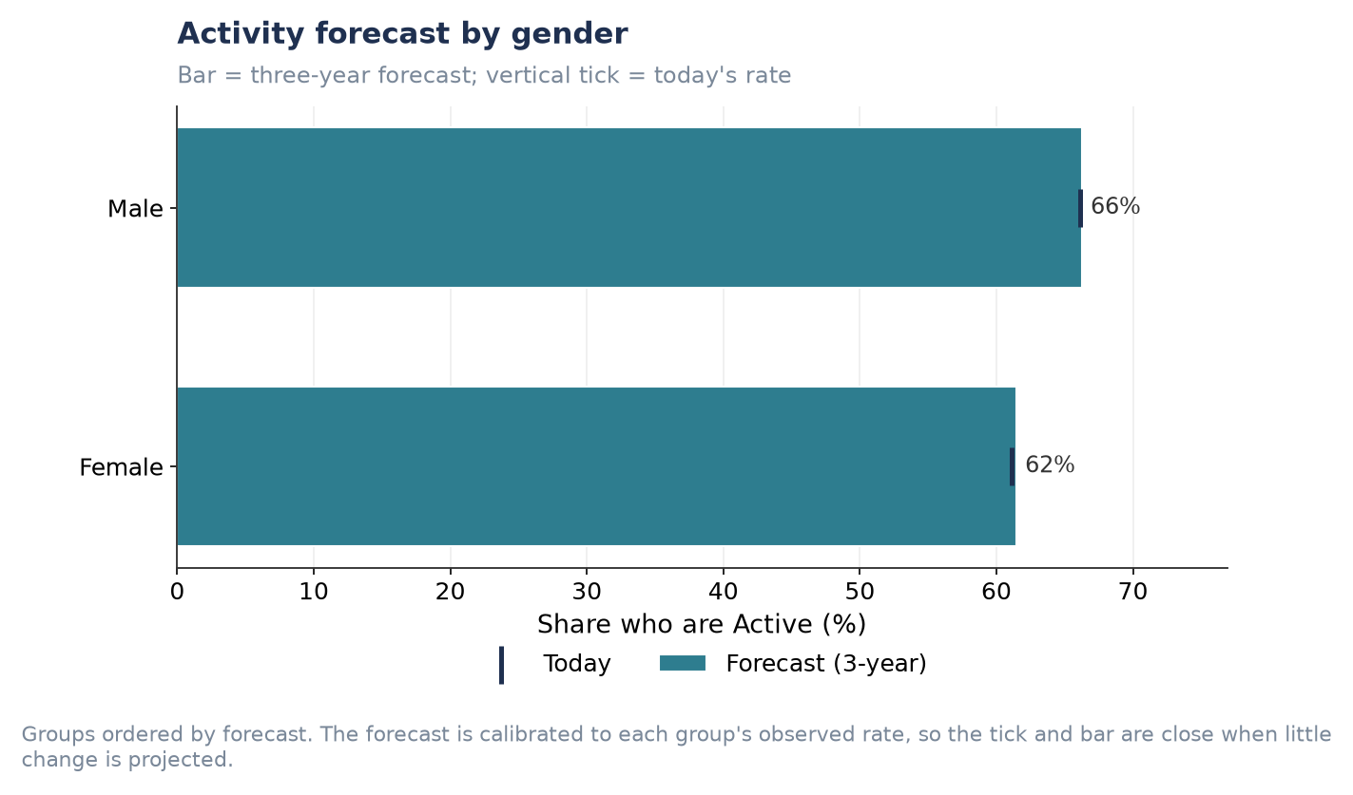
Figure P2.S2. Activity forecast by gender.
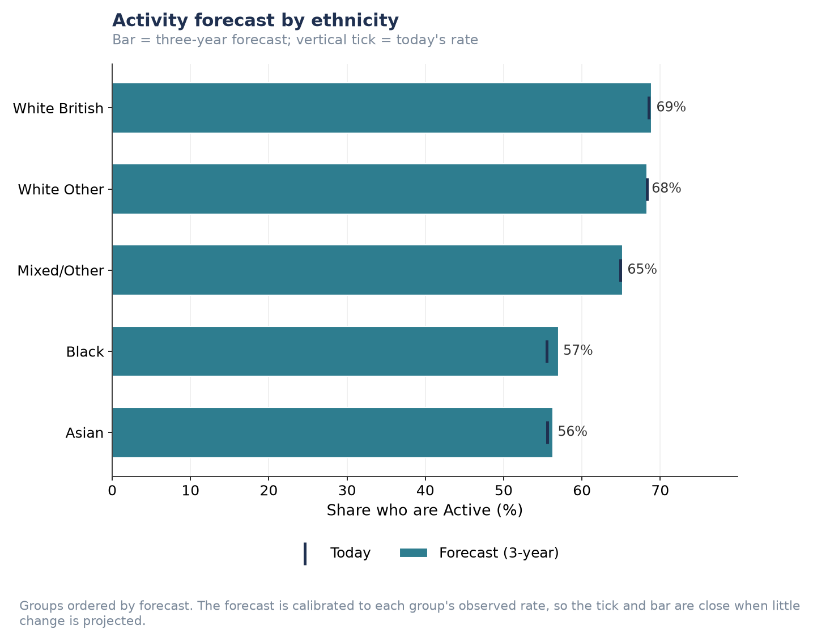
Figure P2.S3. Activity forecast by ethnicity.
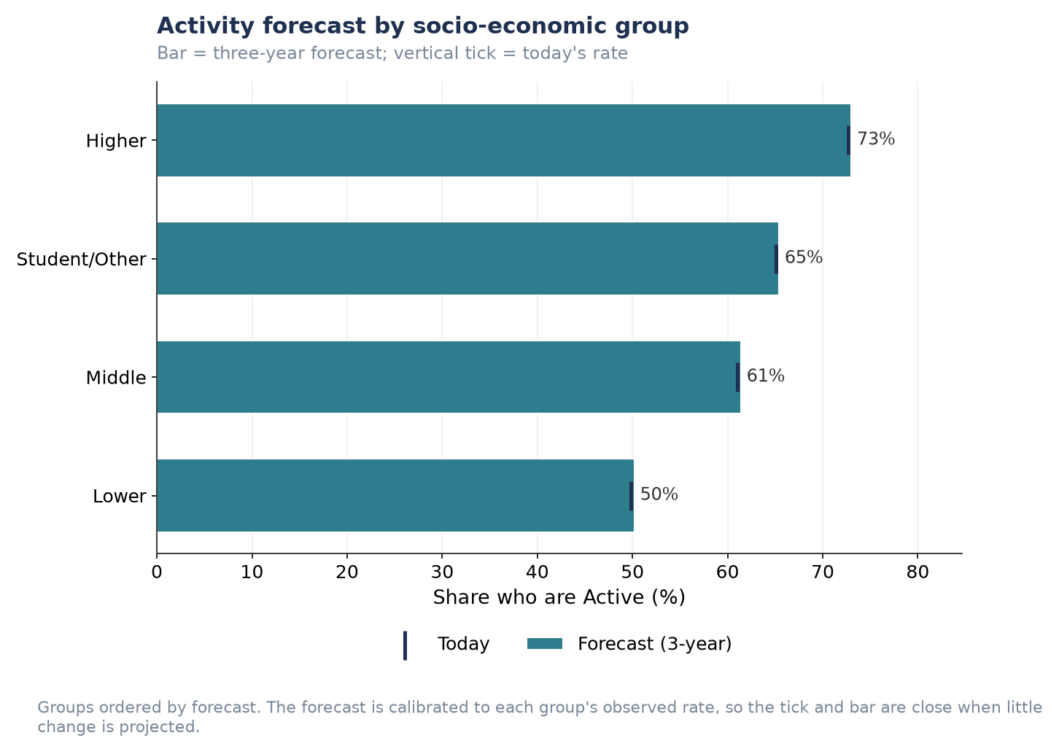
Figure P2.S4. Activity forecast by socio-economic group.
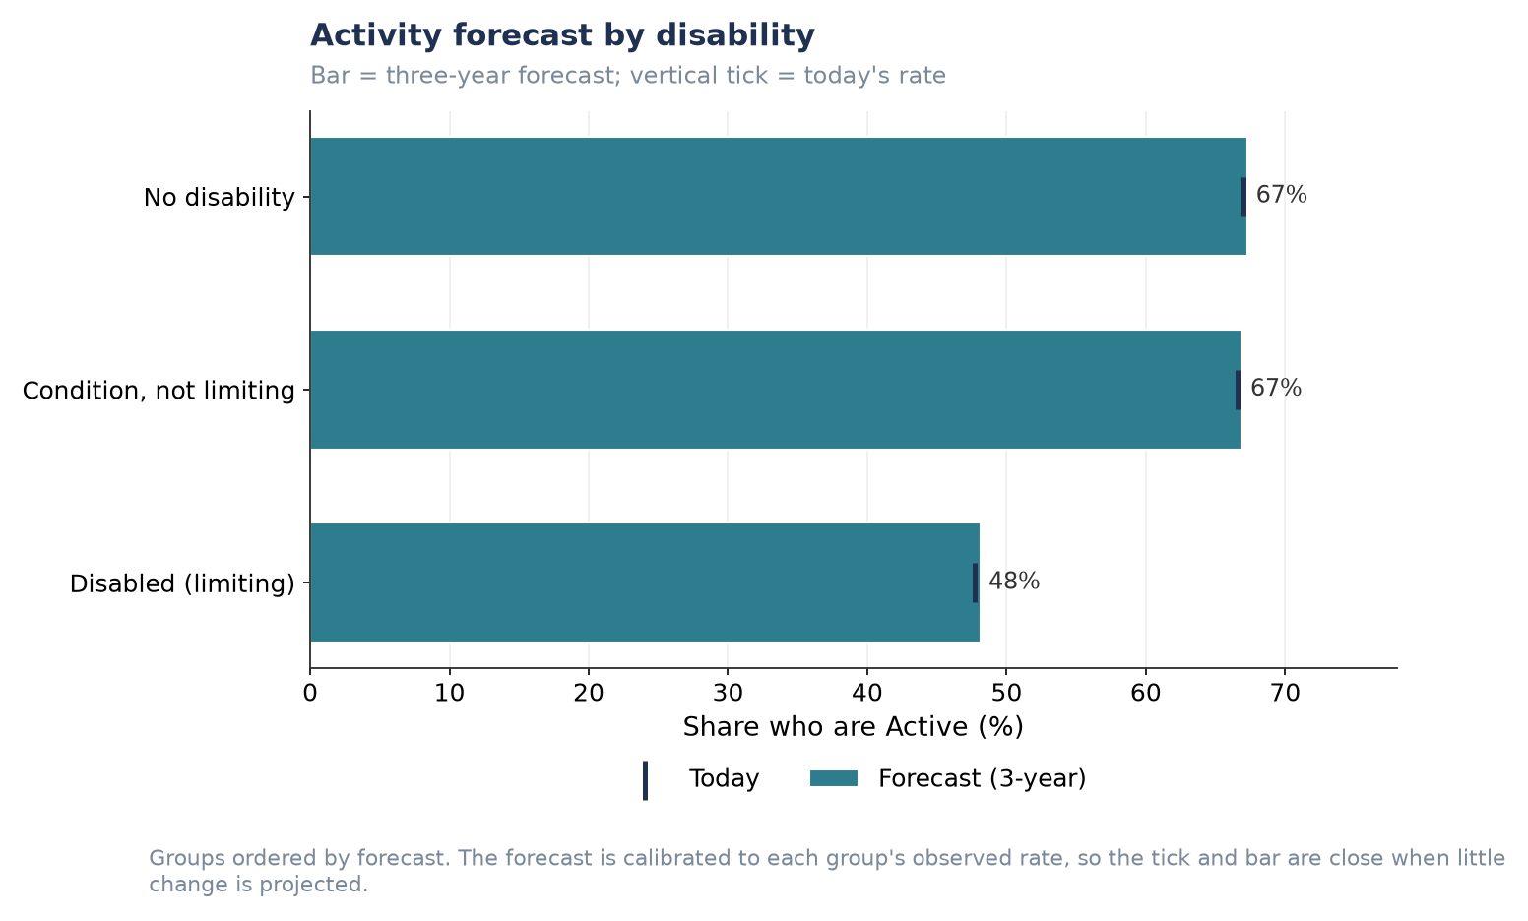
Figure P2.S5. Activity forecast by disability status.

Preferred activities by individual demographic group
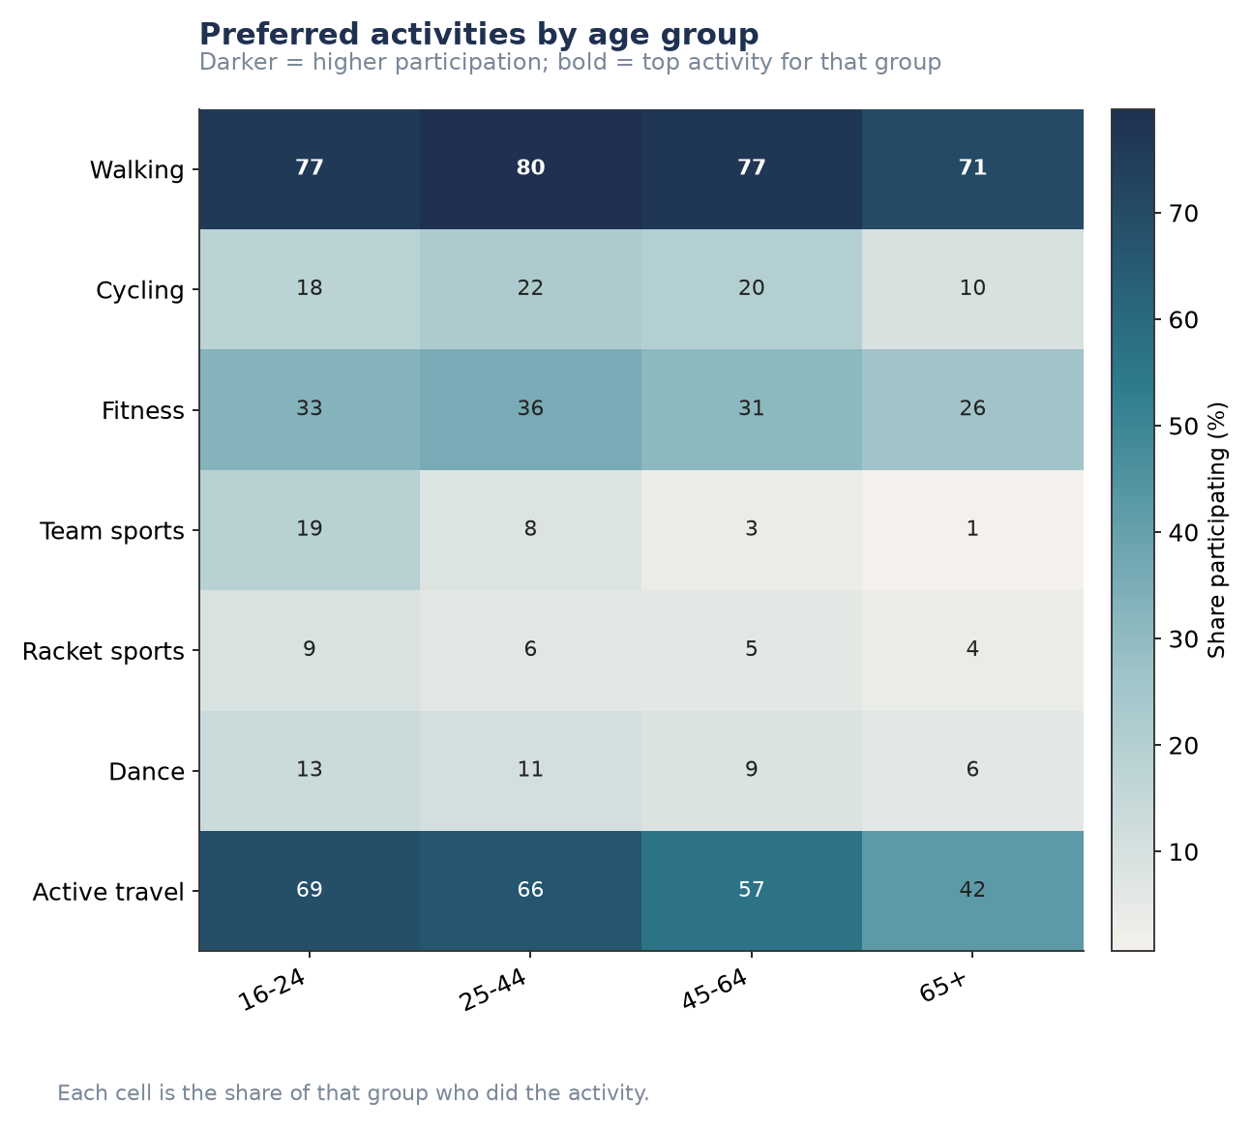
Figure P2.S6. Preferred activities by age group.
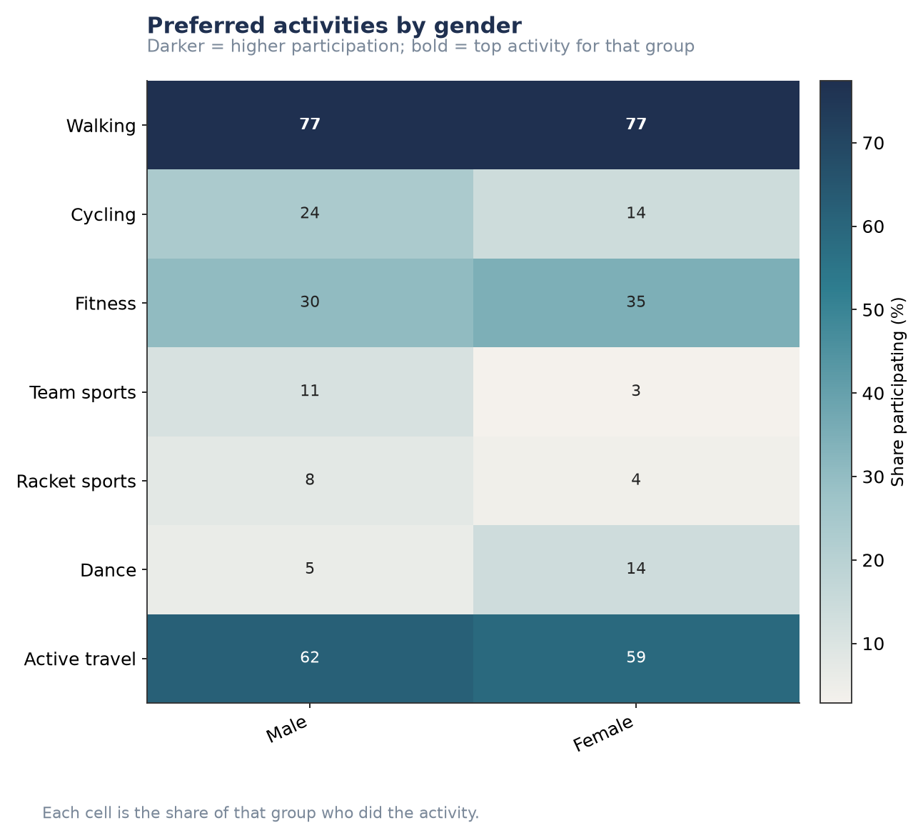
Figure P2.S7. Preferred activities by gender.
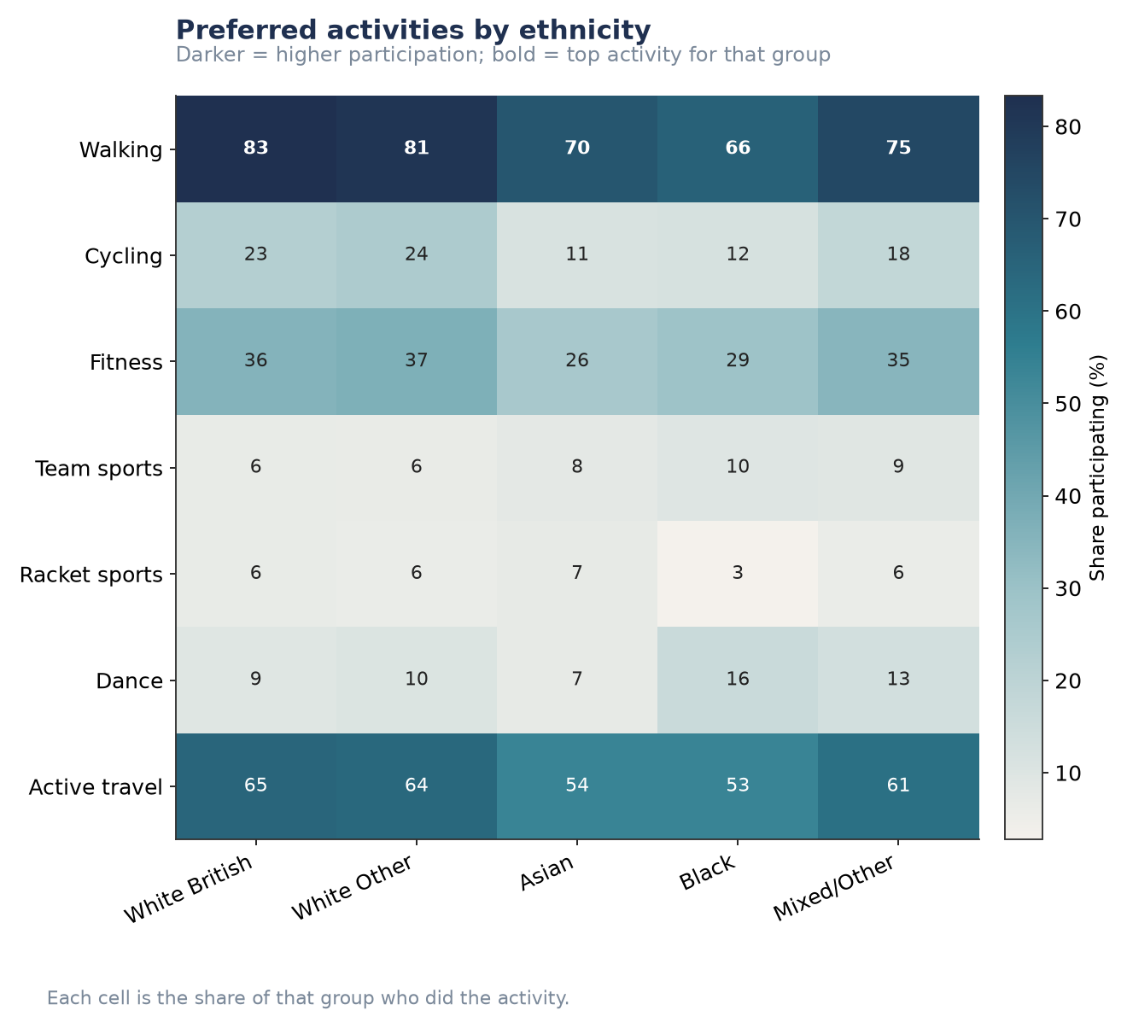
Figure P2.S8. Preferred activities by ethnicity.
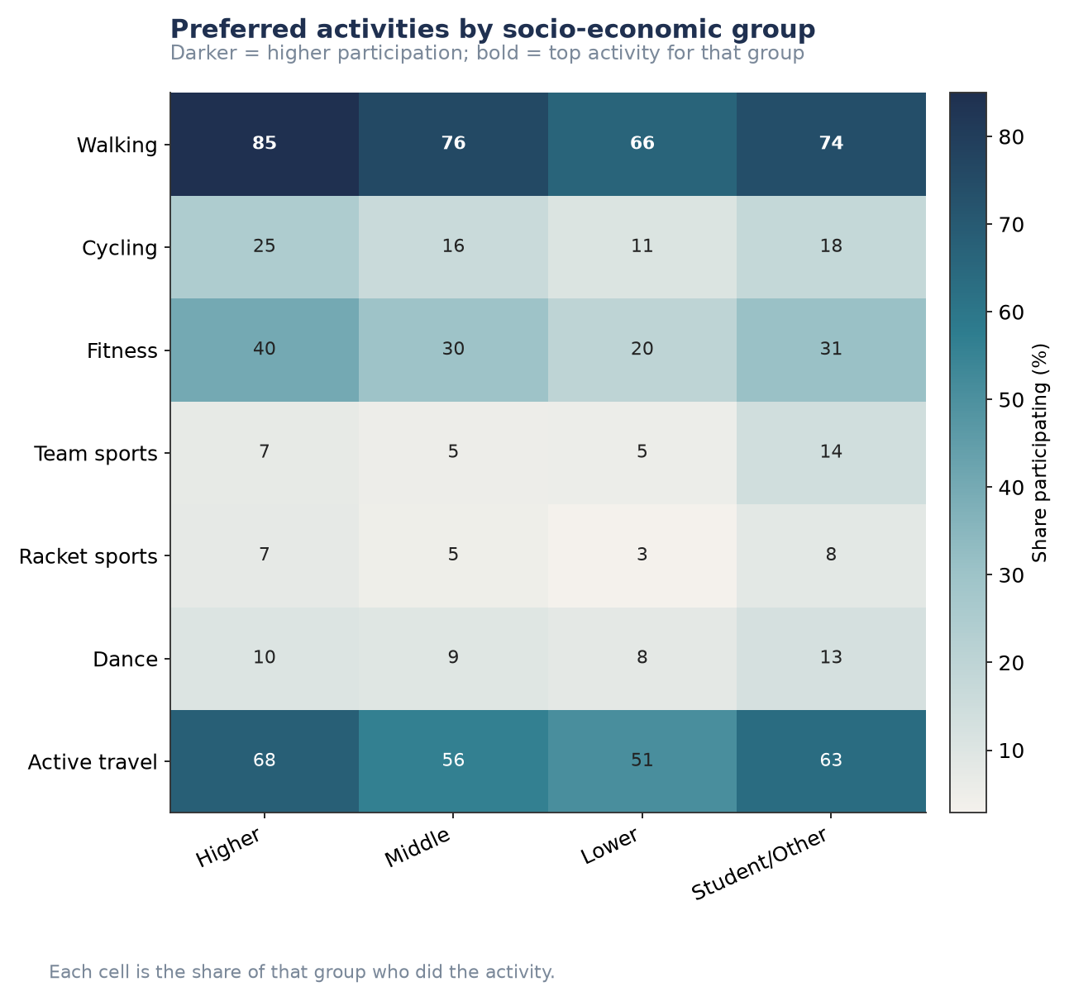
Figure P2.S9. Preferred activities by socio-economic group.
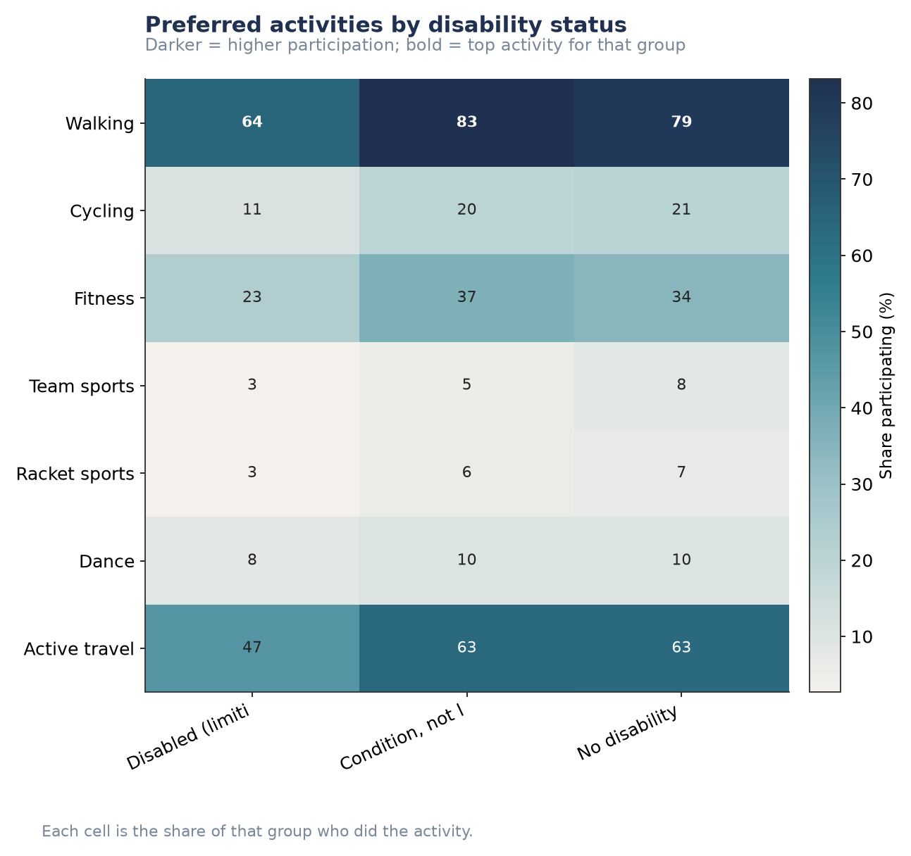
Figure P2.S10. Preferred activities by disability status.

Health conditions, individual breakdowns
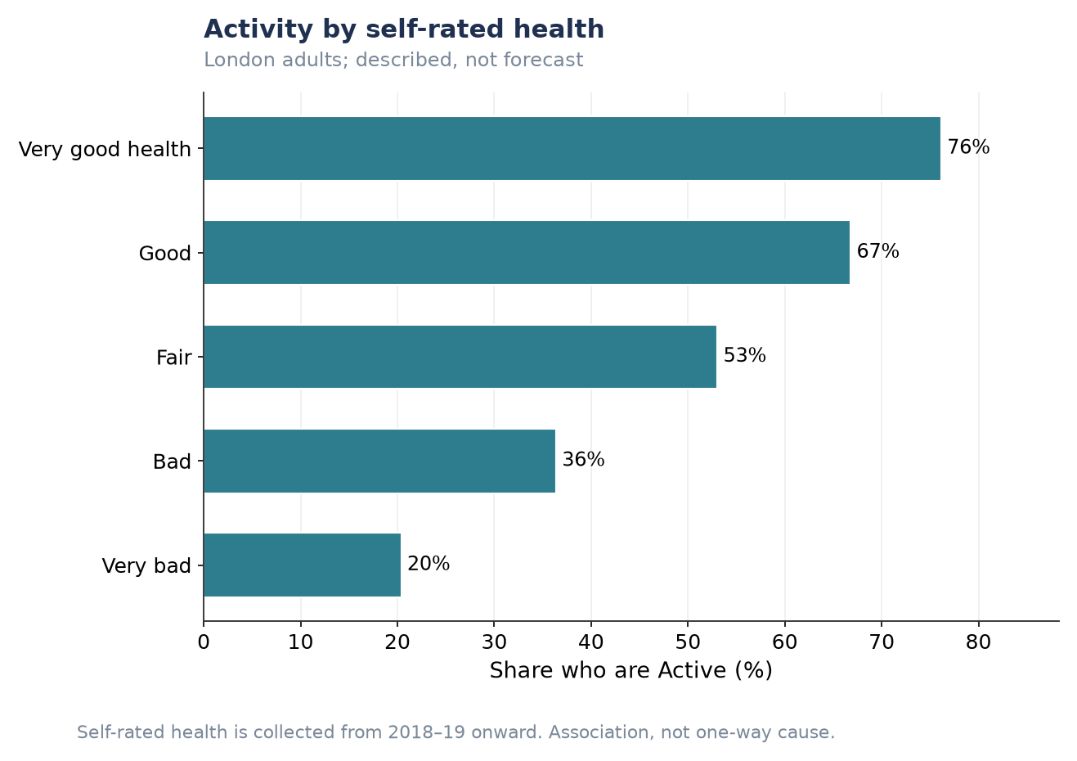
Figure P2.S11. Activity by self-rated health.
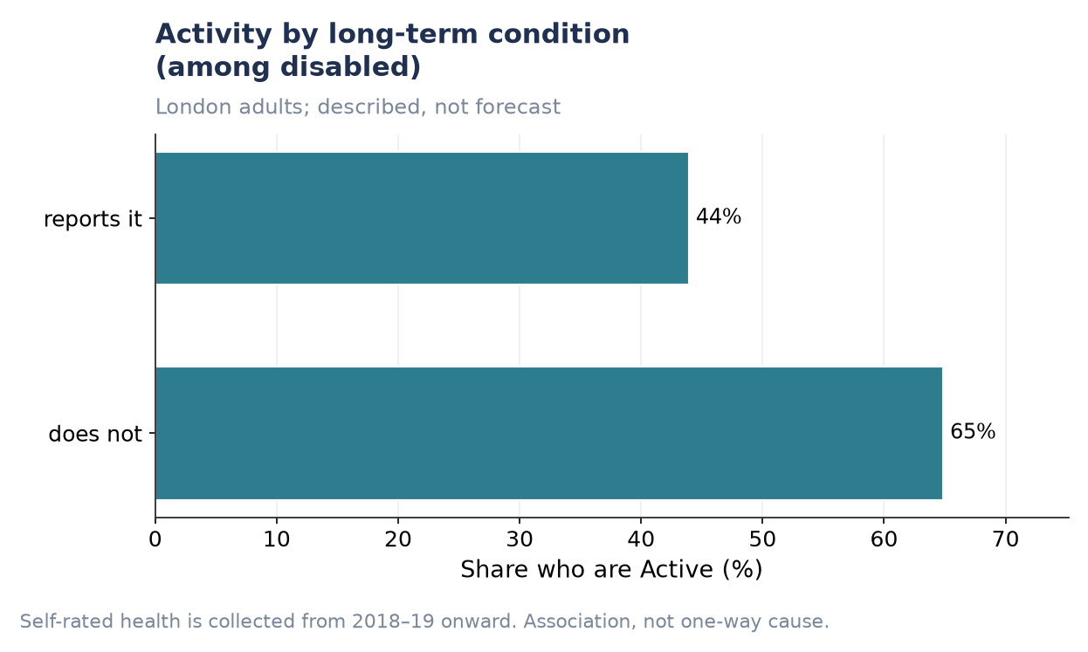
Figure P2.S12. Activity by long-term condition (among disabled respondents).
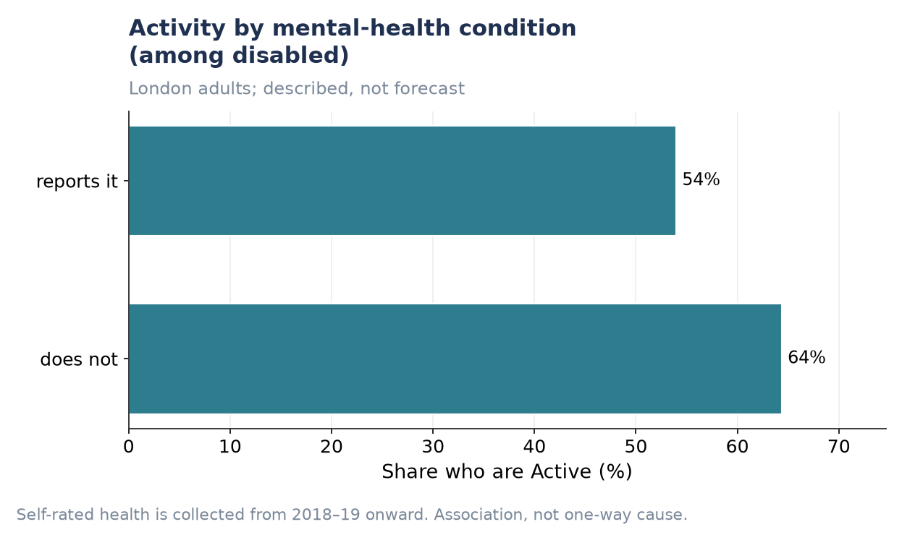
Figure P2.S13. Activity by mental-health condition (among disabled respondents).

How P1 and P2 Connect
Read together, the two pillars tell one coherent story rather than two separate ones. P1 shows London-wide activity is stable only because a demographic headwind (−0.37 points, driven by an ageing population) and a behavioural tailwind (+0.69 points, people becoming more active) are currently cancelling out. P2 identifies exactly which group is driving that headwind — the 65+ group, the least active and the slowest-moving of any demographic segment — and shows the same compounding pattern recurring at borough level, where place effects amplify rather than offset demographic disadvantage. The practical implication for London Sport is that the two levers are not equivalent: demographic composition is a headwind to be planned around, while behavioural change — concentrated in facility-dependent activities that P2 shows are least explained by demographics and most by provision — is the lever most open to influence through investment.

