P2 — Demographic-Specific Insights
This section reports the London Sport brief's second pillar: demographic-specific insights. The same forecasting framework applies as in P1 (Section 3.5; LightGBM propensity model, Section 4.4). For groups that are themselves projection dimensions — age, gender, ethnicity — the ten-year forecast is direct. For groups that are not projection dimensions — socio-economic group, disability — the group's propensity is scaled to its observed activity ratio, a transparent approximation rather than a full re-projection, and should be read with that caveat in mind throughout this section.

Forecasted participation levels by demographic group
Ten-year scenario ranges were produced for age, gender, ethnicity, socio-economic group and disability status.
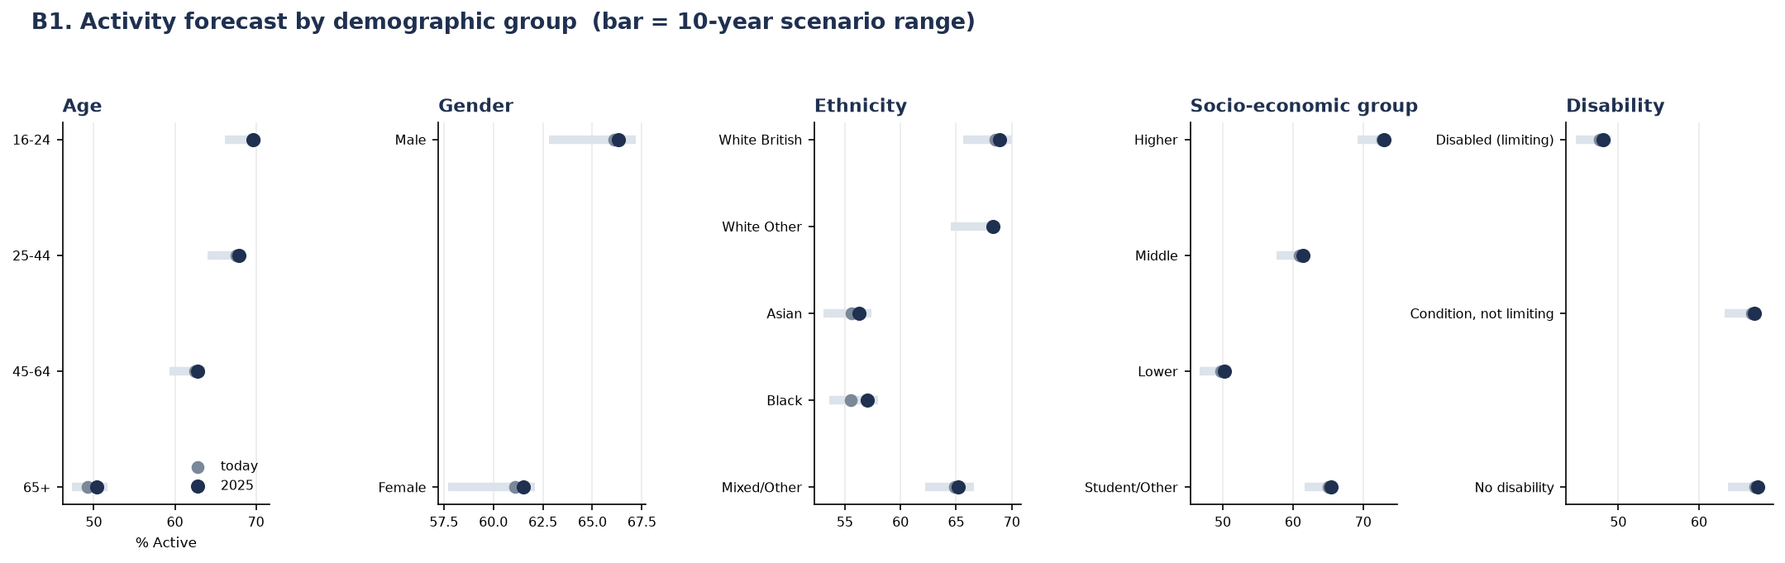
Figure P2.1. Activity forecast by demographic group; bar = 3-year forecast range, dot = today's rate.
Insight: socio-economic group shows the widest gap of any demographic dimension measured — a 23-point spread between the Higher group (73%) and the Lower group (50%), wider than the age gap (70% at 16–24 against 50% at 65+, 20 points), the disability gap (67% against 48%, 19 points) or the ethnicity gap (69% against 56%, 13 points). Gender shows the narrowest gap of any group measured, at 4 points (66% male, 62% female).
Insight: the 65+ group is the clearest illustration of a demographic headwind rather than a behavioural one. It is both the least active group and the one that moves least on its own (roughly +1 point over three years) — yet London's ageing population means this group will make up a growing share of adults over the forecast horizon. This is the mechanism behind the modest downward composition pressure on the London-wide forecast reported in P1: not that older Londoners are becoming less active, but that London is ageing into its least active group.

Types of sport or physical activity each group is most likely to engage in
For each demographic group, participation was broken down across seven activity types, to identify not just how active each group is but what they actually do.
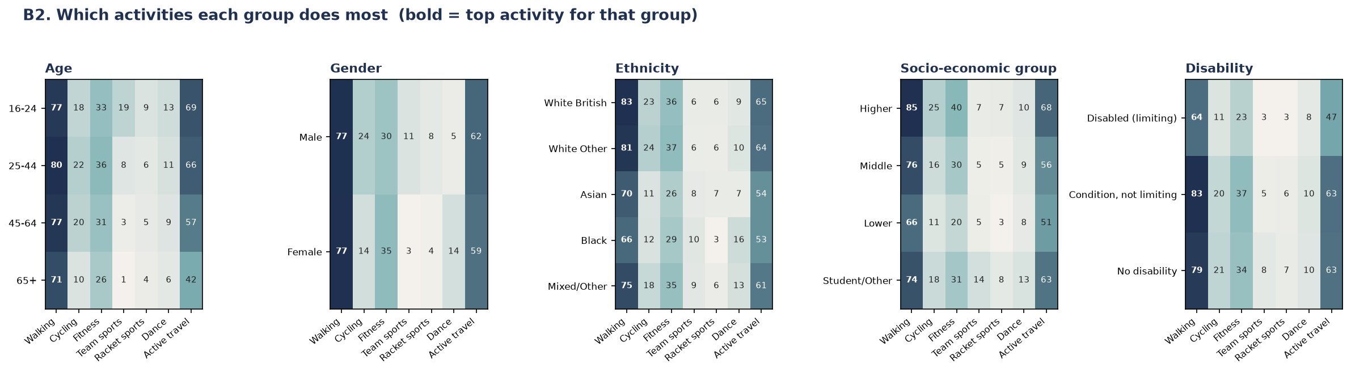
Figure P2.2. Which activities each group does most; bold marks the top activity for that group.
Insight: walking is the top activity for every single demographic group without exception — the one universal behaviour in the dataset, ranging from 66% (Black respondents, disabled/limiting respondents) up to 85% (Higher socio-economic group). Active travel is consistently the second-most common activity for every group.
Insight: the socio-economic gap is not evenly spread across activities — it concentrates in facility-dependent activities. Fitness participation is twice as high in the Higher group as the Lower group (40% against 20%), and cycling is more than double (25% against 11%), while walking — which needs no facility or club — shows a much smaller proportional gap (85% against 66%). This is consistent with the wider project finding that behaviours requiring provision (facilities, clubs, infrastructure) carry a larger socio-economic and place-based gap than behaviours that do not; walking and overall activity are roughly half explained by who lives somewhere, while cycling is only weakly explained by demographics and driven predominantly by place-level factors such as provision.
Insight: two smaller patterns are worth flagging for London Sport's programme design: dance participation among Black respondents (16%) is markedly higher than any other ethnic group (next highest: 10%), a distinctive preference rather than a general activity-level effect; and team-sport participation among the Student/Other socio-economic group (14%) is roughly twice that of any other socio-economic group (5–7%), consistent with student-age team sport engagement (e.g. university sport) rather than a broader socio-economic pattern.

Participation within each London borough
Data note: the brief asks for participation in specific activities within each borough. The available chart instead breaks down age-group participation within each borough (activity-type × borough detail was not available at reportable cell sizes — see the cell-size note below). This is flagged here so the gap is visible rather than implied to be answered.
Borough-by-demographic cells are small: a single borough-by-age cell contains around six respondents in a given survey wave, too few to report reliably. All eight waves were therefore pooled and thin cells suppressed, following the same approach used throughout this project for borough-level demographic detail (Section 3.3).
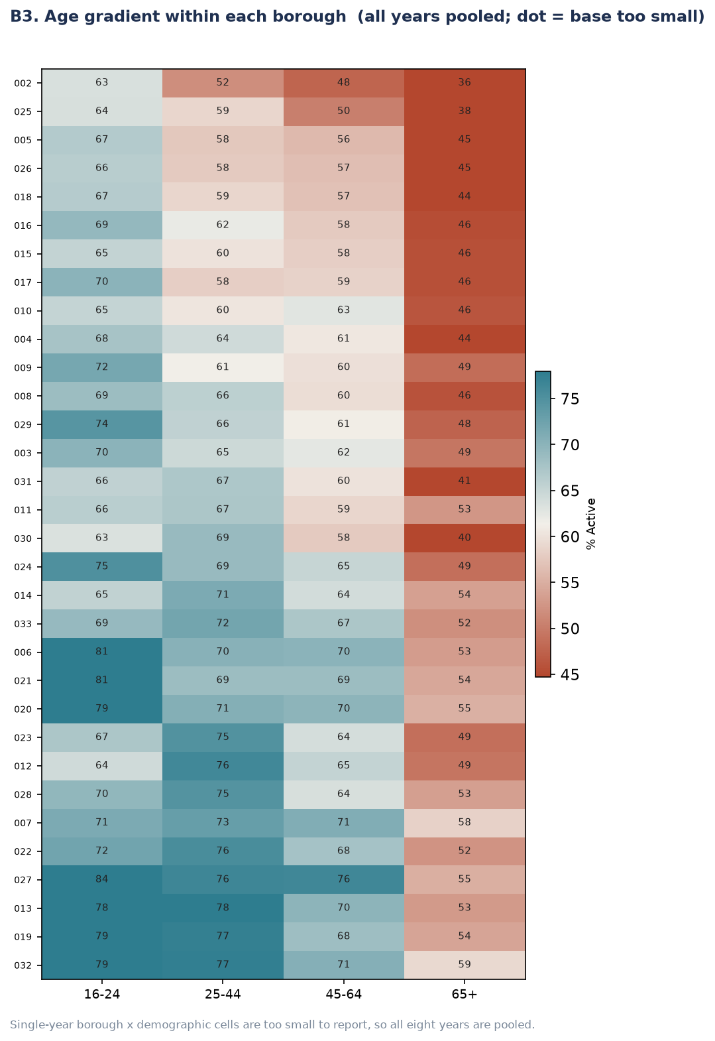
Figure P2.3. Age gradient within each borough, all waves pooled (borough rows are numeric codes pending name labels — see note below).
Insight: the age gradient (16–24 most active, 65+ least active) holds inside every one of the 32 boroughs without exception — there is no borough where older residents are more active than younger ones. But both the overall level and the size of the age gap vary sharply by borough. The widest age gap in the dataset is 29 points (84% for 16–24 falling to 55% for 65+); the narrowest is 13 points. This means a young adult in a low-activity outer borough can have a lower activity rate than an older adult in a high-activity inner borough — place and demography compounding rather than offsetting one another, consistent with the borough-level place effects identified in the forecasting methodology.
Action needed before this chart is presentation-ready: the y-axis currently shows internal numeric borough codes (e.g. ‘027’, ‘002’), not borough names. These need to be mapped back to borough names using the LA_code crosswalk (Section 3.3.1) before this figure goes into the final report, otherwise the borough-specific finding above cannot be attributed to a named borough.

Likelihood of participation among people with health conditions
This bullet is reported descriptively rather than forecast, for two methodological reasons rather than a data-availability oversight alone.
- A stable trend cannot be estimated. Self-rated health is available from 2018–19 onwards — five waves — but two of those five (2019–20 and 2020–21) are COVID-disrupted and are excluded as unrepresentative. That leaves three clean years, which cannot reliably distinguish a genuine trend from noise; a line drawn through three points is not evidence of a trend.
- Health cannot be added to the propensity model. The forecasting engine works by pushing a projected future population through the model, which requires a basis for projecting how that variable will change — and London's future health distribution cannot be projected from this data. Health is also missing entirely from the three earliest waves; had those gaps been filled, the model could learn 'health is missing' as a proxy for 'this is an early wave', contaminating every other trend in the model. This is why health was excluded from the propensity model entirely (Section 3.6/3.7), not only from the forecast.
It is nonetheless reported here because the relationship is too strong to omit: self-rated health is the steepest single relationship in the entire dataset, a 56-point span from 76% active at 'very good' health to 20% active at 'very bad' health — wider than the gap for any demographic group in this section.
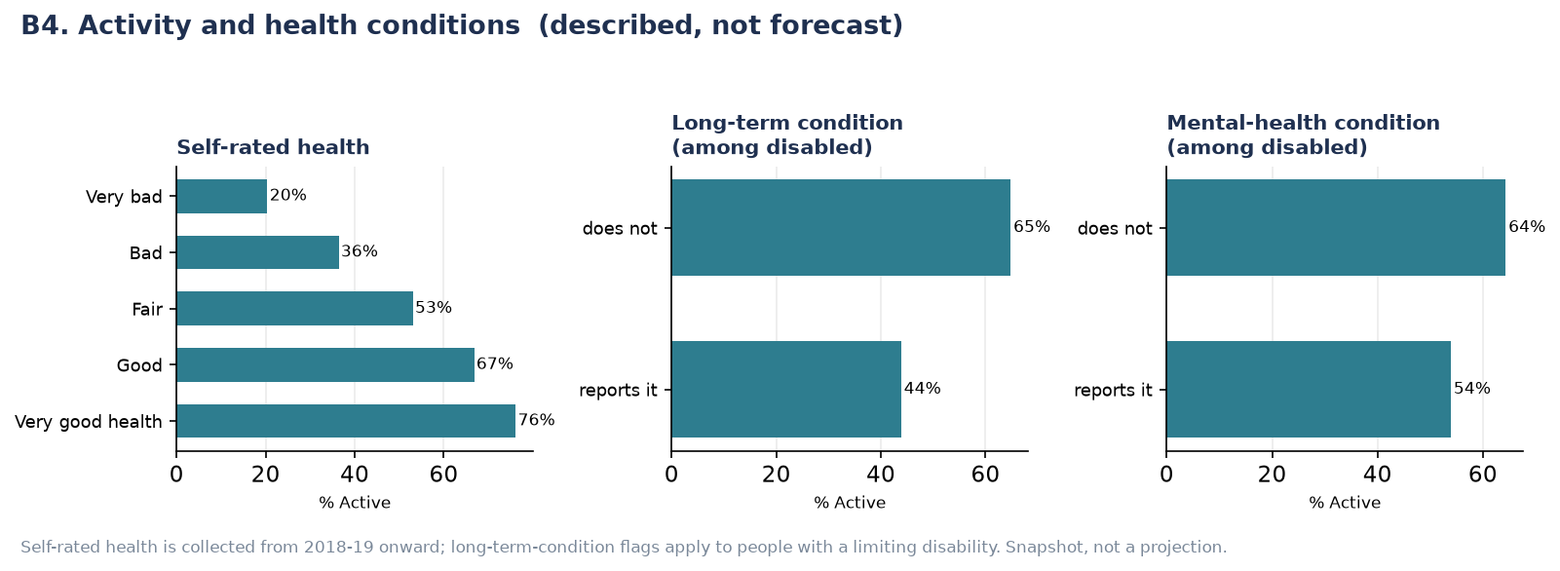
Figure P2.4. Activity by self-rated health, long-term condition and mental-health condition. Described, not forecast.
Insight: the gradient is graded, not a simple binary — activity falls in a near-straight line across all five self-rated health bands (76% → 67% → 53% → 36% → 20%), rather than only differing between 'healthy' and 'unhealthy'. Among people with a limiting disability, those who also report a long-term physical condition are 21 points less active than those who do not (44% against 65%); those who report a mental-health condition are 10 points less active than those who do not (54% against 64%) — a real but smaller gap than for physical long-term conditions.
This relationship is reported as an association, not a one-directional cause: poor health can reduce activity, but inactivity is also known to worsen health outcomes over time. Neither this dataset nor the modelling approach used here can separate the two directions of causation.

Supplementary Figures
The individual-group charts below are provided for completeness; each shows, at larger scale, one panel already summarised in Figures P2.1 and P2.2 above.

Forecast by individual demographic group
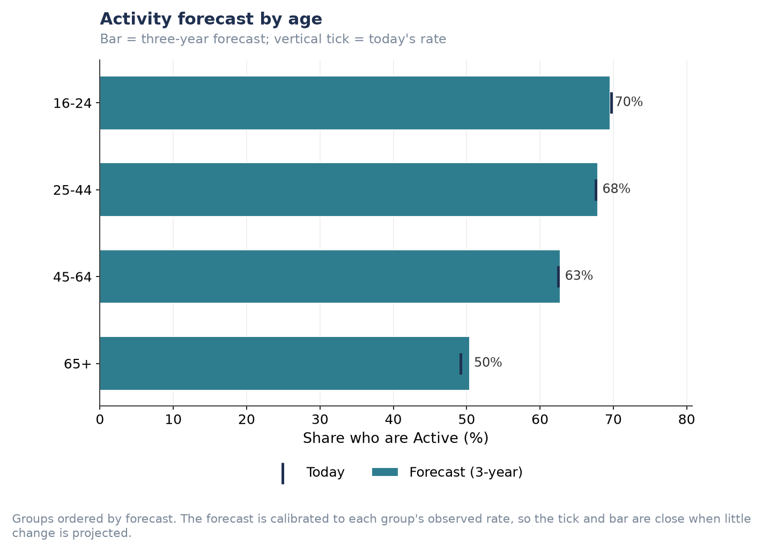
Figure P2.S1. Activity forecast by age.
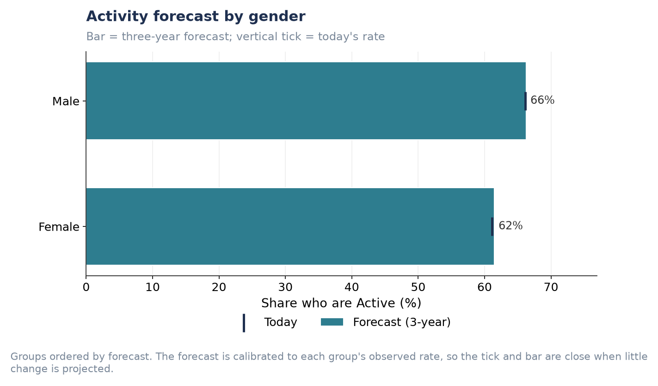
Figure P2.S2. Activity forecast by gender.
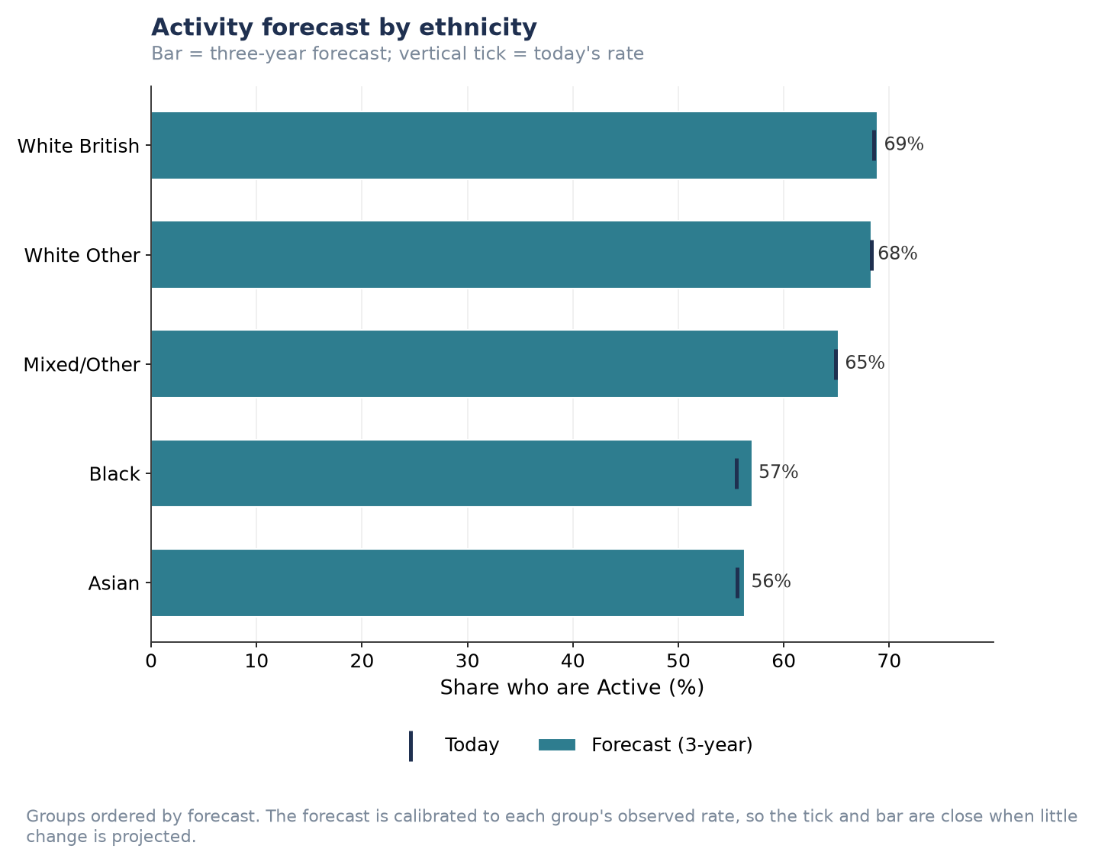
Figure P2.S3. Activity forecast by ethnicity.
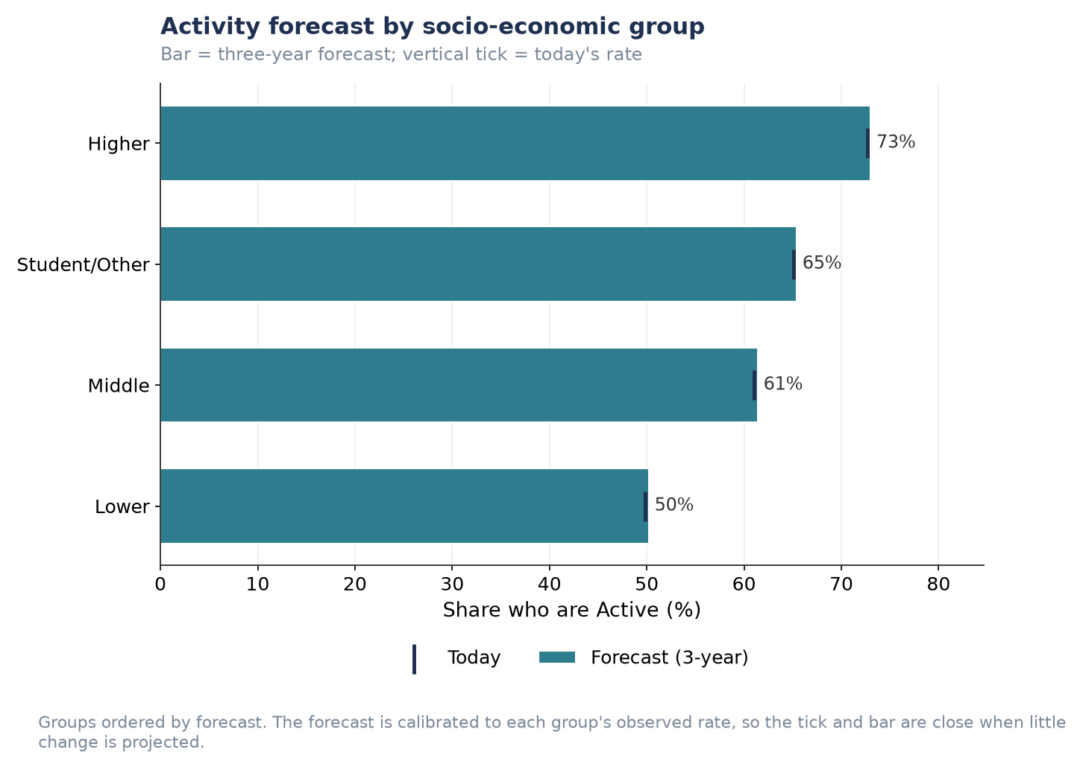
Figure P2.S4. Activity forecast by socio-economic group.
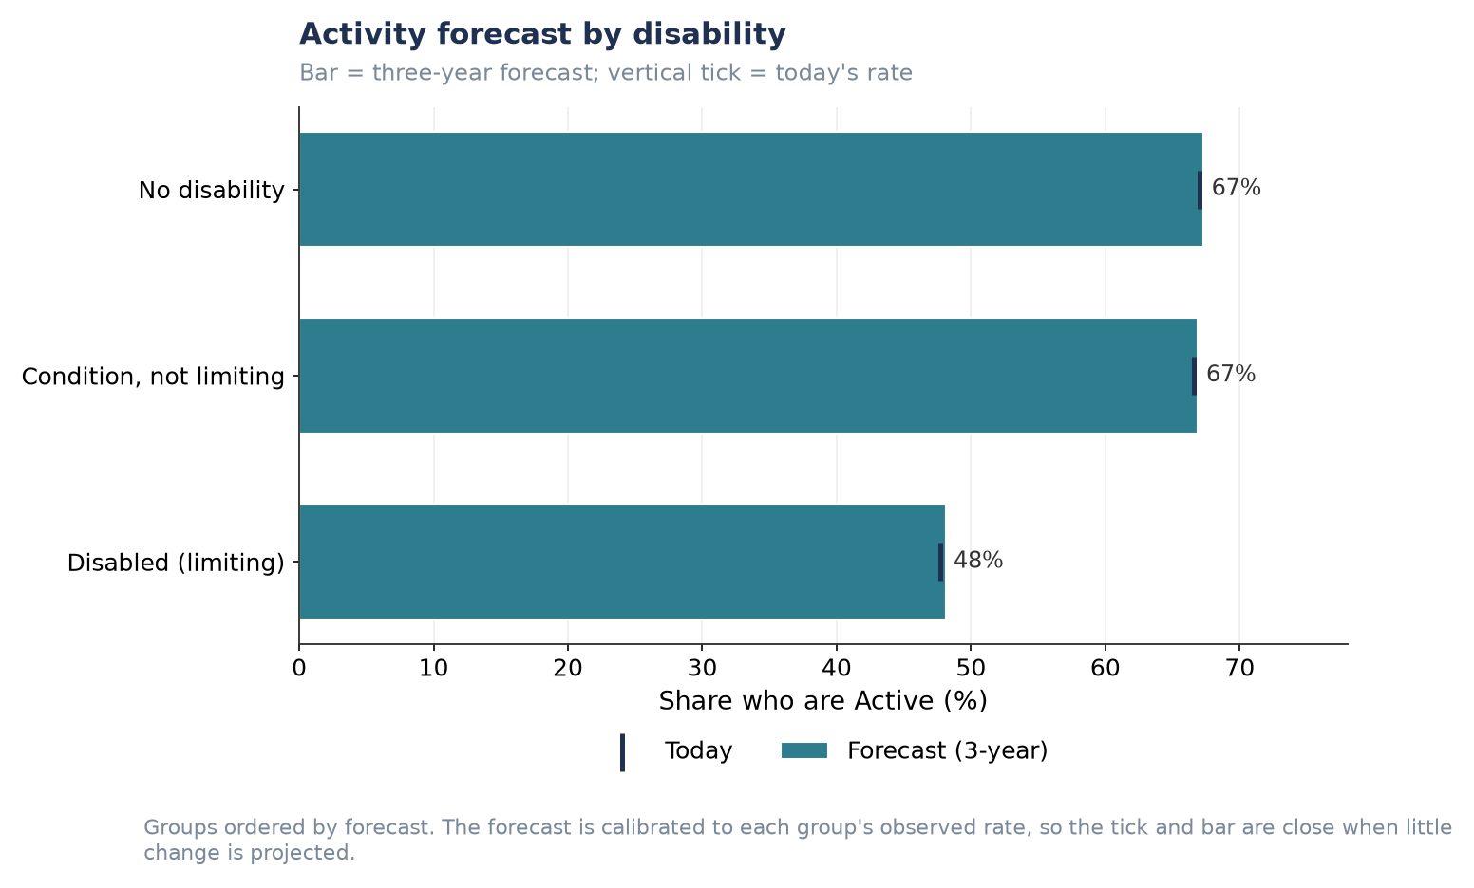
Figure P2.S5. Activity forecast by disability status.

Preferred activities by individual demographic group
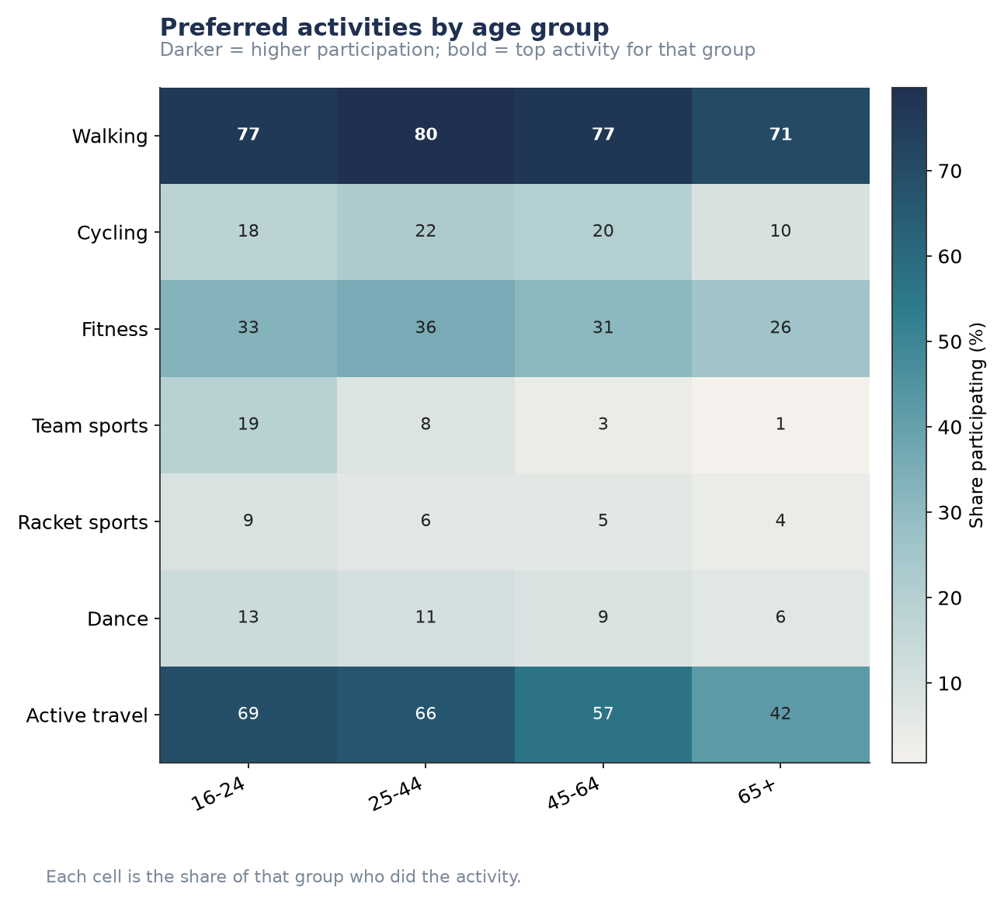
Figure P2.S6. Preferred activities by age group.
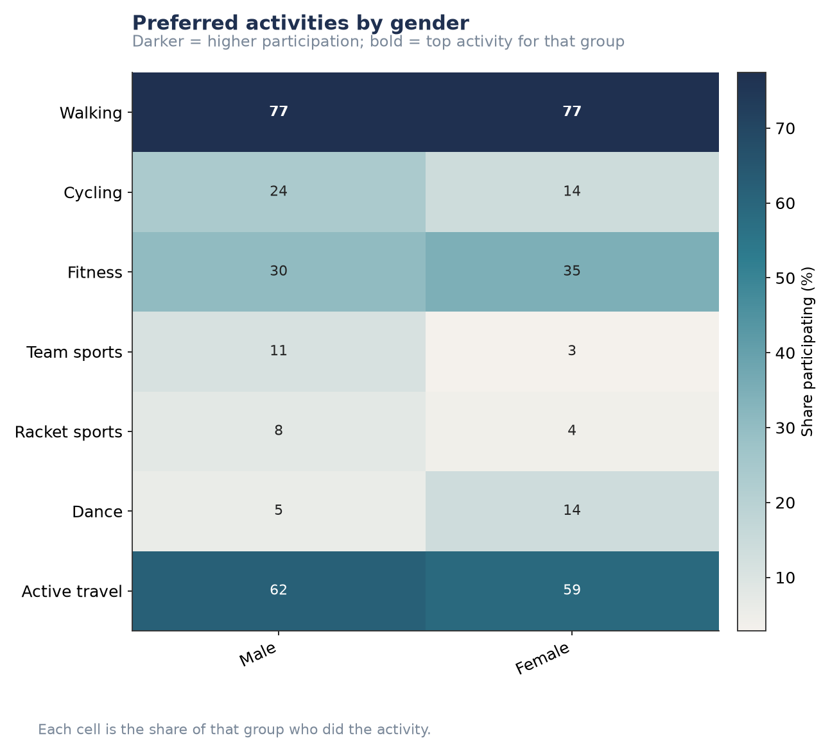
Figure P2.S7. Preferred activities by gender.
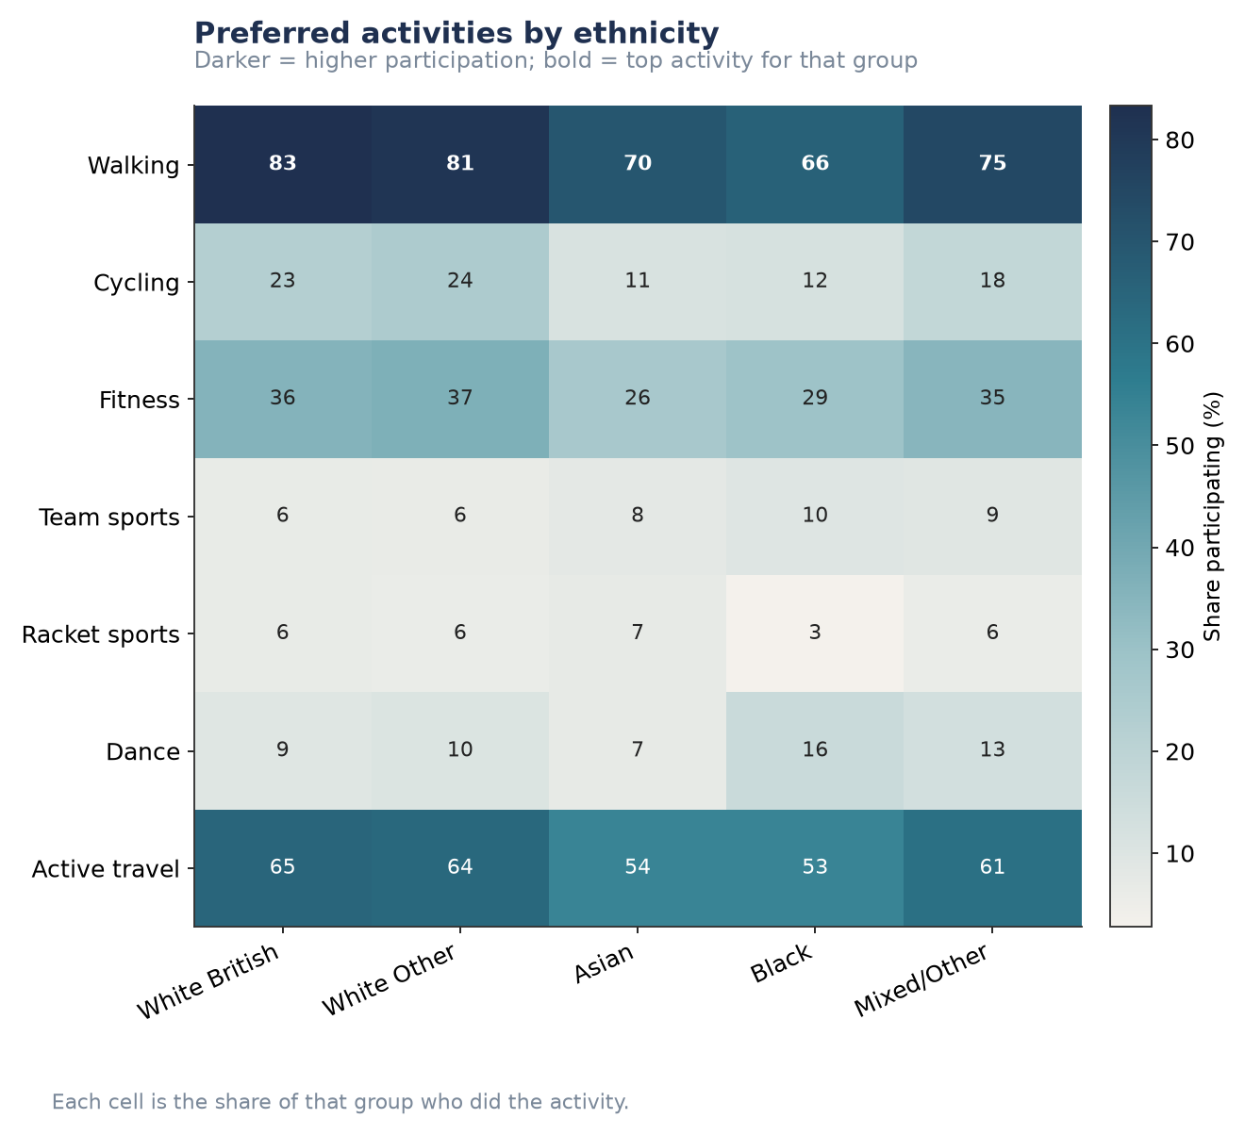
Figure P2.S8. Preferred activities by ethnicity.
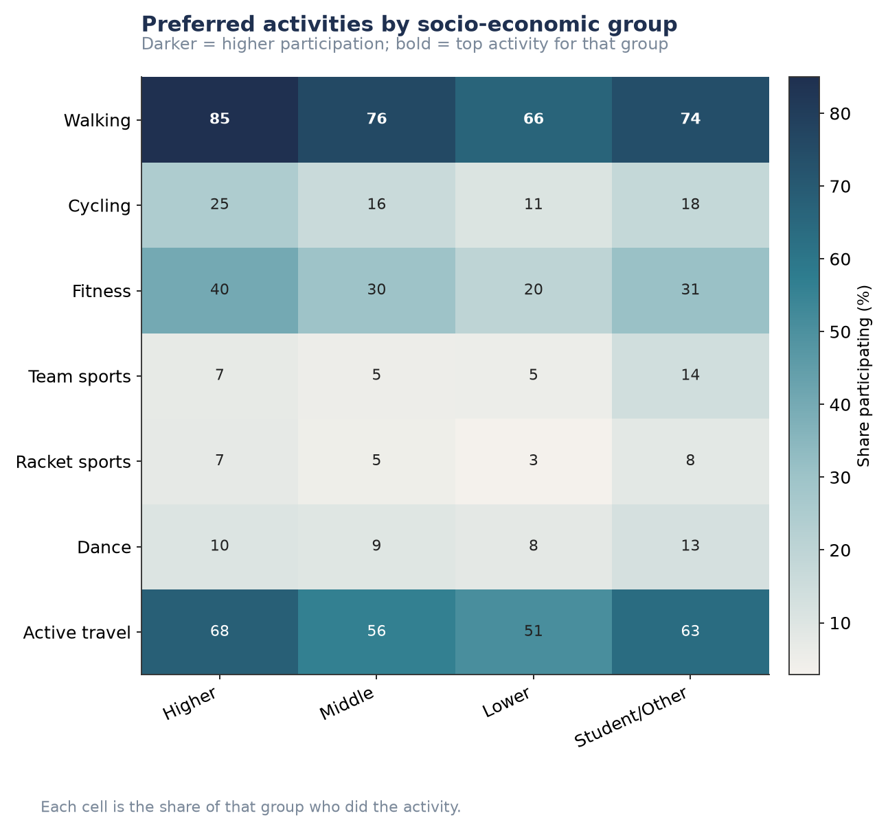
Figure P2.S9. Preferred activities by socio-economic group.
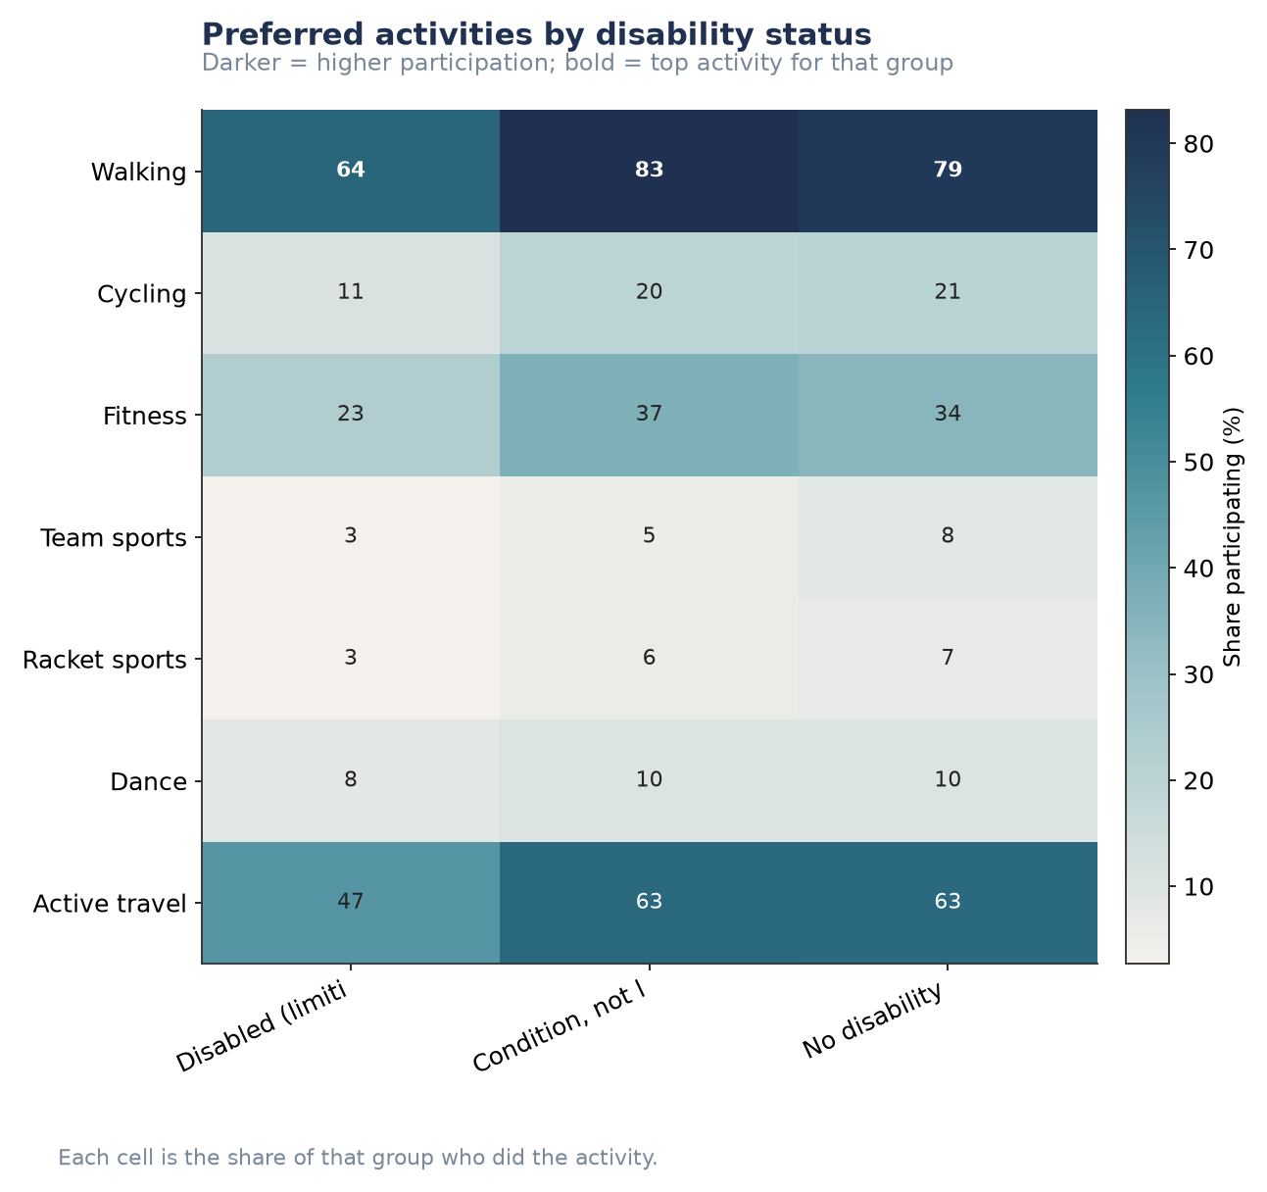
Figure P2.S10. Preferred activities by disability status.

Health conditions, individual breakdowns
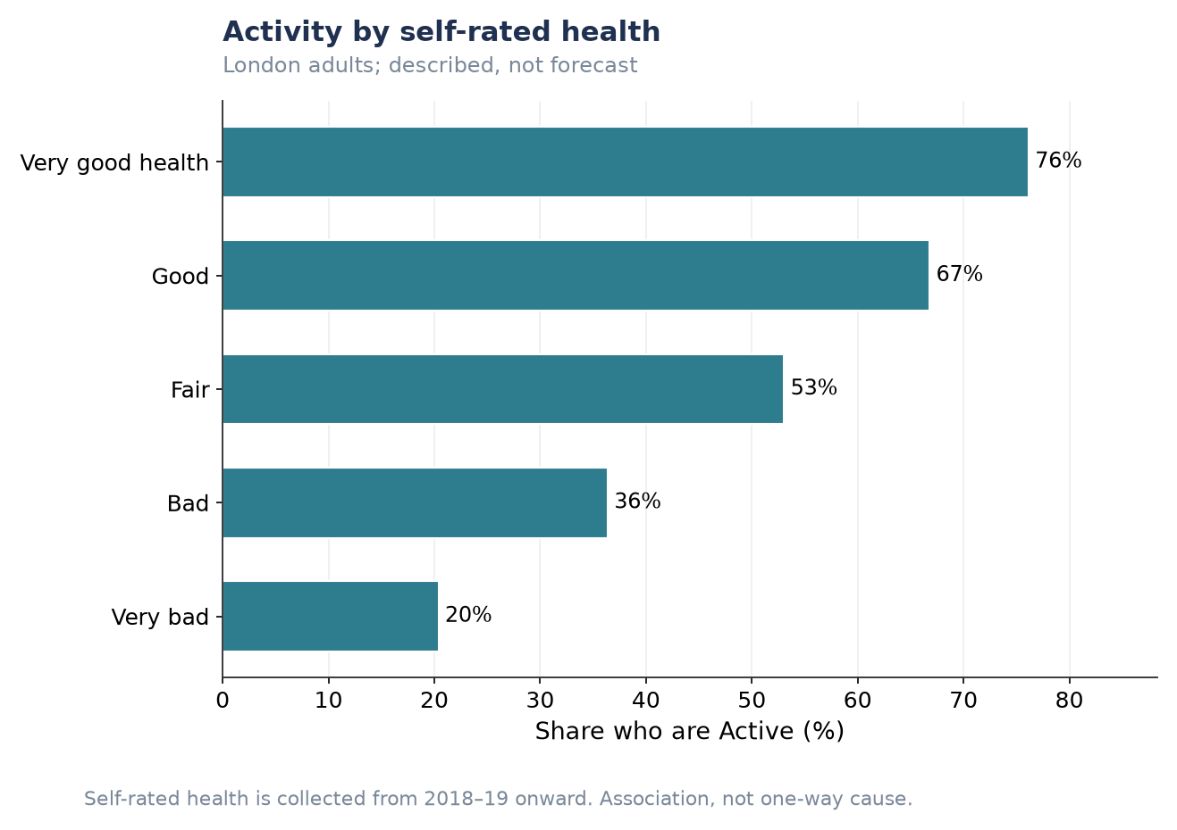
Figure P2.S11. Activity by self-rated health.
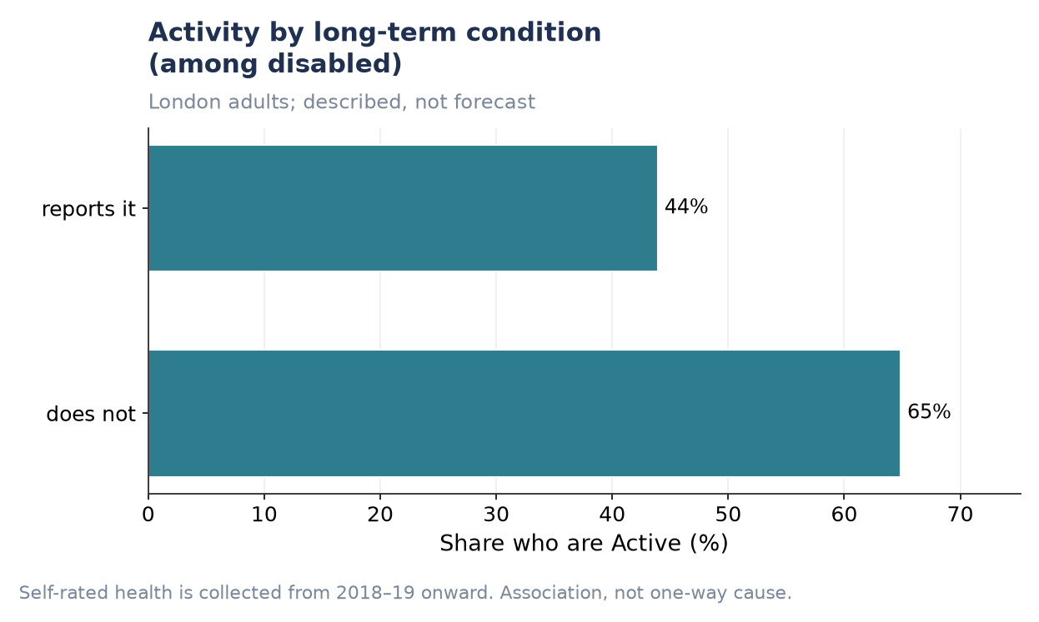
Figure P2.S12. Activity by long-term condition (among disabled respondents).
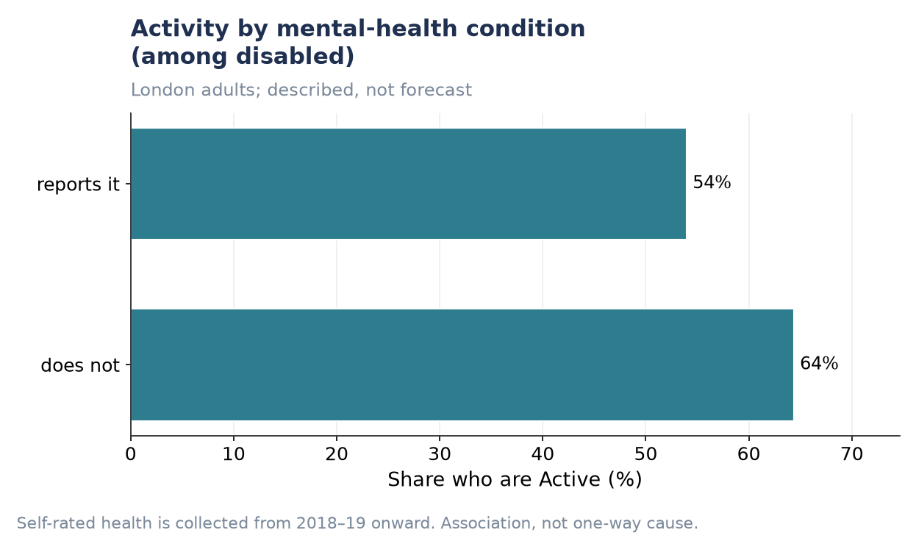
Figure P2.S13. Activity by mental-health condition (among disabled respondents).

