P3 — Indoor vs Outdoor Activity
This section reports the London Sport brief's third pillar: the balance of indoor versus outdoor physical activity. Indoor/outdoor setting questions are asked of a rotating subsample of approximately a third of respondents, so every figure in this section rests on a smaller base than the P1/P2 figures and several bullets are reported as description rather than forecast — each is labelled accordingly below.

The expected balance of indoor versus outdoor physical activity over the next ten years
Data note: this bullet asks for a ten-year outlook. The available projection covers three years only (to 2025–26), built by extending the pre-COVID slope for a ~30% subsample, and is explicitly labelled indicative rather than a full forecast. It is reported here as the best available evidence for this bullet, not as a completed ten-year answer — the same gap already flagged for the equivalent P1 activity-level projections.
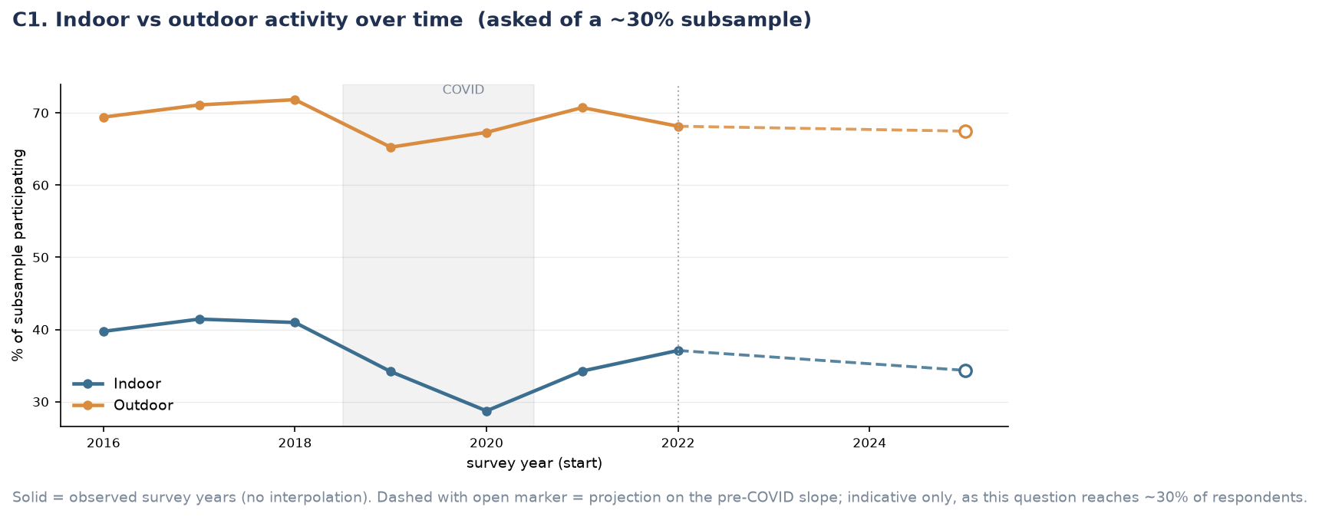
Figure P3.1. Indoor vs outdoor activity over time, observed 2016–2022 and projected to 2025.
Insight: outdoor activity is both far more common and more resilient than indoor activity. Outdoor participation sits around 65–72% throughout the observed period against indoor's 29–42%, and while both fell during COVID, indoor fell further in relative terms (from 41% in 2018 to a low of 28.7% in 2020, a 30% relative drop) and has not recovered as cleanly — it reaches only 37.0% by 2022 against a pre-COVID level of 41%. The indicative projection continues this pattern: indoor is expected to decline further to 34.2% by 2025, while outdoor holds broadly flat at 67.4%. If this projection holds, the gap between indoor and outdoor participation widens over the near term rather than narrowing.

Differences in indoor and outdoor activity preferences among people with varying activity levels
Indoor and outdoor participation were broken down by activity level (Fairly Active, Active). Inactive respondents are not shown, since participation in any setting is zero by definition for this group rather than a reporting gap.
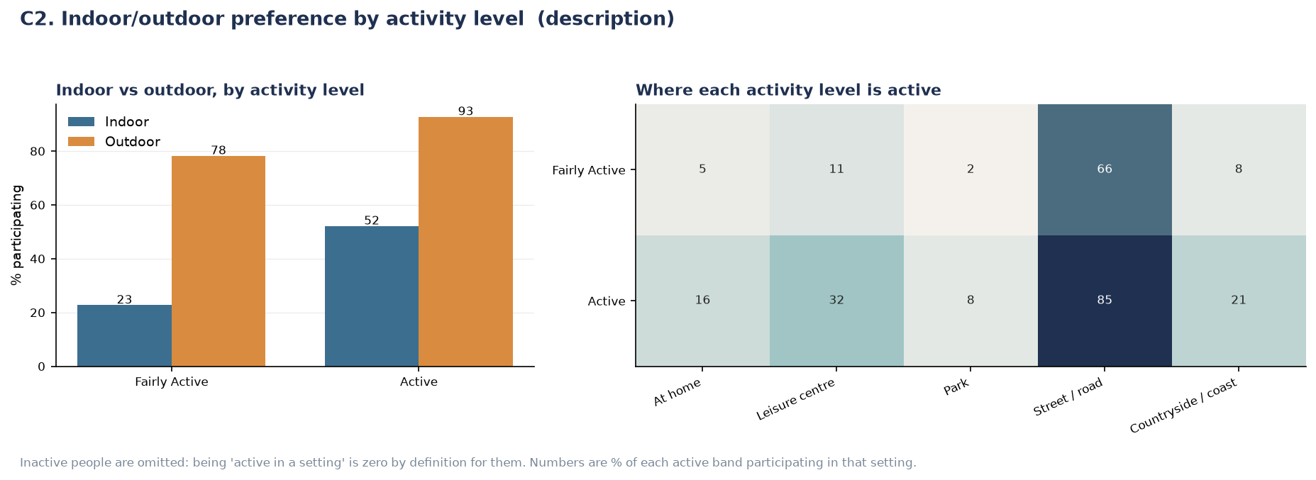
Figure P3.2. Indoor/outdoor preference by activity level, and where each activity level is active.
Insight: indoor activity scales far more steeply with overall activity level than outdoor activity does. Active adults are 2.3 times as likely as Fairly Active adults to do something indoors (52% against 23%), but only 1.2 times as likely outdoors (93% against 78%). In other words, outdoor activity is close to a baseline behaviour that most Fairly Active and Active adults share regardless of how active they are overall, while indoor activity is the setting that actually distinguishes the more active from the less active. This is consistent with indoor activity depending more heavily on facility access and habit-formation (gyms, leisure centres, structured classes) than outdoor activity, which requires only a street, a park or a doorway.
Insight: within each setting, the pattern is dominated by one location. Street or road accounts for the large majority of outdoor activity in both bands (66% Fairly Active, 85% Active) and shows the smallest relative gap between bands (1.3×) — consistent with its low barrier to entry (walking, active travel). Park-based activity has the widest relative gap of any single setting (2%→8%, 4×) despite its small base, suggesting park use specifically, rather than outdoor activity generally, is the more distinguishing behaviour of the two. Indoors, leisure-centre use (11%→32%) and at-home activity (5%→16%) show broadly similar relative scaling (around 3× each).

Relationships between inner vs outer London locations, activity levels and socio-economic factors
Data note: it is not stated on the chart whether this breakdown is restricted to active/fairly active respondents (consistent with the setting-subsample base used elsewhere in this section) or computed across all respondents. This should be confirmed with the analysis before the finding below is finalised in the report, since it affects how the percentages should be read.
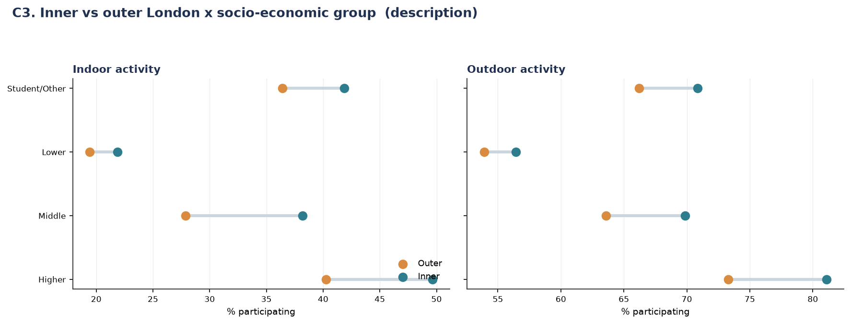
Figure P3.3. Inner vs outer London × socio-economic group, indoor and outdoor activity.
Insight: inner London shows higher participation than outer London in every socio-economic group, for both indoor and outdoor activity, without exception — but the size of that inner-London advantage is not uniform. For the Lower socio-economic group the inner/outer gap is narrow in both settings (around 2.5 points indoor, 2 points outdoor). For the Higher and Middle groups the gap is substantially wider (6–10 points in both settings). Put another way, being in inner London helps every socio-economic group, but it helps the already-more-active higher socio-economic groups more — geography amplifies the socio-economic gap rather than narrowing it.
Insight: the socio-economic gap dominates the geographic one: even the most favourable geographic position for the Lower group (inner London, 22% indoor / 56% outdoor) does not reach the least favourable geographic position for the Higher group (outer London, 40% indoor / 73% outdoor). This mirrors the P1/P2 finding that socio-economic group produces the widest gap of any factor measured across this project — geography here is a secondary, amplifying factor rather than the primary driver.

Supplementary Figures
Individual breakdowns underlying the combined figures above, provided for completeness.

Indoor vs outdoor, by activity level (individual charts)
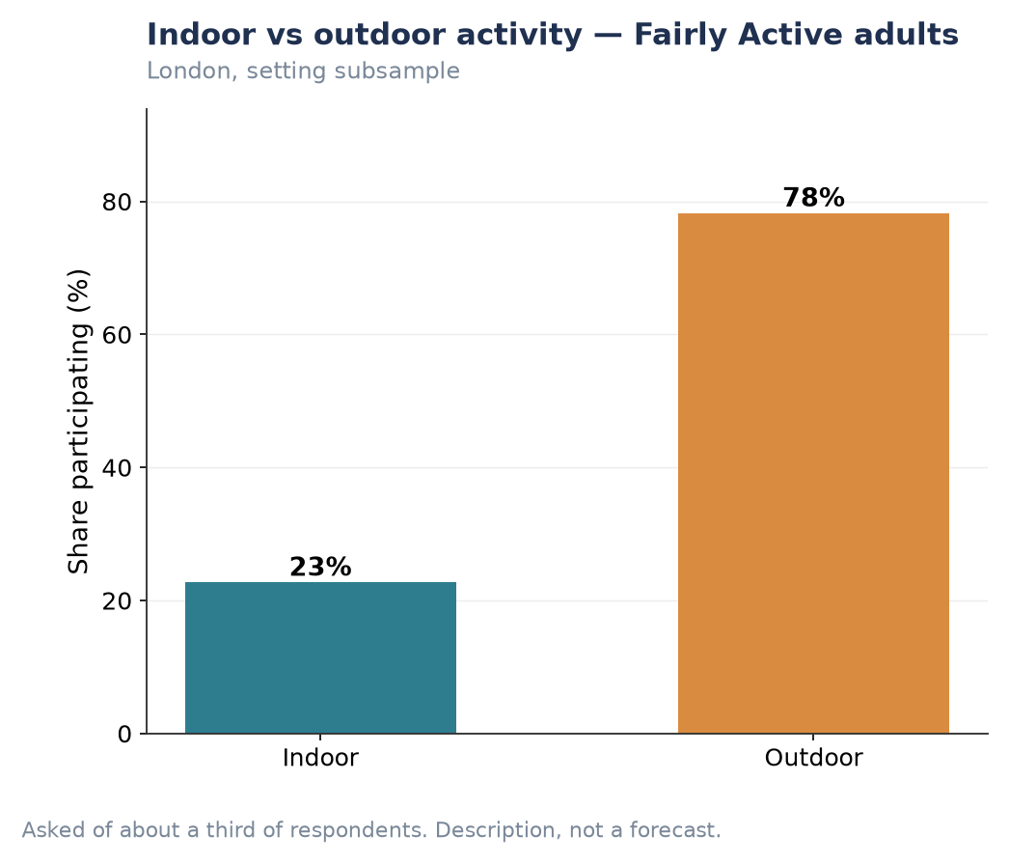
Figure P3.S1. Indoor vs outdoor activity — Fairly Active adults.
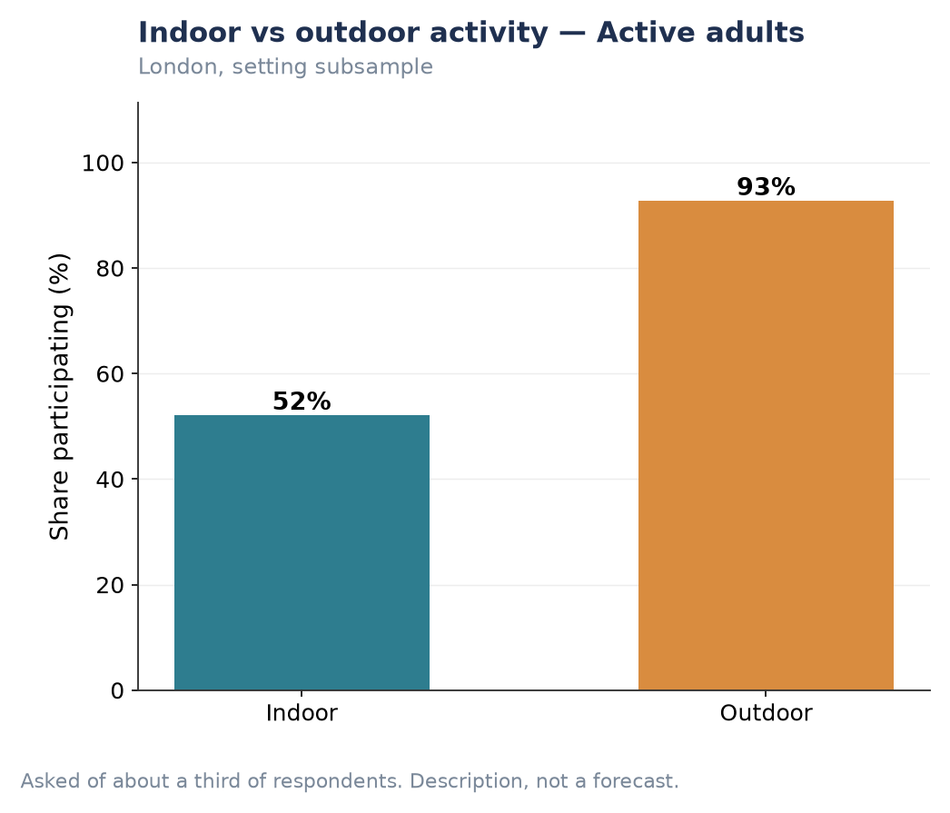
Figure P3.S2. Indoor vs outdoor activity — Active adults.
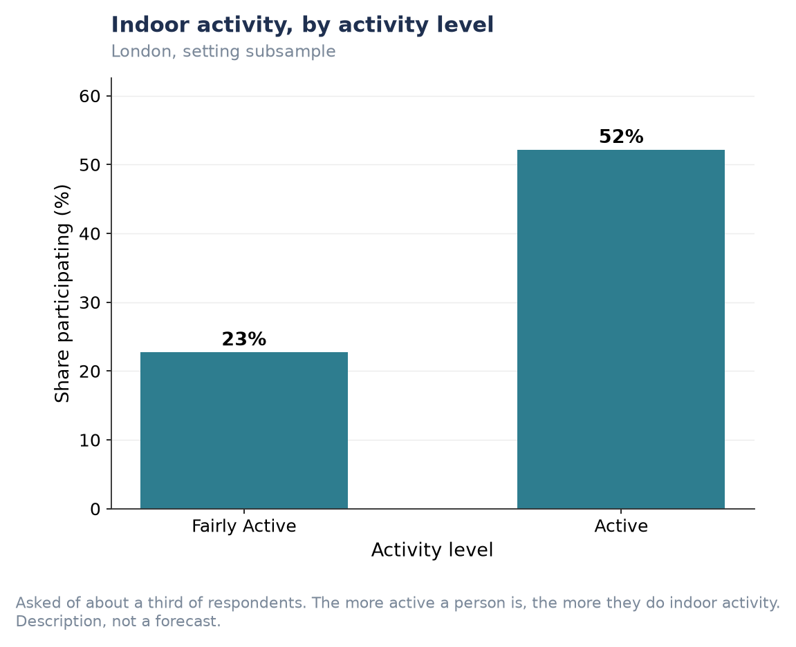
Figure P3.S3. Indoor activity, by activity level.
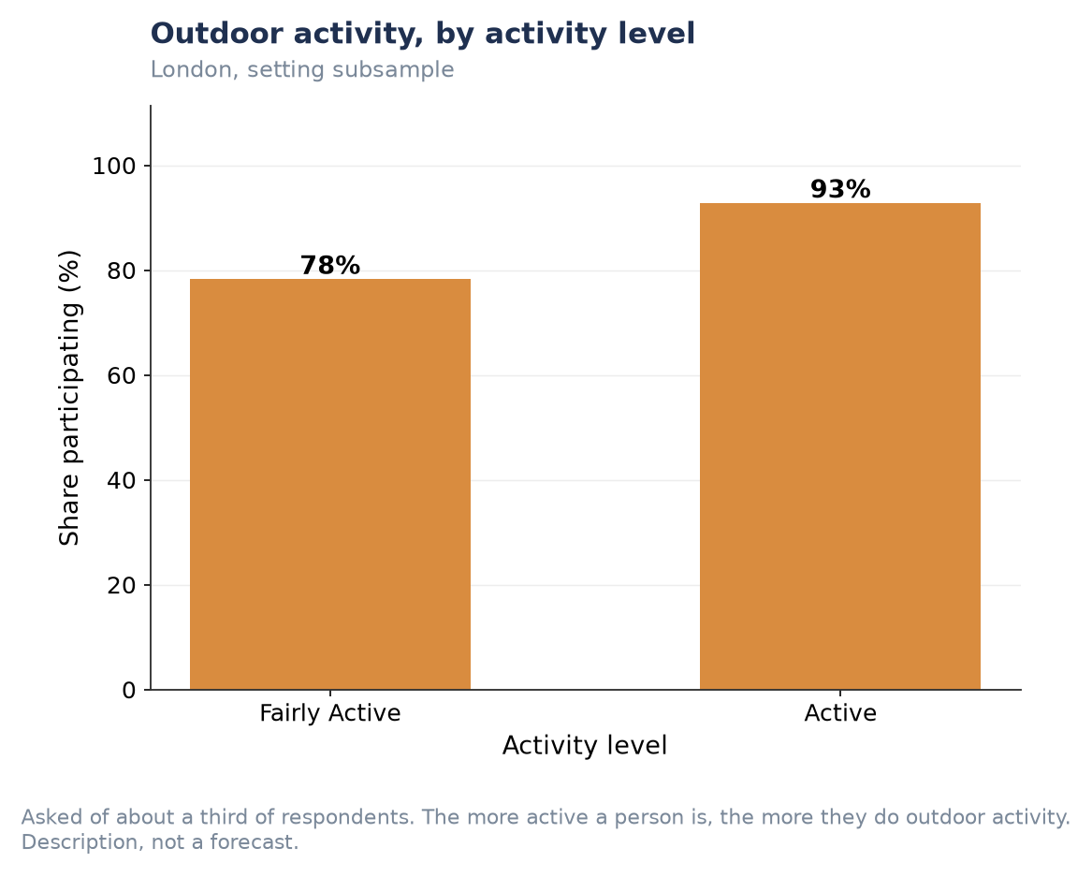
Figure P3.S4. Outdoor activity, by activity level.
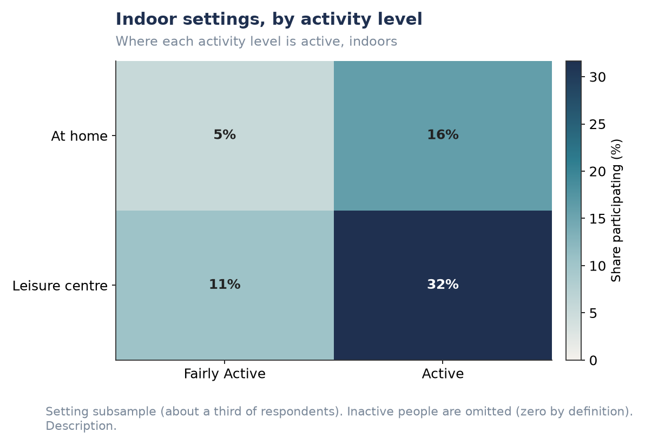
Figure P3.S5. Indoor settings, by activity level (at home / leisure centre).
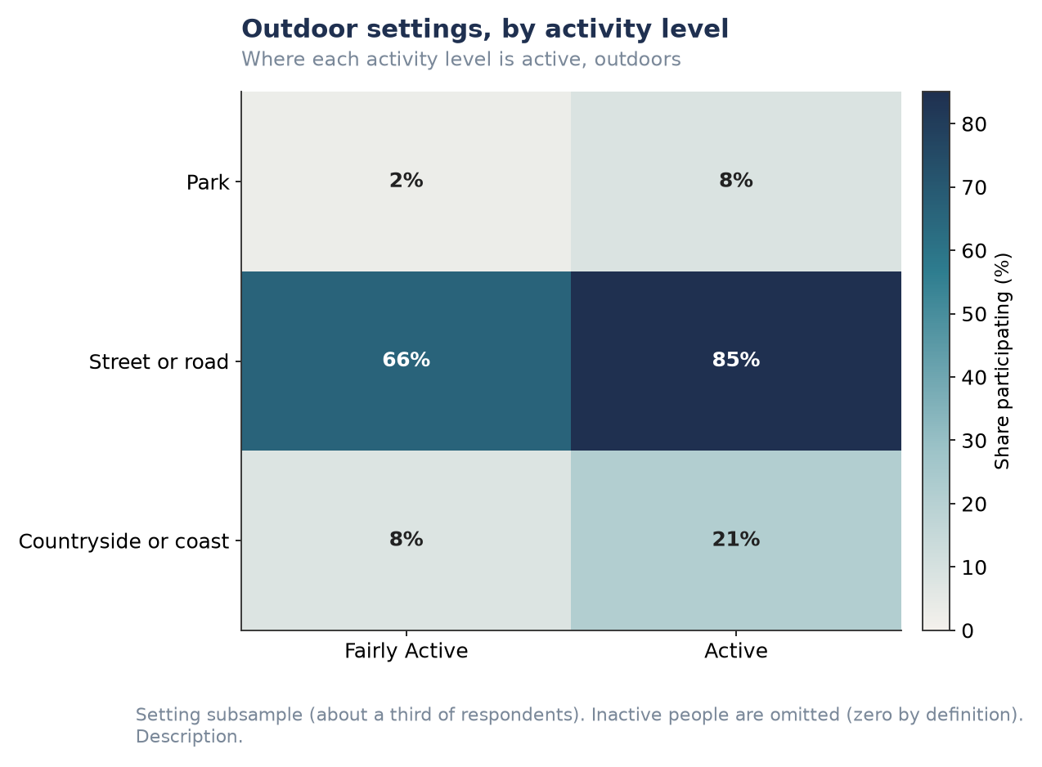
Figure P3.S6. Outdoor settings, by activity level (park / street / countryside).

Inner vs outer London by socio-economic group (individual charts)
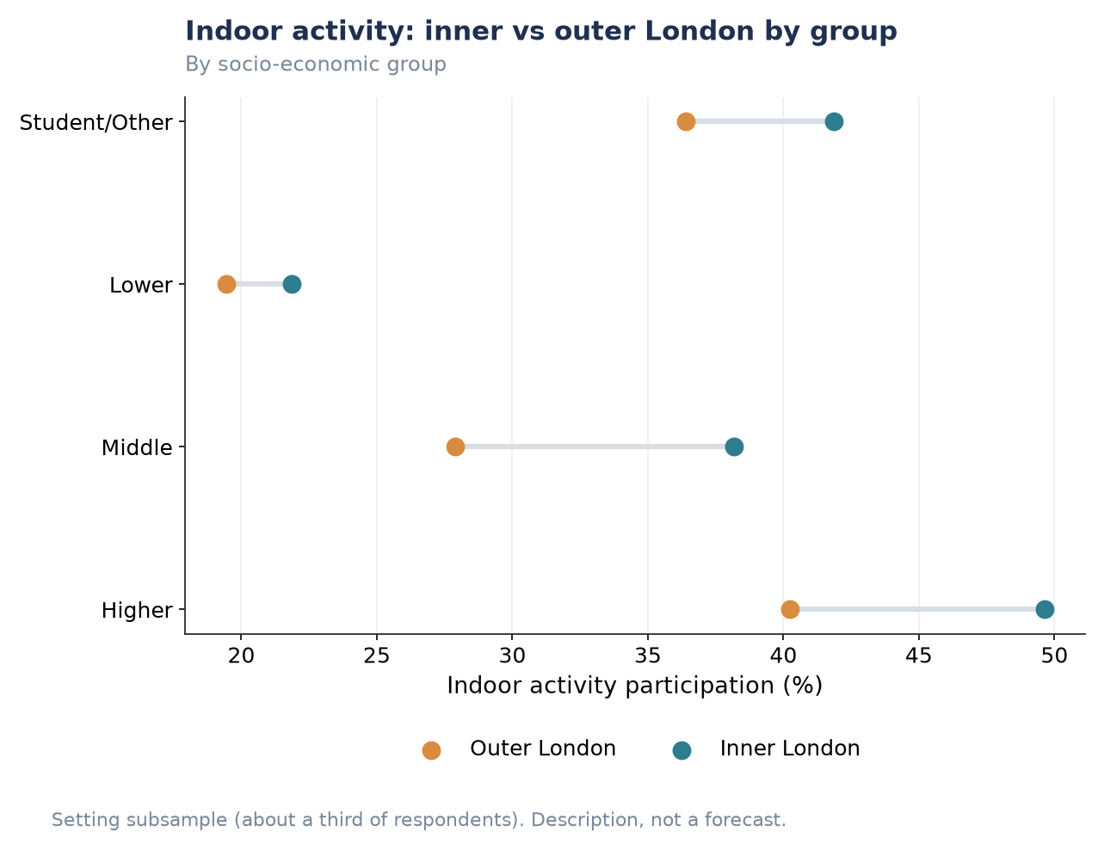
Figure P3.S7. Indoor activity: inner vs outer London by socio-economic group.
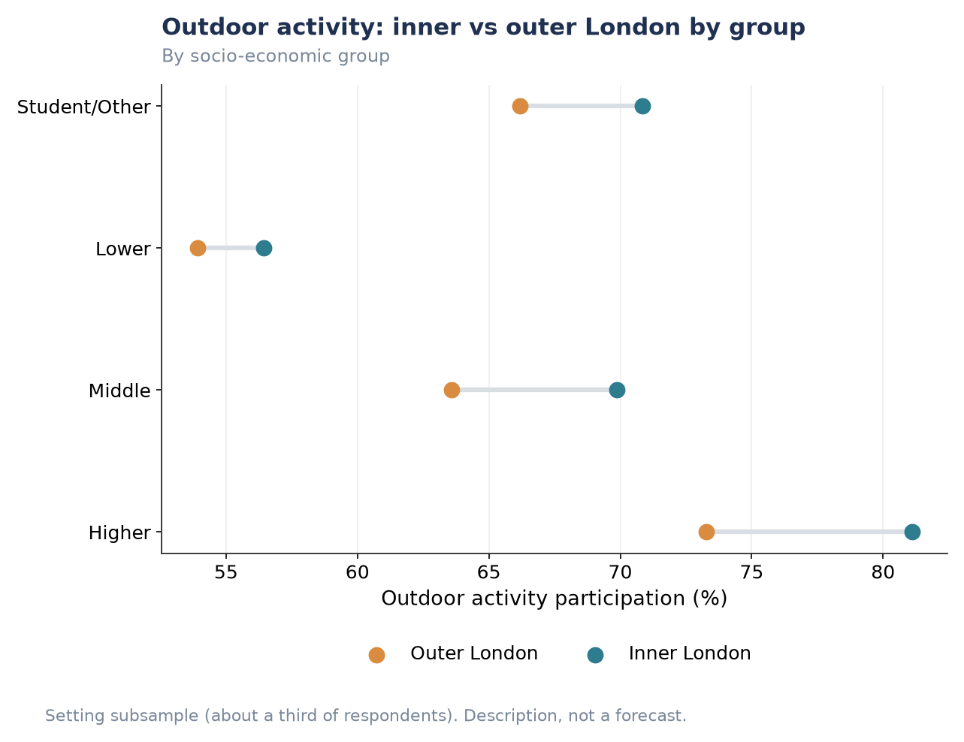
Figure P3.S8. Outdoor activity: inner vs outer London by socio-economic group.

