**ASSIGNMENT-1**

**Q1.** **Discuss the prototyping model. What is the effect of designing a prototype on the overall cost of the**

**project?**

**Ans-**

* In a prototype model, a prototype of the end product is first developed, tested and refined as per customer feedback repeatedly till a final acceptable prototype is achieved which forms the basis for developing the final product.
* In this process model, the system is partially implemented before or during the analysis phase thereby giving the customers an opportunity to see the product early in the life cycle.
* The process starts by interviewing the customers and developing the incomplete high-level paper model.
* This document is used to build the initial prototype supporting only the basic functionality as desired by the customer. Once the customer figures out the problems, the prototype is further refined to eliminate them.
* The process continues until the user approves the prototype and finds the working model to be satisfactory.

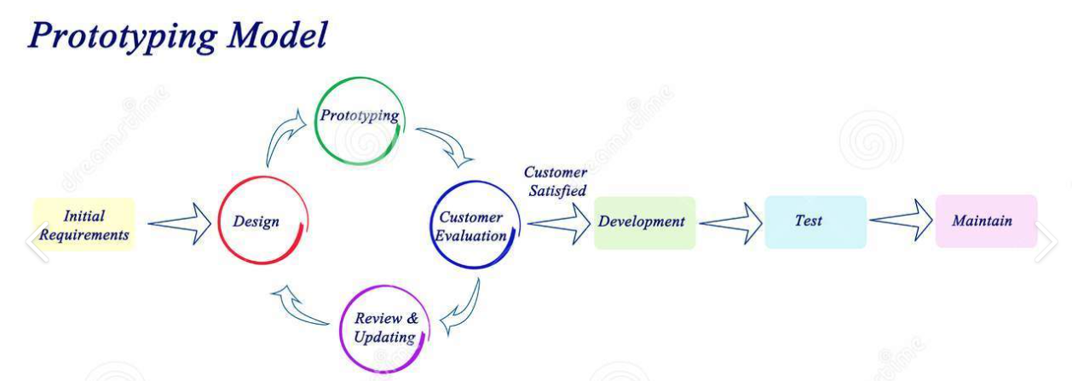

**Fig- Phases in the Prototype model**

>Effects on the cost of project:

* Cost of the development of the software by using prototyping model can be increased because It may take more time to develop a software by using Prototyping model.

**Q2. Compare iterative enhancement model and evolutionary process model.**

**Ans-**

Iterative Enhancement model

# (Incremental Model)

Evolutionary process model

1. The Iterative Enhancement Model is an **1.** The Evolutionary Enhancement Model is

approach to building software in which designed to be allowed to evolve in

the overall lifecycle is compose of response to customers feedback.

several iterations in sequence.

**2**. **When to use this: 2. When to use this:**

2.1Funding Schedule, Risk, Program Complexity, 2.1 Customer need are clear and been explained

or need for early realization of benefits.  In deep to developer team.

2.2 When Requirements are known up-front.  2.2 As it require time ,so there must some time

2.3. When Projects have lengthy left for the market constraints.

development schedules.  2.3 When there are small changes required in

2.4 Projects with new Technology.  Separate part but not a major changes.

* Error Reduction (core modules are used 2.4 Working on new technology which requires

by the customer from the beginning of time to lear.

the phase and then these are tested

thoroughly).

* Uses divide and conquer for a 2.5 When risk is high and continuous targets

breakdown of tasks.  To achieve and report to customer repeatedly

* Lowers initial delivery cost.
* Incremental Resource Deployment.

2.5 Requires good planning and design.

2.6 The total cost is not lower.

2.7 Well-defined module interfaces are required.

3. **Advantages- 3. Advantages-**

3.1Prepares the software fast. 3.1 user get chance to experiment partially

3.2Clients have a clear idea of the project. Develop system.

3.3Changes are easy to implement. 3.2 It reduces the error because the core

3.4Provides risk handling support, module get tested thoroughly.

because of its iterations.

4. **Disadvantages-** 4. **Disadvantages-**

1. A good team and proper planned 4.1 its difficult to divide the problem into

execution are required. Several versions that would be acceptable

1. Because of its continuous to customer which can incrementally

iterations the cost increases. Implemented and delivered.

**Q3 As we move outward along with process flow path of the spiral model, what can we say about software that is being developed or maintained.**

**Ans-**

**Q4 Explain the Scrum Agile methodology.**

**Ans- Introduction:**

* Scrum is an agile development methodology used in the development of Software based on an iterative and incremental processes.  Scrum is adaptable, fast, flexible and effective agile framework that is designed to deliver value to the customer throughout the development of the project.
* The primary objective of Scrum is to satisfy the customer’s need through an environment of transparency in communication, collective responsibility and continuous progress.
* The development starts from a general idea of ​​what needs to be built, elaborating a list of characteristics ordered by priority (product backlog) that the owner of the product wants to obtain.

##### Scrum Methodology & Process

##### Scrum is precisely an evolution of Agile Management. Scrum methodology is based on a set of very defined practices and roles that must be involved during the software development process.

##### It is a flexible methodology that rewards the application of the 12 agile principles in a context agreed by all the team members of the product.

* Scrum is executed in temporary blocks that are short and periodic, called Sprints, which usually range from 2 to 4 weeks, which is the term for feedback and reflection.
* Each Sprint is an entity in itself, that is, it provides a complete result, a variation of the final product that must be able to be delivered to the client with the least possible effort when requested.
* The process has as a starting point, a list of objectives/ requirements that make up the project plan. It is the client of the project that prioritizes these objectives considering a balance of the value and the cost thereof, that is how the iterations and consequent deliveries are determined.
* to achieve short development cycles that can meet the demand of customers without undermining the quality of the result. It is a very easy methodology to implement and very popular for the quick results it gets.

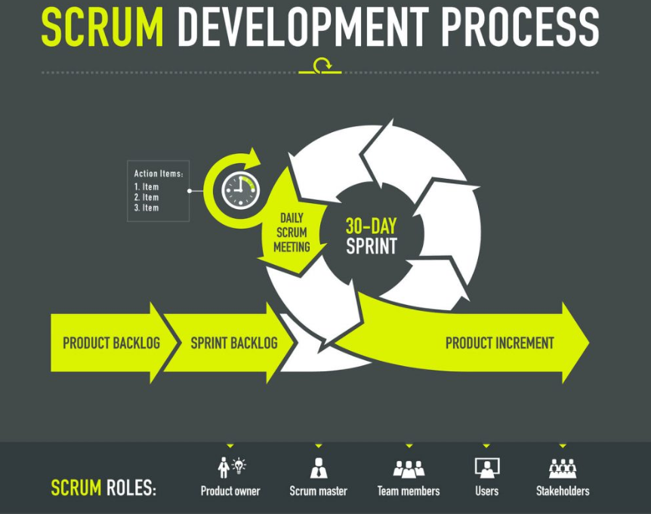

**The Scrum team consists of the following roles:**

**Scrum master:** The person who leads the team guiding them to comply with the rules and processes of the methodology. The Scrum Master is in charge of keeping Scrum up to date, providing coaching, mentoring and training to the teams in case it needs it.

**Product owner (PO):** Is the representative of the stakeholders and customers who use the software. They Translate the vision of the project to the team, validate the benefits in stories to be incorporated into the Product Backlog and prioritize them on a regular basis.

**Team:** A group of professionals with the necessary technical knowledge who develop the project jointly carrying out the stories they commit to at the start of each sprint.

##### **Benefits of Scrum Methodology**

* **Easily Scalable**
* **Compliance of expectations**
* **Flexible to changes**
* **Time to Market reduction**
* **Higher software quality**
* **Timely Prediction**
* **Reduction of risks**

The Six Scrum Principles are:  
1. Control over the empirical process  
2. Self-organization  
3. Collaboration  
4. Value-based prioritization  
5. Time-boxing  
6. Iterative development

##### 

##### **Events in Scrum**

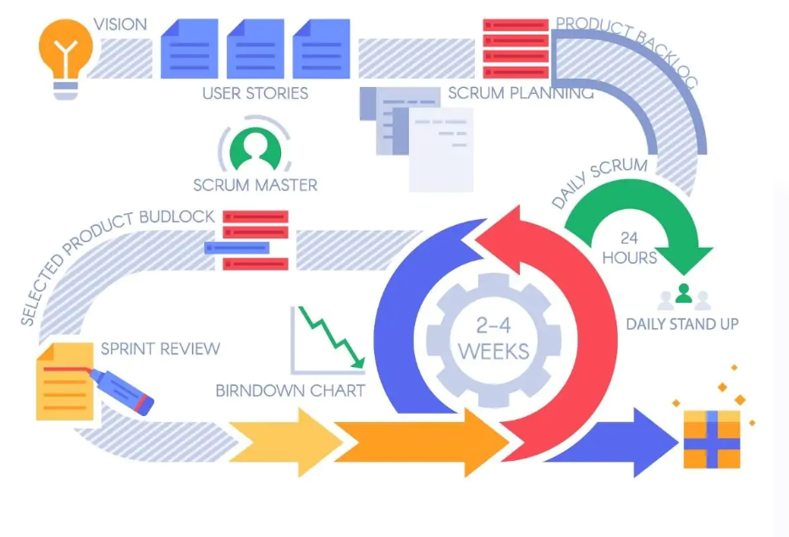

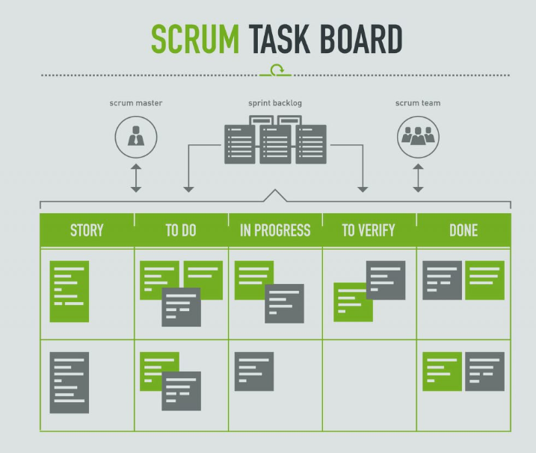

**Q5 Explain the utility of Kanban CFD reports.**

**Ans-** A cumulative flow diagram (CFD) is an advanced analysis tool. It allows teams to see how their workflow efforts and overall project progress are being visualized.

Teams can use the cumulative flow diagram to track how stable their workflow is, anticipate bottlenecks so they can alter their workflow accordingly, and make processes more predictable.

Utilities are:

* By graphing how tasks accumulate over time and their overall distribution across the process stages, cumulative flow diagrams visualize massive amounts of data from which you can gather quantitative and qualitative insights into past and present problems with your workflow stability—and where you should focus on making your processes more efficient.

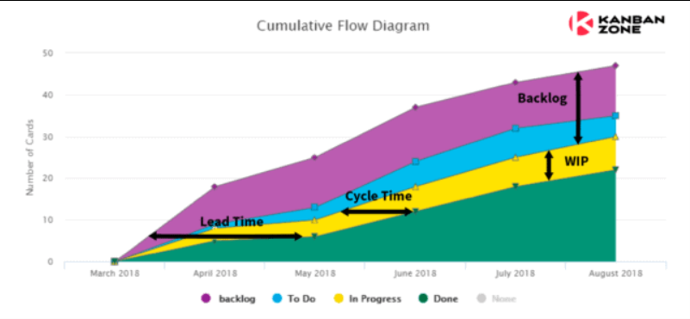

* **From above graph CFD provides the following details which help to analyse the project progress.**

1. **Narrowing bands** – these indicate that WiP(work in progress) items are decreasing, which means items are being completed faster than they come. This can signal that there is more capacity in this state compared to what’s needed. The team can probably assess if resources can be reallocated to balance out the flow.
2. **Widening bands** – these indicate that WiP(work in progress) items are increasing, which means that the entry rate of items into this state is higher than its exit rate. This denotes a bottleneck in the process and the team must analyse why items are being held up in this state.
3. **To Do band is wider than your Done band** – This means that the pace you are creating the work is faster than your team is able to process it. You must look into your *In Progress* states and analyse what is keeping your team from working on these items much faster.
4. **Slope going down** – as the Cumulative Flow Diagram is a historical graph of the *accumulated* items that the team worked on through time, data should not be removed or disappear. The slope should always be increasing. Therefore, if you notice a downward slope then something is wrong with your graph.