ITC5315: Project Status Report WK 1

Created by: YASH PRASAD

Student ID: N01552931

Date: 2024-04-07

# Table of contents

Table of contents 1

Step 0 2

Step 1 3

Step 2 5

Summary 6

## Step 0

Describe why you selected to use a git repository or not

I chose to use a Git repository to store and manage my code because it provides version control, allowing me to track changes, collaborate with others, and revert to previous versions if needed. Additionally, it offers a secure backup of my project files, ensuring their safety and accessibility from anywhere.

## Step 1

Show a screenshot Atlas/Compass once the data has been loaded. Use the Mongosh terminal to run the command: db.<collection>.countDocuments() on the “restaurants“ collection in the “5315-project” database. Show a screenshot of the result. (see <https://www.mongodb.com/docs/manual/reference/method/db.collection.countDocuments/>)

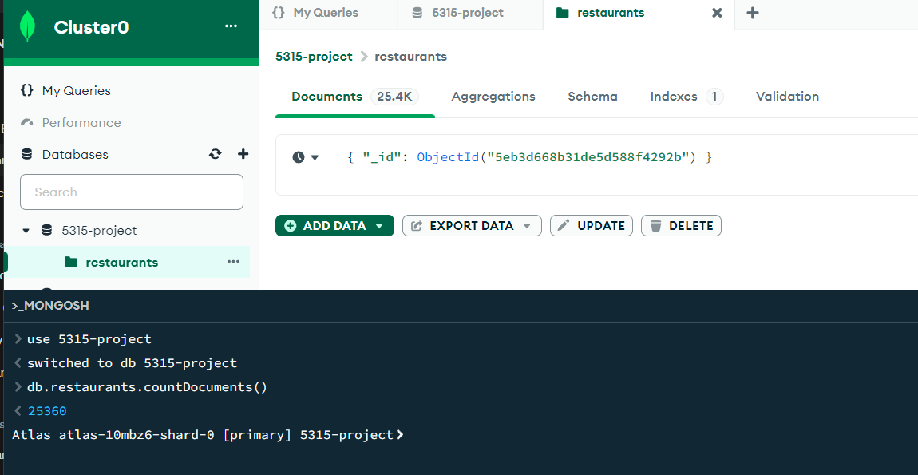

The number of documents in the "restaurants" collection is 25360.

## Step 2

Use “npm run start” to start your server. Show a screenshot of it being started using this command.

Explain any challenges or new learnings that you encountered when implementing the routes. Use Postman to test all the routes. Make sure to include tests for errors / invalid data. List the response codes that you used and why you used them. Show screenshots of all your tests.

## **POST /api/restaurants**:

**GET /api/restaurants:**

**http://localhost:8000/api/restaurants?page=1&perPage=5&borough=Bronx**

**For an invalid route:  
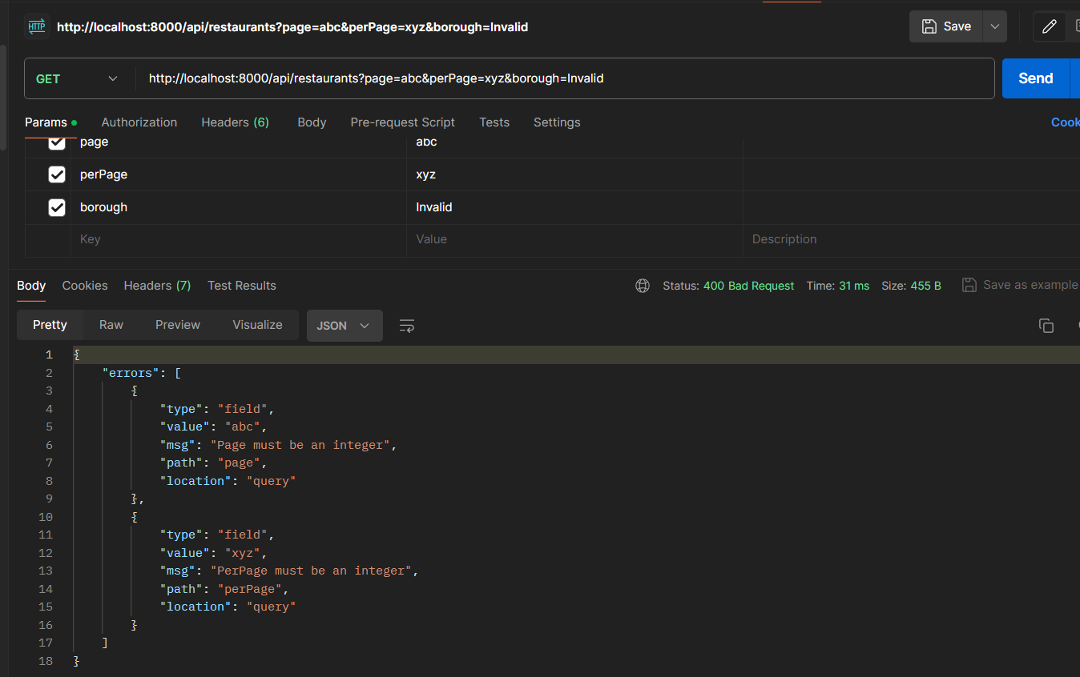**

**GET /api/restaurants/:id   
**

**PUT /api/restaurants:  
**

**After updating:**

**Its also updated in MongoDB Compass:  
**

**For invalid:**

**Also got this error:  
**

**DELETE /api/restaurants**

Before deletion:  
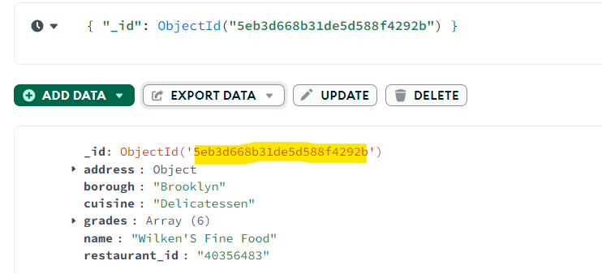

After deletion:  
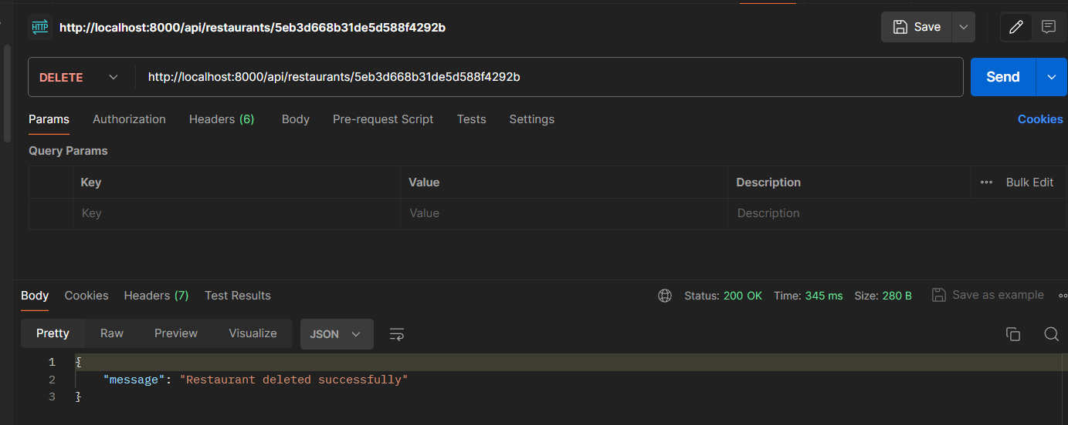

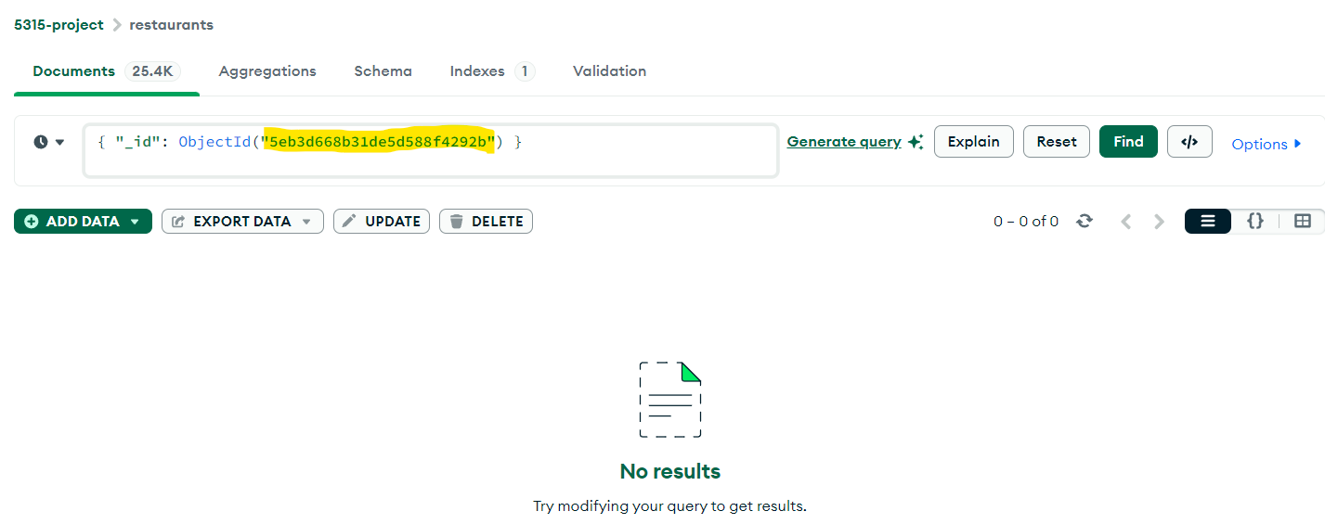

As we can see, the record which had _id: 5eb3d668b31de5d588f4292b is successfully deleted.

Step 3

Describe the steps you used to create the UI. Describe any challenges or new learnings that you encountered while developing the UI. Include screenshots of the UI and screenshots of Postman being used to test the new route.

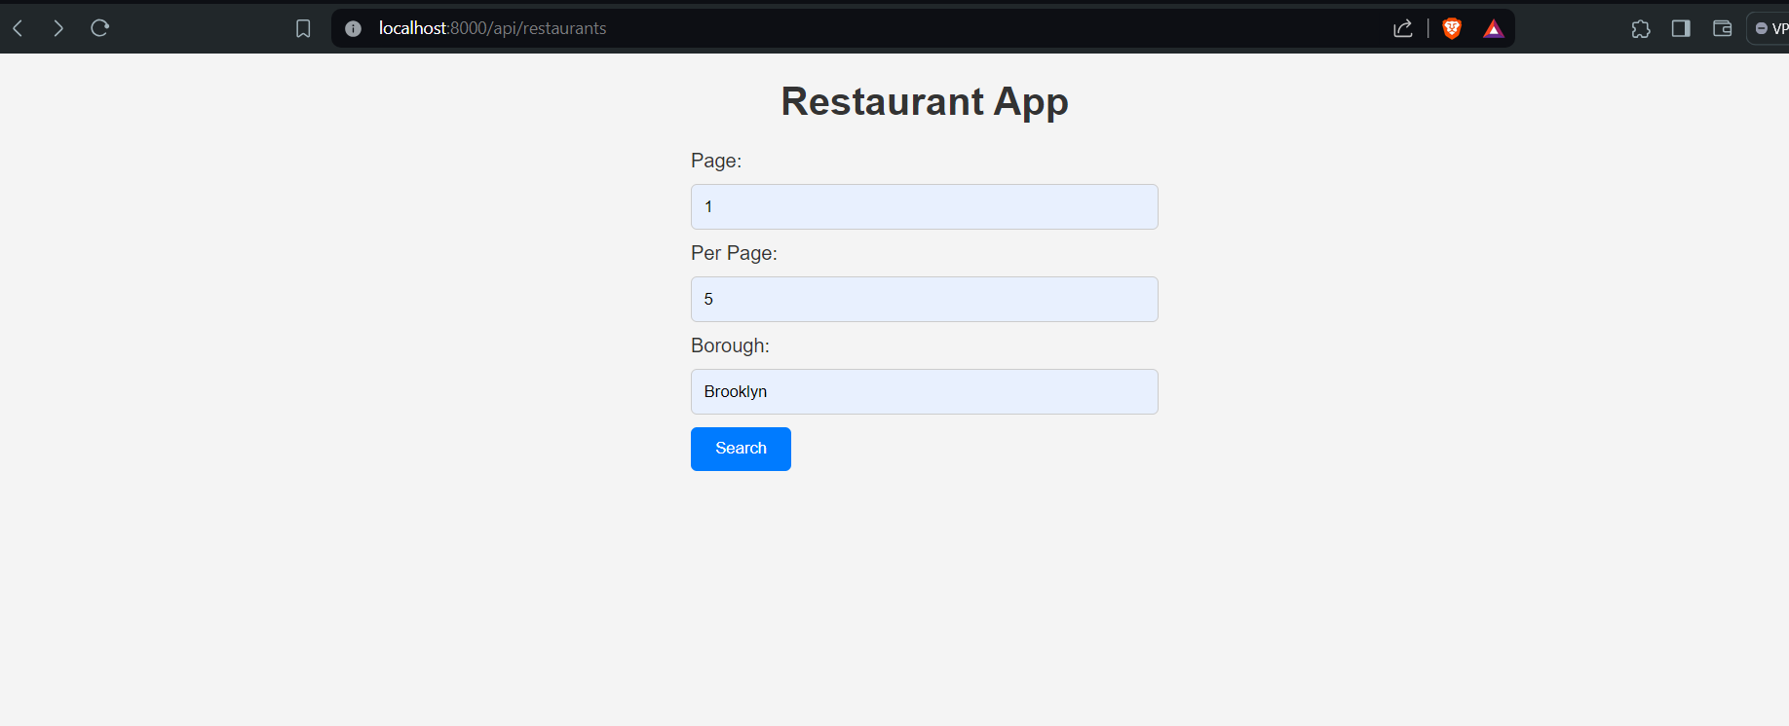  
  
In the UI part, I’m unfortunately still encountering issues. In the form above, I’ve been unable to retrieve data. I think I’m implementing wrong logic in handlebars maybe. exphbs is not a function was the common error i encountered initially a lot.

## Summary

Summarize your experience while working on this project for the first week. Do you have questions about the project for the next class? Questions you want to ask your peers or professor? Would you have done anything differently? Did anything take shorter/longer than you expected?

I had issues working with WK 1 Step 3: Add UI part. For most of the time I was facing issues with handlebars due which I had to make alot of changes to my app.js code. Also my style.css didn’t work so i had to use an inline css for the form. The form did work but didn’t show the desired results.