A PROJECT

ON

**Career Fair Registration System**

**using**

**Java and MySQL**

PREPARED FOR

**Prof. Daya Shankar Pandey**

Professor, Dept. of Computer Science

Instructor-in-Charge, Informatics Practices

PREPARED BY

Yash Purohit 12136

**AISSCE 2018-19**



**MAHESHWARI PUBLIC SCHOOL, JAIPUR**

**8th October 2022**

Certificate

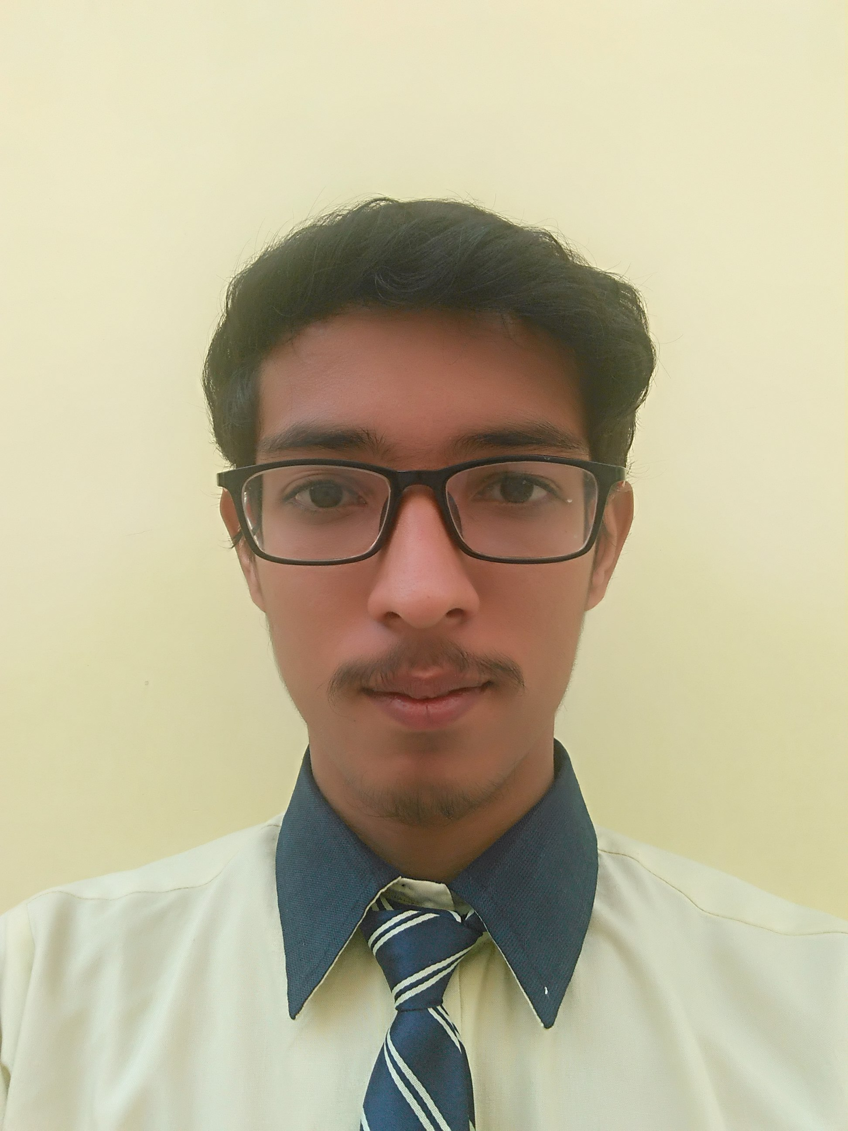

This is to certify that Yash Purohit a student of Class 12th A-1

has successfully completed project on

“EduFair Registration Window”

under the guidance of Daya Shankar Sir.

The Project is absolutely genuine and does not indulge in plagiarism of any kind. The references taken in this project have been declared at the end.

__________________________ ____________________

Signature (Subject Teacher) Signature (Examiner)

Acknowledgements

*“It is not possible to prepare a project without the assistance & encouragement of other people. This one is certainly no exception.”*

On the very outset of this report, I would like to extend my sincere & heartfelt obligation towards all the personages who have helped me in this endeavor. Without their active guidance, I would not have made headway in the project.

I am ineffably indebted to **Respected Daya Shankar Sir** for conscientious guidance and encouragement to accomplish this assignment.

I extend my gratitude to **Maheshwari Public School** for giving me this opportunity.

I also acknowledge with a deep sense of reverence, my gratitude towards my parents and members of my family, who have supported me morally as well as economically.

At last but not the least gratitude goes to all my friends who directly or indirectly helped me to complete this project report.

Any omission in this brief acknowledgement does not mean lack of gratitude.

Yash Purohit

12136

12th A-1

Index

|  |  |  |  |
| --- | --- | --- | --- |
| ***S.No.*** | ***Contents*** | ***Page No.*** | ***Teacher’s Remarks*** |
| 1. | Introduction to the Project | 5 |  |
| 2. | Introduction to Database Connectivity | 6 – 8 |  |
| 3. | Introduction to NetBeansTM IDE | 9 |  |
| 4. | Introduction to MySQL | 10 – 13 |  |
| 5. | System Implementation | 15 |  |
| 6. | Operations on MySQL | 15 – 16 |  |
| 7. | I/O Forms’ Design & Event Coding | 17 – 75 |  |
| 8. | User Manual | 76 |  |

Introduction to the Project

This software project is inspired by the annual education fair held by our school education committee every year. It is a kind form-filling system and is based on online registration system. This project is developed for registering entries for an event and managing them. The purpose of the project is to develop the Management Information System (MIS) for an event to automate the record of the people attending the event to enhance the decision making of the functionaries.

A MIS mainly consists of a computerized database, a collection of inter-related tables for a particular subject or purpose, capable to produce different reports relevant to the user. An application program is tied with the database for easy access and interface to the database. Using Application program or front-end, we can store, retrieve and manage all information in proper way.

This software, being user-friendly in design and working, does not require much technical knowledge to users, and can be used as a powerful tool for automating a Registration Form Filling System.

During Coding and Design of this software project, Java NetBeans IDE, a powerful front-end tool is used for getting Graphical User Interface (GUI) Based integrated platform and coding simplicity. As a back-end, a powerful open source RDBMS, MySQL is used as per requirement of the CBSE curriculum of Informatics Practices Course.

Introduction to

Database Connectivity

There is a requirement of creating an interface (the form), which user may use for accessing information and also there is a requirement of keeping the information saved in the database (table) in an organized manner for future references and uses. We cam create a real life application in two ends:-

* GUI Application(The Front-End)
* Database (The Back-End)

In order to account to a database from within an application, you need a framework that helps you send and execute SQL statements from within the application code. If you want to connect a relational database (e.g. MySQL or Oracle) from within Java, you can do it with JDBC (Java Database Connectivity), API (Application Programming Interface) of Java.

JDBC does mainly the following:-

* Establish a connection with a database.
* Send SQL statements to database server.
* Process the results obtained.

Other than JDBC, we also need the JDBC Driver for MySQL which is a software component enabling a Java Application to interact with MySQL Database.

* Classes Used for Database Connectivity

There are four main classes in the JDBC API hierarchy that are generally used for database connectivity.

These are:-

1. **Driver Manager Class :-** The JDBC DriverManager Class loads the JDBC driver needed to access a particular data source, locates and logs on to the database and returns a Connection object.
2. **Connection Class :-** The JDBC Connection Class manages the communication between a Java client application and a specific database including passing the SQL statements o the DBMS and managing transactions.
3. **Statement Class :**- The JDBC Statement Class contains SQL strings that are submitted to the DBMS. An SQL Select statement returns a ResultSet object that contains the data retrieved as the result of SQL statement.
4. **ResultSet Class :**- The JDBC ResultSet class provides predefined methods to access, analyze and convert data values returned by an executed SQL Select statement. A ResultSet object maintains a cursor which points to its current row of data. When a ResultSet object is first created, the cursor is positioned before the first row.

* GUI Application (The Front-End)

This is the user interface that the user sees and which is responsible for interacting with the user. The front-end is responsible for receiving user’s queries, request, etc. and passing it over to the back-end. The front-end basically includes graphical user interface and the Input Forms, through which users interact with the system. The programmer develops these applications keeping in mind that the user will have a very basic understanding of handling mouse, keyboard and desktop applications.

In this project NetBeans IDE 8.2 is used as the front-end software.

* Database (The Back-End)

It handles all databases accesses through one or more servers. The database helps us to save data permanently in secondary storage devices and keep data ready for future reference, modifications and additions.

It is the end that is not visible but that possesses the user-requests as received by the front-end.

In this project MySQL 5.7 is used as a back-end software.

Introduction to



NetBeans IDE is a free, open source, integrated development environment (IDE) that enables you to develop desktop, mobile and web applications. The IDE supports application development in various languages, including Java, HTML5, PHP and C++. The IDE provides integrated support for the complete development cycle, from project creation through debugging, profiling and deployment. The IDE runs on Windows, Linux, Mac OS X, and other UNIX-based systems.

It offers many features:

* DRAG AND DROP GUI CREATION
* EXCELLENT EDITING
* ADVANCE SOURCE CODE EDITOR
* WEB SERVICES
* EXCELLENT DEBUGGING
* WIZARDS & CODE GENRATION
* MANAGEMENT TOOLS

Introduction to



MySQL is an open source relational database management system (RDBMS). Its name is a combination of "My", the name of co-founder Michael Widenius's daughter, and "SQL", the abbreviation for Structured Query Language. The MySQL development project has made its source code available under the terms of the GNU General Public License, as well as under a variety of proprietary agreements. MySQL was owned and sponsored by a single for-profit firm, the Swedish company MySQL AB, now owned by Oracle Corporation. For proprietary use, several paid editions are available, and offer additional functionality.

MySQL is a central component of the LAMP open-source web application software stack (and other "AMP" stacks). LAMP is an acronym for “Linux, Apache, MySQL, Perl/ PHP/ Python”.

In MySQL database, information is stored in TABLES. A MySQL database contains many tables at once and can store thousands of individual records. MySQL provides you with a rich set of features that support a square environment for storing, maintaining and accessing data. MySQL is a fast, reliable, scalable, alternative to many of the commercial RDBMSs available these days.

* MySQL Database System

The key role of a database system is informative management. A database server is the key to solving the problems of information management. In general, a server must reliably manage a large amount of data in multi user environment so that many users can concurrently access the same data. A database server must also prevent unauthorized access and provide efficient solutions of failure recovery. MySQL operates using client server architecture in which runs on the machine containing the database and clients connected to server over a network. The server operating system is usually a Linux or Windows Operating System.

MySQL is multi user database system i.e. multiple users can access simultaneously. Here:

**THE SERVER:-** MySQL server listens for client requests coming in over the network and accesses database contents accordingly to those requests and provide that to clients.

**CLIENT:-** Client are the programs that connect to the database server and issues queries in pre-specified format. MySQL is compatible with the standard based SQL (Structured Query Language).

* Features of MySQL

**SPEED:**

If the server is optimal, MySQL runs very fast. It support clustered servers for demanding applications.

**EASE OF USE:**

MySQL is a high performance, relatively simple database system.

**COST:**

MySQL is a Free of Cost “Open Source” database.

**QUERY LANGUAGE SUPPORT:**

MySQL understands standard based Structured Query Language.

**PORTABILITY:**

MySQL provides portability as it has been tested or worked on many platforms.

**DATA TYPES:**

MySQL provides many data types to support different types of data.

**SECURITY:**

MySQL offers a privilege and secure password system that is very flexible, and it also provides host verification system.

**SCALABILITY/LIMITS:**

MySQL can hold up to 50 million records, sum up to have 60,000 tables and about 5,00,00,00,000 rows.

**CONNECTIVITY:**

Clients can connect to server, using several protocols.

System Implementation

* Hardware Used:-

While developing the project, the hardware used are:

A PC with Pentium® Dual-Core Processor (2.80 GHz) with 1 GB RAM, SVCA and other necessary devices.

* Software Used:-
* Microsoft Windows® 7 Ultimate as Operating System.
* Java NetBeansTM IDE 8.2 as Front-End Development Environment.
* MySQL 5.7 as Back-End Sever with Database for Testing.
* MS-Word 2013 for documentation and PDF generation.

Operations On MySQL

* **Creating Database “EDUFAIR_REGISTRATION_WINDOW”:**



* **Setting the created database as active database:**



* **Creating Table “Student_Registration” and inserting a Demo Record:**

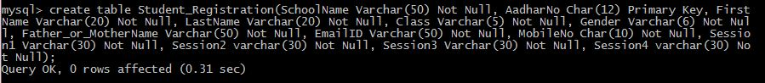

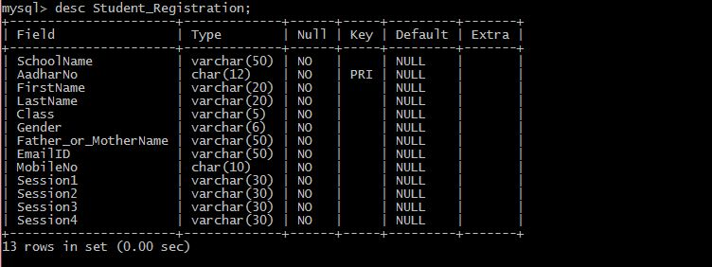



* **Creating Table “School_Registration” and inserting a Demo Record:**



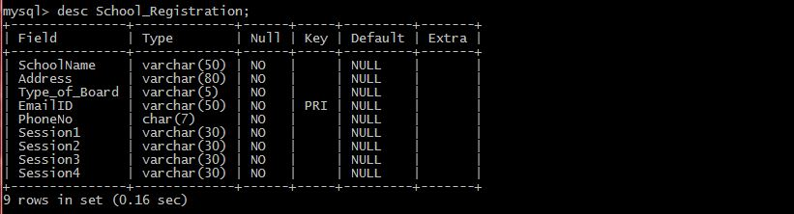



Login Frame

Output Window

(Wrong Password/Username)

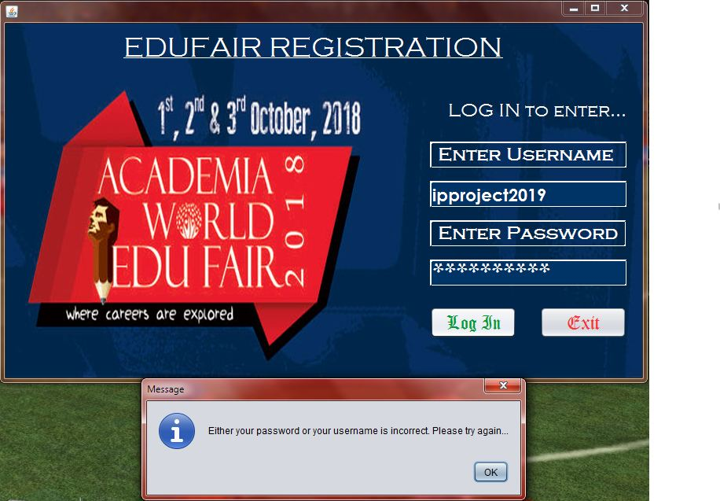

Output Window

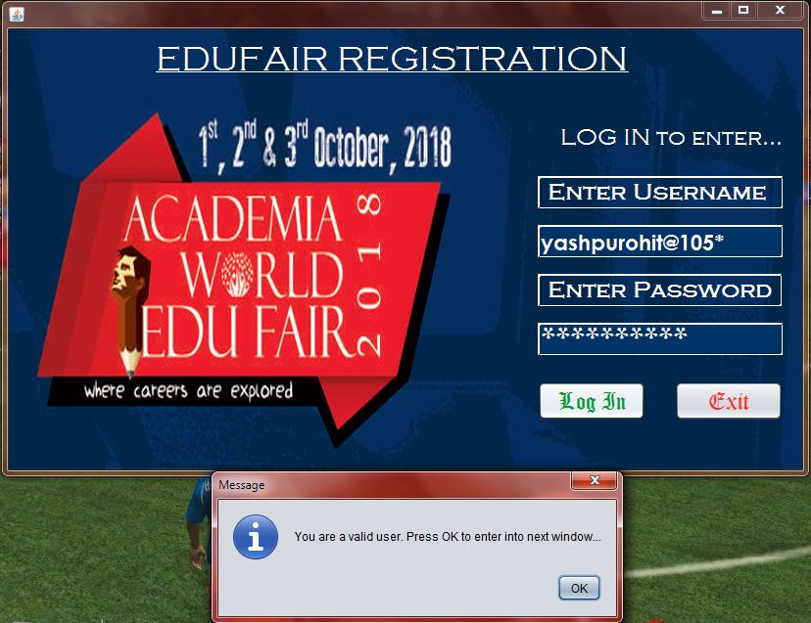(Correct Username &Password)

Specifications:

* Imports

import javax.swing.JOptionPane;

Coding:

* Code for “Log In” Button

String p=new String(jPasswordField1.getPassword());

String a=jTextField1.getText();

if(p.equals("AF1100CF43") && a.equals("yashpurohit@105*"))

{JOptionPane.showMessageDialog(null,"You are a valid user. Press OK to enter into next window...");

Menu_Bar obj =new Menu_Bar();

obj.setVisible(true);

this.dispose();}

else

{JOptionPane.showMessageDialog(null,"Either your password or your username is incorrect. Please try again...");}

* Code for “Exit” Button

System.exit(0);

Menu Bar

Design Window

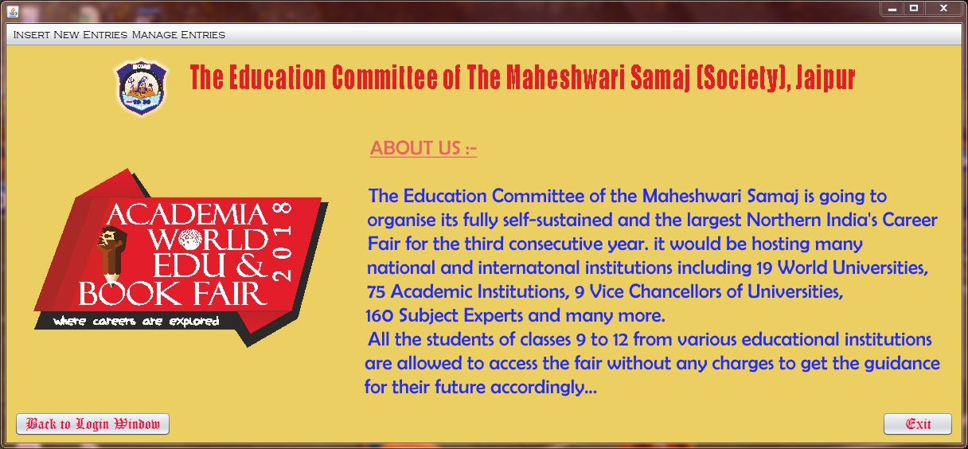

An Overview of Menu Items

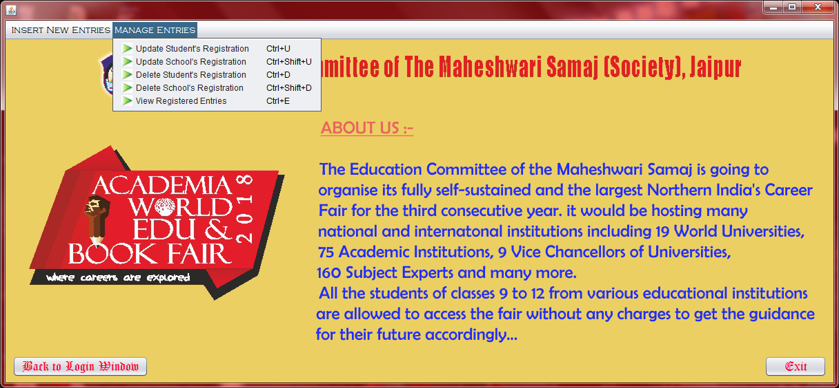

Coding:

* Code for “Back to Login Window” Button

Login_Frame obj =new Login_Frame();

obj.setVisible(true);

this.dispose();

* Code for “Student Registration” Menu Item

Student_Registration obj =new Student_Registration ();

obj.setVisible(true);

this.dispose();

* Code for “School Registration” Menu Item

School_Registration obj =new School_Registration ();

obj.setVisible(true);

this.dispose();

* Code for “Update Student’s Registration” Menu Item

Update_Student_Registration obj =new Update_Student_Registration ();

obj.setVisible(true);

this.dispose();

* Code for “Update School’s Registration” Menu Item

Update_School_Registration obj =new Update_School_Registration ();

obj.setVisible(true);

this.dispose();

* Code for “Delete Student’s Registration” Menu Item

Delete_Student_Registration obj =new Delete_Student_Registration ();

obj.setVisible(true);

this.dispose();

* Code for “Delete School’s Registration” Menu Item

Delete_School_Registration obj =new Delete_School_Registration ();

obj.setVisible(true);

this.dispose();

* Code for “View Registered Entries” Menu Item

View_Registered_Entries obj =new View_Registered_Entries ();

obj.setVisible(true);

this.dispose();

* Code for “Exit” Button

System.exit(0);

Student Registration

Design Window

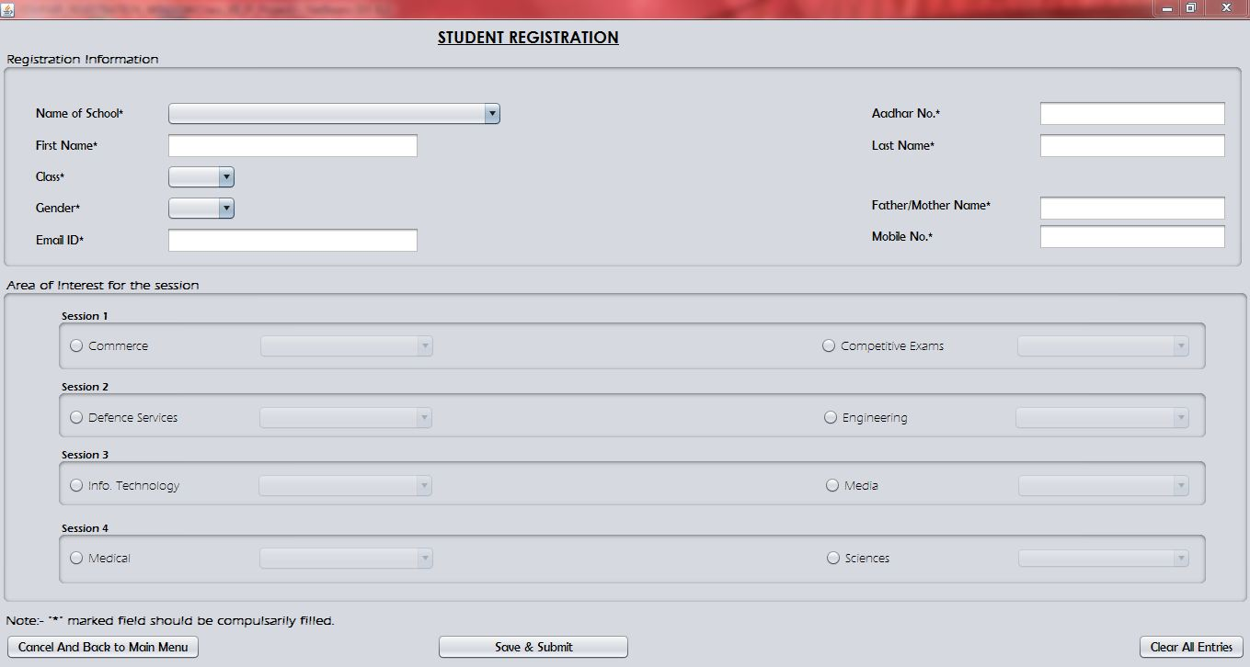

Output Window

(Incorrect Inputs)

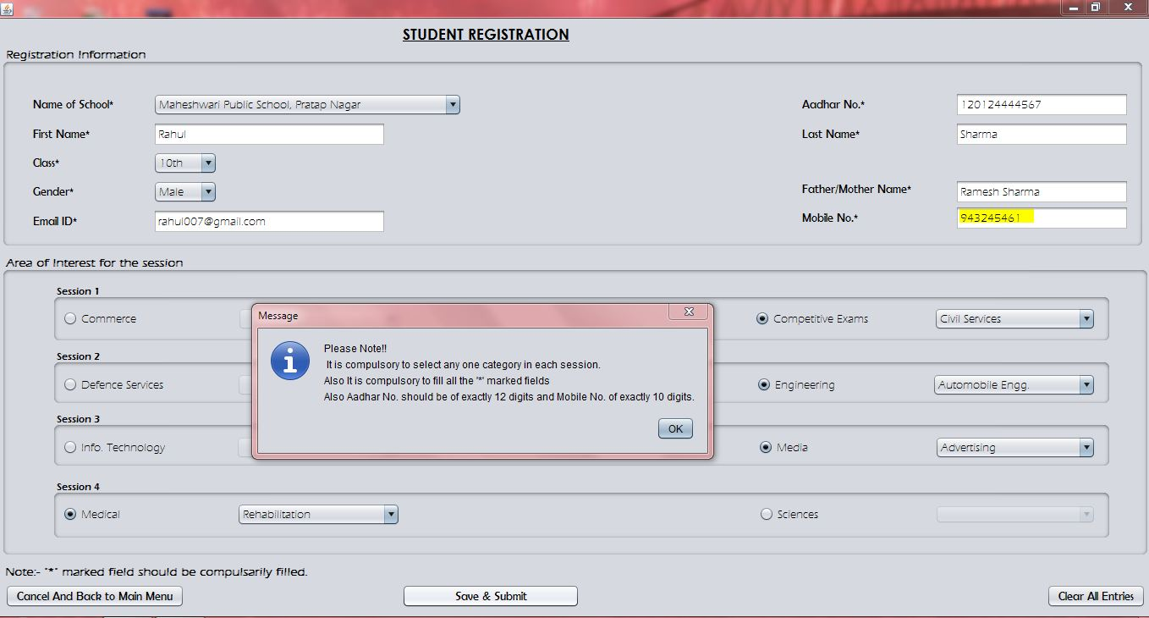

Output Window

(Correct Inputs)

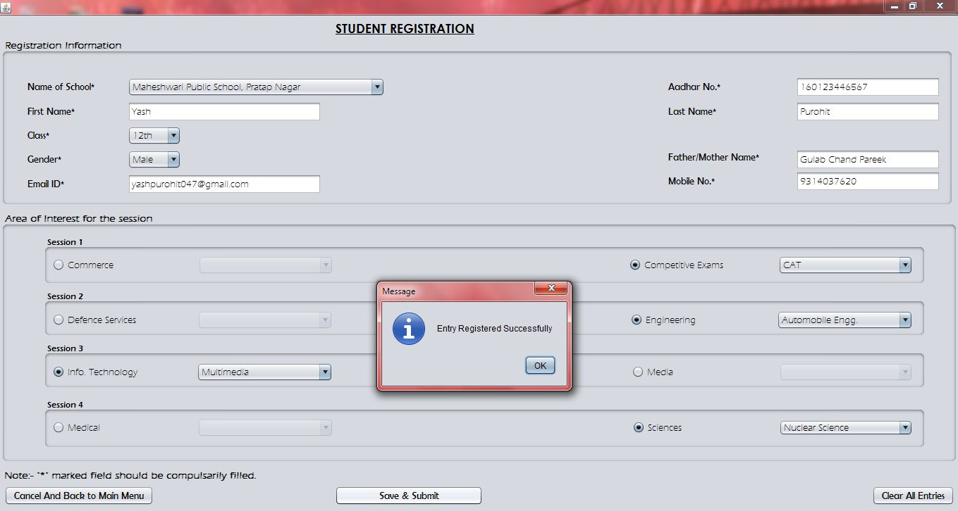

Specifications:

* Imports

import javax.swing.JOptionPane;

import java.sql.*;

* Init Components

jTextField1.setText("");

jTextField2.setText("");

jTextField3.setText("");

jTextField4.setText("");

jTextField5.setText("");

jTextField6.setText("");

RBComm.setSelected(false);

RBComp.setSelected(false);

RBDef.setSelected(false);

RBEngg.setSelected(false);

RBInfo.setSelected(false);

RBMedia.setSelected(false);

RBMedi.setSelected(false);

RBSci.setSelected(false);

jComboBox1.setSelectedIndex(-1);

jComboBox2.setSelectedIndex(-1);

jComboBox3.setSelectedIndex(-1);

OptComm.setSelectedIndex(-1);

OptComp.setSelectedIndex(-1);

OptDef.setSelectedIndex(-1);

OptEngg.setSelectedIndex(-1);

OptInfo.setSelectedIndex(-1);

OptMedia.setSelectedIndex(-1);

OptMedi.setSelectedIndex(-1);

OptSci.setSelectedIndex(-1);

OptComm.setEnabled(false);

OptComp.setEnabled(false);

OptDef.setEnabled(false);

OptEngg.setEnabled(false);

OptInfo.setEnabled(false);

OptMedia.setEnabled(false);

OptMedi.setEnabled(false);

OptSci.setEnabled(false);

Coding:

* Code for “Save & Submit” Button

If ((RBComm.isSelected() || RBComp.isSelected()) && (RBDef.isSelected() || RBEngg.isSelected()) && (RBInfo.isSelected() || RBMedia.isSelected()) && (RBMedi.isSelected() || RBSci.isSelected()) && jTextField1.getText().length()!=0 && jTextField2.getText().length()!=0 && jTextField3.getText().length()!=0 && jTextField4.getText().length()!=0 && jTextField5.getText().length()==10 && jTextField6.getText().length()==12 && jComboBox1.getSelectedIndex()!=-1 && jComboBox2.getSelectedIndex()!=-1 &&jComboBox3.getSelectedIndex()!=-1)

{String SchoolName, AadharNo, FirstName, LastName, CLass, Gender, Father_or_MotherName, EmailID, MobileNo, Session1 ="NULL", Session2="NULL", Session3="NULL", Session4="NULL";

SchoolName= jComboBox1.getSelectedItem().toString();

AadharNo= jTextField6.getText();

FirstName= jTextField1.getText();

LastName= jTextField3.getText();

CLass= jComboBox2.getSelectedItem().toString();

Gender= jComboBox3.getSelectedItem().toString();

Father_or_MotherName= jTextField4.getText();

EmailID= jTextField2.getText();

MobileNo= jTextField5.getText();

{if(RBComm.isSelected())

{if(OptComm.getSelectedItem()=="CA")

Session1="Comm - CA";

else if(OptComm.getSelectedItem()=="CS")

Session1="Comm - CS";

else if(OptComm.getSelectedItem()=="Entrepreneurship")

Session1="Comm - Entrepreneurship";

}

else if(RBComp.isSelected())

{if(OptComp.getSelectedItem()=="CAT")

Session1="Comp - CAT";

else if(OptComp.getSelectedItem()=="Civil Services")

Session1="Comp - Civil Services";

else if(OptComp.getSelectedItem()=="CLAT")

Session1="Comp - CLAT";

}

}

{if(RBDef.isSelected())

{if(OptDef.getSelectedItem()=="Aviation")

Session2="Def - Aviation";

else if(OptDef.getSelectedItem()=="Merchant Navy")

Session2="Def - Merchant Navy";

else if(OptDef.getSelectedItem()=="NDA")

Session2="Def - NDA";

}

else if(RBEngg.isSelected())

{if(OptEngg.getSelectedItem()=="Automobile Engg.")

Session2="Engg - Automobile Engg.";

else if(OptEngg.getSelectedItem()=="Electrical Engg.")

Session2="Engg - Electrical Engg.";

else if(OptEngg.getSelectedItem()=="Mechanical Engg.")

Session2="Engg - Mechanical Engg.";

}

}

{if(RBInfo.isSelected())

{if(OptInfo.getSelectedItem()=="Cyber Law")

Session3="Info - Cyber Law";

else if(OptInfo.getSelectedItem()=="Multimedia")

Session3="Info - Multmedia";

else if(OptInfo.getSelectedItem()=="Networking")

Session3="Info - Networking";

}

else if(RBMedia.isSelected())

{if(OptMedia.getSelectedItem()=="Advertising")

Session3="Media - Advertising";

else if(OptMedia.getSelectedItem()=="Anchoring")

Session3="Media - Anchoring";

else if(OptMedia.getSelectedItem()=="Photography")

Session3="Media - Photography";

}

}

{if(RBMedi.isSelected())

{if(OptMedi.getSelectedItem()=="Pharmacy")

Session4="Medi - Pharmacy";

else if(OptMedi.getSelectedItem()=="Physiotherapy")

Session4="Medi - Physiotherapy";

else if(OptMedi.getSelectedItem()=="Rehabilitation")

Session4="Medi - Rehabilitation";

}

else if(RBSci.isSelected())

{if(OptSci.getSelectedItem()=="Acturial Science")

Session4="Sci - Acturial Science";

else if(OptSci.getSelectedItem()=="Genetic Science")

Session4="Sci - Genetic Science";

else if(OptSci.getSelectedItem()=="Nuclear Science")

Session4="Sci - Nuclear Science";

}

}

try{

Class.forName("java.sql.DriverManager");

Connection con= DriverManager.getConnection ("jdbc:mysql:

//localhost:3306/EDUFAIR_REGISTRATION_WINDOW","root","rootcap");

String sql;

sql="insert into Student_Registration values('"+SchoolName+"', '"+AadharNo+"','"+ FirstName+"', '"+LastName+"', '"+CLass+"', '"+Gender+"', '"+Father_or_MotherName+"', '"+EmailID+"', '"+MobileNo+"', '"+Session1+"', '"+Session2+"', '"+Session3+"', '"+Session4+"')";

Statement st =con.createStatement();

st.executeUpdate(sql);

JOptionPane.showMessageDialog(null,"Entry Registered Successfully");

}

catch(Exception e){JOptionPane.showMessageDialog(null,e.getMessage());}

}

else

JOptionPane.showMessageDialog(null,"Please Note!!"+"\n It is compulsory to select any one category in each session."+"\nAlso It is compulsory to fill all the '*' marked fields"+"\nAlso Aadhar No. should be of exactly 12 digits and Mobile No. of exactly 10 digits.");

* Code for “Cancel And Back to Main Menu” Button

Menu_Bar obj =new =Menu_Bar();

obj.setVisible(true);

this.dispose();

* Code for “Clear All Entries” Button

RBComm.setSelected(false);

RBComp.setSelected(false);

RBDef.setSelected(false);

RBEngg.setSelected(false);

RBInfo.setSelected(false);

RBMedia.setSelected(false);

RBMedi.setSelected(false);

RBSci.setSelected(false);

jTextField1.setText("");

jTextField2.setText("");

jTextField3.setText("");

jTextField4.setText("");

jTextField5.setText("");

jTextField6.setText("");

jComboBox1.setSelectedIndex(-1);

jComboBox2.setSelectedIndex(-1);

jComboBox3.setSelectedIndex(-1);

OptComm.setSelectedIndex(-1);

OptComp.setSelectedIndex(-1);

OptDef.setSelectedIndex(-1);

OptEngg.setSelectedIndex(-1);

OptInfo.setSelectedIndex(-1);

OptMedia.setSelectedIndex(-1);

OptMedi.setSelectedIndex(-1);

OptSci.setSelectedIndex(-1);

OptComm.setEnabled(false);

OptComp.setEnabled(false);

OptDef.setEnabled(false);

OptEngg.setEnabled(false);

OptInfo.setEnabled(false);

OptMedia.setEnabled(false);

OptMedi.setEnabled(false);

OptSci.setEnabled(false);

* Code for “Commerce” RadioButton (RBCommAction Performed)

OptComm.setEnabled(true);

OptComp.setEnabled(false);

* Code for “Comp…Exams” RadioButton (RBCompAction Performed)

OptComp.setEnabled(true);

OptComm.setEnabled(false);

* Code for “Defence” RadioButton (RBDefAction Performed)

OptDef.setEnabled(true);

OptEngg.setEnabled(false);

* Code for “Engineering” RadioButton (RBEnggAction Performed)

OptEngg.setEnabled(true);

OptDef.setEnabled(false);

* Code for “Info…ology” RadioButton (RBInfoAction Performed)

OptInfo.setEnabled(true);

OptMedia.setEnabled(false);

* Code for “Media” RadioButton (RBMediaAction Performed)

OptMedia.setEnabled(true);

OptInfo.setEnabled(false);

* Code for “Medical” RadioButton (RBMediAction Performed)

OptMedi.setEnabled(true);

OptSci.setEnabled(false);

* Code for “Sciences” RadioButton (RBSciAction Performed)

OptSci.setEnabled(true);

OptMedi.setEnabled(false);

School Registration

Design Window

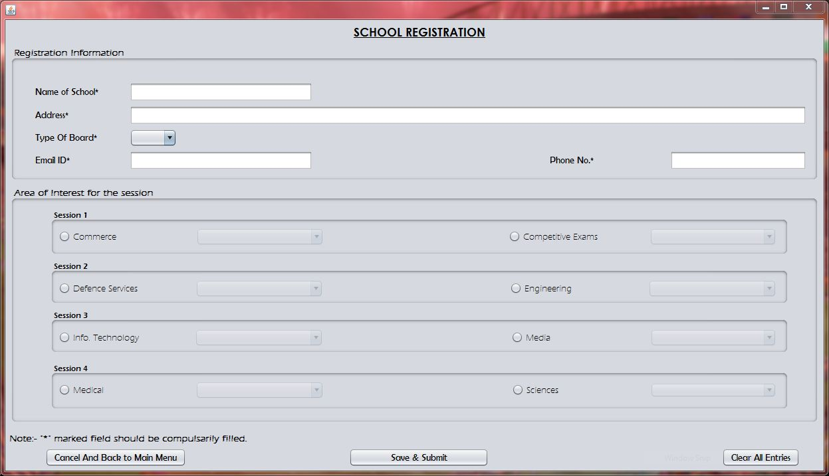

Output Window

(Incorrect Inputs)

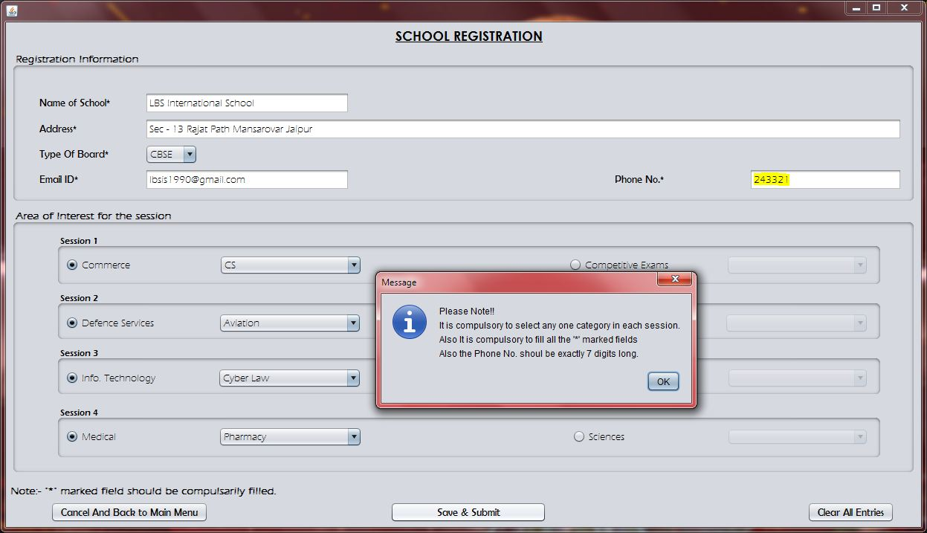

Output Window

(Correct Inputs)

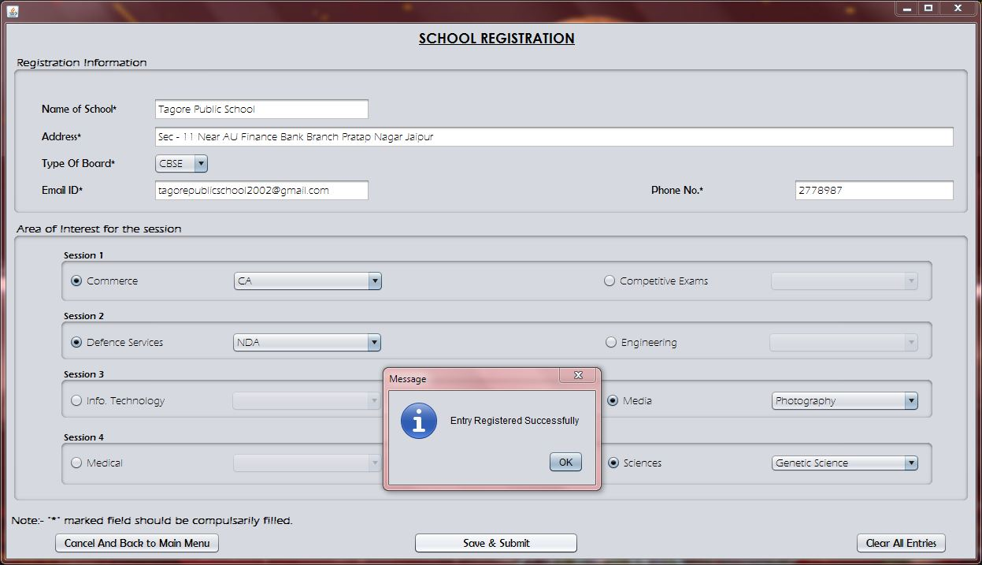

Specifications:

* Imports

import javax.swing.JOptionPane;

import java.sql.*;

* Init Components

jTextField1.setText("");

jTextField2.setText("");

jTextField5.setText("");

jTextField6.setText("");

RBComp.setSelected(false);

RBDef.setSelected(false);

RBEngg.setSelected(false);

RBInfo.setSelected(false);

RBMedia.setSelected(false);

RBMedi.setSelected(false);

RBSci.setSelected(false);

jComboBox2.setSelectedIndex(-1);

OptComm.setSelectedIndex(-1);

OptComp.setSelectedIndex(-1);

OptDef.setSelectedIndex(-1);

OptEngg.setSelectedIndex(-1);

OptInfo.setSelectedIndex(-1);

OptMedia.setSelectedIndex(-1);

OptMedi.setSelectedIndex(-1);

OptSci.setSelectedIndex(-1);

OptComm.setEnabled(false);

OptComp.setEnabled(false);

OptDef.setEnabled(false);

OptEngg.setEnabled(false);

OptInfo.setEnabled(false);

OptMedia.setEnabled(false);

OptMedi.setEnabled(false);

OptSci.setEnabled(false);

Coding:

* Code for “Save & Submit” Button

if((RBComm.isSelected() || RBComp.isSelected()) && (RBDef.isSelected() || RBEngg.isSelected()) && (RBInfo.isSelected() || RBMedia.isSelected()) && (RBMedi.isSelected() || RBSci.isSelected()) && jTextField1.getText().length()!=0 && jTextField2.getText().length()!=0 && jTextField5.getText().length()==7 && jTextField6.getText().length()!=0 && jComboBox2.getSelectedIndex()!=-1)

{String SchoolName, Address, Type_of_Board, EmailID, PhoneNo, Session1="NULL", Session2="NULL", Session3="NULL", Session4="NULL";

SchoolName= jTextField1.getText();

Address= jTextField6.getText();

Type_of_Board= jComboBox2.getSelectedItem().toString();

EmailID= jTextField2.getText();

PhoneNo= jTextField5.getText();

{if(RBComm.isSelected())

{if(OptComm.getSelectedItem()=="CA")

Session1="Comm - CA";

else if(OptComm.getSelectedItem()=="CS")

Session1="Comm - CS";

else if(OptComm.getSelectedItem()=="Entrepreneurship")

Session1="Comm - Entrepreneurship";

}

else if(RBComp.isSelected())

{if(OptComp.getSelectedItem()=="CAT")

Session1="Comp - CAT";

else if(OptComp.getSelectedItem()=="Civil Services")

Session1="Comp - Civil Services";

else if(OptComp.getSelectedItem()=="CLAT")

Session1="Comp - CLAT";

}

}

{if(RBDef.isSelected())

{if(OptDef.getSelectedItem()=="Aviation")

Session2="Def - Aviation";

else if(OptDef.getSelectedItem()=="Merchant Navy")

Session2="Def - Merchant Navy";

else if(OptDef.getSelectedItem()=="NDA")

Session2="Def - NDA";

}

else if(RBEngg.isSelected())

{if(OptEngg.getSelectedItem()=="Automobile Engg.")

Session2="Engg - Automobile Engg.";

else if(OptEngg.getSelectedItem()=="Electrical Engg.")

Session2="Engg - Electrical Engg.";

else if(OptEngg.getSelectedItem()=="Mechanical Engg.")

Session2="Engg - Mechanical Engg.";

}

}

{if(RBInfo.isSelected())

{if(OptInfo.getSelectedItem()=="Cyber Law")

Session3="Info - Cyber Law";

else if(OptInfo.getSelectedItem()=="Multimedia")

Session3="Info - Multmedia";

else if(OptInfo.getSelectedItem()=="Networking")

Session3="Info - Networking";

}

else if(RBMedia.isSelected())

{if(OptMedia.getSelectedItem()=="Advertising")

Session3="Media - Advertising";

else if(OptMedia.getSelectedItem()=="Anchoring")

Session3="Media - Anchoring";

else if(OptMedia.getSelectedItem()=="Photography")

Session3="Media - Photography";

}

}

{if(RBMedi.isSelected())

{if(OptMedi.getSelectedItem()=="Pharmacy")

Session4="Medi - Pharmacy";

else if(OptMedi.getSelectedItem()=="Physiotherapy")

Session4="Medi - Physiotherapy";

else if(OptMedi.getSelectedItem()=="Rehabilitation")

Session4="Medi - Rehabilitation";

}

else if(RBSci.isSelected())

{if(OptSci.getSelectedItem()=="Acturial Science")

Session4="Sci - Acturial Science";

else if(OptSci.getSelectedItem()=="Genetic Science")

Session4="Sci - Genetic Science";

else if(OptSci.getSelectedItem()=="Nuclear Science")

Session4="Sci - Nuclear Science";

} }

try{

Class.forName("java.sql.DriverManager");

Connection con= DriverManager.getConnection ("jdbc:mysql: //localhost:3306/EDUFAIR_REGISTRATION_WINDOW","root","rootcap");

String sql;

sql="insert into School_Registration values('"+SchoolName+"', '"+Address+"','"+Type_of_Board+"', '"+EmailID+"', '"+PhoneNo+"', '"+Session1+"', '"+Session2+"', '"+Session3+"', '"+Session4+"')";

Statement st =con.createStatement();

st.executeUpdate(sql);

JOptionPane.showMessageDialog(null,"Entry Registered Successfully");

}

catch(Exception e){JOptionPane.showMessageDialog(null,e.getMessage());}

}

else

JOptionPane.showMessageDialog(null,"Please Note!!"+"\nIt is compulsory to select any one category in each session."+"\nAlso It is compulsory to fill all the '*' marked fields"+"\nAlso the Phone No. shoul be exactly 7 digits long.");

* Code for “Cancel And Back to Main Menu” Button

Menu_Bar obj =new Menu_Bar();

obj.setVisible(true);

this.dispose();

* Code for “Clear All Entries” Button

jTextField1.setText("");

jTextField2.setText("");

jTextField5.setText("");

jTextField6.setText("");

RBComm.setSelected(false);

RBComp.setSelected(false);

RBDef.setSelected(false);

RBEngg.setSelected(false);

RBInfo.setSelected(false);

RBMedia.setSelected(false);

RBMedi.setSelected(false);

RBSci.setSelected(false);

jComboBox2.setSelectedIndex(-1);

OptComm.setSelectedIndex(-1);

OptComp.setSelectedIndex(-1);

OptDef.setSelectedIndex(-1);

OptEngg.setSelectedIndex(-1);

OptInfo.setSelectedIndex(-1);

OptMedia.setSelectedIndex(-1);

OptMedi.setSelectedIndex(-1);

OptSci.setSelectedIndex(-1);

OptComm.setEnabled(false);

OptComp.setEnabled(false);

OptDef.setEnabled(false);

OptEngg.setEnabled(false);

OptInfo.setEnabled(false);

OptMedia.setEnabled(false);

OptMedi.setEnabled(false);

OptSci.setEnabled(false);

* Code for “Commerce” RadioButton (RBCommAction Performed)

OptComm.setEnabled(true);

OptComp.setEnabled(false);

* Code for “Comp…Exams” RadioButton (RBCompAction Performed)

OptComp.setEnabled(true);

OptComm.setEnabled(false);

* Code for “Defence” RadioButton (RBDefAction Performed)

OptDef.setEnabled(true);

OptEngg.setEnabled(false);

* Code for “Engineering” RadioButton (RBEnggAction Performed)

OptEngg.setEnabled(true);

OptDef.setEnabled(false);

* Code for “Info…ology” RadioButton (RBInfoAction Performed)

OptInfo.setEnabled(true);

OptMedia.setEnabled(false);

* Code for “Media” RadioButton (RBMediaAction Performed)

OptMedia.setEnabled(true);

OptInfo.setEnabled(false);

* Code for “Medical” RadioButton (RBMediAction Performed)

OptMedi.setEnabled(true);

OptSci.setEnabled(false);

* Code for “Sciences” RadioButton (RBSciAction Performed)

OptSci.setEnabled(true);

OptMedi.setEnabled(false);

Update Student’s Registration

Design Window

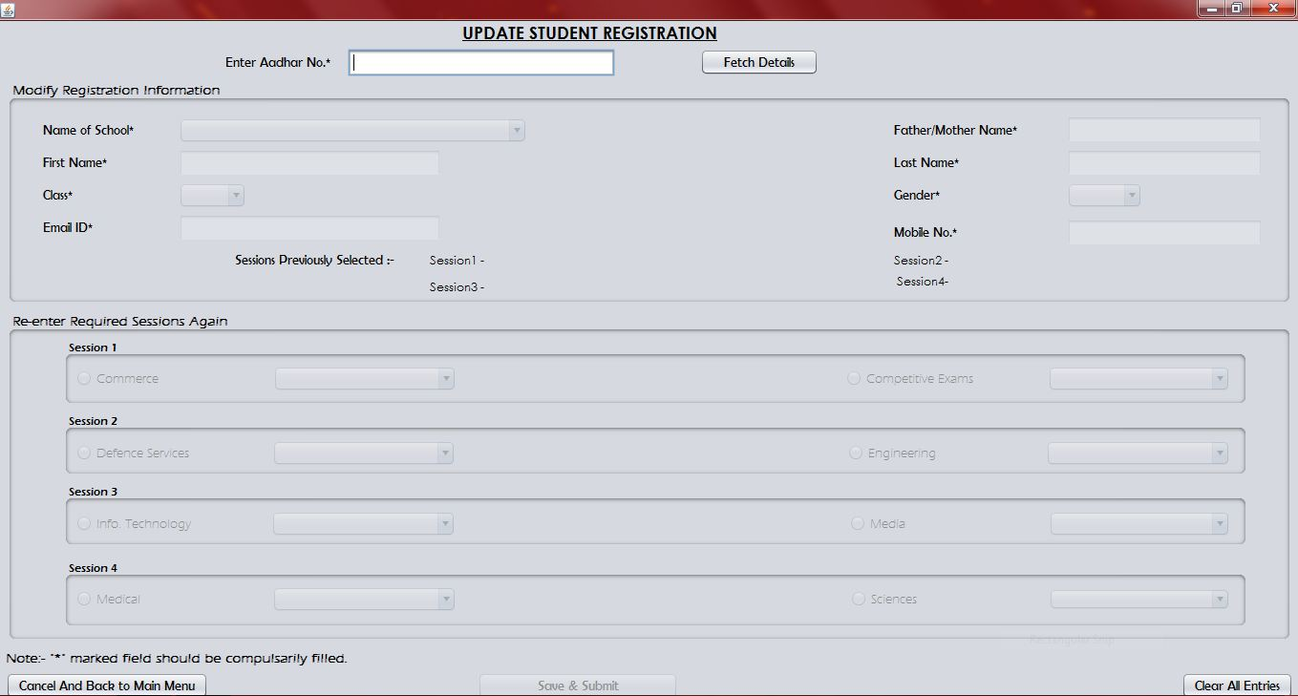

Output Window

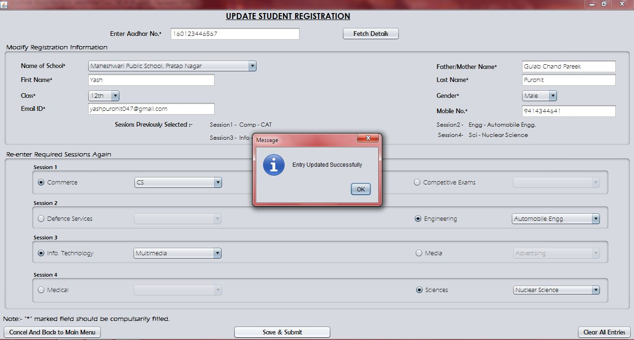

Specifications:

* Imports

import javax.swing.JOptionPane;

import java.sql.*;

* Init Components

jTextField1.setText("");

jTextField2.setText("");

jTextField3.setText("");

jTextField4.setText("");

jTextField5.setText("");

jTextField6.setText("");

RBComm.setSelected(false);

RBComp.setSelected(false);

RBDef.setSelected(false);

RBEngg.setSelected(false);

RBInfo.setSelected(false);

RBMedia.setSelected(false);

RBMedi.setSelected(false);

RBSci.setSelected(false);

jComboBox1.setSelectedIndex(-1);

jComboBox2.setSelectedIndex(-1);

jComboBox3.setSelectedIndex(-1);

OptComm.setSelectedIndex(-1);

OptComp.setSelectedIndex(-1);

OptDef.setSelectedIndex(-1);

OptEngg.setSelectedIndex(-1);

OptInfo.setSelectedIndex(-1);

OptMedia.setSelectedIndex(-1);

OptMedi.setSelectedIndex(-1);

OptSci.setSelectedIndex(-1);

OptComm.setEnabled(false);

OptComp.setEnabled(false);

OptDef.setEnabled(false);

OptEngg.setEnabled(false);

OptInfo.setEnabled(false);

OptMedia.setEnabled(false);

OptMedi.setEnabled(false);

OptSci.setEnabled(false);

jComboBox1.setEnabled(false);

jComboBox2.setEnabled(false);

jComboBox3.setEnabled(false);

jTextField1.setEnabled(false);

jTextField2.setEnabled(false);

jTextField3.setEnabled(false);

jTextField4.setEnabled(false);

jTextField5.setEnabled(false);

RBComm.setEnabled(false);

RBComp.setEnabled(false);

RBDef.setEnabled(false);

RBEngg.setEnabled(false);

RBInfo.setEnabled(false);

RBMedia.setEnabled(false);

RBMedi.setEnabled(false);

RBSci.setEnabled(false);

jButton3.setEnabled(false);

Coding:

* Code for “Fetch Details” Button

jComboBox1.setEnabled(true);

jComboBox2.setEnabled(true);

jComboBox3.setEnabled(true);

jTextField1.setEnabled(true);

jTextField2.setEnabled(true);

jTextField3.setEnabled(true);

jTextField4.setEnabled(true);

jTextField5.setEnabled(true);

RBComm.setEnabled(true);

RBComp.setEnabled(true);

RBDef.setEnabled(true);

RBEngg.setEnabled(true);

RBInfo.setEnabled(true);

RBMedia.setEnabled(true);

RBMedi.setEnabled(true);

RBSci.setEnabled(true);

jButton3.setEnabled(true);

try{

Class.forName("java.sql.DriverManager");

Connection con= DriverManager.getConnection ("jdbc:mysql: // localhost: 3306/EDUFAIR_REGISTRATION_WINDOW","root","rootcap");

String AadharNo, sql;

AadharNo=jTextField6.getText();

sql="select * from Student_Registration where AadharNo=" +AadharNo;

Statement st =con.createStatement();

ResultSet rs =st.executeQuery(sql);

if(!rs.next())

JOptionPane.showMessageDialog(null,"No such Record.");

else{

jTextField1.setText(rs.getString("FirstName"));

jTextField2.setText(rs.getString("EmailID"));

jTextField3.setText(rs.getString("LastName"));

jTextField4.setText(rs.getString("Father_or_MotherName"));

jTextField5.setText(rs.getString("MobileNo"));

jComboBox1.setSelectedItem(rs.getString("SchoolName"));

jComboBox2.setSelectedItem(rs.getString("Class"));

jComboBox3.setSelectedItem(rs.getString("Gender"));

jLabel12.setText(rs.getString("Session1"));

jLabel13.setText(rs.getString("Session2"));

jLabel15.setText(rs.getString("Session3"));

jLabel18.setText(rs.getString("Session4"));

}

}

catch(Exception e){JOptionPane.showMessageDialog(null,e.getMessage());}

* Code for “Save & Submit” Button

if((RBComm.isSelected() || RBComp.isSelected()) && (RBDef.isSelected() || RBEngg.isSelected()) && (RBInfo.isSelected() || RBMedia.isSelected()) && (RBMedi.isSelected() || RBSci.isSelected()) && jTextField1.getText().length()!=0 && jTextField2.getText().length()!=0 && jTextField3.getText().length()!=0 && jTextField4.getText().length()!=0 && jTextField5.getText().length()==10 && jTextField6.getText().length()==12 && jComboBox1.getSelectedIndex()!=-1 && jComboBox2.getSelectedIndex()!=-1 &&jComboBox3.getSelectedIndex()!=-1)

{String SchoolName, AadharNo, FirstName, LastName, CLass, Gender, Father_or_MotherName, EmailID, MobileNo, Session1 ="NULL", Session2="NULL", Session3="NULL", Session4="NULL";

SchoolName= jComboBox1.getSelectedItem().toString();

AadharNo= jTextField6.getText();

FirstName= jTextField1.getText();

LastName= jTextField3.getText();

CLass= jComboBox2.getSelectedItem().toString();

Gender= jComboBox3.getSelectedItem().toString();

Father_or_MotherName= jTextField4.getText();

EmailID= jTextField2.getText();

MobileNo= jTextField5.getText();

{if(RBComm.isSelected())

{if(OptComm.getSelectedItem()=="CA")

Session1="Comm - CA";

else if(OptComm.getSelectedItem()=="CS")

Session1="Comm - CS";

else if(OptComm.getSelectedItem()=="Entrepreneurship")

Session1="Comm - Entrepreneurship";

}

else if(RBComp.isSelected())

{if(OptComp.getSelectedItem()=="CAT")

Session1="Comp - CAT";

else if(OptComp.getSelectedItem()=="Civil Services")

Session1="Comp - Civil Services";

else if(OptComp.getSelectedItem()=="CLAT")

Session1="Comp - CLAT";

}

}

{if(RBDef.isSelected())

{if(OptDef.getSelectedItem()=="Aviation")

Session2="Def - Aviation";

else if(OptDef.getSelectedItem()=="Merchant Navy")

Session2="Def - Merchant Navy";

else if(OptDef.getSelectedItem()=="NDA")

Session2="Def - NDA";

}

else if(RBEngg.isSelected())

{if(OptEngg.getSelectedItem()=="Automobile Engg.")

Session2="Engg - Automobile Engg.";

else if(OptEngg.getSelectedItem()=="Electrical Engg.")

Session2="Engg - Electrical Engg.";

else if(OptEngg.getSelectedItem()=="Mechanical Engg.")

Session2="Engg - Mechanical Engg.";

}

}

{if(RBInfo.isSelected())

{if(OptInfo.getSelectedItem()=="Cyber Law")

Session3="Info - Cyber Law";

else if(OptInfo.getSelectedItem()=="Multimedia")

Session3="Info - Multmedia";

else if(OptInfo.getSelectedItem()=="Networking")

Session3="Info - Networking";

}

else if(RBMedia.isSelected())

{if(OptMedia.getSelectedItem()=="Advertising")

Session3="Media - Advertising";

else if(OptMedia.getSelectedItem()=="Anchoring")

Session3="Media - Anchoring";

else if(OptMedia.getSelectedItem()=="Photography")

Session3="Media - Photography";

}

}

{if(RBMedi.isSelected())

{if(OptMedi.getSelectedItem()=="Pharmacy")

Session4="Medi - Pharmacy";

else if(OptMedi.getSelectedItem()=="Physiotherapy")

Session4="Medi - Physiotherapy";

else if(OptMedi.getSelectedItem()=="Rehabilitation")

Session4="Medi - Rehabilitation";

}

else if(RBSci.isSelected())

{if(OptSci.getSelectedItem()=="Acturial Science")

Session4="Sci - Acturial Science";

else if(OptSci.getSelectedItem()=="Genetic Science")

Session4="Sci - Genetic Science";

else if(OptSci.getSelectedItem()=="Nuclear Science")

Session4="Sci - Nuclear Science";

}

}

try{

Class.forName("java.sql.DriverManager");

Connection con= DriverManager.getConnection ("jdbc:mysql://localhost: 3306/EDUFAIR_REGISTRATION_WINDOW","root","rootcap");

String sql;

sql="update Student_Registration set SchoolName='"+SchoolName+"', FirstName='"+ FirstName+"', LastName='"+LastName+"', Class='"+CLass+"', Gender='"+Gender+"', Father_or_MotherName='"+Father_or_MotherName+"', EmailID='"+EmailID+"', MobileNo='"+MobileNo+"', Session1='"+Session1+"', Session2='"+Session2+"', Session3='"+Session3+"', Session4='"+Session4+"' where AadharNo="+AadharNo;

Statement st =con.createStatement();

st.executeUpdate(sql);

JOptionPane.showMessageDialog(null,"Entry Updated Successfully");

}

catch(Exception e){JOptionPane.showMessageDialog(null,e.getMessage());}

}

else

JOptionPane.showMessageDialog(null,"Please Note!!"+"\n It is compulsory to select any one category in each session."+"\nAlso It is compulsory to fill all the '*' marked fields"+"\nAlso Aadhar No. should be of exactly 12 digits and Mobile No. of exactly 10 digits.");

* Code for “Cancel And Back to Main Menu” Button

Menu_Bar obj= new Menu_Bar();

obj.setVisible(true);

this.dispose();

* Code for “Clear All Entries” Button

RBComm.setSelected(false);

RBComp.setSelected(false);

RBDef.setSelected(false);

RBEngg.setSelected(false);

RBInfo.setSelected(false);

RBMedia.setSelected(false);

RBMedi.setSelected(false);

RBSci.setSelected(false);

jTextField1.setText("");

jTextField2.setText("");

jTextField3.setText("");

jTextField4.setText("");

jTextField5.setText("");

jTextField6.setText("");

jComboBox1.setSelectedIndex(-1);

jComboBox2.setSelectedIndex(-1);

jComboBox3.setSelectedIndex(-1);

OptComm.setSelectedIndex(-1);

OptComp.setSelectedIndex(-1);

OptDef.setSelectedIndex(-1);

OptEngg.setSelectedIndex(-1);

OptInfo.setSelectedIndex(-1);

OptMedia.setSelectedIndex(-1);

OptMedi.setSelectedIndex(-1);

OptSci.setSelectedIndex(-1);

OptComm.setEnabled(false);

OptComp.setEnabled(false);

OptDef.setEnabled(false);

OptEngg.setEnabled(false);

OptInfo.setEnabled(false);

OptMedia.setEnabled(false);

OptMedi.setEnabled(false);

OptSci.setEnabled(false);

jLabel12.setText("");

jLabel13.setText("");

jLabel15.setText("");

jLabel18.setText("");

* Code for “Commerce” RadioButton (RBCommAction Performed)

OptComm.setEnabled(true);

OptComp.setEnabled(false);

* Code for “Comp…Exams” RadioButton (RBCompAction Performed)

OptComp.setEnabled(true);

OptComm.setEnabled(false);

* Code for “Defence” RadioButton (RBDefAction Performed)

OptDef.setEnabled(true);

OptEngg.setEnabled(false);

* Code for “Engineering” RadioButton (RBEnggAction Performed)

OptEngg.setEnabled(true);

OptDef.setEnabled(false);

* Code for “Info…ology” RadioButton (RBInfoAction Performed)

OptInfo.setEnabled(true);

OptMedia.setEnabled(false);

* Code for “Media” RadioButton (RBMediaAction Performed)

OptMedia.setEnabled(true);

OptInfo.setEnabled(false);

* Code for “Medical” RadioButton (RBMediAction Performed)

OptMedi.setEnabled(true);

OptSci.setEnabled(false);

* Code for “Sciences” RadioButton (RBSciAction Performed)

OptSci.setEnabled(true);

OptMedi.setEnabled(false);

Update School’s Registration

Design Window

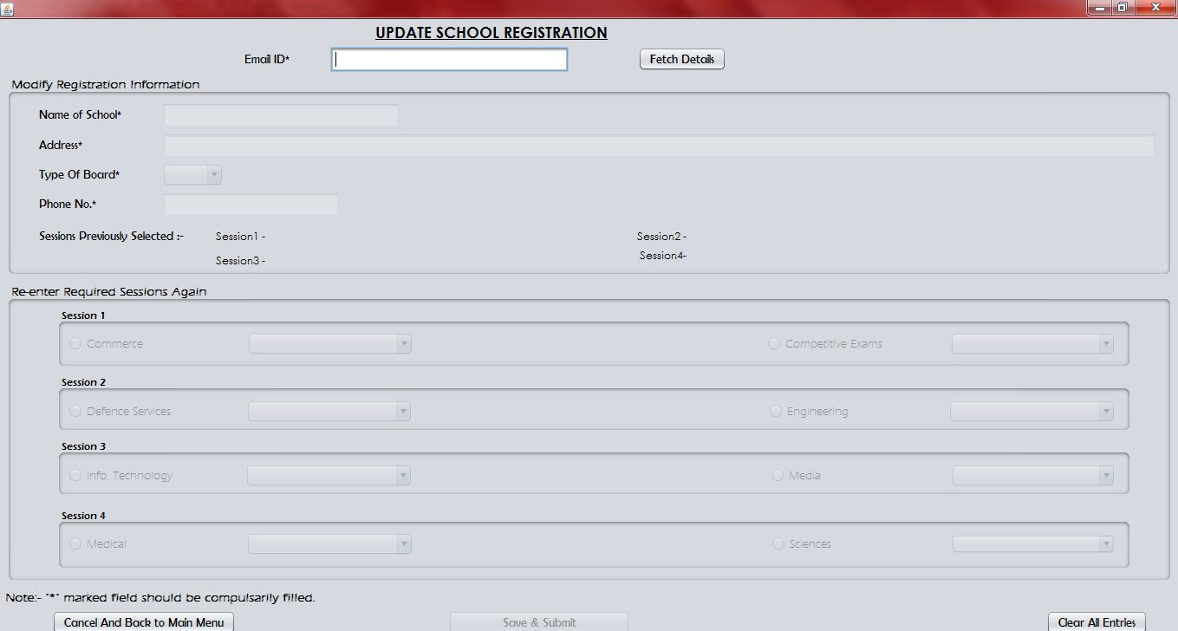

Output Window

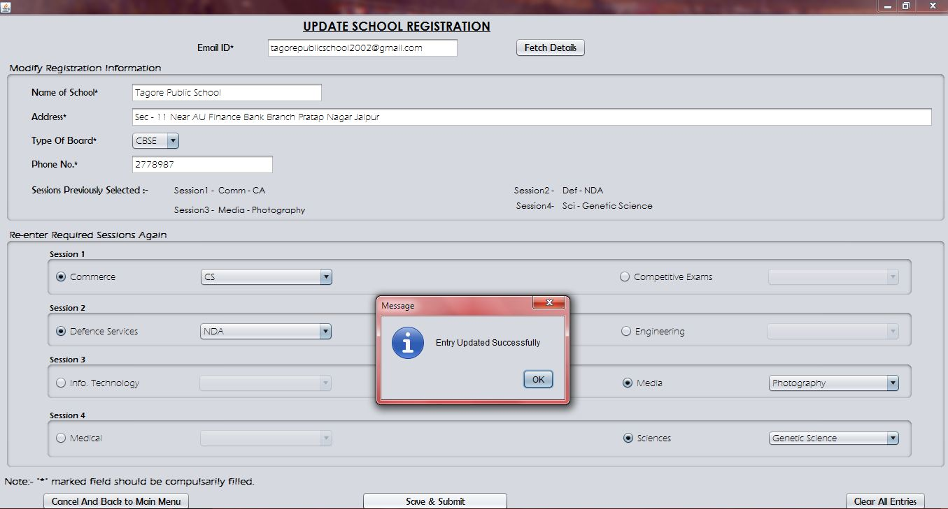

Specifications:

* Imports

import javax.swing.JOptionPane;

import java.sql.*;

* Init Components

jTextField1.setText("");

jTextField2.setText("");

jTextField5.setText("");

jTextField6.setText("");

RBComp.setSelected(false);

RBDef.setSelected(false);

RBEngg.setSelected(false);

RBInfo.setSelected(false);

RBMedia.setSelected(false);

RBMedi.setSelected(false);

RBSci.setSelected(false);

jComboBox2.setSelectedIndex(-1);

OptComm.setSelectedIndex(-1);

OptComp.setSelectedIndex(-1);

OptDef.setSelectedIndex(-1);

OptEngg.setSelectedIndex(-1);

OptInfo.setSelectedIndex(-1);

OptMedia.setSelectedIndex(-1);

OptMedi.setSelectedIndex(-1);

OptSci.setSelectedIndex(-1);

OptComm.setEnabled(false);

OptComp.setEnabled(false);

OptDef.setEnabled(false);

OptEngg.setEnabled(false);

OptInfo.setEnabled(false);

OptMedia.setEnabled(false);

OptMedi.setEnabled(false);

OptSci.setEnabled(false);

jComboBox2.setEnabled(false);

jTextField1.setEnabled(false);

jTextField6.setEnabled(false);

jTextField5.setEnabled(false);

RBComm.setEnabled(false);

RBComp.setEnabled(false);

RBDef.setEnabled(false);

RBEngg.setEnabled(false);

RBInfo.setEnabled(false);

RBMedia.setEnabled(false);

RBMedi.setEnabled(false);

RBSci.setEnabled(false);

jButton3.setEnabled(false);

Coding:

* Code for “Fetch Details” Button

jComboBox2.setEnabled(true);

jTextField1.setEnabled(true);

jTextField6.setEnabled(true);

jTextField5.setEnabled(true);

RBComm.setEnabled(true);

RBComp.setEnabled(true);

RBDef.setEnabled(true);

RBEngg.setEnabled(true);

RBInfo.setEnabled(true);

RBMedia.setEnabled(true);

RBMedi.setEnabled(true);

RBSci.setEnabled(true);

jButton3.setEnabled(true);

try{

Class.forName("java.sql.DriverManager");

Connection con= DriverManager.getConnection ("jdbc:mysql://localhost: 3306/EDUFAIR_REGISTRATION_WINDOW","root","rootcap");

String EmailID, sql;

EmailID=jTextField2.getText();

sql="select * from School_Registration where EmailID='"+EmailID+"'";

Statement st =con.createStatement();

ResultSet rs =st.executeQuery(sql);

if(!rs.next())

JOptionPane.showMessageDialog(null,"No such Record.");

else{

jTextField1.setText(rs.getString("SchoolName"));

jTextField6.setText(rs.getString("Address"));

jTextField5.setText(rs.getString("PhoneNo"));

jComboBox2.setSelectedItem(rs.getString("Type_of_Board"));

jLabel12.setText(rs.getString("Session1"));

jLabel13.setText(rs.getString("Session2"));

jLabel15.setText(rs.getString("Session3"));

jLabel18.setText(rs.getString("Session4"));

}

}

catch(Exception e){JOptionPane.showMessageDialog(null,e.getMessage());}

* Code for “Save & Submit” Button

if((RBComm.isSelected() || RBComp.isSelected()) && (RBDef.isSelected() || RBEngg.isSelected()) && (RBInfo.isSelected() || RBMedia.isSelected()) && (RBMedi.isSelected() || RBSci.isSelected()) && jTextField1.getText().length()!=0 && jTextField2.getText().length()!=0 && jTextField5.getText().length()==7 && jTextField6.getText().length()!=0 && jComboBox2.getSelectedIndex()!=-1)

{String SchoolName, Address, Type_of_Board, EmailID, PhoneNo, Session1="NULL", Session2="NULL", Session3="NULL", Session4="NULL";

SchoolName= jTextField1.getText();

Address= jTextField6.getText();

Type_of_Board= jComboBox2.getSelectedItem().toString();

EmailID= jTextField2.getText();

PhoneNo= jTextField5.getText();

{if(RBComm.isSelected())

{if(OptComm.getSelectedItem()=="CA")

Session1="Comm - CA";

else if(OptComm.getSelectedItem()=="CS")

Session1="Comm - CS";

else if(OptComm.getSelectedItem()=="Entrepreneurship")

Session1="Comm - Entrepreneurship";

}

else if(RBComp.isSelected())

{if(OptComp.getSelectedItem()=="CAT")

Session1="Comp - CAT";

else if(OptComp.getSelectedItem()=="Civil Services")

Session1="Comp - Civil Services";

else if(OptComp.getSelectedItem()=="CLAT")

Session1="Comp - CLAT";

}

}

{if(RBDef.isSelected())

{if(OptDef.getSelectedItem()=="Aviation")

Session2="Def - Aviation";

else if(OptDef.getSelectedItem()=="Merchant Navy")

Session2="Def - Merchant Navy";

else if(OptDef.getSelectedItem()=="NDA")

Session2="Def - NDA";

}

else if(RBEngg.isSelected())

{if(OptEngg.getSelectedItem()=="Automobile Engg.")

Session2="Engg - Automobile Engg.";

else if(OptEngg.getSelectedItem()=="Electrical Engg.")

Session2="Engg - Electrical Engg.";

else if(OptEngg.getSelectedItem()=="Mechanical Engg.")

Session2="Engg - Mechanical Engg.";

}

}

{if(RBInfo.isSelected())

{if(OptInfo.getSelectedItem()=="Cyber Law")

Session3="Info - Cyber Law";

else if(OptInfo.getSelectedItem()=="Multimedia")

Session3="Info - Multmedia";

else if(OptInfo.getSelectedItem()=="Networking")

Session3="Info - Networking";

}

else if(RBMedia.isSelected())

{if(OptMedia.getSelectedItem()=="Advertising")

Session3="Media - Advertising";

else if(OptMedia.getSelectedItem()=="Anchoring")

Session3="Media - Anchoring";

else if(OptMedia.getSelectedItem()=="Photography")

Session3="Media - Photography";

}

}

{if(RBMedi.isSelected())

{if(OptMedi.getSelectedItem()=="Pharmacy")

Session4="Medi - Pharmacy";

else if(OptMedi.getSelectedItem()=="Physiotherapy")

Session4="Medi - Physiotherapy";

else if(OptMedi.getSelectedItem()=="Rehabilitation")

Session4="Medi - Rehabilitation";

}

else if(RBSci.isSelected())

{if(OptSci.getSelectedItem()=="Acturial Science")

Session4="Sci - Acturial Science";

else if(OptSci.getSelectedItem()=="Genetic Science")

Session4="Sci - Genetic Science";

else if(OptSci.getSelectedItem()=="Nuclear Science")

Session4="Sci - Nuclear Science";

}

}

try{

Class.forName("java.sql.DriverManager");

Connection con=DriverManager.getConnection ("jdbc:mysql://localhost: 3306/EDUFAIR_REGISTRATION_WINDOW","root","rootcap");

String sql;

sql="update School_Registration set SchoolName='"+SchoolName+"', Address='"+Address+"', Type_of_Board='"+Type_of_Board+"', PhoneNo='"+PhoneNo+"', Session1='"+Session1+"', Session2='"+Session2+"', Session3='"+Session3+"', Session4='"+Session4+"' where EmailID='"+EmailID+"'";

Statement st =con.createStatement();

st.executeUpdate(sql);

JOptionPane.showMessageDialog(null,"Entry Updated Successfully");

}

catch(Exception e){JOptionPane.showMessageDialog(null,e.getMessage());}

}

else

JOptionPane.showMessageDialog(null,"Please Note!!"+"\nIt is compulsory to select any one category in each session."+"\nAlso It is compulsory to fill all the '*' marked fields"+"\nAlso the Phone No. shoul be exactly 7 digits long.");

* Code for “Cancel And Back to Main Menu” Button

Menu_Bar obj= new Menu_Bar();

obj.setVisible(true);

this.dispose();

* Code for “Clear All Entries” Button

RBComm.setSelected(false);

RBComp.setSelected(false);

RBDef.setSelected(false);

RBEngg.setSelected(false);

RBInfo.setSelected(false);

RBMedia.setSelected(false);

RBMedi.setSelected(false);

RBSci.setSelected(false);

jTextField1.setText("");

jTextField2.setText("");

jTextField5.setText("");

jTextField6.setText("");

jComboBox2.setSelectedIndex(-1);

OptComm.setSelectedIndex(-1);

OptComp.setSelectedIndex(-1);

OptDef.setSelectedIndex(-1);

OptEngg.setSelectedIndex(-1);

OptInfo.setSelectedIndex(-1);

OptMedia.setSelectedIndex(-1);

OptMedi.setSelectedIndex(-1);

OptSci.setSelectedIndex(-1);

OptComm.setEnabled(false);

OptComp.setEnabled(false);

OptDef.setEnabled(false);

OptEngg.setEnabled(false);

OptInfo.setEnabled(false);

OptMedia.setEnabled(false);

OptMedi.setEnabled(false);

OptSci.setEnabled(false);

jLabel12.setText("");

jLabel13.setText("");

jLabel15.setText("");

jLabel18.setText("");

* Code for “Commerce” RadioButton (RBCommAction Performed)

OptComm.setEnabled(true);

OptComp.setEnabled(false);

* Code for “Comp…Exams” RadioButton (RBCompAction Performed)

OptComp.setEnabled(true);

OptComm.setEnabled(false);

* Code for “Defence” RadioButton (RBDefAction Performed)

OptDef.setEnabled(true);

OptEngg.setEnabled(false);

* Code for “Engineering” RadioButton (RBEnggAction Performed)

OptEngg.setEnabled(true);

OptDef.setEnabled(false);

* Code for “Info…ology” RadioButton (RBInfoAction Performed)

OptInfo.setEnabled(true);

OptMedia.setEnabled(false);

* Code for “Media” RadioButton (RBMediaAction Performed)

OptMedia.setEnabled(true);

OptInfo.setEnabled(false);

* Code for “Medical” RadioButton (RBMediAction Performed)

OptMedi.setEnabled(true);

OptSci.setEnabled(false);

* Code for “Sciences” RadioButton (RBSciAction Performed)

OptSci.setEnabled(true);

OptMedi.setEnabled(false);

Delete Student’s Registration

Design Window

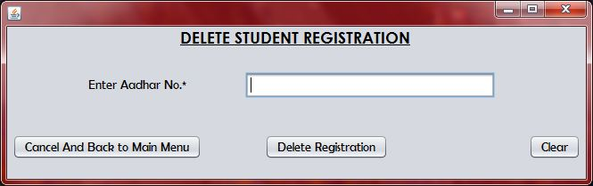

Output Window

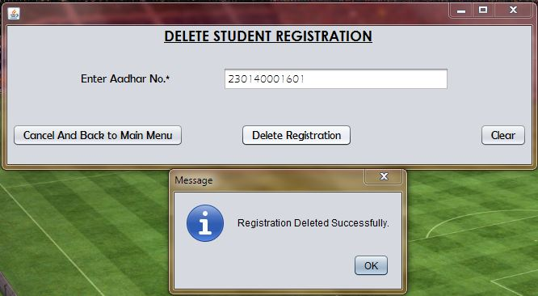

Specifications:

* Imports

import javax.swing.JOptionPane;

import java.sql.*;

Coding:

* Code for “Delete Registration” Button

if(jTextField1.getText().length()==12)

{try{

Class.forName("java.sql.DriverManager");

Connection con=DriverManager.getConnection("jdbc:mysql://localhost: 3306/EDUFAIR_REGISTRATION_WINDOW","root","rootcap");

String AadharNo, sql;

AadharNo=jTextField1.getText();

sql="delete from Student_Registration where AadharNo=" +AadharNo;

Statement st =con.createStatement();

st.executeUpdate(sql);

JOptionPane.showMessageDialog(null,"Registration Deleted Successfully.");

}

catch(Exception e){JOptionPane.showMessageDialog(null,e.getMessage());}

}

else

{JOptionPane.showMessageDialog(null,"Aadhar No. should be exactly 12 digits long. Enter a valid Aadhar No.");}

* Code for “Cancel And Back to Main Menu” Button

Menu_Bar obj =new Menu_Bar();

obj.setVisible(true);

this.dispose();

* Code for “Exit” Button

jTextField1.setText(“”);

Delete School’s Registration

Design Window

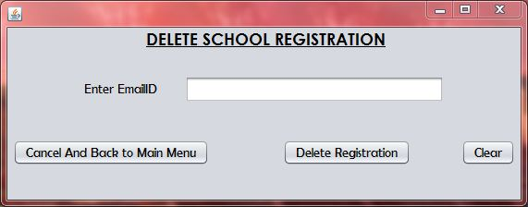

Output Window

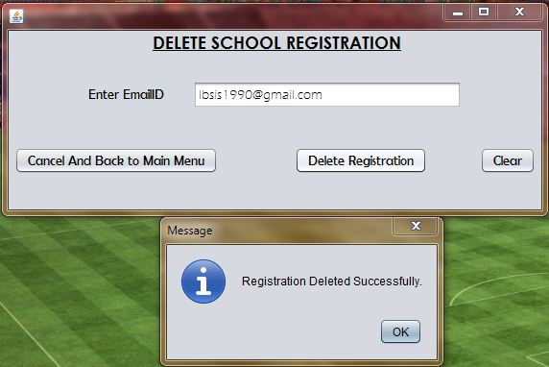

Specifications:

* Imports

import javax.swing.JOptionPane;

import java.sql.*;

Coding:

* Code for “Delete Registration” Button

try{

Class.forName("java.sql.DriverManager");

Connection con=DriverManager.getConnection("jdbc:mysql://localhost: 3306/EDUFAIR_REGISTRATION_WINDOW","root","rootcap");

String EmailID, sql;

EmailID=jTextField1.getText();

sql="delete from School_Registration where EmailID='"+EmailID+"'";

Statement st =con.createStatement();

st.executeUpdate(sql);

JOptionPane.showMessageDialog(null,"Registration Deleted Successfully.");

}

catch(Exception e){JOptionPane.showMessageDialog(null,e.getMessage());}

* Code for “Cancel And Back to Main Menu” Button

Menu_Bar obj =new Menu_Bar();

obj.setVisible(true);

this.dispose();

* Code for “Exit” Button

jTextField1.setText(“”);

View Registered Entries

Design Window

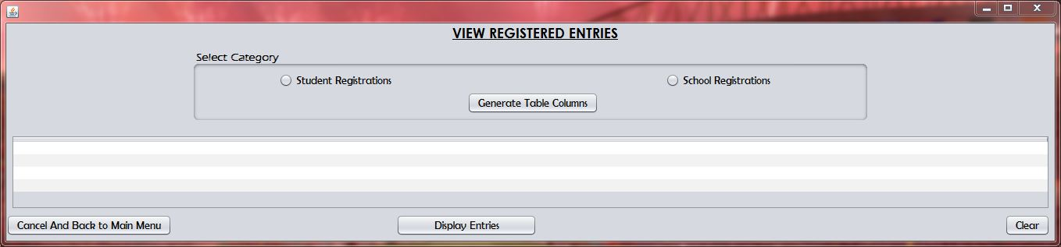

Output Window

(Table Generation 1)

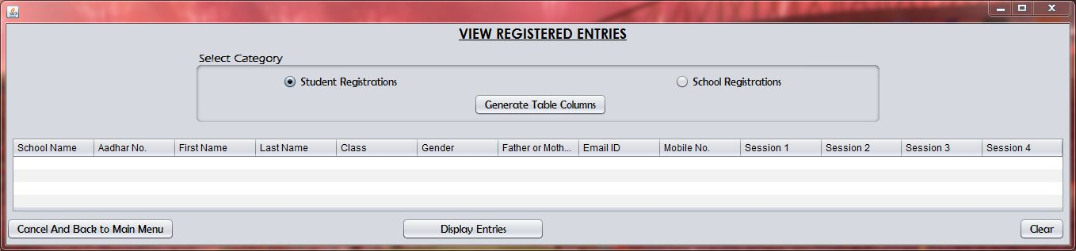

Output Window

(Table Generation 2)

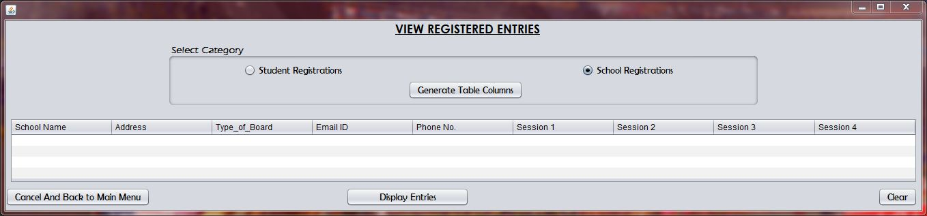

Output Window

(Display Records 1)

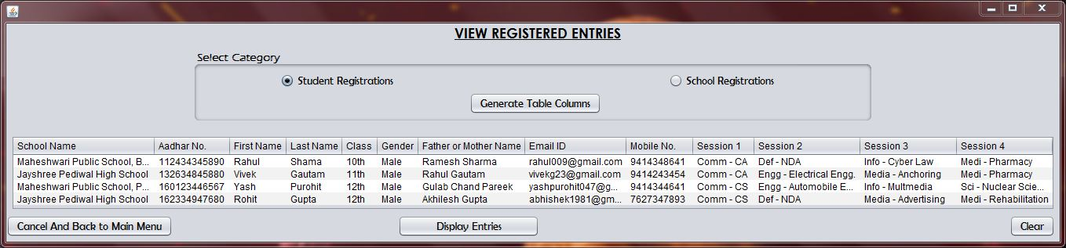

Output Window

(Display Records 1)

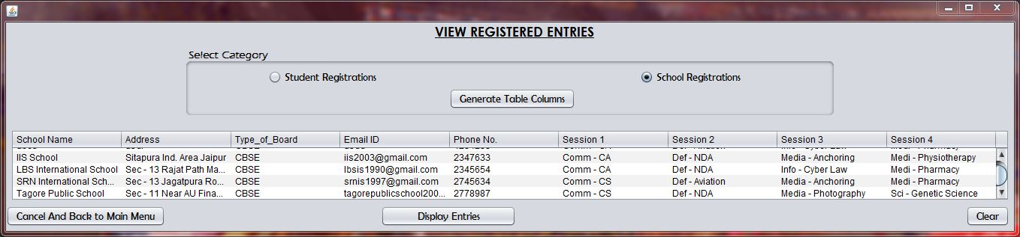

Specifications:

* Imports

import javax.swing.JOptionPane;

import java.sql.*;

import javax.swing.table.DefaultTableModel;

Coding:

* Code for “Generate Table Columns” Button

if(jRadioButton1.isSelected())

{jTable2.setModel(new javax.swing.table.DefaultTableModel(

new Object [][] {

{null, null, null, null, null, null, null, null, null, null, null, null, null},

{null, null, null, null, null, null, null, null, null, null, null, null, null},

{null, null, null, null, null, null, null, null, null, null, null, null, null},

{null, null, null, null, null, null, null, null, null, null, null, null, null}

},

new String [] {

"School Name", "Aadhar No.", "First Name", "Last Name", "Class", "Gender", "Father or Mother Name", "Email ID", "Mobile No.", "Session 1", "Session 2", "Session 3", "Session 4"

}

));

}

else if(jRadioButton2.isSelected())

{jTable2.setModel(new javax.swing.table.DefaultTableModel(

new Object [][] {

{null, null, null, null, null, null, null, null, null},

{null, null, null, null, null, null, null, null, null},

{null, null, null, null, null, null, null, null, null},

{null, null, null, null, null, null, null, null, null}

},

new String [] {

"School Name", "Address", "Type_of_Board", "Email ID", "Phone No.", "Session 1", "Session 2", "Session 3", "Session 4"

}

));

}

* Code for “Display Entries” Button

if(jRadioButton1.isSelected()){

try{

Class.forName("java.sql.DriverManager");

Connection con=DriverManager.getConnection("jdbc:mysql://localhost:

3306/EDUFAIR_REGISTRATION_WINDOW","root","rootcap");

String SchoolName, AadharNo, FirstName, LastName, CLass, Gender, Father_or_MotherName, EmailID, MobileNo, Session1, Session2, Session3, Session4, sql;

sql="select * from Student_Registration";

Statement st =con.createStatement();

ResultSet rs= st.executeQuery(sql);

DefaultTableModel model=(DefaultTableModel) jTable2.getModel();

int rows =model.getRowCount();

if(rows>0){

for(int i=0; i<rows; i++)

model.removeRow(0);

}

while(rs.next()){

SchoolName=rs.getString("SchoolName");

AadharNo=rs.getString("AadharNo");

FirstName=rs.getString("FirstName");

LastName=rs.getString("LastName");

CLass=rs.getString("Class");

Gender=rs.getString("Gender");

Father_or_MotherName=rs.getString("Father_or_MotherName");

EmailID=rs.getString("EmailID");

MobileNo=rs.getString("MobileNo");

Session1=rs.getString("Session1");

Session2=rs.getString("Session2");

Session3=rs.getString("Session3");

Session4=rs.getString("Session4");

model.addRow(new Object[] {SchoolName, AadharNo, FirstName, LastName, CLass, Gender, Father_or_MotherName, EmailID, MobileNo, Session1, Session2, Session3, Session4});

}

}

catch(Exception e){JOptionPane.showMessageDialog(null, e.getMessage());}

}

else if(jRadioButton2.isSelected()){

try{

Class.forName("java.sql.DriverManager");

Connection con=DriverManager.getConnection("jdbc:mysql://localhost: 3306/EDUFAIR_REGISTRATION_WINDOW","root","rootcap");

String SchoolName, Address, Type_of_Board, EmailID, PhoneNo, Session1, Session2, Session3, Session4, sql;

sql="select * from School_Registration";

Statement st =con.createStatement();

ResultSet rs= st.executeQuery(sql);

DefaultTableModel model=(DefaultTableModel) jTable2.getModel();

int rows =model.getRowCount();

if(rows>0){

for(int i=0; i<rows; i++)

model.removeRow(0);

}

while(rs.next()){

SchoolName=rs.getString("SchoolName");

Address=rs.getString("Address");

Type_of_Board=rs.getString("Type_of_Board");

EmailID=rs.getString("EmailID");

PhoneNo=rs.getString("PhoneNo");

Session1=rs.getString("Session1");

Session2=rs.getString("Session2");

Session3=rs.getString("Session3");

Session4=rs.getString("Session4");

model.addRow(new Object[] {SchoolName, Address, Type_of_Board, EmailID, PhoneNo, Session1, Session2, Session3, Session4});

* Code for “Cancel And Back to Main Menu” Button

Menu_Bar obj =new Menu_Bar();

obj.setVisible(true);

this.dispose();

* Code for “Exit” Button

jTextField1.setText(“”);

User Manual

* Please Note:-
* The MySQL server must have username as ***root*** and password as ***rootcap***.

If root password is any other password, it can be changed by running MySQL Server Instance Configure Wizard.

Start ⏵Program ⏵ MySQL ⏵MySQL Server ⏵MySQL Server Instance Config Wizard

Provide current password of root and new password as ***rootcap***, this will change the root password.

* Also Before running the project the Database should be prepared by the help of the sql file attached with the project.