A PROJECT REPORT ON

FAIR FOOD STORE

SUBMITTED IN PARTIAL FULFILLMENT OF
REQUIREMENTS FOR THE DEGREE OF
BACHELOR OF SCIENCE (INFORMATION TECHNOLOGY

FOR THE ACADEMIC YEAR 2014-15
UNIVERSITY OF MUMBAI

SUBMITTED BY

MR.YASH RAWANI
MR.MAYUR SANCHETI

UNDER THE GUIDANCE OF
MR. ZARTAB NAKHWA

K. P. B. HINDUJA COLLEGE OF COMMERCE
315, NEW CHARNI ROAD, MUMBAI 4000 04.



K. P. B. HINDUJA COLLEGE OF COMMERCE
315, NEW CHARNI ROAD, MUMBAI-400 004

A PROJECT REPORT ON
FAIR FOOD STORE

SUBMITTED BY
MR.YASH RAWANI
SEAT NO: 1130160

MR.MAYUR SANCHETI
SEAT NO: 1130166

Bachelor of Science
(Information Technology)
2014-2015

Smt. P.D. Hinduja Trust’s
K.P.B. HINDUJA COLLEGE OF COMMERCE
315, New Charni Road, Mumbai 4000 04 ☎Tel.: 022-40989000 Fax: 2385 93 97 Email:hindujacollege@gmail.com
NAAC Re-Accredited ‘A’
THE BEST COLLEGE OF UNIVERSITY OF MUMBAI FOR THE ACADEMIC YEAR 2010-2011

ISO 9001:2008
Prin. Dr. Minu Madlani – M.Com., Ph.D.
Ref. No. :

CERTIFICATE

This is to certify that the following students of T.Y.B.Sc (Information Technology) during the Academic year 2014-2015 of our college have successfully completed the project on

Name of the Students University Seat no

_______ _________________________
___________ _________________________

This information is true and original to the best of our knowledge.

_________________ _______________
Co-Ordinator Project Guide Dr. Minu Madlani
B.Sc(IT)

____________ _______________
Internal Examiner External Examiner

College Seal

ACKNOWLEDGEMENT

I take this opportunity to express my profound gratitude and deep regards to my teachers for their exemplary guidance, monitoring and constant encouragement throughout the course of this project. The blessings, help and guidance given by them, from time to time, shall carry me a long way in the journey of life on which I am about to embark.
I also take this opportunity to express a deep sense of gratitude to the Head of Department, Mr. Nasir Ansari for his cordial support, valuable information and guidance, which helped me in completing this task through various stages.
I am obliged to the professors and other staff members of K.P.B. Hinduja College of Commerce, for the valuable information provided by them in their respective fields. I am grateful for their co-operation during the period of my project.
Lastly, I thank almighty, our parents, family and friends for their constant encouragement, with which I could carry on this project through thick and thin.

Yours faithfully,

(MR. YASH RAWANI)

(MR. MAYUR SANCHETI)

STATEMENT BY THE CANDIDATE

I wish to state that the work embodied in this project titled “FAIR FOOD STORE
” forms my own contribution to the project work carried out under the guidance of Prof. Mr. Zartab Nakhwa at the Department of Information Technology. This work has not been submitted for any other degree of this or any other University. Wherever references have been made to previous work of others, it has been clearly indicated as such and included in the Bibliography.

- )

- )

Signature of the candidates

Certified by

Signature of the Guide
Date

PROJECT SYNOPSIS

Topic:
FAIR FOOD STORE
This software is used for easier way to purchase genral food stuffs . It will make your own account and show the world what you can make your things easier. It will also show how various product and items can be selled easily.

Features:
- user login
- Easy to use
- Easy to understand
- Easy to buy for user

Software Requirements:
- Windows XP, Windows vista, Windows 7,Windows 8
- Browser

Hardware Components:
- Processor-AMD, i3,i5,i7,Pentium 4
- RAM- 512 MB

Language used:
- JAVA
- SQL

Advantages:
- Easy to use.
- Easy to store information about each user.
- You can easily view photos and videos.
- You can take feedback from user to improve your ingredients.
- Send/Receive Gift Vouchers.

Disadvantages:
- Misuse of user id and password.
- Technical difficulties or server malfunctions

- Lack of touch and feel of merchandise

TABLE OF CONTENTS

SR. NO. | TOPIC | PAGE. NO.
1 | Introduction | 9
2 | System study and analysis | 10
2.1 | Significance study | 10
2.2 | Objective of study | 11
2.3 | Scope of project | 12
2.4 | System Implementation | 13
2.5 | Feasability Study | 18
2.6 | Proposed system | 19
2.7 | Advantages | 20
3 | System Analysis | 21
3.1 | Software Development LifeCycle | 22
3.2 | Gantt chart | 27
3.3 | Event table | 28
3.4 | ER Diagram | 29
3.5 | Use Case | 30
3.6 | Sequence diagram | 31
3.7 | Activity diagram | 33
3.8 | Class Diagram | 35
4 | Program List | 36
5 | Tables List | 37
6 | System testing and conclusion | 39
7 | Data Entry Code | 43
8 | Source code | 44
9 | Conclusion | 83
10 | Screen layout | 84
11 | References/bibliography/websites Used | 89

Introduction

- The word “FAIR FOOD STORE” means to choose from a list, to elect or to determine. The main goal of store is to come up with different and easier choice of product and get it delivered it at home in our given time
- Now a days we can get everything very easily and quickly online so this is a very useful website to shop for a general store which can be a very much time saving.
- Grocery stores, also known as supermarkets, are familiar to everyone. They sell an array of fresh and preserved foods, primarily for preparation and consumption at home.
- They also often sell prepared food, such as hot entrees or salads, for takeout meals. Stores range in size from supermarkets, which may employ hundreds of workers and sell numerous food and nonfood items, to convenience stores with small staffs and limited selections.
- However, convenience stores often sell fuel, including gasoline, diesel fuel, kerosene, and propane.
- Recently, many convenience stores have expanded their scope of services by providing automatic teller machines, money orders, and a more comprehensive selection of food and nonfood products.

SYSTEM STUDY AND ANALYSIS

Systems Analysis and Feasability Report for a Local General Store.
Systems Analysis Introduction - The Current System A local shop, which sells primarily home stuffs local daily needs for a particular home to customers, has also been renting out videos as a video club might do. They do not, however, have members but videos are given to a customer that they may know or recognize. Videos come from one main supplier who sends the manager a list of available videos. When a video is added to stock, it is stamped with the shops name and address and a video number is added. A record of this new video is kept on a card along with the video's details, suppliers' details and when the video was purchased. This is then filed in a small filing cabinet according to video number, found on the card. A large logbook contains the name address and telephone number of a customer who has taken a video out along with the name and number of the video

SIGNIFICANCE OF STUDY
A general store, general merchandise store, general dealer or village shop is a rural or small town store that carries a general line of merchandise.[1]It carries a broad selection of merchandise, sometimes in a small space, where people from the town and surrounding rural areas come to purchase all their general goods. The store carries routine stock and obtains special orders fromwarehouses. It differs from a convenience store or corner shop in that it will be the main shop for the community rather than a convenient supplements
General stores often sell staple food items such as milk and bread, and various household goods such as hardware and electrical supplies. The concept of the general store is very old, and although some still exist, there are far fewer than there once were, due to urbanization, urban sprawl, and the relatively recent phenomenon of big-box stores.

Objectives Of The Project

Small grocery store companies have many objectives. They usually outline these objectives in their business plans well before the start of new fiscal years. These companies can best reach their objectives by staying customer-focused, offering products and services their customers want. That is why most grocery store companies also develop comprehensive marketing plans to reach their key objectives. Marketing plans help the owners better define their target customers and store concepts, such as whether they serve specialty markets like organic food eaters.

The major objective of most grocery store companies is to sell products and earn the highest profits possible. However, grocery store owners face major competition from other retailers like restaurants and mass merchandisers. One strategy grocery stores use to counter the competition is to serve more take-out meals, according to a December 2009 report from the Bureau of Labor Statistics. These ready-to-eat meals serve the customer sector that is looking for convenience. Small grocery store companies may also offer movie rentals, check cashing services and non-food products to build sales and profits. These strategies focus on customers more interested in one-stop shopping

SCOPE OF PROJECT
India is a developing country and Indian consumers spend a larger share of their income on food. ‘General Store’ is the second-largest segment of the retail industry in India. This retail segment is
expected to accurately reflect the performance of organised retail and hence the scope of study is limited to organised retail formats with Food and Grocery as the major product category.

- Less effort and less labour intensive, as the primary cost and focus primary on creating, managing, and running a secure web trading portal.
- Increasing number of users/buyers as individuals will find it easier and more convenient to buy.

System Implementation:

TECHNOLOGY USED

- Language :- Java
- Backend :- SQL Server or My-SQL

SYSTEM REQUIREMENT

- Minimum RAM : - 256 MB
- Hard Disk : - 40 GB
- Operating System : - Windows XP Service Pack2

Software Requirement

Software to be used –
- Java Development Kit 1.6.0.
- NetBeans IDE 8.0.1

NetBeans IDE 8.0.2
NetBeans is an open source Integrated Development Environment for software developers. It is compatible with Windows, Linux, Solaris, and MacOS. Developers can use this great tool to design software using Java SE/FX, Java, Ruby, C/C++, and PHP. It is sponsored by Sun Microsystems and is very powerful thanks to the contributions of thousands of users.
It is really a great tool because it integrates with lots of external resources: MySQL, DB2, Access, SQL Server, Web plugins and others.
With NetBeans you can create professional desktop applications using the Java GUI Builder with Swing Application Framework and Beans Binding. Design web applications using Ajax, JavaScript, and CSS. Make graphic applications that run on mobile phones and PDAs with the JavaFX Mobile, and the Java ME SDK 3.0 support.
This new version introduces integration with Project Kenai, a collaboration environment for developers to host open-source projects. It now integrates native support for Maven, GlassFish, and Hudson, and has improvements on Java, PHP, Ruby, Groovy, and C/C++, as well as support for JavaScript 1.7, and Java ME SDK 3.0.
Advantages
- Multiplatform support.
- Free.
- Collaboration environment.
- Java, PHP, C++, Ruby.
- Plugin expansion.

Disadvantages

- Complex interface
- Maintenance
- Backup / security / antivirus s/w.

Using MySQL benefits:
Security Benefits:
There is an old saying that states that knowledge is power. The ability to securely store and retrieve data is one of the pillars of the IT world. With SQL Server there are several security options to ensure that your data is stored safely.

SQL Server supports two security modes:
- Windows Authentication:
Uses the credentials of the person logged into the Windows machine.
- SQL Server and Windows Authentication (Mixed Authentication):
Uses both Windows Authentication and SQL Server username and password combinations

Other Security features:
Authentication is done through username and password combinations at customer side

J2EE (Java 2 Enterprise Edition)

- JSP
Java Server Pages (JSP) technology provides a simplified, fast way to create dynamic web content. JSP technology enables rapid development of web-based applications that are server and platform-independent.
The JSP Standard Tag Library (JSTL) is a collection of tag libraries that implement general-purpose functionality common to many Web applications.
A JSP also page contains standard markup language elements, such as HTML tags, just like a regular web page.
The main features of JSP technology are:
A language for developing JSP pages, which are text-based documents that describe how to process a request and construct a response.
Constructs for accessing server-side objects.
Mechanisms for defining extensions to the JSP language.

- Servlet
A Servlet is a Java class in Java EE that conforms to the Java Servlet API, a protocol by which a Java class may respond to HTTP requests. Thus, a software developer may use a Servlet to add dynamic content to a Web server using the Java platform.
Servlets are Java objects which execute on the server in response to a browser request. They can either generate HTML or XML directly, or call a JSP to produce the output.

- MySQL

MySQL is a relational database management system (RDBMS) that runs as a server providing multi-user access to a number of databases. MySQL is officially ("My S-Q-L").
Is a popular open source SQL (Structured Query Language) database implementation, available for many platforms, including Windows, Unix/Linux .It is an Open Source development of the SQL language for talking to databases. Most commonly used amongst small business users and run on Linux operating systems. Free open source database software often used on the web.

What is CSS?
CSS stands for Cascading Style Sheets. Styles define how to display HTML elements. Styles were added to HTML 4.0 to solve a problem. External Style Sheets can save a lot of work. CSS is recommended way to control the presentation layer in a web document. The main advantage of CSS over presentational HTML markup is that the styling can be kept entirely separate from the content.

Problem Defination

Limitations

(i) Departmental stores are large-scale retail establishments.

(ii) They have a number of departments organised under one roof.

(iii) Each department specialises in a particular kind of trade.

(iv) Their basic principle is that it is easier to sell more goods to the same customers by providing a large variety of goods than to sell the same kind of goods to many customers. Hence, they provide a large variety of merchandise from a pin to an aeroplane, and act as universal suppliers.

(v) Their aim is to provide quality goods and services to the customers. Restaurants, telephone facilities, recreational facilities, reading rooms etc. are also provided by them.

Feasibility Study:-

The Feasibility Study is the major factor which contributes to the analysis and development of the system. The decision of the system analyst whether to design a particular system or not on its feasibility study and thus form a very important part of the system.

Economic Feasibility:

- The technique of the cost benefit analysis is used to access economic feasibility. It is helpful to find the system development cost, software cost and checks whether it is feasible.
- The system is being developed in JAVA as front end and SQL SERVER as back end tool on windows 7 platform. Hence it is no need to recruit new professionals to operate the system.
- Thus, I can see the system is economically feasible.

Operation Feasibility:

- It considers the acceptability of the system. It checks whether system will be used if it is developed and implemented. The users of the system will be able to handle the system whether the proposed system will cause and trouble etc.
- Proposed system works when given basic information and produces reports as and when required.
- Therefore, system is user friendly.

Technological Feasibility:

- It always focuses on the existing computer hardware and software. These also included the need for more hardware and software and the possibility of installing such facility.

- The whole system is being developed in house with approaching no external software consultant. The system is being developed in JAVA and SQL SERVER.
- Available hardware configuration is sufficient for developing the software. So technically the system under development is feasible.

- Proposed System

- The proposed system is created in JAVA as a Front end. The proposed system deals with very popular interface tool i.e. JAVA as Front end; hence it provides well-placed controlled information to the user.

- The retrieval of the records is much faster than the present system. Hence it causes in saving users time for the further work.

- The user can have fast interaction with application. Because not only the front end provides the faster interaction with the records but the back end device data also provides the proper interaction with the records and gives or prompts the information/messages to the end user if he/she making error during work.

- The proposed system also provides the information about where to click or to press the button for the further information.

- Searching directions is quite faster than the present system since it searches directly from the system that is from the front end.

- The first advantage of the proposed system is that its front end provides easy and précised information to the user to interact with the system and hence it is faster to complete the work.

Advantages:

(i) Shopping convenience:
A departmental store enables the customers to purchase all their requirement under one roof and the customers need not go from one shop to another for making purchases. This provides great convenience to the customers and also saves their time and labour.
(ii) Wide Choice:
The departmental store keeps a large variety of products and hence offers an opportunity to the customers to select goods of their liking from a large stock of goods of different qualities, brands, designs, colours, styles, etc.
(iii) Economies of large scale:
Departmental stores, being large-scale establishments, enjoy all the economies and benefits of large-scale organisations. This reduces their costs and increases the profits.
(iv) Liberal services:
They provide many unique services to their customers like free home delivery, accepting telephone orders, restaurants, recreational facilities, reading rooms, after-sale service, etc. Some of the stores even offer credit facilities to their peop

System Analysis

System analysis is a process of gathering and interpreting facts , diagnosing problems and the information to recommend improvements on the system. It is a problem solving activity that requires intensive communication between the system users and system developers. System analysis or study is an important phase of any system development process. The system is studied to the minutest detail and analyzed.
The system analyst plays the role of the interrogator and dwells deep into the working of the present system. The system is viewed as a whole and the input to the system are identified. The outputs from the organizations are traced to the various processes. System analysis is concerned with becoming aware of the problem, identifying the relevant and decisional variables, analyzing and synthesizing the various factors and determining an optimal or at least a satisfactory solution or program of action.
A detailed study of the process must be made by various techniques like interviews, questionnaires, etc. The data collected by these sources must be scrutinized to arrive to a conclusion. The conclusion is an understanding of how the system functions. This system is called the existing system. Now the existing system is subjected to close study and problem areas are identified.
The designer now functions as a problem solver and tries to sort out the difficulties that the enterprise faces. The solutions are given as proposals. The proposal is then weighed with the existing system analytically and the best one is selected. The proposal is presented to the user for an endorsement by the user. The proposal is reviewed on user request and suitable changes are made. This is loop that ends as soon as the user is satisfied with proposal.

Preliminary study is a process of gathering and interpreting facts, using the information for further studies on the system. Preliminary study is a problem solving activity that requires intensive communication between the system users and system developers. It does various feasibility studies. In these studies a rough figure of the system activities can be obtained, from which the decision about the strategies to be followed for effective system studies and analysis can be taken.

System Life Cycle

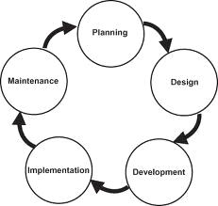

Software Development Life Cycle(SDLC)

- A software development process, also known as a software development lifecycle, is a structure imposed on the development of a software product. Similar terms include software life cycle and software process. There are several models for such processes, each describing approaches to a variety of tasks or activities that take place during the process. Some people consider a lifecycle model a more general term and a software development process a more specific term. For example, there are many specific software development processes that 'fit' the spiral lifecycle model.

- The Systems Development Life Cycle (SDLC), or Software Development Life Cycle in systems engineering, information systems and software engineering, is the process of creating or altering systems, and the models and methodologies that people use to develop these systems. The concept generally refers to computer or information systems.

- In software engineering the SDLC concept underpins many kinds of software development methodologies. These methodologies form the framework for planning and controlling the creation of an information system the software development process.

- As in any other engineering discipline, software engineering also has some structured models for software development. This document will provide you with a generic overview about different software development methodologies adopted by contemporary software firms. Read on to know more about the Software Development Life Cycle (SDLC) in detail.

- Software Development Life Cycle or SDLC is a model of a detailed plan on how to create, develop, implement and eventually fold the software. It’s a complete plan outlining how the software will be born, raised and

SDLC MODEL

I have used “V-Model” for my project.
Q) What is V-Model?
- V-Model represents a software development process which may be considered and extension of waterfall model.
- Instead of moving down in the linear way, the process steps are bent upwards after the coding phase, to form typical V shape.
Q) Why V-Model?
- Simple and easy to use.
- Testing activities like Planning, Test designing, happens well before coding. This saves a lot of time. Hence higher chances of success over the waterfall model.
- Pro-active defect tracking- that is, defects are found at early stage.
- Avoid downward flow of defects.
- Works well for small projects where requirements are easily understood.

Phases of V-Model:-

User Requirement:-
- This phase is used to plan the entire working of the project.
- This phase helps to find that what is the actual user requirement.
In this phase it took about 2 months to gather all information and planned the working of my project.
- I referred many existing apps of Emergency Service and studied the working of the domain.
System Requirements:-
- It is the phase where the system engineers analyze and understand the business of the proposed system by studying user requirements document.
- Here I figured out what are the system requirements for my project.
- I figured out what hardware and software requirements are demanded by my project.
- Hence I used Java as my front end and MySql as my back end.
- With this phase I figured out that the minimum OS version that I need is a Win7, with minimum 512MB RAM and 1 GB or greater harddisk.

Global Design:-
- This phase is used in realizing brief functionality of each modules, number of modules their relationship etc.
- In this phase I decided which modules I need to develop, how many modules are required for my project, how the modules are related to each other
- I also figured out my database tables, architecture diagram connectivity of my modules with database.
- Basically I carried out integration testing in this stage.

Detailed Design:-

- In this phase designed system each modules is broken into smaller units so that the programmer can start coding directly.
- In this phase I divided my modules into smaller units and started to design and code them. I performed unit testing in this phase.
- I developed small and individual units and tested them.

GANTT CHART:-
A Gantt chart is a type of bar chart that illustrates a project schedule. Gantt charts illustrate the start and finish dates of the terminal elements and summary elements of a project.
Terminal elements and summary elements comprise the work breakdown structure of the project.
Gantt charts can be used to show current schedule status using percent-complete shadings.
This allows you to see at a glance:
What the various activities are
When each activity begins and ends
How long each activity is scheduled to last
Where activities overlap with other activities, and by how much
The start and end date of the whole project
MONTHS  PHASES | SEPT | OCT | NOV | DEC | JAN | FEB | MAR | APR
PLANNING
DESIGNING
CODING
TESTING

11/09/2014
11/10/2014
19/10/2014
31/10/2014

5/12/2014
22/12/2014
17/02/2015
30/12/2014
13/03/2015
21/04/2015
10/12/2014
20/04/2015
Expected
Actual

EVENT TABLE
Event:
- An event occurs at a specific time and place, can be described, and should be remembered by system.

- An event describes, in sufficient detail, a particular user action. Rather than the program actively collecting user-generated events, the Java run time notifies the program when an interesting event occurs. Programs that handle user interaction in this fashion are said to be Event Driven.

- Most programs, to be useful, must respond to commands from the user. To do so, Java programs rely on events that describe user actions.

Types of Event
- Event Table :

EVENT | TRIGGER | ACTIVITY | SOURCE | RESPONSE | DESTINATION
Login | User Login | User Enter  Username and Password | User | Login Successful or Failed | User
To Contact  Us | User Clicks on Contact  Us | User can contact us in need of help | User | Resolve querys of User | User
To order | User Clicks on Orders | User orders for a particular | User | order is confirmed | User

Entity-Realtionship Diagram:

Use Case Diagram:-
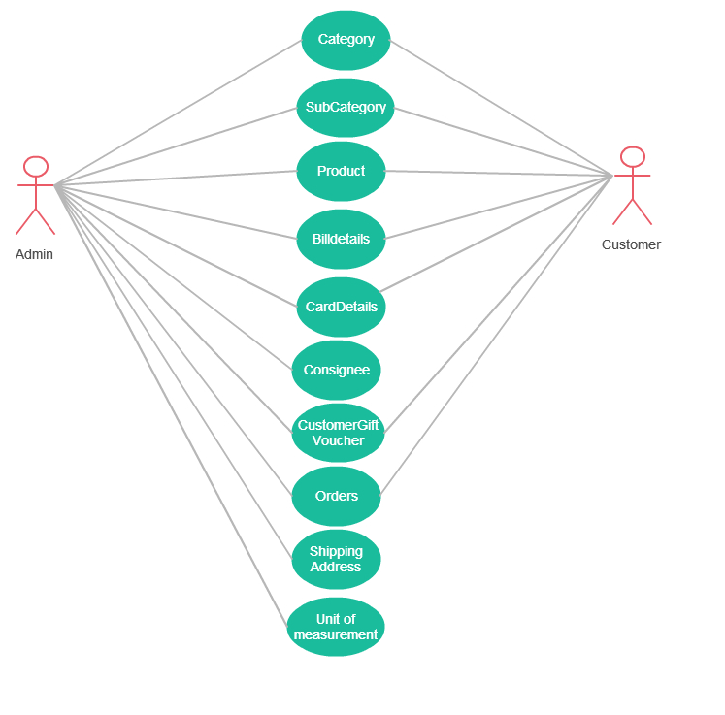

Collaboration Diagram/Sequence Diagram

Admin Login Diagram
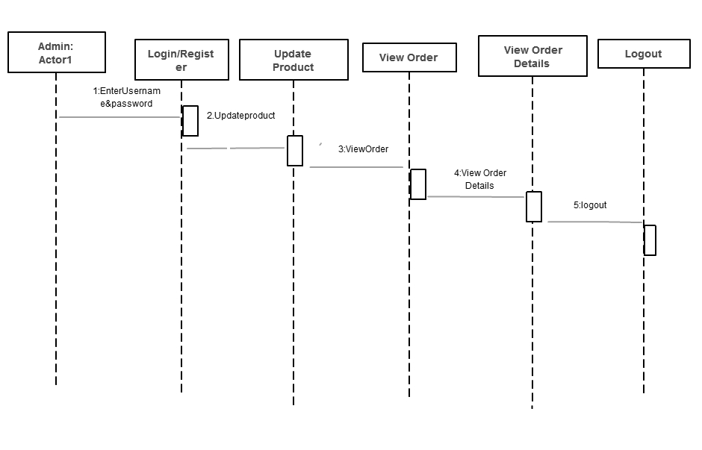

Customer Login Diagram

Activity Diagram:
Customer_Login_Diagram.

Admin_Activity_Diagram:

Class Diagram :

Program List

MODULE | FUNCTION
LOGIN | User should login before purchase.
Admin | Admin can see all the product can also update it and also view orders and their details and has every right to make changes.
Customer | Customer should login and can find any product which he requires and can place a order related to it.

Table List:

Table Name | Fields | Data Type
Admin | AdminID | varchar(20)
Admin | AdminFirstName | varchar(60)
Admin | AdminMiddleName | varchar(20)
Admin | AdminLastName | varchar(20)
Admin | Username | varchar(400)
Admin | AdminPassword | varchar(100)
Admin | Email | varchar(60)
Admin | ContactNumber | varchar(20)
Admin | Address | varchar(400)
Admin | Gender | varchar(10)
Admin | Date of birth | Date
Customer | AdminID | varchar(20)
Customer | AdminFirstName | varchar(20)
Customer | AdminMiddleName | varchar(20)
Customer | AdminLastName | varchar(20)
Customer | Username | Varchar(20)
Customer | AdminPassword | varchar(20)
Customer | Email | varchar(20)
Customer | ContactNumber | varchar(20)
Customer | Address | varchar(400)
Customer | Gender | varchar(20)
Customer | Date of birth | Date
Customer | Photo | Longblob
Product | ProductID | varchar(40)
Product | ProductName | varchar(40)
Product | Categoryid | varchar(40)
Product | Subcategoryid | varchar(40)
Product | Brandid | Varchar(15)
Product | UnitofMeasurementid | varchar(20)
Product | Quantity on hand | varchar(50)
Orders | Photo | Longblob
Orders | Orderid | varchar(60)
Orders | Orderdate | Date
Orders | Ordertime | Time
Orders | CustomerID | varchar(20)
Orders | Total Amount | varchar(20)
Orders | Discount Amount | varchar(20)
Orders | Giftvoucherid | varchar(400)
Orders | Billamount | varchar(400)
Orders | Taxamount | varchar(20)
Orders | Payment type | varchar(20)
Bill Details | BillID | varchar(20)
Bill Details | Orderid | varchar(60)
Bill Details | Amount | varchar(20)
Bill Details | BankName | varchar(20)
Bill Details | Cardnumber | varchar(20)
Bill Details | Billdate | Date
Bill Details | Billtime | Time
Category | CategoryID | varchar(20)
Category | Categoryname | varchar(60)
Category | Description | varchar(100)
Unit of measurement | Unit of measurement ID | varchar(20)
Unit of measurement | Unit of measurement | varchar(60)
Unit of measurement | Description | varchar(100)
Subcategory | SubcategoryID | varchar(20)
Subcategory | CategoryID | varchar(20)
Subcategory | Subcategoryname | varchar(200)

System Testing

Methodology Adopted For Testing

Testing is a process of executing a program with the intent of finding errors. A good test case is the one that has a high probability of finding an as yet undiscovered error. A successful test is one that uncovers an as yet undiscovered error. If testing is conducted successfully it will uncover error in software and testing demonstrates that software functions appear to have been met. In addition, data collected as testing provide good indication of software reliability and some indication of software quality as a whole. But testing cannot show the absence of errors and defects, it can only show that errors and defects are present.

TESTING PRINCIPLES:
- All tests should be traceable to customer requirements.
- Test should be planned long before testing begins.
- Testing should begin in small scale and progress towards large scale.
- Exhaustive testing is not possible.
- To be most effective testing should be conducted by independent third party.

TESTING METHODS:
Test must be designed with the highest likelihood to find possible errors in the system to avoid major problems before the system goes live. There are two methods to design the test cases.

White Box Testing

White box testing is a test case design method that uses the control structure of the procedural design to drive test cases. Using white box testing the software engineer can derive test cases that gurantee that all independent paths within the module have been exercised at least once. Exercise all logical decisions on their true or false side. Execute all loops at their boundaries and within their operational bounds. Exercise internal data structures to ensure their validity.

Black Box Testing

Black box tests are used to demonstrate that software function are operational, that input is properly accepted and output is correctly produced. It is also used to demonstrate the integrity of external information is maintained. Black box test examine some fundamental aspects of system with little regard of the internal logical structure of the software.

Verification And Validity

Verification refers to the set of activities that ensure, software correctly implements a specific function. Validity refers to different set of activities that ensure, the software that has been built is traceable to customer requirements.

Types of Tests

ALPHA TESTING: It tests the software at the developer’s site. Software testers conduct the tests using information about customer requirements. It is usually done in the presence of the developer.

BETA TESTING: It tests the software at the client’s site. End user performs testing in absence of developer and lists down all the errors and problems occurred during testing.

SYSTEM TESTING: Tests to examine compatibility of software with hardware such as CPU, RAM and disk drives.

RECOVERY TESTING: Uses tests cases to examine how easily and completely system recovers from disasters such power failure or disk crash or any natural disaster.

Software testing strategies adopted

The following are the different prospective we tested:
Internal program logic by “white box” test case design techniques. Software requirements using “black box” test case design techniques. After testing individual components integration was done. After integration testing of software was tested as a whole. Finally, a series of tests were executed once the full program was in operation.

UNIT TESTING: All units testing will be done in White Box fashion. Testing will be conducted using Basis Path testing methods, because of its simplicity and high effectiveness. Loop testing will also be conducted to compliment the Basis Path testing. Individual components are tested separately. Due to the system’s modular design, there is no need for test beds.
INTEGRATION TESTING: The interface of the modules is tested. Using black box technique the interfaces and linking of different modules is checked for flaws. Any corrections to faulty interface are made.
FUNCTIONAL TESTING: Testing will be done in a black box fashion to check the functionality of the system as a whole. Using different test cases the logic of the system is checked for flaws.
SYSTEM TESTING: In system checking, the software as a whole is observed and checked to see if it meets the user requirements .we tested it again with

Data Entry form

Login

Fields | Functions
UserName | User have his/her unique ID
Password | Password set by User
User Type | Select a type from admin and customer

Source Code:

Web Pages:

Menu.jsp

<html>
<head>
<title>General Store</title>
<meta http-equiv="Content-Type" content="text/html; charset=iso-8859-1">
<link rel="stylesheet" type="text/css" href="style.css" />
</head>
<body>
<jsp:include page="header.jsp"/>
<div id="wrapper">
<div id="content_inside">
<jsp:include page="sidebar.jsp"/>

<div id="main_block">
<div class="about">
<%--img src="images/title2.gif" alt="" width="191" height="30" /><br /--%>
<h1>Menu</h1>
<p>

Login
&nbsp;&nbsp;
<a href="Login.jsp">Login</a>
<br/><br/>
Category
&nbsp;&nbsp;
<a href="ShowAddCategory">Add</a>
&nbsp;&nbsp;
<a href="DisplayCategory">Show</a>
<br/><br/>
Subcategory
&nbsp;&nbsp;
<a href="ShowAddSubcategory">Add</a>
&nbsp;&nbsp;
<a href="DisplaySubcategory">Show</a>
<br/><br/>
Brand
&nbsp;&nbsp;
<a href="ShowAddBrand">Add</a>
&nbsp;&nbsp;
<a href="DisplayBrand">Show</a>
<br/><br/>
Product
&nbsp;&nbsp;
<a href="ShowAddProduct">Add</a>
&nbsp;&nbsp;
<a href="DisplayProduct">Show</a>
<br/><br/>
Unitofmeasurement
&nbsp;&nbsp;
<a href="ShowAddUnitofmeasurement">Add</a>
&nbsp;&nbsp;
<a href="DisplayUnitofmeasurement">Show</a>
<br/><br/>
Orderdetails
&nbsp;&nbsp;
<a href="ShowAddorderdetails">Add</a>
&nbsp;&nbsp;
<a href="DisplayOrderdetails">Show</a>
<br/><br/>
Customer
&nbsp;&nbsp;
<a href="ShowAddCustomer">Add</a>
&nbsp;&nbsp;
<a href="DisplayCustomer">Show</a>
<br/><br/>
Admin
&nbsp;&nbsp;
<a href="ShowAddAdmin">Add</a>
&nbsp;&nbsp;
<a href="DisplayAdmin">Show</a>
<br/><br/>
Orders
&nbsp;&nbsp;
<a href="ShowAddOrders">Add</a>
&nbsp;&nbsp;
<a href="DisplayOrders">Show</a>
<br/><br/>
Giftvoucher
&nbsp;&nbsp;
<a href="ShowAddGiftvoucher">Add</a>
&nbsp;&nbsp;
<a href="DisplayGiftvoucher">Show</a>
<br/><br/>
Customergiftvoucher
&nbsp;&nbsp;
<a href="ShowAddCustomergiftvoucher">Add</a>
&nbsp;&nbsp;
<a href="DisplayCustomergiftvoucher">Show</a>
<br/><br/>
Billdetails
&nbsp;&nbsp;
<a href="ShowAddBilldetails">Add</a>
&nbsp;&nbsp;
<a href="DisplayBilldetails">Show</a>
<br/><br/>
Consignee
&nbsp;&nbsp;
<a href="ShowAddConsignee">Add</a>
&nbsp;&nbsp;
<a href="DisplayConsignee">Show</a>
<br/><br/>
Shoppingcart
&nbsp;&nbsp;
<a href="ShowAddShoppingcart">Add</a>
&nbsp;&nbsp;
<a href="DisplayShoppingcart">Show</a>
<br/><br/>
Carddetails
&nbsp;&nbsp;
<a href="ShowAddCarddetails">Add</a>
&nbsp;&nbsp;
<a href="DisplayCarddetails">Show</a>
<br/><br/>
Shippingaddress
&nbsp;&nbsp;
<a href="ShowAddShippingaddress">Add</a>
&nbsp;&nbsp;
<a href="DisplayShippingaddress">Show</a>
<br/><br/></p>
</div>
</div>
</div>
</div>
<jsp:include page="footer.jsp"/>
</body>
</html>

Login.jsp
<html>
<head>
<title>General Store</title>
<meta http-equiv="Content-Type" content="text/html; charset=iso-8859-1">
<link rel="stylesheet" type="text/css" href="style.css" />
</head>

<body>
<jsp:include page="header.jsp"/>

<div id="wrapper"> <div id="content_inside">
<jsp:include page="sidebar.jsp"/>
<div id="main_block">

<div class="about">
<%--img src="images/title2.gif" alt="" width="191" height="30" /><br /--%>
<h1>Login</h1>
<p><Form action="Validator" method="post">
<table>
<tr>
<td> Username: </td>
<td>
<input type="text" name="txtUN" />
</td>
</tr>
<tr>
<td> Password:

</td>
<td>
<input type="password" name="txtPwd" />
</td>
</tr>
<tr>
<td>User Type:</td>
<td>
<select name="cboUserType">
<option>Admin</option>
<option>Customer</option>
</select>
</td>
</tr>
<tr>
<td colspan="2" align="center">

<input type="Submit" value="Login"/>
</td>
</tr>
<%
Object errMsg=request.getAttribute("errMsg");
if(errMsg!=null)
{
%>
<tr>
<td colspan="2" align="center">
<%= errMsg.toString() %>
</td>
</tr>
<% } %>
</table>
</form></p>
</div>

</div>
</div>
</div>
<jsp:include page="footer.jsp"/>
</body>
</html>

Home.jsp
<html>
<head>
<title>General Store</title>
<meta http-equiv="Content-Type" content="text/html; charset=iso-8859-1">
<link rel="stylesheet" type="text/css" href="style.css" />
</head>

<body>
<jsp:include page="header.jsp"/>

<div id="wrapper">
<div id="content_inside">
<jsp:include page="sidebar.jsp"/>
<div id="main_block">
<div class="about">
<%--img src="images/title3.gif" alt="DATA UNAVAILABLE" width="191" height="30" /><br /--%>

<h1>Home </h1>
<p>

<%
Object objUserName = session.getAttribute("username");
Object objUserType = session.getAttribute("usertype");
Object objUserObj = session.getAttribute("userobj");

if (objUserName != null && objUserType != null && objUserObj != null) {
String strUserType = objUserType.toString();

if (strUserType.equals("Admin")) {
Admin obj = (Admin) objUserObj;
%>
Hello <%= objUserName.toString()%>.<br/>
Your Name is <%= obj.getAdminfirstname() + " " + obj.getAdminmiddlename() + " " + obj.getAdminlastname()%>.<br/>
User type is Admin. <br/>
<%
} else if (strUserType.equals("Customer")) {
Customer obj = (Customer) objUserObj;
%>
Hello <%= objUserName.toString()%>.<br/>
Your Name is <%= obj.getCustomerfirstname() + " " + obj.getCustomermiddlename() + " " + obj.getCustomerlastname()%>.<br/>
User type is Customer. <br/>
<%
} else {
%>
Hello guest user.
<%
}
} else {
%>
Hello guest user.
<%
}
%></p>
</div>

</div>
</div>
</div>
<jsp:include page="footer.jsp"/>
<a href="index.jsp"></a>
</body>
</html>
Validator.java

import java.io.IOException;
import javax.servlet.RequestDispatcher;
import javax.servlet.ServletException;
import javax.servlet.annotation.WebServlet;
import javax.servlet.http.HttpServlet;
import javax.servlet.http.HttpServletRequest;
import javax.servlet.http.HttpServletResponse;
import javax.servlet.http.HttpSession;
import org.dao.AdminDAO;
import org.entity.Customer;
import org.dao.CustomerDAO;
import org.entity.Admin;

/**
*
* @author Aditya
*/
@WebServlet(name = "Validator", urlPatterns = {"/Validator"})
public class Validator extends HttpServlet {

/**
* Processes requests for both HTTP <code>GET</code> and <code>POST</code>
* methods.
*
* @param request servlet request
* @param response servlet response
* @throws ServletException if a servlet-specific error occurs
* @throws IOException if an I/O error occurs
*/
protected void processRequest(HttpServletRequest request, HttpServletResponse response)
throws ServletException, IOException {
response.setContentType("text/html;charset=UTF-8");
try {
String strUN = request.getParameter("txtUN");
String strPW = request.getParameter("txtPwd");
String strUT = request.getParameter("cboUserType");

if(strUT.equals("Admin"))
{
AdminDAO dao = new AdminDAO();
Admin adm = dao.Validate(strUN, strPW);

if(adm != null)
{
HttpSession sess = request.getSession();
sess.setAttribute("username", strUN);
sess.setAttribute("usertype", strUT);
sess.setAttribute("userobj", adm);

RequestDispatcher rd = request.getRequestDispatcher("Home.jsp");
rd.forward(request, response);
return;
}
else
{
request.setAttribute("errMsg","Invalid username or password for this role.");
RequestDispatcher rd = request.getRequestDispatcher("Login.jsp");
rd.forward(request, response);
return;
}
}
else if(strUT.equals("Customer"))
{
CustomerDAO dao = new CustomerDAO();
Customer cus = dao.Validate(strUN, strPW);

if(cus != null)
{
HttpSession sess = request.getSession();
sess.setAttribute("username", strUN);
sess.setAttribute("usertype", strUT);
sess.setAttribute("userobj", cus);

RequestDispatcher rd = request.getRequestDispatcher("Home.jsp");
rd.forward(request, response);
return;
}
else
{
request.setAttribute("errMsg","Invalid username or password for this role.");
RequestDispatcher rd = request.getRequestDispatcher("Login.jsp");
rd.forward(request, response);
return;
}
}

}
catch(Exception e)
{
e.printStackTrace();
}
}

SERVLETS:

AdderAdmin.java
import java.io.IOException;
import java.io.PrintWriter;
import javax.servlet.RequestDispatcher;
import javax.servlet.ServletException;
import javax.servlet.annotation.WebServlet;
import javax.servlet.http.HttpServlet;
import javax.servlet.http.HttpServletRequest;
import javax.servlet.http.HttpServletResponse;
import org.dao.AdminDAO;
import org.entity.Admin;

/**
*
* @author YASH
*/
@WebServlet(name = "AdderAdmin", urlPatterns = {"/AdderAdmin"})
public class AdderAdmin extends HttpServlet {

/**
* Processes requests for both HTTP <code>GET</code> and <code>POST</code>
* methods.
*
* @param request servlet request
* @param response servlet response
* @throws ServletException if a servlet-specific error occurs
* @throws IOException if an I/O error occurs
*/
protected void processRequest(HttpServletRequest request, HttpServletResponse response)
throws ServletException, IOException {
response.setContentType("text/html;charset=UTF-8");
try
{
String Adminid = request.getParameter("txtAdminid");
String Adminfirstname = request.getParameter("txtAdminfirstname");
String Adminmiddlename = request.getParameter("txtAdminmiddlename");
String Adminlastname = request.getParameter("txtAdminlastname");
String Username = request.getParameter("txtUsername");
String Adminpassword = request.getParameter("txtAdminpassword");
String Email = request.getParameter("txtEmail");
String Contactnumber = request.getParameter("txtContactnumber");
String Address = request.getParameter("txtAddress");
String Gender = request.getParameter("txtGender");
String Dateofbirth = request.getParameter("txtDateofbirth");

Admin a = new Admin();
a.setAdminid(Adminid);
a.setAdminfirstname(Adminfirstname);
a.setAdminmiddlename(Adminmiddlename);
a.setAdminlastname(Adminlastname);
a.setUsername(Username);
a.setAdminpassword(Adminpassword);
a.setEmail(Email);
a.setContactnumber(Contactnumber);
a.setAddress(Address);
a.setGender(Gender);
a.setDateofbirth(Dateofbirth);

AdminDAO dao = new AdminDAO();
boolean status = dao.add(a);
String str = "";
if(status){
str = "Admin details added successfully...";
}else{
str = "Unable to add Admin details";
}
request.setAttribute("Strmsg", str);
RequestDispatcher rd = request.getRequestDispatcher("status.jsp");
rd.forward(request, response);
return;
}
catch(Exception e)
{
e.printStackTrace();
}
}

// <editor-fold defaultstate="collapsed" desc="HttpServlet methods. Click on the + sign on the left to edit the code.">
/**
* Handles the HTTP <code>GET</code> method.
*
* @param request servlet request
* @param response servlet response
* @throws ServletException if a servlet-specific error occurs
* @throws IOException if an I/O error occurs
*/
@Override
protected void doGet(HttpServletRequest request, HttpServletResponse response)
throws ServletException, IOException {
processRequest(request, response);
}

/**
* Handles the HTTP <code>POST</code> method.
*
* @param request servlet request
* @param response servlet response
* @throws ServletException if a servlet-specific error occurs
* @throws IOException if an I/O error occurs
*/
@Override
protected void doPost(HttpServletRequest request, HttpServletResponse response)
throws ServletException, IOException {
processRequest(request, response);
}

/**
* Returns a short description of the servlet.
*
* @return a String containing servlet description
*/
@Override
public String getServletInfo() {
return "Short description";
}// </editor-fold>

}

DeleteAdmin.java
package org.controller;

import java.io.IOException;
import java.io.PrintWriter;
import javax.servlet.RequestDispatcher;
import javax.servlet.ServletException;
import javax.servlet.annotation.WebServlet;
import javax.servlet.http.HttpServlet;
import javax.servlet.http.HttpServletRequest;
import javax.servlet.http.HttpServletResponse;
import org.dao.AdminDAO;

/**
*
* @author YASH
*/
@WebServlet(name = "DeleterAdmin", urlPatterns = {"/DeleterAdmin"})
public class DeleterAdmin extends HttpServlet {

/**
* Processes requests for both HTTP <code>GET</code> and <code>POST</code>
* methods.
*
* @param request servlet request
* @param response servlet response
* @throws ServletException if a servlet-specific error occurs
* @throws IOException if an I/O error occurs
*/
protected void processRequest(HttpServletRequest request, HttpServletResponse response)
throws ServletException, IOException {
response.setContentType("text/html;charset=UTF-8");
try{
String Adminid = request.getParameter("id");
AdminDAO dao = new AdminDAO();
boolean status = dao.delete(Adminid);
String str = "";
if(status){
str = "Admin details deleted successfully...";
}else{
str = "Unable to delete Admin details";
}
request.setAttribute("Strmsg", str);
RequestDispatcher rd = request.getRequestDispatcher("status.jsp");
rd.forward(request, response);
return;
}catch(Exception e){
e.printStackTrace();
}
}

// <editor-fold defaultstate="collapsed" desc="HttpServlet methods. Click on the + sign on the left to edit the code.">
/**
* Handles the HTTP <code>GET</code> method.
*
* @param request servlet request
* @param response servlet response
* @throws ServletException if a servlet-specific error occurs
* @throws IOException if an I/O error occurs
*/
@Override
protected void doGet(HttpServletRequest request, HttpServletResponse response)
throws ServletException, IOException {
processRequest(request, response);
}

/**
* Handles the HTTP <code>POST</code> method.
*
* @param request servlet request
* @param response servlet response
* @throws ServletException if a servlet-specific error occurs
* @throws IOException if an I/O error occurs
*/
@Override
protected void doPost(HttpServletRequest request, HttpServletResponse response)
throws ServletException, IOException {
processRequest(request, response);
}

/**
* Returns a short description of the servlet.
*
* @return a String containing servlet description
*/
@Override
public String getServletInfo() {
return "Short description";
}// </editor-fold>

}

DisplayerAdmin.java
package org.controller;

import java.io.IOException;
import java.io.PrintWriter;
import javax.servlet.RequestDispatcher;
import javax.servlet.ServletException;
import javax.servlet.annotation.WebServlet;
import javax.servlet.http.HttpServlet;
import javax.servlet.http.HttpServletRequest;
import javax.servlet.http.HttpServletResponse;
import org.dao.AdminDAO;
import org.entity.Admin;

/**
*
* @author YASH
*/
@WebServlet(name = "DisplayAdmin", urlPatterns = {"/DisplayAdmin"})
public class DisplayAdmin extends HttpServlet {

/**
* Processes requests for both HTTP <code>GET</code> and <code>POST</code>
* methods.
*
* @param request servlet request
* @param response servlet response
* @throws ServletException if a servlet-specific error occurs
* @throws IOException if an I/O error occurs
*/
protected void processRequest(HttpServletRequest request, HttpServletResponse response)
throws ServletException, IOException {
response.setContentType("text/html;charset=UTF-8");
try{
AdminDAO dao = new AdminDAO();
Admin AdminArr[] = dao.getAll();
request.setAttribute("Data", AdminArr);
RequestDispatcher rd = request.getRequestDispatcher("ShowAdmin.jsp");
rd.forward(request, response);
return;
}catch(Exception e){
e.printStackTrace();

}
}

// <editor-fold defaultstate="collapsed" desc="HttpServlet methods. Click on the + sign on the left to edit the code.">
/**
* Handles the HTTP <code>GET</code> method.
*
* @param request servlet request
* @param response servlet response
* @throws ServletException if a servlet-specific error occurs
* @throws IOException if an I/O error occurs
*/
@Override
protected void doGet(HttpServletRequest request, HttpServletResponse response)
throws ServletException, IOException {
processRequest(request, response);
}

/**
* Handles the HTTP <code>POST</code> method.
*
* @param request servlet request
* @param response servlet response
* @throws ServletException if a servlet-specific error occurs
* @throws IOException if an I/O error occurs
*/
@Override
protected void doPost(HttpServletRequest request, HttpServletResponse response)
throws ServletException, IOException {
processRequest(request, response);
}

/**
* Returns a short description of the servlet.
*
* @return a String containing servlet description
*/
@Override
public String getServletInfo() {
return "Short description";
}// </editor-fold>

}

ShowAddAdmin.java

package org.controller;

import java.io.IOException;
import java.io.PrintWriter;
import javax.servlet.RequestDispatcher;
import javax.servlet.ServletException;
import javax.servlet.annotation.WebServlet;
import javax.servlet.http.HttpServlet;
import javax.servlet.http.HttpServletRequest;
import javax.servlet.http.HttpServletResponse;

/**
*
* @author YASH
*/
@WebServlet(name = "ShowAddAdmin", urlPatterns = {"/ShowAddAdmin"})
public class ShowAddAdmin extends HttpServlet {

/**
* Processes requests for both HTTP <code>GET</code> and <code>POST</code>
* methods.
*
* @param request servlet request
* @param response servlet response
* @throws ServletException if a servlet-specific error occurs
* @throws IOException if an I/O error occurs
*/
protected void processRequest(HttpServletRequest request, HttpServletResponse response)
throws ServletException, IOException {
response.setContentType("text/html;charset=UTF-8");
try
{
RequestDispatcher rd = request.getRequestDispatcher("AddAdmin.jsp");
rd.forward(request, response);
return;
}
catch(Exception e)
{
e.printStackTrace();
}
}

// <editor-fold defaultstate="collapsed" desc="HttpServlet methods. Click on the + sign on the left to edit the code.">
/**
* Handles the HTTP <code>GET</code> method.
*
* @param request servlet request
* @param response servlet response
* @throws ServletException if a servlet-specific error occurs
* @throws IOException if an I/O error occurs
*/
@Override
protected void doGet(HttpServletRequest request, HttpServletResponse response)
throws ServletException, IOException {
processRequest(request, response);
}

/**
* Handles the HTTP <code>POST</code> method.
*
* @param request servlet request
* @param response servlet response
* @throws ServletException if a servlet-specific error occurs
* @throws IOException if an I/O error occurs
*/
@Override
protected void doPost(HttpServletRequest request, HttpServletResponse response)
throws ServletException, IOException {
processRequest(request, response);
}

/**
* Returns a short description of the servlet.
*
* @return a String containing servlet description
*/
@Override
public String getServletInfo() {
return "Short description";
}// </editor-fold>

}

ShowUpadateAdmin.java

package org.controller;

import java.io.IOException;
import java.io.PrintWriter;
import javax.servlet.RequestDispatcher;
import javax.servlet.ServletException;
import javax.servlet.annotation.WebServlet;
import javax.servlet.http.HttpServlet;
import javax.servlet.http.HttpServletRequest;
import javax.servlet.http.HttpServletResponse;
import org.dao.AdminDAO;
import org.entity.Admin;

/**
*
* @author YASH
*/
@WebServlet(name = "ShowUpdateAdmin", urlPatterns = {"/ShowUpdateAdmin"})
public class ShowUpdateAdmin extends HttpServlet {

/**
* Processes requests for both HTTP <code>GET</code> and <code>POST</code>
* methods.
*
* @param request servlet request
* @param response servlet response
* @throws ServletException if a servlet-specific error occurs
* @throws IOException if an I/O error occurs
*/
protected void processRequest(HttpServletRequest request, HttpServletResponse response)
throws ServletException, IOException {
response.setContentType("text/html;charset=UTF-8");
try{
String AdminId = request.getParameter("id");
AdminDAO dao = new AdminDAO();
Admin Admin = dao.getById(AdminId);
request.setAttribute("data",Admin);
RequestDispatcher rd = request.getRequestDispatcher("UpdateAdmin.jsp");
rd.forward(request, response);
return;
}
catch(Exception e){
e.printStackTrace();
}
}

// <editor-fold defaultstate="collapsed" desc="HttpServlet methods. Click on the + sign on the left to edit the code.">
/**
* Handles the HTTP <code>GET</code> method.
*
* @param request servlet request
* @param response servlet response
* @throws ServletException if a servlet-specific error occurs
* @throws IOException if an I/O error occurs
*/
@Override
protected void doGet(HttpServletRequest request, HttpServletResponse response)
throws ServletException, IOException {
processRequest(request, response);
}

/**
* Handles the HTTP <code>POST</code> method.
*
* @param request servlet request
* @param response servlet response
* @throws ServletException if a servlet-specific error occurs
* @throws IOException if an I/O error occurs
*/
@Override
protected void doPost(HttpServletRequest request, HttpServletResponse response)
throws ServletException, IOException {
processRequest(request, response);
}

/**
* Returns a short description of the servlet.
*
* @return a String containing servlet description
*/
@Override
public String getServletInfo() {
return "Short description";
}// </editor-fold>

}

UpdaterAdmin.java

package org.controller;

import java.io.IOException;
import java.io.PrintWriter;
import javax.servlet.RequestDispatcher;
import javax.servlet.ServletException;
import javax.servlet.annotation.WebServlet;
import javax.servlet.http.HttpServlet;
import javax.servlet.http.HttpServletRequest;
import javax.servlet.http.HttpServletResponse;
import org.entity.Admin;
import org.dao.AdminDAO;

/**
*
* @author YASH
*/
@WebServlet(name = "UpdaterAdmin", urlPatterns = {"/UpdaterAdmin"})
public class UpdaterAdmin extends HttpServlet {

/**
* Processes requests for both HTTP <code>GET</code> and <code>POST</code>
* methods.
*
* @param request servlet request
* @param response servlet response
* @throws ServletException if a servlet-specific error occurs
* @throws IOException if an I/O error occurs
*/
protected void processRequest(HttpServletRequest request, HttpServletResponse response)
throws ServletException, IOException {
response.setContentType("text/html;charset=UTF-8");
try
{
String Adminid = request.getParameter("txtAdminid");
String Adminfirstname = request.getParameter("txtAdminfirstname");
String Adminmiddlename = request.getParameter("txtAdminmiddlename");
String Adminlastname = request.getParameter("txtAdminlastname");
String Username = request.getParameter("txtUsername");
String Adminpassword = request.getParameter("txtAdminpassword");
String Email = request.getParameter("txtEmail");
String Contactnumber = request.getParameter("txtContactnumber");
String Address = request.getParameter("txtAddress");
String Gender = request.getParameter("txtGender");
String Dateofbirth = request.getParameter("txtDateofbirth");

Admin a = new Admin();
a.setAdminid(Adminid);
a.setAdminfirstname(Adminfirstname);
a.setAdminmiddlename(Adminmiddlename);
a.setAdminlastname(Adminlastname);
a.setUsername(Username);
a.setAdminpassword(Adminpassword);
a.setEmail(Email);
a.setContactnumber(Contactnumber);
a.setAddress(Address);
a.setGender(Gender);
a.setDateofbirth(Dateofbirth);

AdminDAO dao = new AdminDAO();
boolean status = dao.update(a);
String str = "";
if(status){
str = "Admin details updated successfully...";
}else{
str = "Unable to add Admin details";
}
request.setAttribute("Strmsg", str);
RequestDispatcher rd = request.getRequestDispatcher("status.jsp");
rd.forward(request, response);
return;
}
catch(Exception e)
{
e.printStackTrace();
}
}

// <editor-fold defaultstate="collapsed" desc="HttpServlet methods. Click on the + sign on the left to edit the code.">
/**
* Handles the HTTP <code>GET</code> method.
*
* @param request servlet request
* @param response servlet response
* @throws ServletException if a servlet-specific error occurs
* @throws IOException if an I/O error occurs
*/
@Override
protected void doGet(HttpServletRequest request, HttpServletResponse response)
throws ServletException, IOException {
processRequest(request, response);
}

/**
* Handles the HTTP <code>POST</code> method.
*
* @param request servlet request
* @param response servlet response
* @throws ServletException if a servlet-specific error occurs
* @throws IOException if an I/O error occurs
*/
@Override
protected void doPost(HttpServletRequest request, HttpServletResponse response)
throws ServletException, IOException {
processRequest(request, response);
}

/**
* Returns a short description of the servlet.
*
* @return a String containing servlet description
*/
@Override
public String getServletInfo() {
return "Short description";
}// </editor-fold>

}

DAO Admin

package org.dao;
import org.entity.Admin;

import java.sql.Connection;
import java.sql.PreparedStatement;
import java.sql.ResultSet;
import java.util.ArrayList;
import org.entity.Admin;
import org.utility.DBConnection;

public class AdminDAO {
public boolean add(Admin a)throws Exception{
String query = "insert into Admin(Adminid,Adminfirstname,Adminmiddlename,Adminlastname,Username,Adminpassword,Email,Contactnumber,Address,Gender,Dateofbirth) values(?,?,?,?,?,?,?,?,?,?,?)";
Connection con=DBConnection.getConnection();
PreparedStatement ps=con.prepareStatement(query);
ps.setString(1,a.getAdminid());
ps.setString(2,a.getAdminfirstname());
ps.setString(3,a.getAdminmiddlename());
ps.setString(4,a.getAdminlastname());
ps.setString(5,a.getUsername());
ps.setString(6,a.getAdminpassword());
ps.setString(7,a.getEmail());
ps.setString(8,a.getContactnumber());
ps.setString(9,a.getAddress());
ps.setString(10,a.getGender());
ps.setString(11,a.getDateofbirth());
int rs = ps.executeUpdate();
con.close();
if(rs>0)
{
return true;
}
else
{
return false;
}
}

public boolean update(Admin a)throws Exception{
String query = "update Admin set Adminid=?, Adminfirstname=?, Adminmiddlename=?, Adminlastname=?,Username=?,Adminpassword=?,Email=?,Conatctnumber=?, Address=?, Gender=?, Dateofbirth=?, Where Adminid=?";
Connection con=DBConnection.getConnection();
PreparedStatement ps=con.prepareStatement(query);

ps.setString(1,a.getAdminid());
ps.setString(2,a.getAdminfirstname());
ps.setString(3,a.getAdminmiddlename());
ps.setString(4,a.getAdminlastname());
ps.setString(5,a.getUsername());
ps.setString(6,a.getAdminpassword());
ps.setString(7,a.getEmail());
ps.setString(8,a.getContactnumber());
ps.setString(9,a.getAddress());
ps.setString(10,a.getGender());
ps.setString(11,a.getDateofbirth());
int rs=ps.executeUpdate();
con.close();
if(rs>0)
{
return true;
}
else
{
return false;
}
}
public boolean delete(String Admin)throws Exception{
String query = "delete from Admin Where Adminid=?";
Connection con=DBConnection.getConnection();
PreparedStatement ps=con.prepareStatement(query);

ps.setString(1,Admin);
int rs=ps.executeUpdate();
con.close();
if(rs>0)
{
return true;
}
else
{
return false;
}
}
public Admin Validate(String un, String pwd)throws Exception{
Admin a = null;
String query = "Select Adminid,Adminfirstname,Adminmiddlename,Adminlastname,Username,Adminpassword,Email,Contactnumber,Address,Gender,Dateofbirth From Admin Where Username=? and Adminpassword=?";
Connection con=DBConnection.getConnection();
PreparedStatement ps=con.prepareStatement(query);

ps.setString(1,un);
ps.setString(2,pwd);

ResultSet rs = ps.executeQuery();
if(rs.next()){
a = new Admin();
a.setAdminid(rs.getString("Adminid"));
a.setAdminfirstname(rs.getString("Adminfirstname"));
a.setAdminmiddlename(rs.getString("Adminmiddlename"));
a.setAdminlastname(rs.getString("Adminlastname"));
a.setUsername(rs.getString("Username"));
a.setAdminpassword(rs.getString("Adminpassword"));
a.setEmail(rs.getString("Email"));
a.setContactnumber(rs.getString("Contactnumber"));
a.setAddress(rs.getString("Address"));
a.setGender(rs.getString("Gender"));
a.setDateofbirth(rs.getString("Dateofbirth"));
}
con.close();
return a;
}

public Admin getById(String Adminid)throws Exception{
Admin a = null;
String query = "Select Adminid,Adminfirstname,Adminmiddlename,Adminlastname,Username,Adminpassword,Email,Contactnumber,Address,Gender,Dateofbirth From Admin Where Adminid=?";
Connection con=DBConnection.getConnection();
PreparedStatement ps=con.prepareStatement(query);

ps.setString(1,Adminid);

ResultSet rs = ps.executeQuery();
if(rs.next()){
a = new Admin();
a.setAdminid(rs.getString("Adminid"));
a.setAdminfirstname(rs.getString("Adminfirstname"));
a.setAdminmiddlename(rs.getString("Adminmiddlename"));
a.setAdminlastname(rs.getString("Adminlastname"));
a.setUsername(rs.getString("Username"));
a.setAdminpassword(rs.getString("Adminpassword"));
a.setEmail(rs.getString("Email"));
a.setContactnumber(rs.getString("Contactnumber"));
a.setAddress(rs.getString("Address"));
a.setGender(rs.getString("Gender"));
a.setDateofbirth(rs.getString("Dateofbirth"));
}
con.close();
return a;
}
public Admin[] getAll()throws Exception{
ArrayList<Admin> al = new ArrayList();
String query = "Select Adminid,Adminfirstname,Adminmiddlename,Adminlastname,Username,Adminpassword,Email,Contactnumber,Address,Gender,Dateofbirth From Admin";
Connection con=DBConnection.getConnection();
PreparedStatement ps=con.prepareStatement(query);
ResultSet rs = ps.executeQuery();
while(rs.next()){
Admin a = new Admin();
a.setAdminid(rs.getString("Adminid"));
a.setAdminfirstname(rs.getString("Adminfirstname"));
a.setAdminmiddlename(rs.getString("Adminmiddlename"));
a.setAdminlastname(rs.getString("Adminlastname"));
a.setUsername(rs.getString("Username"));
a.setAdminpassword(rs.getString("Adminpassword"));
a.setEmail(rs.getString("Email"));
a.setContactnumber(rs.getString("Contactnumber"));
a.setAddress(rs.getString("Address"));
a.setGender(rs.getString("Gender"));
a.setDateofbirth(rs.getString("Dateofbirth"));
al.add(a);
}
Admin arr[] = new Admin[al.size()];
for(int i=0; i < arr.length; i++){
arr[i] = al.get(i);
}
con.close();
return arr;
}
}

Entity Admin

/*
* To change this license header, choose License Headers in Project Properties.
* To change this template file, choose Tools | Templates
* and open the template in the editor.
*/
package org.entity;

/**
*
* @author YASH
*/
import java.io.Serializable;
public class Admin implements Serializable {
private String Adminid;
private String Adminfirstname;
private String Adminmiddlename;
private String Adminlastname;
private String Username;
private String Adminpassword;
private String Email;
private String Contactnumber;
private String Address;
private String Gender;
private String Dateofbirth;

public Admin() {
}

public Admin(String Adminid) {
this.Adminid = Adminid;
}

public Admin(String Adminid, String Adminfirstname, String Adminmiddlename, String Adminlastname, String Username, String Adminpassword, String Email, String Contactnumber, String Address, String Gender, String Dateofbirth) {
this.Adminid = Adminid;
this.Adminfirstname = Adminfirstname;
this.Adminmiddlename = Adminmiddlename;
this.Adminlastname = Adminlastname;
this.Username = Username;
this.Adminpassword = Adminpassword;
this.Email = Email;
this.Contactnumber = Contactnumber;
this.Address = Address;
this.Gender = Gender;
this.Dateofbirth = Dateofbirth;
}

public String getAdminid() {
return Adminid;
}

public void setAdminid(String Adminid) {
this.Adminid = Adminid;
}

public String getAdminfirstname() {
return Adminfirstname;
}

public void setAdminfirstname(String Adminfirstname) {
this.Adminfirstname = Adminfirstname;
}

public String getAdminmiddlename() {
return Adminmiddlename;
}

public void setAdminmiddlename(String Adminmiddlename) {
this.Adminmiddlename = Adminmiddlename;
}

public String getAdminlastname() {
return Adminlastname;
}

public void setAdminlastname(String Adminlastname) {
this.Adminlastname = Adminlastname;
}

public String getUsername() {
return Username;
}

public void setUsername(String Username) {
this.Username = Username;
}

public String getAdminpassword() {
return Adminpassword;
}

public void setAdminpassword(String Adminpassword) {
this.Adminpassword = Adminpassword;
}

public String getEmail() {
return Email;
}

public void setEmail(String Email) {
this.Email = Email;
}

public String getContactnumber() {
return Contactnumber;
}

public void setContactnumber(String Contactnumber) {
this.Contactnumber = Contactnumber;
}

public String getAddress() {
return Address;
}

public void setAddress(String Address) {
this.Address = Address;
}

public String getGender() {
return Gender;
}

public void setGender(String Gender) {
this.Gender = Gender;
}

public String getDateofbirth() {
return Dateofbirth;
}

public void setDateofbirth(String Dateofbirth) {
this.Dateofbirth = Dateofbirth;
}

}

Utility

/*
* To change this license header, choose License Headers in Project Properties.
* To change this template file, choose Tools | Templates
* and open the template in the editor.
*/
package org.utility;

import java.sql.Connection;
import java.sql.DriverManager;

/**
*
* @author YASH
*/
public class DBConnection {

public static Connection getConnection() throws Exception{
String d = "com.mysql.jdbc.Driver";
String url= "jdbc:mysql://localhost:3306/grossarydb";
String un = "root";
String pwd = "admin";
Class.forName(d);
Connection con = DriverManager.getConnection(url, un, pwd);

return con;
}

}

Logout.java
package org.controller;

import java.io.IOException;
import java.io.PrintWriter;
import javax.servlet.RequestDispatcher;
import javax.servlet.ServletException;
import javax.servlet.annotation.WebServlet;
import javax.servlet.http.HttpServlet;
import javax.servlet.http.HttpServletRequest;
import javax.servlet.http.HttpServletResponse;
import javax.servlet.http.HttpSession;

/**
*
* @author YASH
*/
@WebServlet(name = "Logout", urlPatterns = {"/Logout"})
public class Logout extends HttpServlet {

/**
* Processes requests for both HTTP <code>GET</code> and <code>POST</code>
* methods.
*
* @param request servlet request
* @param response servlet response
* @throws ServletException if a servlet-specific error occurs
* @throws IOException if an I/O error occurs
*/
protected void processRequest(HttpServletRequest request, HttpServletResponse response)
throws ServletException, IOException {
response.setContentType("text/html;charset=UTF-8");
try {
HttpSession sess = request.getSession();
sess.removeAttribute("username");
sess.removeAttribute("usertype");
sess.removeAttribute("userobj");
sess.invalidate();

request.setAttribute("errMsg", "Thanks for using our site.");
RequestDispatcher rd = request.getRequestDispatcher("Login.jsp");
rd.forward(request, response);
return;
} catch (Exception e) {
e.printStackTrace();
}
}

// <editor-fold defaultstate="collapsed" desc="HttpServlet methods. Click on the + sign on the left to edit the code.">
/**
* Handles the HTTP <code>GET</code> method.
*
* @param request servlet request
* @param response servlet response
* @throws ServletException if a servlet-specific error occurs
* @throws IOException if an I/O error occurs
*/
@Override
protected void doGet(HttpServletRequest request, HttpServletResponse response)
throws ServletException, IOException {
processRequest(request, response);
}

/**
* Handles the HTTP <code>POST</code> method.
*
* @param request servlet request
* @param response servlet response
* @throws ServletException if a servlet-specific error occurs
* @throws IOException if an I/O error occurs
*/
@Override
protected void doPost(HttpServletRequest request, HttpServletResponse response)
throws ServletException, IOException {
processRequest(request, response);
}

/**
* Returns a short description of the servlet.
}

Conclusion:-

- Internet is the fastest growing media during the past decade and online shopping is growing rapidly
- Using mobile numbers for confirmation of purchase will reduce chances of fake ordering.
- This online website provides an easy way to the customers to purchase food items, and other necessary general stuffs online.
- The software is feasible for everyone.
- Now a days online websites are getting huge preferences so we can make of these websites very well.

Screen Layouts & Report Layout :

Home:-

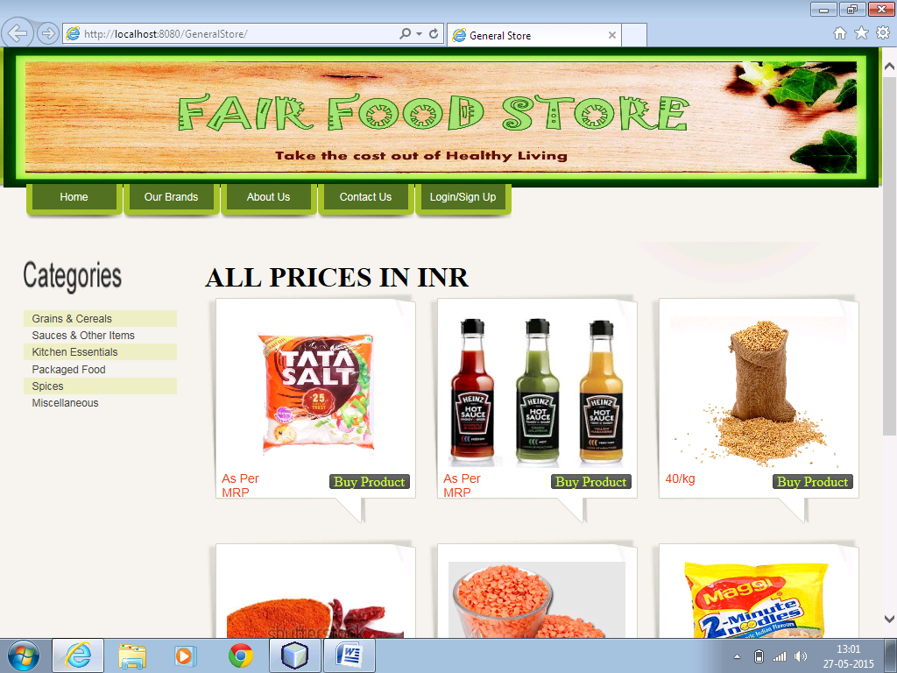

Login/Sign Up:-

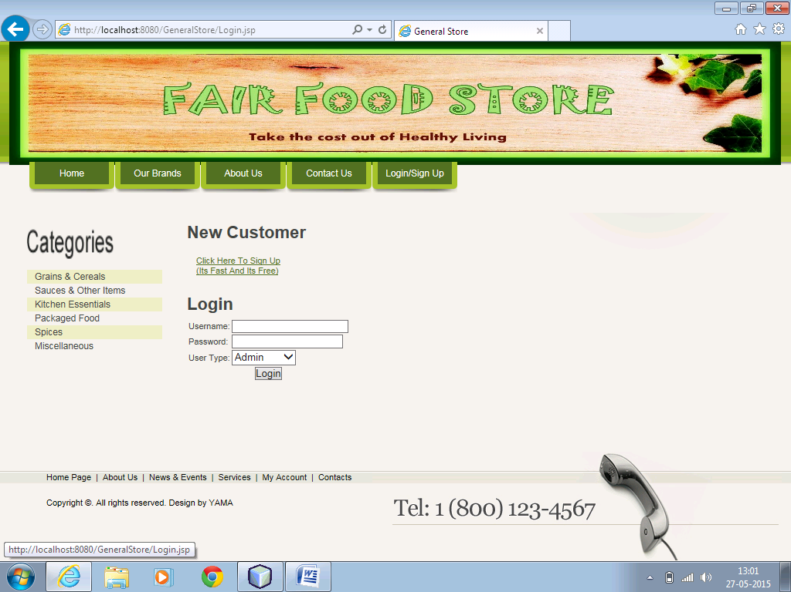

Welcome:-

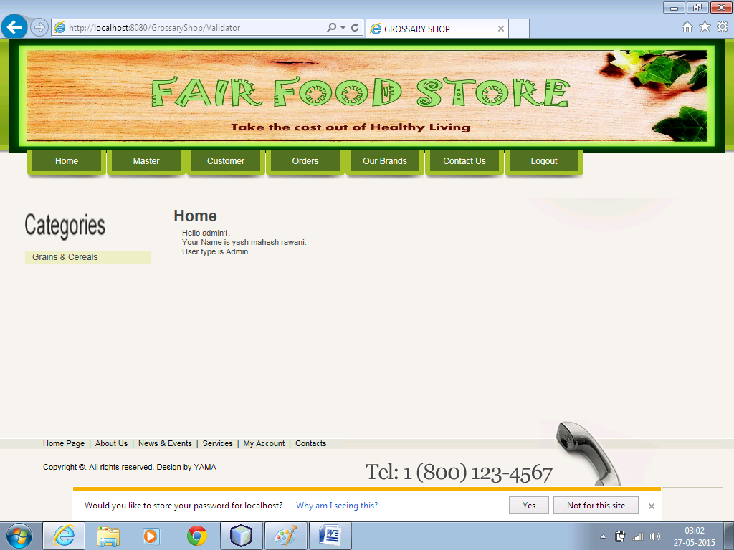

Admin:-

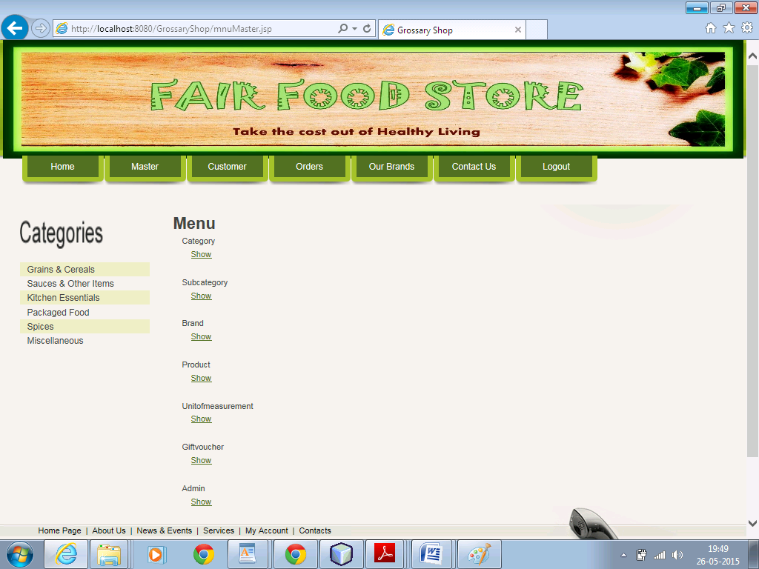

Customer:-

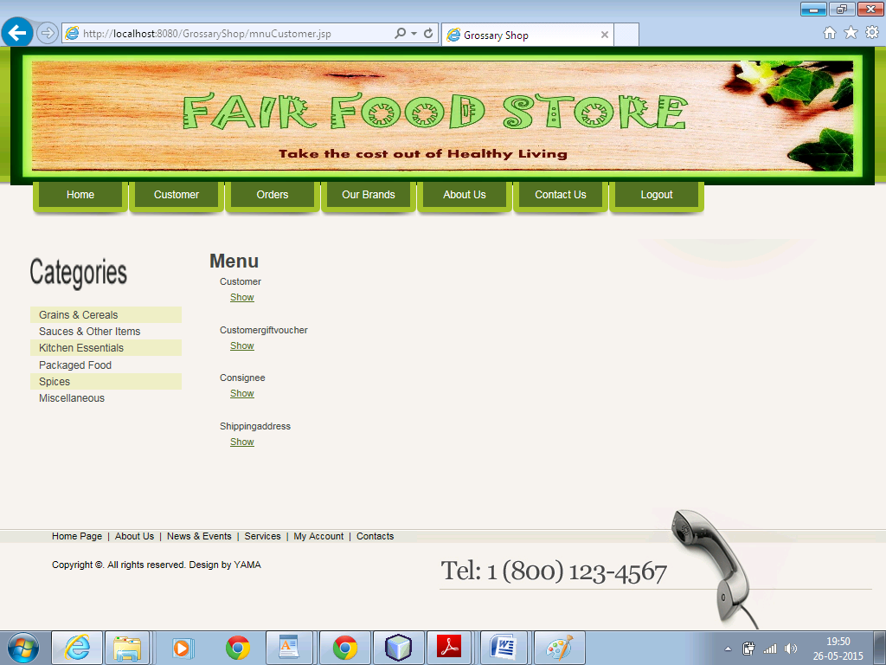

Bibliography

https://www.google.com
http://www.w3schools.com/
http://www.javatpoint.com/MVC-in-jsp
http://www.slideshare.net/nitinbhasin3/online-voting-system-project-file?from_action=save
http://www.free-css.com/free-css-templates/page15#shout
http://www.codecademy.com/en/tracks/web
http://www.free-css.com/
http://www.wikipedia.com

