

“Final Report for Data visualization Website”

Yash Rawat

M00789313

Computer Science

Middlesex University London

Coursework 2

CST 3340

# Table of Contents:

1. Introduction……………………………………………………………………………3
2. Website Description…………………………………………………………………...4
3. Front-end Screenshots…………………………………………………………………5
4. Architecture Diagram………………………………………………………………….6
5. Machine Learning with AWS SageMaker…………………………………………….8
6. Sentiment Analysis (currently not functional) …………………………………………9

1. Conclusion…………………………………………………………………………….10
2. References…………………………………………………………………………….11

# Introduction

Our website is a one-page platform that provides weather data, forecasts, and sentiment analysis for specific cities to users. The user-friendly interface of the website allows visitors to engage with the available features and obtain valuable insights on weather conditions and public sentiment.

The top page of the website offers customers a visually appealing layout as well as a city selection option. The default city is London, but users can select from a list that includes Manchester, Edinburgh, Birmingham, and Liverpool. When a city is selected, the website generates a graph with historical weather data in blue and forecasts for the next 24 hours in orange.

The graph depicts weather trends, allowing viewers to understand both past and future changes in temperature, precipitation, wind speed, or other pertinent meteorological characteristics. Users can plan their activities, make informed judgements, and prepare for expected weather conditions by observing historical data and predictions.

Additionally, our website hopes to integrate sentiment analysis, *even though this capability is now inaccessible due to AWS Comprehend access being blocked on the AWS Educate account.* The sentiment analysis application would have collected sentiments from text data connected with the chosen city, allowing users to get insights into public perceptions and reactions to weather occurrences. We intend to address this issue in the future in order to improve the user experience.

For front-end development, our website employs JavaScript or a JavaScript framework to create a good user experience. AWS Lambda functions run the backend, which take weather data from web services and forecast it using AWS SageMaker, a sophisticated machine learning engine that assures accurate and trustworthy forecasts.

The ultimate purpose of our website is to provide clients with credible weather data, forecasts, and sentiment analysis (future enhancement) so that they can make informed decisions and preparations. Users may successfully manage their activities, plan for weather-related scenarios, and stay up to speed on the most recent weather information by merging past weather trends, future projections, and anticipated public mood.

In summary, our website provides a user-friendly and visually appealing experience, allowing visitors to select a city of interest and analyse historical weather data, projections, and sentiment analysis (future enhancement). Our platform's purpose is to improve users' understanding of weather conditions and assist them in making educated decisions in their daily lives by leveraging current technology and data-driven insights.

# ****Website Description****

Our website is a one-page platform dedicated to providing clients with precise weather information, forecasts, and sentiment analysis for individual cities. The website's clean and user-friendly interface makes it simple for users to navigate and access the necessary weather-related data.

When customers arrive at the website's main page, they are greeted with an easy-to-use city selection option. The default city is London, but users can select from a list of cities that includes Manchester, Edinburgh, Birmingham, and Liverpool. Users can personalize the weather information to their exact place of interest by selecting this option.

When a city is selected, the website generates a graph that displays both historical weather data and forecasts for the following 24 hours. A blue line indicates historical weather data, while an orange line represents forecasts. This graph shows viewers a visual depiction of weather patterns, allowing them to examine recent trends and forecast future changes in temperature, precipitation, wind speed, and other meteorological factors.

Our website also includes sentiment analysis, albeit this capability is temporarily disabled due to AWS Comprehend access being restricted on the AWS Educate account. Once implemented, the sentiment analysis tool will provide insights into public sentiment and reactions to weather occurrences, assisting users in evaluating public perception and sentiment in relation to specific weather circumstances.

The website makes use of JavaScript or a JavaScript framework to deliver a smooth and engaging user experience. AWS Lambda functions enable the extraction of meteorological data from online sources and the development of exact predictions via AWS SageMaker, a premier machine learning technology known for its outstanding forecasting capabilities.

Our website aims to empower individuals by providing them with credible weather information, accurate predictions, and sentiment analysis (future enhancement). By combining historical data, future estimates, and public mood analysis, users may make informed decisions, plan their activities, and be ready for weather-related occurrences.

Finally, our website offers a visually appealing and user-friendly platform for accessing meteorological data, projections, and sentiment analysis (future enhancement). Our platform provides clients with the tools they need to stay informed, plan their days, and make decisions based on reliable weather information by leveraging the power of modern technology and data-driven insights.

# Front-End Screenshots

# The image above depicts the index page of our weather website. A graph in the centre of the page displays historical data as well as predictions for the selected city. The graph depicts the evolution of temperature, precipitation, and other meteorological factors throughout time. The blue line indicates historical data, which provides insight into previous weather conditions. The orange line indicates forecasts generated by our machine learning models for the next 24 hours. Users can use this graphic representation to examine weather trends and make informed decisions based on predicted changes.

# A sentiment analysis display can be found on the right side of the index page. The sentiment analysis tool is presently unavailable due to API access restrictions. Instead, a fictitious graph displaying the required sentiment analysis results is displayed. When fully operational, this feature will give users with insights into public opinion and reactions to weather events, allowing them to learn how people perceive and respond to different weather circumstances.

# Additionally, at the top of the page, there is a city selection function that allows users to move between Manchester, Edinburgh, Birmingham, and London. The default city is London, which is displayed when the website first loads. Please keep in mind that due to API difficulties, the available data for the selected city is restricted to the last week.

# Architecture Diagram

The graphic demonstrates the creation of an AWS account and the integration of various AWS services. The action starts with the user gaining access to AWS S3 (Simple Storage Service), which is signified by a user icon hopping onto the S3 icon. The user's interaction then connects to AWS API Gateway, which is represented by an arrow connecting the S3 icon and the API Gateway icon.

When a user clicks on the S3 component, the API Gateway issues a "ongetPredections" route request, which calls the "getPrediction" Lambda function. This function uses the Weather API to retrieve and send historical weather data to SageMaker. SageMaker makes predictions based on past data and provides the results to the Lambda function, which includes both the historical and forecast data. The Lambda function then sends the results to the front end aswell as caches them into the DynamoDb, where they are shown to the user.

When a visitor visits our website's S3 (Simple Storage Service) component, the API Gateway sends the "ongetSentiment" route request. The request is handled by the API Gateway, which routes it to the proper Lambda function called "getSentiment."

The "getSentiment" Lambda function is in charge of retrieving information from the News API. It gathers pertinent data about the chosen city, which is then utilized to ascertain people's attitudes about that location.

The collected data would have been sent via the Lambda function to AWS Comprehend, an AWS natural language processing service. To assess people's sentiment, AWS Comprehend would do sentiment analysis on news data. AWS comphrend would give them back to Lambda and it saves the data form it to the DynamoDb and would have send it to the DynamoDb.

However, due to the current state of affairs, we were be unable to use AWS Comprehend in our project for sentiment analysis. As a result, the sentiment analysis feature has been deactivated.

In its current condition, the Lambda function will not perform the sentiment analysis phase. It would instead bypass this step and not submit the news data to AWS Comprehend.

The remaining functions of the Lambda function will continue to function, such as getting data from the News API and delivering it to the front end. The Lambda function will deliver the gathered news data to the front end, where the user can view it.

While sentiment analysis is currently unavailable, other components of the capabilities, such as news data acquisition and delivery to the front end, are.

# Machine Learning with AWS SageMaker

In our weather website project, we used AWS SageMaker's machine learning capabilities, which necessitated the construction of a machine learning role. The machine learning role is critical in determining the appropriate privileges for accessing and utilizing various SageMaker resources and services.

We built a specialized IAM (Identity and Access Management) role for our machine learning operations to ensure seamless interaction with AWS services such as data storage, training instances, and model deployment. This role was meticulously constructed to grant only the necessary permissions while adhering to the idea of least privilege.

The machine learning role was configured with permissions to access and read data stored in Amazon S3 buckets, allowing us to quickly retrieve historical weather data for training our models. Furthermore, the role has been granted access to other AWS services such as AWS Lambda for serverless computing, AWS CloudFormation for infrastructure management, and AWS CloudWatch for monitoring and logging.

We validated that the required rights were granted to execute machine learning operations efficiently within the SageMaker environment by correlating the machine learning role with our SageMaker resources, such as training tasks and model deployments. This enhanced the efficiency of data processing, training, and deployment of machine learning models for weather forecasting.

When establishing the machine learning role, we followed best practises such as using least privilege and constantly analysing and modifying the role's permissions as needed. This solution improves the security and integrity of our SageMaker workflows, hence safeguarding our data and resources.

The machine learning job was a vital component of our weather website project, allowing us to leverage the capabilities of AWS SageMaker for precise weather predictions. It offered the necessary rights and access to AWS services, enabling for the seamless integration of machine learning capabilities into our application.

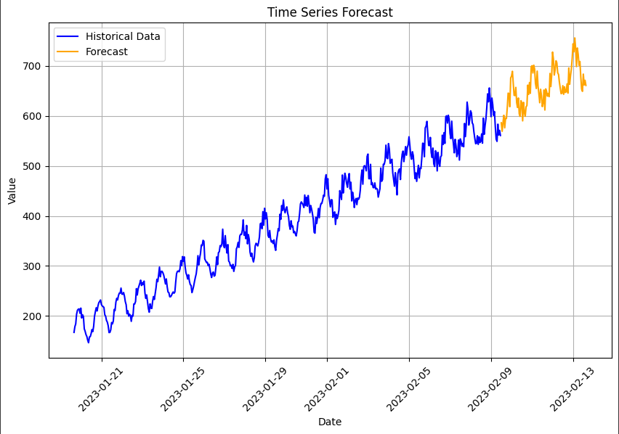

# Sentiment Analysis (currently not functional)

The sentiment analysis component of our weather website, which mainly provides insights into public sentiment and reactions to weather occurrences, is currently inoperable. This section highlights the issues we've encountered with AWS Comprehend access and has been discussed with the module leader.

6.1 Challenge with AWS Comprehend Access

AWS Comprehend, a sophisticated tool for natural language processing and sentiment analysis supplied by Amazon Web Services, is one of the major components required for sentiment analysis. However, we presently have limited access to AWS Comprehend due to limits set on the AWS Educate account.

As a result, we regret that we are unable to provide sentiment analysis results at this time. We appreciate the benefit that this feature might bring to our weather website by providing users with insights on public perceptions of different weather circumstances. However, due to existing limitations, we are unable to perform sentiment analysis on the textual data grabbed from News Api to show the results using the AWS Comprehend service.

Although sentiment analysis is not now available, we have put up a dummy sentiment analysis for the front of the website and to display the sentiment of the people on weather living in or near the cities.

# Conclusion

In conclusion, our weather data visualization website has made tremendous progress in providing clients with dependable weather data, forecasts, and potential sentiment analysis for chosen cities. We met hurdles and gained useful insights throughout the development process, paving the path for future upgrades and expansions.

Summary of Achievements:

One of our most significant accomplishments was the successful deployment of a user-friendly one-page website interface. Users can access historical weather data and forecasts for the next 24 hours by selecting a city. To develop machine learning-based weather predictions, we used AWS SageMaker and the DeepAR algorithm. S3 was used for data storage, API Gateway was used for request processing, DynamoDB was used for data management, Lambda was used for serverless services and CloudWatch for monitoring purposes By offering a visually appealing interface, the JavaScript or JavaScript framework-based front-end design improves the user experience.

Challenges and Lessons Learned:

Due to account limits on the AWS Educate account, we encountered challenges when using AWS Comprehend for sentiment analysis. As a result, the sentiment analysis feature has been deactivated. This issue, on the other hand, highlighted the importance of AWS service resource availability and access limits. We found the importance of data preprocessing, feature extraction, and hyperparameter tweaking for accurate weather predictions. We expanded our knowledge and skills in designing scalable and reliable apps by overcoming technical hurdles and learning about AWS infrastructure.

Future Enhancements and Extensions:

We intend to remove the AWS Comprehend access barrier in the future so that sentiment analysis can be performed. As a result, users will obtain valuable insights into public perceptions and reactions to weather events. We would like to expand the number of cities available to clients, providing them with more possibilities for weather analysis. Another goal is to improve the responsiveness and mobile friendliness of the website in order to provide a consistent user experience across devices. Future enhancements will include real-time weather data updates, user verification, customizable settings, and more data visualizations like interactive maps or charts.

Finally, our weather data visualization website tries to give visitors with accurate forecasts, dependable information, and sentiment analysis. Regardless of the obstacles, we are dedicated to enhancing the website, expanding its capabilities, and introducing useful features in order to provide users with complete weather information. We aim to improve user experiences and enable informed decision-making based on reliable meteorological data by harnessing data-driven insights and continuing development initiatives.

# References

* (No date a) *Tutorial: Configuring A static website on Amazon S3*. Available at: https://docs.aws.amazon.com/AmazonS3/latest/userguide/HostingWebsiteOnS3Setup.html (Accessed: 15 July 2023).
* (No date b) *Class: Aws.dynamodb.documentclient — AWS SDK for JavaScript*. Available at: https://docs.aws.amazon.com/AWSJavaScriptSDK/latest/AWS/DynamoDB/DocumentClient.html (Accessed: 15 July 2023).
* (No date c) *Working with websocket apis - amazon API gateway*. Available at: https://docs.aws.amazon.com/apigateway/latest/developerguide/apigateway-websocket-api.html (Accessed: 15 July 2023).
* (No date d) *Mapit*. Available at: https://mapit.mysociety.org/docs/ (Accessed: 15 July 2023).
* (No date e) *Get started - AWS CloudFormation*. Available at: https://docs.aws.amazon.com/AWSCloudFormation/latest/UserGuide/GettingStarted.Walkthrough.html (Accessed: 15 July 2023).
* *A cloud guru - get cloud certified* (no date) *A Cloud Guru - Get Cloud Certified*. Available at: https://www.pluralsight.com/cloud-guru (Accessed: 15 July 2023).
* *Documentation - typescript for JavaScript programmers* (no date) *TypeScript*. Available at: https://www.typescriptlang.org/docs/handbook/typescript-in-5-minutes.html (Accessed: 15 July 2023).
* Linode (2023) *Introduction to WebSockets*, *Linode Guides & Tutorials*. Available at: https://www.linode.com/docs/guides/introduction-to-websockets/ (Accessed: 15 July 2023).
* Mishra, A. (2019) *Machine learning in the AWS cloud: Add intellegence to applications with Amazon Sagemaker and Amazon Rekognition*, *Amazon*. Available at: https://docs.aws.amazon.com/sagemaker/latest/dg/deepar_hyperparameters.html (Accessed: 15 July 2023).
* *Sentiment Analysis Guide* (no date) *MonkeyLearn*. Available at: https://monkeylearn.com/sentiment-analysis/ (Accessed: 15 July 2023).
* Shui, H. (2014) *Ming Bai Liao: Shui Hetian/Ashui Zuo pin = comprehend: Water poon water poon works*, *Amazon*. Available at: https://aws.amazon.com/comprehend/ (Accessed: 15 July 2023).
* Simon, J. (2018) *Predicting world temperature with time series and Deepar on amazon sagemaker*, *Medium*. Available at: https://julsimon.medium.com/predicting-world-temperature-with-time-series-and-deepar-on-amazon-sagemaker-e371cf94ddb5 (Accessed: 15 July 2023).
* Vogels, W. (2012) *Amazon dynamodb – a fast and scalable nosql database service designed for internet scale applications*, *All Things Distributed*. Available at: https://www.allthingsdistributed.com/2012/01/amazon-dynamodb.html (Accessed: 15 July 2023).