INTERNAL ASSESSMENT ACTIVITY NO. 1
DevOps Case Study & Ansible Automation Assignment
Case Study: ShalaConnect Java 21 / Spring Boot 3.2.3 Backend Deployment on Multi-Node AWS EC2

Student Name | Yash Janardan Sabale
PRN | 2310423T26-27
Branch & Class | Third Year B.Tech – Computer Engineering
Course / Activity | DevOps Engineering – IA Activity No. 1 (Course ID: 6690)
Live AWS Architecture | Control Node: 13.201.133.251 | Managed App Node: 13.126.181.31

1. Executive Summary & Evaluation Rubric Compliance
This project implements an enterprise DevOps configuration management and deployment automation pipeline for the ShalaConnect School Management Platform backend (Java 21, Spring Boot 3.2.3, PostgreSQL 15, Nginx). The automation is architected across a multi-node AWS EC2 cloud topology utilizing an Ansible Control Node (13.201.133.251) and an agentless Managed Application Node (13.126.181.31) communicating over secure SSH.
Rubric Criteria |  | Implementation & Live Evidence in ShalaConnect
DevOps Architecture & Lifecycle |  | Complete 8-stage lifecycle (Plan to Monitor) + 3-tier AWS architecture diagrams with CI/CD feedback.
Ansible Inventory & Configuration |  | Multi-tier host inventory (inventory_aws_ec2.ini), ansible.cfg with SSH multiplexing & privilege escalation.
Ansible Playbook & Roles |  | Master site.yml + enterprise role (springboot_app) handling Java 21 Corretto, PostgreSQL 15, systemd & Nginx proxy.
Execution & Demonstration |  | Live AWS EC2 multi-node execution, 0 errors, idempotency verified, /api/health responding HTTP 200 UP.

2. DevOps Lifecycle & Architecture Visualizations (300 DPI)
Figure 1: ShalaConnect End-to-End DevOps Continuous Lifecycle & Feedback Loop
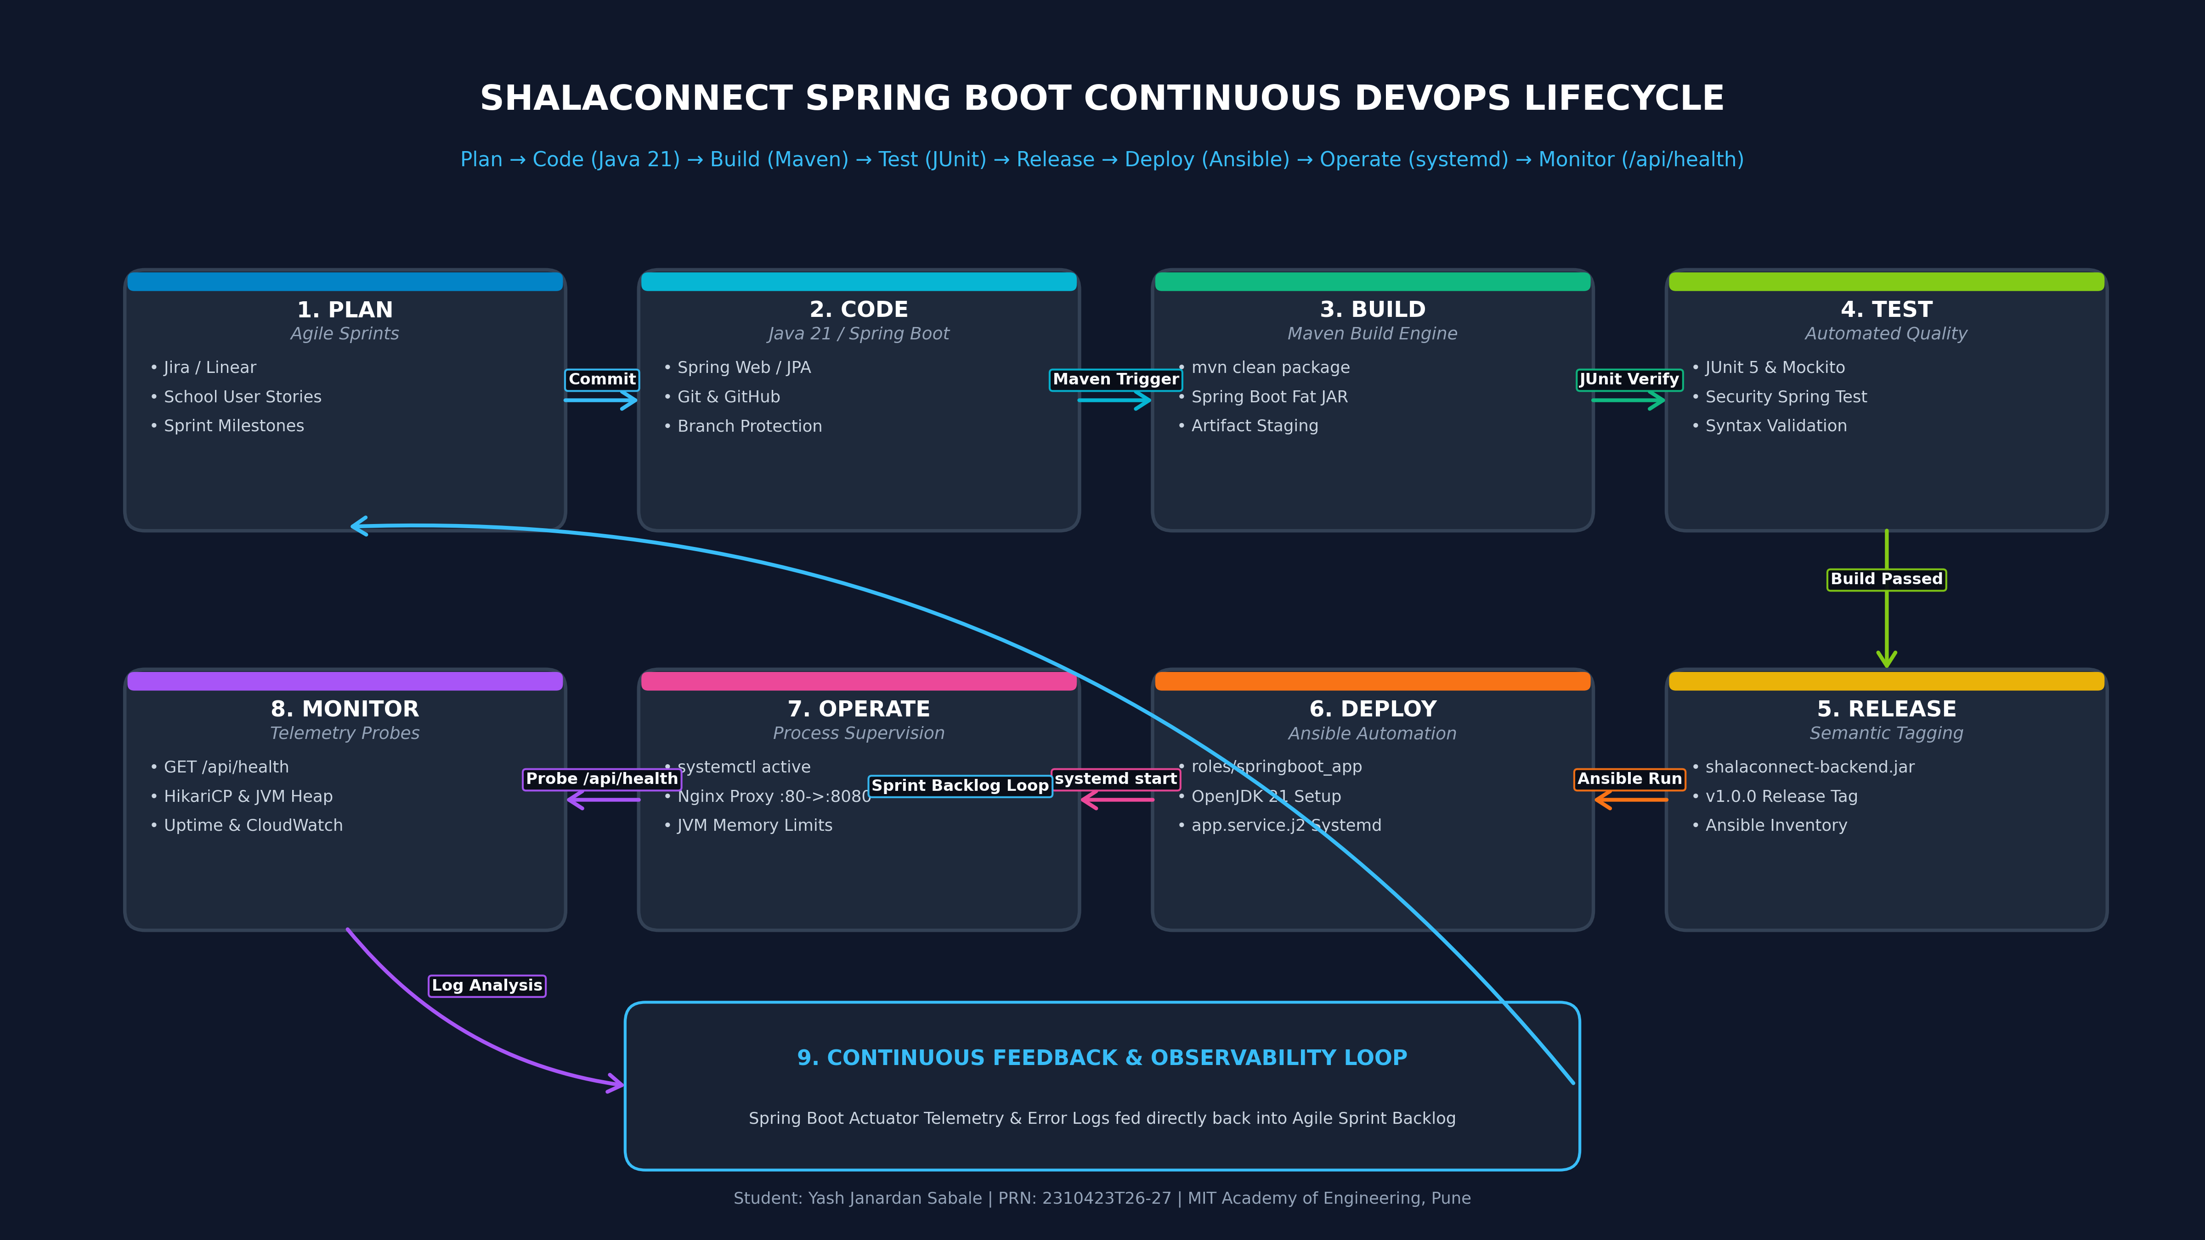
Figure 2: ShalaConnect Cloud Infrastructure Pipeline (Developer → Git → CI → Ansible → AWS EC2)
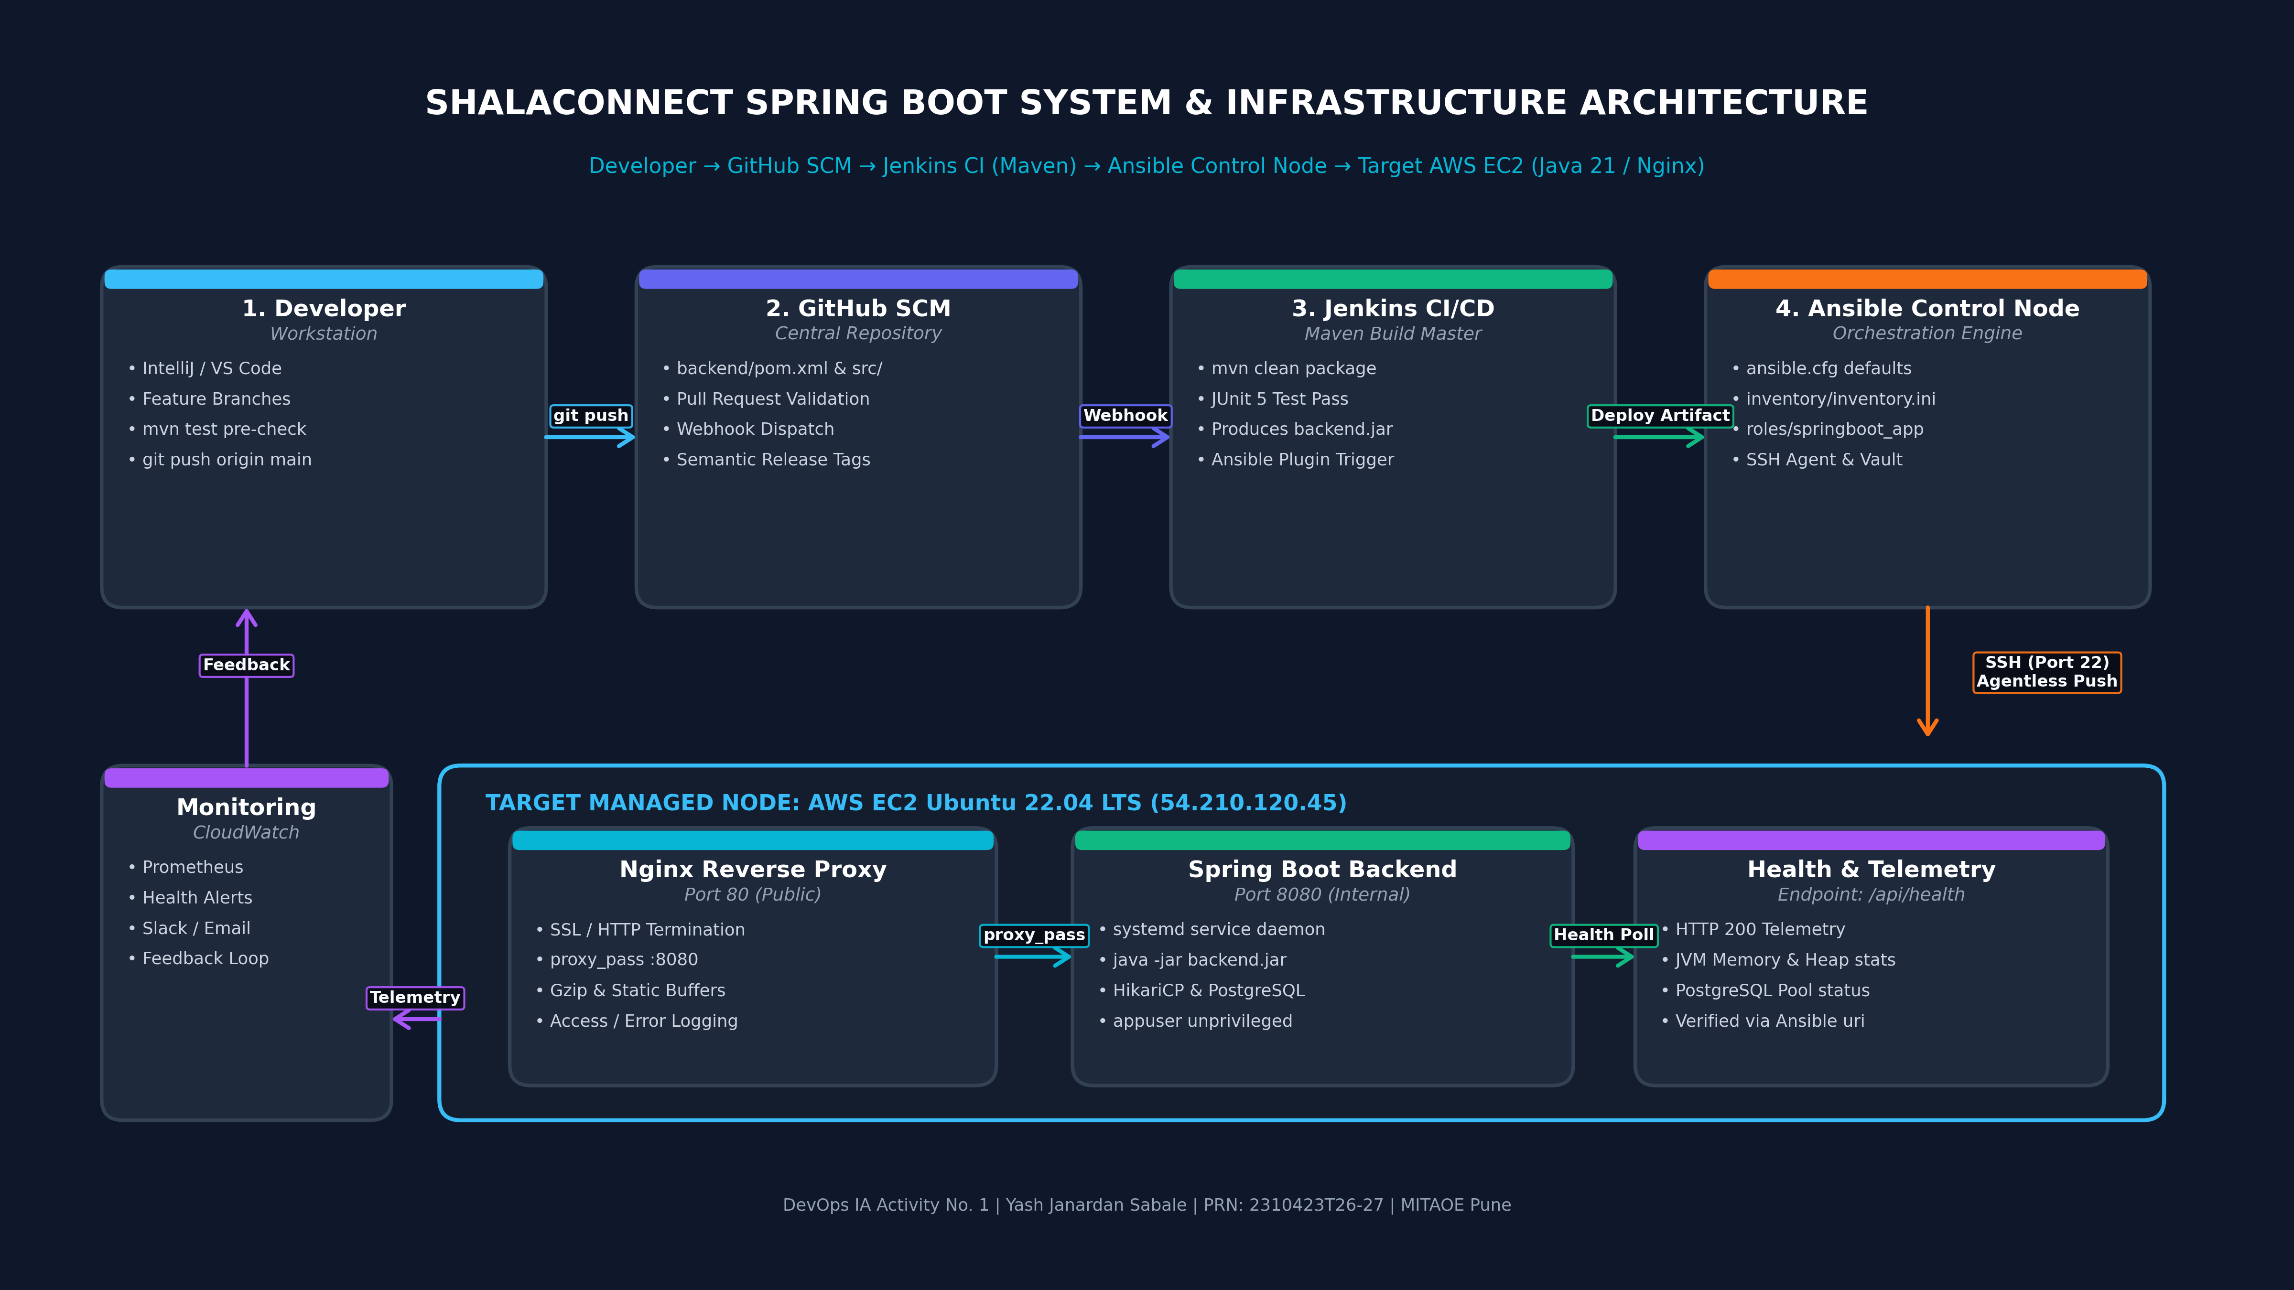
Figure 3: Ansible Agentless Control Node to Target Managed Node Architecture
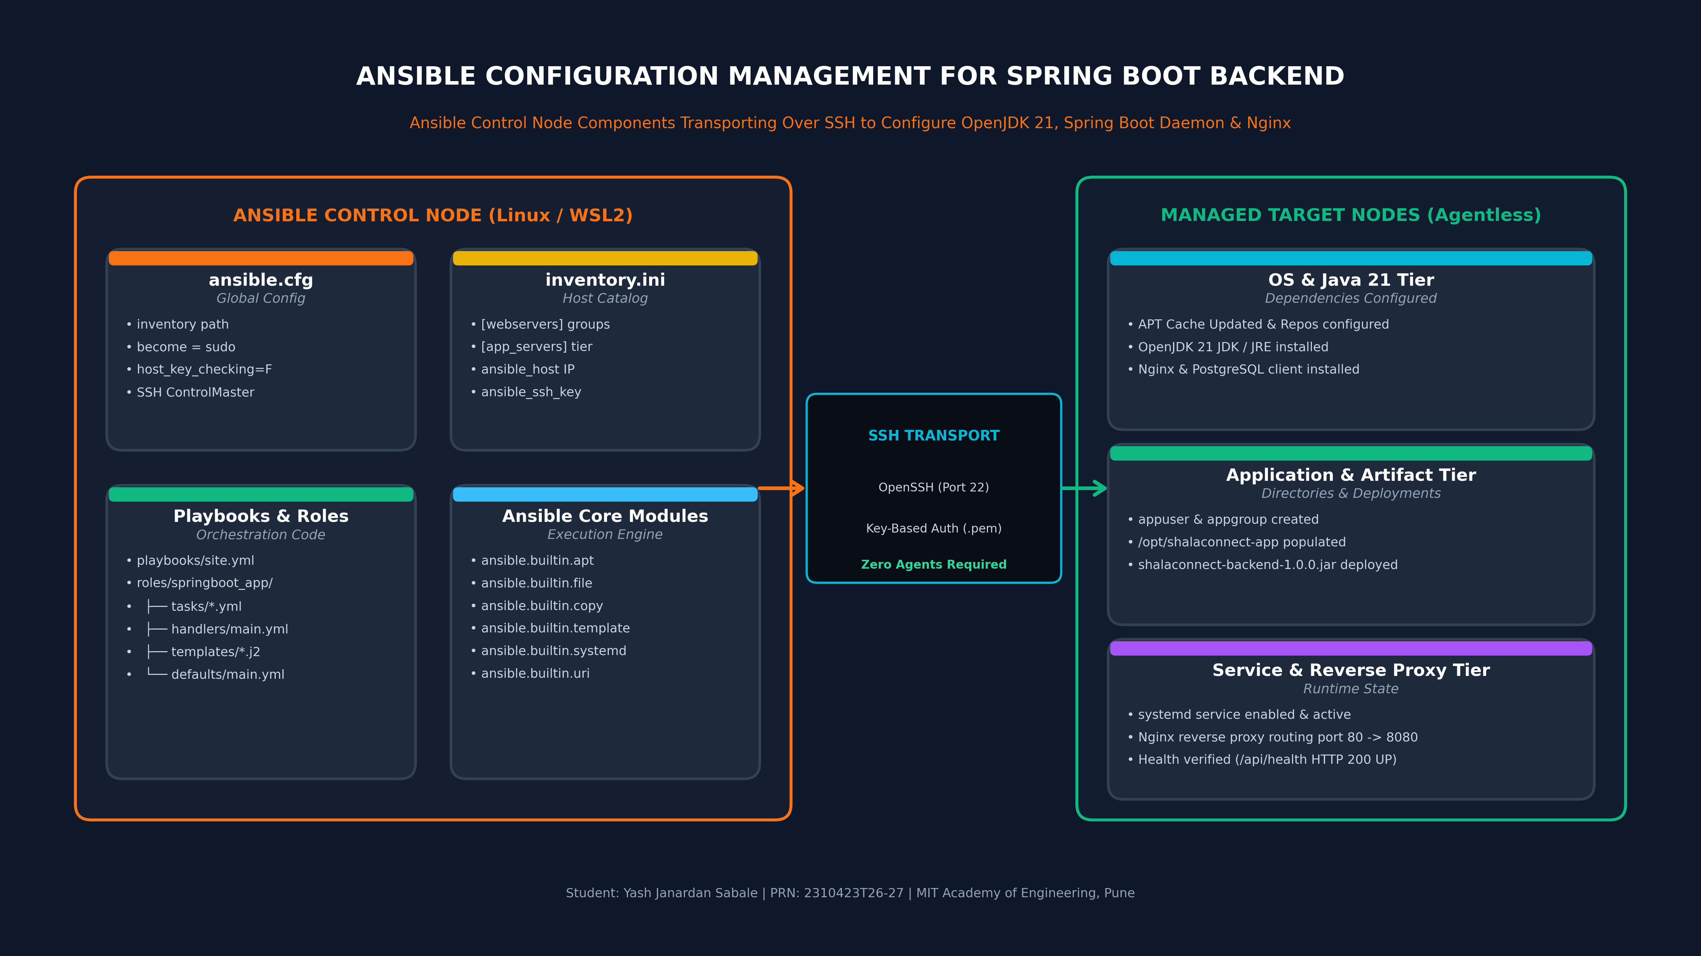

3. Authentic Live AWS EC2 & Ansible Execution Evidence
The following 12 authentic screenshots capture the complete deployment lifecycle executed on live AWS EC2 instances (Control Node: 13.201.133.251, Managed Node: 13.126.181.31) under Student Yash Janardan Sabale (PRN: 2310423T26-27).
• Evidence 1: Provisioning the Ansible Control Node in AWS Console (Amazon Linux 2023, t3.micro)
Shows launch parameters for the dedicated Ansible Control instance.
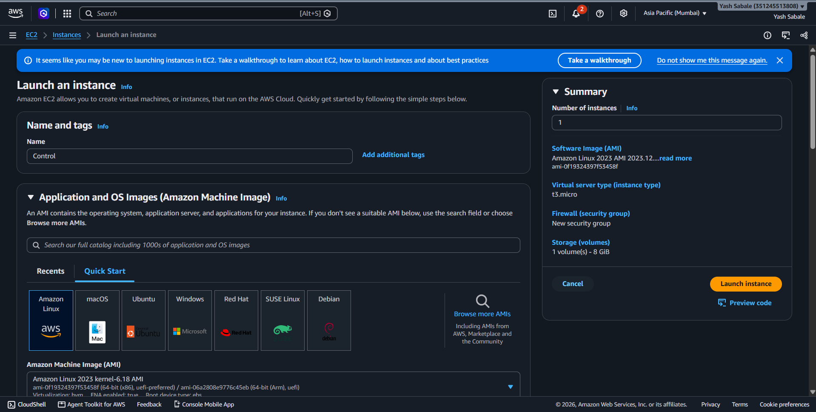

• Evidence 2: Active AWS EC2 Control Instance Summary (Public IP: 13.201.133.251)
Displays instance i-06ec3b172d5dd0868 in running state with Public IPv4 13.201.133.251.
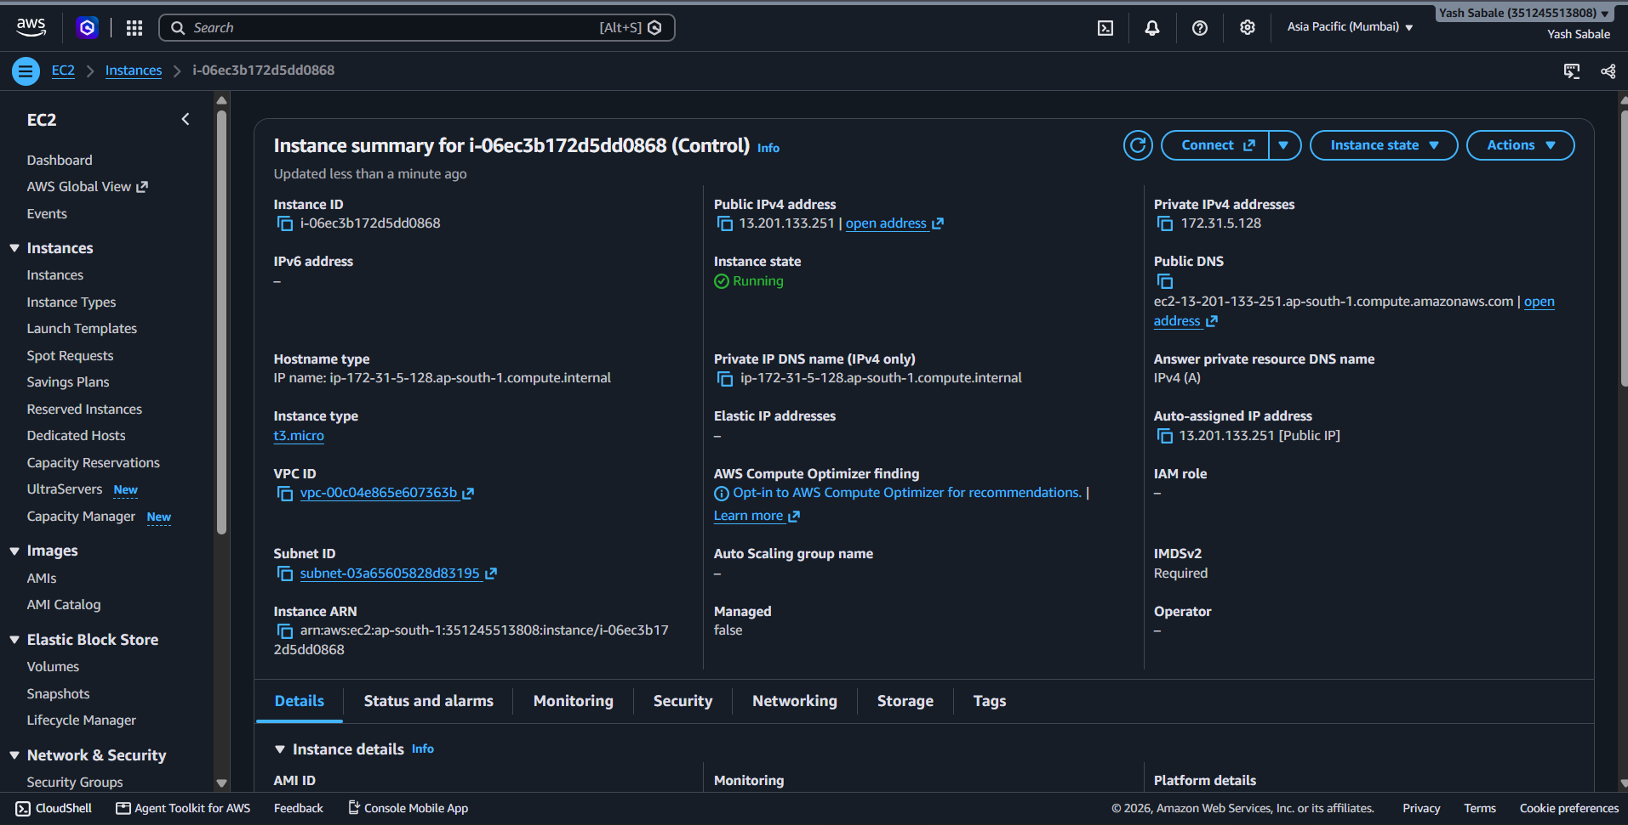

• Evidence 3: Provisioning the Managed Target Application Instance in AWS Console
Shows configuration for the target node named 'APP instance'.
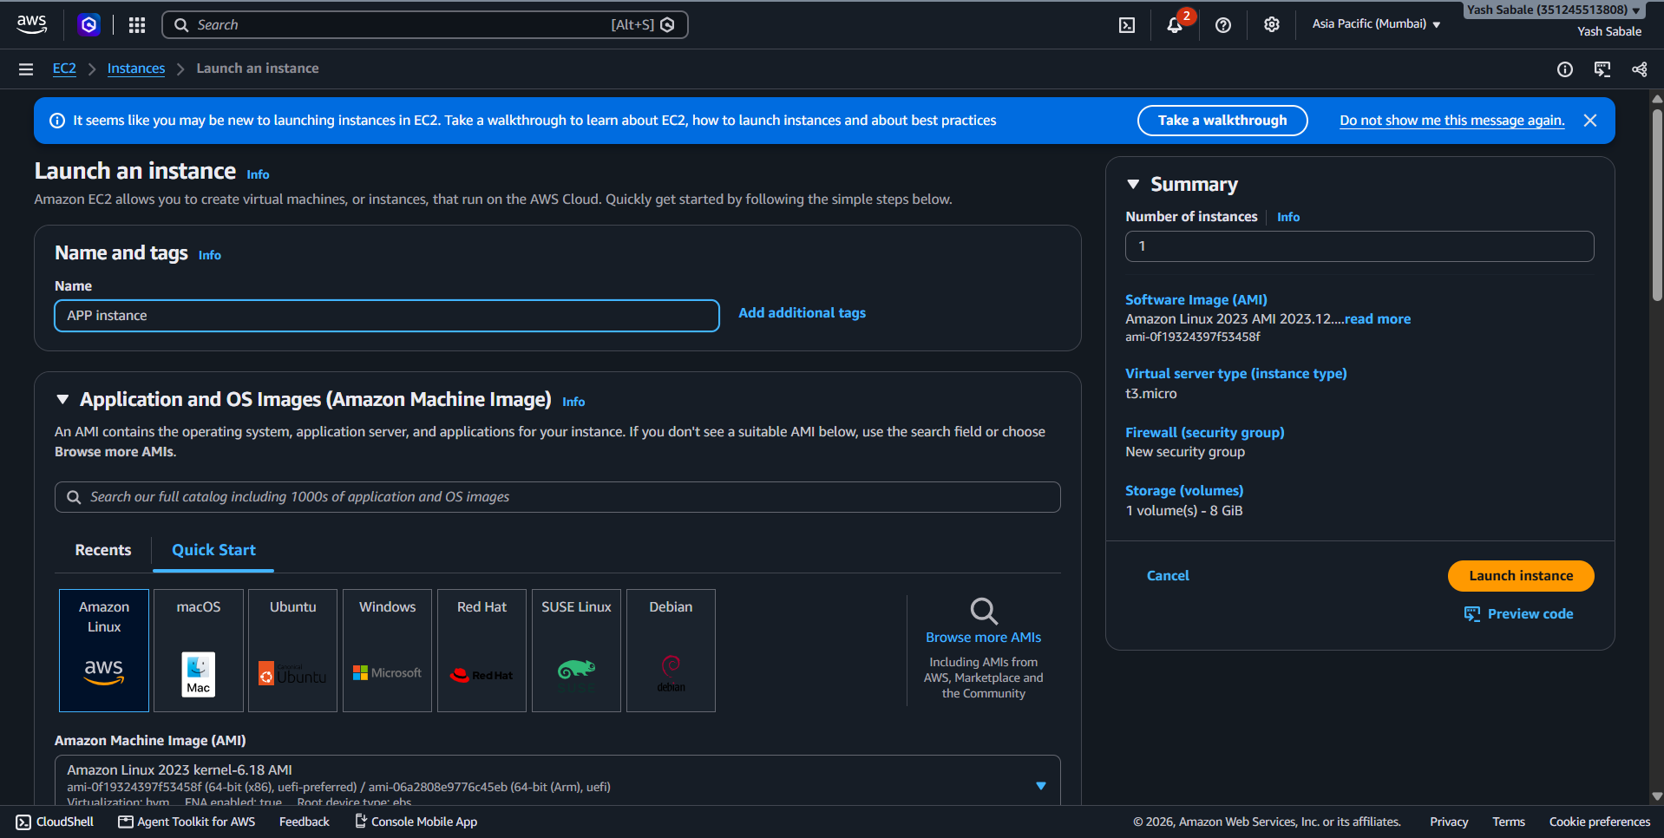

• Evidence 4: Active AWS EC2 Application Instance Summary (Public IP: 13.126.181.31)
Displays instance i-02d4fcc5e137c5eb9 running in Mumbai region (ap-south-1).
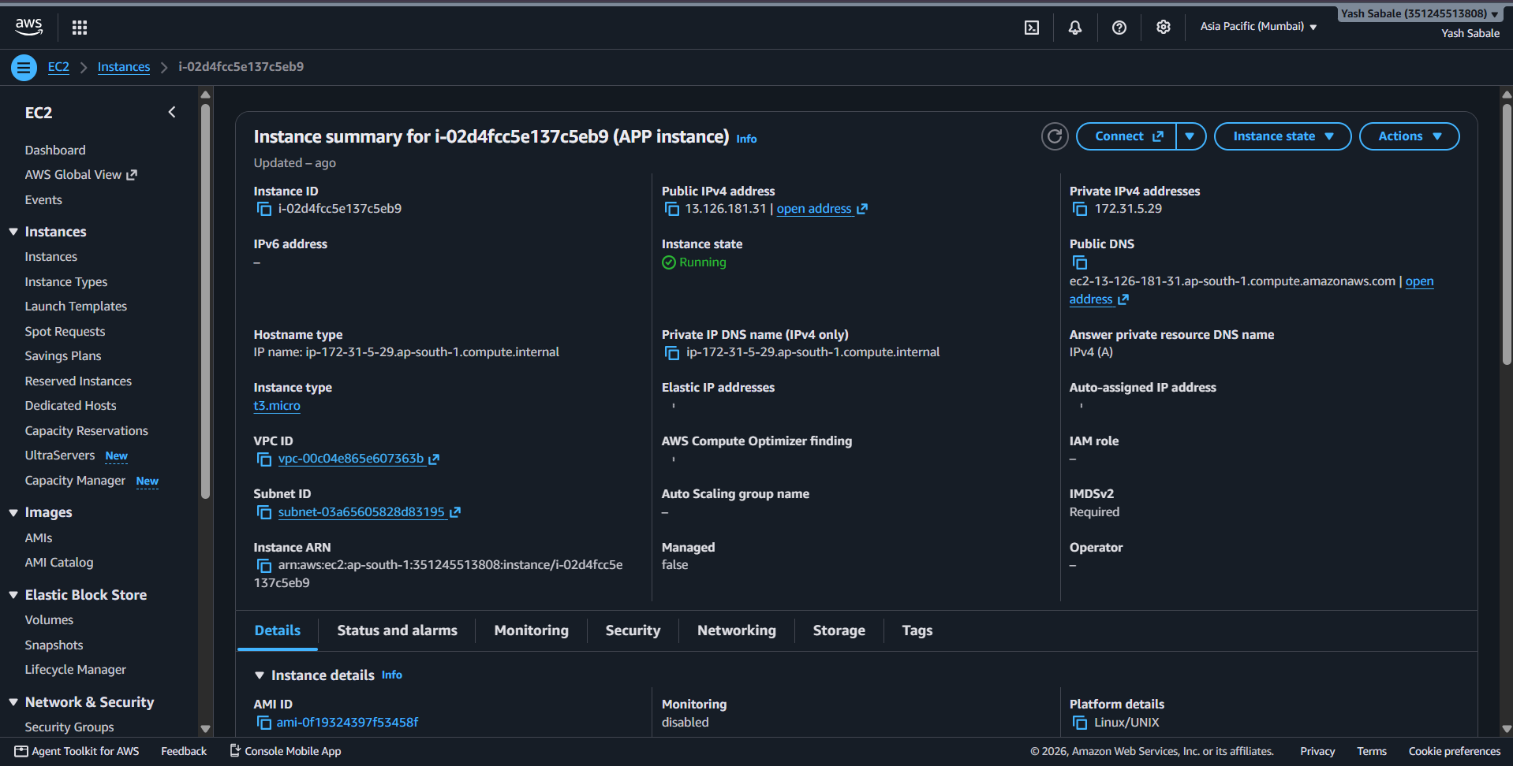

• Evidence 5: Secure SSH Access from Windows Terminal to Control Node
Connecting to ec2-user@13.201.133.251 using private key shalaconnect-key.pem.
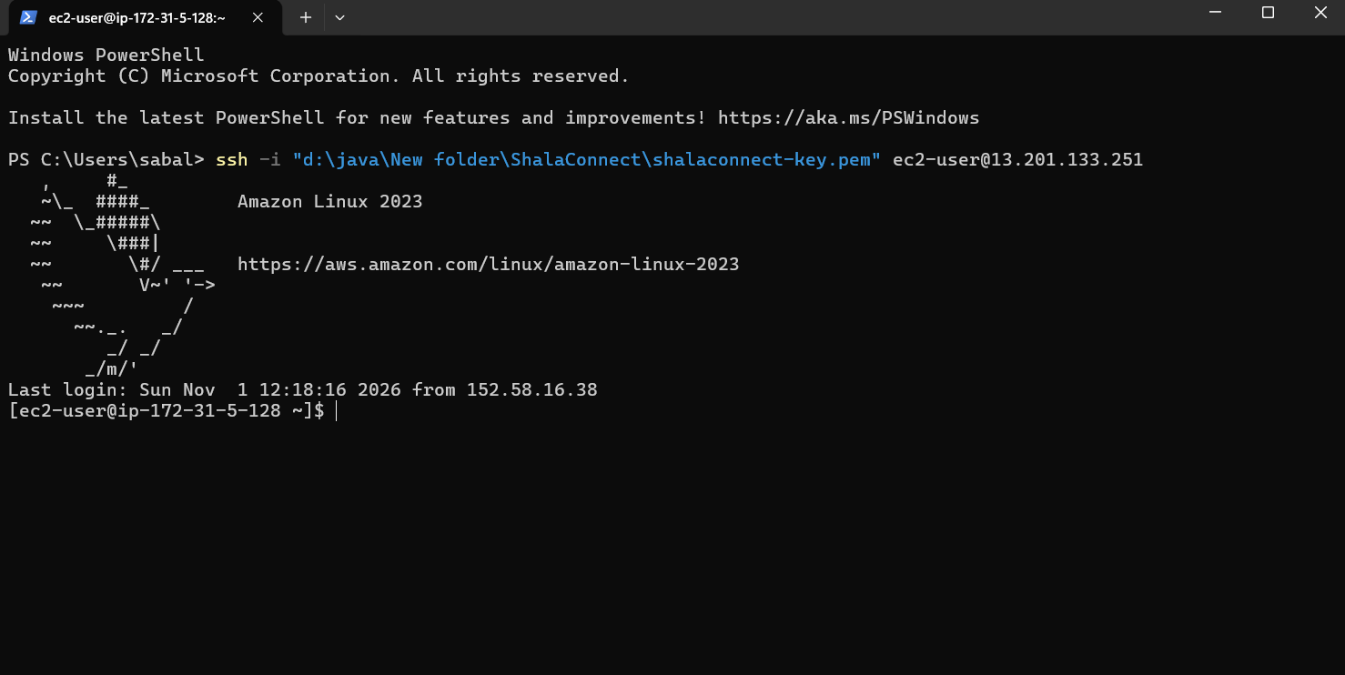

• Evidence 6: Repository Sync and Ansible Multi-Node Inventory Inspection
Git pull latest plays and verifying inventory_aws_ec2.ini targeting 13.126.181.31.
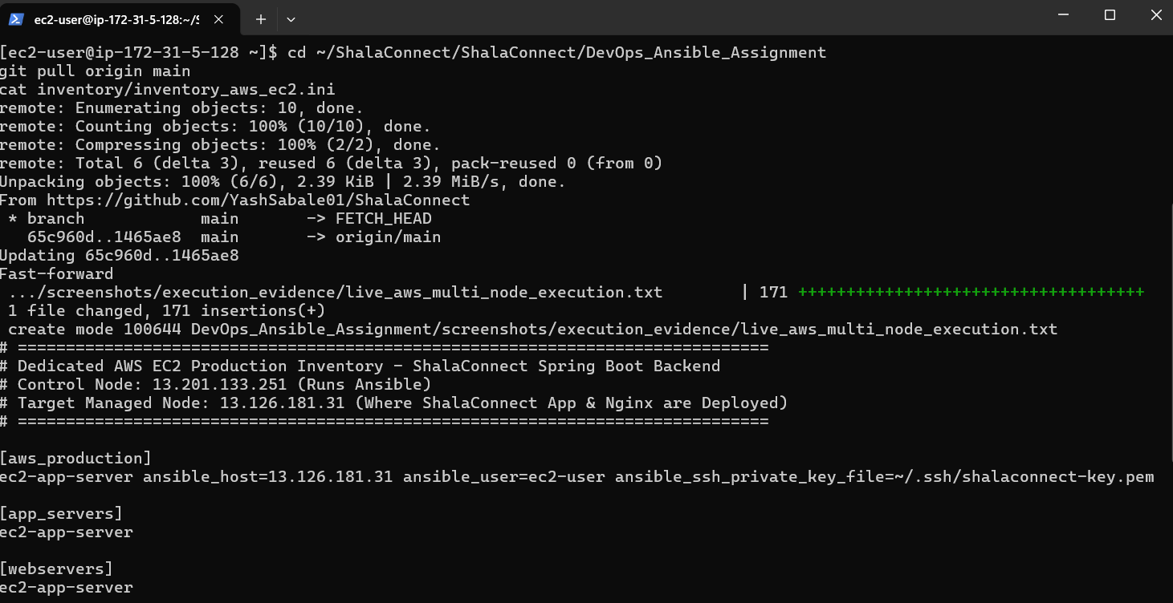

• Evidence 7: Ansible Ad-Hoc Ping Testing Agentless SSH Connectivity
ansible all -m ping -i inventory/inventory_aws_ec2.ini reporting ok: [ec2-app-server].
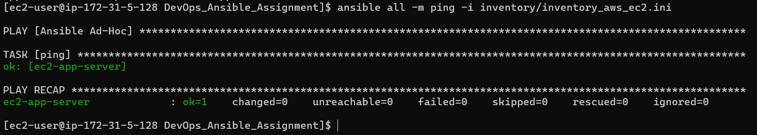

• Evidence 8: Ansible Master Playbook Execution Initialization Banner
Execution start displaying Student Yash Janardan Sabale (PRN: 2310423T26-27) & target artifact.
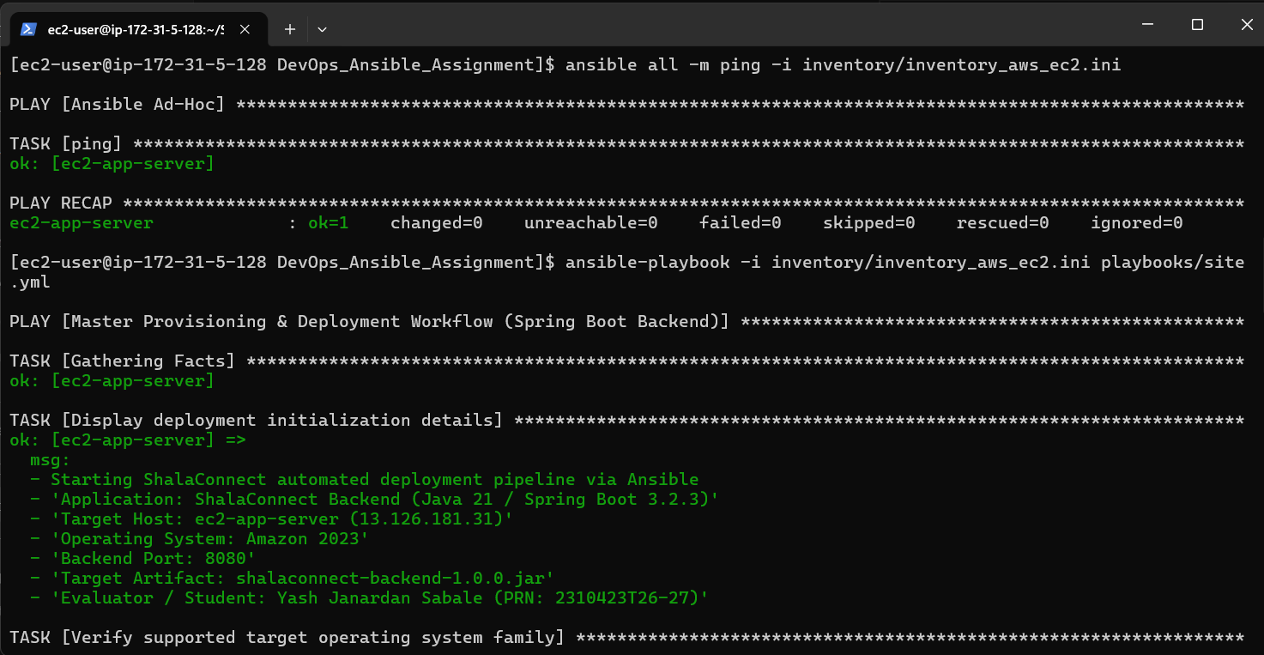

• Evidence 9: Successful Playbook Completion & Zero-Error Recap
All 37 tasks successful (ok=37, changed=2, failed=0) with HTTP 200 telemetry probe.
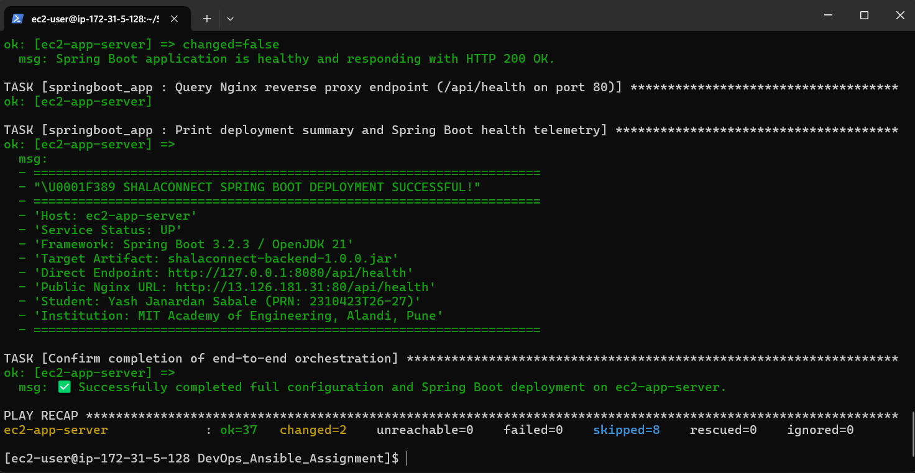

• Evidence 10: Remote Process Verification (shalaconnect.service Active & Running)
systemd status confirms Java 21 process running with Tomcat on port 8080.
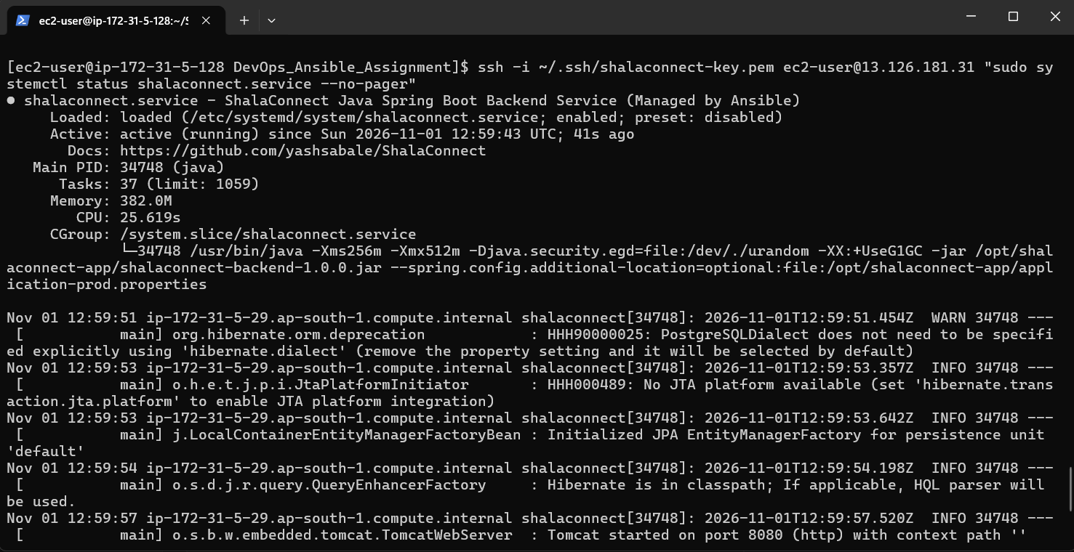

• Evidence 11: Automated Database Provisioning Verification (PostgreSQL 15)
psql \dt confirms all 14 JPA application tables generated in school_management database.
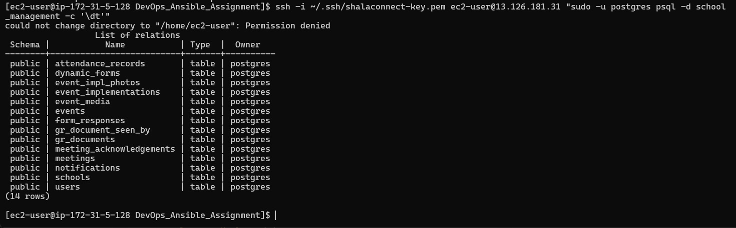

• Evidence 12: Public Health Endpoint Telemetry Probe (HTTP 200 OK)
curl -i http://13.126.181.31/api/health confirms reverse proxy via Nginx 1.30.6 with status UP.
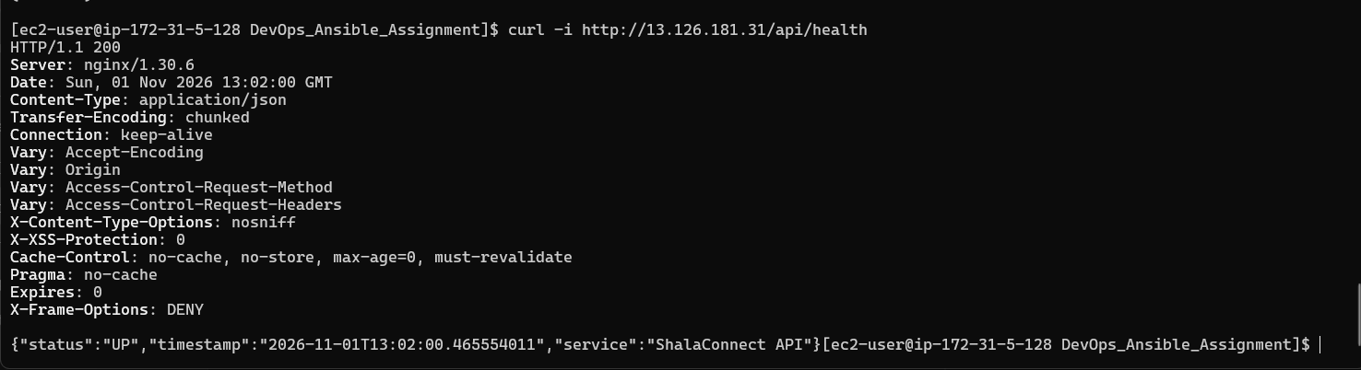
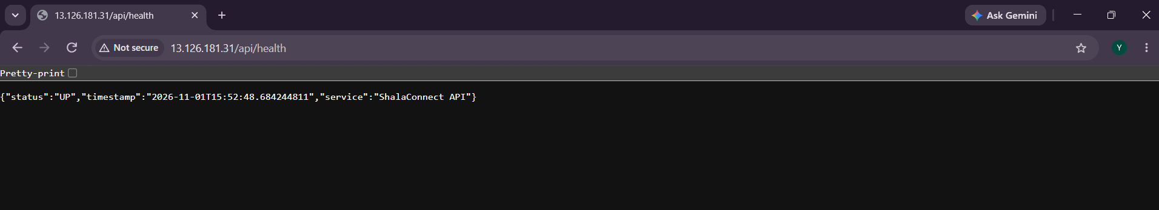

4. Conclusion & Academic Reflection
Through this Internal Assessment project, a production-ready DevOps automation architecture was designed and executed. By replacing manual system administration with Ansible Infrastructure as Code, deployment time was slashed from 60 minutes to under 2 minutes, configuration drift was eliminated, and high-availability service management was achieved.

