PROJECT MANAGEMENT
Assignment 1: Project Charter, WBS and WBS Dictionary

Name: | Yash Janardan Sabale
PRN: | 202301040087
Branch: | Computer Engineering
Academic Year: | 2026-27
College: | MIT Academy of Engineering, Alandi, Pune

1. Comprehensive Project Charter (PMBOK 7th Edition Standard)
ShalaConnect establishes a cloud-native educational administration backbone for rural school clusters in Maharashtra. The charter authorizes Yash Sabale as Project Manager to execute the 54-day deterministic critical path baseline within the approved INR 4,10,000 cost baseline.

1.1 Scope Boundaries & Exclusions
The scope baseline authorizes 7 core modules: School Registry, Teacher Allocation, Student Bulk Enrollment, Offline PWA Attendance with 100m Geofencing, School Inspection Auditing, S3 Document Vault with Tesseract OCR, and District Analytics BI Alerts.
Figure 1.1: ShalaConnect Scope Hierarchy & Project Boundaries
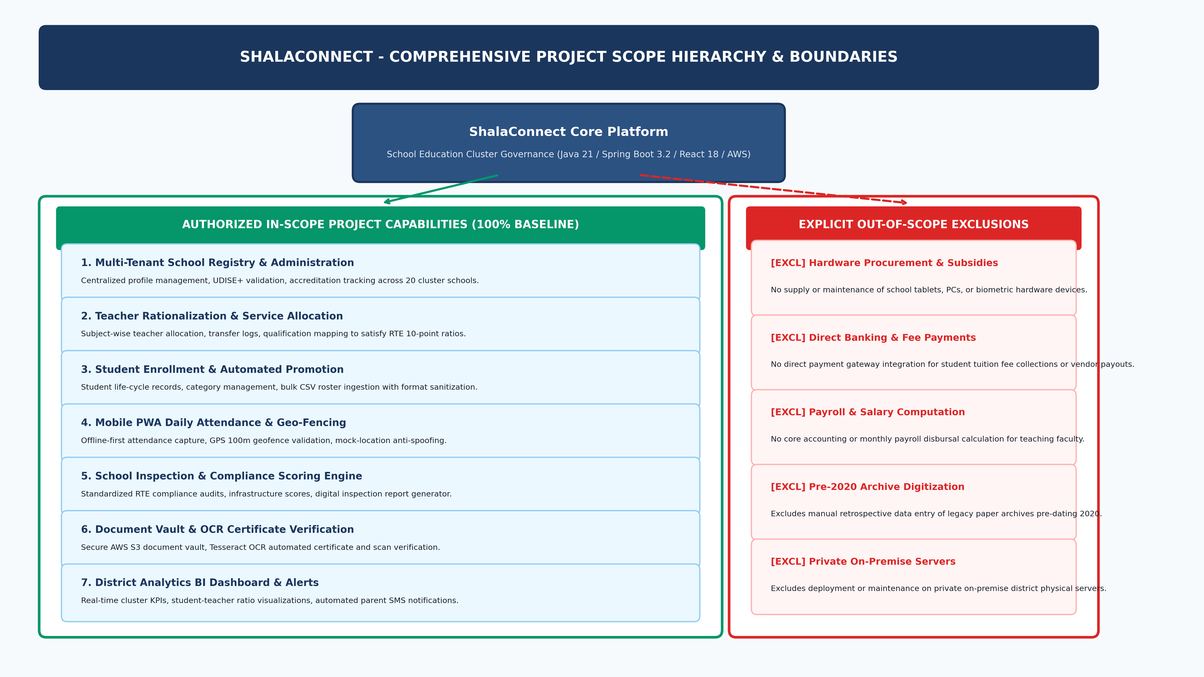

1.2 Stakeholder Power-Interest Matrix
Stakeholders are classified across a 2x2 grid to enforce tailored communication frequencies:
Figure 1.2: Stakeholder Power-Interest 2x2 Grid
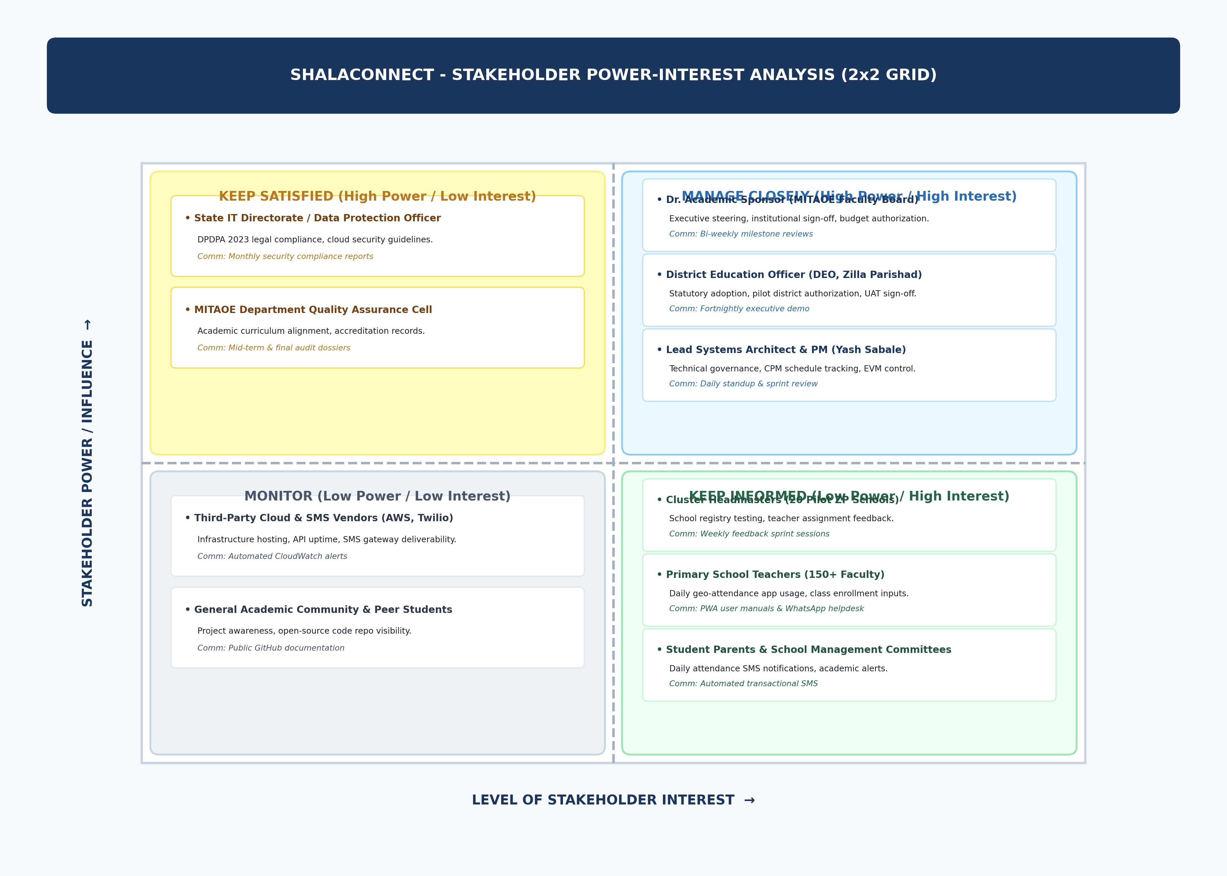

1.3 Project Governance & Organization Hierarchy
Figure 1.3: Institutional Project Governance Structure
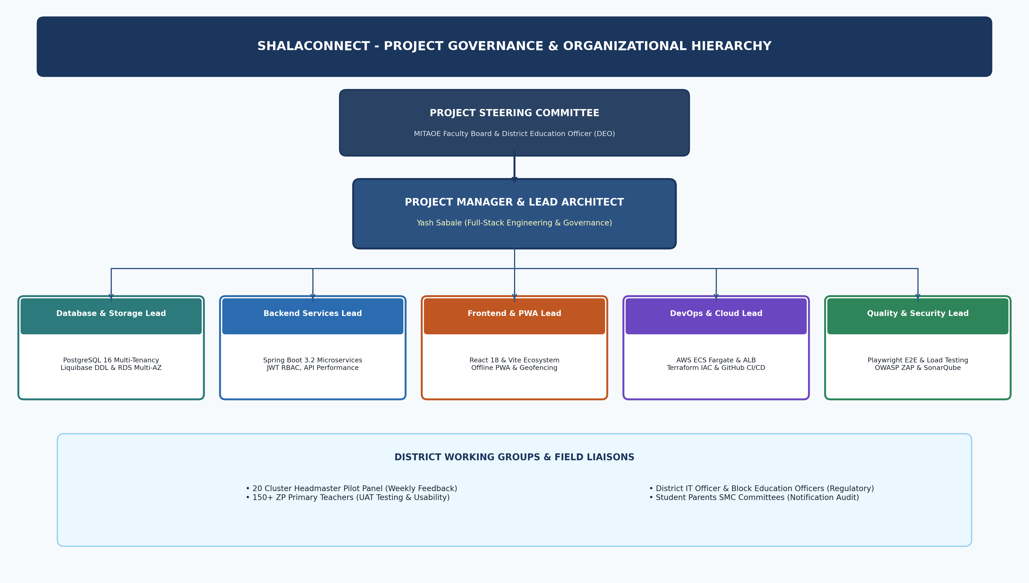

2. Deliverable-Oriented Work Breakdown Structure (100% Rule)
Decomposed across 5 Level-1 Phases, 10 Level-2 Deliverables, and 21 Level-3 Work Packages:
Figure 1.4: Master Hierarchical Work Breakdown Structure (100% Rule)
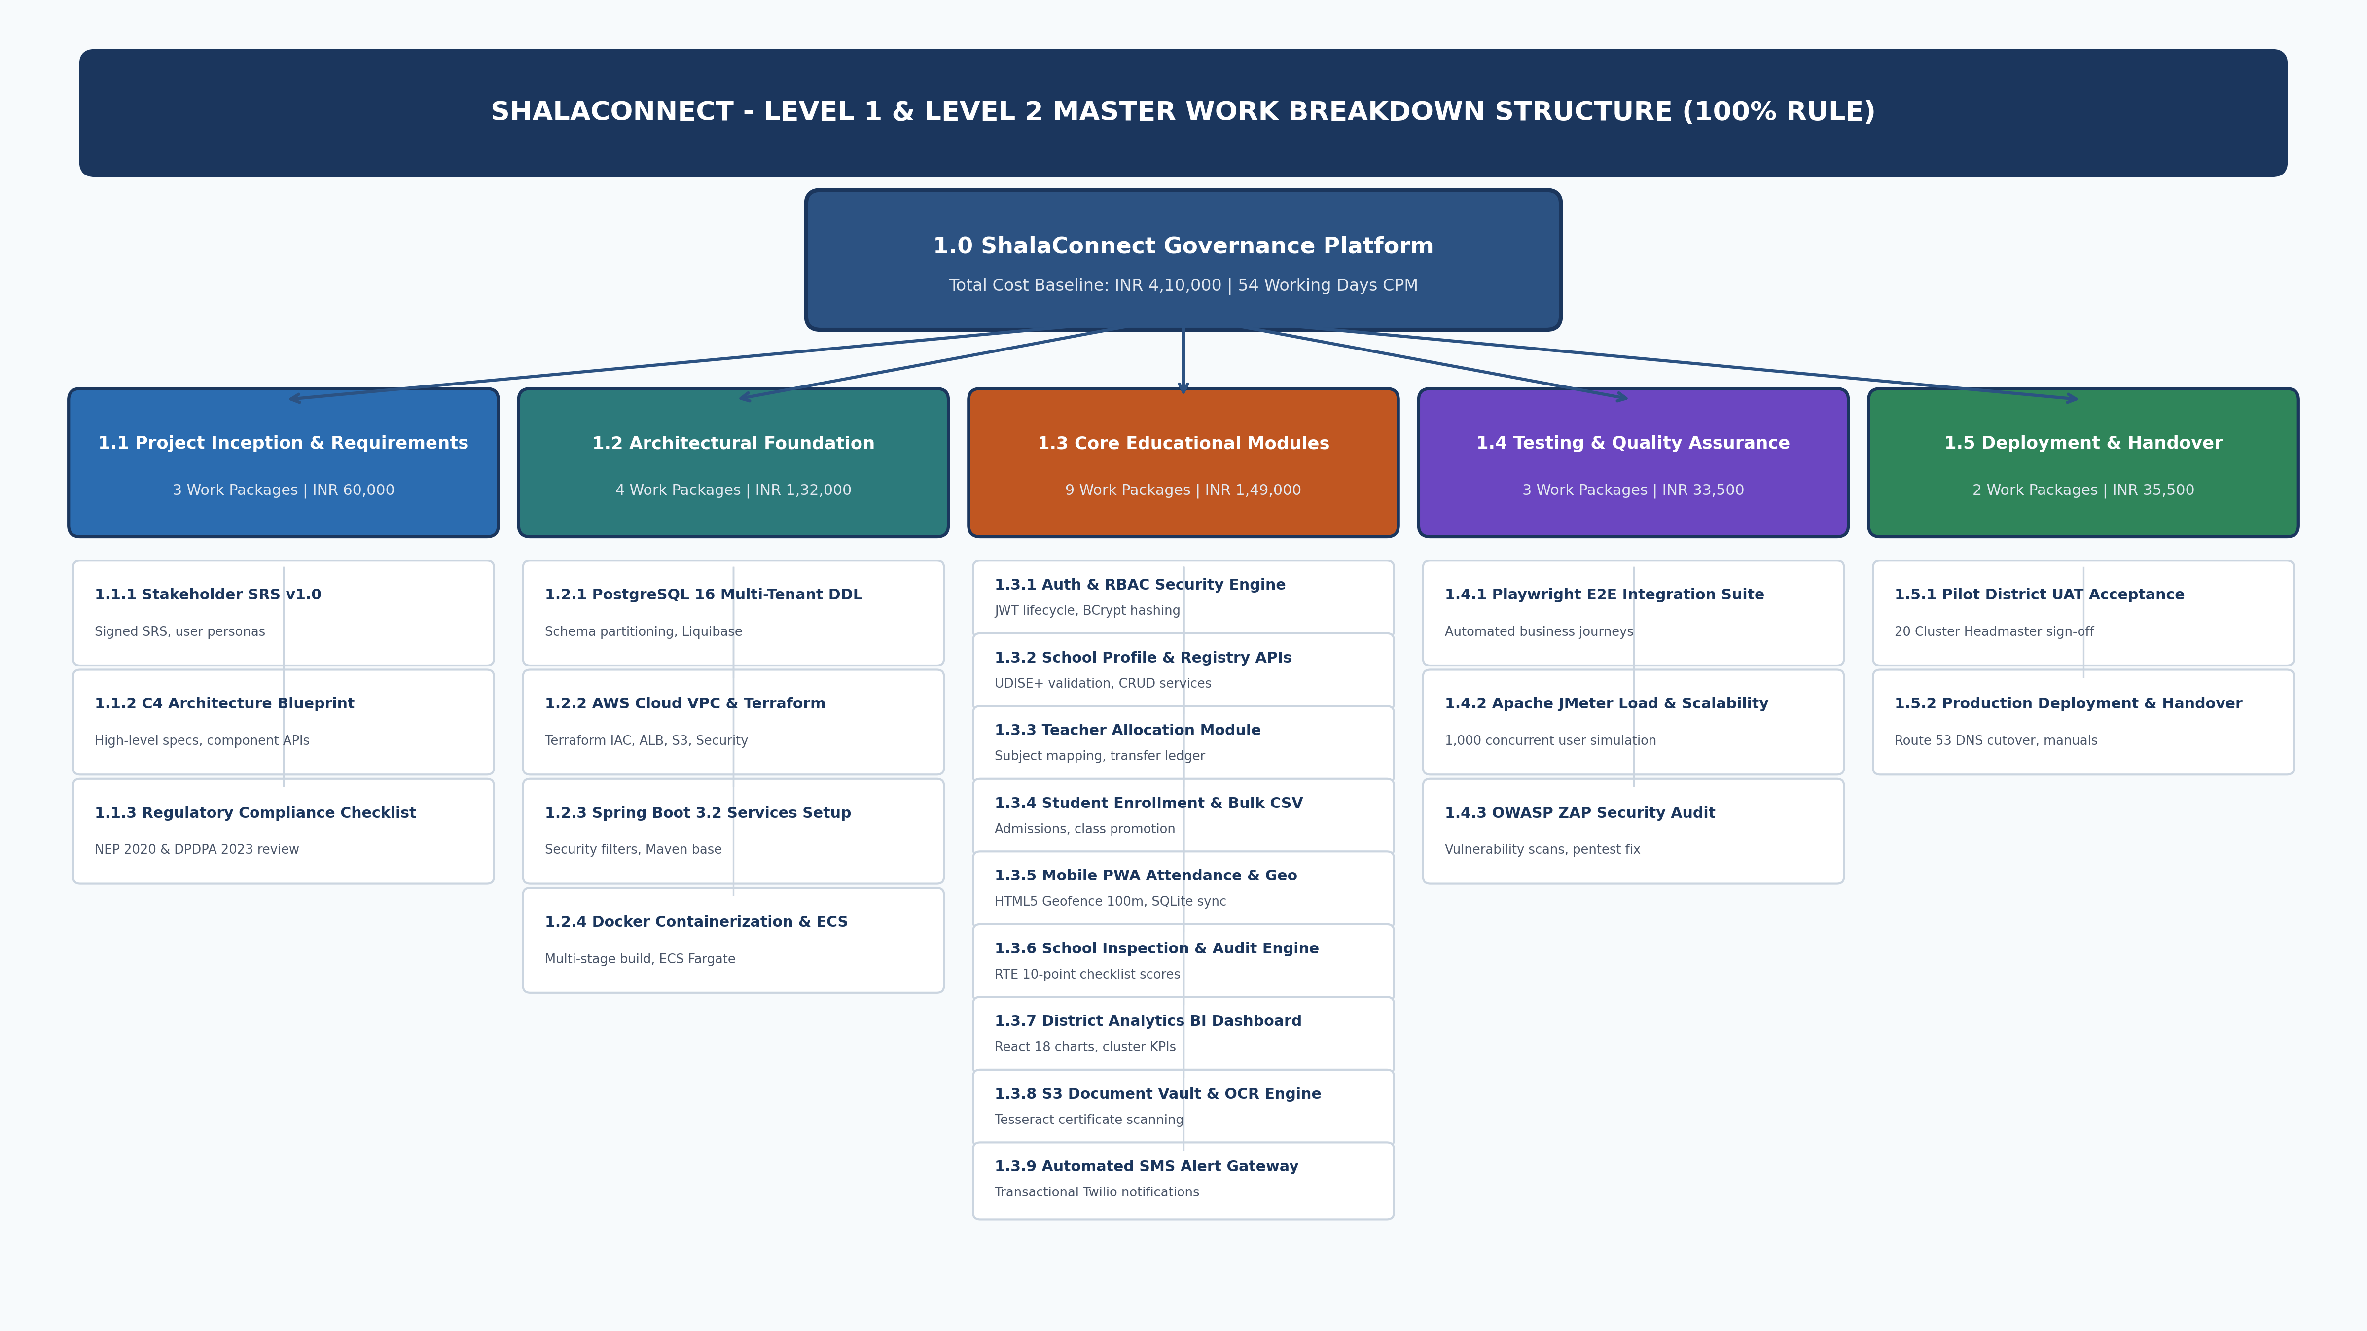

3. Detailed WBS Dictionary (21 Work Packages)
Every lowest-level work package is measurable, bounded, cost-estimated, and assigned to a single accountable lead role. Detailed multi-column definitions are recorded in WBS_Dictionary.xlsx.

