PROJECT MANAGEMENT
Assignment 2: Project Plan, Critical Path and Budget Estimation

Name: | Yash Janardan Sabale
PRN: | 202301040087
Branch: | Computer Engineering
Academic Year: | 2026-27
College: | MIT Academy of Engineering, Alandi, Pune

1. Activity Definition & Critical Path Method (CPM)
The deterministic CPM schedule comprises 21 activities derived directly from the WBS Dictionary. Standard forward and backward passes establish an unyielding 54-working-day critical path across 13 zero-float activities.
Figure 2.1: Activity-on-Node (AON) Network Diagram with Standard 7-Block CPM Nodes
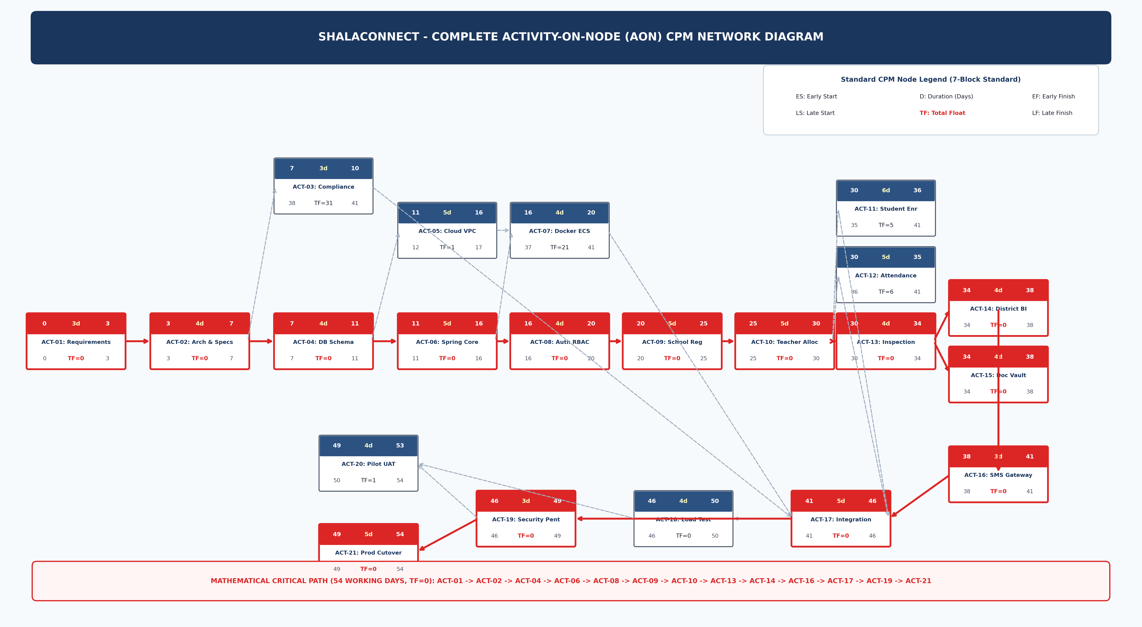
Figure 2.2: Dedicated Critical Path Linear Traversal (Day 0 to Day 54)
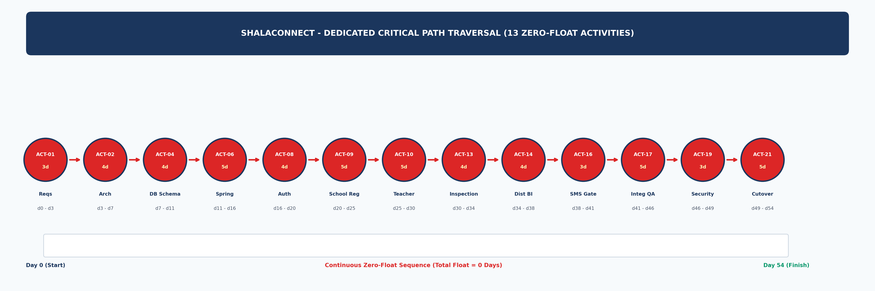

2. Schedule Baseline Gantt Chart & Resource Allocation
Figure 2.3: 16-Week Schedule Baseline Gantt Chart (Critical Path in Red)
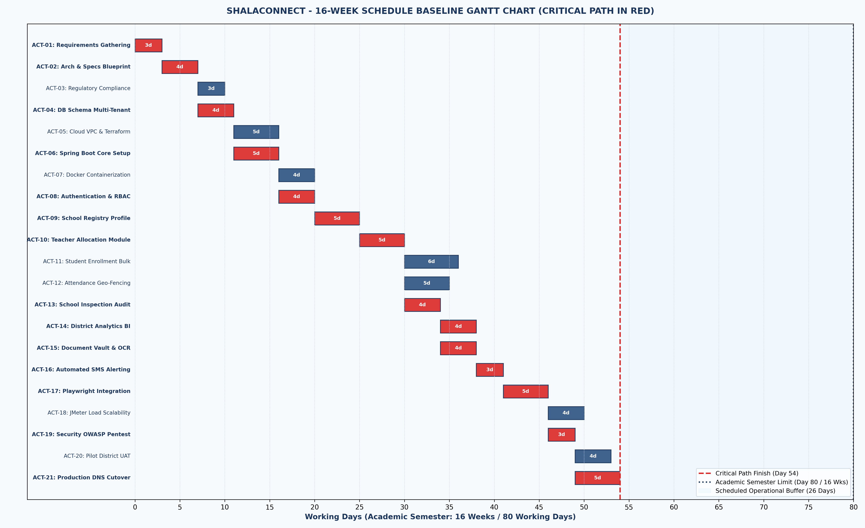
Figure 2.4: Resource Allocation & Weekly Staffing Workload Histogram
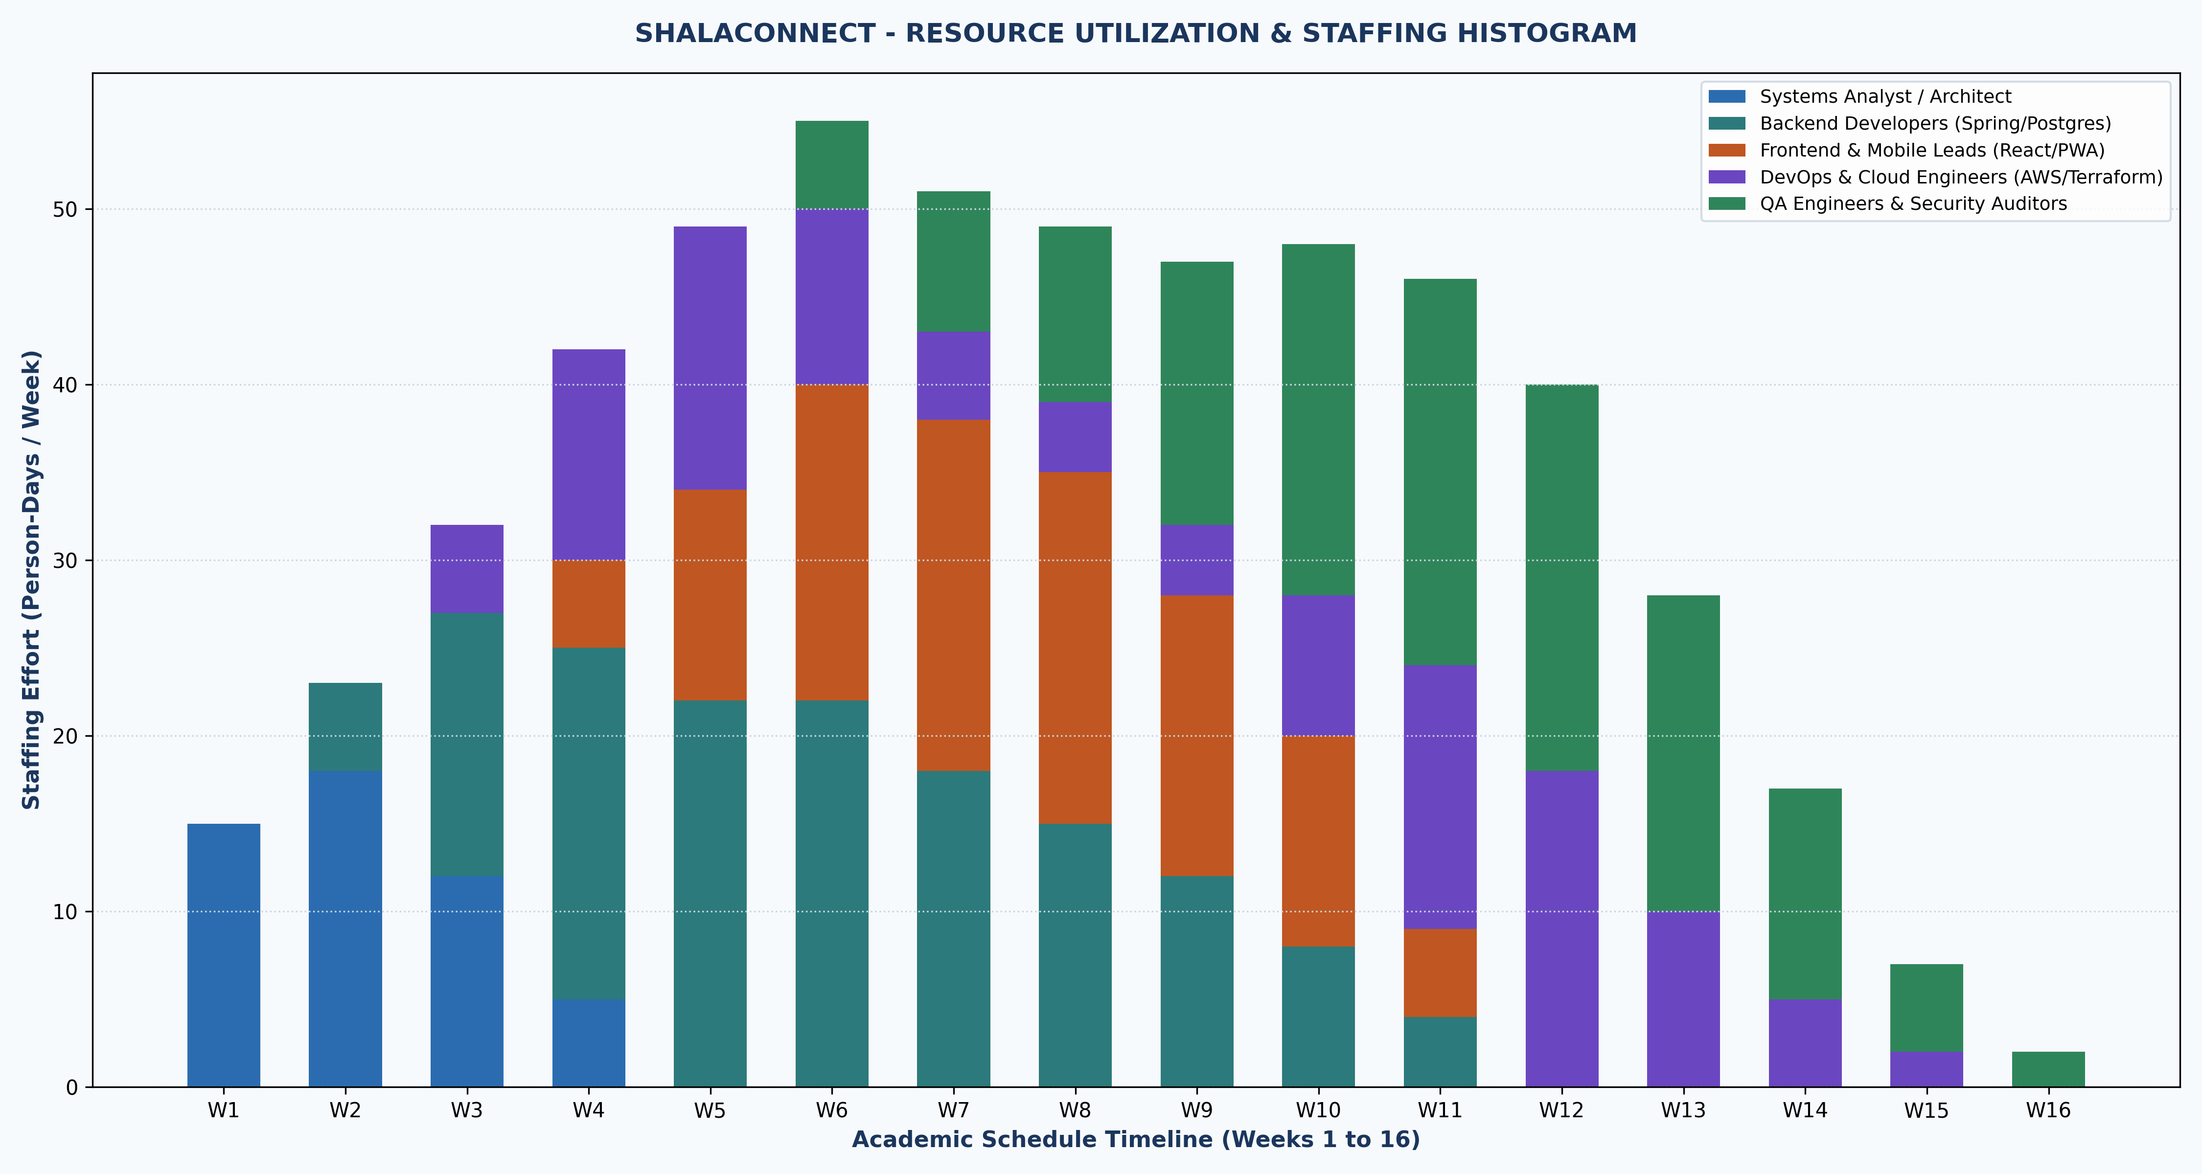

3. Bottom-Up Budget Aggregation & S-Curve Baseline
Figure 2.5: Cost Baseline Aggregation & Budget Breakdown Charts
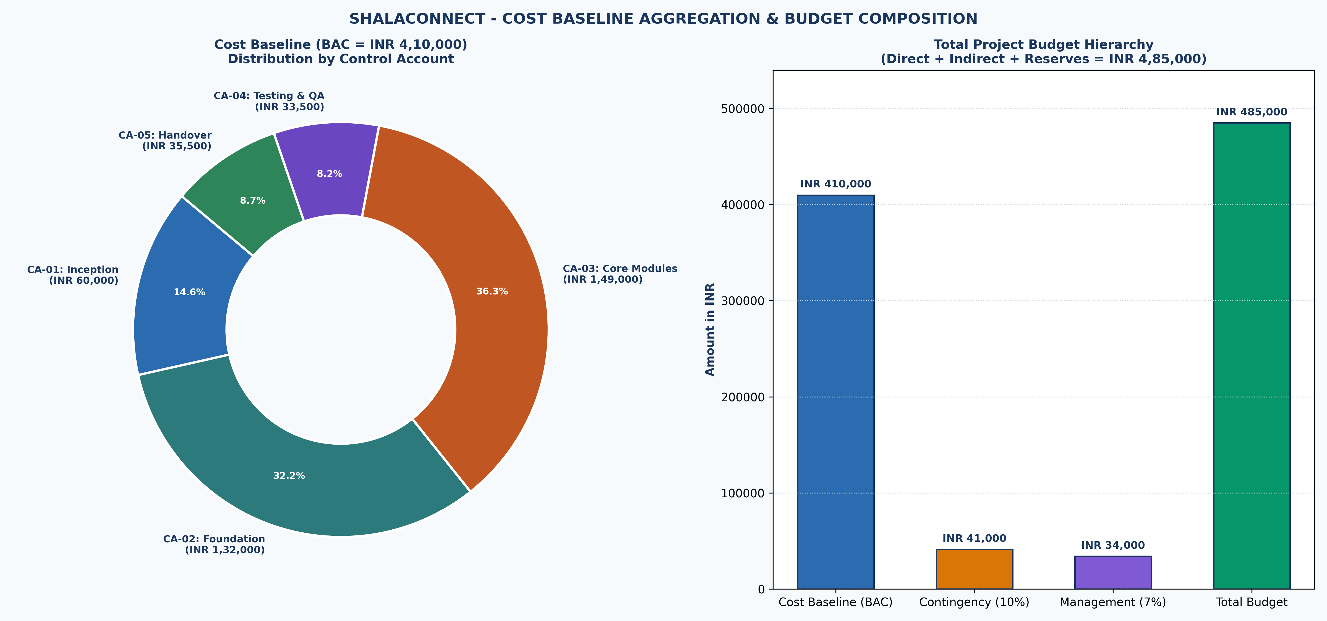
Figure 2.6: Time-Phased Cumulative Expenditure S-Curve Baseline


