PROJECT MANAGEMENT
Assignment 3: Kanban Board and Execution Control Plan

Name: | Yash Janardan Sabale
PRN: | 202301040087
Branch: | Computer Engineering
Academic Year: | 2026-27
College: | MIT Academy of Engineering, Alandi, Pune

1. Agile Kanban Execution Framework & Little's Law
ShalaConnect applies a 5-column Kanban pull system. Little's Law (WIP = Throughput x Cycle Time) mathematically proves that capping in-flight WIP to 6 tasks compresses cycle time from 34.3 days to 16.2 days (52.8% latency reduction).
Figure 3.1: Agile Kanban 5-Column Workflow Architecture with Enforced WIP Limits
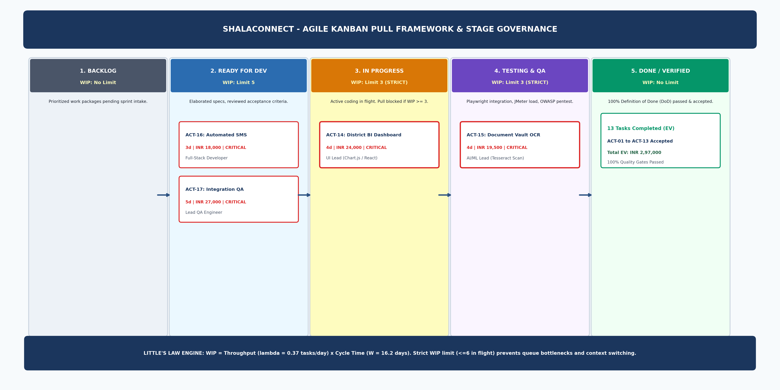

2. Responsibility Assignment Matrix (RACI)
Figure 3.2: Comprehensive RACI Responsibility Assignment Heatmap
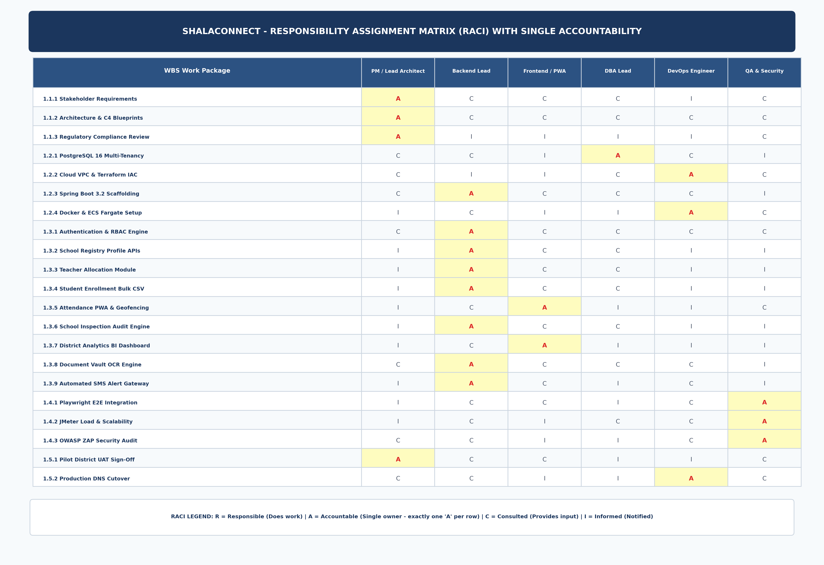

3. Day 35 Earned Value Management (EVM) Performance Audit
Mid-project audit at Day 35 confirms favorable cost efficiency (CPI = 1.050, CV = +INR 14,143) and minor non-critical schedule lag (SPI = 0.928) absorbed by the 26-day operational buffer. Forecasted EAC is INR 3,90,476 (INR 19,524 surplus).
Figure 3.3: Day 35 EVM Performance S-Curve Analysis (PV, EV, AC, and EAC Forecast)


