PROJECT MANAGEMENT
Assignment 4: Risk Management Plan and Risk Register

Name: | Yash Janardan Sabale
PRN: | 202301040087
Branch: | Computer Engineering
Academic Year: | 2026-27
College: | MIT Academy of Engineering, Alandi, Pune

1. Risk Governance & Breakdown Structure (RBS)
Risk management follows PMBOK Guide 7th Edition and ISO 31000 standards. Risks are structured across 4 RBS categories: Technical, External, Organizational, and Project Management.
Figure 4.1: Hierarchical Risk Breakdown Structure (RBS) Taxonomy
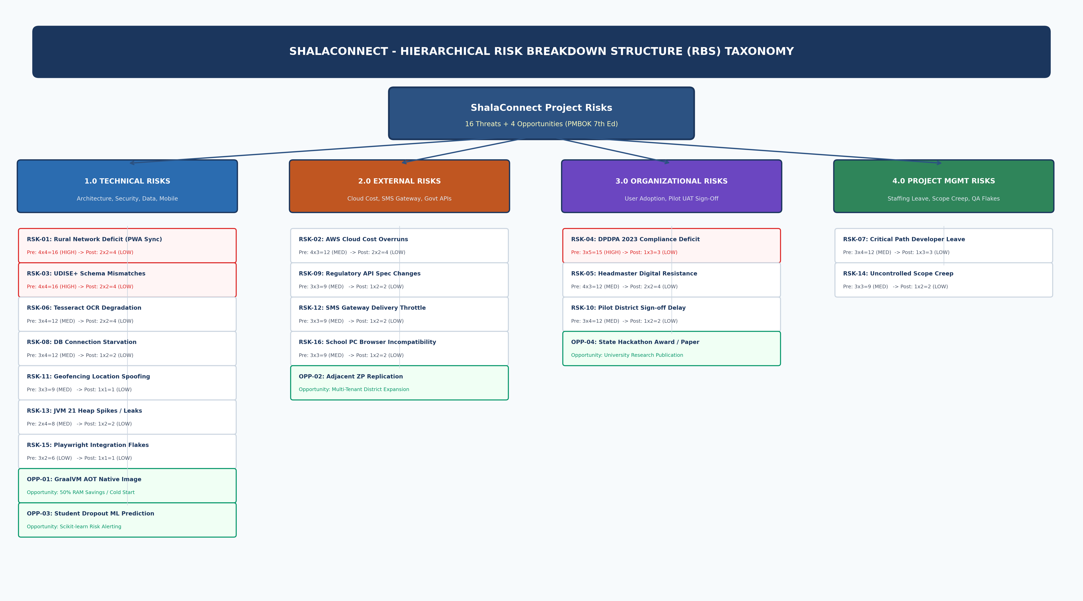

2. Quantitative 5x5 Probability-Impact Heatmap Matrix
Figure 4.2: 5x5 Probability-Impact Heatmap Matrix (All 20 Risks Plotted)
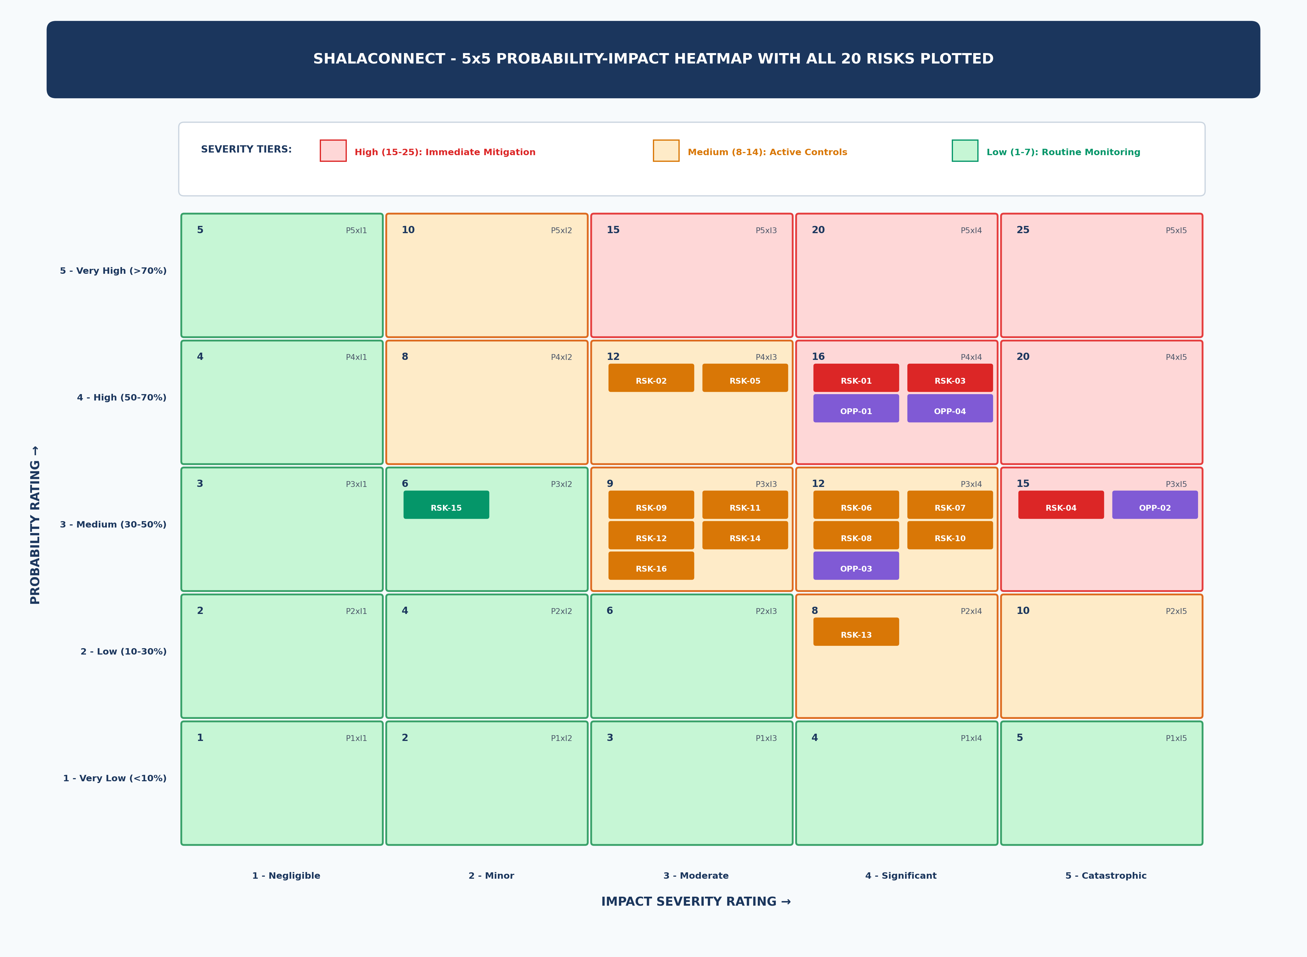

3. Risk Response Playbooks & Residual Score Reduction
Playbooks for top threats (RSK-01 to RSK-05) compress financial exposure by 69.6% from INR 67,200 down to INR 20,400, fully covered by the INR 41,000 Contingency Reserve.
Figure 4.3: Pre- vs. Post-Mitigation Risk Score Reduction Dashboard


