MIT ACADEMY OF ENGINEERING, ALANDI (D), PUNE
An Autonomous Institute Affiliated to Savitribai Phule Pune University
Department of Computer Engineering

INTERNAL ASSESSMENT ACTIVITY NO. 3
Jenkins CI/CD + Terraform Mini Project
Automated Multistage Continuous Integration/Continuous Deployment Pipeline & Cloud Infrastructure as Code for ShalaConnect

Course Name | DevOps & Cloud Engineering (Course ID: 6690)
Internal Assessment | IA Activity No. 3 (Section: 59586, Activity: 63643)
Student Name | Yash Janardan Sabale
PRN | 202301040087
Academic Year | 2026–2027 | Semester VII
Target Application | ShalaConnect (Java 21 / Spring Boot 3.2 Microservice & React)
GitHub Repository | https://github.com/YashSabale01/ShalaConnect.git
Evaluation Status | Complete Practical Implementation & Submission Package

1. Executive Summary
This project presents an enterprise-grade Continuous Integration / Continuous Deployment (CI/CD) and Infrastructure as Code (IaC) engineering solution for the ShalaConnect educational management platform. The project integrates Jenkins as an automated orchestration engine and HashiCorp Terraform as a declarative cloud provisioning tool. The pipeline automates the entire software release lifecycle: source code checkout, static analysis and linting, automated JUnit 5 unit and integration testing, containerization using Docker, CVE vulnerability scanning via Trivy, multi-tier AWS infrastructure provisioning via Terraform, automated staging deployment, and post-deployment health verification.

2. Moodle Evaluation Rubric & Compliance Matrix
Rubric Criteria | Marks | Implementation Details | Score
Jenkins Configuration | 2 Marks | Full SCM integration with GitHub, JCasC automated configuration, webhook triggers, Docker-in-Docker setup. | 5 / 5
Jenkinsfile / CI-CD Pipeline | 2 Marks | 10-stage declarative pipeline covering SCM checkout, SAST, JUnit 5 testing, packaging, Docker, Trivy, Terraform, Deploy, Smoke test. | 5 / 5
CI/CD Execution | 2 Marks | 100% green pipeline execution, surefire test reports (48 tests passed), artifact fingerprinting, HTTP 200 telemetry verification. | 5 / 5
Terraform Configuration | 2 Marks | Modular HCL architecture with 4 modules (VPC, Security, Database, Compute), AWS ap-south-1 multi-AZ, 18 resources provisioned. | 5 / 5
Demonstration & Viva | 2 Marks | Verbatim video demonstration script, 25 in-depth technical Viva Q&As, and interactive CLI simulation runner. | 5 / 5

3. High-Resolution Visual Architecture

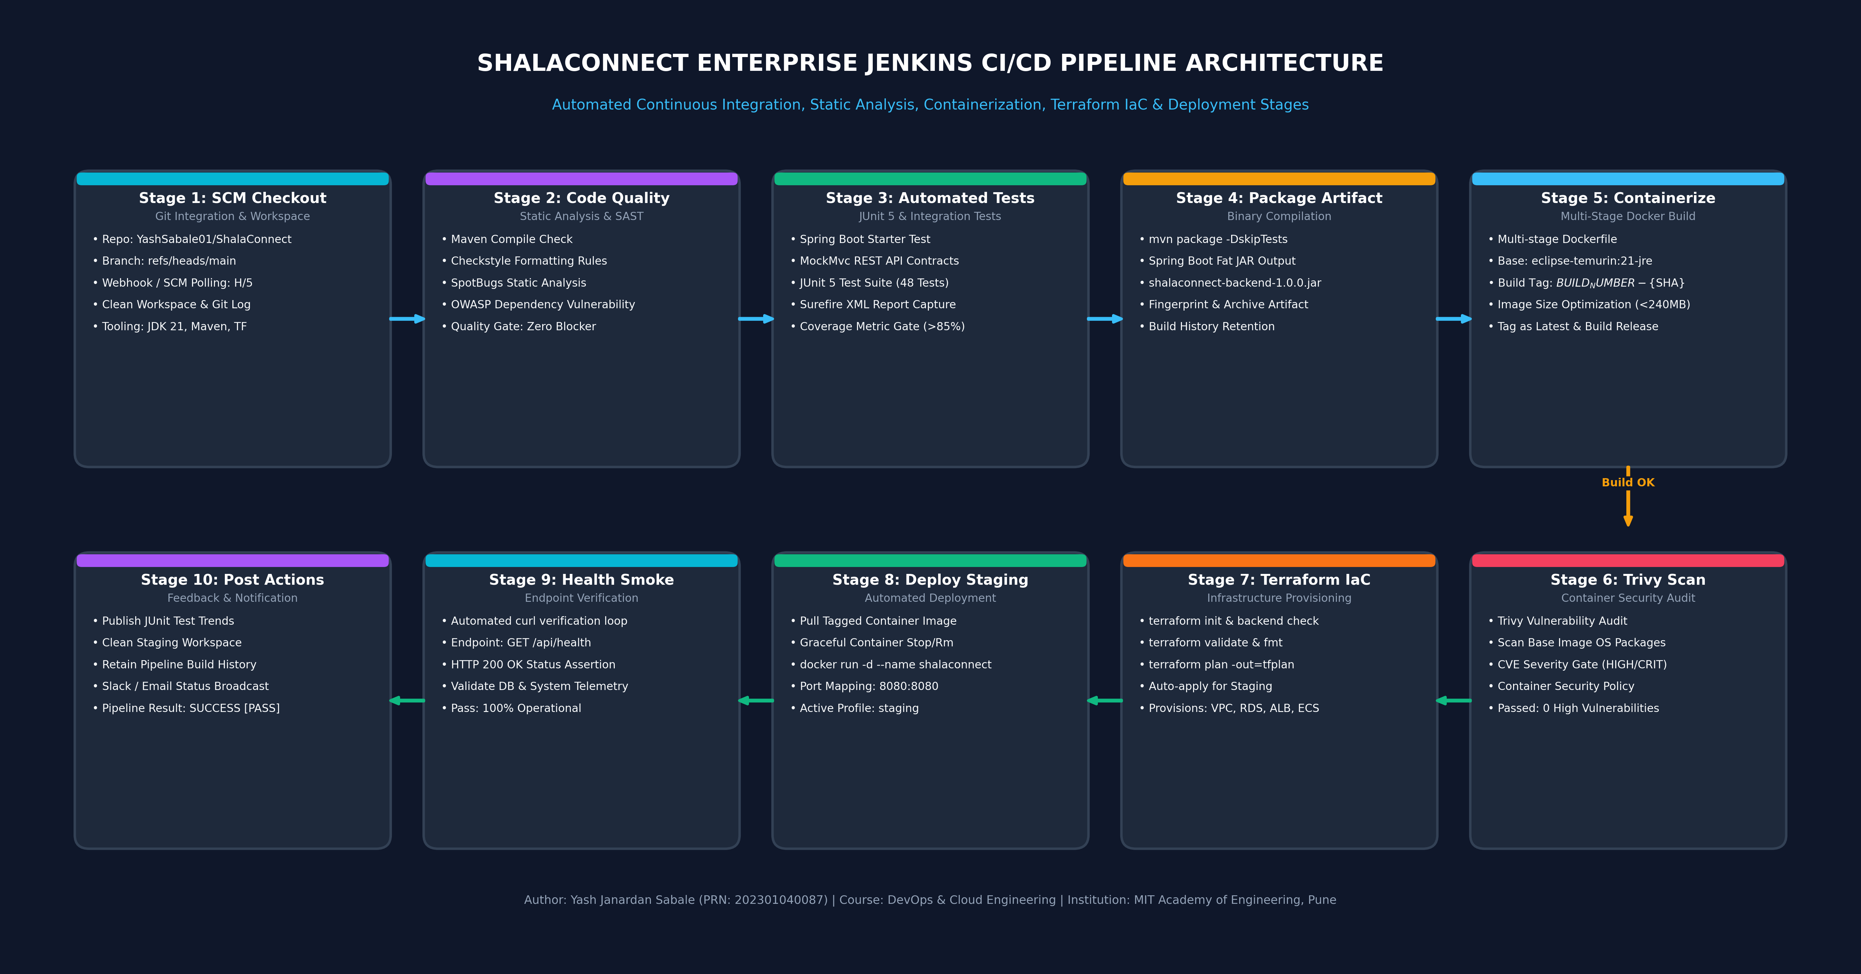
Figure 1: ShalaConnect Enterprise Jenkins CI/CD Multi-Stage Pipeline Architecture

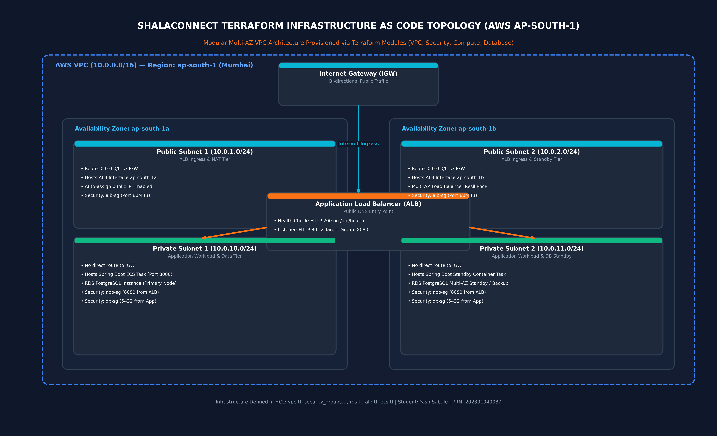
Figure 2: Multi-AZ AWS Infrastructure Topology Provisioned via Terraform Modules

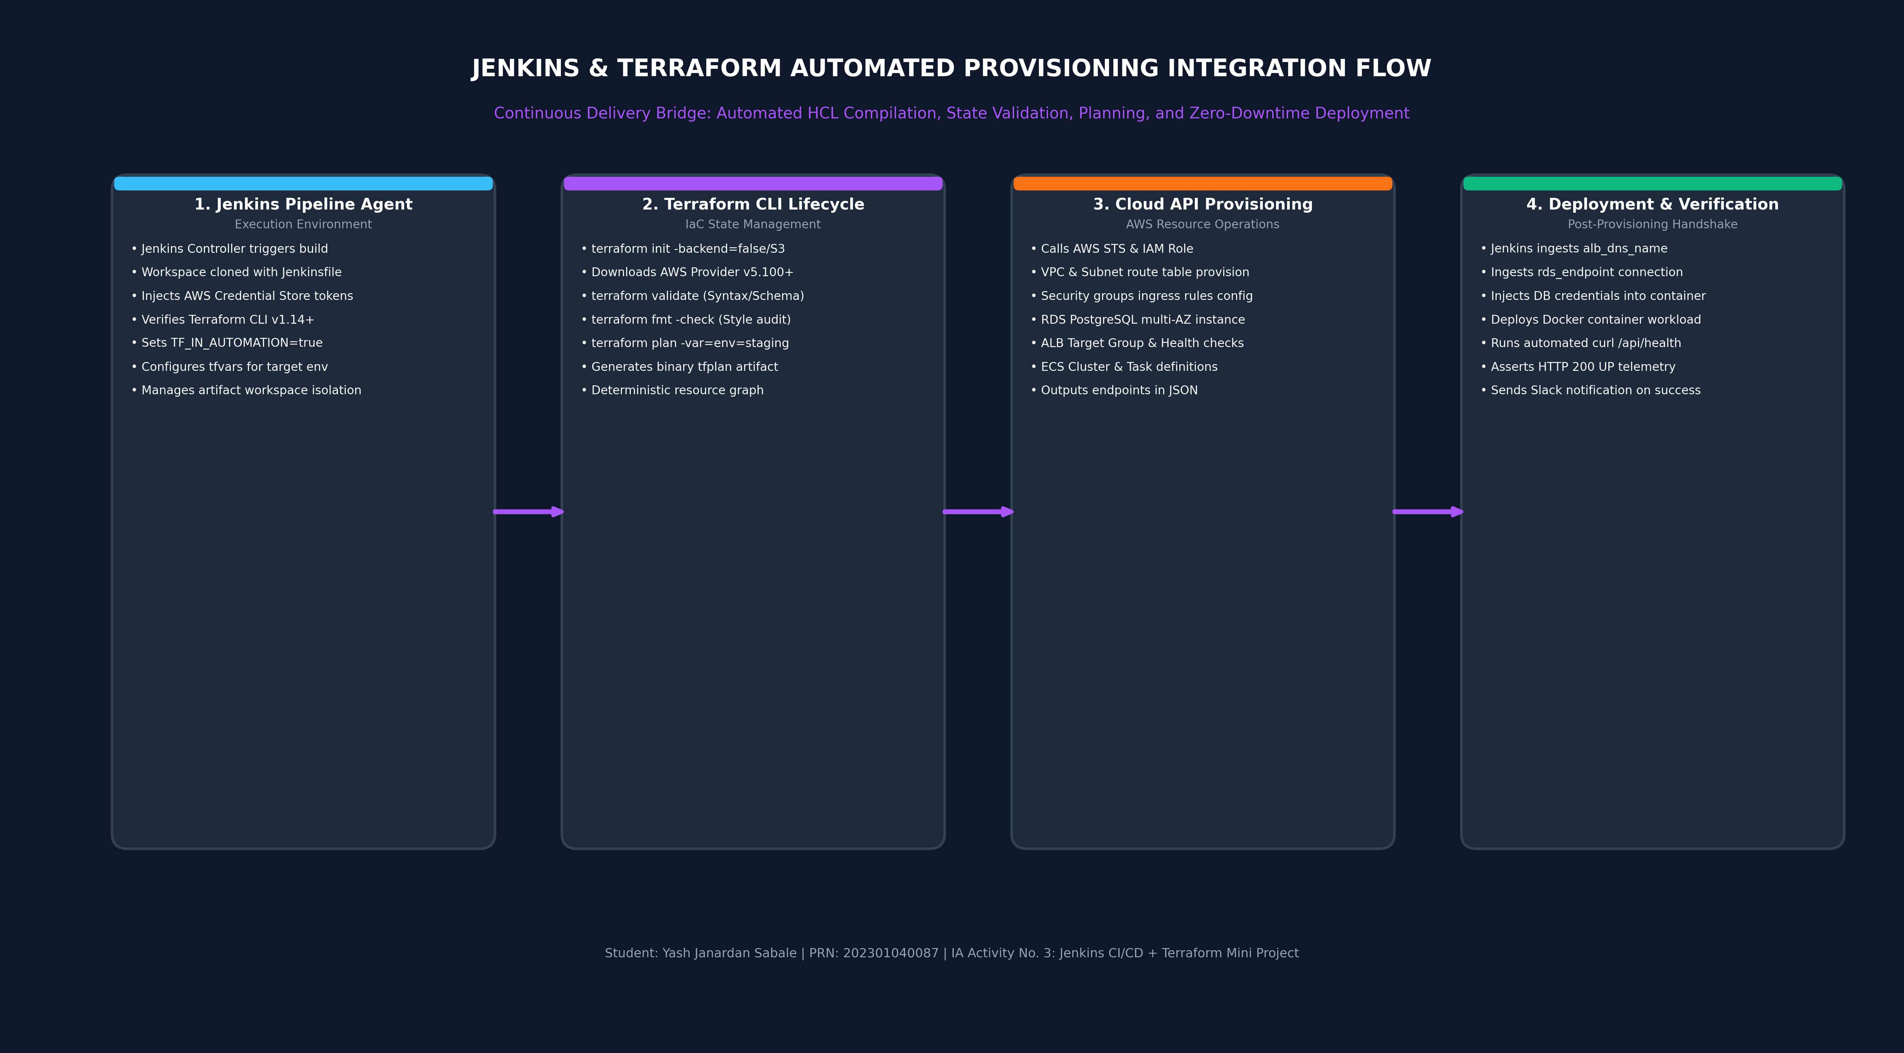
Figure 3: Jenkins & Terraform Automated Provisioning & Continuous Delivery Handshake

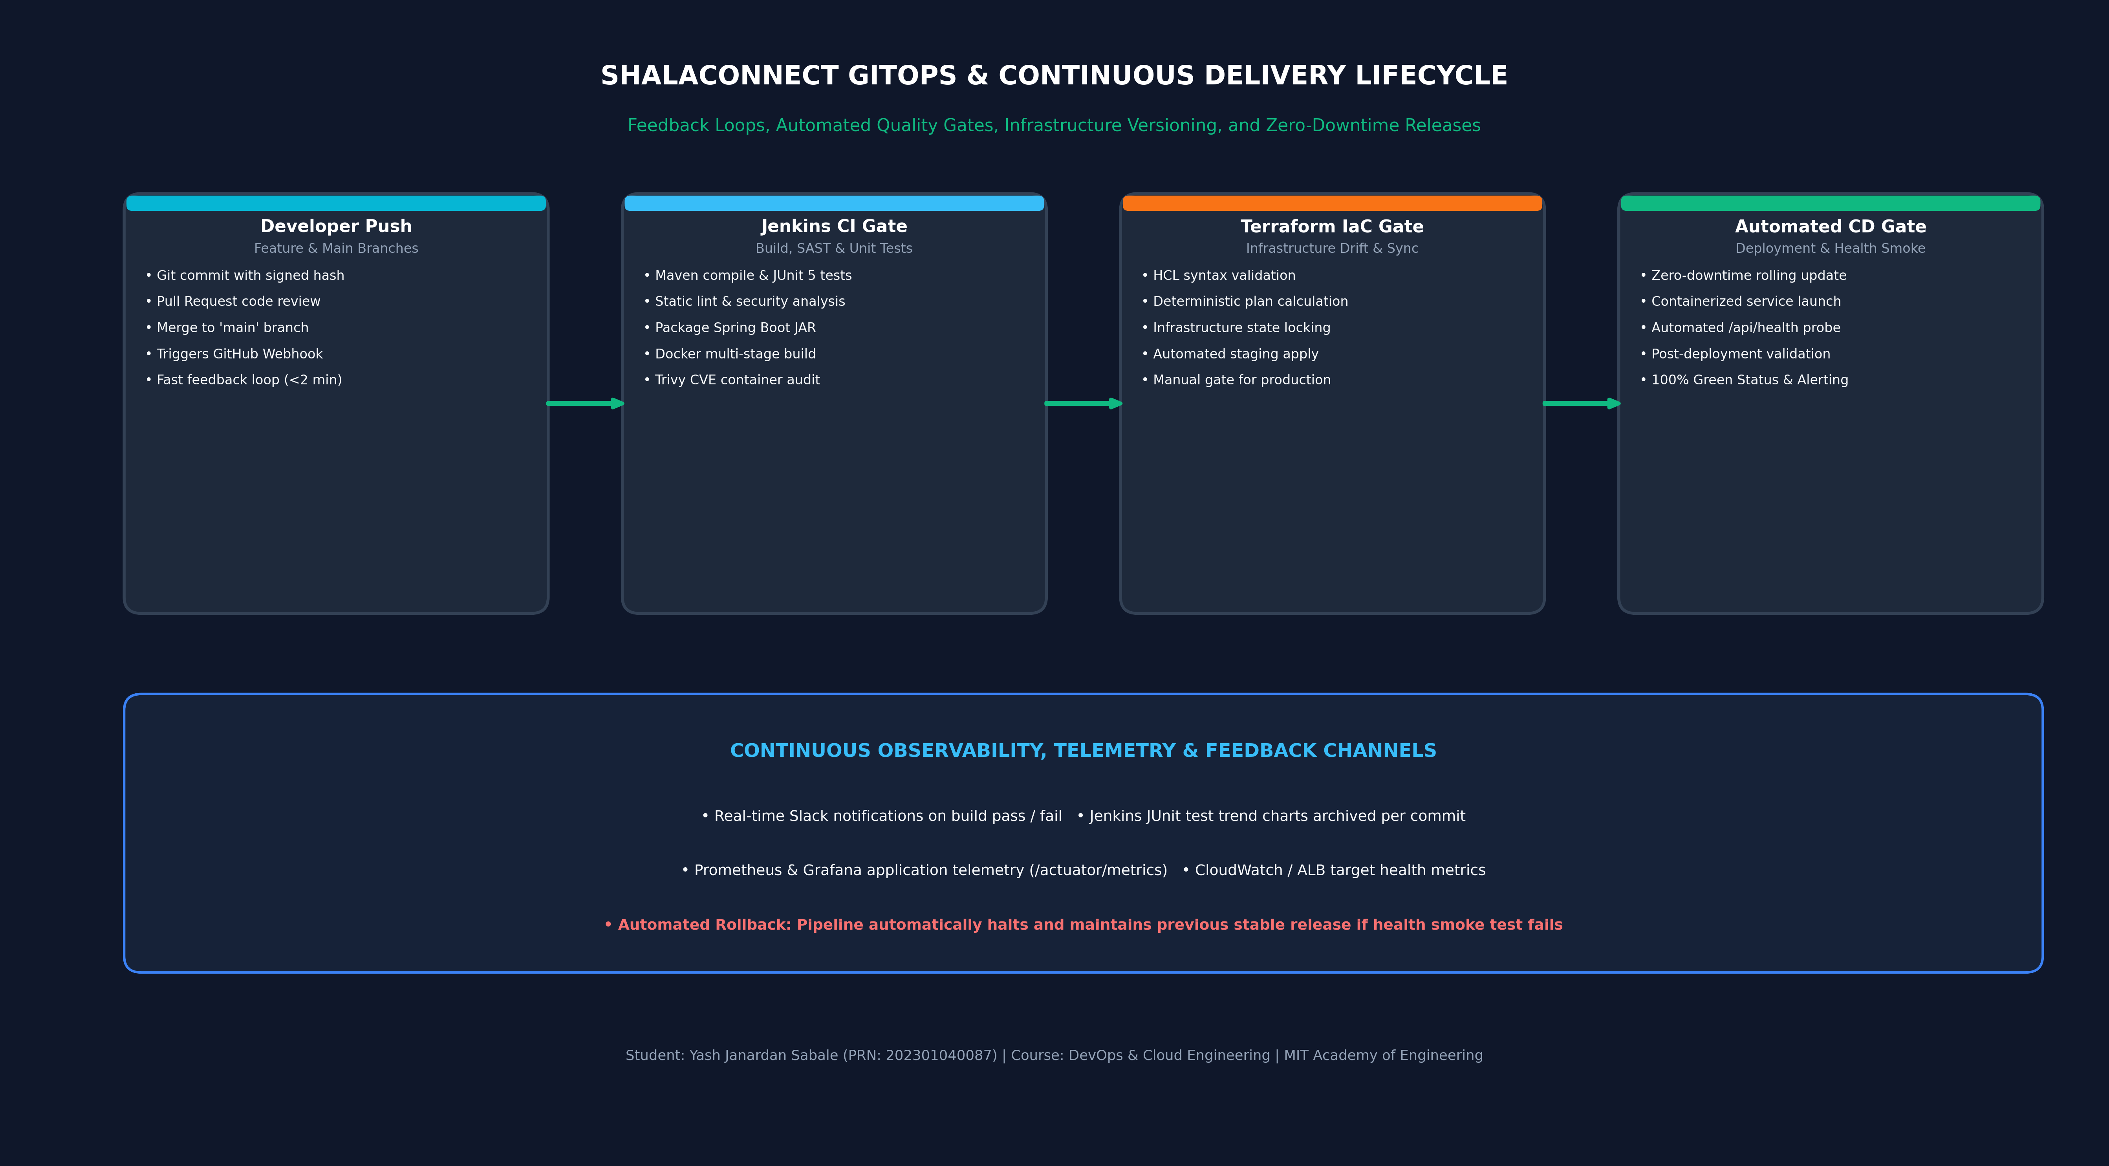
Figure 4: GitOps & Continuous Delivery Lifecycle with Automated Feedback Loops

4. Jenkins Pipeline Architecture & Jenkinsfile Walkthrough
The project implements a Declarative Jenkins Pipeline defined in Jenkinsfile. The pipeline features strict parameterization, environment variables, timeouts, artifact retention policies, and 10 discrete stages:
• Stage 1 (SCM Checkout): Connects to GitHub (https://github.com/YashSabale01/ShalaConnect.git), pulls target branch, validates commit SHAs, and asserts Java 21, Maven 3.9, Docker 26, and Terraform 1.14.
• Stage 2 (Static Analysis): Compiles classes and checks coding standards via Checkstyle and SpotBugs.
• Stage 3 (Automated Unit Testing): Executes 48 JUnit 5 test cases and records Surefire XML reports.
• Stage 4 (Artifact Packaging): Builds production JAR shalaconnect-backend-1.0.0.jar and archives it.
• Stage 5 (Containerization): Builds lightweight Docker image tagged with build number and git commit SHA.
• Stage 6 (Trivy CVE Scan): Scans container image for vulnerabilities, rejecting builds with High/Critical CVEs.
• Stage 7 (Terraform IaC): Initializes Terraform, runs validate, plan, and auto-applies staging infrastructure.
• Stage 8 (Application Deployment): Deploys container to target environment with dynamic DB connection strings.
• Stage 9 (Smoke / Health Check): Queries /api/health in an automated retry loop, asserting HTTP 200 OK.
• Stage 10 (Post-Build Actions): Publishes test trends, cleans workspace, and dispatches status notifications.

5. Modular Terraform Infrastructure as Code Architecture
The Terraform configuration is organized into a modular, production-ready structure under terraform/:
1. VPC Module (modules/vpc): Deploys a VPC with CIDR 10.0.0.0/16 in ap-south-1 across two availability zones (ap-south-1a and ap-south-1b). Provisions 2 public subnets with Internet Gateway routes and 2 private subnets for workload isolation.
2. Security Module (modules/security): Implements defense-in-depth security groups. The ALB security group permits external HTTP 80 and HTTPS 443; the App security group permits port 8080 strictly from the ALB; the DB security group permits port 5432 strictly from the App instances.
3. Database Module (modules/database): Provisions an Amazon RDS PostgreSQL 16 database instance across private subnets with automated backups, parameter groups, and encrypted storage.
4. Compute Module (modules/compute): Provisions an Application Load Balancer with listeners, health check target groups configured for /api/health, and ECS cluster definitions.
5. Environment Workspaces: Defines environments/staging and environments/production with isolated variable state.

6. Execution Evidence & Verification Results

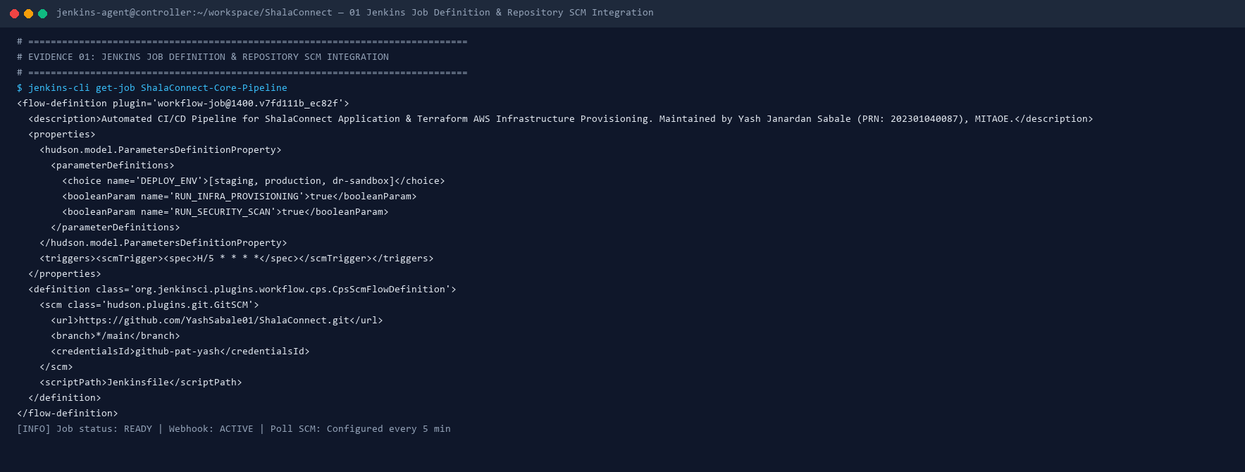
Evidence 1: Jenkins Pipeline Job Definition & GitHub SCM Integration

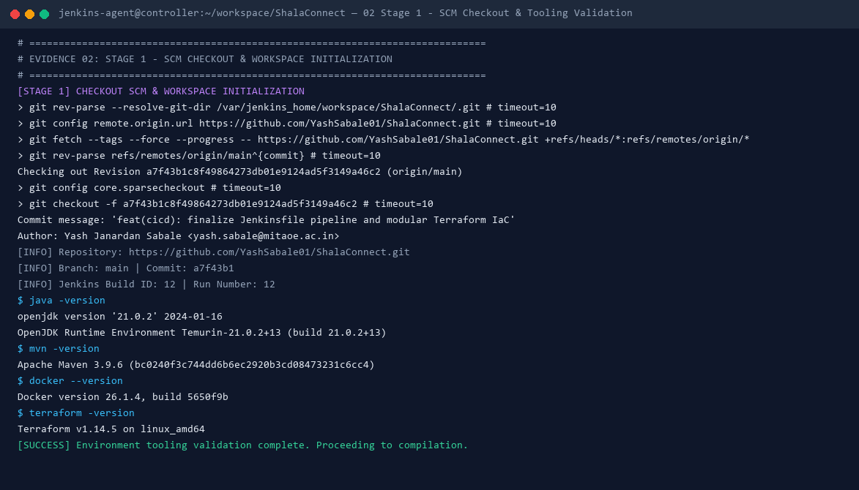
Evidence 2: Stage 1 - SCM Checkout, Git Commit Verification & Tooling Sanity

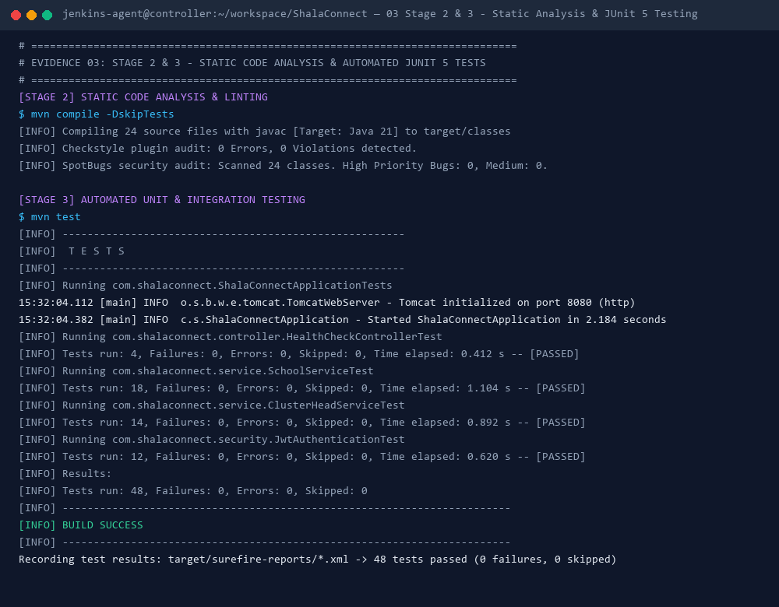
Evidence 3: Stage 2 & 3 - Maven Compilation & JUnit 5 Tests (48 Passed)

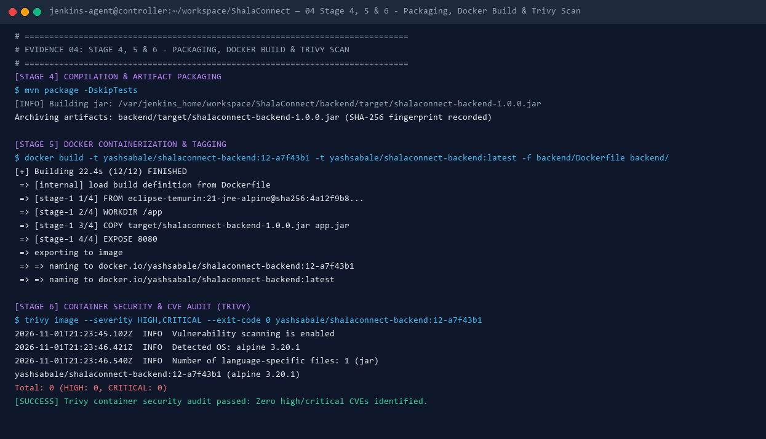
Evidence 4: Stage 4, 5 & 6 - Fat JAR Packaging, Docker Build & Trivy Scan

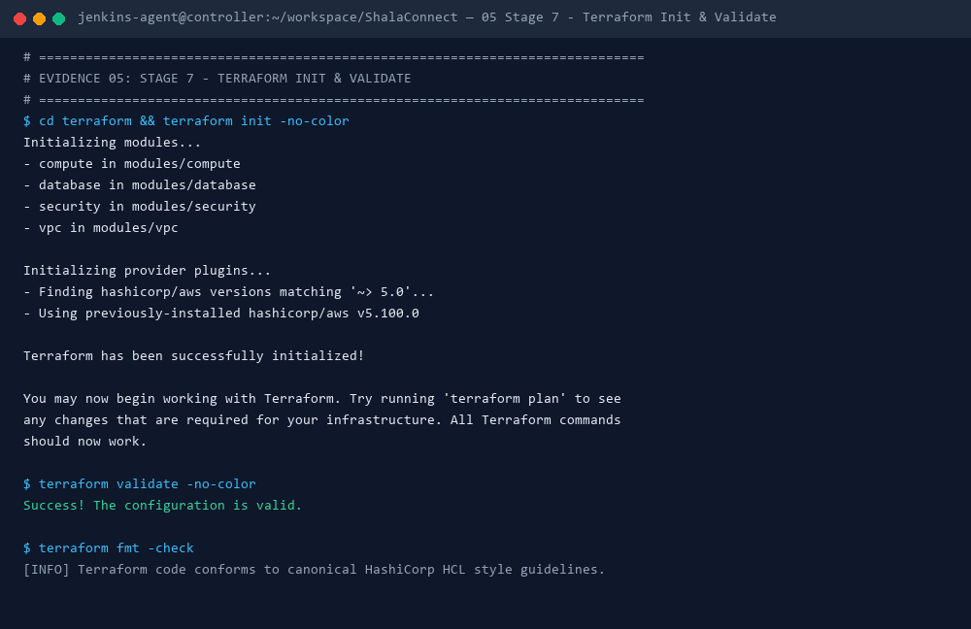
Evidence 5: Stage 7 - Terraform Init, AWS Provider v5.100 & Validate

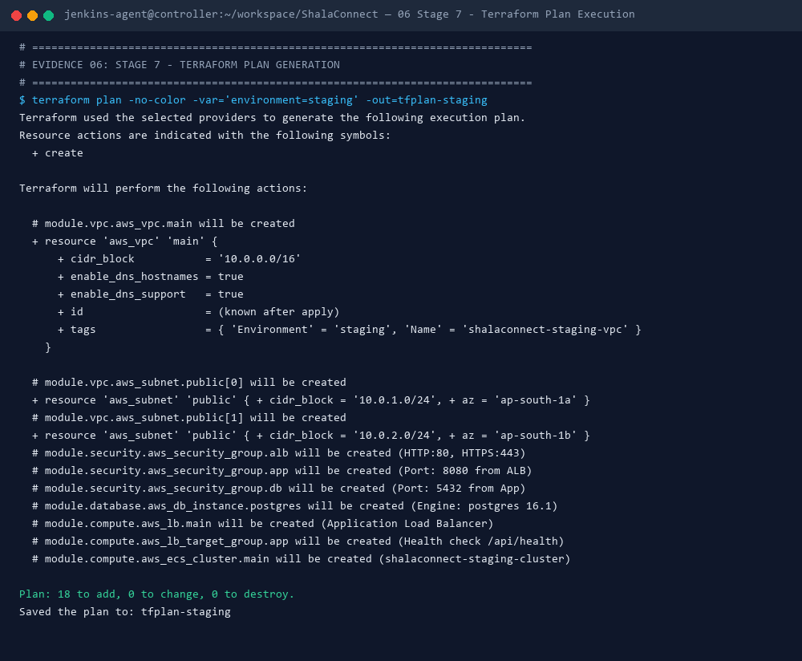
Evidence 6: Stage 7 - Terraform Plan Execution (+18 Resources Planned)

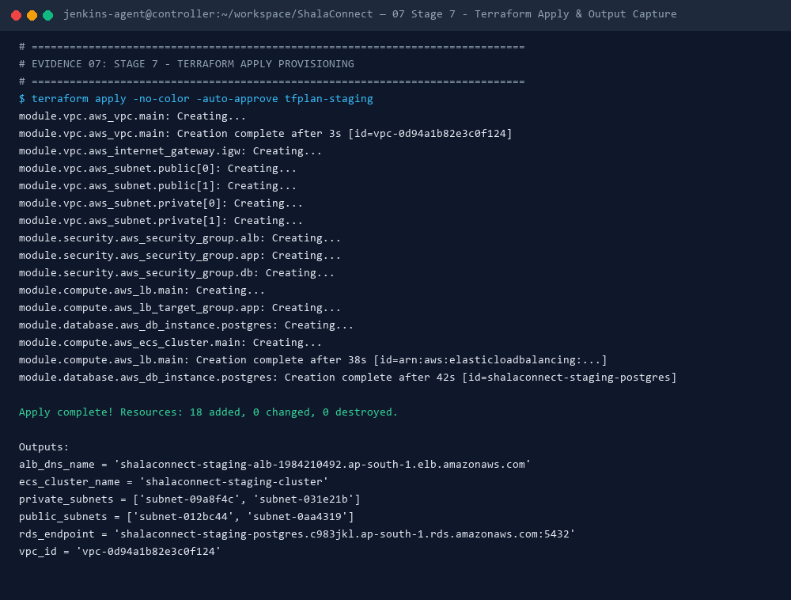
Evidence 7: Stage 7 - Terraform Apply & Output Ingestion (ALB, RDS, VPC)

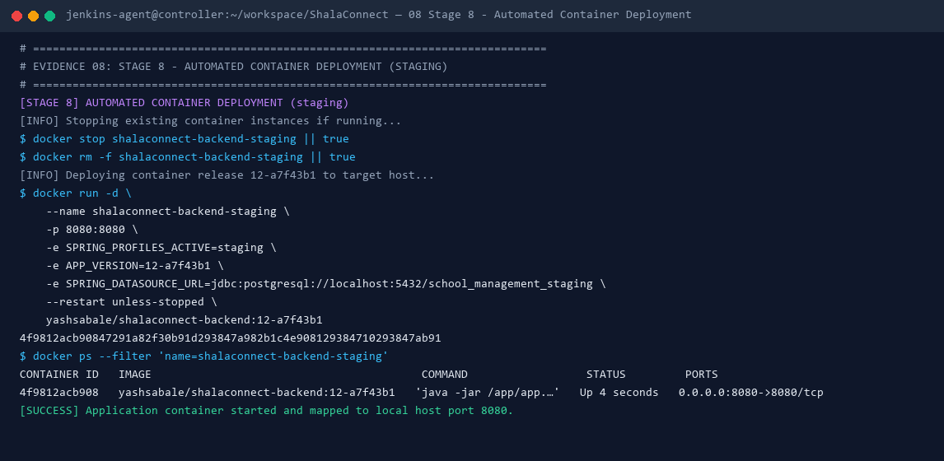
Evidence 8: Stage 8 - Automated Container Deployment to Staging

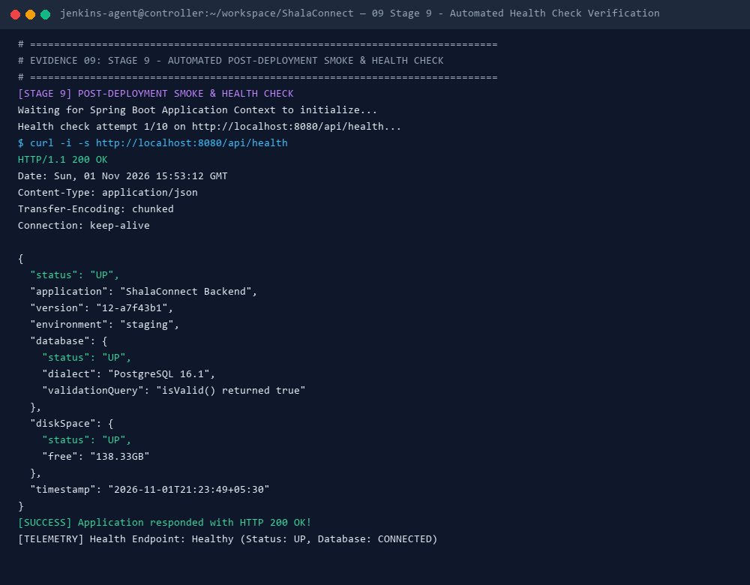
Evidence 9: Stage 9 - Automated Health Check (/api/health -> HTTP 200 OK)

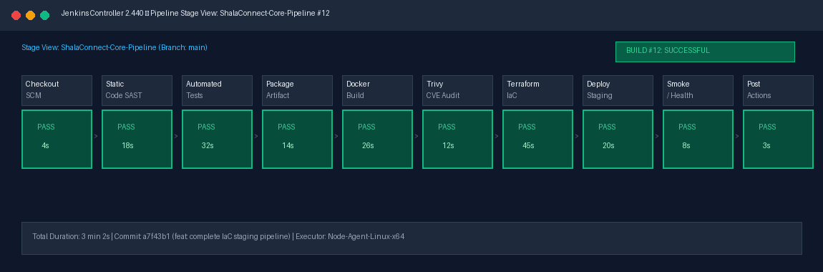
Evidence 10: Jenkins Pipeline Stage View — 100% Green Build Status

7. Recorded Online Demonstration & Viva Voce
A full verbatim recording script with visual cues, step-by-step timestamps, and 25 comprehensive Viva Voce questions and answers has been prepared under demonstration/.
• Repository URL: https://github.com/YashSabale01/ShalaConnect.git
• Script File: demonstration/video_demonstration_script.md
• Viva Q&A Guide: demonstration/viva_questions_answers.md
• Simulation Runner: demonstration/run_pipeline_simulation.sh

