PROJECT REPORT
ANALYTICS DASHBOARD RETAIL SALES & PROFIT
Submitted by
YASH GANESH SADBHAVE

Retail Sales & Profit Analytics Dashboard

1. Executive Summary
This project demonstrates how raw retail transaction records can be transformed into business intelligence. The dashboard summarizes revenue, estimated profit, orders, unique customers, average order value, and profit margin. It also provides monthly trends, region and category comparisons, and a simple customer-recency review.

2. Problem Statement
Retail teams may have transaction data but lack a concise view of what is happening, which factors may be driving performance, where risks may exist, and what actions should be considered. The project addresses this by presenting selected KPIs and visual analyses in an interactive dashboard.

3. Objectives
- Generate and prepare a reproducible demonstration dataset.
- Calculate core business KPIs and enable filter-based analysis.
- Visualize revenue trends and performance by category and region.
- Flag customers with long gaps since their most recent order.
- Translate observations into cautious, actionable business recommendations.

4. Dataset and Tools
Dataset: synthetic retail transactions generated in the project code with a fixed random seed. It includes order date, order ID, customer ID, region, category, product, sales channel, quantity, unit price, discount, revenue, and estimated profit. No external dataset URL is used in this version because the data is generated locally. If the organizer requires an external dataset URL, replace this generator with a permitted dataset not used in the masterclasses and record its exact source URL in README.md.
Tools: Python, Pandas, NumPy, Streamlit, and Plotly. The report charts below are illustrative and generated from synthetic data.

5. Key Performance Indicators
KPI | Definition | Decision value
Revenue | Sum of discounted order-line revenue | Tracks sales scale
Estimated profit | Revenue less simulated cost and discount penalty | Highlights approximate profitability
Orders | Distinct order IDs | Indicates transaction volume
Unique customers | Distinct customer IDs in filtered data | Shows customer reach
Average order value | Revenue divided by distinct orders | Supports basket-value analysis
Profit margin | Estimated profit divided by revenue | Helps identify margin review areas
Customer recency | Days since customer’s latest order | Supports retention review

6. Illustrative Visual Analysis
The following charts demonstrate the types of visualizations included. Values are generated from the synthetic dataset and must not be reported as real business outcomes.
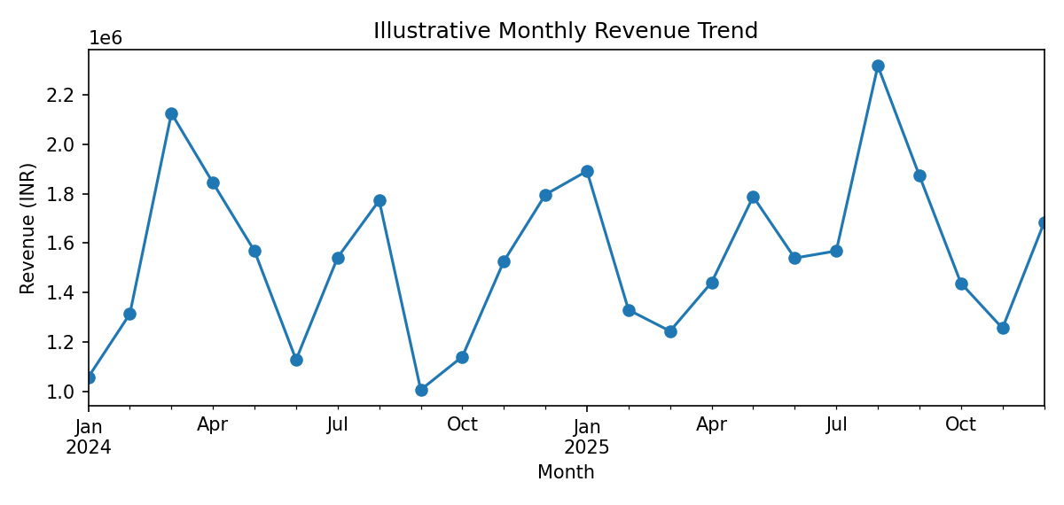
Figure 1. Monthly revenue trend. Use the interactive date filters to inspect selected periods.
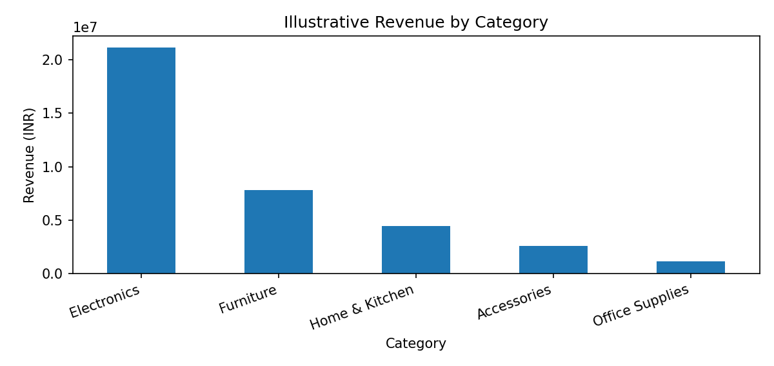
Figure 2. Revenue by product category. Compare revenue with profit before prioritizing categories.
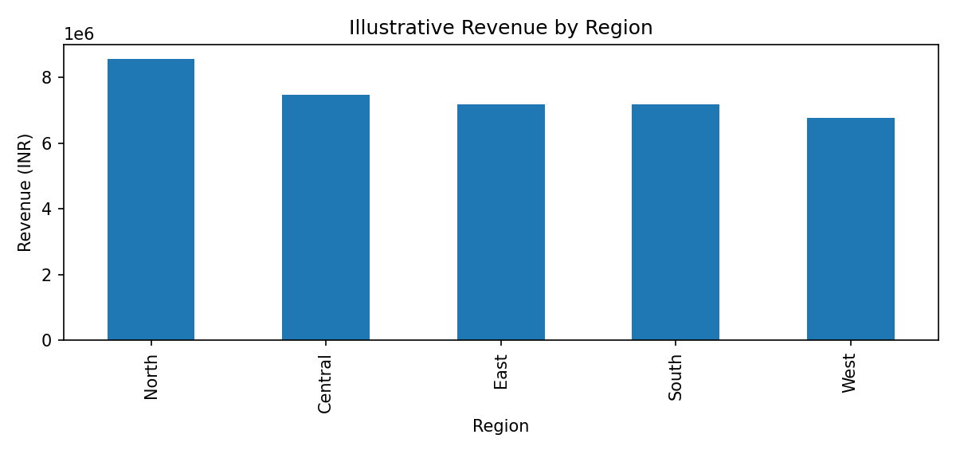
Figure 3. Revenue by region. Regional performance can guide follow-up analysis, not automatically determine budgets.

7. Dashboard Modules
- Executive Overview: KPI cards, monthly revenue line chart, regional revenue comparison, and generated insight notes.
- Sales & Products: category-level revenue, order revenue-versus-profit scatter plot, category summary, and CSV download.
- Customer & Risk: customer recency distribution, count/share of customers inactive for 180+ days, and a table of customers for review.

8. Recommended Actions
- Investigate regions with declining revenue using real order, inventory, and campaign data.
- Review categories with lower estimated margins for discounting, supplier-cost, and pricing patterns.
- Consider a small retention-offer experiment for high-value customers who have not ordered recently.
- Track a small set of KPIs consistently instead of overcrowding the dashboard with charts.

9. Limitations and Ethics
The dataset is synthetic. Profit is simulated from a random cost ratio and a discount penalty. The inactive-customer flag is a simple recency rule, not a validated churn model. No causal conclusions or real-world forecasts are claimed. Recommendations should be validated using authorized real data before operational use.

10. How to Run
Install Python 3.10+, run `pip install -r requirements.txt`, then run `streamlit run project.py`. The dashboard opens in a local browser, usually at http://localhost:8501.

11. Conclusion
The project illustrates the business intelligence workflow: data → information → insight → decision → action. It combines a focused set of KPIs with visual trends and risk indicators, while clearly documenting the limitations of the synthetic data.

12. Submission Deliverables
Submit project.py, requirements.txt, Project_Report.docx, README.md, and the GitHub repository URL. Upload the files individually if the official submission form requires individual files. Confirm any mandatory filename convention from the organizer’s form.

