Experiment - 2

# Aim:

To study and Implement Infrastructure as a Service (IaaS) using AWS/ Microsoft Azure.

**Pre-Requisites:** Amazon AWS Account

# Theory:

*IAAS* – IaaS (Infrastructure as a Service) is a cloud computing model where a service provider delivers underlying computing infrastructure such as servers, storage, and network as a service to its customers. The customers can deploy and run their software and applications on the provided infrastructure without the need to manage the underlying hardware and infrastructure. This allows organizations to outsource their IT infrastructure and focus on their core business while the service provider takes care of maintenance and management of the infrastructure. Examples of IaaS providers include Amazon Web Services (AWS), Microsoft Azure, and Google Cloud Platform (GCP).

# 

# 

# 

# 

# 

# Implementation

*Procedure To Create a Virtual Machine on Amazon AWS:*

*i. Go to Amazon AWS Website*

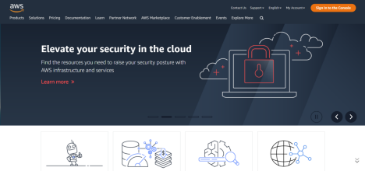

*ii. Login into your AWS account.*

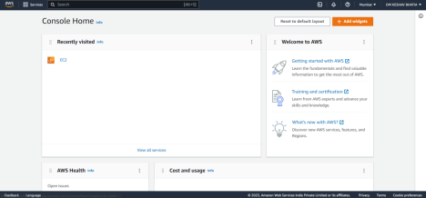

*iii. Go to Services >> Compute >> EC2*

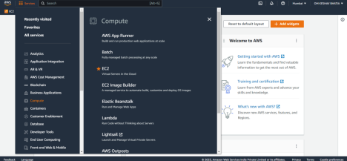

*iv. EC2 Dashboard Will Open Up. Click On Instances >> Launch Instances 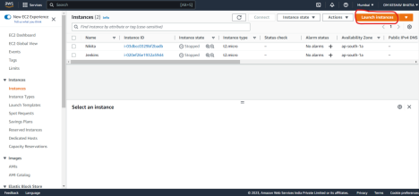*

*v. Enter the Number of Instances You Want to Create and Name them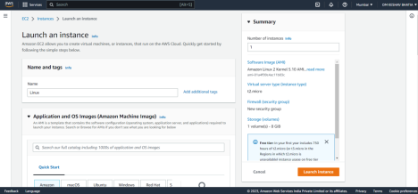*

*vi. Select the OS For Your Instance: Any Free Os (recommended) 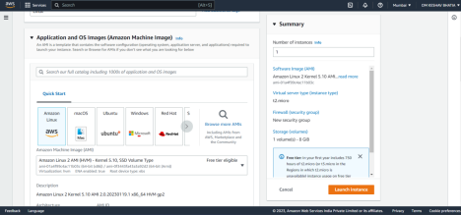*

*vii. Select Instance Type: t2 micro (recommended)*

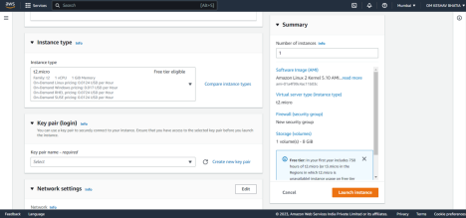

*viii. In Key-Pair Login. Select “Create New Key Pair”*

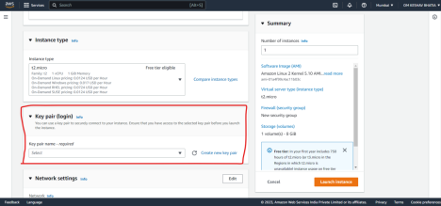

*ix. Enter Key-Pair Name and Apply the Following Settings. Click On Create Key Pair*

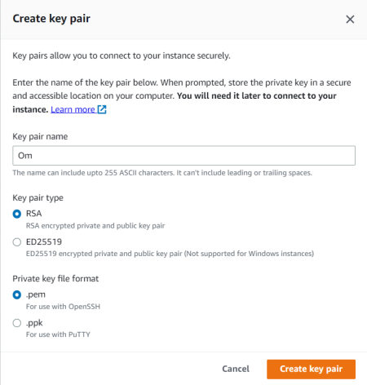

*x. Keep Network and Storage Settings As it is And Click on Launch Instance. 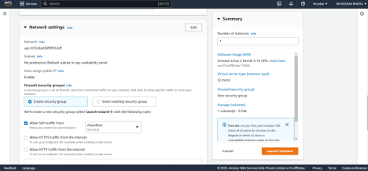*

*xi. Now Click on The Id to Launch the Instance.*

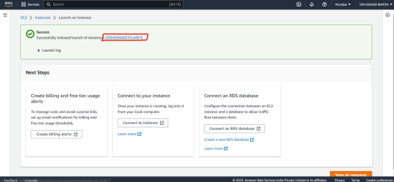

*xii. Now the Instance is Running and Performing Some System Checks. 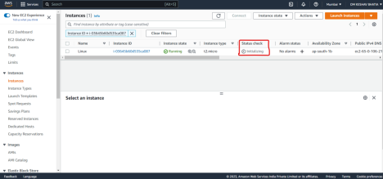*

*xiii. Once Checks Are Completed Select the Instance and Click on Connect.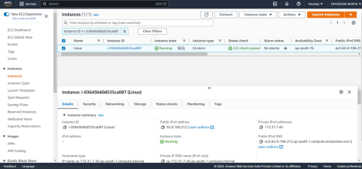*

*xiv. Click On Connect.*

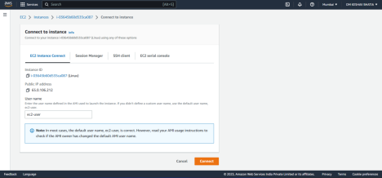

*Thus, Now Our Virtual Machine Is Successfully Created On AWS*

***Output:***

*Virtual machine with Amazon Linux OS running on it.*

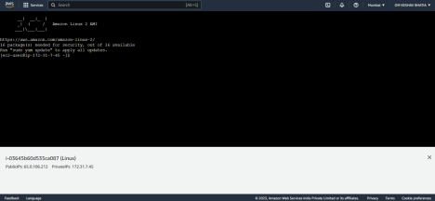

# Conclusion:

Thus, we learned about one of the major services of cloud computing i.e., Infrastructure As A Service (IAAS). And we also saw how to create and run virtual machines on Cloud Platforms such as Amazon AWS.