Experiment - 3

# Aim:

To study and Implement Platform as a Service using AWS Elastic Beanstalk Pre-Requisites: Amazon AWS Account

# Theory:

PAAS – PaaS, or Platform as a Service, is a type of cloud computing that provides a platform for customers to develop, run, and manage applications and services over the internet, without having to worry about the infrastructure and maintenance. Think of PaaS as a playground for developers where they can build and launch their applications without having to worry about the underlying technology or infrastructure. PaaS provides the necessary tools and resources for developers, such as storage, computing power, and networking, so they can focus solely on writing code and building their applications. For example, if you're a developer who wants to build a new mobile app, you can use a PaaS solution to easily develop, test, and launch the app without having to worry about setting up and maintaining the servers, storage, and network infrastructure. You simply write the code and let the PaaS handle the rest. In short, PaaS is like a building block for developers that enables them to build, deploy, and manage their applications quickly and efficiently, without having to worry about the technicalities of the underlying infrastructure.

# Implementation

*Procedure To Create a Virtual Machine on Amazon AWS:*

*i. Go to Amazon AWS Website*

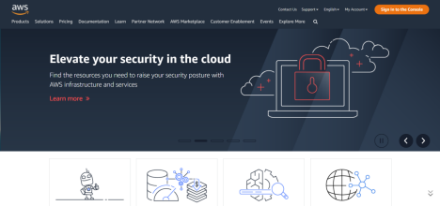

*ii. Login into your AWS account.*

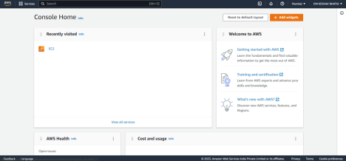

*iii. Search For Elastic Beanstalk Service*

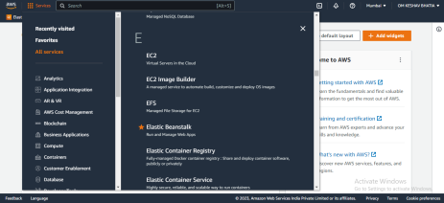

*iv. Click On Create Application*

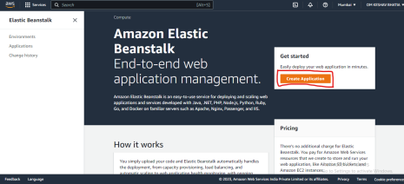

*v. Provide Name for Your Web Application:*

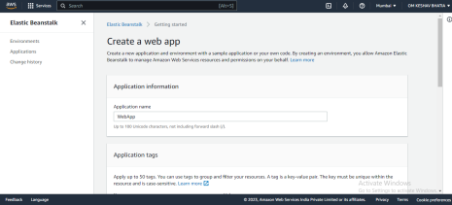

*vi. Select the platform configuration as per your need:*

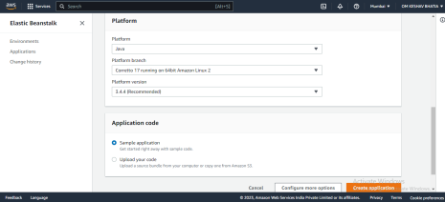

*vii. Select Sample code or upload your code as per your choice and then click on create an application.*

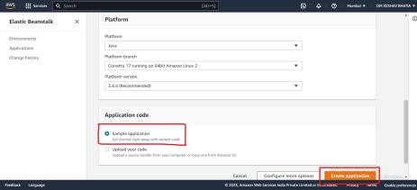

*Note: If You select Upload Your Code you need to upload a code file for the web application*

*viii. Wait Until the Environment is Created*

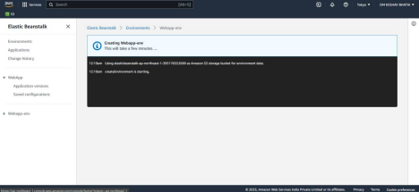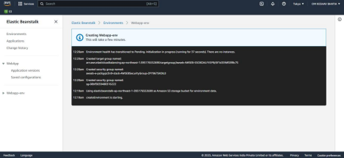

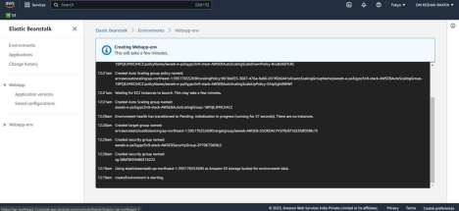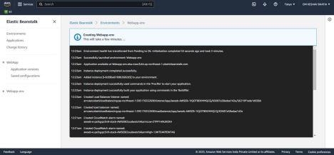

*ix. Once the Environment is created you can check its status. Click on environments on the extreme left*

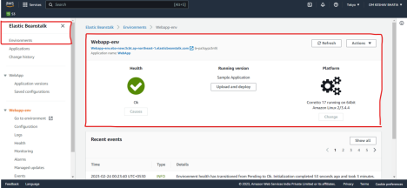

*x. Click on the below link to deploy the web application*

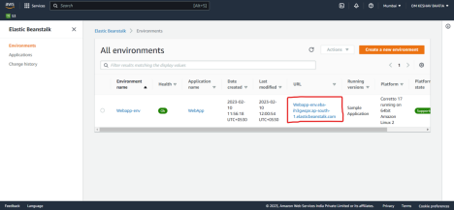

*Output:*

**

# Conclusion:

Thus, we learned about one of the major services of cloud computing i.e., Infrastructure As A Service (PAAS). And we also saw how to create and deploy Web – Applications / Websites on Cloud Platforms such as Amazon AWS