Experiment 4:

# Aim

To study and Implement Storage as a Service using Own Cloud/ AWS S3

# Theory

Storage as a Service (SaaS) is a cloud computing model that provides users with storage infrastructure and related services over the Internet. Amazon Web Services (AWS) provides a range of SaaS options for storage, including:

* Amazon S3 (Simple Storage Service): A highly scalable object storage service that is designed to store and retrieve any amount of data from anywhere on the web.
* Amazon EBS (Elastic Block Store): A high-performance block storage service that is designed for use with Amazon EC2 instances.
* Amazon Glacier: A secure, durable, and extremely low-cost storage service for data archiving and long-term backup.
* Amazon EFS (Elastic File System): A fully-managed file storage service that is designed to be highly available and scalable.
* AWS Storage Gateway: A hybrid cloud storage service that enables users to seamlessly connect their on-premises environments to AWS storage services.

Each of these services is designed to meet specific storage needs, and they can be used individually or in combination to create a custom storage solution that best fits your organization's needs. Additionally, AWS provides a range of tools and services to help you manage your storage resources, including monitoring, analytics, and security feature

# 

# Implementation

*Step 1: In AWS, Services ;Storage ; S3*

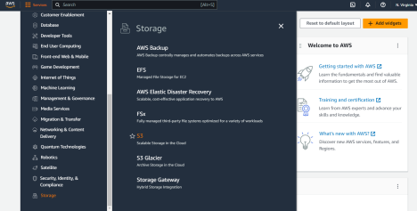

*Step 2: click on create bucket*

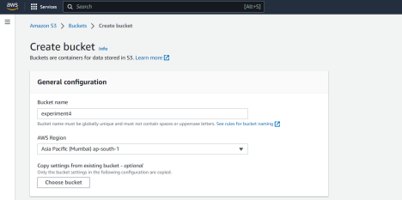

*Step 3: Adding Bucket name and choosing AWS Region*

*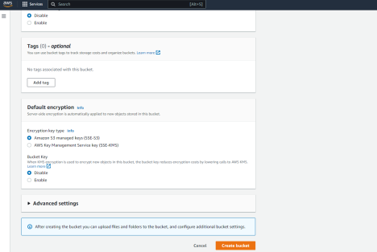Step 4: Enable Bucket Versioning*

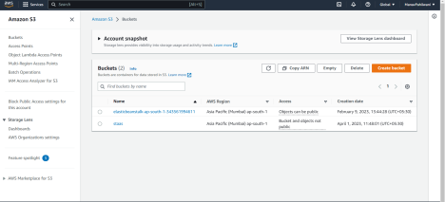

# 

# Conclusion

In conclusion, AWS provides a wide range of Storage as a Service (SaaS) options to help organizations manage their storage needs. From highly scalable object storage with Amazon S3 to secure and low-cost data archiving with Amazon Glacier, AWS provides a flexible and customizable solution to meet various storage requirements.