Experiment 5

# Aim:

To study and ImplementDatabase as a Service on SQL/NoSQL databases like AWS RDS, AZURE SQL/ MongoDB Lab/ Firebase.

# Theory :-

***Database As A Service:***

Database as a service (DBaaS) is a cloud computing managed service offering that provides access to a database without requiring the setup of physical hardware, the installation of software, or the need to configure the database. Most maintenance and administrative tasks are handled by the service provider, freeing up users to quickly benefit from using the database.

DBaaS uses The DBaaS model is ideal for small to medium-sized businesses that do not have well-staffed IT departments. Offloading the service and maintenance of the database to the DBaaS provider enables small to medium-sized businesses to implement applications and systems that they otherwise could not afford to build and support on-premises. Workloads involving data with stringent regulatory requirements may not be suitable for a DBaaS model.

Furthermore, mission-critical applications that require optimal performance and 99.999% of uptime may be better suited for on-premises implementation. This is not to say that mission critical workloads cannot run on cloud services, but much of the DBaaS adoption to date has been for less crucial applications, such as development and pilot programs.

# 

# Implementation -

*DynamoDB*

*Step 1: Select Database in Services*

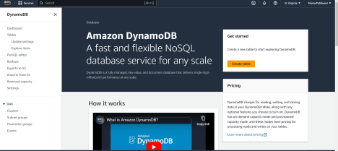

*Step 2: Go to DynamoDB*

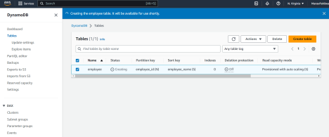

*Step 3: Click on create table*

*Give a name for the table*

*Select partition key and sort key*

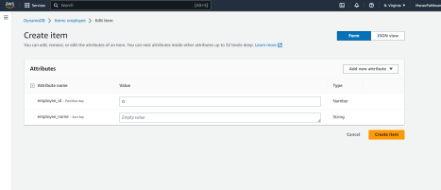

*Step 4: Click on create table*

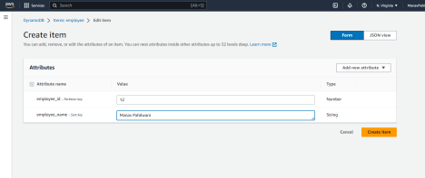

*Step 5: Go to actions and click on create an item*

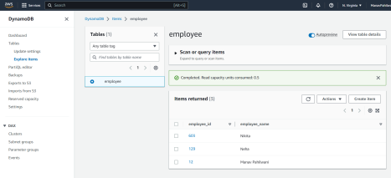

*Step 6: Go to scan and then filter*

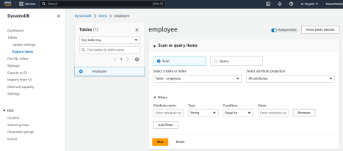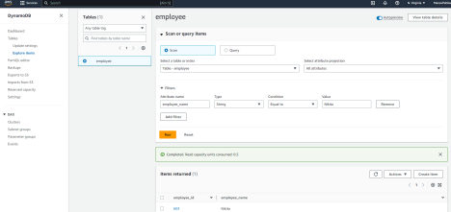

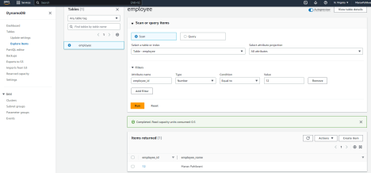

*Step 7: Delete the table*

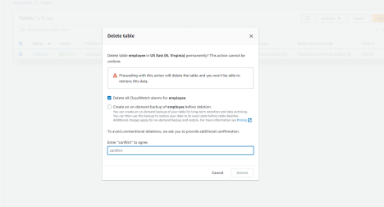

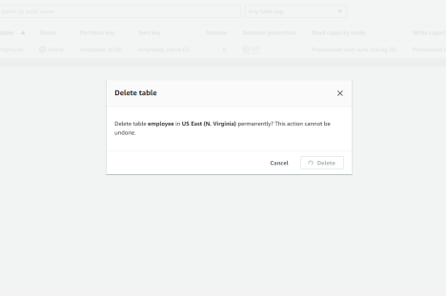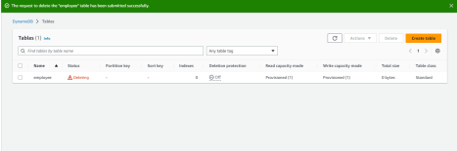

*RDS:*

*Step8: Nowagaingotoservices. ClickondatabaseandgotoRDS*

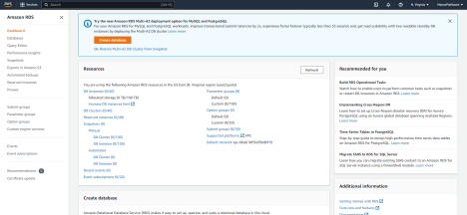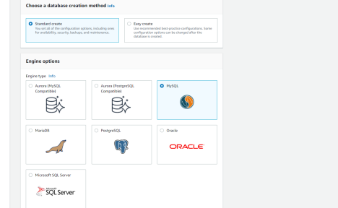

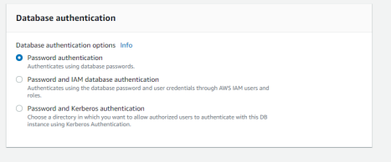

*Step9: Clickoncreateadatabase. Itmaytakesometimetocreateadatabase. After itgets createdclickon ittoseedetails.*

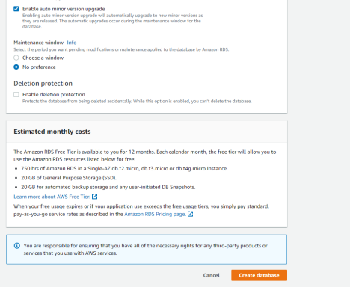

*Step 10: Click on vpc*

*Step 11: Delete the instance. It may take some time to delete the instance (database).*

# 

# 

# Conclusion -

Amazon Web Services (AWS) provides a wide range of Database as a Service (DBaaS) options to help organizations manage their database needs. AWS's managed database services include Amazon RDS (Relational Database Service) for relational databases such as MySQL, Oracle, and PostgreSQL; Amazon DynamoDB for NoSQL databases; and Amazon Redshift for data warehousing. These services are designed to be highly scalable, reliable, and cost-effective, and they offer a range of features for backup and recovery, monitoring, security, and performance optimization.