Experiment 9

Aim - To study container orchestration using Kubernetes

Theory -

Kubernetes is an open-source platform for container orchestration that is widely used for deploying, scaling, and managing containerized applications. It provides a range of features for automating the deployment and management of containerized applications, including load balancing, auto-scaling, and rolling updates.

One notable example of Kubernetes in action is its use by the popular online retailer, Etsy. Etsy is a marketplace for handmade and vintage items that is based in Brooklyn, New York. The company has been using Kubernetes since 2016 to manage its containerized infrastructure, which consists of over 5,000 containers running on over 2,000 nodes.

Before adopting Kubernetes, Etsy was using a combination of manual configuration management and custom scripts to manage its containerized infrastructure. This approach was time-consuming and error-prone, and made it difficult to scale and manage the company's rapidly growing infrastructure.

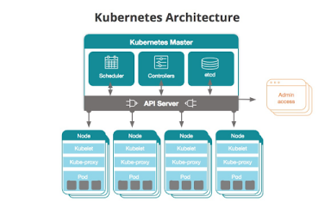

With Kubernetes, Etsy was able to automate much of its infrastructure management, including load balancing, service discovery, and rolling updates. This allowed the company to rapidly scale its infrastructure in response to changing demand, while also ensuring high availability and uptime for its customers.

In addition to its benefits for infrastructure management, Kubernetes also provided Etsy with a number of benefits for application development. By standardizing its container environment with Kubernetes, Etsy was able to improve the consistency and reliability of its applications, while also enabling developers to deploy and test new features more quickly and easily.

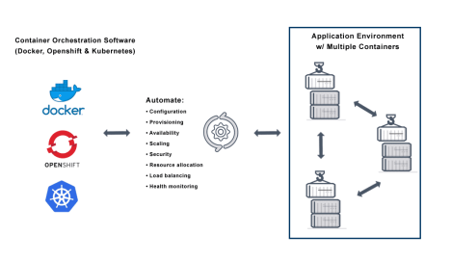

Overall, Kubernetes has been a critical component of Etsy's success, allowing the company to scale its infrastructure and applications rapidly and reliably. The platform's powerful orchestration capabilities, combined with its flexibility and ease of use, have made it a popular choice for organizations of all sizes looking to manage containerized applications at scale.

Conclusion

Kubernetes is a powerful platform for container orchestration that provides a range of features for automating the deployment and management of containerized applications. Its ability to automate infrastructure management tasks, such as load balancing and service discovery, allows organizations to rapidly scale their infrastructure in response to changing demand, while also ensuring high availability and uptime.