A Project Report on

**“Parametric design and analysis of Machine Elements using Python”**

*By*

Yash Ramchandra Sarda (C-298)

Prasad Suresh Jagdale (B-118)

Harshal Dattatray Sawant (C-244)

Ishan Anand Prabhune (B-111)

**Guided by**

***Dr. S.S. Mulik Sir***

**GROUP NO. 3**



Department of Mechanical Engineering

**Sinhgad Technical Education Society’s**

R.M.D. Sinhgad School of Engineering, Warje, Pune

Savitribai Phule Pune University, Pune.

[2020-21]

Sinhgad Technical Education Society’s

R.M.D. Sinhgad School of Engineering, Warje, Pune



Date : 26/05/2021

Place : Pune

**Dr. M. V. Nagarhalli** **Dr. V.V. Dixit**

Head of the Department Principal

**ACKNOWLEDGEMENT**

I take this opportunity here to thank all those who had helped us in making this seminar.

First of I express our deep gratitude to our project guide **Prof. Dr. S.S. Mulik Sir** for their valuable support, help & guidance from time to time during the project work. I am also grateful to our Head of Department, **Dr. M.V. Nagarhalli** for giving us this opportunity and to guide us throughout this journey.

Last but not the least, I would like to thank our entire teaching staff who assisted me directly or indirectly throughout the duration of this time period.

**Mr. Yash Ramchandra Sarda (71939582J)**

**Mr. Ishan Anand Prabhune (71939502L)**

**Mr. Prasad Suresh Jagdale (71939503J)**

**Mr. Harshal Dattatray Sawant (71939502L)**

***Parametric Design And Analysis Of Machine Elements Using Python***

**Abstract:**

The idea behind this project was to minimize the efforts and hard work of Engineers behind their designing process. As they are the one’s who are bringing automation all over the globe, and so with the flow we also decided to make the designing process automated, so an Engineer will only give the parameters or conditions like Power, Load, Tensile Stress of material, etc which he think best for situation and our program will give the safest calculation. We had implemented the 3 machine elements in our project for simplification and easy to understand to everyone.

**Introduction:**

As everything is moving towards Automation, we got idea to automate our design works, our design calculations to solve them with in just matter of time. With the help of Python programming language and some awesome tools we are trying to make the tired and time-consuming work of designing, easy and fast to finish within just some few seconds. We also had added functionality to plot the Shear Force and Bending Moment diagram or to save it as an image as user want which could be used to further analyze.

Our program will not only give the designed calculations but to ensure the design is safe for the given parameters it will also try to check its safety under various loads and if the design is not safe it will again design the elements for given parameters by increasing the FOS 0.5 until user doesn’t get the safest design.

We also wanted to know how do the CNC machine plots the code so accurately so we also tried to make a simple CNC code plotting Program which could be used for getting the error and solve them before going to the CNC machine.

Thus, reducing the error which occurs during machining the products. By our CNC plotting program user could also realize how to fix some issue and also will be able to experiment the different codes output.

We also had implemented small program to draw the 2D design in AutoCAD by connecting it to through an API (Application Programming Interface) where after designing shaft the AutoCAD will draw the simple 2D drawing of the Shaft with designed parameters thus helping user to analyze it practically as well.

**Problem Statement:**

To develop a software which will recursively design safest dimension for the selected elements for given parameters, load conditions and to plot the given CNC code for testing to see for any error.

**Objectives:**

* To save the time and efforts of Designing calculations.
* To reduce tired work of smart Engineers/Students so they could have time for their productivity.
* To automate the designing and drawing process in AutoCAD.
* To improve efficiency by designing the safest element.
* To see for and solve the error before going to CNC machine.

**Methodology:**

The main aim of our project is to design the safest dimension for given elements.

For it we have to gather all the design formulae and their failure condition of the following 3 elements.

* Cotter Pin
* Kunkle Pin
* Shaft

We had designed all our algorithm on basis of torsional theory and bending theory.

We had given how we had arranged the formulae and made our own algorithm so the computer can understand it and we also optimize the code so it would do the work even more quickly with less power and less time consuming.

We had to take consider of the failures of elements in different circumstances and we also made an algorithm for same so the program will design the safest possible dimensions.

**Design Procedure for Shaft:**

 For Shaft subjected to twisting Moment

**T     tau      G 0**

**---  = ---  =  -----****🡪 Torsional Theory**

**J     d/2       L**

        T = Twisting Moment   --- >> unit  N-mm

        Power  =  2 * π * N * T / 60

            where P = Power = Watt

                  N = Rpm

                  T = N-m

         In case of belt drives the twisting moment (T) is given by

                T = (T1-T2)*R

                where

                     T1 = Tension in tight side  --->> unit Newton

                     T2 = Tension in slack side  --->> unit Newton

                     R = Radius of the Pulley  --->> unit meter

tau  = Shear stress  ---->> unit N / mm^2

        r = Distance From Neutral Axis to the outer mo Syt fibre.

        J = Polar Moment of Inertia

        For Solid Shaft    J = π/32 * d^4 --->> unit mm^4

        For Hollow Shaft    J = π/32 * ( D^4 - d^4 )

Thus

            For solid shaft       T = π/16 * tau * d^3

                                &

For Hollow Shaft       T = π/16 * tau * D^3 * (1 - k^4)

            where k = d / D (ratio of inner dia to outer dia)

       therefore

            For solid Shaft d = cuberoot ((T * 16) / (tau*π))

                                &

        For Hollow Shaft D = cuberoot ((T * 16) / (tau * π * (1 - k^4))

 For Bending Moment

         M     sigma B

        ---  = -------

         I        y

         M = Bending Moment        --->> unit N-m

            For Solid Shaft     M = π/32 * sigma B * d^3

            For Hollow Shaft    M = π/32 * sigma B * D^3 (1 - k^4)

            where k = d/D

         I = Moment Of Inertia     --->> unit mm^4

            For Solid Shaft     I = π/64 * d^4

            For Hollow Shaft    I = π/64 * (D^4 - d^4)

        sigma B = Bending stress    --->> unit N/mm^2

            sigma B = (32 * M) / (π * d^3)

            tau = (16 * T) / (π * d^3)

        y = Distance from neutral axis to the outer mo Syt fibre

            y = d/2     --->> unit mm

    If Numerical requires both twisting and bending moment following will be  the procedure

     tau max = 0.5 * sqrt (sigma B^2 + 4 * tau^2

        By Simplifying

 tau max = 16 * sqrt[ M^2 + T^2 ] / ( π * d^3 )

The Twisting Moment due to maximum Syt shear Stress on surface of

Shaft is known as equivalent Twisting moment i.e., Te

        Te = sqrt[ M^2 + T^2 ]

   i.e.  Te = π/16 * tau max * d^3 . . . eqn

Te = Equivalent Twisting Moment

Me = Equivalent Bending Moment

Me = 0.5 * [ M^2 + Te^2]

Calculating by   **T       G 0**

**---  =  -----**

**J      L**

     T J= ((Te*16)/(tau*pi) ... eqn

As We know

        Tmax = π /16 * tau * (D^4 - d^4)/D

        (D^4 - d^4)/D = (Tmax*16) / (π * tau) ... eqn 1

    i.e., T J = (D^4 - d^4)/D

From this eqn J = (Te * L) / (G * 0)

J = π /32 *(D^4 - d^4)

thus--->    (D^4 - d^4) = J * 32 / pi ... eqn 2

Let consider d1 d2 = J * 32 /pi 

           Therefore d1 d2 = D^4 - d^4

           And T J = (D^4 - d^4)/D

             i.e.

             d1 d2 / D = T J

             i.e.

             D = d1 d2 / T J

The max() is a function which takes maximum from given two values

Twisting OD = d1 d2 / T J

Twisting ID =  max((Twisting OD ^4 - J) ^ 0.25), Twisting OD*k)

            (D^4 - d^4)/D = T J

            and from eqn 3 we get (D^4 - d^4) thus solved....

            Id g0 = (D**4 - J) ** (1/4)

         solving by T/J = tau/r

D T = (Te*16)/((tau*pi)*(1-(k**4)))

      Bending OD= D T**(1/3)

      Bending ID = Bending OD*k

From solving by all Above formulae we get the safe Dimension of Shaft

for given Parameter

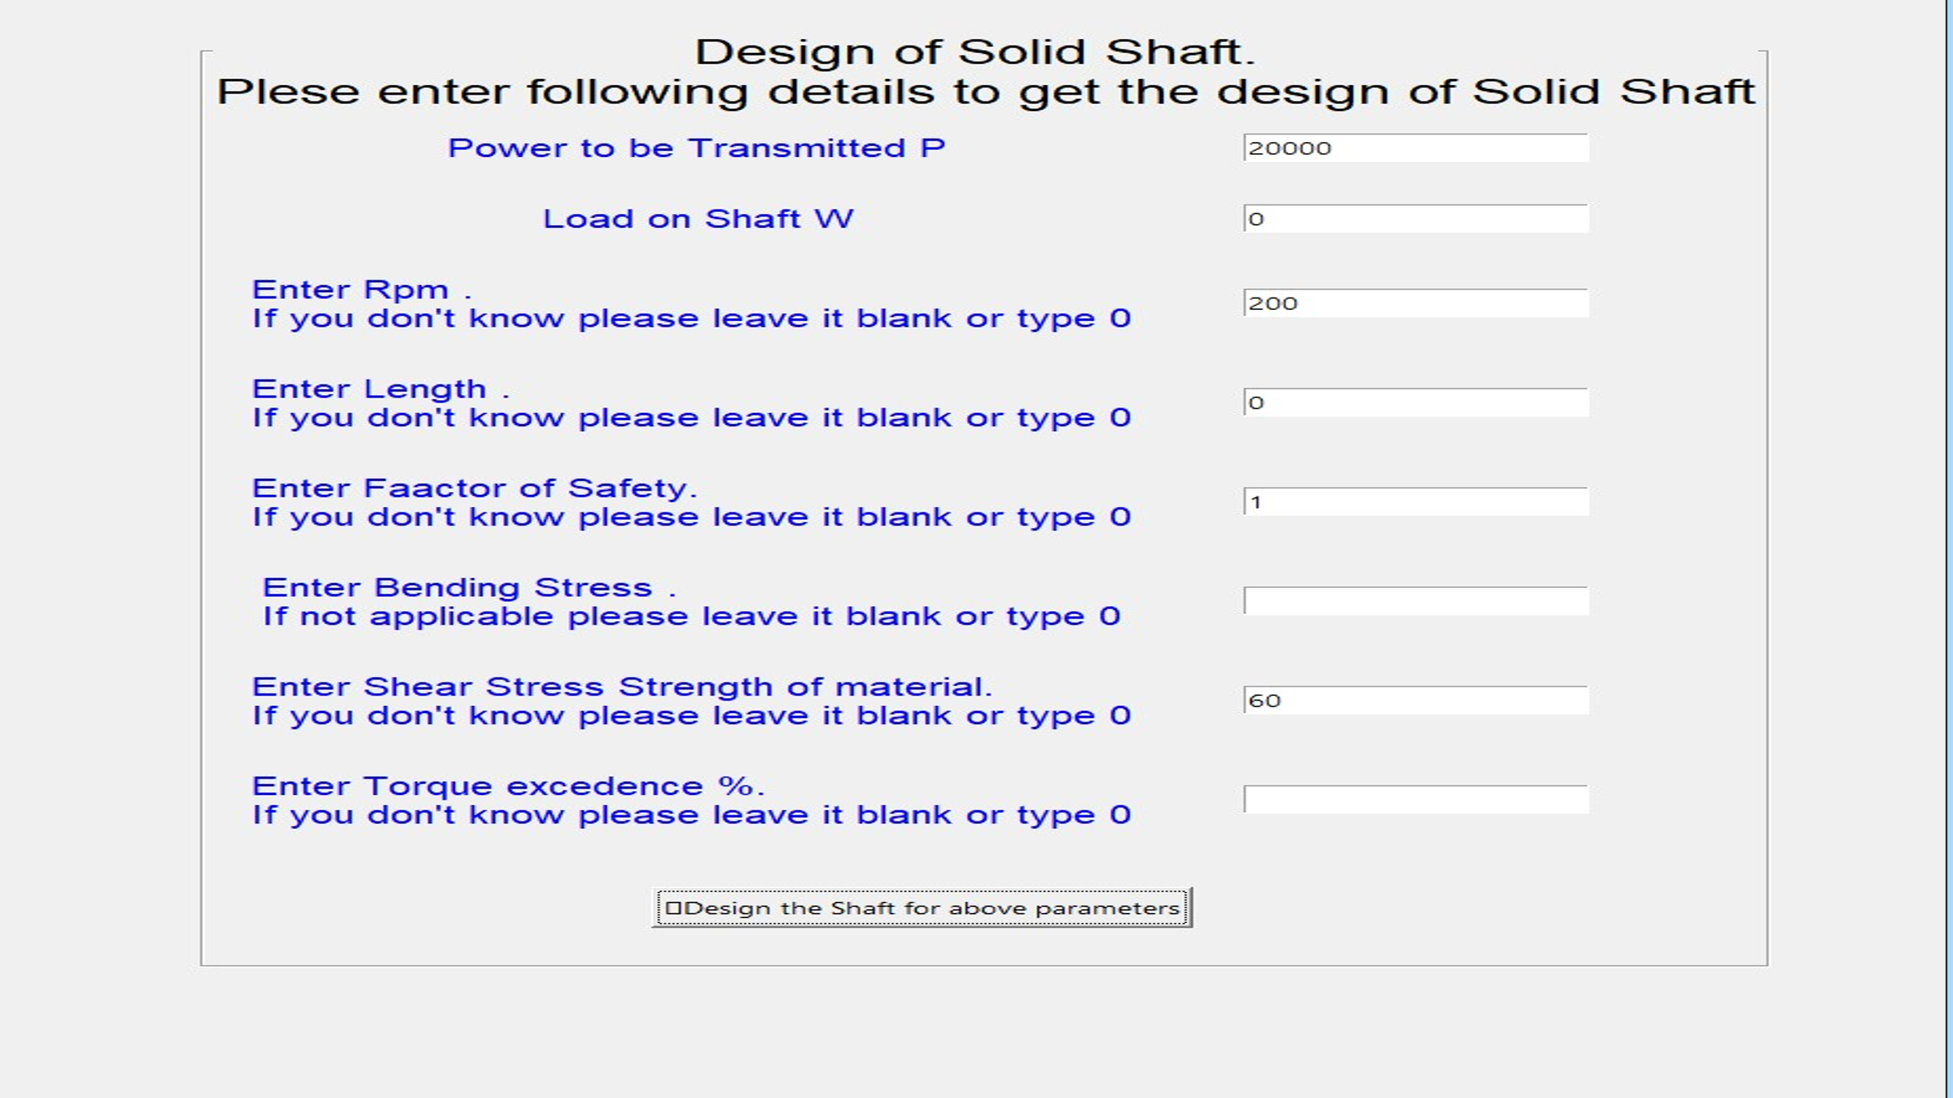**Solid Shaft Problem**

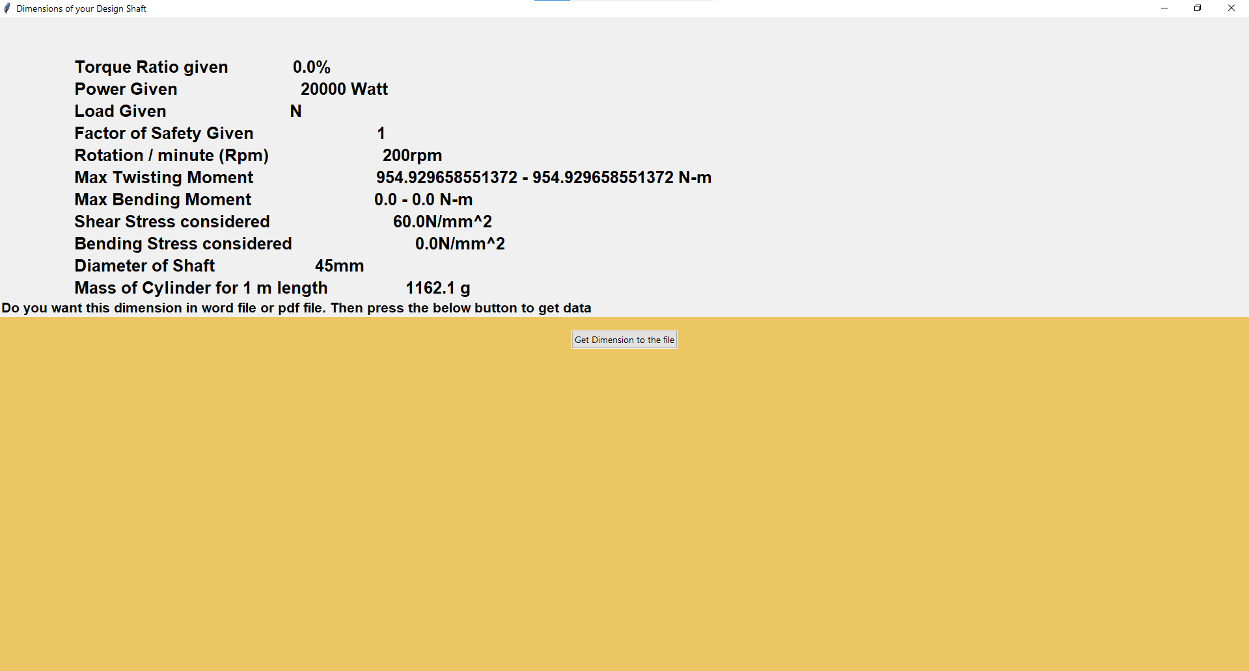**And It’s solution**

**Design Procedure for Knuckle Pin:**

P = Power to Be Transmitted

Syt = Shear Strength of Material

Syc = Compression Strength of Material

tau = Shear Stress of material

## Diameter of rod

     = Syt*π/4 #a1 => area affecting

    Diameter of Rod () =

    ## Diameter of Knuckle Pin

     = 2*π*tau/4 #a2 => area affecting

    Diameter of pin (*Dp*)= max (**,**)

    ## Thickness of Single Eye

    t1 = max(1.25* , P/(Syc\**Dp*))

    ## Thickness of Fork

    t = max(0.75* , P/(Syc*Dp*2))

    ## Diameter

    a5 = P/(tau*t)

    D = max (a5+*Dp* , 2*)

    ## Analysis of Fork end in Tension failure

    a6 = 2*t*(D-*Dp*)

     Syt1 = P / a6

    ## Analysis of Fork end in shear

    a7 = 2*t*(D-*Dp*)

    tau1 = P / a7

If Syt1 < Syt and tau1 < tau then design is safe for the given parameters

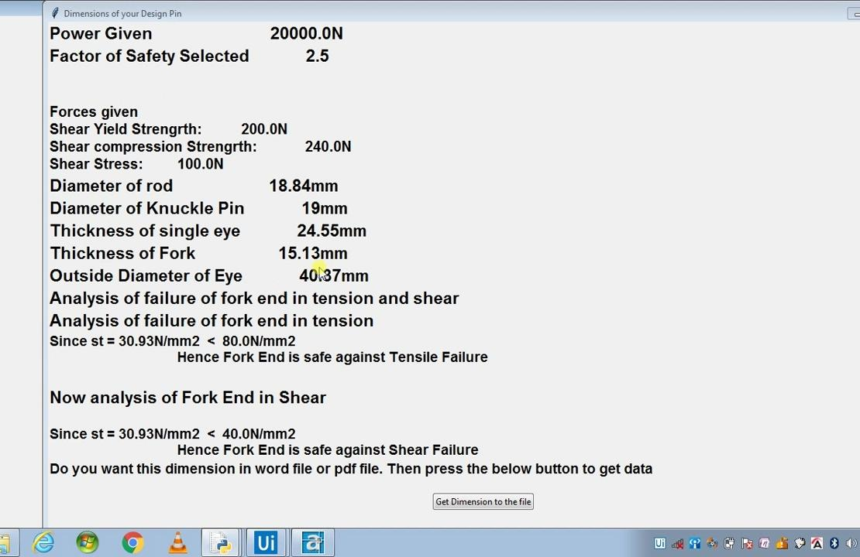

**Design of Knuckle Pin problem**

**Design of Cotter Pin:**

Design of rod under tension:

        Diameter of rod (d) = sqrt (P * p4 / Syt)

Design of spigot end tensile:

        d2 = sqrt(P/(p4-0.25) * Syt))

        t = (d2/4)

Design of spigot considering crushing:

        d2 = sqrt (P * 4 / Syc)

        t = d2 / 4

Shearing failure of spigot:

        a = (P/(tau*d2*2))

Crushing of spigot end:

        Syc1 = P / (d2*t)

        If the Syc1 < Syc then design is safe up to this point

Design of spigot collar:

        t1 = (P/(tau*pi*d2))

Design of socket under tension:

        A = P/ Syt

        o = A+(p4*(d2**2) - (d2*t))

Solving the Quadratic Eqn we get the D

       D1 = solve quadra (p4, -1*t, -o)

d1 = D1^0.25

Design of socket in crushing failure:

        d4 = P / ((Syc * t) + d2)

Design of socket in shearing failure:

        c = (P/(2*tau*(d4-d2)))

Design of cotter considering shearing failure:

        b = (P/(tau*2*t))

        Length of Pin (L) = (4*d)

        e = (1.2*d)

Bending of cotter:

        z = (t*(b**2))/6

        Moment of inertia (M) = (P / 2) * ((d4/6) + (d2/12))

        sb =  (M/z)

If sb > Syc then design is unsafe up to this point

**CNC Programming:**

We had developed a small program of plotting the diagram of CNC machine code. In this we had implemented Absolute Programming Method.

**Absolute Programming Method:**

In Absolute Programming Method each **point or location on the workpiece is set at a certain distance from the zero or reference point. All of coordinates and movements values are consider from Origin (0,0).**

**Means in our Program the each and every input point or coordinates mu Syt be given as reference from the origin only.**

**We implemented this because we thought in determining each and every point with reference to same fix point (in our case it’s origin (0,0)), it will be easy for user to determine each point.**

**Input in Our Program:**

Let draw a square of 200 x 200 unit in our program.

The input mu Syt be in following format.

Xpx Ypy

Where px = point refer to X axis

py = point refer to Y axis

X & Y => for referring which axis the points are referring.

We could also give input as 🡪 Yp Xc

Where p = point refer to Y axis

And c = point refer to x axis.

So code to draw rectangle will be

X200 Y0 🡪 drawing the base of rectangle

X200 Y200 🡪 the right most side of rectangle

X0 Y200 🡪 Drawing the top line of rectangle.

X0 Y0 🡪 Again coming to origin to close the rectangle.

**Circle:**

Let’s add the circle in our centre of our rectangle which have diameter of

100 unit.

To add circle user must specify the centre of the circle and then radius in following way.

X100 Y100 R50

In above line X100 Y100is centre point of our rectangle as

200/2 = 100 & 200/2 =100.

R50 represents radius of circle which 100/2 = 50 as the diameter was 100.

So, in this way we could add a circle to our Rectangle.

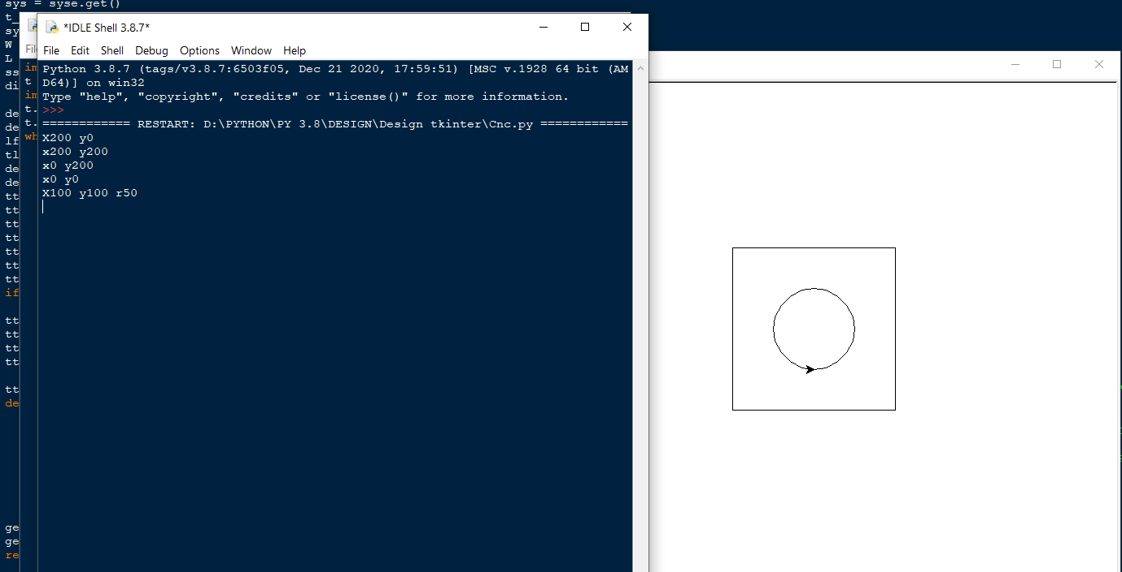

**Advantages:**

Our program has better efficiency to calculate the safe dimension fastly and better productivity to design the specified elements with calculated dimension.

* Easy to use.
* Easy to implement.
* Save time.
* Quick and correct analysis.
* Wide range of applications.
* Program is portable.
* No need of training.
* No cost or power consuming.
* Easy to detect errors.

**Applications:**

* Could be use by Professor’s to explain students about parametric design.
* Could be use by students to experiment and also to verify or do their calculations.
* Could be use in industry in small scale for designing the small elements and if the software is upgraded it could be used for all design elements.
* Our CNC plotting could be used in industry before going to actual CNC machine thus reducing the errors and also waste.

**Conclusion:**

In this semester we have successfully developed the software for parametric design and analysis of machine elements. We also developed the small program for CNC code plotting.

We had connected to AutoCAD through an API by which we could draw the 2D drawing of the designed dimension just within few seconds.

**References:**

* + [www.python.org/docs.com](http://www.python.org/docs.com):

For solving the and learning about Python errors.

* + [www.github.com](http://www.github.com/)

To manage our Project code

* + <https://pypi.org/project/pyautocad>

As manual for using pyautocad API

* + [https://pyautocad.readthedocs.io](https://pyautocad.readthedocs.io/)

For referring to different failures of pyautocad api and designing 2D elements in AutoCAD

* + <https://www.youtube.com>

For referencing the different errors and their solutions occurred while calculating the dimensions