Dear Sir/Ma’am,

This is to inform you that we have successfully received the following three datasets from **Sprocket Central Pty Ltd:**

* *Customer Demographic*
* *Customer Addresses*
* *Transactions data*

However, before beginning with the analysis phase, we went through the process of examining the quality of the datasets received as a part of our standard procedures, and we found a list of issues that need to be resolved before proceeding further.

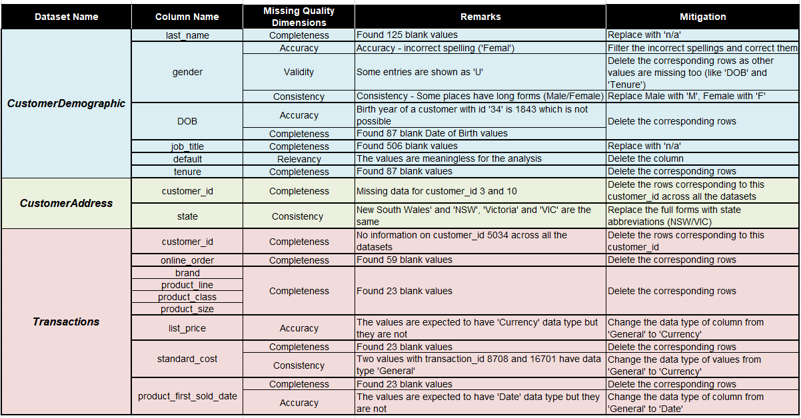Kindly note that these issues have been elaborated in the table below along with the solutions to mitigate them to enhance the quality of the subsequent dataset.

We urge you to work through these changes and ensure consistent quality across all the datasets following which we can proceed with in-depth analysis for deriving meaningful insights.

Regards,

Yash Shah.

KPMG