ACROPOLIS INSTITUTE OF TECHNOLOGY AND
RESEARCH
Department of IT, CSE (DS), CSE (IoT)
Synopsis
on
AegisAI : Foresight through Fortification.

- Introduction
  - Overview
The Aegis AI project is conceived as a cutting-edge, intelligence-driven solution aimed at drastically improving the safety of women in public, urban, and semi-urban environments. It is a proactive, real-time security analytics system built upon state-of-the-art Artificial Intelligence (AI) and Computer Vision (CV) technologies. Moving beyond the passive nature of traditional Closed-Circuit Television (CCTV) surveillance, Aegis AI utilizes advanced Machine Learning (ML) models to continuously monitor live video feeds. Its core function is the early detection and prediction of potential safety threats by analysing contextual factors, behavioural anomalies, and environmental cues. The system is designed not just to record crime, but to pre-emptively alert law enforcement, enabling intervention before an incident can fully unfold.
  - Purpose
The primary purpose is to establish a secure and fortified environment for women by bridging the technological gap in immediate, preventive security. Specifically, Aegis AI aims to:
- Enhance Proactive Security: Shift the paradigm from reactive investigation to predictive prevention by identifying subtle indicators of potential danger.
- Expedite Law Enforcement Response: Provide crucial, location-specific intelligence and visual evidence instantaneously to police and security personnel, drastically reducing response times.
- Offer Data-Driven Strategic Insights: Generate continuous, quantifiable data on high-risk locations, times of vulnerability, and gender distribution patterns, allowing city planners and security agencies to allocate resources more effectively and plan safer infrastructure.
- Restore Public Confidence: Through visible and effective protection, the system seeks to build trust in public spaces and encourage the free movement of women at all hours.

- Literature Survey
  - Existing Problem
Current literature and real-world application reveal significant limitations in existing security measures, justifying the need for Aegis AI:
- Reactive Nature of CCTV: Standard surveillance systems are predominantly used for forensic analysis following an event. They lack the intelligence to interpret live events and cannot autonomously trigger warnings in time to save a victim.
- Inefficiency of Manual Surveillance: Relying on human guards for real-time threat detection across vast urban areas is inefficient, costly, and unreliable. Human attention span and cognitive processing are insufficient to monitor dozens of video feeds simultaneously for subtle anomalies.
- Limitations of Personal Alert Systems: Emergency apps require the victim to be conscious and capable of activating the alert, which is often not feasible during an assault or threat. They are inherently reactive and dependent on the individual's action.
- Lack of Contextual Understanding: Existing basic motion detection or object recognition systems are generic and cannot distinguish between a friendly greeting and an aggressive gesture, leading to high rates of false positives and a lack of specific threat identification relevant to gender-based violence.
  - Proposed Solution
Aegis AI proposes a solution centred on deep learning for behavioural and contextual analysis. The system will leverage state-of-the-art neural networks to achieve the following:
    - Gender and Identity Classification: Accurately identify and track individuals, classifying them by gender to monitor gender ratio imbalances (a unique threat indicator).
    - Unusual Gesture and Action Recognition: Utilize 3D Convolutional Neural Networks (3D CNNs) or similar models to recognize dynamic actions, such as 'chasing,' 'grabbing,' 'aggression,' or 'distress gestures' that precede an incident.
    - Spatial and Temporal Anomaly Detection: Identify unusual clustering (e.g., loitering), high-risk locations (e.g., dimly lit areas, deserted spots), and high-risk timings (e.g., late night hours) to contextualize activity as a potential threat.
    - Confidence Scoring: Assign a dynamic Threat Score to flagged situations. Alerts are generated only when the score exceeds a set threshold, minimizing false positives while ensuring timely warnings.

- Theoretical Analysis
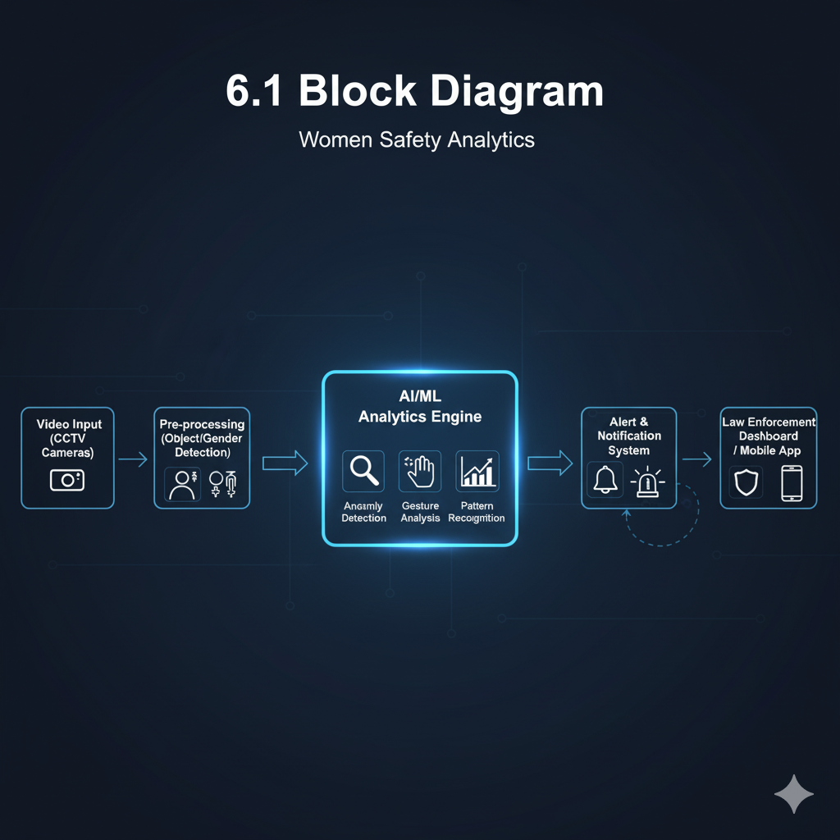
  - Block Diagram
Fig.1. Block Diagram
  - Hardware/Software Designing
3.2.1 Hardware Requirements:
The system demands high computational power and reliable infrastructure:
- High-Resolution IP Cameras (H.265 enabled): Required for clear image fidelity, essential for accurate gesture recognition and classification tasks.
- Central Processing Unit (CPU) & Graphics Processing Unit (GPU): High-core CPU for system management and pre-processing; multiple High-Performance GPUs (e.g., NVIDIA Tesla or comparable cards) are critical for accelerating ML model inference on multiple concurrent video streams.
- High-Speed RAM & Storage: Sufficient DDR4/DDR5 RAM for caching video frames; NVMe SSDs are necessary for fast data loading and storage of real-time logs and short-term video buffers.
- Network Infrastructure: High-throughput network switches and dedicated bandwidth to handle the continuous influx of high-definition video data without latency.
- Cloud/Edge Infrastructure: Scalable cloud computing resources (e.g., AWS EC2, Azure VMs) or high-performance Edge Computing devices near camera clusters for localized processing and reduced latency.
3.2.2 Software Requirements:
The system requires a robust and open-source-friendly software stack:
- Operating System (OS): Linux (e.g., Ubuntu LTS) is preferred due to its superior stability, open-source compatibility, and optimized support for GPU drivers (CUDA/cuDNN).
- Programming Languages: Python (primary language for ML, data processing, and backend) and potentially C++ (for optimizing high-performance modules like video stream decoding and custom processing kernels).
- Machine Learning Frameworks: TensorFlow or PyTorch for model training and deployment. Specific libraries like OpenCV and Dlib will be essential for foundational computer vision tasks.
- Database Management System (DBMS): PostgreSQL (SQL) for structured data like incident reports and user authentication, and potentially MongoDB (NoSQL) for unstructured data like system logs and metadata from video processing.
- Deployment & Containerization: Docker and Kubernetes for managing and scaling the microservices architecture, ensuring high availability and fault tolerance.
- Applications
The flexibility and scalability of Aegis AI allow for deployment across a broad spectrum of environments where public safety is paramount:
- Public Transit Systems: Monitoring subway platforms, bus stops, and train carriages to ensure safety during commute hours.
- Educational Institutions: Protecting students on university campuses, particularly in parking lots, libraries, and deserted paths at night.
- Urban Parks and Recreational Areas: Providing continuous surveillance in open, often sparsely populated areas.
- Commercial & Retail Centers: Enhancing security in shopping mall parking garages and secluded corridors.
- Smart City Integration: Serving as a crucial layer of intelligence within a broader city surveillance network, contributing to city-wide crime forecasting maps.

REFERENCES
- Kalshetty, Y. R., et al. (2024). "Women Safety Analytics – Protecting Women from Safety Threats." International Journal of Innovative Research in Technology (IJIRT).
- Raji, I., & Sholademi, D. B. (2023). "Predictive Policing: The Role of AI in Crime Prevention." International Journal of Computer Applications in Technology (IJCAT).
- Adams, A., & D' Silva, E. M. (2025). "Technology-Enabled Gender-Based Violence Solutions: The Story of Red Dot Foundation and Safecity." Routledge.
- Rigano, C. (2019). "Using Artificial Intelligence to Address Criminal Justice Needs." NIJ Journal 280, National Institute of Justice

Guided By: Group Members:

Prof. Mahendra Verma Om Patil (0827IT221102)

Riddhi Pathak (0827IT221120)

Saloni Jain (0827IT221128)

Sarthak Kacholiya (0827IT221132)

