ACROPOLIS INSTITUTE OF TECHNOLOGY AND RESEARCH
Department of Information Technology
Synopsis
On

SENECT

Introduction

1.1 Overview
The SENECT is a website designed to foster meaningful connections between alumni and students at a university. It aims to provide a centralized platform for university students to connect with their alumni and seek any sort of professional support, also allowing the alumni to create communities and host events, enhancing the overall student experience.

1.2 Purpose

The primary objectives of the app are:

To facilitate effective mentorship relationships between alumni and students.

To offer a comprehensive platform for academic and career resources.

To create a vibrant community where users can connect, collaborate, and learn from each other.

To enhance student engagement and overall university experience.

Literature Survey
Sr. No | Name of Solution/System | Features | Limitations/  Drawbacks
1. | My Alumni Network | Stay updated about events and reunions, and discuss and share updates with fellow alumni | Proper alumni connecting facilities are not available like for one-to-one communication
2. | Alma Connect | Alumni networking app helping you connect with alumni | No feature of accessing the LinkedIn profile of alumni
3. | UniConnect | App for universities, offering key features such as Career Connect, Notice Board, AI assistant, Mentorship. | Not targeting the customers whose sole purpose is to get mentorship or guided by seniors.

2.1 Existing Problem
- Limited Access to Mentorship: Many students struggle to find suitable mentors or have limited opportunities for personalized guidance.
- Lack of Centralized Resources: Students often face difficulties in accessing academic materials, career advice, and networking opportunities.
- Isolation and Lack of Community: Students may feel disconnected from their peers and miss out on valuable social interactions.
- No platform to connect Student & Alumni particularly: There is no particular platform for students to connect to their Alumni.

2.2 Proposed Solution
- Mentorship Programs: Numerous studies have demonstrated the positive impact of mentorship on student success, academic performance, and career development. For instance, research has shown that mentored students are more likely to persist in their studies, achieve higher grades, and secure better job placements.
- Online Communities: Studies have highlighted the benefits of online platforms in fostering social connections, knowledge sharing, and community building. For example, studies have found that online communities can provide a sense of belonging, support, and motivation for students.
- Career Development Tools: Research has explored the effectiveness of online tools in providing career guidance, job search assistance, and professional development. For instance, studies have shown that online platforms can help students develop their career goals, identify job opportunities, and improve their interview skills.

- Theoretical Analysis

1. Social Network Theory
The SENECT app draws inspiration from social network theory, which emphasizes the importance of social connections and relationships in shaping individuals' behaviour and outcomes. By creating a platform for students to interact, collaborate, and build relationships, the app can leverage the power of social networks to enhance student engagement, support, and academic success.

  - Technology Adoption Model (TAM)
TAM provides a framework for understanding the factors that influence individuals' adoption of new technologies. The app can be designed to align with TAM principles by:
- Perceived Usefulness: Demonstrating how the platform can benefit students by providing valuable resources, improving academic performance, and facilitating career development.
- Perceived Ease of Use: Ensuring a user-friendly interface and intuitive navigation to minimize barriers to adoption.
- Social Influence: Encouraging students to join the platform by highlighting the positive experiences of others and the benefits of being part of a supportive community.

  - Block Diagram
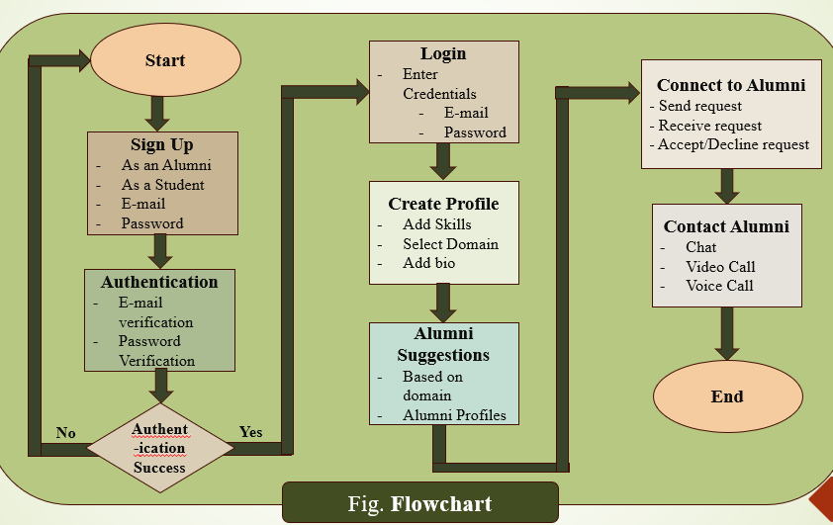

3.2 Hardware Requirements
- High-performance server for efficient data processing and handling.
- Reliable internet connection for seamless user experience.
- Sufficient storage capacity for data storage and backups.
- Processor: Quad-Core CPU (e.g., Intel Xeon or AMD Ryzen)
- Memory: 8 GB RAM (or more)
- Storage: 256 GB SSD (or more)

  - Software Components
- Front-end development: HTML, CSS, JavaScript.
- Back-end development: Node.js with Express.js or a similar framework.
- Database: Firebase for efficient data storage and retrieval.

- Applications
The SENECT website can be applied to various university settings, including:
- Undergraduate students: Providing mentorship, academic support, and career guidance.
- Graduate students: Facilitating research collaborations and professional networking.
- International students: Offering cultural exchange, language support, and academic adjustment assistance.

REFERENCES
- LinkedIn
- “The Impact of Mentorship on Student Success" by J. M. Jenkins and A. M. Johnson (Journal of Educational Research, 2017)
- “Online Communities and Social Media" by A. M. O’Reilly and P. M. Leonardi (Stanford University Press, 2016)
- Designing Effective Mentorship Programs" by J. M. Jenkins et al. (Proceedings of the ACM Conference on Human Factors in Computing Systems, 2019)

Guided By: Group Members:

Prof. Kapil Sahu 1. Saloni Jain (0827IT221128)

2. Riddhi Pathak (0827IT221120)

3. Sakshi Pandya (0827IT221127)

4. Shivani Bafna (0827IT233D09)

