Project Title: LogOps AI: Automated DevOps Incident Resolution System using Retrieval-Augmented Generation (RAG)
Domain: Generative AI, DevOps/SRE, Cloud Infrastructure
Student Name: Yash Shedge
Date: January 2026

1. Abstract
In modern cloud environments, server logs are generated at a velocity and volume that exceed human capacity for manual review. "Alert Fatigue" often leads to critical errors being missed or resolved incorrectly.
LogOps AI is an intelligent Site Reliability Engineering (SRE) assistant designed to automate the detection, analysis, and resolution of server incidents. Unlike standard log parsers, this system utilizes a Retrieval-Augmented Generation (RAG) pipeline to ground its AI-generated solutions in verified company Standard Operating Procedures (SOPs). By combining real-time log ingestion with a local Large Language Model (Llama 3), LogOps AI ensures that infrastructure fixes are instant, accurate, and compliant with security policies, without exposing sensitive data to external APIs.

2. Problem Statement
- Volume: Production servers generate millions of log lines daily; finding the "needle in the haystack" (critical errors) is time-consuming.
- Knowledge Gaps: Junior engineers often lack the specific domain knowledge to fix complex errors, leading to "trial and error" debugging which can cause downtime.
- Security Risks: Using public AI tools (like ChatGPT) to debug server logs poses a severe security risk, as logs often contain sensitive PII (Personally Identifiable Information) or IP addresses.
- Hallucinations: General-purpose LLMs often invent dangerous commands (e.g., "delete database") when they lack context about a specific company's environment.

3. Proposed Solution
LogOps AI addresses these challenges through a three-pillared approach:
- Real-Time Monitoring: A producer-consumer pipeline that watches log files instantly as they are written.
- RAG Architecture: Instead of relying on the AI's training data, the system retrieves the exact "fix" from a secured internal Knowledge Base (SOP Manual) before answering.
- Local Inference: All processing is done locally using Ollama (Llama 3), ensuring 100% data privacy.

- System Architecture

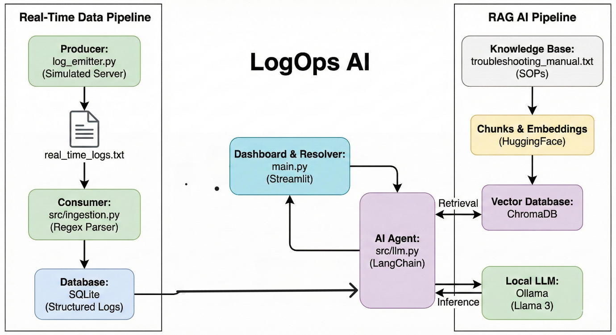

The system follows a modular architecture consisting of five core components:

4.1. The Log Producer (Simulation Layer)
- Component: log_emitter.py
- Function: Simulates a live production environment by generating a continuous stream of logs (INFO, WARNING, ERROR) to a file (real_time_logs.txt). This mimics tools like CloudWatch or Datadog agents.

4.2. The Ingestion Layer (Consumer)
- Component: src/ingestion.py
- Function: "Tails" the real-time log file. It utilizes Regular Expressions (Regex) to parse unstructured text lines into structured JSON objects (Timestamp, Service Name, Severity, Message) and filters out noise (non-error logs).

4.3. The Knowledge Base (RAG Brain)
- Component: src/rag.py & ChromaDB
- Function: Stores the company's "Troubleshooting Manual" as vector embeddings. It uses semantic search to retrieve the most relevant policy for a given error (e.g., matching "Connection Refused" to the "Database Restart Policy").

4.4. The Resolution Agent (LLM)
- Component: src/llm.py
- Function: Combines the retrieved SOP with the specific error log to construct a prompt. It uses the local Llama 3 model to generate a human-readable explanation and a copy-pasteable CLI command.

4.5. The Dashboard (Frontend)
- Component: main.py (Streamlit)
- Function: An interactive UI for SREs to monitor the "Pending Error" queue and trigger the AI resolution process.

5. Methodology

5.1. Data Pipeline & Pattern Matching
The system employs Regex for precise pattern recognition.
- Pattern Used: (\d{4}-\d{2}-\d{2}) \[(.*?)\] (\w+) (.*)
- This ensures that even if logs are messy, the system correctly identifies the Service (e.g., [payment-service]) and Severity (CRITICAL).

5.2. Retrieval-Augmented Generation (RAG)
To prevent hallucinations, the system uses a strict "Context-Aware" workflow:
- Query: User selects an error.
- Retrieve: System searches the Vector Database for the top 1 matching SOP document.
- Augment: The AI is instructed: "Use ONLY the following context to answer."
- Generate: The final output is produced in a structured JSON format containing the Root Cause, Fix Steps, and Code Snippet.

6. Technology Stack
Component | Technology Used
Programming Language | Python 3.10+
Frontend UI | Streamlit
LLM (AI Model) | Llama 3 (via Ollama)
Orchestration | LangChain
Vector Database | ChromaDB
Embeddings | HuggingFace (all-MiniLM-L6-v2)
Database | SQLite (with SQLAlchemy)
Testing | Pytest, Pytest-cov

7. Key Features & Results
- Zero-Cost Operation: By running Llama 3 locally, the project incurs no API costs (unlike OpenAI GPT-4).
- Data Privacy: Sensitive logs never leave the local network.
- Compliance Enforcement: The AI refuses to suggest fixes that contradict the internal Knowledge Base.
- Real-Time Detection: Errors are captured and flagged within milliseconds of occurring.
- Structured Output: Engineers receive executable commands, not just vague advice.

8. Conclusion & Future Scope
Conclusion:
LogOps AI successfully demonstrates that Generative AI can be safely integrated into critical DevOps workflows. By leveraging RAG, we have eliminated the "hallucination" risk common in LLMs, transforming a creative tool into a reliable policy-enforcement engine. The project solves the dual problem of "Alert Fatigue" and "Knowledge Silos" in IT teams.
Future Scope:
- Automated Execution: Currently, the system suggests the fix. Future versions could integrate with Ansible to automatically run the fix for low-risk errors.
- Multi-Modal Logs: expanding support to parse screenshot errors or graph metrics.
- Feedback Loop: Implementing a "Human-in-the-Loop" mechanism where approved fixes are fed back into the Knowledge Base to improve future accuracy.

References
- Retrieval-Augmented Generation for Knowledge-Intensive NLP Tasks (Lewis et al., 2020)
- LangChain Documentation (langchain.com)
- Ollama / Llama 3 Technical Report (Meta AI, 2024)

