Experiment 10

Aim: Implementation of Association Rule Mining algorithm (Apriori)

Theory
Association Rule Mining is a technique used to discover interesting relationships (associations) between variables in large databases. It’s widely used in market basket analysis to understand customer purchase behavior by finding sets of products that frequently co-occur in transactions.
Apriori Algorithm is one of the most popular algorithms for mining frequent itemsets and deriving association rules. It uses a breadth-first search strategy and employs a hash tree structure to store candidate itemsets. The key steps involved in the Apriori algorithm are:
- Generate Frequent Itemsets: Find all itemsets whose support (the frequency of occurrence in transactions) is greater than or equal to a user-specified minimum support threshold.
- Generate Association Rules: From the frequent itemsets, derive rules that have a minimum confidence level. The confidence of a rule A→BA \rightarrow BA→B is the likelihood that item B is purchased when item A is purchased.

Key Terms
- Support: The proportion of transactions in the database that contain a particular itemset. It's calculated as:
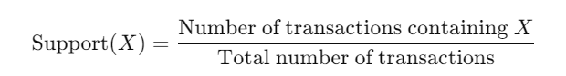
Confidence: A measure of how often items in BBB appear in transactions that contain AAA. It's calculated as:
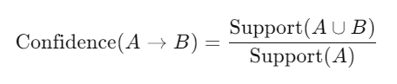

Pseudocode for the Apriori Algorithm:
function Apriori(transactions, min_support, min_confidence):
# Step 1: Generate initial itemsets
C1 = generate_candidates(transactions) # Single item candidates
L1 = filter_candidates(C1, min_support) # Frequent itemsets of size 1

# Step 2: Generate frequent itemsets of size k
k = 2
L = L1
while L is not empty:
Ck = generate_candidates(L, k) # Generate candidate itemsets of size k
L = filter_candidates(Ck, min_support) # Frequent itemsets of size k
k += 1

# Step 3: Generate association rules from frequent itemsets
rules = []
for each frequent itemset in L:
generate_rules(frequent_itemset, min_confidence)

return rules

function generate_candidates(itemsets, k):
# Join step: Join itemsets with themselves to generate new candidates
candidates = []
for i in itemsets:
for j in itemsets:
if i and j can be joined to form a new candidate:
candidates.append(new_candidate)
return candidates

function filter_candidates(candidates, min_support):
# Count support for each candidate in transactions
frequent_itemsets = []
for candidate in candidates:
support = count_support(candidate, transactions)
if support >= min_support:
frequent_itemsets.append(candidate)
return frequent_itemsets

function generate_rules(frequent_itemset, min_confidence):
# Generate all non-empty subsets of the frequent itemset
subsets = all_non_empty_subsets(frequent_itemset)
for subset in subsets:
# Calculate confidence
confidence = calculate_confidence(frequent_itemset, subset)
if confidence >= min_confidence:
rules.append((subset, frequent_itemset - subset, confidence))

Code:
import numpy as np
import pandas as pd
from apyori import apriori
# Load the dataset
store_data = pd.read_csv('./CSV_files/store_data.csv', header=None)
# Display the first few rows of the dataset
print(store_data.head(10))
# Convert all data to strings
store_data = store_data.astype(str)
# Preprocess the data for Apriori (converting DataFrame to a list of lists)
# Assuming each transaction is in a single row with items separated by commas
records = store_data.values.tolist()
# Remove any potential NaN values if they exist
records = [[str(item) for item in transaction if pd.notna(item)] for transaction in records]
# Applying the Apriori algorithm
association_rules = apriori(records, min_support=0.0045, min_confidence=0.2, min_lift=3, min_length=2)
association_results = list(association_rules)
# Print the number of rules generated
print(f"Total number of association rules: {len(association_results)}")
# Loop through the association results to extract and print rules and their metrics
for item in association_results:
# First index of the inner list contains the base item and add item
pair = item[0]
items = [x for x in pair]
print(f"Rule: {items[0]} -> {items[1]}")
# Second index of the inner list contains support
print(f"Support: {item[1]}")
# Third index contains the confidence and lift
print(f"Confidence: {item[2][0][2]}")
print(f"Lift: {item[2][0][3]}")
print("=====================================")
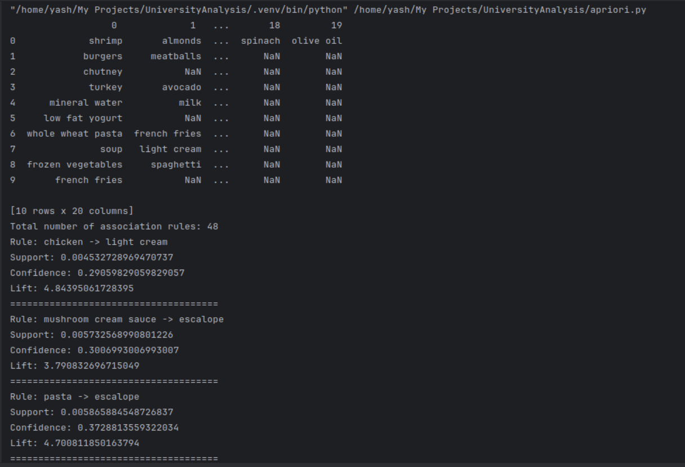
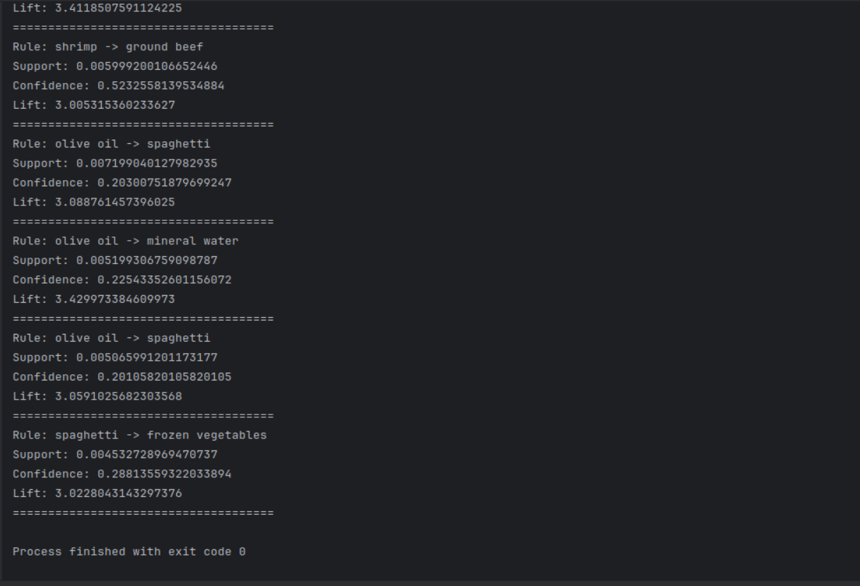
Result:

