Experiment 4

Group: Yash Shelar (2203159)
Ashmit Shelke (2203154)

Aim: Implementation of all dimension table and fact table based on case study.
Theory:
Dimensions : In the context of data warehousing, dimensions are descriptive attributes or categories that help provide context to the facts (quantitative data) in a fact table. Dimensions allow users to slice and dice the data for better analysis and reporting.
Characteristics of Dimensions:
- Contextual Data: They describe "what," "when," "where," and "who" related to business processes.
- Categories of Analysis: They provide different perspectives (e.g., time, geography, product) for analyzing the facts.
- Hierarchical Structure: Dimensions often contain hierarchies, such as year → quarter → month → day in a time dimension.
Example: If you are analyzing sales data, dimensions may include:
Product (e.g., product name, category)
Customer (e.g., name, age, region)
Time (e.g., year, month, day)

Business Dimensions : Business Dimensions are specific types of dimensions that represent key elements of an organization's operations, usually aligned with business entities, processes, or organizational structures. These dimensions are often critical for analyzing and understanding the business from a high level perspective.
Characteristics of Business Dimensions:
- Direct Relevance to Business: They are designed to represent business aspects that decisionmakers care about, such as customers, products, sales channels, or departments.
- Used for Strategic Analysis: Business dimensions help in analyzing critical metrics that align with an organization’s goals and objectives.
- Operational Impact: They are connected to the key operations and processes that drive the company’s performance.
Examples of Business Dimensions:
1. Customer Dimension: Contains customerrelated information like name, age, region, customer segment, and loyalty tier. Used to analyze sales or service performance based on customer demographics or behavior.
2. Product Dimension: Contains information about products like product name, category, brand, and price. Helps analyze sales performance across different products or product categories.
3. Geography Dimension: Represents locations, including country, region, city, and store. Useful for geographicbased performance analysis.
4. Time Dimension: Contains temporal data, like day, month, quarter, year. Essential for timebased analysis like tracking performance over time (e.g., monthly sales).
In a data warehouse, dimension tables and fact tables play a key role in organizing data for analysis. Here's a brief overview of each:

Dimension Table: It stores descriptive attributes related to the facts (measurements or events) in the fact table.
Characteristics:
- Contains textual, descriptive data (e.g., product name, location, time, etc.).
- Provides context to the data in the fact table.
- Typically has a primary key that is referenced by the fact table (foreign key).
- Often denormalized to improve query performance.
Example:
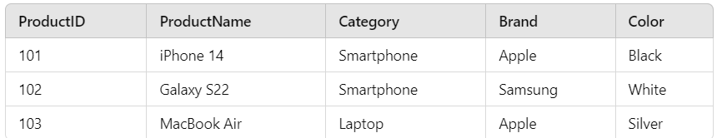

Fact Table: Stores quantitative data (facts) for analysis, often related to business processes.
Characteristics:
- Contains numeric values or measurements, such as sales, profit, or counts.
- Each row is uniquely defined by a combination of foreign keys that reference dimension tables.
- The fact table can grow large due to the volume of data it captures (e.g., transactions).
- Supports aggregation, like sums, averages, counts, etc.
Example:
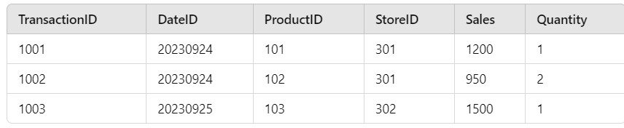
Dimension tables provide additional information to describe the facts.
Fact tables provide the core business metrics for analysis.

Information Package: An Information Package is a tool used in the early stages of dimensional modeling and data warehouse design. It helps to define the key business processes, metrics, and dimensions that will be used to build the data warehouse. Essentially, it is a detailed specification of what needs to be captured and analyzed.
Key Components:
1. Business Process: Defines the major business operations that need to be analyzed (e.g., sales, inventory, shipping). The fact table is usually designed around this business process.
2. Facts (Metrics): Represents the quantitative data or key performance indicators (KPIs) that are of interest (e.g., revenue, profit, number of sales). These are the measurements that populate the fact table.
3. Dimensions: These are the descriptive attributes or contextual data related to the facts (e.g., product, customer, region, time). Dimensions help break down the facts for meaningful analysis.
4. Granularity: Refers to the level of detail captured in the fact table. This can be at the transaction level (e.g., individual sale) or an aggregate level (e.g., daily or monthly sales).
5. Data Source: Identifies where the data for the facts and dimensions will come from (e.g., ERP systems, CRM systems, external data sources)
Purpose:
- It ensures alignment between business needs and the data warehouse design.
- It helps stakeholders understand what data will be available for reporting and analysis.
- Serves as a blueprint for designing the fact and dimension tables in the data warehouse.

OLAP (Online Analytical Processing): It is a category of software tools that enable users to interactively analyze multidimensional data from multiple perspectives. OLAP systems are used primarily for data mining, business reporting, financial analysis, and other business intelligence applications.

Key Features:
1. Multidimensional Data: OLAP allows users to view data in multiple dimensions, which are often referred to as "cubes." A dimension could be time, location, product, or other characteristics of the data.
2. Fast Query Performance: OLAP systems are optimized for rapid query performance, making it easy to analyze large datasets interactively.
3. Complex Calculations: OLAP systems support complex calculations like aggregations, percentages, and trends over time.

OLAP Operations:
1. Roll Up (Consolidation): Aggregates the data along a dimension, moving from detailed data to summary data. Example: Viewing sales data by region instead of by city.
2. Drill Down: The reverse of rollup; it allows users to navigate from summary data to more detailed data. Example: Drilling down from sales data for a country to sales data for a specific city.
3. Slice: Selects a single layer of the data cube by fixing one dimension. Example: Viewing sales data for a specific year while keeping other dimensions constant.
4. Dice: Extracts a subcube by selecting specific values for multiple dimensions. Example: Viewing sales for a specific product line in multiple regions and years.
5. Pivot (Rotation): Reorients the multidimensional view of the data to provide alternative perspectives. Example: Swapping the rows and columns in a report from showing sales by product to sales by region.
6. Drill Across: A method to retrieve data from different cubes that share one or more dimensions. Example: Analyzing sales data across product and marketing expenditure cubes.
7. Drill Through: Enables users to retrieve underlying transactional data from the OLAP cube by drilling through layers. Example: Going from aggregate sales data to the individual transaction level.
These operations allow users to dynamically navigate through complex data, gaining deeper insights into business performance.

Advantages:
1. Multidimensional Data Analysis: OLAP allows users to analyze data across multiple dimensions (such as time, location, product), offering a more comprehensive view of the business.
2. Fast Query Performance: Optimized for quick querying of large datasets, OLAP systems enable interactive and realtime data exploration, making it ideal for fast decisionmaking.
3. Complex Analytical Queries: OLAP supports complex calculations like trend analysis, aggregation, and percentage calculations, making it easier for business users to perform advanced data analysis without deep technical knowledge.
4. Data Summarization and Drill Down Capabilities: Users can roll up data for highlevel summaries or drill down for more detailed information, providing flexibility in how data is viewed and analyzed.
5. User Friendly: OLAP tools are designed for nontechnical users, offering an intuitive interface for analyzing data without needing to write complex SQL queries.
6. Improved Decision Making: The ability to quickly analyze data from multiple angles helps organizations gain actionable insights, leading to better and more informed decisions.
7. Supports Historical Data Analysis: OLAP systems store and process historical data, making it easy to perform time based analysis, track trends, and compare performance over time.
8. Enhanced Data Visualization: OLAP tools often come with powerful data visualization features, allowing users to create reports, charts, and dashboards that make insights easier to understand and communicate.
9. Efficient Data Storage: OLAP systems use specialized storage methods, like multidimensional cubes, that optimize data retrieval and storage, making them efficient even with large datasets.
10. Supports Business Intelligence (BI): OLAP is a key component of Business Intelligence systems, helping businesses gain insights that can lead to improved strategies, forecasting, and resource optimization.

Code:
--slice
SELECT
c.course_id,
c.course_name,
s.student_name,
d.department_name
FROM
courses c
JOIN
fact_table f ON c.course_id = f.course_id
JOIN
students s ON f.student_id = s.student_id
JOIN
department d ON f.department_id = d.department_id;

SELECT
c.course_id,
c.course_name,
s.student_name,
d.department_name
FROM
courses c
JOIN
fact_table f ON c.course_id = f.course_id
JOIN
students s ON f.student_id = s.student_id
JOIN
department d ON f.department_id = d.department_id
WHERE
c.semester_name = 'Semester 1';

--Dice
SELECT f.student_id, f.total_marks
FROM fact_table f
JOIN courses c ON f.course_id = c.course_id
WHERE c.semester_name = 'Semester 1';

SELECT f.student_id, f.total_marks
FROM fact_table f
JOIN courses c ON f.course_id = c.course_id
JOIN department d ON f.department_id = d.department_id
WHERE c.semester_name = 'Semester 1'
AND d.department_name = 'Computer Science'
AND c.course_name IN ('Mechanics', 'Introduction to Programming');

--Drill Down
SELECT
c.course_id,
c.course_name,
SUM(f.total_marks) AS total_marks
FROM
fact_table f
JOIN
courses c ON f.course_id = c.course_id
GROUP BY
c.course_id, c.course_name;

SELECT
s.student_id,
s.student_name,
d.department_name,
c.course_id,
c.course_name,
f.total_marks
FROM
fact_table f
JOIN
students s ON f.student_id = s.student_id
JOIN
department d ON f.department_id = d.department_id
JOIN
courses c ON f.course_id = c.course_id
WHERE
c.course_id = 5002; -- Replace with the specific course ID you want to filter by

--Roll up
SELECT
d.department_name,
c.semester_name,
SUM(f.total_marks) AS total_marks
FROM
fact_table f
JOIN
courses c ON f.course_id = c.course_id
JOIN
students s ON f.student_id = s.student_id
JOIN
department d ON f.department_id = d.department_id
GROUP BY
d.department_name, c.semester_name;

SELECT
d.department_name,
c.semester_name,
SUM(f.total_marks) AS total_marks
FROM
fact_table f
JOIN
courses c ON f.course_id = c.course_id
JOIN
students s ON f.student_id = s.student_id
JOIN
department d ON f.department_id = d.department_id
GROUP BY
ROLLUP(d.department_name, c.semester_name);

--Pivot
SELECT
s.student_name,
SUM(CASE WHEN f.paper1 IS NOT NULL THEN f.paper1 ELSE 0 END) AS Paper1_Marks,
SUM(CASE WHEN f.paper2 IS NOT NULL THEN f.paper2 ELSE 0 END) AS Paper2_Marks,
SUM(CASE WHEN f.paper3 IS NOT NULL THEN f.paper3 ELSE 0 END) AS Paper3_Marks,
SUM(CASE WHEN f.paper4 IS NOT NULL THEN f.paper4 ELSE 0 END) AS Paper4_Marks,
SUM(CASE WHEN f.paper5 IS NOT NULL THEN f.paper5 ELSE 0 END) AS Paper5_Marks,
SUM(CASE WHEN f.paper6 IS NOT NULL THEN f.paper6 ELSE 0 END) AS Paper6_Marks,
SUM(CASE WHEN f.paper7 IS NOT NULL THEN f.paper7 ELSE 0 END) AS Paper7_Marks
FROM
fact_table f
JOIN
students s ON f.student_id = s.student_id
GROUP BY
s.student_name
ORDER BY
s.student_name;

SELECT
paper,
MAX(CASE WHEN student_name = 'James Taylor' THEN mark END) AS "James Taylor",
MAX(CASE WHEN student_name = 'Emily Davis' THEN mark END) AS "Emily Davis",
MAX(CASE WHEN student_name = 'Michael Johnson' THEN mark END) AS "Michael Johnson",
MAX(CASE WHEN student_name = 'Daniel Brown' THEN mark END) AS "Daniel Brown",
MAX(CASE WHEN student_name = 'Olivia Lee' THEN mark END) AS "Olivia Lee",
MAX(CASE WHEN student_name = 'Emma Walker' THEN mark END) AS "Emma Walker",
MAX(CASE WHEN student_name = 'John Doe' THEN mark END) AS "John Doe",
MAX(CASE WHEN student_name = 'Sophia Wilson' THEN mark END) AS "Sophia Wilson",
MAX(CASE WHEN student_name = 'Jane Smith' THEN mark END) AS "Jane Smith",
MAX(CASE WHEN student_name = 'Liam Harris' THEN mark END) AS "Liam Harris"
FROM (
SELECT
s.student_name,
'Paper 1' AS paper, f.paper1 AS mark
FROM Fact_Table f
JOIN Students s ON f.student_id = s.student_id
UNION ALL
SELECT s.student_name, 'Paper 2' AS paper, f.paper2 AS mark FROM Fact_Table f JOIN Students s ON f.student_id = s.student_id
UNION ALL
SELECT s.student_name, 'Paper 3' AS paper, f.paper3 AS mark FROM Fact_Table f JOIN Students s ON f.student_id = s.student_id
UNION ALL
SELECT s.student_name, 'Paper 4' AS paper, f.paper4 AS mark FROM Fact_Table f JOIN Students s ON f.student_id = s.student_id
UNION ALL
SELECT s.student_name, 'Paper 5' AS paper, f.paper5 AS mark FROM Fact_Table f JOIN Students s ON f.student_id = s.student_id
UNION ALL
SELECT s.student_name, 'Paper 6' AS paper, f.paper6 AS mark FROM Fact_Table f JOIN Students s ON f.student_id = s.student_id
UNION ALL
SELECT s.student_name, 'Paper 7' AS paper, f.paper7 AS mark FROM Fact_Table f JOIN Students s ON f.student_id = s.student_id
) AS marks
GROUP BY paper
ORDER BY paper;

Without Slice:
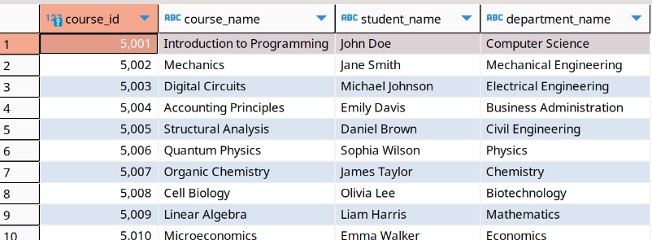
With Slice :
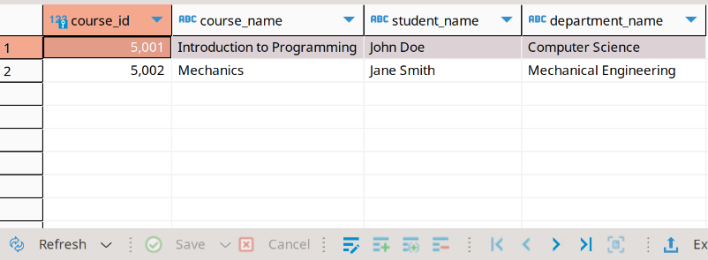

Without Dice:
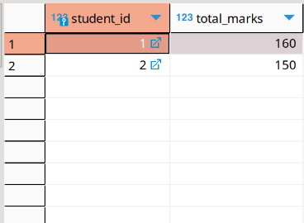
With Dice:
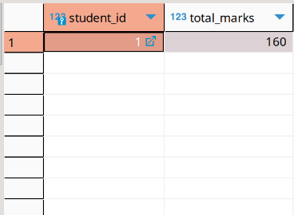

WIthout Drill Down:
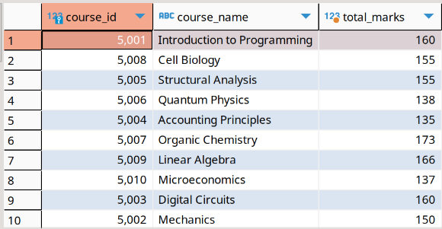
With Drill Down:
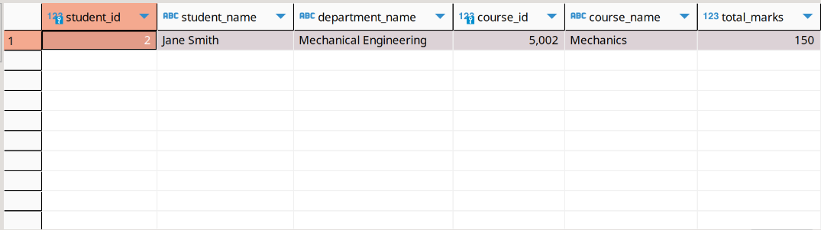

Without Roll Up:
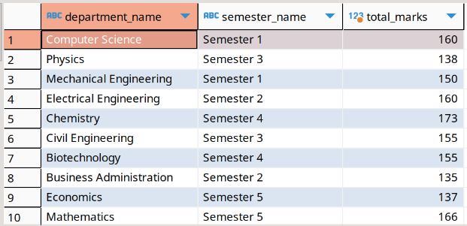
With Roll Up:
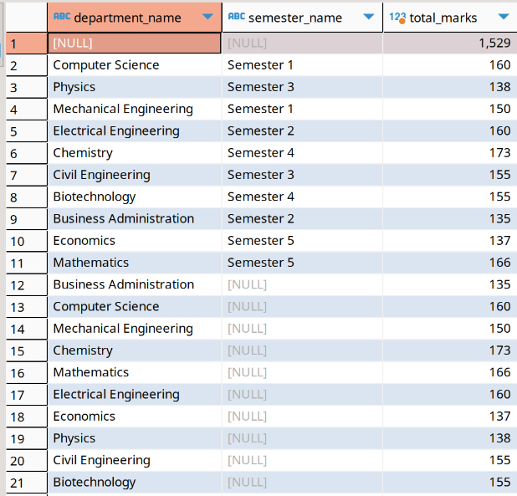

Without Pivot:
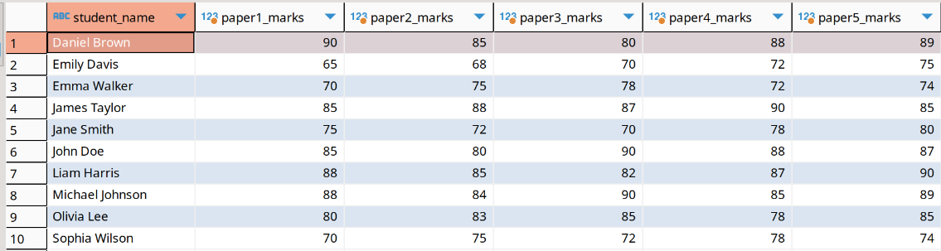
With Pivot:
