Experiment 5
Group: Yash Shelar (2203153)
Ashmit Shelke (2203154)

Aim: Implementation of OLAP operations: Slice, Dice, Rollup, Drill down and Pivot based on experiment 1.
Theory:
OLAP (Online Analytical Processing): It is a category of software tools that enable users to interactively analyze multidimensional data from multiple perspectives. OLAP systems are used primarily for data mining, business reporting, financial analysis, and other business intelligence applications.

Key Features:
1. Multidimensional Data: OLAP allows users to view data in multiple dimensions, which are often referred to as "cubes." A dimension could be time, location, product, or other characteristics of the data.
2. Fast Query Performance: OLAP systems are optimized for rapid query performance, making it easy to analyze large datasets interactively.
3. Complex Calculations: OLAP systems support complex calculations like aggregations, percentages, and trends over time.

OLAP in Excel: It refers to the integration of OLAP (Online Analytical Processing) capabilities within Microsoft Excel. Excel provides powerful data analysis tools that allow users to connect to OLAP cubes, create pivot tables, and perform multidimensional data analysis easily.

Benefits:
1. Familiar Interface: Excel provides a familiar and userfriendly environment for performing OLAP operations.
2. Multidimensional Data Analysis: Users can explore large datasets with ease, leveraging Excel’s ability to handle OLAP cubes.
3. Flexibility: OLAP in Excel allows users to customize their data views, enabling quick exploration of data from multiple angles.
4. Advanced Reporting: Users can create detailed reports, dashboards, and charts based on OLAP data directly in Excel.
5. No SQL Knowledge Required: Business users can perform complex queries and analyses without writing SQL code.
By integrating OLAP capabilities with Excel, users get the power of advanced data analysis combined with the simplicity of Excel's interface.

Before Rollup:
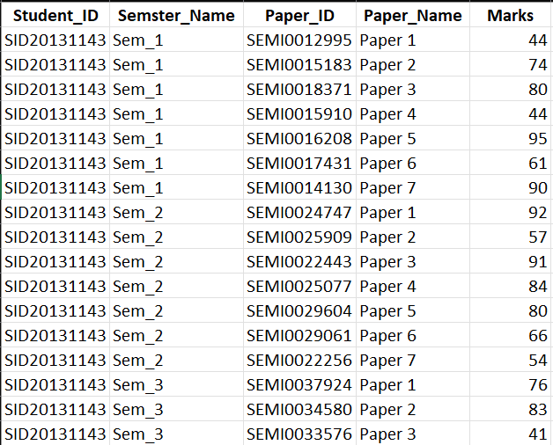
After Rollup:
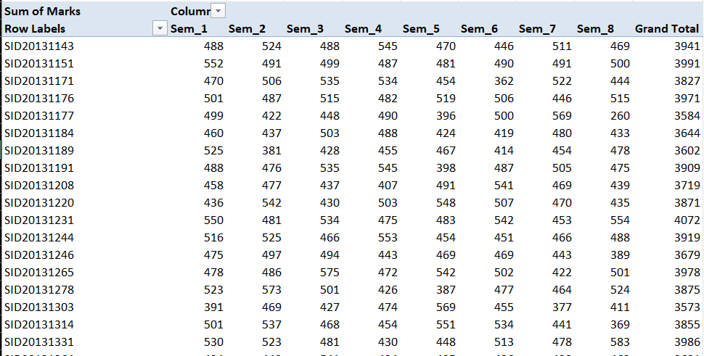
(Papers from 1 to 7 are merged(summation) for each semester)

Drilldown:
Before:

After:
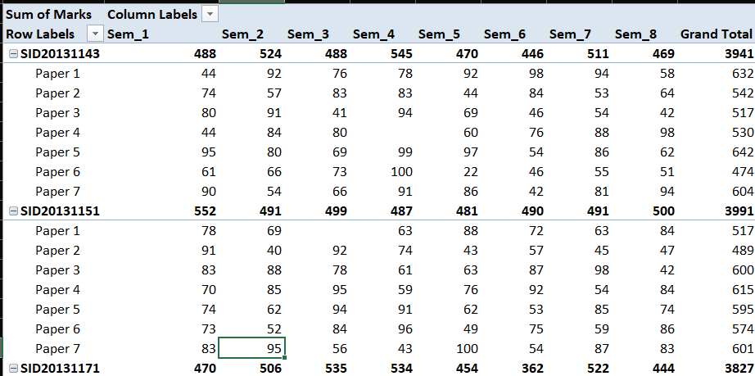

(Semester wise and paper wise marks for each student)
Slice:
Before:

After:
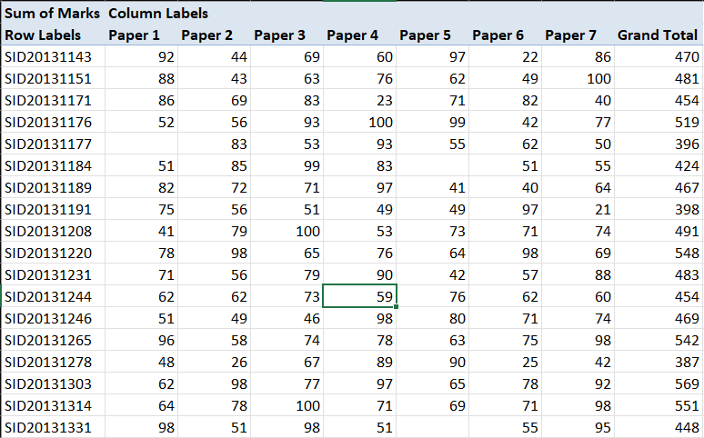
(Sliced by semester 5 results only)

Dice:
Before:

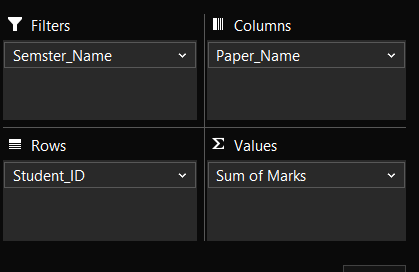
After:
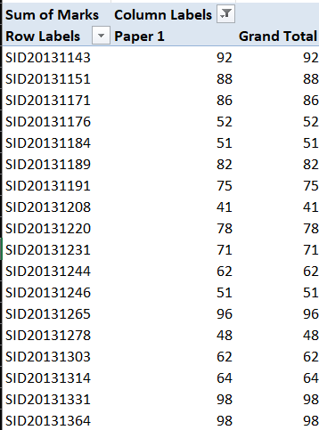
(Diced by only semester 5 and paper 1 marks)

Pivot:
Before:

After:
