EXPERIMENT 7

Data Pre-processing
Data pre-processing is a crucial step in the data mining process that involves preparing raw data for further analysis. It may include data cleaning, transformation, normalization, and integration.

Steps in Data Pre-processing
- Data Cleaning: Removing noise and inconsistencies from the dataset.
- Data Transformation: Converting data into a suitable format, such as normalization or aggregation.
- Data Reduction: Reducing the volume but producing the same or similar analytical results.
- Data Integration: Combining data from diﬀerent sources to provide a uniﬁed view.

Classiﬁcation

Naive Bayes Classiﬁcation

Theory:
Naive Bayes is a probabilistic classiﬁer based on Bayes’ theorem, which assumes that the presence of a particular feature in a class is independent of the presence of any other feature. It is particularly eﬀective for large datasets and is used for spam detection, sentiment analysis, etc.

Formula:
The probability of class C given features X is calculated as:
P (X∣C) ⋅ P (C)

Where:
P (C∣X) =
P (X)

P (C∣X) = Posterior probability of class C given feature X. P (X∣C) = Likelihood of feature X given class C.
P (C) = Prior probability of class C. P (X) = Evidence.

Example:
Suppose we have a dataset of emails classiﬁed as "Spam" and "Not Spam". The features are the presence of speciﬁc words (e.g., "buy", "discount", "free").
Email | Buy | Discount | Free | Class
1 | 1 | 1 | 1 | Spam
2 | 0 | 1 | 1 | Spam

Email | Buy | Discount | Free | Class
3 | 0 | 0 | 1 | Not Spam
4 | 1 | 0 | 0 | Not Spam

To classify a new email with features X = (1, 1, 0), we calculate:
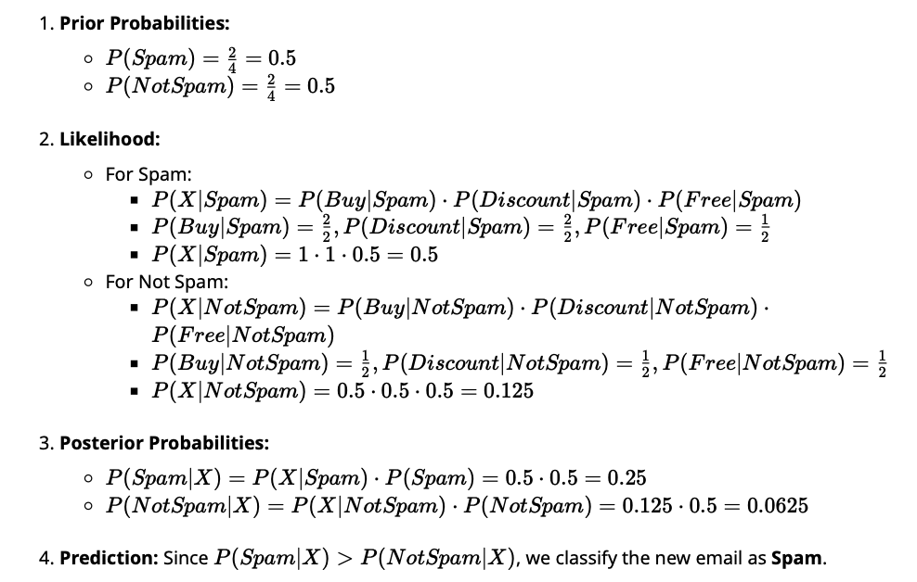

- Decision Tree Classiﬁcation ( J48)

Theory:
J48 is an implementation of the C4.5 algorithm used for generating decision trees. It creates a tree structure where each node represents a feature, each branch represents a decision rule, and each leaf node represents an outcome.

Algorithm Steps:

  - Choose the best attribute to split the data based on information gain or gain ratio.
  - Create a decision node that branches out based on the attribute.
  - Repeat for each branch until all data is classiﬁed.

Example:
Using the same email dataset as before, let’s classify the emails using a decision tree.

1. Calculate Entropy:

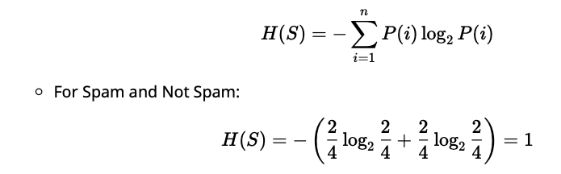

For Calculate Information Gain for each feature:
For Buy:

IG(Buy) = H(S) − H(S∣Buy)

For Discount and Free, repeat the calculation similarly.

Choose the feature with the highest gain to split the dataset.

- Construct the tree based on the splits.

Clustering

K-Means Clustering

Theory:
K-Means is a centroid-based clustering algorithm that partitions n data points into k clusters. Each data point belongs to the cluster with the nearest mean.

Algorithm Steps:
  - Choose k initial centroids randomly.
  - Assign each data point to the nearest centroid.
  - Update centroids by calculating the mean of assigned points.
  - Repeat steps 2-3 until convergence.

Example:
Let’s cluster the following 2D points using K-Means with k = 2.

Point | X | Y
1 | 1 | 2
2 | 2 | 3
3 | 6 | 5
4 | 7 | 8

- Initial Centroids: Randomly choose Point 1 (1, 2) and Point 3 (6, 5) as centroids.

- Assignment Step: Calculate the distance of each point to the centroids using Euclidean distance:

D =
(x₂ − x₁)2 + (y₂ − y₁)2
- Update Step: Calculate new centroids:
Cluster 1: Mean of points assigned to centroid 1. Cluster 2: Mean of points assigned to centroid 2.

- Iterate until centroids stabilize.

Hierarchical Clustering

Theory:
Hierarchical clustering creates a tree of clusters called a dendrogram. It can be agglomerative (bottom-up) or divisive (top-down).

Algorithm Steps for Agglomerative Clustering:

  - Treat each data point as a single cluster.
  - Merge the closest pair of clusters.
  - Repeat until only one cluster remains.

Example:
Using the same points as in K-Means, calculate the distance between points.

Distance Matrix Calculation:
0 | D1,2 | D1,3 | D1,4
D2,1 | 0 | D2,3 | D2,4
D3,1 | D3,2 | 0 | D3,4
D4,1 | D4,2 | D4,3 | 0

D =

- Merge the closest clusters based on the minimum distance.

- Repeat until all points are merged into a single cluster.

Data Preprocessing
Before performing classiﬁcation or clustering, the dataset typically requires pre-processing. Let’s assume we have a dataset containing information about emails, where our goal is to classify them into "Spam" and "Not Spam".

Sample Dataset

Email | Buy | Discount | Free | Class
1 | 1 | 1 | 1 | Spam
2 | 0 | 1 | 1 | Spam
3 | 0 | 0 | 1 | Not Spam
4 | 1 | 0 | 0 | Not Spam
5 | 1 | 1 | 0 | Spam

Steps in Data Pre-processing

- Data Cleaning: Check for missing values and correct or remove them. For our dataset, there are no missing values.

- Data Transformation: Normalize or scale the data if necessary. In this case, since we have binary values (0 and 1), scaling isn’t needed.

- Data Reduction: Simplify the dataset by removing any irrelevant features. All features seem relevant for our classiﬁcation goal.

- Data Integration: Combine datasets if needed. In this case, we are working with a single dataset.

Now that the dataset is pre-processed, we can proceed to the classiﬁcation and clustering tasks.

Classiﬁcation - Naive Bayes

Theory

Naive Bayes is a simple and eﬀective algorithm based on Bayes' theorem. It assumes that the presence of a particular feature in a class is independent of the presence of any other feature.

Example
Given the dataset, we want to classify a new email with features X = (1, 1, 0) (i.e., Buy=1, Discount=1, Free=0).

Calculate Prior Probabilities:

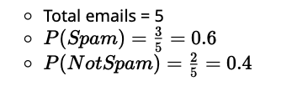

  - Calculate Likelihoods:

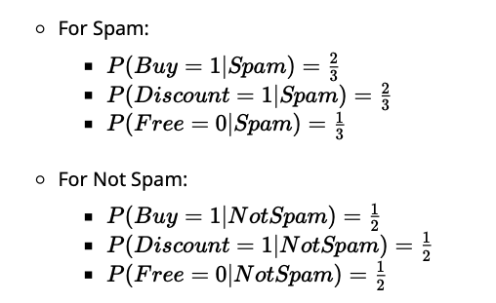

Calculate Posterior Probabilities:
For Spam:
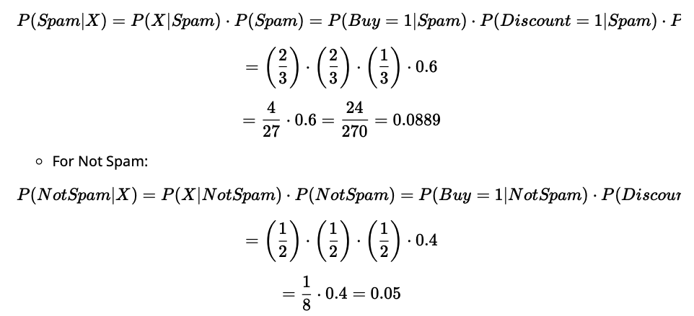

4. Compare Posterior Probabilities:
P (Spam∣X) ≈ 0.0889
P (NotSpam∣X) = 0.05

Since P (Spam∣X) > P (NotSpam∣X), we classify the new email as Spam.

Classiﬁcation - Decision Tree ( J48)

Theory

J48 is a decision tree algorithm that creates a tree structure based on the features of the dataset. Each internal node represents a feature, each branch represents a decision rule, and each leaf node represents an outcome.

Example

  - Calculate Entropy:

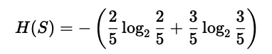

= − (0.4 ⋅ −1.32 + 0.6 ⋅ −0.736) = 0.971

Calculate Information Gain for each feature:

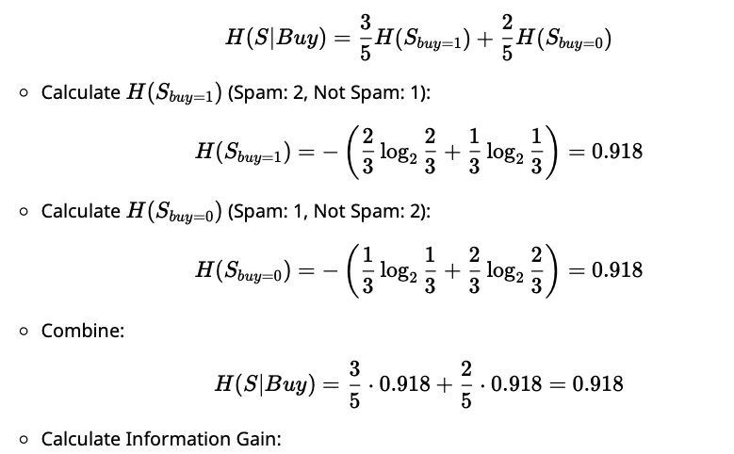

  - Create Decision Tree: Since Discount has the highest Information Gain, we choose it as the root node. We can then split the data based on this feature and repeat the process for subgroups until we reach leaf nodes.

The ﬁnal decision tree would look something like this:
/ \
Spam Not Spam Spam Not Spam
No
\
/ Yes
/ \
Discount
mathematica

C) Clustering - K-Means Theory
K-Means is an unsupervised learning algorithm used for clustering that aims to partition n
observations into k clusters in which each observation belongs to the cluster with the nearest mean.

Example

Given the following 2D points:

Point | X | Y
1 | 1 | 2
2 | 2 | 3
3 | 6 | 5
4 | 7 | 8
5 | 8 | 8

Let's cluster these points using k = 2.

  - Initialize Centroids: Let's say we randomly select Points 1 (1, 2) and 3 (6, 5) as our initial centroids.

Assign Points to Clusters:
Calculate the Euclidean distance for each point to each centroid.
D =
(x₂ − x₁)2 + (y₂ − y₁)2

For Point 1 (1, 2):
Distance to Centroid 1 (1, 2) = 0
(1 − 6)2 + (2 − 5)2
Distance to Centroid 2 (6, 5) = Repeat for other points.
25

= = 5

After calculating distances, let’s say we ﬁnd:
Points 1 and 2 belong to Cluster 1.
Points 3, 4, and 5 belong to Cluster 2.

Update Centroids:
Calculate the new centroid for Cluster 1:

New Centroid₁ = ( 1 + 2 , 2 + 3 ) = (1.5, 2.5)
2 2
Calculate the new centroid for Cluster 2:

New Centroid₂ = ( 6 + 7 + 8 , 5 + 8 + 8 ) = (7, 7)
3 3

Repeat Assignment and Update:
Reassign points based on the new centroids and update them again until convergence (centroids do not change).

  - Final Clusters: Assume after a few iterations, we converge with:
Cluster 1: Points 1, 2
Cluster 2: Points 3, 4, 5

Clustering - Hierarchical Clustering

Theory
Hierarchical clustering builds a hierarchy of clusters using either a bottom-up (agglomerative) or top- down (divisive) approach.

Example
Using the same points:

Point | X | Y
1 | 1 | 2
2 | 2 | 3
3 | 6 | 5
4 | 7 | 8
5 | 8 | 8

Calculate Distance Matrix:
Calculate the pairwise distances:
D1,2 =
(2 − 1)2 + (3 − 2)2

Continue for other pairs.

The distance matrix might look like this:

= ≈ 1.414

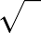
2
 | P 1 | P 2 | P 3 | P 4 | P 5
P 1 | 0 | 1.414 | 5.0 | 6.324 | 7.0
P 2 | 1.414 | 0 | 4.472 | 5.656 | 6.403
P 3 | 5.0 | 4.472 | 0 | 3.162 | 3.162
P 4 | 6.324 | 5.656 | 3.162 | 0 | 1.0
P 5 | 7.0 | 6.403 | 3.162 | 1.0 | 0

Agglomerative Clustering Steps:
Start with each point as its cluster.
Merge the two closest clusters. For example, P 1 and P 2 are merged.

Repeat Merging:
Continue merging the closest clusters until all points belong to a single cluster.

Dendrogram:
The merging process can be visualized in a dendrogram, showing the hierarchy of clusters formed at each stage.

Hierarchical Clustering Steps

We'll continue with the same dataset of points:

Point | X | Y
1 | 1 | 2
2 | 2 | 3
3 | 6 | 5
4 | 7 | 8
5 | 8 | 8

Step 1: Calculate the Distance Matrix

We will compute the pairwise Euclidean distances between all points.

D =
(x₂ − x₁)2 + (y₂ − y₁)2

Point Pair | Distance
P1 - P2 | (2 − 1)2 + (3 − 2)2 | = | 2 ≈ 1.414
P1 - P3 | (6 − 1)2 + (5 − 2)2 | = | 34 ≈ 5.831
P1 - P4 | (7 − 1)2 + (8 − 2)2 | = | (62 + 62 ) = | 72 ≈ 8.485
P1 - P5 | (8 − 1)2 + (8 − 2)2 | = | (72 + 62 ) = | 85 ≈ 9.220
P2 - P3 | (6 − 2)2 + (5 − 3)2 | = | 20 ≈ 4.472
P2 - P4 | (7 − 2)2 + (8 − 3)2 | = | (52 + 52 ) = | 50 ≈ 7.071
P2 - P5 | (8 − 2)2 + (8 − 3)2 | = | (62 + 52 ) = | 61 ≈ 7.810
P3 - P4 | (7 − 6)2 + (8 − 5)2 | = | 10 ≈ 3.162
P3 - P5 | (8 − 6)2 + (8 − 5)2 | = | (22 + 32 ) = | 13 ≈ 3.606
P4 - P5 | (8 − 7)2 + (8 − 8)2 | = | 1 = 1.000

Distance matrix

Point | P1 | P2 | P3 | P4 | P5
P1 | 0 | 1.414 | 5.831 | 8.485 | 9.220
P2 | 1.414 | 0 | 4.472 | 7.071 | 7.810
P3 | 5.831 | 4.472 | 0 | 3.162 | 3.606
P4 | 8.485 | 7.071 | 3.162 | 0 | 1.000
P5 | 9.220 | 7.810 | 3.606 | 1.000 | 0

Step 2: Agglomerative Clustering

Start with each point as its cluster:
Initial clusters: {P1}, {P2}, {P3}, {P4}, {P5}

Find the closest pair of clusters:
The closest points are P4 and P5 with a distance of 1.0. Merge these into a new cluster: New cluster: {P4, P5}

Update the distance matrix:
Calculate the new distances from the new cluster {P4, P5} to the remaining clusters.
To calculate the distance between a new cluster and a point, we typically use the minimum distance (single linkage) or average distance (complete linkage). Here, we will use single linkage.

Updating Distances

Distances to new cluster {P4, P5}:

Distance from {P4, P5} to P1:
D(P 4, P 5, P 1) = min(D(P 4, P 1), D(P 5, P 1)) = min(8.485, 9.220) = 8.485

Distance from {P4, P5} to P2:
D(P 4, P 5, P 2) = min(D(P 4, P 2), D(P 5, P 2)) = min(7.071, 7.810) = 7.071

Distance from {P4, P5} to P3:
D(P 4, P 5, P 3) = min(D(P 4, P 3), D(P 5, P 3)) = min(3.162, 3.606) = 3.162

Updated Distance Matrix

Point | P1 | P2 | P3 | {P4, P5}
P1 | 0 | 1.414 | 5.831 | 8.485
P2 | 1.414 | 0 | 4.472 | 7.071
P3 | 5.831 | 4.472 | 0 | 3.162
{P4, P5} | 8.485 | 7.071 | 3.162 | 0

Step 3: Repeat the Merging Process

Next Closest Clusters:
The next closest clusters are P3 and {P4, P5} with a distance of 3.162. Merge these into a new cluster:
New cluster: {P3, P4, P5}

Update the Distance Matrix Again:
Calculate distances to the new cluster {P3, P4, P5}.

Distance from {P3, P4, P5} to P1:
D(P 3, P 4, P 5, P 1) = min(D(P 3, P 1), D(P 4, P 5, P 1)) = min(5.831, 8.485) = 5.831

Distance from {P3, P4, P5} to P2:
D(P 3, P 4, P 5, P 2) = min(D(P 3, P 2), D(P 4, P 5, P 2)) = min(4.472, 7.071) = 4.472

Updated Distance Matrix

Point | P1 | P2 | {P3, P4, P5}
P1 | 0 | 1.414 | 5.831
P2 | 1.414 | 0 | 4.472
{P3, P4, P5} | 5.831 | 4.472 | 0
Step 4: Final Merge
The next closest points are P2 and {P3, P4, P5} with a distance of 4.472. Merge these into a new cluster:
Final cluster: {P2, P3, P4, P5}

Final Distance Matrix

Point | P1 | {P2, P3, P4, P5}
P1 | 0 | 5.831
{P2, P3, P4, P5} | 5.831 | 0
Final Cluster
Finally, we merge P1 with {P2, P3, P4, P5} to create a single cluster.

Dendrogram Representation

To visualize the clustering, we can create a dendrogram. Here's a conceptual representation based on the merges:

┌───── P1
|
| ┌───── P2
| |
| | ┌───── P3
markdown
| | | | |
| | | | | | ┌───── P4
| | | | | | |
| | | | | | └───── P5
└────────┘

The vertical lines represent the distance at which the clusters are merged. The shorter the line, the closer

Naïve Bayes:
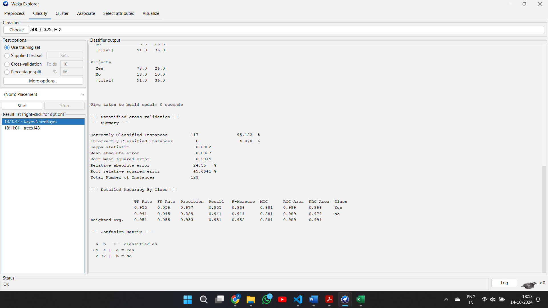
Decision Tree(J48):
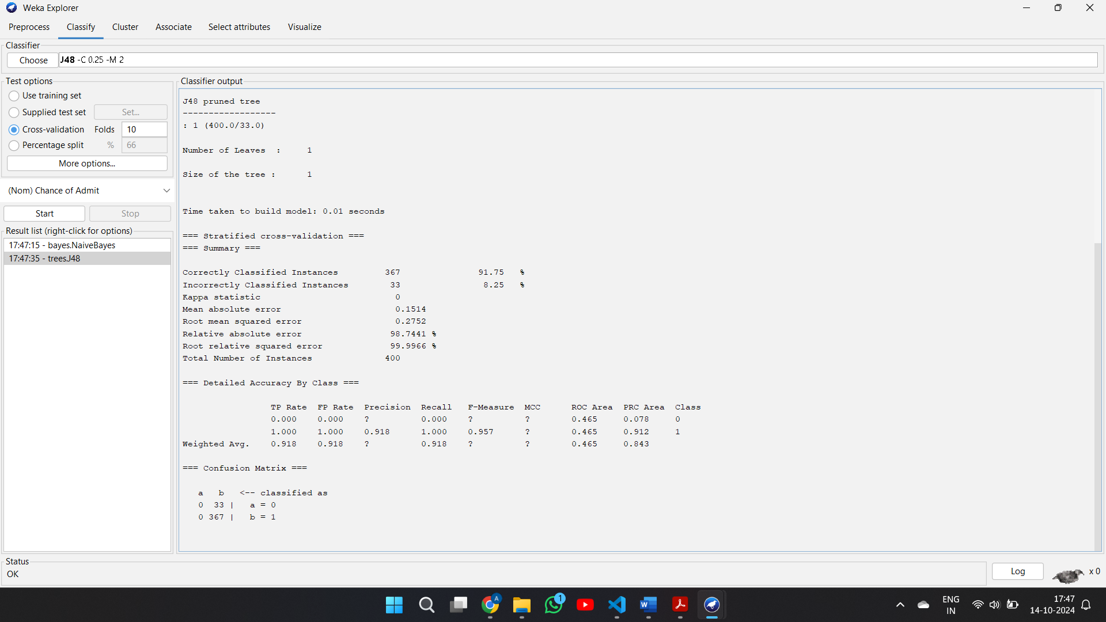
Hierarchical Clustering(J48):
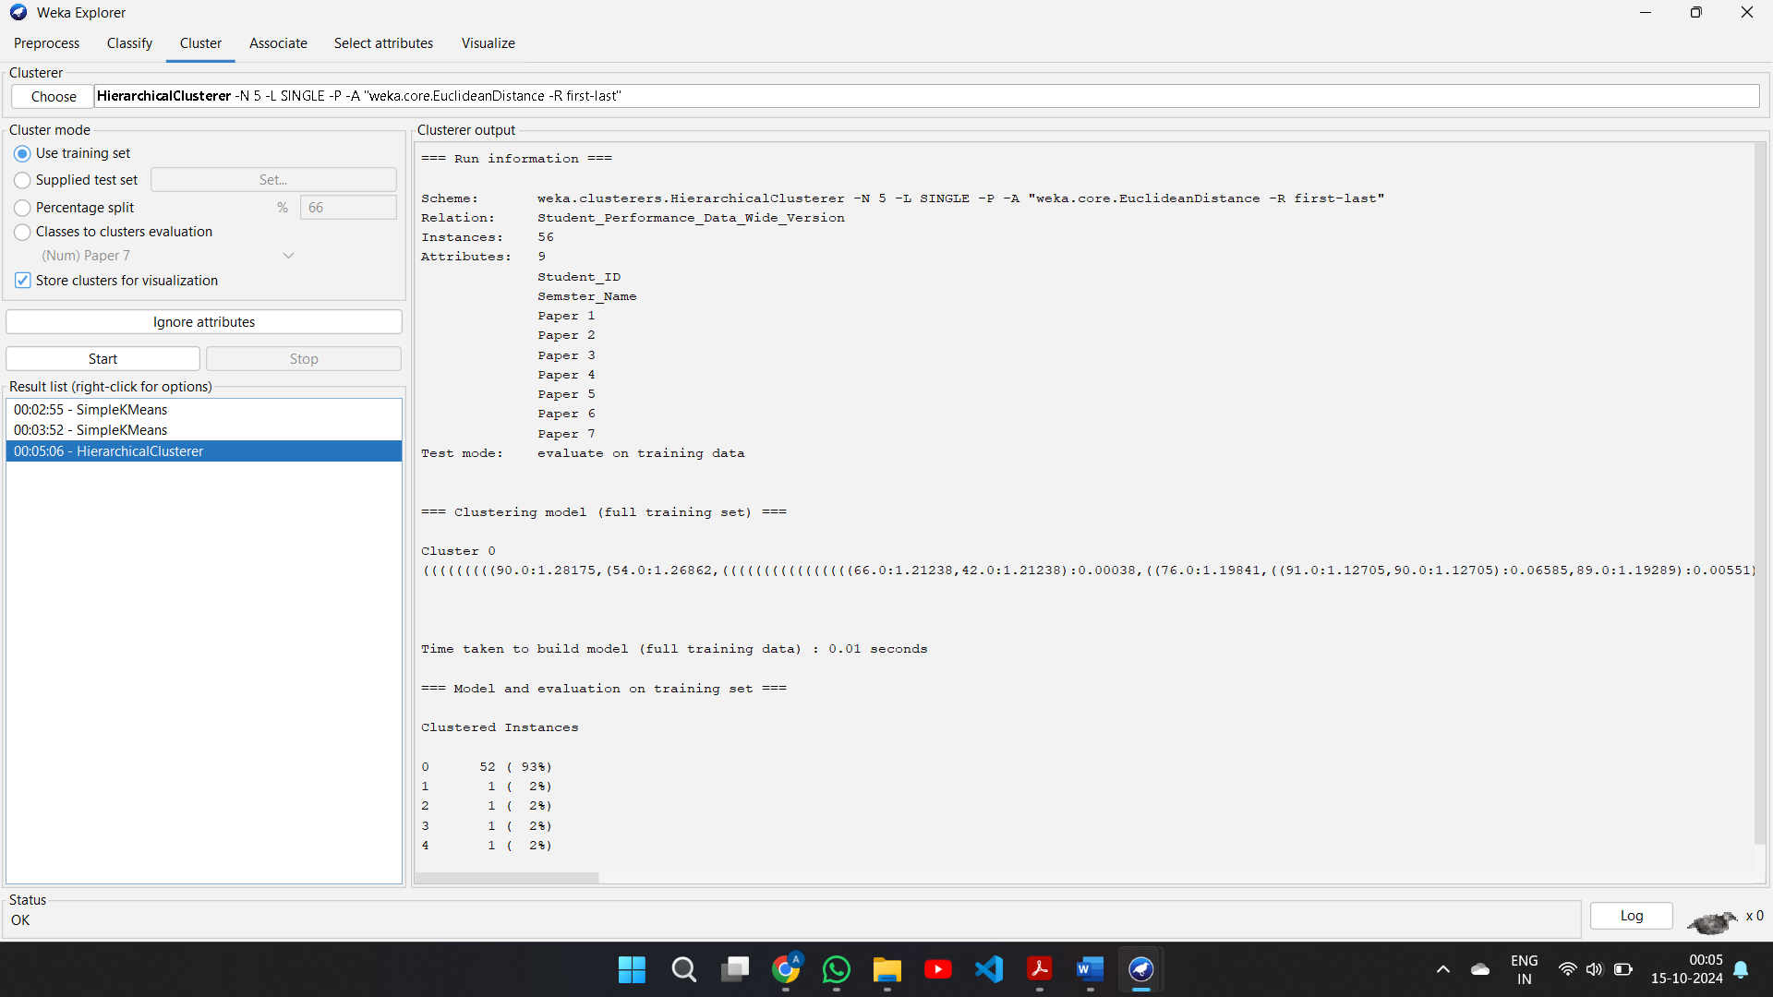

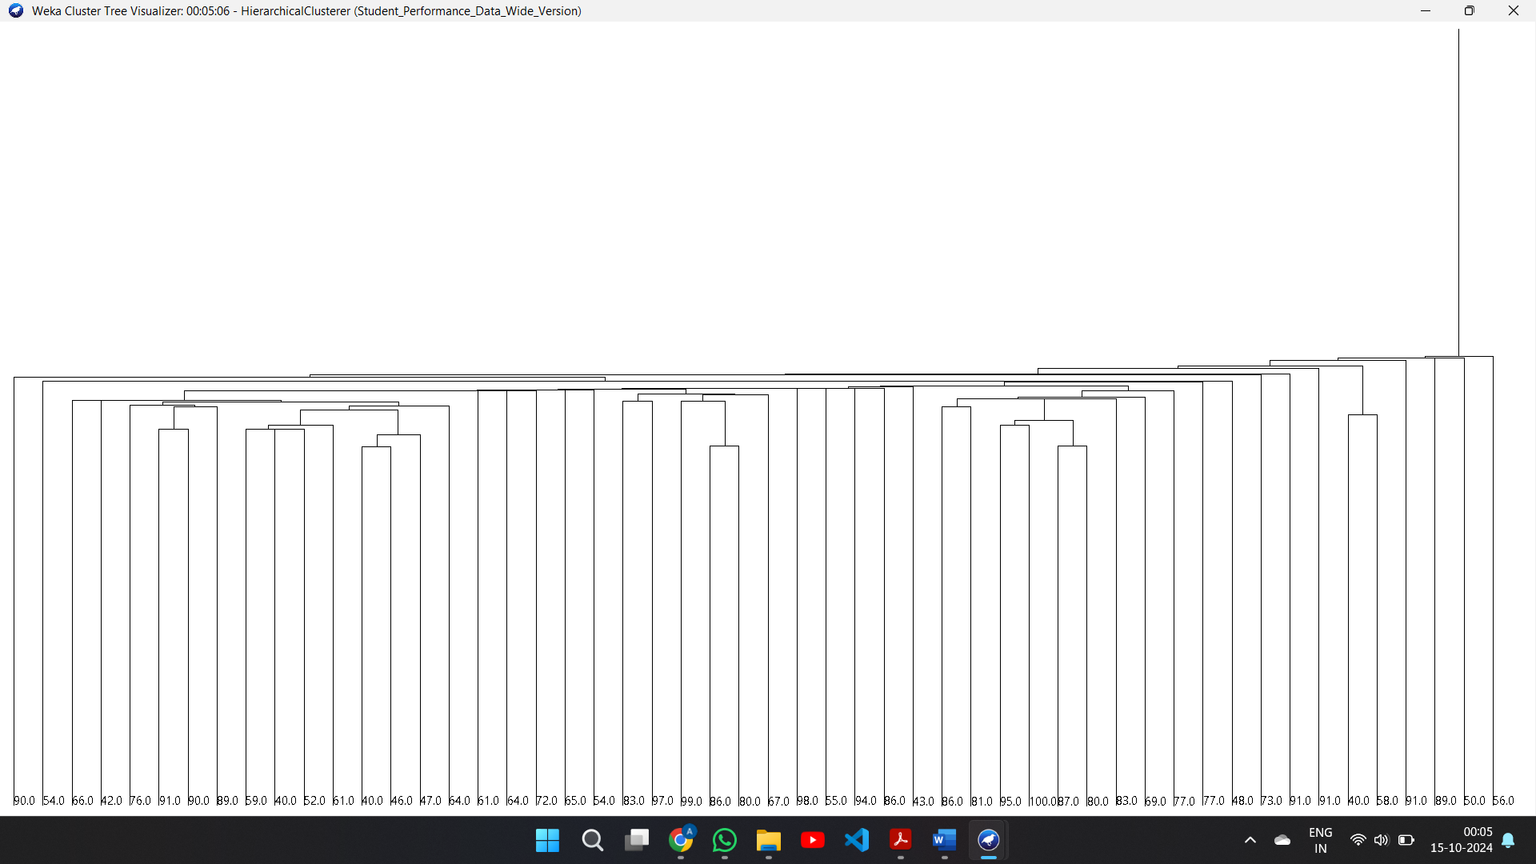

Simple K means:
