EXPERIMENT 8
Aim: Perform data Pre-processing task and data mining tasks on datasets using data mining tool (WEKA/Rtool) Association Mining- Apriori, FP-tree

Theory:

Association Mining - Apriori Algorithm
The Apriori Algorithm is a classic algorithm used for mining frequent itemsets and generating association rules. It operates on the principle that a subset of a frequent itemset must also be a frequent itemset.

Key Concepts:
- Support: The proportion of transactions that contain a particular itemset.
- Confidence: The probability that a transaction containing one item will also contain another item.
- Lift: The ratio of the observed support to that expected if X and Y were independent.

Example:
Dataset:

Let’s consider a dataset representing transactions at a bookstore. Each transaction contains items purchased by customers.

Transaction ID |  | Items Purchased
T1 | Book A, Book B, Book C
T2 | Book A, Book D
T3 | Book B, Book C
T4 | Book A, Book C, Book D
T5 | Book A, Book E
T6 | Book B, Book D, Book E
T7 | Book C, Book D, Book E
T8 | Book A, Book B, Book C, Book E

Objective:

- Find all frequent itemsets with a minimum support threshold of 50%.
- Generate strong association rules with a minimum confidence threshold of 80%.

Step-by-Step Solution:

Step 1: Calculate Support for 1-Itemsets

Item | Support Count | Support (%)
Book A | 5 | 62.50%
Book B | 4 | 50%
Book C | 5 | 62.50%
Book D | 4 | 50%
Book E | 4 | 50%

- Minimum support = 50%.
- Frequent 1-itemsets: {Book A}, {Book B}, {Book C}, {Book D}, {Book E}.

Step 2: Generate 2-Itemsets and Calculate Support

Itemset | Support Count | Support (%)
{Book A, Book B} | 3 | 37.50%
{Book A, Book C} | 4 | 50%
{Book A, Book D} | 3 | 37.50%
{Book A, Book E} | 3 | 37.50%
{Book B, Book C} | 3 | 37.50%
{Book B, Book D} | 3 | 37.50%
{Book B, Book E} | 2 | 25%
{Book C, Book D} | 3 | 37.50%
{Book C, Book E} | 3 | 37.50%
{Book D, Book E} | 2 | 25%

- Frequent 2-itemsets: {Book A, Book C}, {Book B, Book D}, {Book C, Book D}.

Step 3: Generate 3-Itemsets and Calculate Support

Itemset | Support Count | Support (%)
{Book A, Book C, Book D} | 2 | 25%
{Book B, Book C, Book D} | 2 | 25%

- No frequent 3-itemsets found as none meet the minimum support threshold.

Step 4: Generate Association Rules from Frequent Itemsets

1. Rule: Book A → Book C
- Confidence = Support(Book A ∪ Book C) / Support(Book A) = 50% / 62.5% = 80%
- Meets the threshold, accept.

2. Rule: Book C → Book A
- Confidence = Support(Book A ∪ Book C) / Support(Book C) = 50% / 62.5% = 80%
- Meets the threshold, accept.

3. Rule: Book B → Book D
- Confidence = Support(Book B ∪ Book D) / Support(Book B) = 50% / 50% = 100%
- Meets the threshold, accept.

Strong Association Rules:

- Book A → Book C (Confidence: 80%)
- Book C → Book A (Confidence: 80%)
- Book B → Book D (Confidence: 100%)

Association Mining - FP-Growth Algorithm

Theory:
The FP-Growth Algorithm is an efficient method of mining frequent itemsets without generating candidate itemsets, using a data structure called an FP-Tree.

Example:
Using the same dataset as before:
Step-by-Step Solution:

Step 1: Calculate Support Counts for Items
This is the same as in the Apriori example.
Item | Support Count
Book A | 5
Book B | 4
Book C | 5
Book D | 4
Book E | 4

Step 2: Create FP-Tree
- Step 2.1: Identify frequent items and order them. Here, let’s order by support: {Book A, Book C, Book B, Book D, Book E}.
- Step 2.2: Initialize FP-Tree with a root labelled "Null".
Insert Transactions into the FP-Tree:

1. T1: Book A, Book B, Book C
- Ordered Items: Book A, Book B, Book C
- Insert Path: Null → Book A(1) → Book B(1) → Book C(1)

2. T2: Book A, Book D
- Ordered Items: Book A, Book D
- Insert Path: Null → Book A(2) → Book D(1)

3. T3: Book B, Book C
- Ordered Items: Book B, Book C
- Insert Path: Null → Book B(2) → Book C(1)

4. T4: Book A, Book C, Book D
- Ordered Items: Book A, Book C, Book D
- Insert Path: Null → Book A(3) → Book C(2) → Book D(1)

5. T5: Book A, Book E
- Ordered Items: Book A, Book E
- Insert Path: Null → Book A(4) → Book E(1)

6. T6: Book B, Book D, Book E
- Ordered Items: Book B, Book D, Book E
- Insert Path: Null → Book B(3) → Book D(2) → Book E(1)

7. T7: Book C, Book D, Book E
- Ordered Items: Book C, Book D, Book E
- Insert Path: Null → Book C(3) → Book D(2) → Book E(1)

8. T8: Book A, Book B, Book C, Book E
- Ordered Items: Book A, Book B, Book C, Book E
- Insert Path: Null → Book A(5) → Book B(4) → Book C(4) → Book E(1)

FP-Tree Structure:
Null
|
Book A (5)
/ | \
Book B(3) Book C(4) Book E(1)
/ \
Book D(2) Book E(1)

Step 3: Mine the FP-Tree

- Start Mining from Book E:

- Conditional Pattern Base for Book E:
- From the paths leading to Book E:
- Book A (count: 2)
- Book B (count: 1)
- Book C (count: 1)

- Frequent Patterns with Book E:
- {Book E, Book A}: Support = 3
- {Book E, Book B}: Support = 2
- {Book E, Book C}: Support = 2

- Next, Mine from Book D:

- Conditional Pattern Base for Book D:
- From the paths leading to Book D:
- Book A (count: 2)
- Book B (count: 1)

- Frequent Patterns with Book D:
- {Book D, Book A}: Support = 3
- {Book D, Book B}: Support = 2

- Next, Mine from Book C:

- Conditional Pattern Base for Book C:
- From the paths leading to Book C:
- Book A (count: 4)
- Book B (count: 2)

- Frequent Patterns with Book C:
- {Book C, Book A}: Support = 5
- {Book C, Book B}: Support = 3

Apriori:
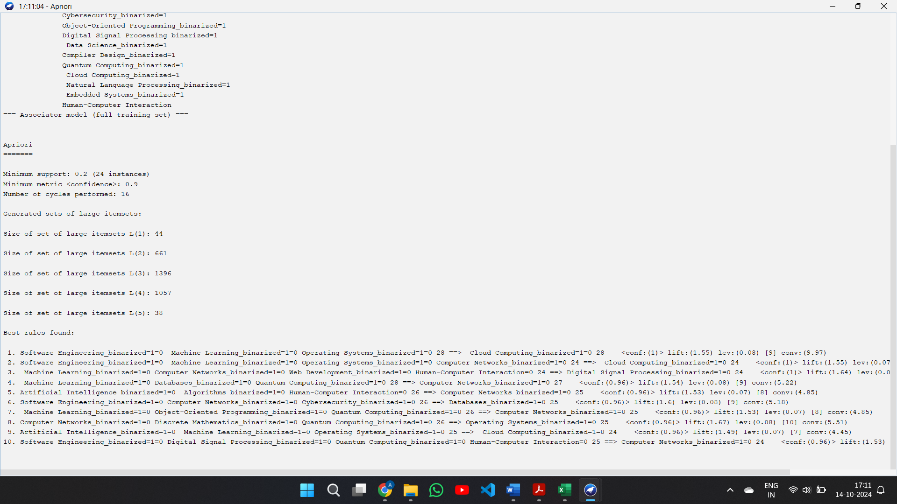
FP tree:

