LA-6(A)

NAME: YASH SIGCHI

REG NO: 23BAI1242

DATE: 17/02/2025

**PL/SQL BLOCK FOR BELOW**

* Factorial of a number

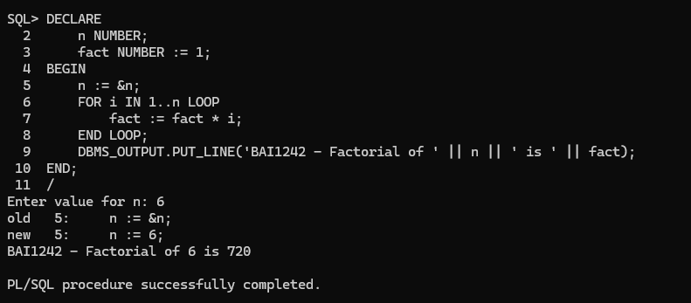

* Greatest of three numbers (input from user)

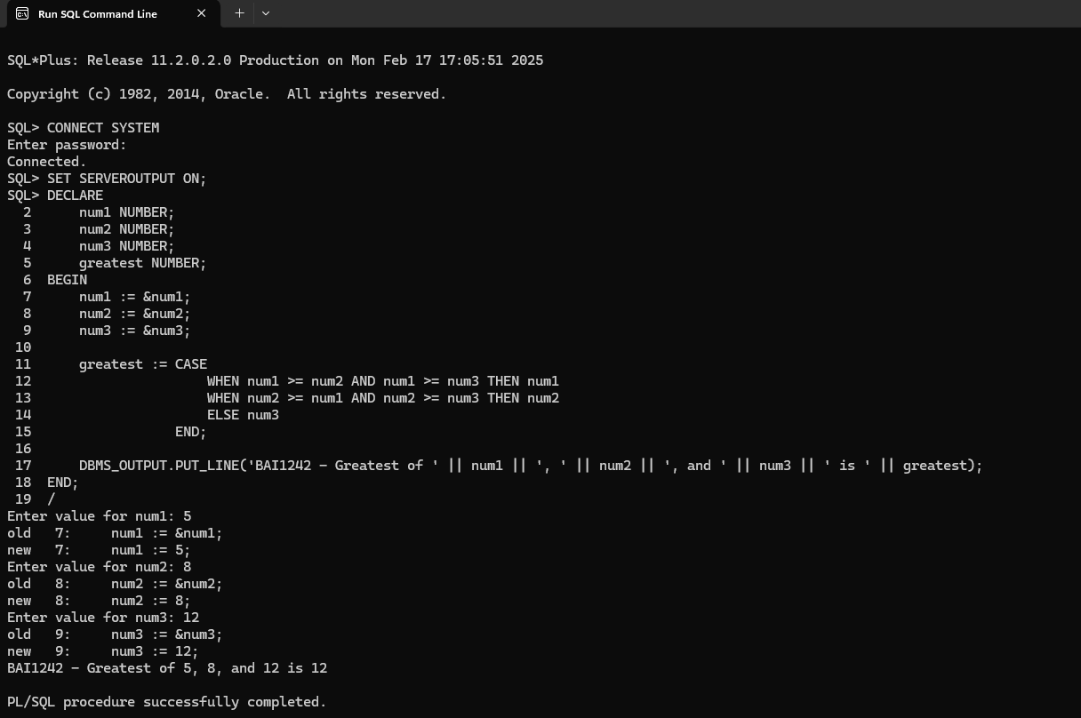

* Find whether the given string is palindrome or not (input from user)

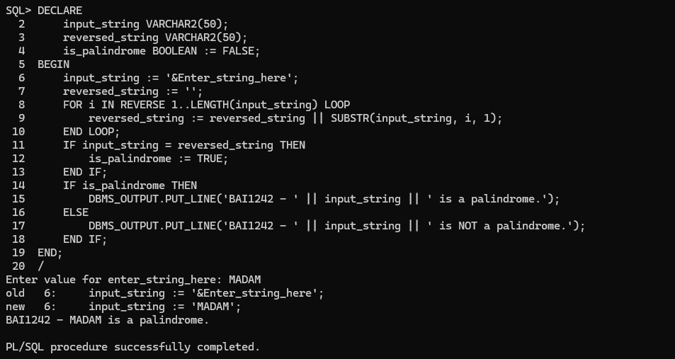  
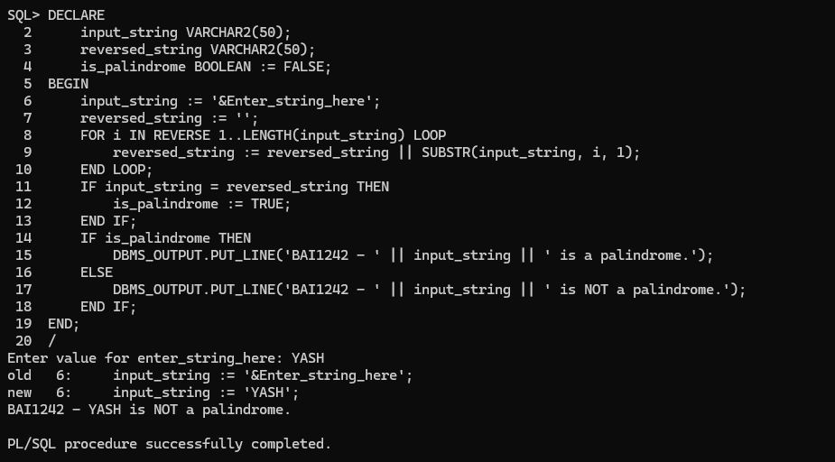

* Sum of 100 numbers

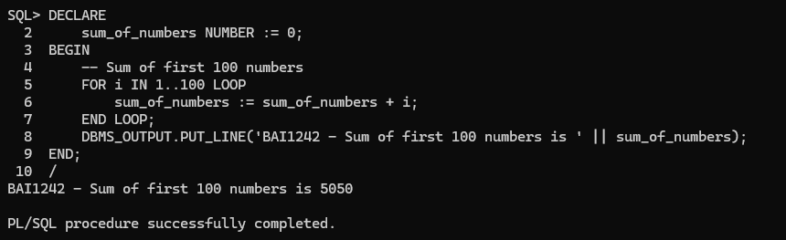

* Reverse a given number (input from user)

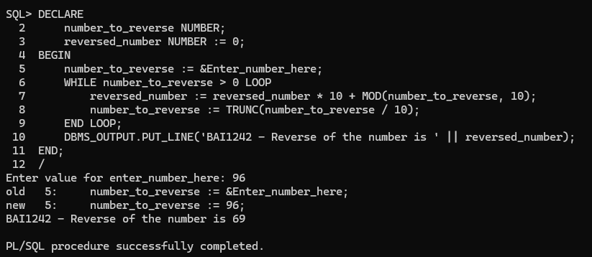

* Print Fibonacci series of a user input

