
QOMO HiteVision
R&D center

QClick SDK Manual

（V 1.0）

2010 Dec

（V 1.0） 1
1 Introduction 4
2 Architecture 4
3 Workflow 5
4 Modules 5
4.1 SDK Supports 6
4.1.1 BOOL InitHost ( ) 7
4.1.2 BSTR GetHostInfo (long lFlag) 7
4.1.3 long SetHostChannel (short nChannelNO) 8
4.1.4 long SetKeypadNO (long lKeypadNO) 8
4.1.5 long HomeworkSetExamTitle (short nExamID LPCTSTR pExamTitle, short nQuestion Num) 9
4.1.6 Long HomeworkSetQuestionInfo (short nQuestionNO, short nQuestionType, LPCTSTR pQuestionInfo, LPCTSTR pAnswer); 10
4.1.7 long StartSession (LPCTSTR pClassName,LPCTSTR pTeacherName, long lMaxStudents,short nSessionType, BOOL bLoginFlag， BOOL bAutoLoginFlag) 11
4.1.8 BOOL AllowLogin (long lDeviceNO, LPCTSTR pStudentID, BOOL bIsAllowLogin); 12
4.1.9 long StartQuestion (short nQuestionNO,short nQuestionType, short nNumberOfOption, BOOL bIsSendQuestion, LPCTSTR pQuestionInfo，LPCTSTR pCorrectAnswer) 13
4.1.10 long StopQuestion () 14
4.1.11 long StopSession() 15
4.1.1 BSTR GetStudentAnswer(LPCTSTR pStudentID, short nQuestionNO) 15
Under normal\homework mode, get student answers. 15
4.1.2 BOOL HomeworkSendExamInfo() 16
4.1.3 BOOL CloseHost () 16
4.2 Events of SDK 16
4.2.1 OnDeviceChanged (short nHostModel LPCTSTR pChannelNO, LPCTSTR pHostVersion) 17
4.2.2 OnKeypadLogin (long lKeypadNO, LPCTSTR pStudentID) 17
4.2.3 OnAnswerReceived (long lKeypadNO, LPCTSTR pStudentID, LPCTSTR pAnswer) 18
4.2.4 OnControlerReceived (short nCmd) 18
4.2.5 OnKeypadLogout (long lKeypadNO, LPCTSTR pStudentID) 19
4.2.6 OnHomeworkAnswerReceived(long lKeyPadNO, LPCTSTR pStudentID) 19
4.2.7 OnHomeworkAskForQuestions (long lKeyPadNO, LPCTSTR pStudentID) 19

- Introduction
This document focuses on the description of QOMO QRF300,700,900 main receivers’ SDK detail designs and instructions, including the communication method and different protocols.

- Architecture
QClick SDK (Software Development Kit)mainly used ActiveX, users can use various development languages(eg. VC++, C++Builder, Delphi, VB, Visual FoxPro, PB,C#,VB.net, etc.)to develop QClick program.

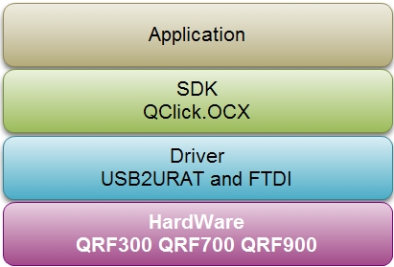

- Workflow
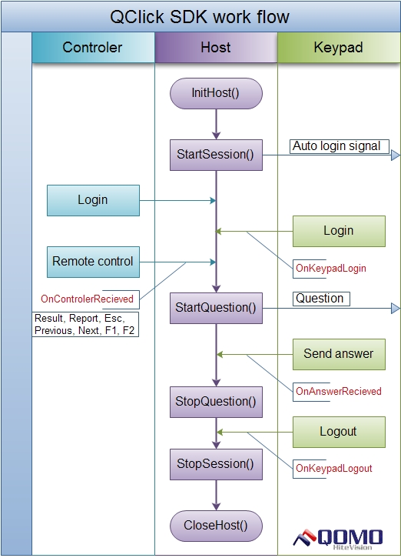
- Modules
QClick SDK methods and events.
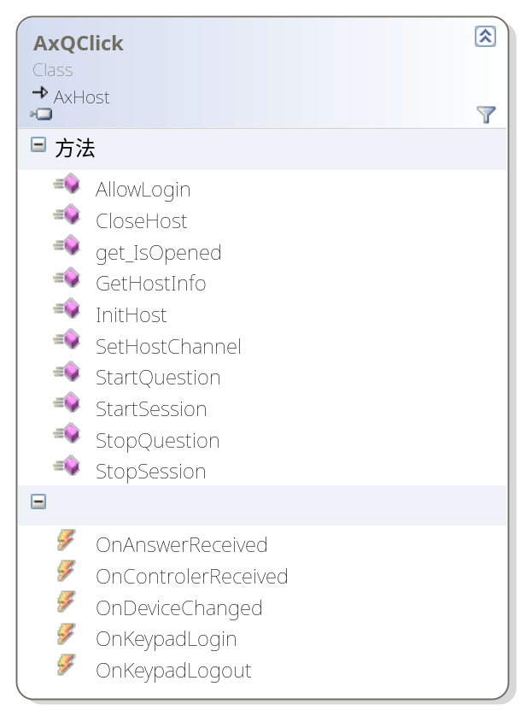

SDK Supports
 | QRF900 | QRF700 | QRF300
InitHost | √ | √ | √
GetHostInfo | √ | √ | √
SetHostChannel | √ | √ | √
SetKeypadNO | × | × | √
StartSession | √ | √ | √
AllowLogin | √ | √ | ×
StartQuestion | √ | √ | √
StopQuestion | √ | √ | √
StopSession | √ | √ | √
CloseHost | √ | √ | √
HomeworkSetExamTitle | √ | √ | ×
HomeworkSetQuestionInfo | √ | × | ×
HomeworkSendExamInfo | √ | × | ×
GetStudentAnswer | √ | √ | ×
√: Support ×:Not support

BOOL InitHost ( )
【Function】
Initialize hardware. Once the initialization is success, you can get the channel No., model type and version through GetHostInfo().
【Parameter】
None.
【Return】
True: indicates the connection with the main receiver is success
False: Indicates the main receiver is no found
【Example】

BSTR GetHostInfo (long lFlag)
【Function】
Get the related information of the Host, such as model, version and channel.
【Parameter】
 | QRF900 | QRF700 | QRF300
lFlag | √ | √ | √

lFlag:
lFlag = 0: Get channel No. 0~40
lFlag = 1:Get model type, like RF900
lFlag = 2:Get firmware version, like ARS900 Host v1.01
【Return】
Return strings: Get model information
【Example】
None

long SetHostChannel (short nChannelNO)
【Function】
Set channel No. for the model.
【Parameter】
 | QRF900 | QRF700 | QRF300
nChannelNO | √ | √ | √

short nChannelNO: Channel No. that is to set
【Return】
Return 0: Channel No. set successfully
Return 1: the parameter is 49<nChannelNO<0
Return 2: Channel set failed
Return 3: Currently be in the session, unable to set channel No.
【Example】
None

long SetKeypadNO (long lKeypadNO)
【Function】
Set the device ID (Only For RF300).
【Parameter】
 | QRF900 | QRF700 | QRF300
lKeypadNO | × | × | √
√: Support ×:Not support, input anything
long nChannelNO: the Device ID that is to set
nChannelNO =0 :for instructor keypad.
nChannelNO =1~400: for student keypad.
【Return】
Return 0：set up successfully.
Return 1：parameter is 400< lKeypadNO <0。
Return 2：Fail to set up.
Return 3: Currently be in the session, unable to set the device ID
【Example】
None

long HomeworkSetExamTitle (short nExamID LPCTSTR pExamTitle, short nQuestion Num)
【Function】
Under normal and homework activity mode, set quiz paper ID and name.
【Parameter】
 | QRF900 | QRF700 | QRF300
nExamID | √ | √ | ×
pExamTitle | √ | √ | ×
nQuestionNum | √ | √ | ×
√: Support ×:Not support, input anything

int nExamID: the fixed serial number of each quiz paper, it is used in the occasion student re-login to find the quiz paper under normal mode and homework mode.
LPCTSTR pExamTitle: Name of the quiz paper. It is sent to the student keypad, maximum length is 14 bytes.
short nQuestionNum: Total number of questions in the current quiz paper.
【Return】
Return 0: Operation successfully.
Return 1: Operation failed.

Long HomeworkSetQuestionInfo (short nQuestionNO, short nQuestionType, LPCTSTR pQuestionInfo, LPCTSTR pAnswer);
【Function】
Under normal and homework activity mode, set question information for the current quiz paper.
【Parameter】
 | QRF900 | QRF700 | QRF300
nQuestionNO | √ | × | ×
nQuestionType | √ | × | ×
pQuestionInfo | √ | × | ×
pAnswer | √ | × | ×
√: Support ×:Not support, input anything
short nQuestionNO: Question No.
short nQuestionType:Question Type
nQuestionType=0：single answer, in several options, only one option can be chosen
nQuestionType=1：multiple answer, in several options, student can choose more than one options
nQuestionType=2：cloze & Short Answer, no options to choose, just let the students to filling the blank with the exact words or phases
nQuestionType=3：True or False, two options with true or false. Student can only choose either of them to respond
LPCTSTR pQuestionInfo：information of the correspond number of question.
LPCTSTR pAnswer: correct answer for the current question.
【Return】
Return 0: Operation successfully.
Return 1: Do not use SetExamTitle to set up quiz paper information.
【Example】
None

long StartSession (LPCTSTR pClassName,LPCTSTR pTeacherName, long lMaxStudents,short nSessionType, BOOL bLoginFlag， BOOL bAutoLoginFlag)
【Function】
Start a session. Set the class information desired to start a session. Once student keypad login should receive the setup class information. Only when the class information is set, instructor keypad and student keypad should login.

【Parameter】
 | QRF900 | QRF700 | QRF300
pClassName | √ | √ | ×
pTeacherName | √ | √ | ×
lMaxStudents | √ | √ | ×
nSessionType | √ | √ | ×
bLoginFlag | √ | √ | ×
bAutoLoginFlag | × | × | ×
√: Support ×:Not support, input anything

LPCTSTR pClassName: Selected class that is to run a quiz, default set is Sample Class.
LPCTSTR pTeacherName：Selected teacher that is to run a quiz, default set is Sample Teacher.
long lMaxStudents：Student number in the class, default set is 100, maximum number is 999.
short nSessionType：activity mode, default set is 0
nSessionType=0： NORMAL_QUIZ
nSessionType=1： RUSH_QUIZ
nSessionType=2： ELIMINATION
nSessionType=3： SURVEY
nSessionType=4： VOTE
nSessionType=5: Paper_Quiz
nSessionType=6: HomeWork
nSessionType=7: Multiple Mode
BOOL bLoginFlag：indicates allows students ways to login, default set is 0

- bLoginFlag =0：as long as the number of students less than the total number set, all students are able to login, and it is unnecessary to check whether the student ID is in the selected class.
- bLoginFlag =1：Need to check whether the student ID exists in the selected class then send the force login information.
BOOL bAutoLoginFlag: indicates whether the system allows student to login automatically.
bAutoLoginFlag = 1: allow auto login
bAutoLoginFlag = 0: not allow auto login
【Return】
Return 0: success.
Return 1: failed. Reason(do not execute Init.)
Return 2: Do not use StopSession data.
Return 3: Do not use SetExamTitle data(under normal \ homework mode)
【Example】
None

BOOL AllowLogin (long lDeviceNO, LPCTSTR pStudentID, BOOL bIsAllowLogin, BOOL bIsSendStudentName， LPCTSTR pStudentName);
【Function】
When student remote login, the software check whether the remote is allowed to login.
【Parameter】

 | QRF900 | QRF700 | QRF300
lDeviceNO | √ | √ | ×
pStudentID | √ | √ | ×
bIsAllowLogin | √ | √ | ×
bIsSendStudentName | *(Required) | *(Required)
pStudentName | *(Required) | *(Required)
√: Support ×:Not support, input anything

lDeviceNO: receive the keypad No.(1~999) when student keypad login.
pStudentID：receive the student Id when student keypad login.
bIsAllowLogin：if need access control set True.
BOOL bISSendStudentName: whether to send student name
LPCTSTR pStudentName: student name
【Return】
1: Operation successfully.
0: Operation failed.

long StartQuestion (short nQuestionNO,short nQuestionType, short nNumberOfOption, BOOL bIsSendQuestion, LPCTSTR pQuestionInfo，LPCTSTR pCorrectAnswer, short nQuestionSessionType)
【Function】
Start to test a question. Set the test information. Send the test information to the main receiver when each question starts, and response to the answers according to the preset test information.

【Parameter】

 | QRF900 | QRF700 | QRF300
nQuestionNO | √ | √ | ×
nQuestionType | √ | √ | ×
nNumberOfOption | √ | √ | ×
bIsSendQuestion | √ | × | ×
pQuestionInfo | √ | × | ×
pCorrectAnswer | √ | × | ×
nQuestionSessionType | √ | √ | √
√: Support ×:Not support, input anything

nQuestionNO：Question No. The current question, maximum is 99
every question need a unique NO during session.
nQuestionType：nQuestionType represents a property of the question.
nQuestionType=0：single answer, in several options, only one option can be chosen
nQuestionType=1：multiple answer, in several options, student can choose more than one options
nQuestionType=2：cloze & Short Answer, no options to choose, just let the students to filling the blank with the exact words or phases
nQuestionType=3：True or False, two options with true or false. Student can only choose either of them to respond
nNumberOfOption：nNumberOfOption is referring to the maximum number of the options for a question. For example, for a 4 choice single answer, you may set nNumberOfOption as 4.
In this way, once the student response outside of ABCD, such like E, the student keypad will show “Invalid Answer” which means out of range.
bIsSendQuestion: send the question to keypad or not.
LPCTSTR pQuestionInfo: question contents , default set null value, maximum is 500.
LPCTSTR pCorrectAnswer: correct answer of the current question.

short nQuestionSessionType: current question mode：only valid in the Multiple Mode （7）. Under multiple mode, single question can be set as normal mode, rush quiz and vote. 【value remains the same with nSessionType in StartSession】only valid with the following modes: normal, rush quiz, vote.

Note：If the current activity mode is Homework or paper quiz, then all parameters for the function can be any value.

【Return】
0 success.
1 failed. Need Init the device first.
2 failed. Need start a session first.
3 Do not use StopQuestion data
【Example】

long StopQuestion ()
【function】
Stop current question. Once received this signal, student is not allowed to answer any more.
【Parameter】

【Return】
0: Success.
1: Failed. Need initialize host first.
2: Failed. Must start a session first.
3:Failed. Must start a question first.

long StopSession()
【Function】
Stop current session. When receive this signal, clear the class data (ID & keypad No.)and wait for the preset information of starting a session. Student automatically logout, for it is unable to login in this state.
【Parameter】

【Return】
0: Success.
1: Failed. Need initialize host first.
2: Failed. Must start a session first.
【Example】

BSTR GetStudentAnswer(LPCTSTR pStudentID, short nQuestionNO)
【Function】
Under normal\homework mode, get student answers.
【Parameter】
 | QRF900 | QRF700 | QRF300
pStudentID | *(Required) | *(Required)
nQuestionNO | *(Required) | *(Required)

LPCTSTR pStudentID：selected student ID to get the answer
short nQuestionNO：current question No. of answer receiving
【Return】
Students answers of the current question
【Sample】

BOOL HomeworkSendExamInfo()
【Function】
Under normal\ homework mode, whether to send questions to students when it is asked
【Parameter】

【Return】
0：success
1：Haven’t set up question information（not use SetQuestionInfo data）
2：haven’t start a quiz（not use StartSession data）
【Sample】

BOOL CloseHost ()
【Function】
Turn off the serial port
【Parameter】
None
【Return】
True: successful
False: fail

Events of SDK
 | QRF900 | QRF700 | QRF300
OnDeviceChanged | √ | √ | √
OnKeypadLogin | √ | √ | ×
OnKeypadLogout | √ | √ | ×
OnAnswerReceived | √ | √ | √
OnControlerReceived | √ | √ | √
OnHomeworkAnswerReceived | √ | √ | ×
OnHomeworkAskForQuestions | √ | × | ×
√: Support ×:Not support

OnDeviceChanged (short nHostModel LPCTSTR pChannelNO, LPCTSTR pHostVersion)
【Function】
Events that happen when the state of the main receiver changes, aim at the plug-in and plug-out operations of the main receiver.
【Parameter】
nHostModel：Type of main receiver
nHostModel: =0 no receiver
NHostModel =1 QRF900
nHostModel =2 QRF700
nHostModel =3 QRF600
nHostModel =4 QRF500
nHostModel =5 QRF300
nHostModel =6 QIR300

LPCTSTR pChannelNO：main receiver strings：
Plug-in: show the actual channel No.
Plug-out: show 0

LPCTSTR pHostVersion：main receiver version strings：
Plug-in：show the actual version
Plug-out: none

【Return】

OnKeypadLogin (long lKeypadNO, LPCTSTR pStudentID)
【Function】
Event that happen when receive the login signal
【Parameter】
lKeypadNO：Unique id of each keypad. The fixed instructor remote No. is 0, while student remote is 1~999
pStudentID：Student ID
【Return】

OnAnswerReceived (long lKeypadNO, LPCTSTR pStudentID, LPCTSTR pAnswer)
【Function】
Events happen when receive student answer(including rush quiz)
【Note】：In rush quiz, parameter of pAnswer shows nothing
【Parameter】
lKeypadNO：Unique id for each keypad. The fixed instructor remote No. is 0, while student remote is 1~999
pStudentID：Student ID
pAnswer: the answer that student responded
【Return】

OnControlerReceived (short nCmd)
【Function】
Receive the commands from instructor remote
【Parameter】
short nCmd：Command byte
nCmd = 1, F1 button command
nCmd = 2, F2 button command
nCmd = 3, OK button command//（QRF900 without this command）
nCmd = 4, last page command
nCmd = 5, next page command
nCmd = 6, Run quiz command
nCmd = 7, Stop quiz command
nCmd = 8, view histogram command
nCmd = 9, View report command
nCmd = 10 Exit command
nCmd = 11, Run command（300）
nCmd = 12， channel conflicts command
【Return】

OnKeypadLogout (long lKeypadNO, LPCTSTR pStudentID)
【Function】
Event that happen when receive the keypad logout signal.
【Parameter】
lKeypadNO：Unique id for each keypad. The fixed instructor remote No. is 0, while student remote is 1~999
pStudentID：Student ID
【Return】

OnHomeworkAnswerReceived(long lKeyPadNO, LPCTSTR pStudentID)
【Function】
Events happen when receive answers under normal\homework mode. Get the answers for the current student through BSTR GetStudentAnswer(LPCTSTR pStudentID, short nQuestionNO)when this event happens.
【Parameter】
long lKeypadNO：Device No. Accumulated value. Instructor device No. fixed as 0, student device is 1~999

LPCTSTR pStudentID：student ID
【Return】

【Sample】

OnHomeworkAskForQuestions (long lKeyPadNO, LPCTSTR pStudentID)
【Function】
Events happen when receive information that student ask for sending question under normal\homework mode. When this event happens, send questions to student clickers through BOOL HomeworkSendExamInfo()
【Parameter】
long lKeypadNO：Device No. Accumulated value. Instructor device No. fixed as 0.student device No. is 1~999

LPCTSTR pStudentID：student ID
【Return】

【Sample】

