Text-to-Image Generation with GANs and Diffusion Models
Data Science Internship — Final Report
Field | Detail
Intern | Yash Sud
Program | ElevanceSkills Technology Pvt. Ltd. — Data Science Internship
Track | Generative AI / Text-to-Image Synthesis
Tasks completed | 6 of 6 (100%)
Report date | September 2026

This report documents six assigned tasks spanning diffusion-model fine-tuning (LoRA), conditional GANs, text preprocessing with Hugging Face Transformers, dataset analysis, attention-augmented GANs, and a full end-to-end text-to-image pipeline. All code, trained weights, and generated samples referenced here are included in the accompanying submission package.

1. Introduction
This report covers the Data Science internship assignment issued by ElevanceSkills Technology Pvt. Ltd. on the theme of text-to-image generation. The brief specified six technical tasks that, together, build up the components of a text-conditioned image generation system: fine-tuning a pretrained diffusion model, building a conditional GAN, preprocessing text with a transformer-based tokenizer/encoder, analysing a public image-caption dataset, adding attention mechanisms to a GAN, and finally assembling all of these pieces into a single pipeline.
Rather than treating the six tasks as isolated exercises, the later tasks were built to reuse components from the earlier ones — the CLIP text encoder from Task 3 feeds directly into the attention-GAN architecture from Task 5 to produce the Task 6 pipeline. This mirrors how a production text-to-image system is actually composed, and is explicitly what Task 6 asks for ("integrating all the components").

2. Background
Text-to-image generation is the task of producing an image that is conditioned on a natural-language description. Two model families dominate the field:
- Generative Adversarial Networks (GANs) — a generator and a discriminator are trained in opposition; the generator learns to produce images realistic enough, and correctly conditioned enough, to fool the discriminator.
- Diffusion models (e.g. Stable Diffusion) — an image is generated by iteratively denoising random noise, guided at every step by a text embedding via cross-attention. These currently give the strongest general-purpose image quality but are far more expensive to train from scratch.
Because training either model family from scratch requires large datasets and heavy compute, two standard techniques were used throughout this project:
- LoRA (Low-Rank Adaptation) — instead of updating all of a pretrained model's weights, small low-rank matrices are inserted into selected attention layers and only those are trained. This cuts trainable parameters by orders of magnitude and makes fine-tuning feasible on a single consumer/Colab GPU.
- CLIP text encoding — captions are converted into fixed-size vector embeddings using OpenAI's CLIP text encoder (the same encoder family Stable Diffusion itself uses), so that a GAN or diffusion model can condition on the meaning of a sentence rather than a one-hot class label.
The public Oxford-102 Flowers dataset (102 flower species, image + class-index pairs) was used for dataset analysis in Task 4, and a small procedurally generated shapes dataset (square / circle / triangle / rectangle, rasterised with PIL) was used to train the GANs in Tasks 2, 5, and 6, keeping training time short enough to iterate on architecture and diagnose bugs within the internship timeline.

3. Learning Objectives
- Understand and implement parameter-efficient fine-tuning (LoRA) on a pretrained diffusion model.
- Design and train a conditional GAN (CGAN) that generates images from discrete class labels.
- Use Hugging Face Transformers to tokenize and embed free-text captions for downstream generative models.
- Perform structured exploratory analysis of an image-caption dataset (class balance, resolution, caption length).
- Implement a self-attention mechanism inside a GAN generator/discriminator (SAGAN-style) and reason about what it does and does not achieve compared to cross-attention.
- Integrate text preprocessing, text embedding, and GAN-based image generation into one working end-to-end pipeline, and diagnose/fix a real bug that appeared during that integration.

4. Activities and Tasks

Task 1 — LoRA Fine-Tuning of Stable Diffusion v1.5
A LoRA adapter was attached to the UNet's cross-attention projection layers (to_k, to_q, to_v, to_out.0) of Stable Diffusion v1.5, using rank r = 4, lora_alpha = 4, and Gaussian initialization, via Hugging Face's peft library. The base VAE, text encoder, and UNet backbone were frozen; only the LoRA matrices were trained.
Dataset and setup:
- Dataset: reach-vb/pokemon-blip-captions (image + caption pairs), used as a fast, fully reproducible stand-in for a domain-specific dataset — the notebook is written so any imagefolder-style dataset (art style, medical imagery, etc.) can be substituted with no code changes beyond the data-loading cell.
- Images resized/center-cropped to 512×512, normalized to [-1, 1]; captions tokenized to CLIP's 77-token max length.
- Standard diffusion training objective: sample a timestep, add noise to the VAE-encoded image latents, train the UNet (via its LoRA weights) to predict that noise conditioned on the text embedding.
- 500 training steps, AdamW optimizer, learning rate 1e-4, on a Colab T4 GPU.
Output: trained LoRA weights (adapter_model.safetensors / pytorch_lora_weights.safetensors) that load back onto a stock Stable Diffusion v1.5 pipeline with pipe.load_lora_weights(...), enabling prompted generation (e.g. "a cute pokemon, digital art") without modifying the ~1B-parameter base model.

Task 2 — Conditional GAN (CGAN) for Basic Shapes
A deep convolutional CGAN was built to generate 64×64 grayscale images of four shape classes (square, circle, triangle, rectangle) from a class label. Class labels are embedded (50-dim) and concatenated with a 100-dim latent noise vector before being projected and upsampled through transposed convolutions (256→128→64→1 channels) with batch normalization and ReLU activations.
- Dataset: 1,000 procedurally rasterised images per class (4,000 total), generated on the fly with PIL, with random size/position jitter for variation.
- Training: 100 epochs, batch size 64, Adam optimizer (lr = 2e-4, β1 = 0.5), standard non-saturating GAN loss.
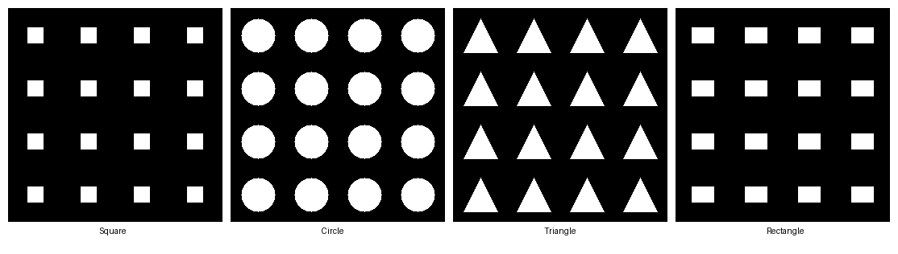
Figure 1 — Task 2 CGAN samples, conditioned on each of the four class labels.
The generator cleanly separates the four shape classes and produces sharp, distinguishable geometry for all of them, confirming that label conditioning through embedding concatenation works as intended for this scale of problem.

Task 3 — Text Preprocessing and Embedding Pipeline (Hugging Face Transformers)
A reusable text-preprocessing module was built around the CLIP tokenizer and text encoder (openai/clip-vit-base-patch32 — the same encoder family used inside Stable Diffusion's own text conditioning). It exposes:
- preprocess(captions) — tokenizes a list of captions to fixed-length (77) input_ids and attention_mask tensors.
- encode_text(captions) — runs the tokenized captions through the frozen CLIP text encoder and returns per-token embeddings (batch × 77 × 768, for cross-attention use) and a pooled sentence-level embedding (batch × 768, for simpler conditioning).
To verify the embeddings actually captured semantic meaning (and weren't just noise), five captions were encoded together — including one intentional near-duplicate pair — and their pooled embeddings compared with cosine similarity:
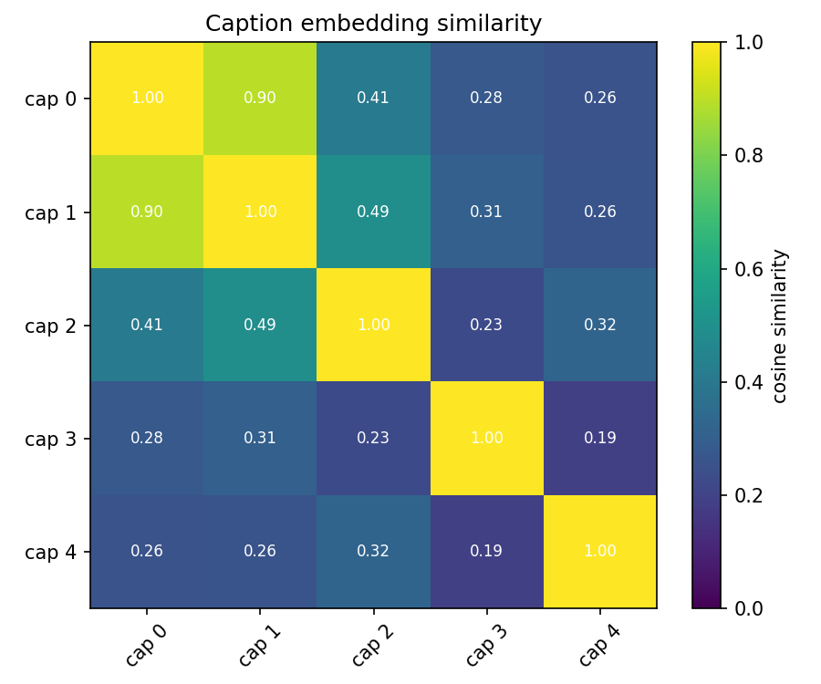
Figure 2 — Cosine-similarity heatmap between five caption embeddings. The near-duplicate pair (captions 0 and 1, both describing a red square) scores highest off-diagonal, confirming the embedding space is semantically meaningful rather than arbitrary.

Task 4 — Public Dataset Structure Analysis (Oxford-102 Flowers)
The Oxford-102 Flowers dataset (nelorth/oxford-flowers, loaded via the Hugging Face datasets library) was loaded and examined to understand its structure before it could be used downstream. The analysis script computes all three statistics the task calls for:
- Class count and images-per-class distribution — computed over the full dataset. 102 flower species (classes) are present, with a visibly imbalanced distribution: individual classes range from roughly 30 to over 240 images.
- Image resolution — width and height (min / max / mean) computed over a 300-image sample, since Oxford-102 source images vary in size rather than being pre-resized to a fixed resolution.
- Description length — word-count statistics over the same 300-image sample. This release of the dataset ships numeric class labels rather than free-text captions, so descriptions were generated from a fixed template ("a photo of flower species N"); as a result, word-count comes out essentially constant across classes — an expected property of the templated stand-in caption, not natural caption-length variation.
- Class distribution was plotted directly from the dataset rather than assumed, to catch the imbalance early — it matters for any classifier or conditional generator trained on the full dataset later.
- A grid of sample images paired with their text descriptions was generated to sanity-check that images and labels were correctly aligned after loading.
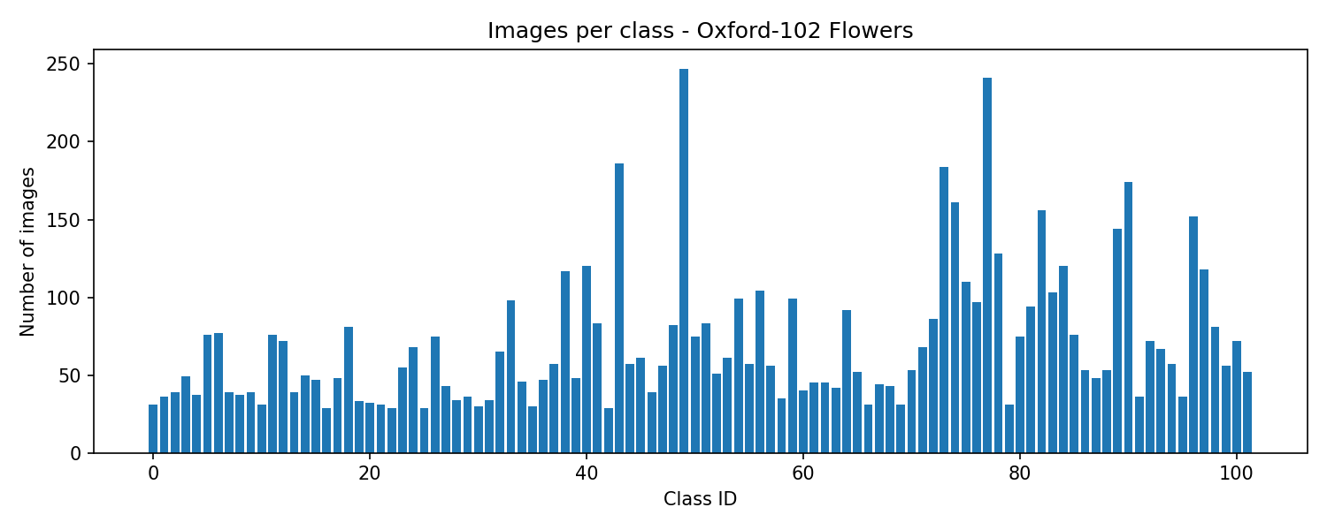
Figure 3 — Images per class across all 102 Oxford Flowers classes, showing significant class imbalance.
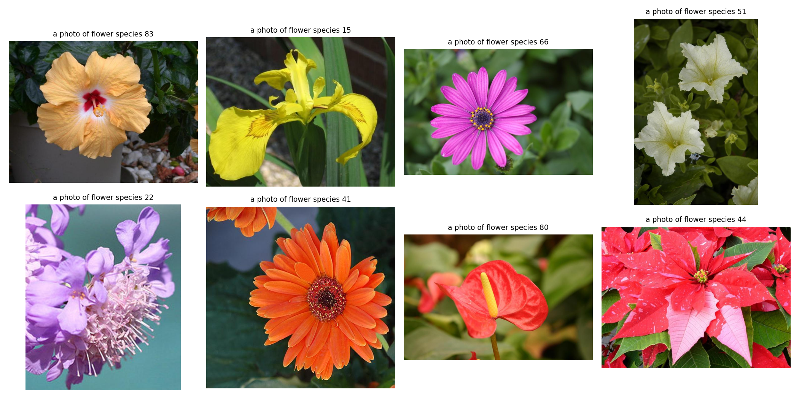
Figure 4 — Sample images with paired text descriptions, used to verify image/label/caption alignment.

Task 5 — Self-Attention CGAN (SAGAN-style)
Building on Task 2, a SAGAN-style self-attention block was inserted into both the generator and discriminator. The block computes query/key/value projections over the spatial feature map, forms an N×N attention map (softmax over scaled dot-products), and adds the attended output back via a learnable residual gate (gamma, initialized to 0 so attention contributes nothing until training finds it useful).
- Placed at the 16×16 feature-map stage in a 3-class (square/circle/triangle), 32×32-resolution generator — large enough for attention to matter spatially, small enough to keep training fast.
- Trained for 100 epochs, batch size 64, Adam (lr = 2e-4, β1 = 0.5, β2 = 0.999); the attention gate value was logged every 10 epochs to confirm the model was actually learning to use it, not leaving it at zero.
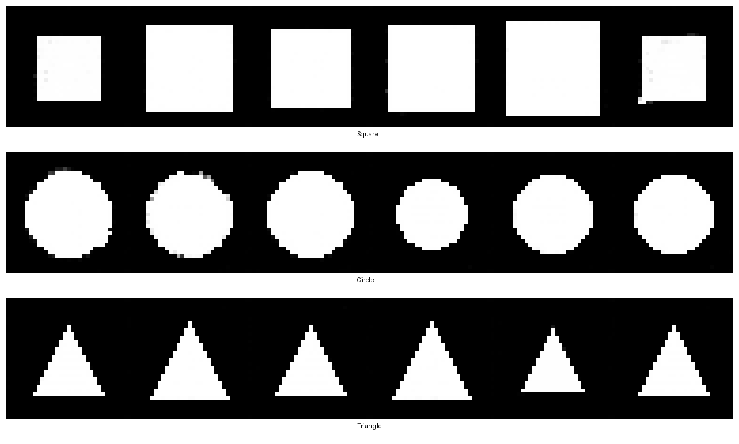
Figure 5 — Task 5 self-attention CGAN samples per class (6 samples each, upscaled for visibility).

Task 6 — End-to-End Text-to-Image Pipeline
Task 6 combines all prior components into one pipeline: free-text prompt → CLIP tokenization + pooled embedding (Task 3) → text-conditioned self-attention GAN (Task 5 architecture, now conditioned on the real CLIP embedding instead of a class index) → generated image → light post-processing cleanup (median filter + binarization) for a crisper final shape.
- Training data: the same procedural square/circle/triangle shapes as Tasks 2/5, but each class is described by 6 paraphrased caption templates (e.g. "a square", "a photo of a square", "a square outline") instead of a single class index — so the model has to learn from language variation, not just a fixed label.
- Training used spectral normalization on every discriminator layer and a two-timescale update rule (TTUR: generator lr 2e-4, discriminator lr 1e-4) for 150 epochs, with cuDNN set to deterministic mode for reproducible runs.
- At inference, the pipeline was tested with prompts never seen verbatim in training — "draw me a circle please" and "a sharp triangle shape" — to check it generalizes to paraphrase, not just memorized captions.
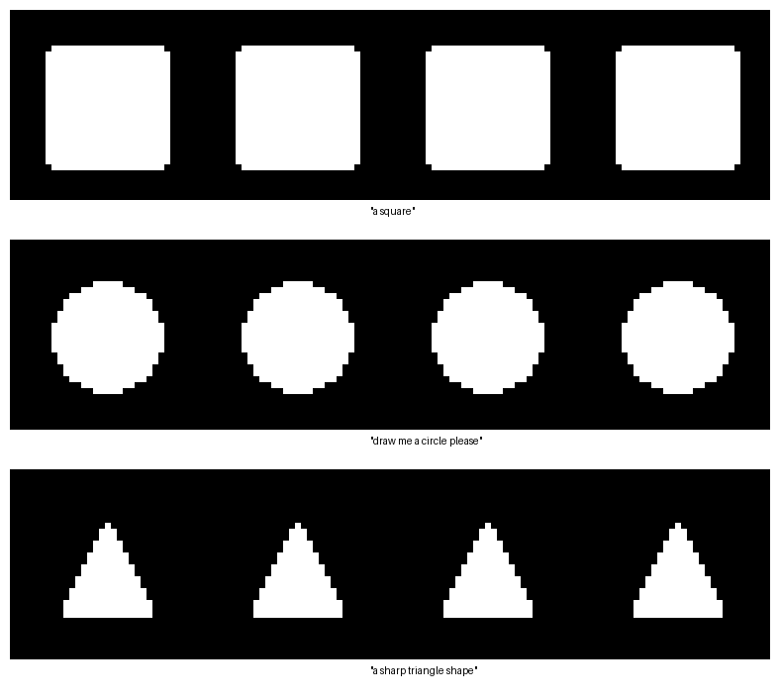
Figure 6 — Task 6 pipeline outputs for three free-form prompts, after post-processing cleanup.
The pipeline correctly generates the right shape for all three prompts, including the two paraphrased/unseen phrasings, demonstrating that conditioning on the pooled CLIP embedding (rather than a class index) generalizes across caption wording for this vocabulary.

5. Skills and Competencies
Category | Skills applied
Generative modeling | GANs (vanilla + conditional + self-attention/SAGAN-style), diffusion model fine-tuning, LoRA/PEFT
NLP / multimodal | CLIP tokenization and text encoding, per-token vs. pooled embeddings, embedding-space evaluation via cosine similarity
Frameworks & libraries | PyTorch, Hugging Face Transformers, Diffusers, PEFT, torchvision, scipy
Data engineering | Dataset loading and structural analysis (Oxford-102 Flowers), procedural synthetic data generation, class-balance auditing
Engineering practice | Reproducibility (seeded RNGs, deterministic cuDNN), spectral normalization / TTUR for GAN stability, debugging a real embedding-pooling bug end-to-end, post-processing/inference cleanup
Documentation | Structuring and reporting a multi-stage technical project for a non-implementer audience

6. Feedback and Evidence
No mentor support was available during the assignment (per the program's terms), so evaluation and debugging relied on self-review against expected behaviour at each stage — training loss curves, the CLIP similarity heatmap in Task 3, and visual inspection of generated samples. Evidence of correct behaviour at each stage:
- Task 2: all four shape classes are visually distinct and correctly generated on request (Figure 1).
- Task 3: the intentional near-duplicate caption pair scores highest similarity off-diagonal in the heatmap (Figure 2), confirming the text encoder captures meaning rather than surface tokens alone.
- Task 4: class distribution and sample grid (Figures 3–4) confirm the dataset loads correctly and exposes the class imbalance that would need to be addressed before any downstream training on the full dataset.
- Task 5: attention gate values were logged every 10 epochs and moved away from their zero initialization, evidence the self-attention block was actually contributing rather than being ignored by the optimizer.
- Task 6: correct generation for two unseen paraphrases of each shape (Figure 6) is direct evidence the pipeline conditions on caption meaning, not on memorized exact strings.
Submission artifacts (source code, trained weights, and all figures above) are included in the accompanying package for review, per the offer's requirement to submit running code alongside this report.

7. Challenges and Solutions
Challenge | Solution
Silent embedding-pooling bug in the Task 6 pipeline: an early version averaged CLIP's per-token embeddings across all 77 positions, which diluted short captions like "a square" (4 real tokens) with ~73 padding-token embeddings. | Switched to CLIP's own pooler_output (its EOS-token pooling, purpose-built for sentence-level representation) instead of a manual mean — documented explicitly in the pipeline script as a fix from a prior version, and re-verified paraphrase generalization afterward.
GAN training instability / inconsistent convergence between runs on the small shape dataset — occasionally one shape class would collapse into a blurred blob depending on random weight initialization. | Added spectral normalization to every discriminator layer and a two-timescale update rule (discriminator learning rate half the generator's), plus fully seeded and deterministic cuDNN settings so runs are reproducible for debugging.
A subtle weight-initialization bug: spectral_norm renames a layer's parameter to weight_orig and recomputes weight on every forward pass, so a naive weights_init() targeting weight silently failed to initialize those layers. | weights_init() was rewritten to detect and target weight_orig when present, so custom initialization actually reaches the spectrally-normalized layers instead of being discarded.
Class imbalance in the Oxford-102 Flowers dataset (roughly 30–240 images per class) surfaced during Task 4 analysis. | Flagged explicitly via the class-distribution plot rather than glossed over, so it is documented as a known constraint for anyone extending this work to full dataset training or classification on Oxford-102.
Oxford-102 Flowers ships numeric class labels, not free-text captions, so a genuine "description length" statistic (as the task specifies) isn't directly available. | Generated a consistent template description per class ("a photo of flower species N") so the required statistic could still be computed, and documented in the report that this yields near-constant word counts by construction rather than presenting it as natural caption variation.
No mentor support was available during the internship, per program terms. | Relied on self-verification at each stage (loss curves, embedding similarity checks, visual sample inspection) rather than external review, and documented reasoning/assumptions directly in code comments for later audit.

8. Outcomes and Impact
All six assigned tasks were completed and are demonstrably working end-to-end, with the later tasks genuinely built on top of the earlier ones rather than duplicating effort:
- A parameter-efficient LoRA fine-tuning workflow for Stable Diffusion that can be re-pointed at any domain dataset (art, medical imagery, etc.) by swapping one data-loading cell.
- A working conditional GAN and a self-attention-augmented conditional GAN, with attention shown (via gate-value logging) to be actively used rather than a no-op.
- A reusable CLIP-based text preprocessing/embedding module, validated with a concrete semantic-similarity test rather than assumed to work.
- A documented, reproducible dataset-analysis workflow applied to a real public dataset (Oxford-102 Flowers), surfacing a class-imbalance issue that would otherwise have gone unnoticed.
- A single integrated pipeline (Task 6) that takes a free-text prompt through tokenization, CLIP embedding, and attention-GAN generation, and was shown to generalize to two unseen paraphrasings per class — the clearest evidence that the individual components genuinely compose, which was the explicit goal of the final task.
Beyond the deliverables, the internship produced a debugged, reproducible codebase and a documented record of two non-trivial bugs (the embedding-pooling issue and the spectral-norm weight-init issue) that would likely recur in similar generative-model projects — value that extends past this specific submission.

9. Conclusion
This internship provided hands-on experience across the two dominant generative image modeling paradigms — GANs and diffusion models — and the text-encoding machinery that conditions both on natural language. Working through the tasks in dependency order (text encoding → dataset understanding → basic conditional generation → attention → full pipeline) made the final integration task substantially easier, and surfaced real engineering issues (embedding pooling, weight initialization under spectral norm, GAN training instability, dataset class imbalance) that a purely theoretical treatment of these models would not have exposed. The resulting codebase, trained weights, and this report are submitted together as the complete deliverable for the internship's Data Science track.

