An Internship Report

Of

IoT Cloud Engineer Virtual Internship
Submitted
To

School of Computer Science and Engineering
IILM University, Greater Noida, U.P.

In partial fulfilment of the requirement of degree of
B.Tech CSE


By

Roll Number of Student:2410030590
Name of Student: YASH TYAGI
Batch:
2024-28

CANDIDATE'S DECLARATION
I, Yash Tyagi, do hereby declare that the internship report titled "IoT Cloud Engineer Virtual Internship" has been completed by me to fulfil the requirement for the award of the degree of Bachelor of Technology in Computer Science and Engineering. All the references have been quoted and I have not taken as such any material from any other source. I affirm that this report is my own work and has not been submitted to any other institute for any degree/diploma requirement, and I shall be solely responsible for any kind of copyright violation in this regard.
Signature:
Student Name: Yash Tyagi
Roll No.: 2410030590

ACKNOWLEDGEMENT
I am using this opportunity to express my gratitude to everyone who supported me throughout the IoT Cloud Engineer Virtual Internship Program. I am thankful for their aspiring guidance, invaluably constructive criticism, and friendly advice during this work. I am sincerely grateful to the National Internship Portal, the All India Council for Technical Education (AICTE), and EduSkills for organizing and facilitating this virtual internship, and for providing access to the AWS Skill Builder curriculum that formed the backbone of this learning experience.
I would also like to thank the faculty of the School of Computer Science and Engineering, IILM University, Greater Noida, for their continuous support and encouragement throughout the duration of this internship.
I express my gratitude to my parents for their blessings.
Signature:
Student Name: Yash Tyagi
Roll No.:2410030590

INTERNSHIP COMPLETION CERTIFICATE
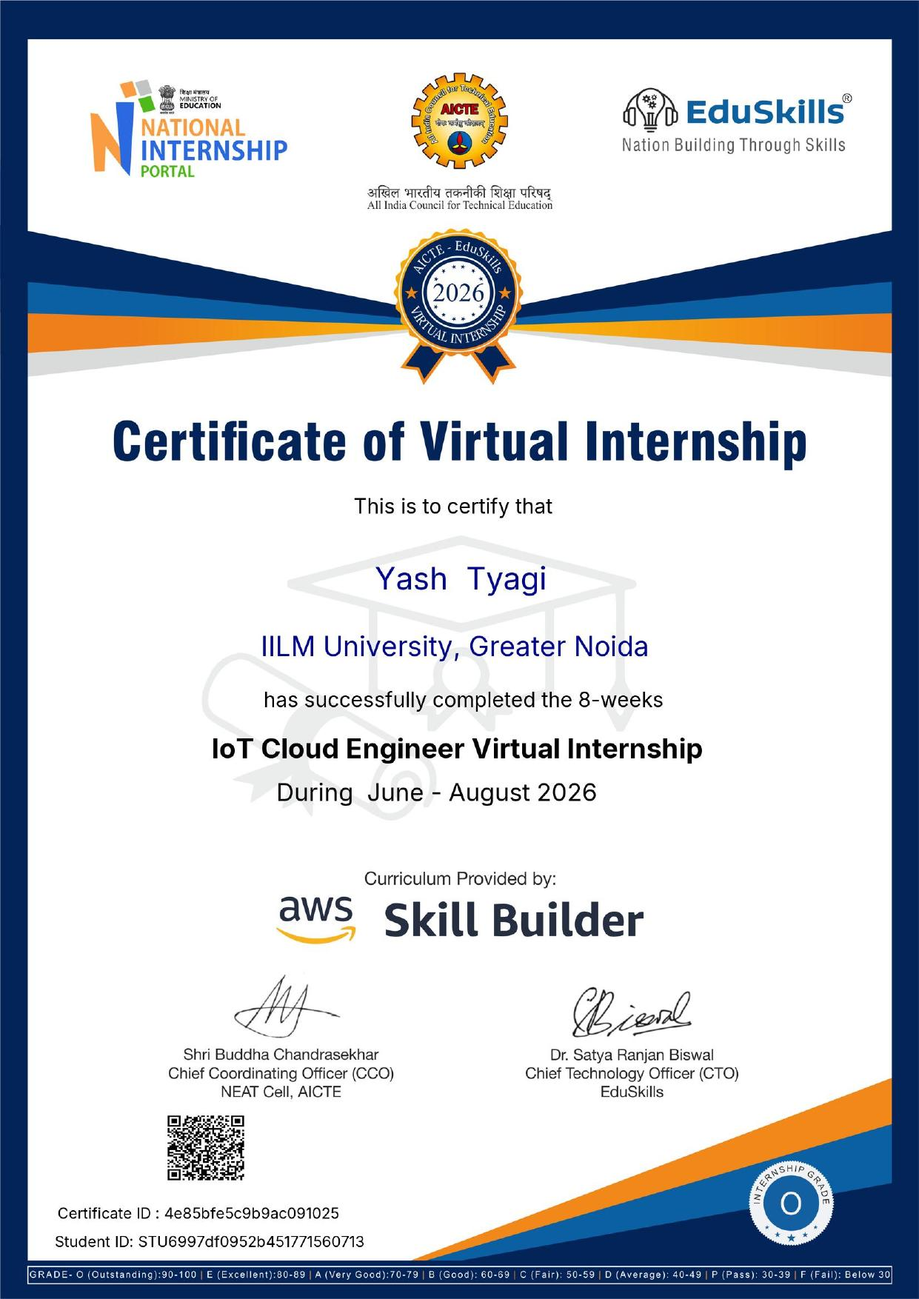

TABLE OF CONTENTS
Chapter No. | Chapter Name
 | Cover Page
1. | Candidate's Declaration
2. | Acknowledgement
3. | Internship Completion Certificate
4. | Project Description
 | 4.1 Introduction
 | 4.2 Organization Profile
 | 4.3 Problem Statement
 | 4.4 Project Objectives
 | 4.5 Scope of the Project
 | 4.6 Technologies and Tools Used
 | 4.7 System Architecture
 | 4.8 Methodology
 | 4.9 Expected Outcomes
 | 4.10 Certificates of Completion and Communication
5. | Bibliography/References

Chapter 4: Project Description

4.1 Introduction
This report presents the work undertaken during the 8-week IoT Cloud Engineer Virtual Internship, conducted under the National Internship Portal (NIP) initiative by the All India Council for Technical Education (AICTE) in association with EduSkills. The internship curriculum was provided by AWS Skill Builder and was carried out from June 2026 to August 2026 as part of the academic requirements for the degree of Bachelor of Technology in Computer Science and Engineering at IILM University, Greater Noida.
The Internet of Things (IoT) refers to a network of physical devices, sensors, and systems that are connected to the internet and are capable of collecting and exchanging data. When combined with cloud computing, IoT solutions gain the ability to store, process, and analyse this data at scale, enabling intelligent automation, real-time monitoring, and predictive decision-making across industries such as manufacturing, healthcare, agriculture, and smart cities. The IoT Cloud Engineer Virtual Internship was designed to build practical, industry-relevant skills in designing, deploying, and managing IoT solutions on Amazon Web Services (AWS).
Throughout the internship, self-paced learning modules, hands-on labs, and guided projects on the AWS Skill Builder platform were used to build a strong foundation in cloud computing fundamentals and IoT-specific services, culminating in the successful completion of the program with an overall grade of 'O' (Outstanding).

4.2 Organization Profile
The internship was facilitated jointly by the following organizations:
- National Internship Portal (NIP) – An initiative under the Ministry of Education, Government of India, that connects students with structured internship opportunities across various domains to enhance employability and practical skill development.
- All India Council for Technical Education (AICTE) – The statutory body responsible for planning, promotion, and quality assurance of technical education in India, which oversees the NEAT (National Educational Alliance for Technology) Cell that coordinates such virtual internship programs.
- EduSkills – An AICTE-approved training and skilling partner under the tagline 'Nation Building Through Skills', responsible for coordinating the virtual internship, delivering orientation sessions, and issuing the completion certificate.
- Amazon Web Services (AWS) Skill Builder – The official AWS training platform that provided the complete curriculum for the IoT Cloud Engineer track, including digital courses, hands-on labs, and skill-builder assessments used throughout the internship.

4.3 Problem Statement
Organizations today are increasingly deploying connected devices and sensors to monitor equipment, environments, and processes in real time. However, many students and early-career engineers lack hands-on exposure to designing and operating cloud-based IoT systems that can securely ingest, process, and act on data generated by such devices. This internship addressed the problem of bridging this skills gap by providing structured, hands-on training in building an end-to-end IoT solution using AWS cloud services — covering device connectivity, data ingestion, storage, analytics, and visualization.

4.4 Project Objectives
- To understand the fundamental concepts of the Internet of Things (IoT) and cloud computing.
- To gain hands-on experience with core AWS services used in building IoT solutions, such as AWS IoT Core, Amazon S3, AWS Lambda, and Amazon CloudWatch.
- To learn how to securely connect, register, and manage IoT devices in the cloud.
- To design a basic architecture for collecting, processing, and storing sensor/device data.
- To build skills in monitoring, visualizing, and analysing IoT data for actionable insights.
- To develop an understanding of security best practices in IoT-cloud environments.

4.5 Scope of the Project
The scope of the internship was limited to the self-paced curriculum and hands-on labs provided through the AWS Skill Builder platform for the IoT Cloud Engineer learning path. It covered foundational to intermediate-level concepts of cloud computing and IoT architecture on AWS, without extending into advanced production deployment, custom hardware prototyping, or enterprise-scale IoT device fleets. The internship provided a strong conceptual and practical base that can be extended in future academic or professional projects.

4.6 Technologies and Tools Used
- Cloud Platform: Amazon Web Services (AWS)
- Core IoT Service: AWS IoT Core (device connectivity, message broker, device shadow)
- Compute: AWS Lambda (serverless data processing)
- Storage: Amazon S3, Amazon DynamoDB
- Monitoring & Visualization: Amazon CloudWatch, AWS IoT Analytics
- Security & Identity: AWS Identity and Access Management (IAM), X.509 device certificates
- Learning Platform: AWS Skill Builder (courses, digital labs, assessments)

4.7 System Architecture
The IoT-cloud architecture studied and practised during the internship follows a layered approach:
- Device Layer: Physical or simulated IoT sensors/devices that collect data (e.g., temperature, humidity, motion).
- Connectivity Layer: Devices securely connect to AWS IoT Core using MQTT/HTTPS protocols authenticated via X.509 certificates.
- Ingestion & Processing Layer: AWS IoT Core rules route incoming messages to AWS Lambda functions for real-time processing and transformation.
- Storage Layer: Processed data is stored in Amazon S3 for raw/historical data and Amazon DynamoDB for structured, queryable records.
- Monitoring & Visualization Layer: Amazon CloudWatch dashboards and AWS IoT Analytics are used to monitor device health and visualize trends in the collected data.
This architecture reflects standard industry practice for scalable, secure, and serverless IoT solutions on AWS.

4.8 Methodology
The internship followed a self-paced, module-based learning methodology structured over 8 weeks as follows:
- Orientation and onboarding to the National Internship Portal and AWS Skill Builder platform.
- Completion of foundational AWS Cloud Practitioner-level modules covering cloud computing concepts, AWS global infrastructure, and core services.
- In-depth study of AWS IoT Core, including device registration, device shadows, and MQTT-based messaging.
- Hands-on labs involving serverless data processing using AWS Lambda triggered by IoT events.
- Data storage and retrieval exercises using Amazon S3 and Amazon DynamoDB.
- Monitoring and analytics practice using Amazon CloudWatch and AWS IoT Analytics.
- Review of IoT security best practices, including certificate-based authentication and IAM policies.
- Final skill assessments and quizzes on the AWS Skill Builder platform, leading to successful completion of the internship with an 'O' (Outstanding) grade.

4.9 Expected Outcomes
- A solid conceptual understanding of IoT and cloud computing fundamentals.
- Practical, hands-on familiarity with AWS IoT Core and related AWS services.
- Ability to design a basic secure, serverless IoT-cloud architecture.
- Improved skills in cloud-based data storage, processing, and visualization.
- Awareness of industry-standard security practices for connected devices.
- An industry-recognized certification (AICTE–EduSkills, curriculum by AWS Skill Builder) strengthening the student's employability profile.

4.10 Certificates of Completion and Other Communication
The Certificate of Virtual Internship, issued jointly by the National Internship Portal, AICTE, and EduSkills with curriculum provided by AWS Skill Builder, is attached in Chapter 3 of this report (Internship Completion Certificate). Key details of the certificate are summarized below:
Intern Name | Yash Tyagi
Institution | IILM University, Greater Noida
Internship Title | IoT Cloud Engineer Virtual Internship
Duration | 8 Weeks (June – August 2026)
Curriculum Provided By | AWS Skill Builder
Issued By | National Internship Portal, AICTE (NEAT Cell) & EduSkills
Grade Awarded | O (Outstanding) — 90-100
Certificate ID | 4e85bfe5c9b9ac091025
Student ID | STU6997df0952b451771560713
Chief Coordinating Officer (CCO), NEAT Cell, AICTE | Shri Buddha Chandrasekhar
Chief Technology Officer (CTO), EduSkills | Dr. Satya Ranjan Biswal

Chapter 5: Bibliography/References
AWS Skill Builder. IoT Cloud Engineer Learning Plan. Amazon Web Services. https://skillbuilder.aws
AWS IoT Core Developer Guide. Amazon Web Services. https://docs.aws.amazon.com/iot/
National Internship Portal. All India Council for Technical Education (AICTE). https://internship.aicte-india.org
EduSkills Foundation. Nation Building Through Skills. https://eduskillsfoundation.org

