(1).**what is Sdlc?**

**A**.SDLC is a structure imposed on the development of a software Productthat defines the process for planning, implementation,Testing, documentation, deployment, and ongoing maintenance and Support.

(2).**What is software testing?**

**A**.Software Testing is a process used to identify the correctness, Completeness, and quality of developed computer software.

(3).**What is agile methodology?**

**A**.Agile SDLC model is A Combination of iterative and incremental Process models with focus on process adaptability and customer Satisfaction by rapid delivery of working software product.

(4).**What is SRS?**

**A**.software requirements specification is a complete descriptionof the Behavior of the system to be developed.

(5).**What is oops?**

**A**.Identifying objects and assigning responsibilities to these objects.

(6).**Write Basic Concepts of oops.**

* **A.OOPS (Object-oriented programming system) basic concept is ( i )** class

( ii ) Object

( iii ) Encapsulation

( iv ) Inheritance

( v ) Polymorphism

( vi ) Abstraction

(7). **What is object?**

**A.**This is the basic unit of object oriented programming (OOP). That is both Data and function that operate on data are bundled as a Unit called as object.

(8).**What is Class?**

**A**. class represents an abstraction of the object and abstracts the Properties And behaviour of that object. When you define a class, you define Aa blueprint for an object.

(9).**What is Encapsulation?**

**A.**Encapsulation isthe practice of including in an object everythingit needs Hidden from other objects. The internal state is usually not accessible by Other objects.

(10).**What is inheritance?**

**A.**Inheritance means that one class inherits the characteristics of Another class. This is also called a “is a” relationship.

(11).**What is polymorphism?**

**A.**Polymorphism means “having manyforms”. It allows different objects to respond to the same message indifferent Ways, the responsespecific to the typeof theobject.

(**12**).**Draw Use case on Online book shopping ?**

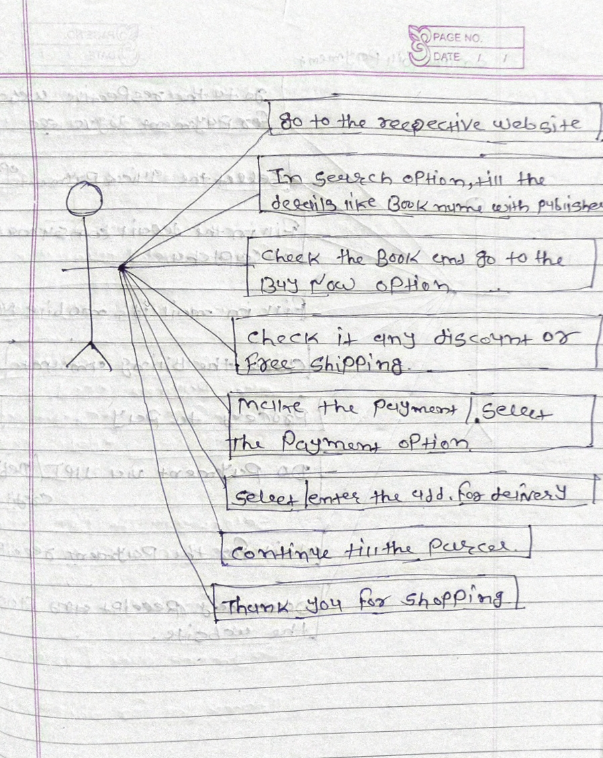

(13).**Draw Use case on online bill payment system (paytm)?**

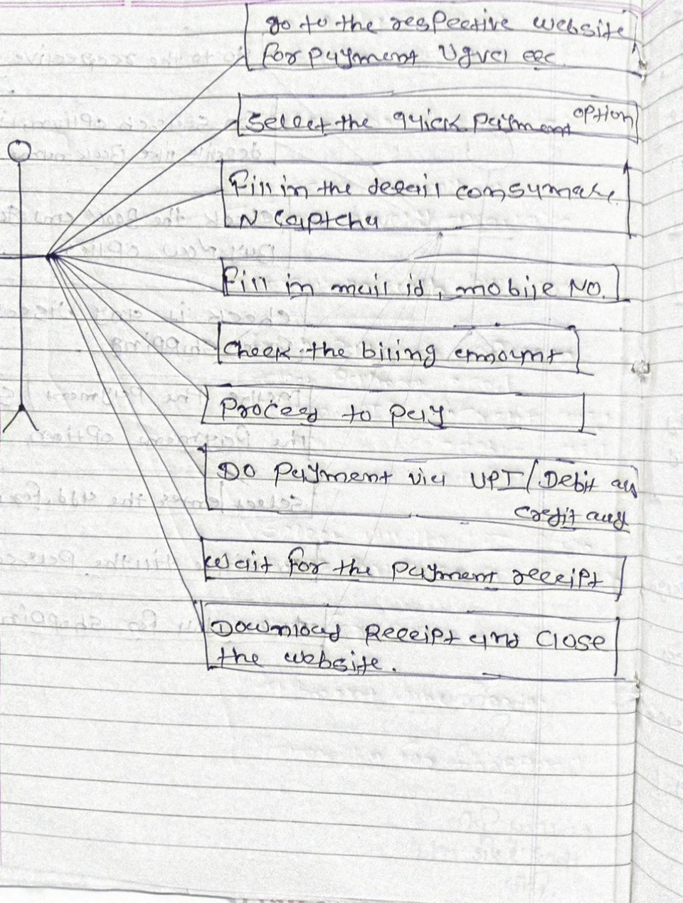

**(14)Write SDLC phases with basic introduction?**

**A.SDLC phases is,**

**1.Requirement Gathering :- Requirements definitions usually consist of Natural language, Supplemented by (e.g., UML) diagrams and tables.**

**2.Analysis :- The analysis phase defines the.requirements of the system,Independent of How these requirements will be accomplished.**

**3.Design :- The Design team can now expand upon the information Established in the requirement document. The requirement document Must guide this decision process. Analysing the trade-offs of necessary Complexity allows for many things To remain simple which, in turn, will Eventually lead to a higher quality Product.**

**4.Implementation :- Implementation – Code, Critical Error Removal The Implementation phase Deals with issues of quality, Performance, Baselines, Libraries, and debugging.**

**5.Testing :- Simply stated, quality is very Important. Many companies Have not learned that quality is Important and deliver more Claimed Functionality but at Lower quality level.**

**6.Maintenance :- Repair defects and adapt the solution.to the new. requirements.**

**(15).Explain Phases of the waterfall model ?**

**A.**Waterfall model is The classical software lifecycle models the software Development as a step – by – step “ waterfall ” between the variou Development phases. Waterfall is a short term project. Requirements must be Frozen to early in the life product.

**(16).)Write phases of spiral model?**

**A.( i ) Planning :-** Determination of objective, alternatives and constraints.

**( ii ) Risk Analysis :-** Analysis alternatives and identifications/ resolution of risk

**( iii ) Customer Evaluation :-** Assessment of the result of engineering.

**( iv ) Engineering :-** Development of the “ next level ” product.

**(17).Write agile manifesto principles ?**

**A.**There are four principal :**1.**individual interaction

**2.**working software

**3.**customer collaboration

**4.**Responding to change

**(18).Explain working methodology of agile model and also write pros and Cons ?**

**A. Agile SDLC model is a combination of iterative and incremental Process Models with focus on process adaptability and customer Satisfaction by rapid Delivery of working software product.**

**Pros :- •** Is a very realistic approach to software development

**•** Promotes teamwork and cross training?

**•** Functionality can be developed rapidly and demonstrated.

**•** Resource requirements are minimum.

**•** Suitable for fixed or changing requirements.

**Cons :- •** Not suitable for handling complex dependencies.

**•** More risk of sustainability, maintainability and extensibility.

**•** An overall plan, an agile leader and agile PM practice is a must Without which it will not work.

**•** Depends heavily on customer interaction, so if customer is not clear, Team Can be driven in the wrong direction.

**•** There is very high individual dependency, since there is minimum. Documentation generated.

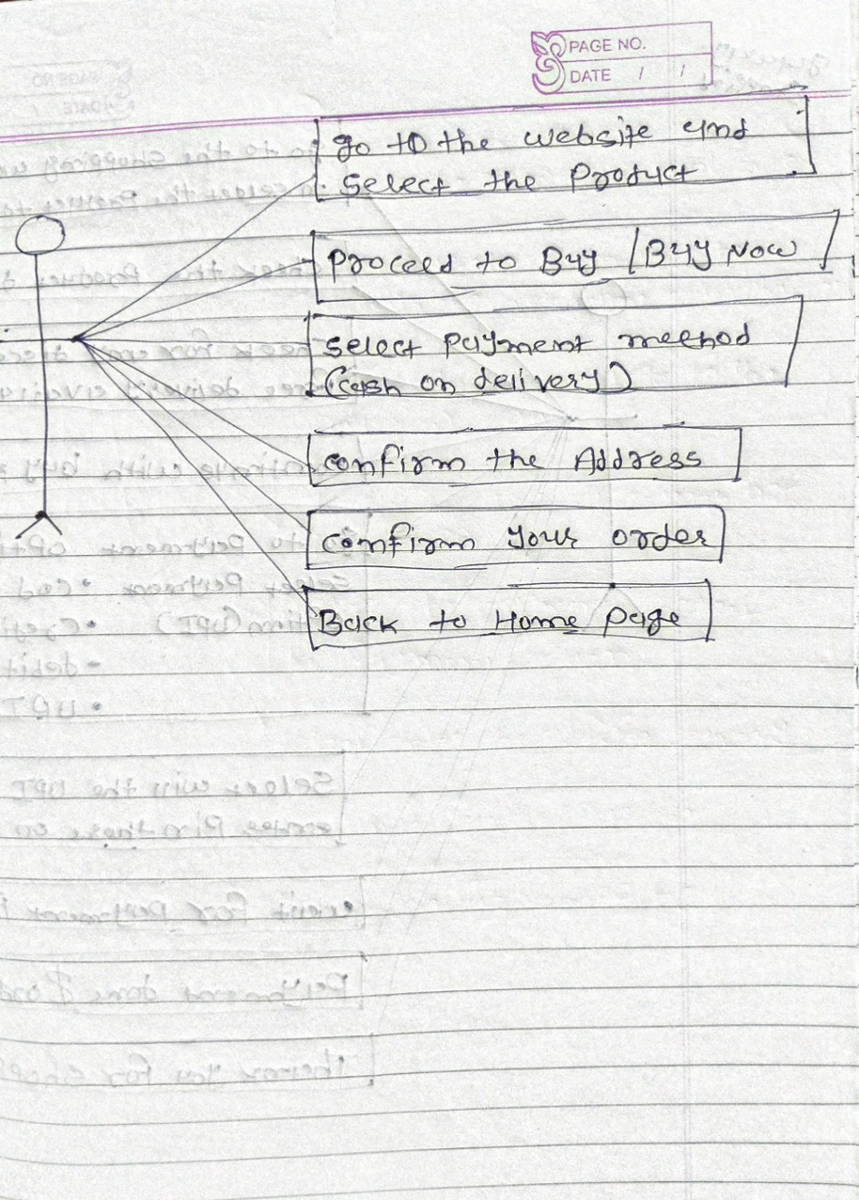**(19).Draw use case on Online shopping product using COD?**

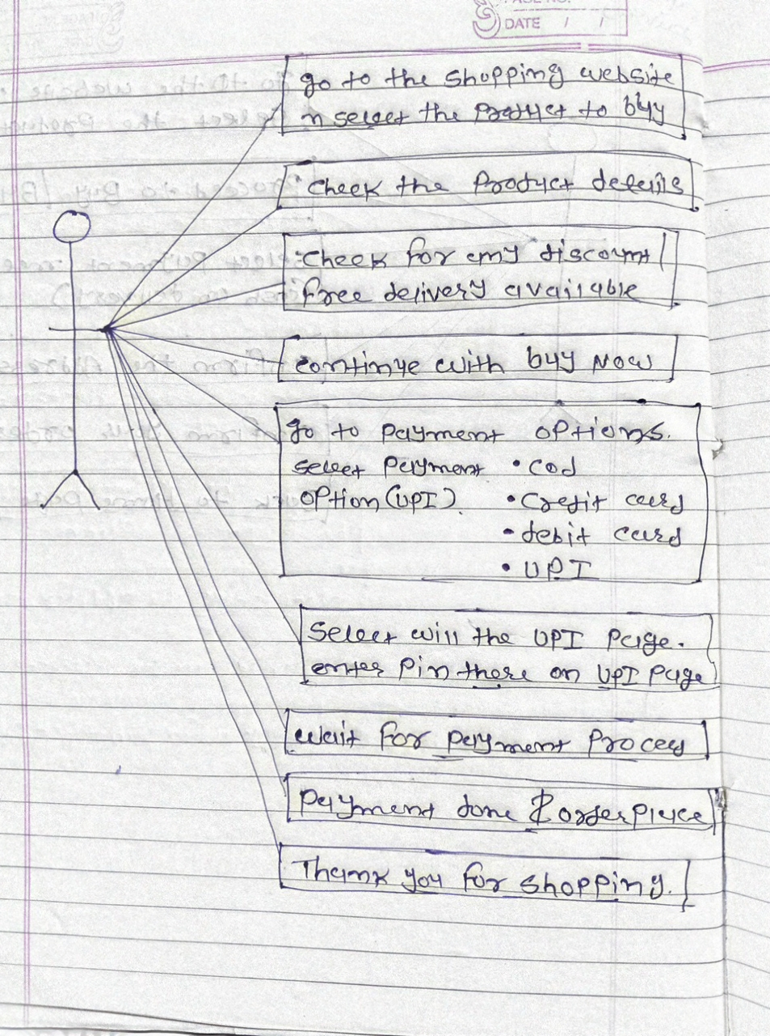**(20).Draw usecase on Online shopping product using payment gateway.**