
Name: _________________
Roll No: ________________
Section: ________________

Int-213
PYTHON
PROJECT

Topic- Classic Snake Game

Submitted to- Mr. Sagar Pandey

Submission date- November 2020

By – Yash Vardhan Korrapati ramjeevan
11908366 11908530
61 69
Summary

In this project named ‘The Classic Snake Game’ we have tried using some libraries like pygame , time and random to make the program run smoothly and provide a good gaming experience.

We have tried to keep the code simple and have added a lot of comments just to make the program more understandable.

Acknowledgement

We would like to express my special thanks of gratitude to my teacher Mr.Sagar Pandey who gave us the golden opportunity to do this wonderful project on the topic The Classic Snake Game which also helped me in doing a lot of Research and we came to know about so many new things we am really thankful to him.
Secondly we would also like to thank my friends who helped me a lot in finalizing this project within the limited time frame.

Content

- Title page
- Summary
- Acknowledgement
- Introduction
- Project Objective
- Result
- Reference

Introduction

Snake is the common name for a video game concept where the player manoeuvres a line which grows in length, with the line itself being a primary obstacle. The concept originated in the 1976 arcade game Blockade, and the ease of implementing Snake has led to hundreds of versions (some of which have the word snake or worm in the title) for many platforms.
For our version we have used the name ‘The Snake Game’.

Following is the list of some of the functions that have been used in the program with their description against them.

Function | Description
init() | Initializes all of the imported Pygame modules (returns a tuple indicating success and failure of initializations)
display.set_mode() | Takes a tuple or a list as its parameter to create a surface (tuple preferred)
update() | Updates the screen
quit() | Used to uninitialize everything
set_caption() | Will set the caption text on the top of the display screen
event.get() | Returns list of all events
Surface.fill() | Will fill the surface with a solid color
time.Clock() | Helps track time
font.SysFont() | Will create a Pygame font from the System font resources

Now we will be breaking the down code and explain it bit by bit.

Creation of the screen

To create the screen using Pygame, made the use of the display.set_mode() function. Also, we have used the init() and the quit() methods to initialize and uninitialize everything at the start and the end of the code respectively. The update() method is used to update any changes made to the screen.

Now, you have a screen to play your Snake Game, but when you try to click on the close button, the screen does not close. This is because you have not specified that your screen should exit when you hit that close button

Creating the Snake

To create the snake, we will first initialize a few colour variables in order to colour the snake, food, screen, etc. The colour scheme used in Pygame is RGB i.e “Red Green Blue”. In case you set all these to 0’s, the colour will be black and all 255’s will be white. So our snake will actually be a rectangle. To draw rectangles in Pygame, you can make use of a function called draw.rect() which will help you draw the rectangle with the desired colour and size.

Moving the Snake

To move the snake, you will need to use the key events present in the KEYDOWN class of Pygame. The events that are used over here are, K_UP, K_DOWN, K_LEFT, and K_RIGHT to make the snake move up, down, left and right respectively. Also, the display screen is black coloured.

I have created new variables x1_change and y1_change in order to hold the updating values of the x and y coordinates respectively.

Game over conditions

In this snake game, if the player hits the boundaries of the screen, then he loses. To specify that, we have made use of an ‘if’ statement that defines the limits for the x and y coordinates of the snake to be less than or equal to that of the screen. Also, make a note over here that we have used variables instead so that it becomes easy in case you want to make any changes to the game later on.

The food item

Here, I will be adding some food for the snake and when the snake crosses over that food the size of the snake increases by one unit or one rectangle Also, We have made a small change wherein we will include the options to quit the game or to play again when the player loses.

Increasing the length of snake

The following code will increase the size of our sake when it eats the food. Also, if the snake collides with his own body, the game is over and you you’ll see a message as “You Lost! Press Q-Quit or P-Play Again“. The length of the snake is basically contained in a list and the initial size that is specified in the following code is one block.

The score

Last but definitely not the least, you will need to display the score of the player. To do this, We have created a new function as “Your_score”. This function will display the length of the snake subtracted by 1 because that is the initial size of the snake.

So by combining all these methods and logics we are finally able to produce an output window in which the player is able to play the game and the game gets over when the snake either hits the boundary or hits itself also the length of the snake increases if the snake eats a food item.

The output screen looks something like this:

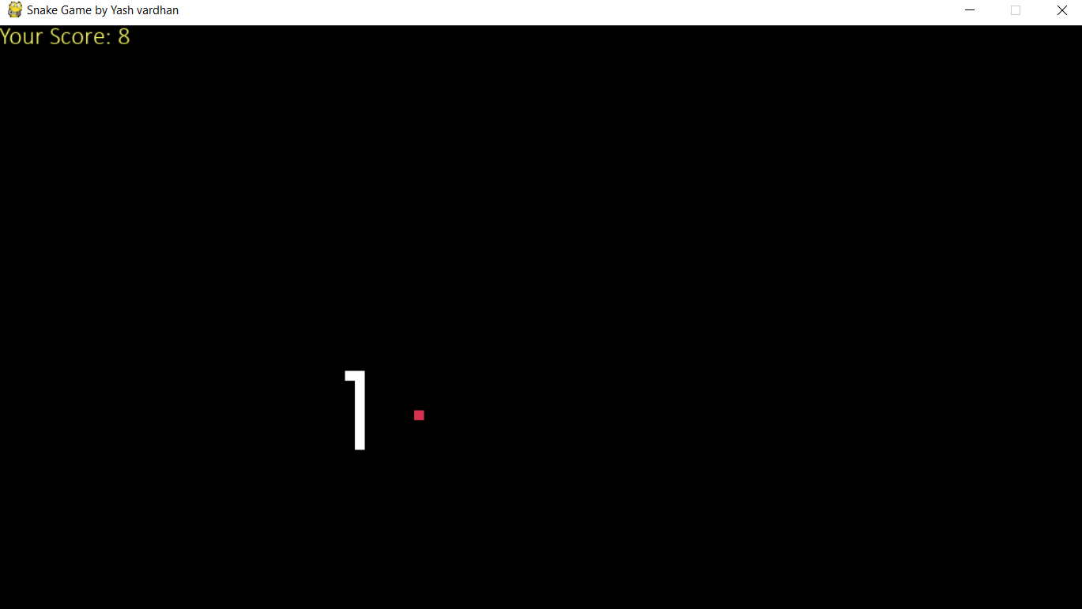

Here in the output screen we can see that we have a white coloured snake a red coloured food item a black coloured back ground and out current score at the top left corner.

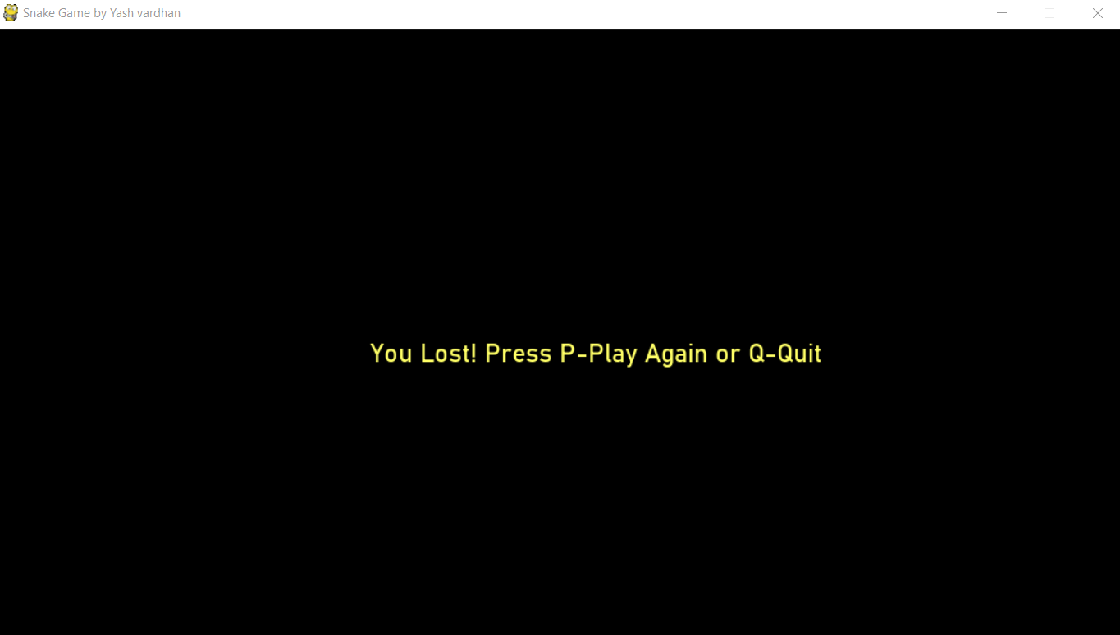

This is when you either hit the boundary or the snake hits itself and the game gets over

Project Objective
The objective of this project to learn about the different type of libraries that python can handle and about the different methods the library include in them.
In the completion of this project we learnt about three libraries, which are-
Random library
Pygame library
Time library

We also learnt about work distribution and time management and learnt how to work in a team.

We also learnt about some functions like init(),update(),quit(),fill() etc.

Result

The result of the code must be pretty clear by now.
On running the code we get a window with the snake and one food item in it and as we gradually control the snake using the arrow keys and start eating the food the length of the snake also if the snake hits the boundary or hits itself the game gets over. The visuals for the same can be seen above in the images provided.
References

Class Notes
Sourcecodester.com
Stackoverflow.com

THANK YOU

