Surrogate Modeling of a Binary Distillation Column Using DWSIM and Machine Learning
Project Report
Name: Yash Waghmare
FOSSEE Autumn 2026 Internship — Screening Task 3
Submission Date: [submission date]

1. Problem Statement
Distillation columns are usually simulated in DWSIM to obtain accurate steady-state performance data, but a single rigorous DWSIM run for one operating condition takes noticeable time. Tasks such as process optimization, sensitivity analysis, or repeated what-if evaluation need the column to be solved hundreds or thousands of times over a range of conditions, and repeatedly calling DWSIM for every evaluation quickly becomes expensive and impractical for interactive or iterative use.
This project addresses that cost by building a machine-learning surrogate for a Benzene–Toluene binary distillation column simulated in DWSIM under Peng–Robinson thermodynamics. A large batch of DWSIM simulations was generated over a range of feed and column operating conditions, and several regression models were trained to reproduce the column's key performance outputs directly from those operating conditions, without calling DWSIM again. Once trained, the surrogate predicts these outputs almost instantly, which makes it suitable for use inside an optimization loop or a sensitivity study where the rigorous simulator would otherwise be the bottleneck.
The surrogate predicts four outputs: x_D_benzene (distillate benzene purity), x_B_benzene (bottoms benzene purity), Q_C (condenser duty), and Q_R (reboiler duty).

2. DWSIM Flowsheet / Model Description

2.1 Thermodynamic Model
The column separates a Benzene–Toluene mixture using Peng–Robinson thermodynamics, a property package well suited to this class of hydrocarbon system.

2.2 Flowsheet Configuration
The flowsheet is not built manually in the DWSIM GUI. Instead, it is constructed and solved programmatically in src/simulation/model_generator.py, using DWSIM's Automation API through pythonnet, so the same construction logic can be re-run for every sampled operating condition in the sampling scripts.
The main components of the flowsheet are:
- Benzene and Toluene as the two compounds, with the Peng–Robinson property package assigned to the column.
- A feed material stream, a distillate product stream, a bottoms product stream, and two energy streams (condenser duty and reboiler duty) connected to the column so that Q_C and Q_R can be read back once the column solves.
- A DistillationColumn unit operation, with the number of stages set for each sampled case.
- Feed conditions defined by pressure, a fixed molar flow of 100 kmol/h, and a benzene/toluene composition, with the feed flashed on a Pressure–Vapour-Fraction (PVF) basis.
- A feed stage computed from the sampled feed-stage fraction, and a column top pressure set from the feed pressure and applied uniformly across the stages.
- A condenser specification given as reflux ratio, and a reboiler specification given as the bottoms product molar flow rate (feed flow × bottoms fraction).
- Convergence checks after solving: the flowsheet is run, and the solved and calculated flags are checked before any output is trusted; failed cases are logged with their error message.
- Output extraction of x_D and x_B from the distillate and bottoms composition, and Q_C and Q_R from the condenser and reboiler duty, only for cases confirmed to have solved.
A representative saved flowsheet is included at dwsim_flowsheets/binary_distillation.dwxmz.

2.3 Simulation and Output Extraction
Every dataset used later in the project is produced by calling this same flowsheet-construction and solving logic once per sampled operating condition, so that all simulations, whether used for training or holdout evaluation, come from an identical model.
Figure 1: DWSIM flowsheet used for the binary distillation simulation.

3. Input and Output Variables

3.1 Sampled Inputs
These seven quantities are sampled per case and used directly as ML model features (see notebooks/04_Model_Training.ipynb):
- pressure_atm — feed / column pressure
- requested_vapor_fraction — feed vapour-phase mole fraction, the target vapour fraction of the PVF flash
- benzene_feed_fraction — feed benzene mole fraction (toluene_feed_fraction = 1 − benzene, so it is not an independent second input)
- stages — number of column stages
- feed_stage_fraction — feed-stage location, expressed as a fraction of total stages
- reflux_ratio — condenser reflux ratio
- bottoms_fraction — fraction of feed withdrawn as bottoms product

3.2 Derived Variables
A few additional quantities are computed from the sampled inputs rather than sampled independently:
- feed_stage (an absolute stage index) = round(feed_stage_fraction × stages), clipped to a valid stage — this is the value actually used to connect the feed to the column.
- bottoms_flow_kmol_h = feed_flow_kmol_h × bottoms_fraction, passed to the reboiler's product-flow specification.
Feed temperature is obtained from the PVF flash calculation rather than being sampled independently, and is not used as an ML feature.
- column_pressure_pa (= pressure_atm × 101325) is the same physical quantity as feed pressure, expressed in different units, rather than an independent extra input.
- feed_flow_kmol_h is logged for every row but held fixed at 100 kmol/h across all cases, so it is never varied and never used as a feature.

3.3 Output Variables
Column name | Meaning | Unit
x_D_benzene | Distillate (top product) benzene mole fraction | mole fraction, dimensionless
x_B_benzene | Bottoms (bottom product) benzene mole fraction | mole fraction, dimensionless
Q_C | Condenser duty | kW
Q_R | Reboiler duty | kW

4. Dataset Generation Strategy
All datasets are produced with the same simulation logic in src/simulation/model_generator.py, invoked from four sampling scripts that differ in sampler, sample count, and purpose:
File | Purpose | Sampling method | Requested | Valid rows
01_sobol_validation.py | Smoke test of the DWSIM automation pipeline | Sobol | 10 | 10
02_sobol_intermediate_validation.py | Intermediate validation, incl. a dedicated vapour-fraction check | Sobol | 256 + 32 | 256 / 32
03_generate_2560_sobol.py | Main training/validation pool | Sobol | 2,560 | 2,524
04_generate_500_lhs.py | Independent holdout set | LHS | 500 | 491

The main Sobol sampling run requested 2,560 cases, of which 2,524 valid rows were retained for model development. The independent LHS run requested 500 cases, of which 491 valid rows were retained for holdout evaluation. The resulting modelling dataset therefore contains 3,015 valid rows.
Sobol, a low-discrepancy, space-filling sequence, is used for the large training/validation pool, while an independently seeded Latin Hypercube design is used purely for the holdout set. This means the holdout data comes from a differently structured sample rather than just more points from the same Sobol grid.
Each sampled point is passed through the DWSIM simulation pipeline, and every case is logged with explicit convergence and validity flags (dwsim_solved, column_calculated, output_values_valid, composition_valid, temperature_valid, case_valid), along with an error message for diagnosing failed cases. Non-converged cases, roughly 2% of both the Sobol and LHS batches, are excluded from the modelling dataset rather than silently dropped, and remain in the raw *_not_converged.csv files.
The cleaned, combined modelling dataset used downstream is data/04_processed_dwsim/final_ml_dataset.csv (3,015 valid rows), which carries a split column distinguishing its two sources: sobol_train_val (2,524 rows, used for the 70/30 train/validation split and tuning) and lhs_holdout (491 rows, used only for the final holdout evaluation and physical-consistency checks). A second file, data/04_processed_dwsim/sobol_training_cleaned.csv, holds just the Sobol training pool's input and target columns and is used as the baseline-median source for the sensitivity sweeps in Section 10.

5. Range of Operating Conditions
Variable | Meaning | Minimum | Maximum | Unit
pressure_atm | Feed / column pressure | 1.0 | 2.0 | atm
requested_vapor_fraction | Feed vapour-phase mole fraction | 0.00 | 0.30 | mole fraction
benzene_feed_fraction | Feed benzene mole fraction | 0.30 | 0.70 | mole fraction
stages | Number of column stages | 10 | 30 | count
feed_stage_fraction | Feed-stage location (fraction of stages) | 0.30 | 0.70 | fraction
reflux_ratio | Reflux ratio | 1.2 | 4.5 | dimensionless
bottoms_fraction | Fraction of feed withdrawn as bottoms | 0.40 | 0.60 | fraction

These ranges are taken from src/sampling/03_generate_2560_sobol.py and are applied identically to the LHS holdout batch in 04_generate_500_lhs.py.

6. Data Preprocessing Steps
Preprocessing is carried out in notebooks/01_Data_Quality_Check.ipynb and notebooks/02_Data_Cleaning_Preprocessing.ipynb, applied to the raw Sobol and LHS batches before they are combined into the final dataset:
- Convergence and validity filtering: each case's solved/calculated/valid flags are combined into a single case_valid flag, and rows that fail this check are excluded from the modelling dataset rather than imputed or guessed.
- Diagnostic columns (error code and message) are kept in the saved CSVs, so excluded or failed cases remain traceable.
- Feature/target separation: the seven sampled input columns are used as the model features, and the four output columns as targets.
- Scaling: features are standardised for the models that require it (SVR, ANN, and the polynomial expansion used for Polynomial Regression); the tree ensembles (Random Forest, XGBoost) are trained on the unscaled feature values.
- Target scaling: the ANN is trained on a standardised version of the targets, with predictions transformed back to physical units before evaluation; the other models are trained directly on the unscaled targets.
- Train/validation/holdout separation: the Sobol pool is split 70/30 into training and validation (random_state=42); the LHS pool is kept completely separate and used only for holdout evaluation and physical-consistency checks.
No missing-value imputation or additional feature engineering beyond the derived variables in Section 3.2 was applied.

7. ML Methods Implemented
Model development is carried out in notebooks/04_Model_Training.ipynb.

7.1 Initial Exploration
Six regression approaches were explored at first, including Linear Regression as a simple baseline used to check whether a purely linear mapping was adequate before moving to nonlinear methods.

7.2 Final Model Comparison
Five models were carried through hyperparameter tuning, holdout evaluation and final selection, with Polynomial Regression superseding plain Linear Regression once it became clear that some curvature in the response needed to be captured:
- Polynomial Regression — a degree-2 polynomial feature expansion followed by linear regression, capturing mild curvature without the variance of a fully nonparametric model.
- Random Forest — a bagged ensemble of decision trees.
- XGBoost — gradient-boosted trees trained sequentially on residuals.
- SVR — support vector regression with an RBF kernel, wrapped to handle multiple outputs since SVR does not natively support them.
- ANN — a fully connected feed-forward neural network trained on scaled inputs and scaled targets.

8. Model Training and Validation Procedure

8.1 Training and Validation
notebooks/04_Model_Training.ipynb splits the 2,524-row Sobol pool 70/30 (random_state=42) into training and validation subsets. The five final models were trained on the training subset and evaluated on the validation subset. Linear Regression was used as an initial baseline before the five final models were carried forward for tuning and holdout evaluation.

8.2 Hyperparameter Tuning
notebooks/05_Hyperparameter_Tuning.ipynb tunes each model over the same train/validation split, and the final chosen hyperparameters are recorded in data/05_tuning_results/best_params.json:
Model | Tuned hyperparameters
Random Forest | n_estimators=500, max_depth=16, min_samples_leaf=1, max_features="log2"
XGBoost | n_estimators=500, max_depth=4, learning_rate=0.05, subsample=0.7, colsample_bytree=1.0
SVR | C=200, epsilon=0.01, gamma="scale"
ANN | hidden_layer_sizes=(128,64), alpha=0.001, learning_rate_init=0.01
Polynomial Regression | degree=2

Tuned validation R² per target is recorded in data/05_tuning_results/validation_r2_scores.csv; the corresponding holdout numbers in Section 9 are the primary basis for model selection in this report.

8.3 Holdout Evaluation
notebooks/06_Final_Holdout_Evaluation.ipynb evaluates the five tuned models on the 491-row LHS holdout set, data never used in training, validation or tuning, and writes the results to data/06_physical_checks/holdout_error_metrics.csv. The 491-row LHS dataset was kept separate from training, validation and tuning and was used for the final holdout evaluation, drawn from a different sampling design (LHS rather than Sobol).

8.4 Validation-to-Holdout Behaviour
Comparing tuned validation R² against holdout R² shows all five models remain closely matched between the two, which supports the models generalising to the independently sampled LHS design rather than only memorising the Sobol grid. The one clear overfitting pattern is specific to Random Forest before max_features tuning: a large train–validation R² gap on the purity targets (train ≈ 0.96/0.93 vs. validation ≈ 0.67/0.47), attributed to highly correlated trees dominated by benzene_feed_fraction and reflux_ratio splits. Restricting max_features to "sqrt", and later tuning to "log2" with max_depth=16, reduced but did not close this gap — Random Forest remains the weakest model on holdout purity even after tuning, consistent with a residual underfitting/bias issue for this feature set rather than a variance problem alone.

9. Performance Comparison of Models

9.1 Holdout Performance
Holdout metrics for all five models on all four targets, from data/06_physical_checks/holdout_error_metrics.csv, are shown below. Higher R² is better; lower MAE and RMSE are better, with RMSE penalising large individual errors more than MAE.
Model | Target | MAE | RMSE | R²
Random Forest | x_D_benzene | 0.0409 | 0.0502 | 0.8638
Random Forest | x_B_benzene | 0.0498 | 0.0641 | 0.7675
Random Forest | Q_C | 49.6000 | 68.4500 | 0.9774
Random Forest | Q_R | 49.5400 | 68.3100 | 0.9775
XGBoost | x_D_benzene | 0.0054 | 0.0081 | 0.9964
XGBoost | x_B_benzene | 0.0055 | 0.0076 | 0.9967
XGBoost | Q_C | 10.4400 | 13.4100 | 0.9991
XGBoost | Q_R | 10.8200 | 13.9300 | 0.9991
SVR | x_D_benzene | 0.0082 | 0.0110 | 0.9935
SVR | x_B_benzene | 0.0084 | 0.0106 | 0.9937
SVR | Q_C | 14.7000 | 31.7800 | 0.9951
SVR | Q_R | 14.3600 | 31.4300 | 0.9952
ANN | x_D_benzene | 0.0037 | 0.0048 | 0.9987
ANN | x_B_benzene | 0.0038 | 0.0051 | 0.9985
ANN | Q_C | 9.1200 | 11.7000 | 0.9993
ANN | Q_R | 9.8100 | 12.4400 | 0.9993
Polynomial Regression | x_D_benzene | 0.0140 | 0.0181 | 0.9822
Polynomial Regression | x_B_benzene | 0.0148 | 0.0183 | 0.9811
Polynomial Regression | Q_C | 5.8800 | 7.6300 | 0.9997
Polynomial Regression | Q_R | 5.1600 | 6.7100 | 0.9998

On the two purity targets, ANN and XGBoost are clearly strongest on holdout (R² ≥ 0.996), SVR is close behind, Polynomial Regression is noticeably weaker (R² ≈ 0.981–0.982), and Random Forest is the weakest by a wide margin (R² ≈ 0.86 / 0.77).
On the two duty targets, the ranking flips: Polynomial Regression has the best holdout R² (≈0.9997–0.9998), ANN is close behind (≈0.9993), and Random Forest is again the weakest, though still respectable (R² ≈ 0.977).
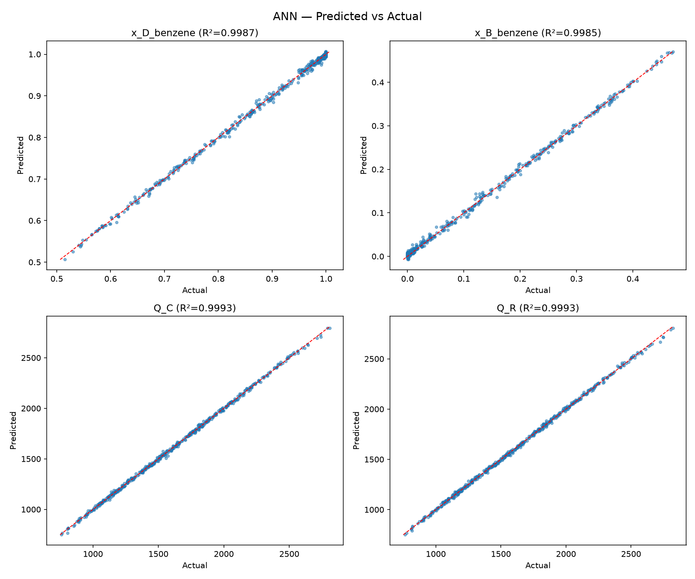
Figure 2: Predicted vs. actual, ANN, all four targets.
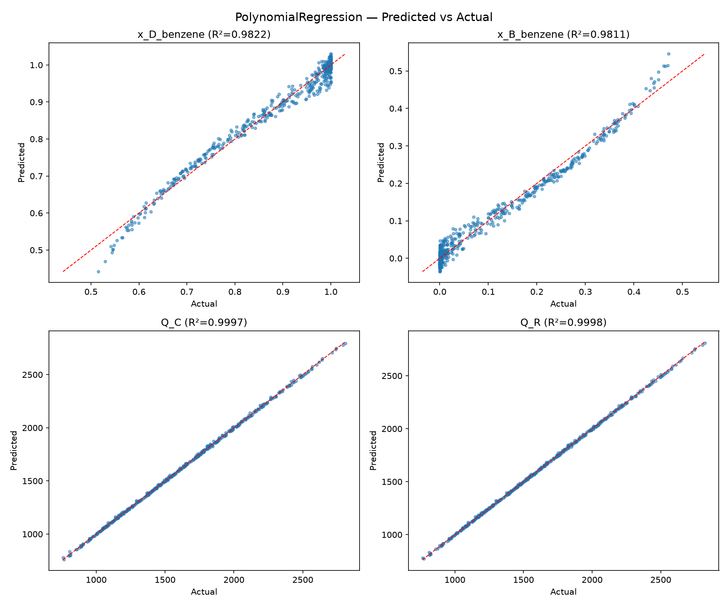
Figure 3: Predicted vs. actual, Polynomial Regression, all four targets.
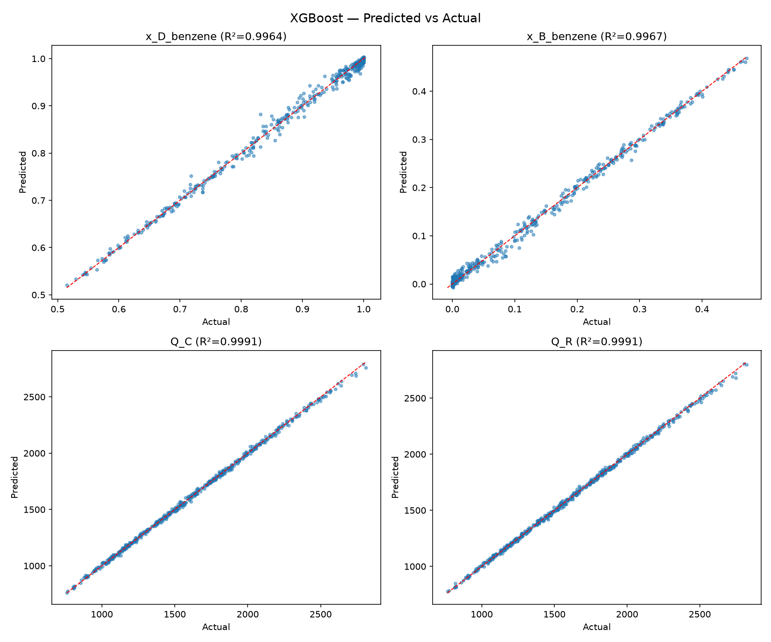
Figure 4: Predicted vs. actual, XGBoost, all four targets.
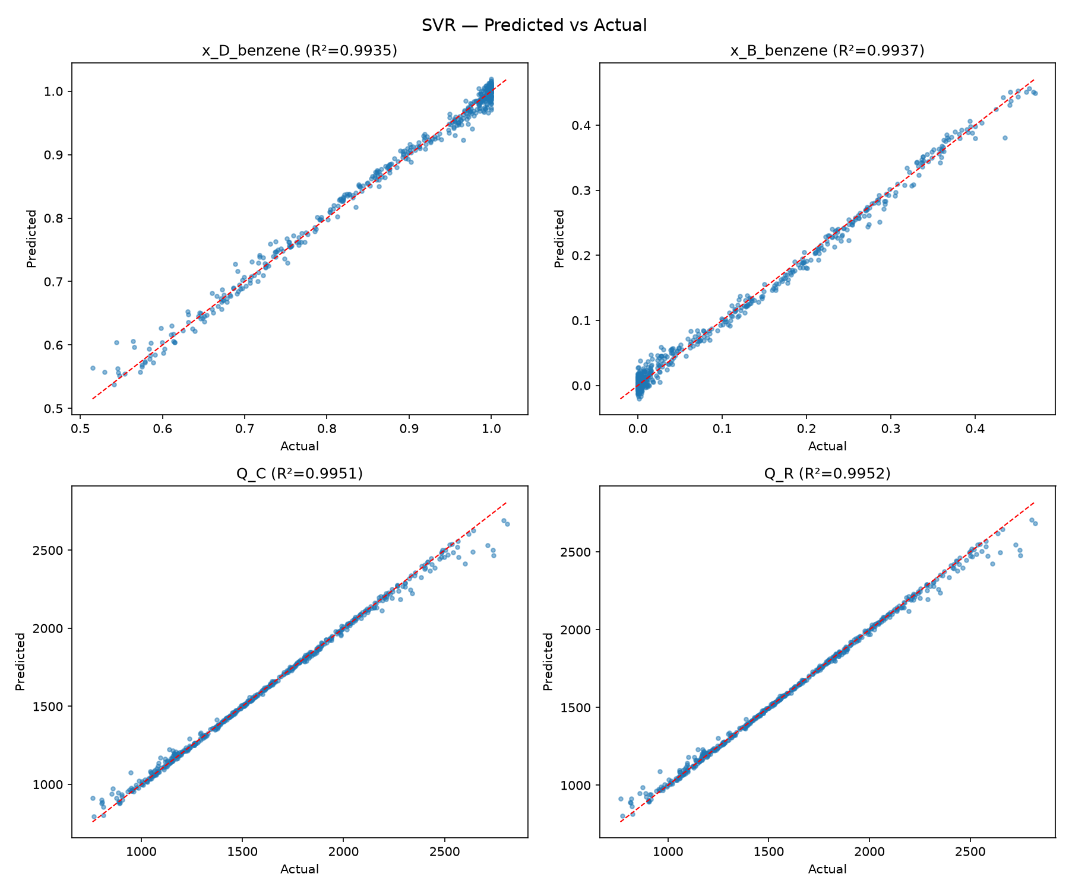
Figure 5: Predicted vs. actual, SVR, all four targets.
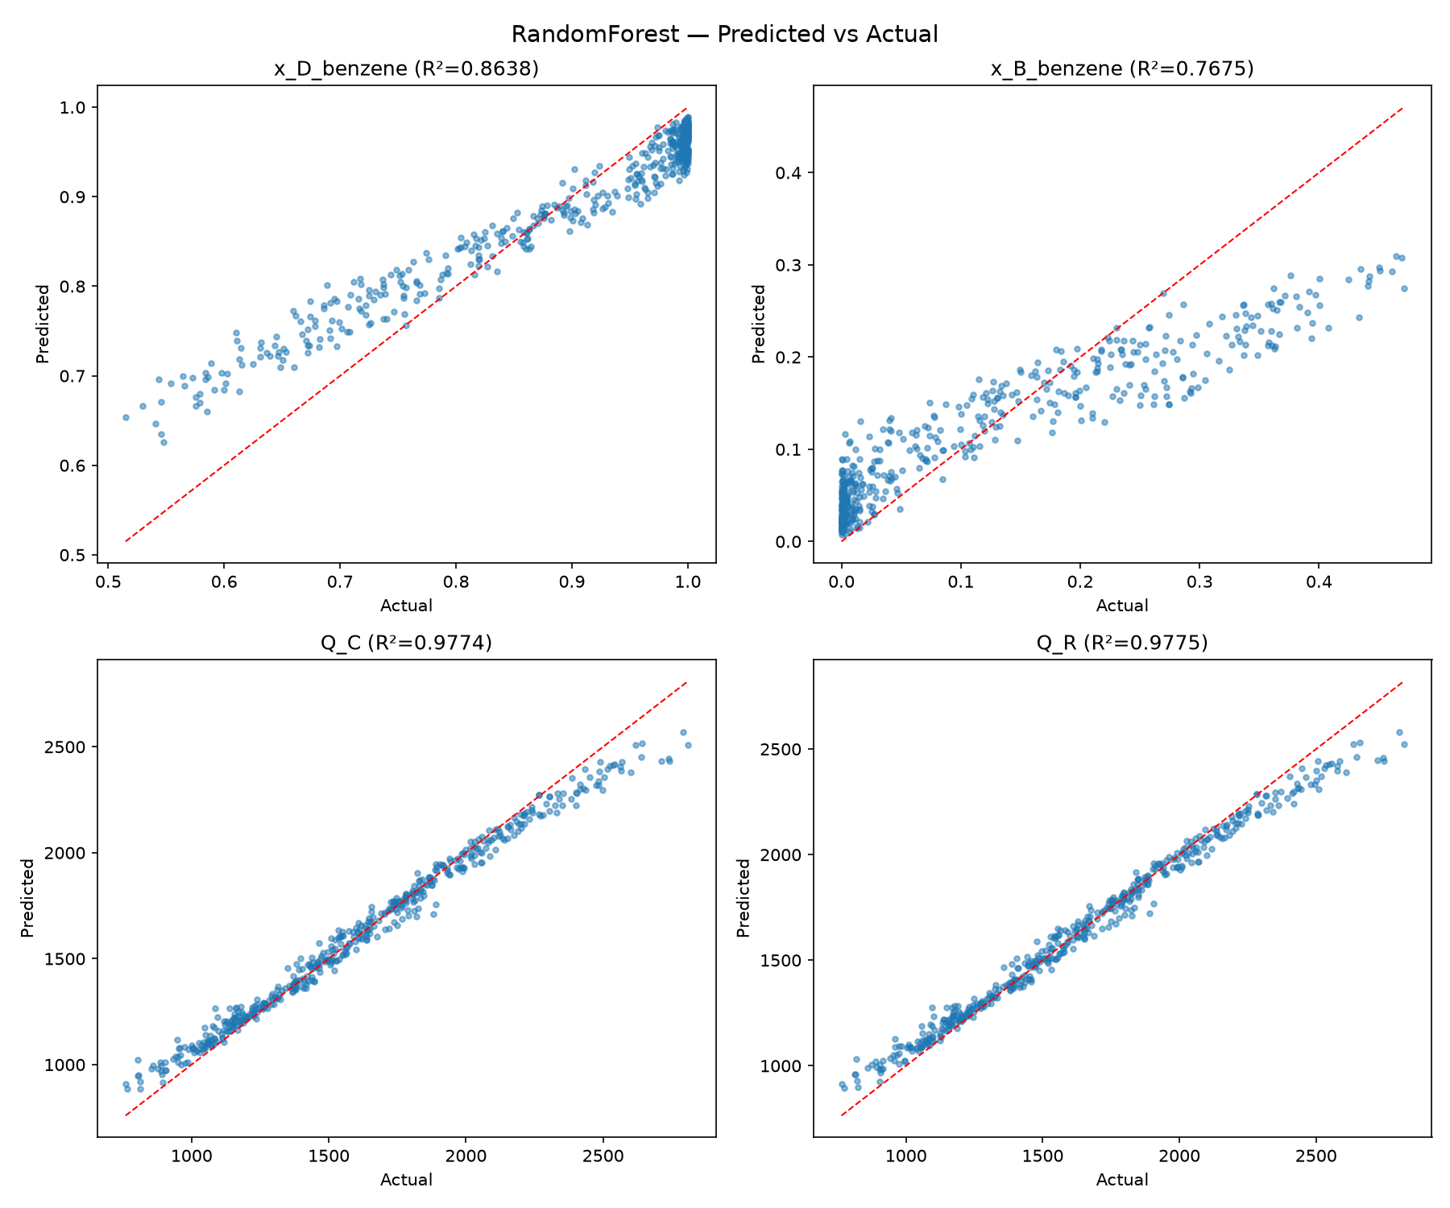
Figure 6: Predicted vs. actual, Random Forest, all four targets.
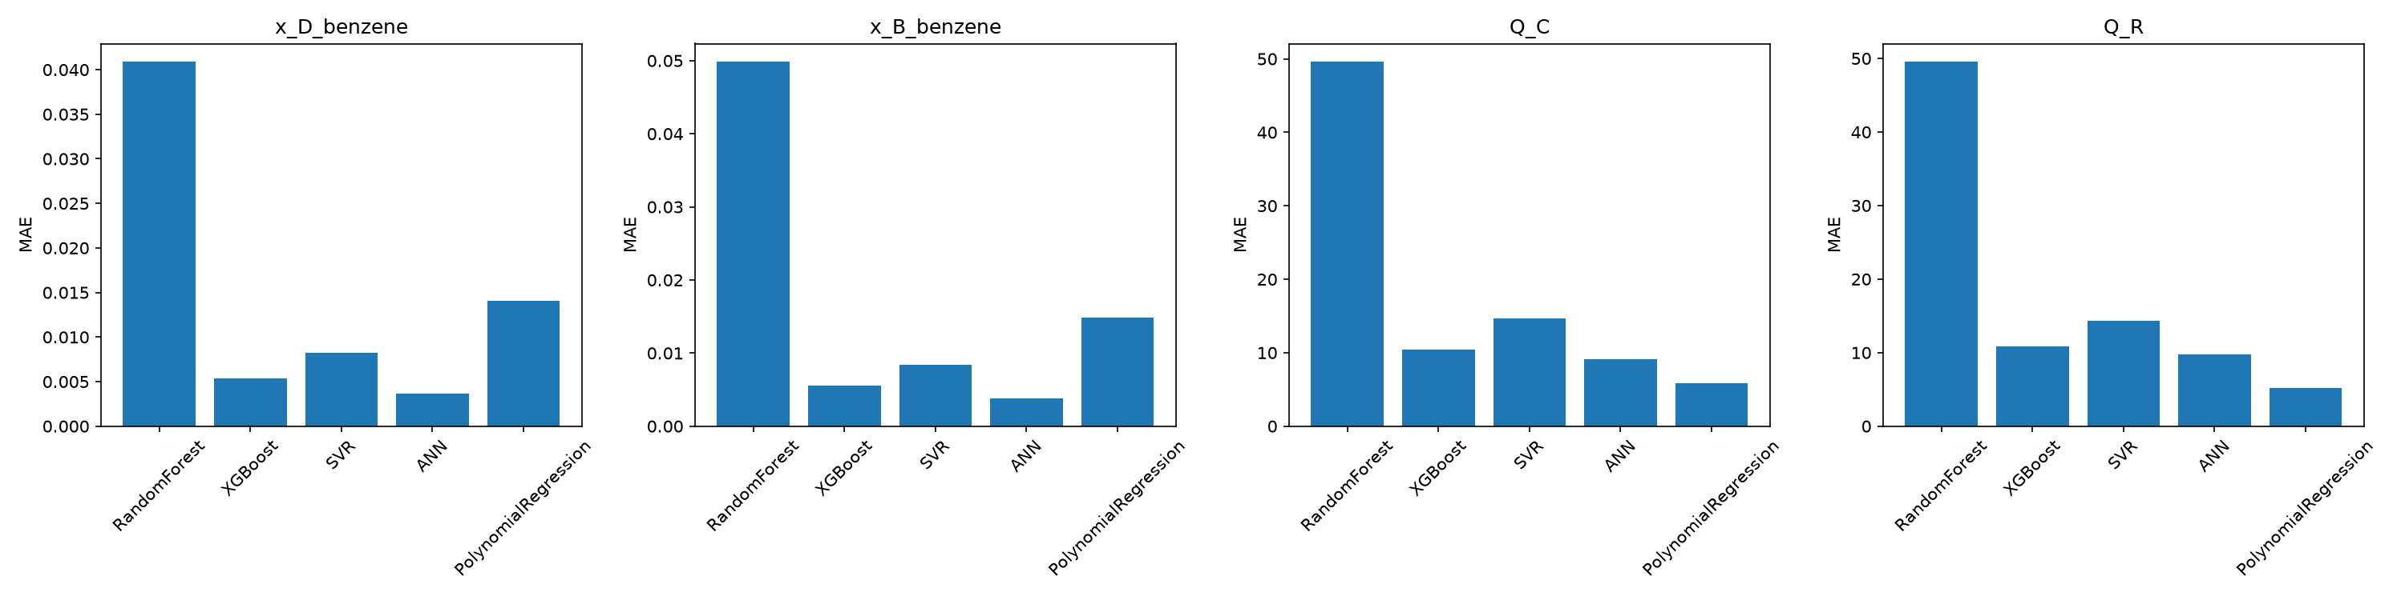
Figure 7: MAE comparison for the five final models across the four outputs.
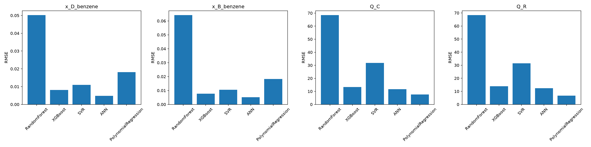
Figure 8: RMSE comparison for the five final models across the four outputs.
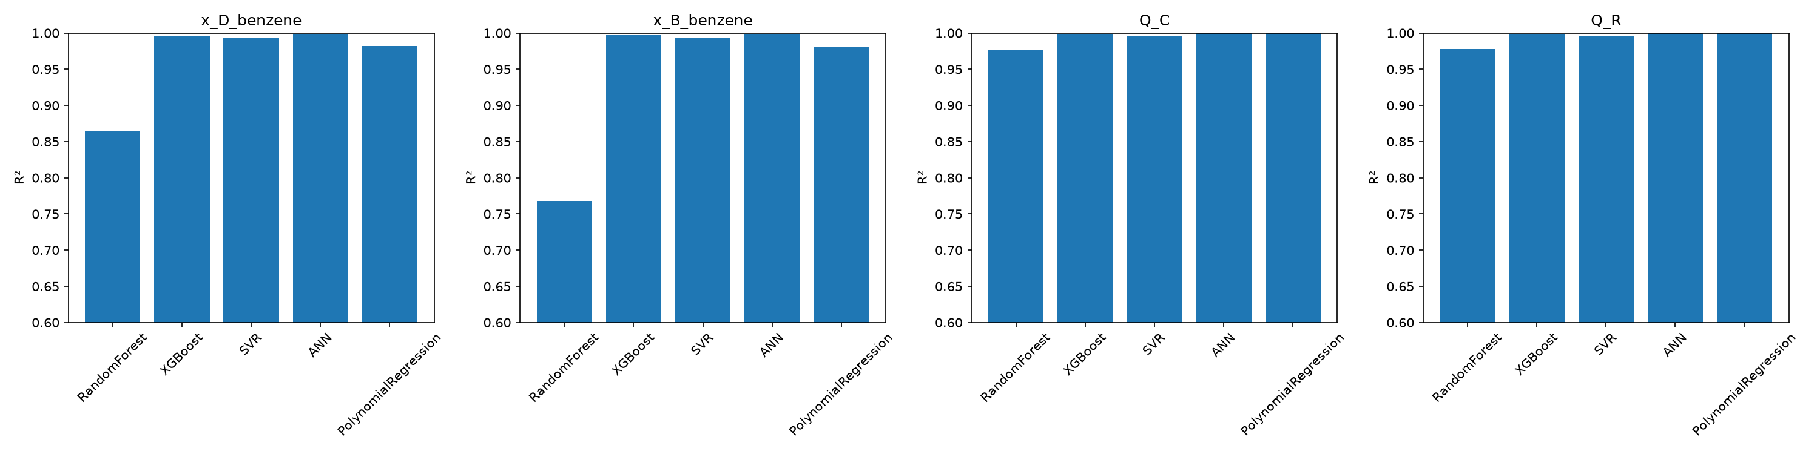
Figure 9: R² comparison for the five final models across the four outputs.

9.2 Primary Single-Model Selection
ANN was selected as the primary single-model surrogate because it provides the best overall balance across the four outputs. It is the strongest individual model on both purity targets, remains highly competitive though not the single best on both duty targets, and its validation-to-holdout R² is stable across all four outputs, showing that it is not overfitting the training design.

9.3 Target-Specific Model Selection
A per-target look at the same holdout metrics, matching data/06_physical_checks/final_model_selection.json, shows that per-target accuracy can be improved beyond what any single model achieves across all outputs:
Target | Best-performing model on holdout
x_D_benzene | ANN
x_B_benzene | ANN
Q_C | Polynomial Regression
Q_R | Polynomial Regression

- ANN performs best for the two purity targets — its flexible nonlinear form fits the steep, saturating shape of the purity response near the [0,1] bounds better than a fixed degree-2 polynomial or the tuned tree ensembles.
- Polynomial Regression performs best for the two duty targets — Q_C and Q_R are close to smooth, near-quadratic functions of the sampled operating conditions over the explored range, which favours a low-order polynomial and is reflected in its very tight validation-to-holdout agreement on these two targets.
When the targets are considered separately, ANN gives the best results for both purity outputs, while Polynomial Regression gives the best results for the two duty outputs. This gives two possible deployment choices: ANN when one unified model is preferred, and ANN + Polynomial Regression when target-specific accuracy is the priority.

10. Physical Consistency and Robustness Discussion
notebooks/07_Physical_Consistency_Check.ipynb performs two checks on the same holdout predictions: hard physical-bounds violations, and qualitative sensitivity sweeps of reflux ratio and feed composition, holding every other input at the Sobol training-set median, to see whether each model's predicted trend direction matches expected distillation behaviour.

10.1 Physical Bounds
From data/06_physical_checks/bounds_violation_summary.csv — composition bounds x_D, x_B ∈ [0,1], non-negative duties, and x_D not less than x_B, across the 491-row holdout set:
Model | x_D<0 | x_D>1 | x_B<0 | x_B>1 | Q_C<0 | Q_R<0 | x_D<x_B
Random Forest | 0 | 0 | 0 | 0 | 0 | 0 | 0
XGBoost | 0 | 40 | 59 | 0 | 0 | 0 | 0
SVR | 0 | 82 | 70 | 0 | 0 | 0 | 0
ANN | 0 | 50 | 25 | 0 | 0 | 0 | 0
Polynomial Regression | 0 | 90 | 88 | 0 | 0 | 0 | 0

Random Forest produced zero physical-bound violations on the 491-row holdout set. This gives it the strongest physical consistency among the tested models, although its purity prediction accuracy was substantially lower , but this comes at the cost of being the least accurate model on the purity targets (Section 9). Random Forest has the best physical consistency, but its purity prediction accuracy is lower than the other models, the most physically consistent model is not the most accurate one.
ANN produced 50 predictions above x_D = 1 and 25 predictions below x_B = 0 out of 491 holdout cases. ANN produced 50 predictions above x_D = 1 and 25 predictions below x_B = 0. XGBoost produced 40 and 59 respectively, SVR produced 82 and 70, and Polynomial Regression produced 90 and 88., but it is not zero, so ANN's physical-consistency behavior is mid-pack rather than best-in-class.
No model produced a negative condenser or reboiler duty, and no model predicted x_D below x_B on any holdout case — the more basic sanity relationships between the two duty outputs and between the two purity outputs are respected by every model, even the ones that occasionally clip outside [0,1].
The violations are concentrated in the steep, near-pure-benzene region of the purity curve, consistent with model extrapolation past the physical bound rather than an unrelated training defect.

10.2 Sensitivity Analysis
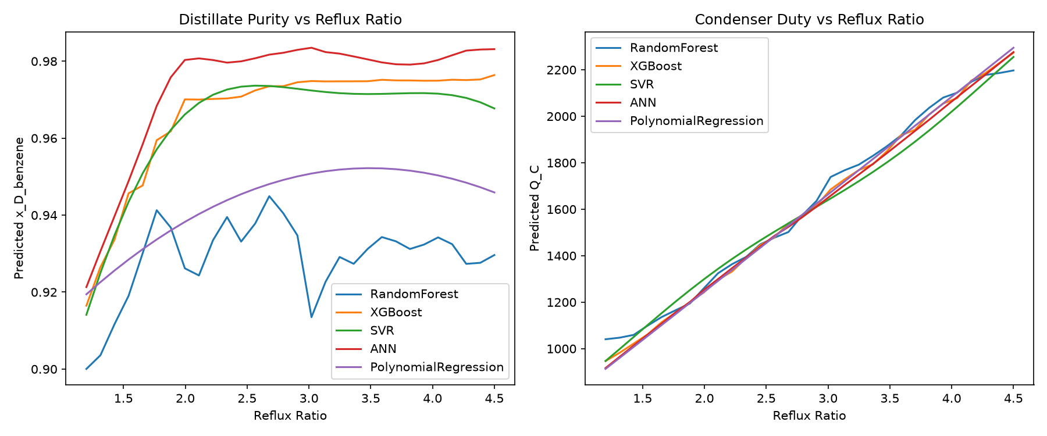
Figure 10: Predicted distillate purity and condenser duty as a function of reflux ratio, all five models, other inputs held at the Sobol training-set median.
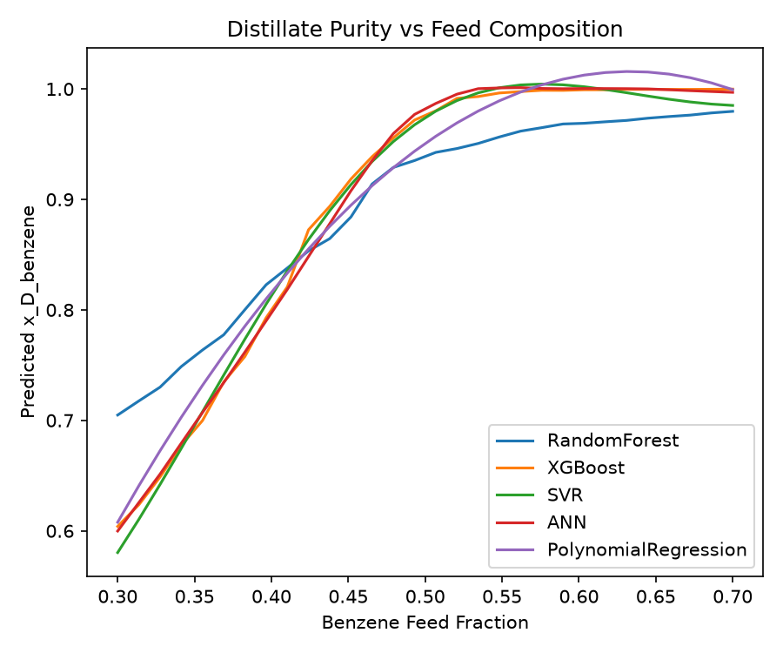
Figure 11: Predicted distillate purity as a function of feed benzene fraction, all five models.
The sensitivity plots show the response of the predicted outputs to changes in reflux ratio and feed benzene fraction while the remaining inputs are fixed at the Sobol training-set median. The models generally reproduce the expected increasing trend with both reflux ratio and feed benzene fraction, although Random Forest shows noticeably less smooth behavior in the reflux-ratio sweep.

10.3 Feature Importance and Generalization
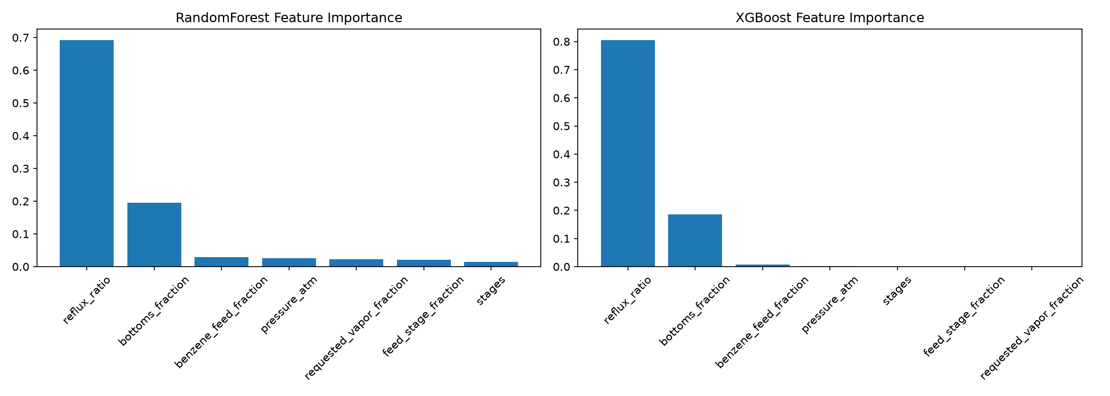
Figure 12: Tree-based feature importance, Random Forest and XGBoost.
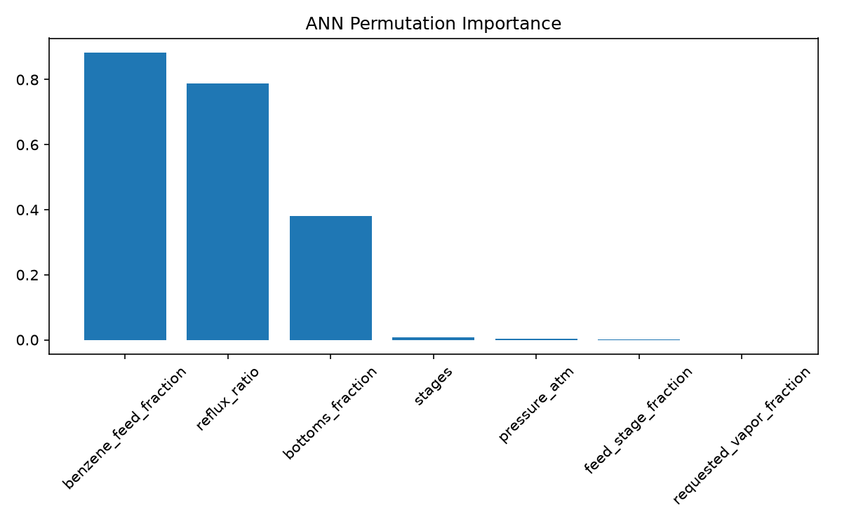
Figure 13: Permutation feature importance, ANN.
As discussed in Section 8, tuned validation R² and holdout R² remain closely matched for all five models on all four targets, which is the main evidence of robustness in this project. The one clearly identified overfitting/underfitting pattern is Random Forest's persistently weaker fit on the purity targets, a bias/underfitting issue for this feature set that tuning reduced but did not eliminate, rather than a sudden holdout-only failure.

11. Final Conclusion
This project built an automated, DWSIM-driven surrogate-modeling workflow for a Benzene–Toluene binary distillation column under Peng–Robinson thermodynamics. DWSIM was used to generate the simulation data across seven physically meaningful operating conditions, mapped to the four required outputs over a combined 3,015-row Sobol-plus-LHS dataset with an independent holdout split.
Five machine learning models — Polynomial Regression, Random Forest, XGBoost, SVR and ANN — were trained, tuned and evaluated on unseen holdout data using MAE, RMSE and R², alongside an explicit physical-bounds violation count rather than accuracy alone.
ANN is the primary single-model surrogate because it provides the strongest overall balance of predictive accuracy across all four outputs while maintaining stable validation-to-holdout performance. On a target-specific basis, ANN is the best-performing model for the two purity targets (x_D_benzene, x_B_benzene), while Polynomial Regression is the best-performing model for the two duty targets (Q_C, Q_R). ANN alone is the preferred choice when a single, unified, deployable model is required, while the ANN + Polynomial Regression combination is the better choice when maximum per-output accuracy is the priority and deploying two models is acceptable.
The surrogate models are intended for operating conditions within the ranges represented in the generated dataset. Predictions outside these ranges should be treated cautiously and verified against the rigorous DWSIM model.

Project Structure
The project is organized into separate folders for DWSIM simulation, dataset generation and processing, machine-learning model development, evaluation, trained models, and result visualization.
DWSIM-Distillation-Surrogate-Model/
├── data/
│ ├── 01_validation_runs/
│ │ ├── dataset_256_dwsim.csv
│ │ ├── dwsim_10_samples.csv
│ │ └── test_32_vapor_fraction_checked.csv
│ ├── 02_raw_train_sobol/
│ │ ├── dataset_2560_converged.csv
│ │ └── dataset_2560_not_converged.csv
│ ├── 03_raw_holdout_lhs/
│ │ ├── lhs_500_converged.csv
│ │ └── lhs_500_not_converged.csv
│ ├── 04_processed_dwsim/
│ │ ├── final_ml_dataset.csv
│ │ └── sobol_training_cleaned.csv
│ ├── 05_tuning_results/
│ │ ├── best_params.json
│ │ └── validation_r2_scores.csv
│ └── 06_physical_checks/
│ ├── bounds_violation_summary.csv
│ ├── final_model_selection.json
│ └── holdout_error_metrics.csv
├── dwsim_flowsheets/
│ └── binary_distillation.dwxmz
├── models/
│ └── 01_trained_models_all_5/
│ ├── ann.pkl
│ ├── polynomial_regression.pkl
│ ├── poly_features.pkl
│ ├── random_forest.pkl
│ ├── scaler_X.pkl
│ ├── scaler_y.pkl
│ ├── svr.pkl
│ └── xgboost.pkl
├── notebooks/
│ ├── 01_Data_Quality_Check.ipynb
│ ├── 02_Data_Cleaning_Preprocessing.ipynb
│ ├── 03_Visualization_EDA.ipynb
│ ├── 04_Model_Training.ipynb
│ ├── 05_Hyperparameter_Tuning.ipynb
│ ├── 06_Final_Holdout_Evaluation.ipynb
│ ├── 07_Physical_Consistency_Check.ipynb
│ └── 08_Result_Plots.ipynb
├── outputs/
│ └── plots/
│ ├── feature_importance_ann.png
│ ├── feature_importance_trees.png
│ ├── Error Comparison/
│ │ ├── error_comparison_mae.png
│ │ ├── error_comparison_r2.png
│ │ └── error_comparison_rmse.png
│ ├── Predicted vs Actual/
│ │ ├── predicted_vs_actual_ANN.png
│ │ ├── predicted_vs_actual_PolynomialRegression.png
│ │ ├── predicted_vs_actual_RandomForest.png
│ │ ├── predicted_vs_actual_SVR.png
│ │ └── predicted_vs_actual_XGBoost.png
│ └── Sensitivity Analysis/
│ ├── sensitivity_feed_composition.png
│ └── sensitivity_reflux_ratio.png
└── src/
├── sampling/
│ ├── 01_sobol_validation.py
│ ├── 02_sobol_intermediate_validation.py
│ ├── 03_generate_2560_sobol.py
│ └── 04_generate_500_lhs.py
└── simulation/
├── dwsim_automation.py
└── model_generator.py
│
└── sample_predictions.py

Key Project Files
- data/ — raw and processed simulation datasets, tuning results, and the final holdout and physical-consistency check outputs.
- dwsim_flowsheets/ — the saved DWSIM flowsheet used to run the simulation.
- models/ — the five trained model files and the preprocessing objects required for prediction.
- notebooks/ — the data-quality, preprocessing, training, tuning, holdout-evaluation and physical-consistency notebooks.
- outputs/plots/ — all figures generated for this report, including error comparisons, predicted-vs-actual plots and sensitivity plots.
- src/ — the DWSIM simulation and sampling scripts used to generate the dataset.

