**Ramdeobaba University, Nagpur**

**Department of Computer Science and Engineering**

**Session: 2025-26**

**Design and Analysis of Algorithms Lab III Semester**

**PRACTICAL NO. 8**

Yash Wanjari

A2_B3_40

**Aim:** Implement Graph Colouring algorithm using the Graph colouring concept.

**Problem Statement:**

A GSM is a cellular network with its entire geographical range divided into hexadecimal cells. Each cell has a communication tower which connects with mobile phones within cell. Assume this GSM network operates in different frequency ranges. Allot frequencies to each cell such that no adjacent cells have same frequency range.

Consider an undirected graph G = (V, E) shown below. Find the colour assigned to each node using Backtracking method. Input is the adjacency matrix of a graph G (V, E), where V is the number of Vertices and E is the number of edges.

**Graph 1:**

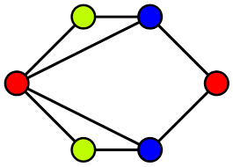

**Graph 2:**

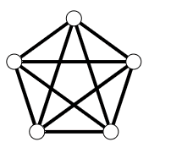

Code:

public class GraphColoring {

static final int V = 5;

static boolean[][] graph = {

{false, true, true, true, false},

{true, false, true, false, true },

{true, true, false, true, true },

{true, false, true, false, true },

{false, true, true, true, false}

};

static int[] color = new int[V];

static boolean isSafe(int v, boolean[][] graph, int[] color, int c) {

for (int i = 0; i < V; i++)

if (graph[v][i] && c == color[i])

return false;

return true;

}

static boolean graphColoringUtil(boolean[][] graph, int m, int[] color, int v) {

if (v == V)

return true;

for (int c = 1; c <= m; c++) {

if (isSafe(v, graph, color, c)) {

color[v] = c;

if (graphColoringUtil(graph, m, color, v + 1))

return true;

color[v] = 0; // backtrack

}

}

return false;

}

static boolean graphColoring(boolean[][] graph, int m) {

for (int i = 0; i < V; i++)

color[i] = 0;

if (!graphColoringUtil(graph, m, color, 0)) {

System.out.println("Solution does not exist");

return false;

}

System.out.println("Assigned Colours:");

for (int i = 0; i < V; i++)

System.out.println("Vertex " + (i + 1) + " ---> Colour " + color[i]);

return true;

}

public static void main(String[] args) {

int m = 3; // Number of colors

graphColoring(graph, m);

}

}

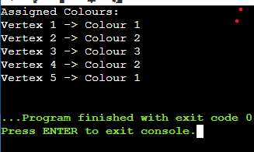

Leet Code Submission: <https://leetcode.com/problems/flower-planting-with-no-adjacent/description/>

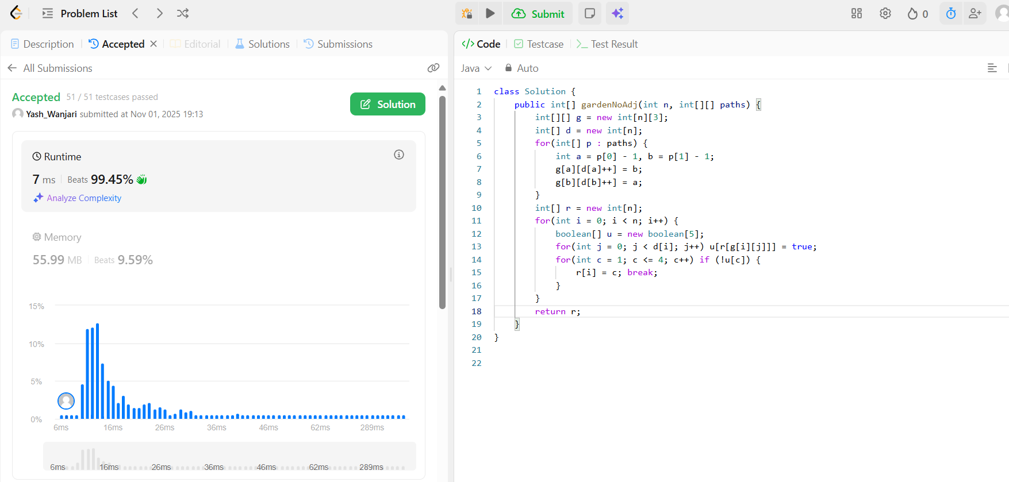

Github:

<https://github.com/YashWanjari/DAA_lab>