AWS EC2 & EBS
Step-by-Step Lab Documentation
Performed by Yashantu Singh | Region: Asia Pacific (Mumbai)

1. Amazon EC2 Dashboard Overview
The first screenshot shows the Amazon Elastic Compute Cloud (EC2) home page in the AWS Management Console. This is the starting point for managing virtual servers in the AWS Cloud.

What is EC2?
Amazon EC2 (Elastic Compute Cloud) is a web service that provides resizable compute capacity in the cloud. It allows users to:
- Create, manage, and monitor virtual machines (instances)
- Choose from over 600 instance types with different CPU, memory, and storage configurations
- Select from multiple operating systems including Linux, Windows, macOS, and more
- Use flexible pricing models such as On-Demand, Reserved, and Spot Instances

Key Dashboard Features
- Launch Instance button – quickly start creating a new virtual server
- View Dashboard – see a summary of all running resources
- Left sidebar – navigate to Instances, Images (AMIs), Elastic Block Store, Security Groups, etc.
- Region selector (top-right) – the lab was performed in Asia Pacific (Mumbai)
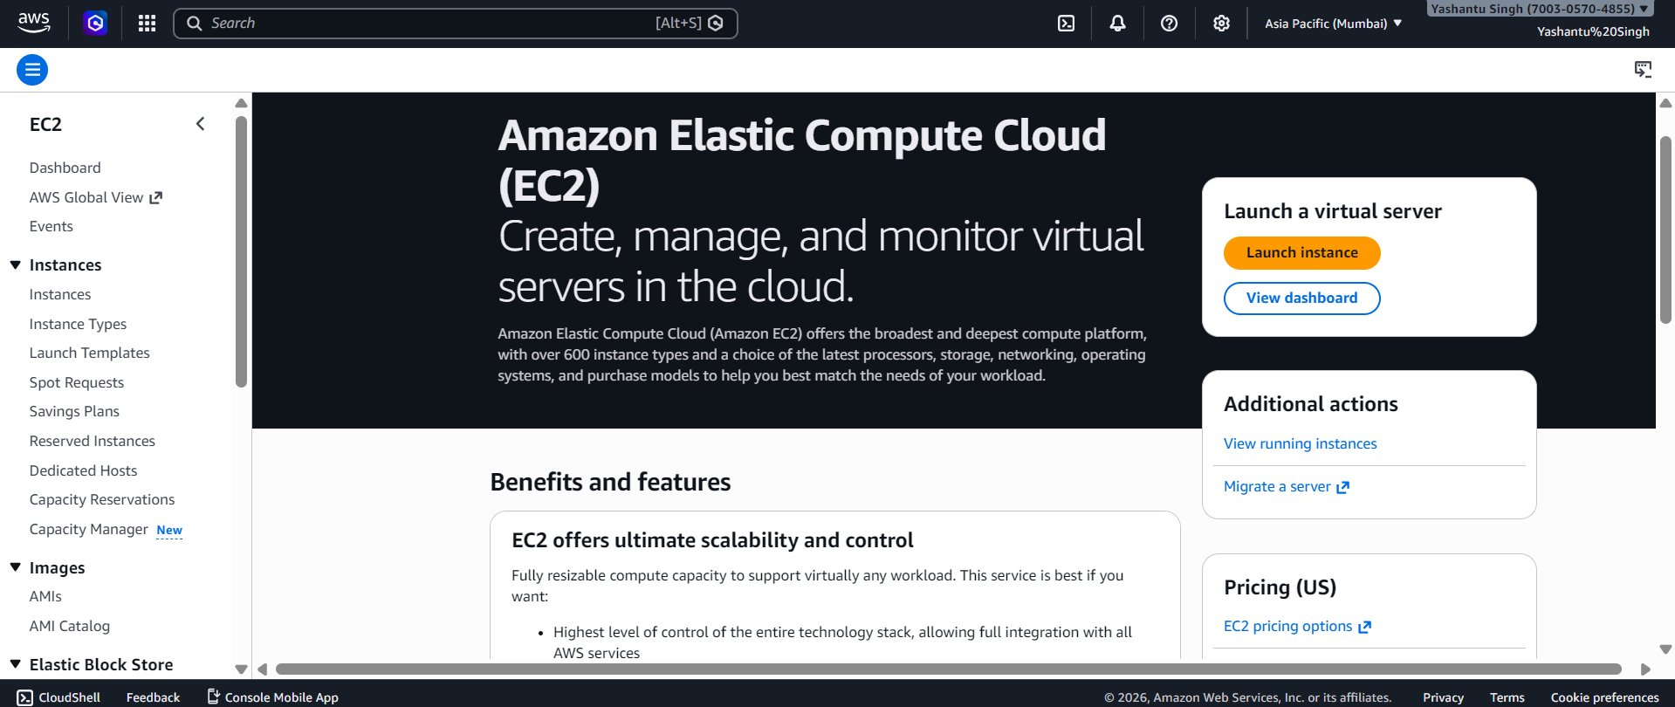
Image 1: Amazon EC2 Dashboard

2. Instances List (Initially Empty)
The second screenshot shows the EC2 Instances page before any instance has been launched. The message "No instances – You do not have any instances in this region" confirms a clean starting state in the Mumbai region.

Key Columns in the Instances Table
- Name – a user-defined label for the instance
- Instance ID – unique AWS identifier (e.g., i-0375d9c33c9a1c8e2)
- Instance State – Running, Stopped, Terminated, etc.
- Instance Type – hardware configuration (e.g., t3.micro)
- Status Check – system and instance health checks
- Availability Zone – the physical data center within the region
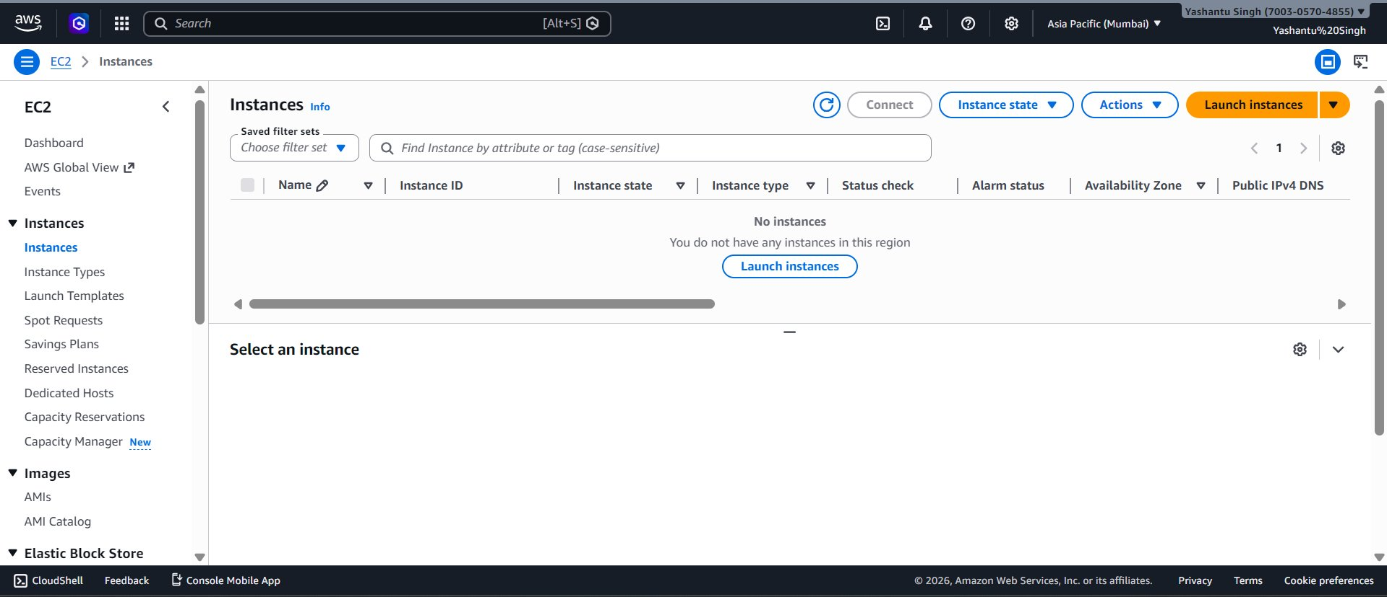
Image 2: EC2 Instances List (Empty)

3. Launching a New EC2 Instance
Screenshots 3 through 7 document the step-by-step process of launching an EC2 instance named "My web Server" using the Launch Instance wizard.

Step 1: Name and Tags
The instance was named "My web Server". Tags are key-value pairs used to organize and identify AWS resources. The Name tag is the most common and appears as the display name in the console.
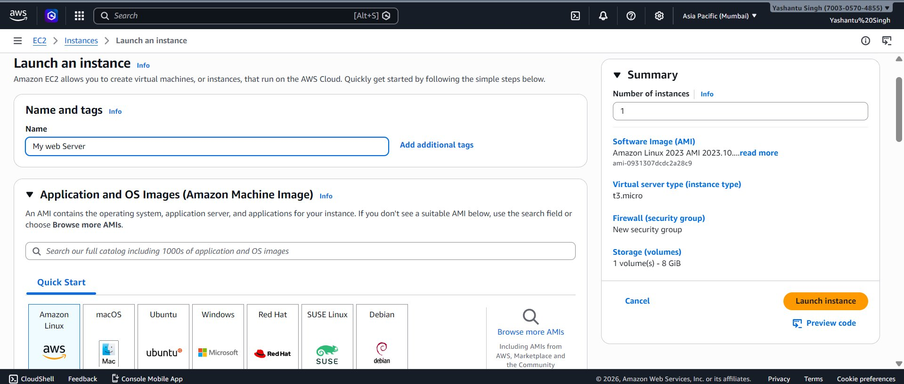
Image 3: Launch an Instance – Name & AMI Selection

Step 2: Amazon Machine Image (AMI) Selection
An AMI (Amazon Machine Image) is a pre-configured template containing the operating system and application software for the instance. The selected AMI was:
- Amazon Linux 2023 AMI (kernel-6.1) – Free tier eligible
- AMI ID: ami-0931307dcdc2a28c9
- Architecture: 64-bit (x86), Boot mode: uefi-preferred
- Username: ec2-user (default Linux user)

Step 3: Instance Type
The chosen instance type was t3.micro (Free tier eligible) – 2 vCPUs, 1 GiB Memory, On-Demand Linux ~$0.0112 USD/hour.

Step 4: Key Pair (Login)
"Proceed without a key pair" was selected, allowing browser-based SSH via EC2 Instance Connect later.
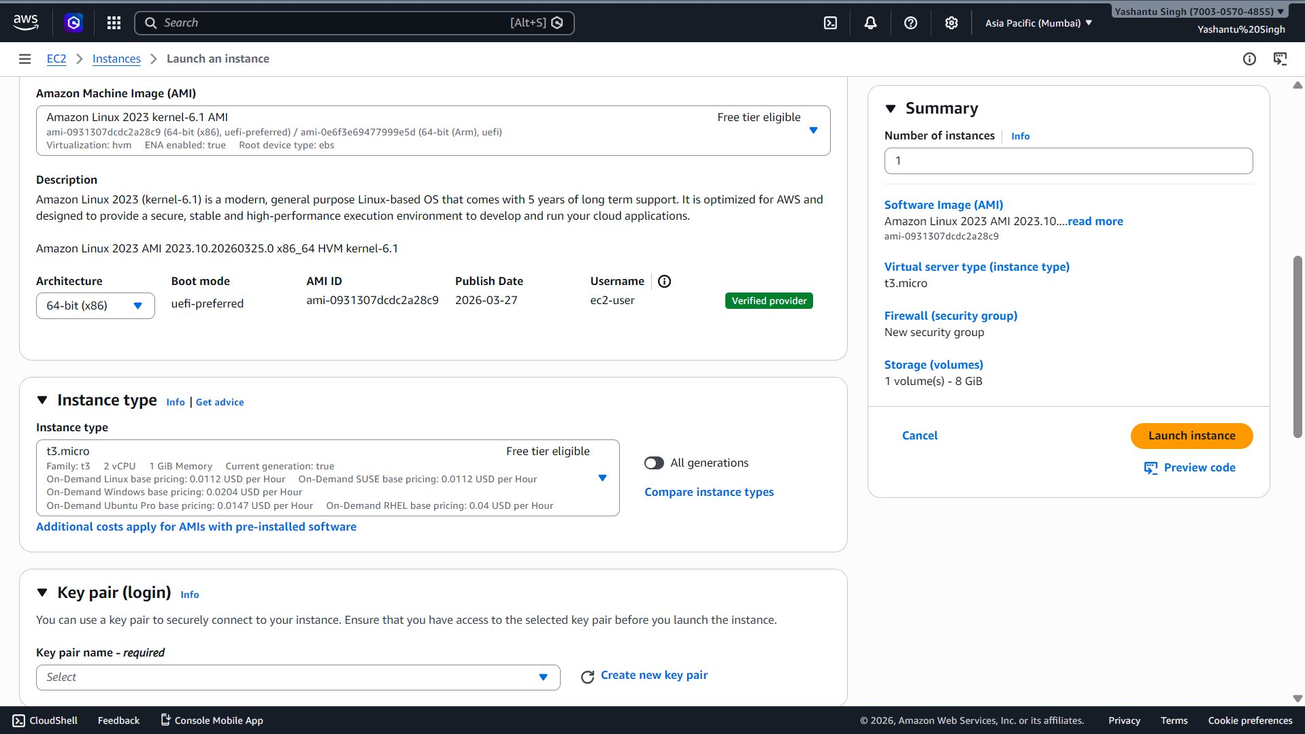
Image 4: Instance Type & Key Pair Settings

Step 5: Network Settings & Security Group
A new security group "launch-wizard-1" was created with SSH (port 22) allowed from anywhere (0.0.0.0/0). VPC: vpc-0a7a4b4c49799ced1, Auto-assign Public IP: Enabled.
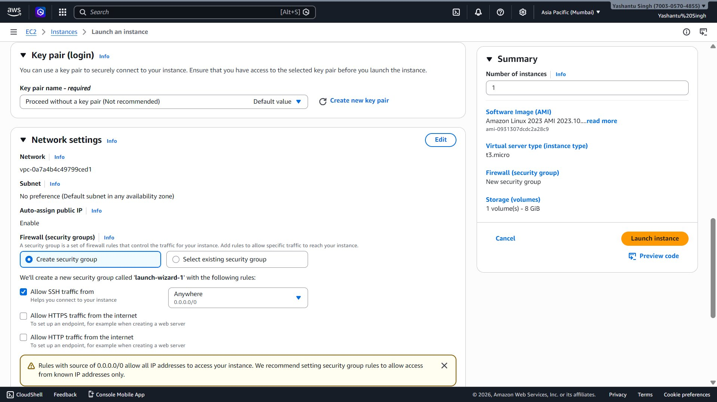
Image 5: Network Settings & Security Group
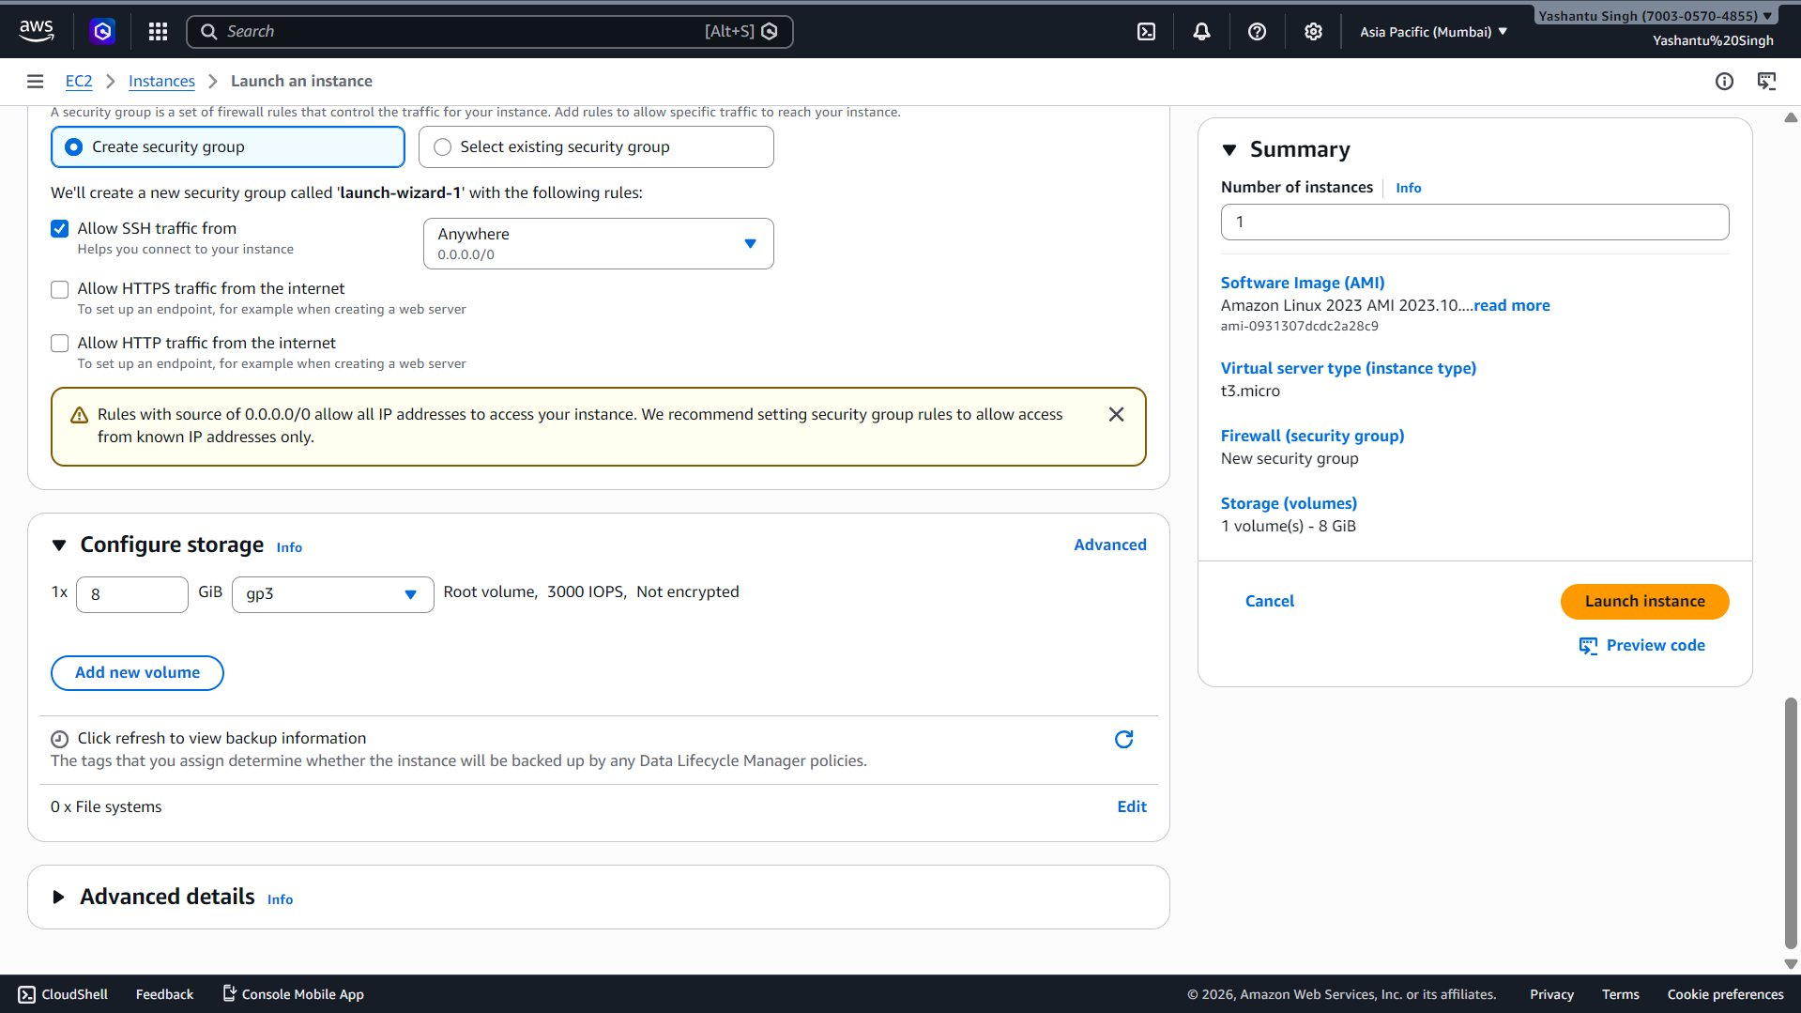
Image 6: Configure Storage

Step 6: Configure Storage
Root volume: 1x 8 GiB, gp3 (General Purpose SSD), 3000 IOPS, not encrypted.

4. Instance Successfully Launched
The green banner confirms: "Successfully initiated launch of instance (i-0375d9c33c9a1c8e2)". The instance now appears as Running in the Instances list (t3.micro, Availability Zone: ap-south-1a).
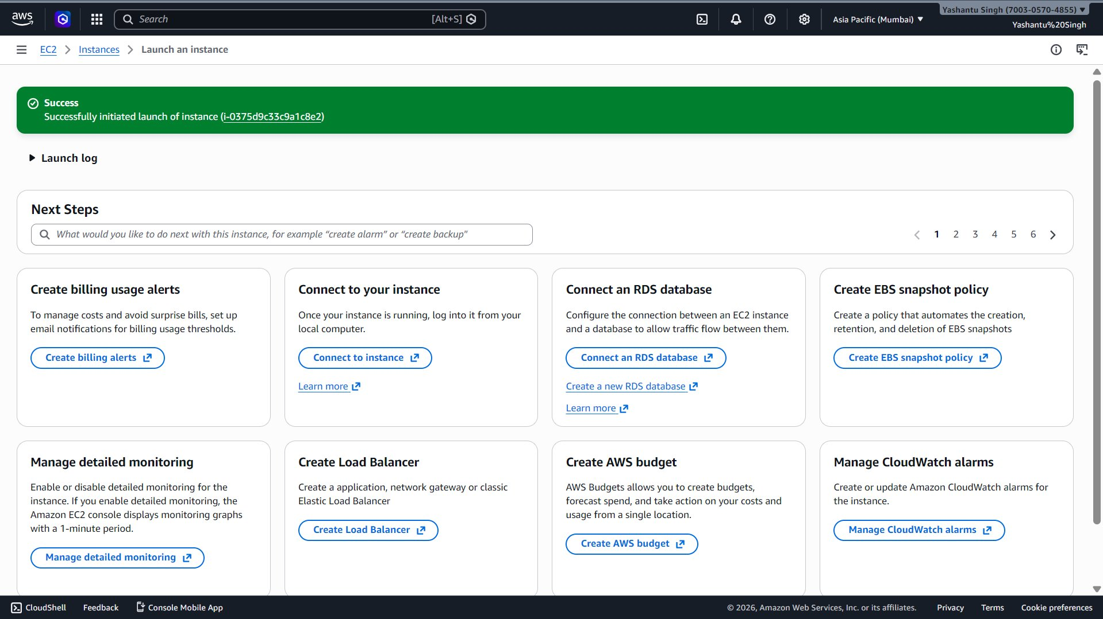
Image 7: Instance Successfully Launched
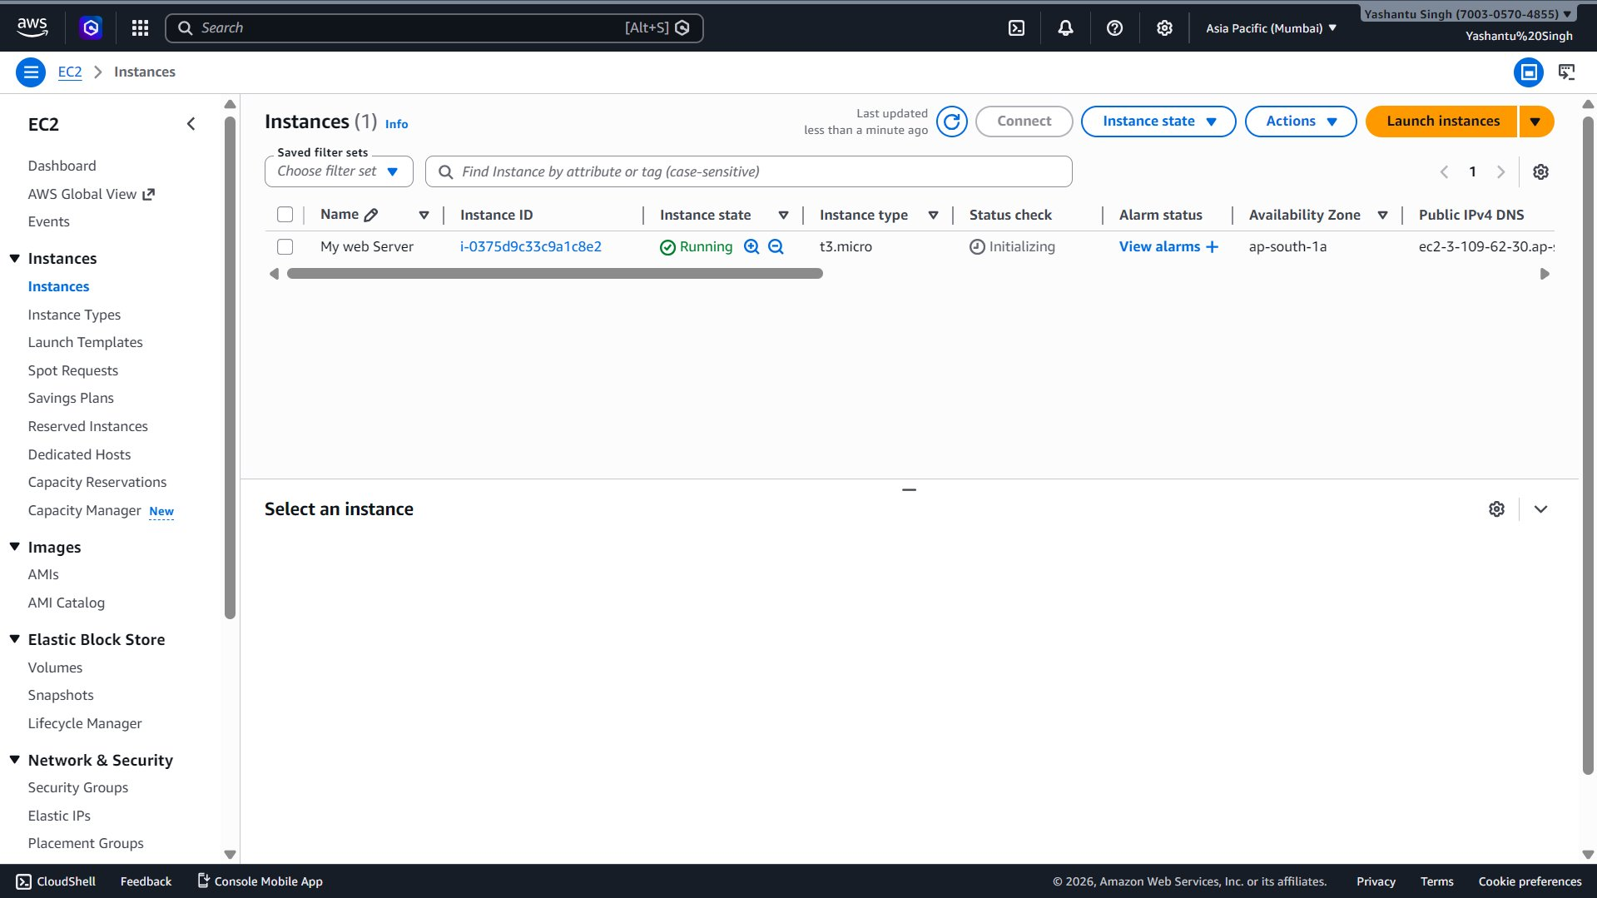
Image 8: EC2 Instance Running

5. Elastic Block Store (EBS) – Volumes

What is EBS?
Amazon Elastic Block Store (EBS) provides persistent block-level storage volumes for EC2 instances. Data on EBS survives instance restarts and can be detached and reattached to other instances.

EBS Volumes List
After launching the EC2 instance, one EBS volume (vol-075e59ff2a2970661) was automatically created as the root volume – 8 GiB, gp3, 3000 IOPS.
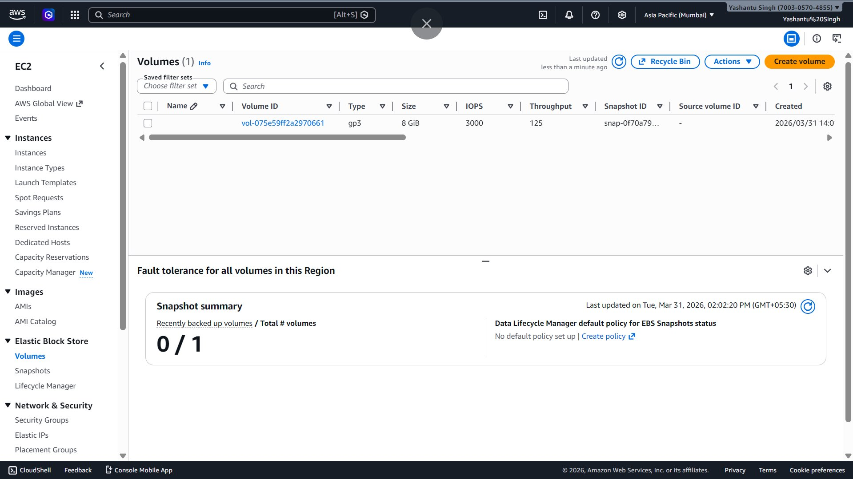
Image 9: EBS Volumes List

Volume Details
- Volume ID: vol-075e59ff2a2970661 | State: In-use
- Size: 8 GiB, Type: gp3, IOPS: 3000, Throughput: 125 MiB/s
- Availability Zone: aps1-az1 (ap-south-1a)
- Attached to: i-0375d9c33c9a1c8e2 (My web Server) at /dev/xvda
- Encryption: Not encrypted | Created: Tue Mar 31, 2026 14:01:12 GMT+0530
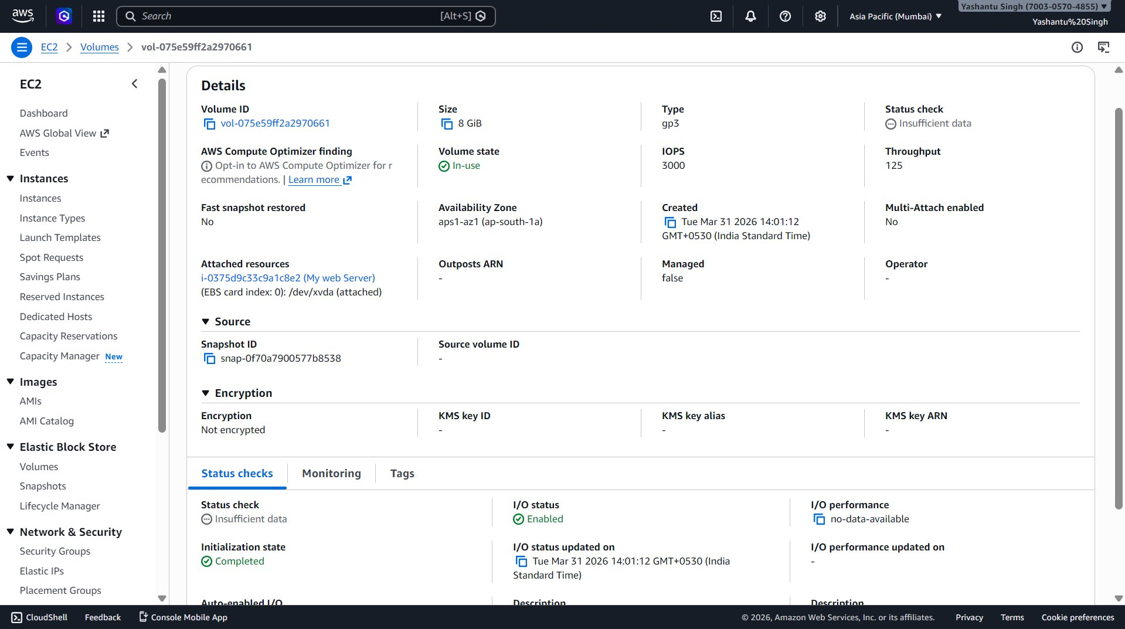
Image 10: EBS Volume Details

Creating a New EBS Volume
A second EBS volume was manually created with: gp3, 8 GiB, 3000 IOPS, 125 MiB/s throughput, in AZ aps1-az1. The volume must be in the same Availability Zone as the EC2 instance to be attached.
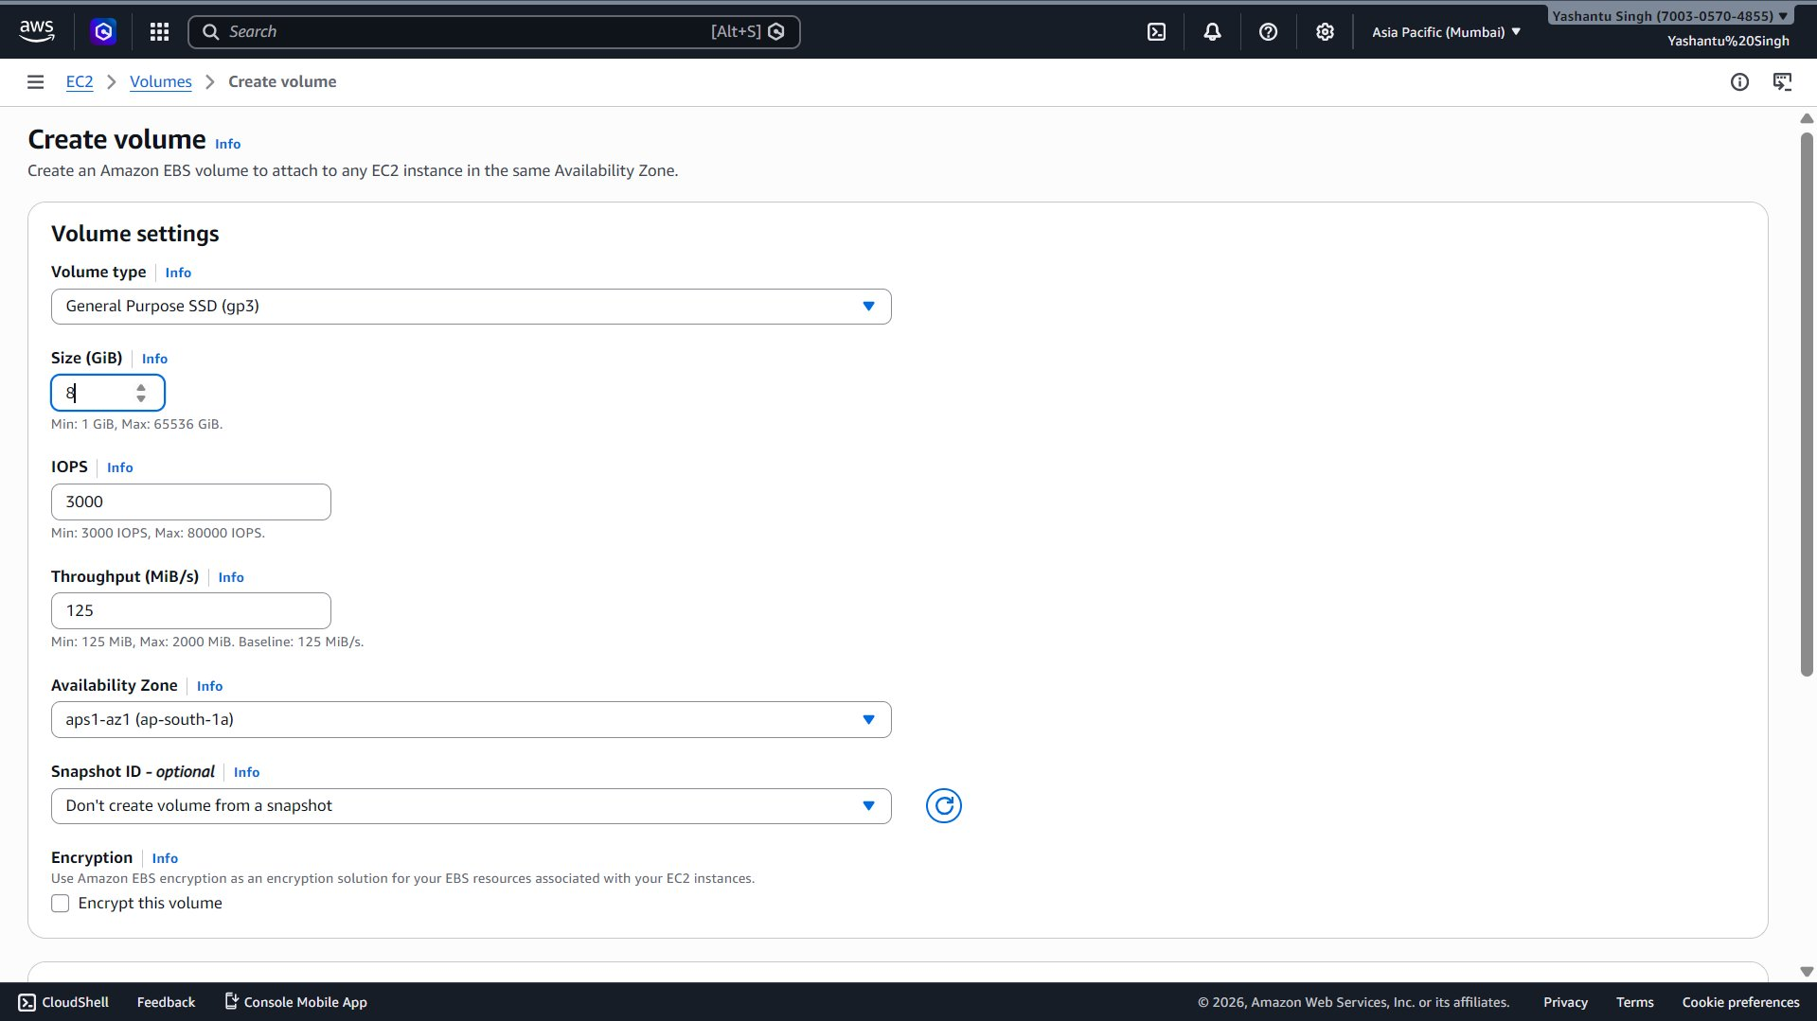
Image 11: Create New EBS Volume
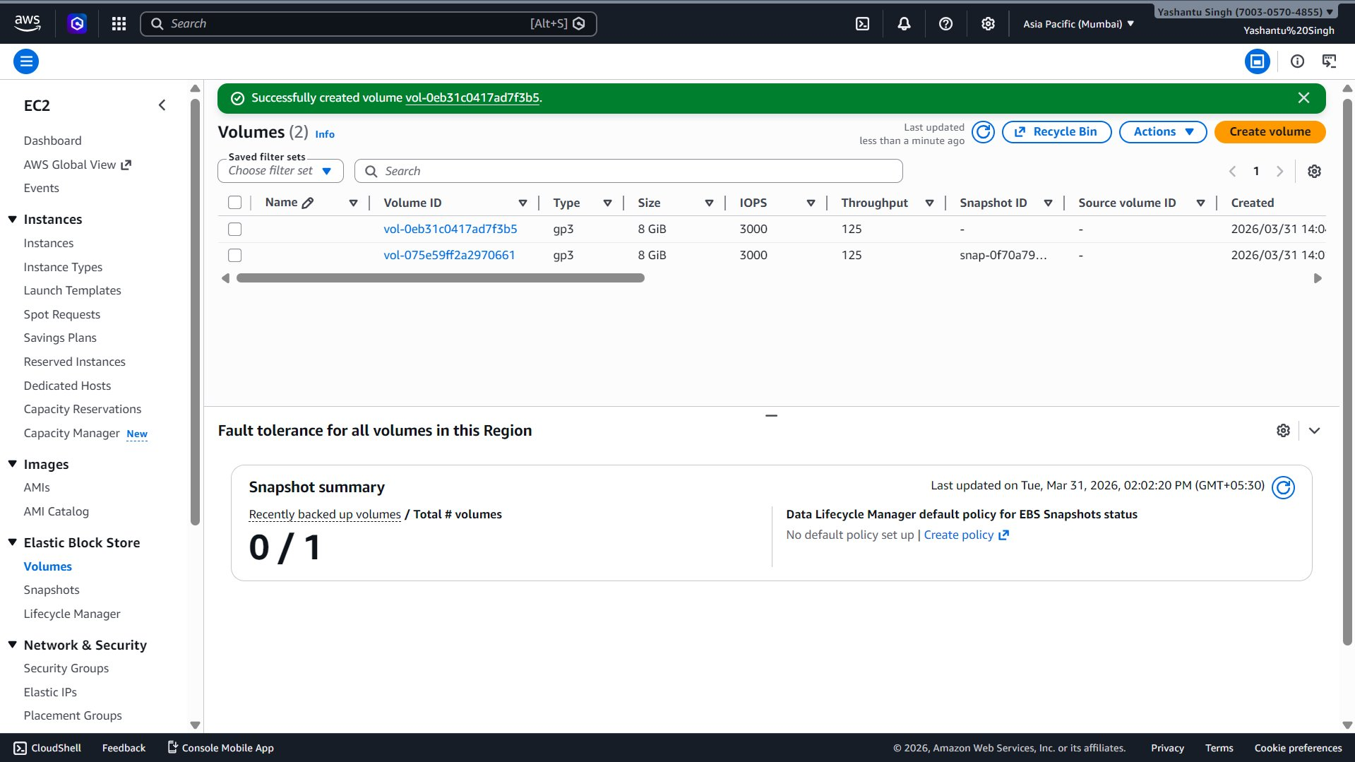
Image 12: Second EBS Volume Created

6. Connecting to EC2 via Instance Connect
EC2 Instance Connect provides browser-based SSH access without needing a local SSH client or key pair. Instance details: Public IP 13.201.191.81, Private IP 172.31.7.193.
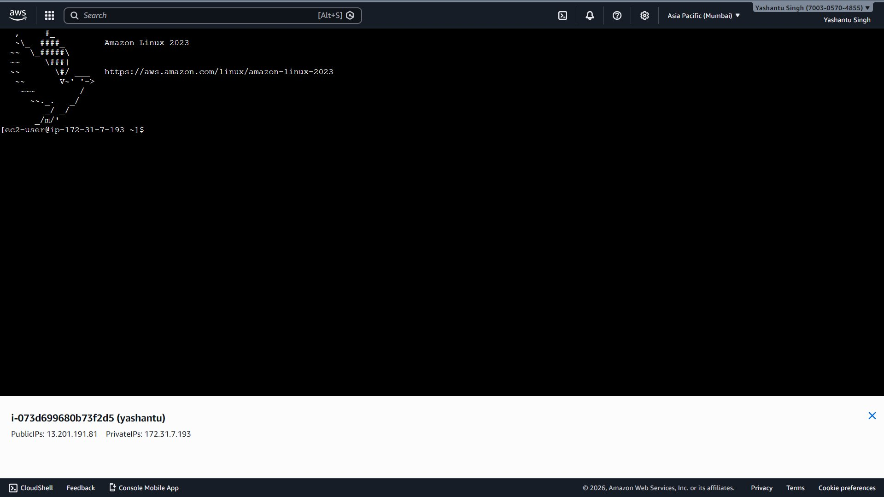
Image 13: Connected to EC2 via Instance Connect

Using Vim Editor
Vim was opened to create a file. The screen shows INSERT mode (bottom-left) with "hello" typed inside the editor.
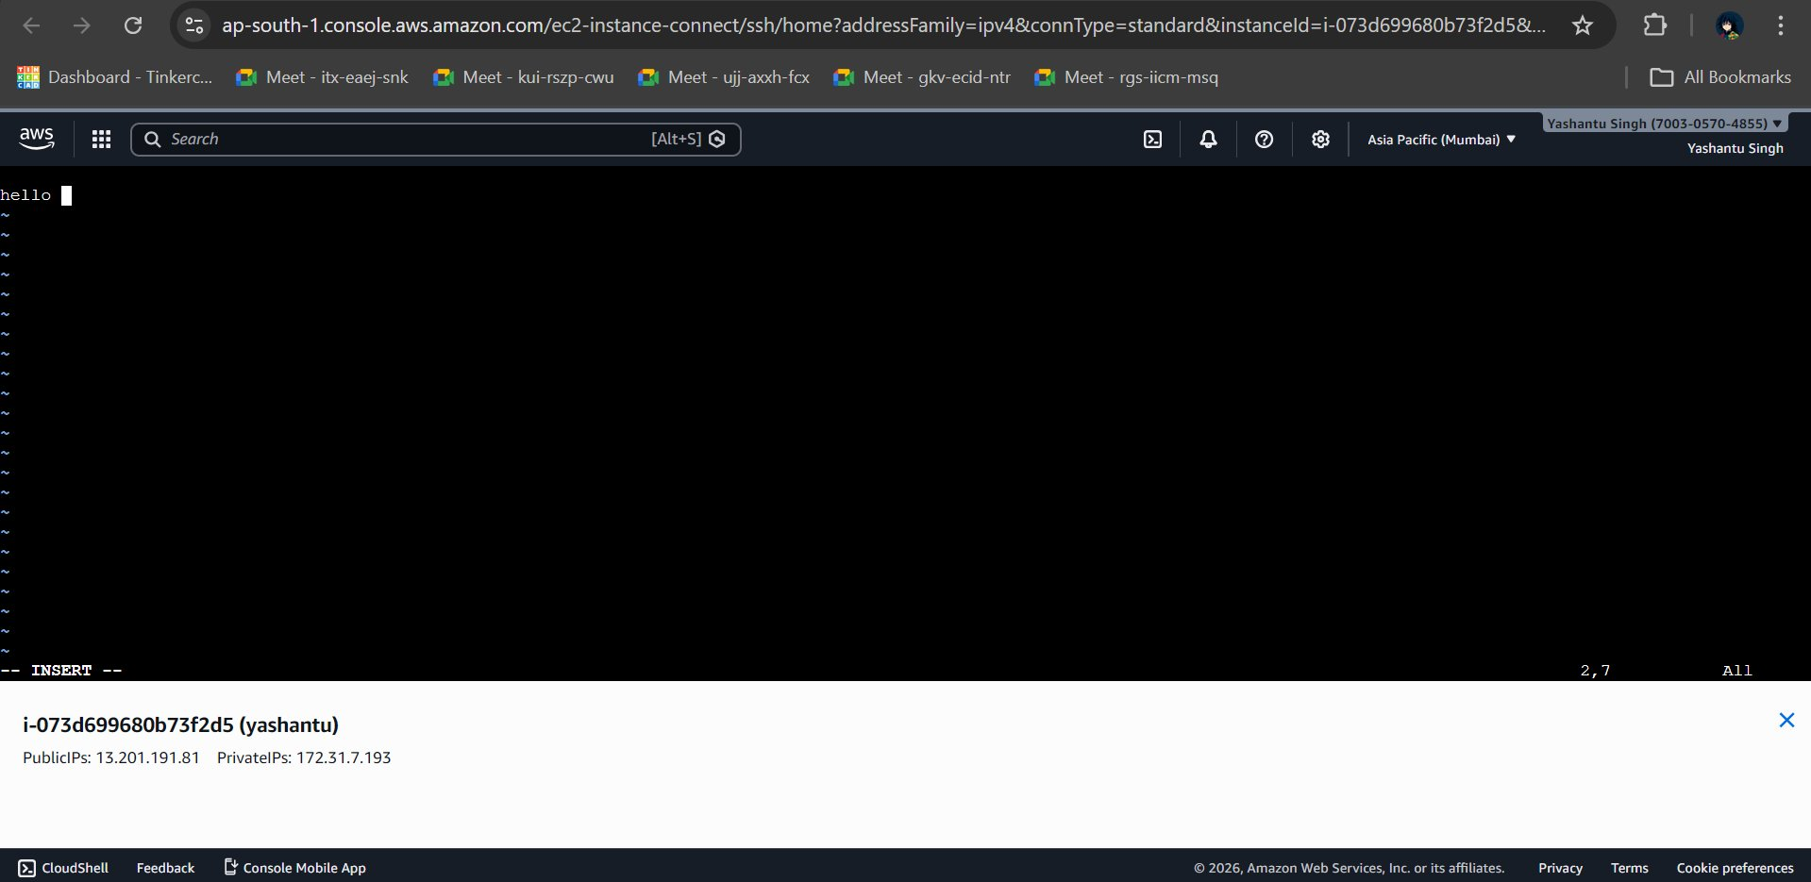
Image 14: Vim Editor on EC2

Linux Commands Executed
- pwd – prints current directory: /home/ec2-user
- mkdir yash – creates directory named "yash"
- cd yash/ then pwd – confirms path: /home/ec2-user/yash
- vim first.txt – creates and edits first.txt
- vim yash.txt – creates and edits yash.txt with content "hello"
- cat hello.txt – error: "No such file or directory"
- cat yash.txt – output: hello (confirms file saved correctly)
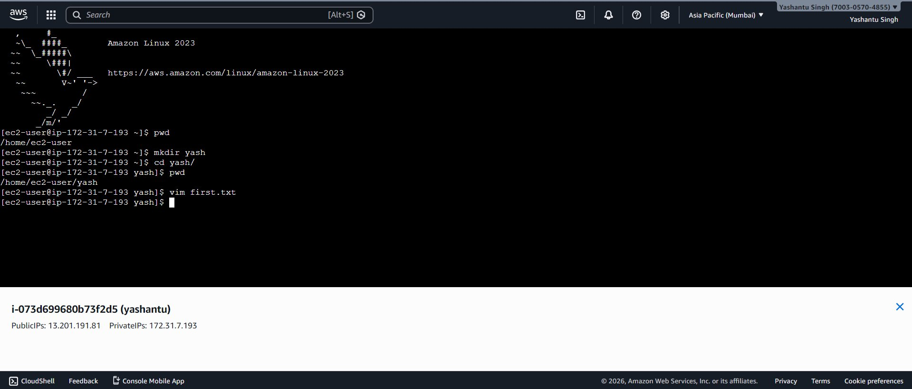
Image 15: Linux Commands – mkdir, pwd, vim
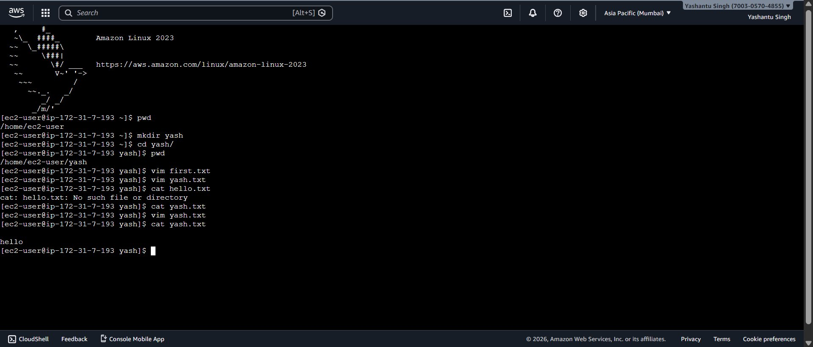
Image 16: Linux Commands – cat yash.txt Output

7. Summary of Lab Activities
- Navigated to EC2 Dashboard in AWS Console (Asia Pacific – Mumbai region)
- Launched EC2 instance "My web Server" – Amazon Linux 2023, t3.micro (free tier)
- Configured security group (SSH), 8 GiB gp3 storage, no key pair
- Verified instance running (ID: i-0375d9c33c9a1c8e2, AZ: ap-south-1a)
- Explored attached EBS root volume and its details
- Created an additional 8 GiB EBS volume in the same AZ
- Connected to EC2 using EC2 Instance Connect (browser SSH)
- Ran Linux commands: pwd, mkdir, cd, vim, cat to manage files on the server
This lab demonstrates foundational AWS cloud skills: EC2 instance provisioning, EBS storage management, security group configuration, and remote Linux server administration.

