Hive mini project_01 solution:

As hive is installed using docker image. At first we need to go hive server location and copy the files from local to hadoop using following commands:

* docker exec -it 773c55b5faa6286a691211f5260375ef30bbc2d67a8b5f432675cb6a010fa8f2 /bin/bash
* docker cp AgentLogingReport.csv 773c55b5faa6286a691211f5260375ef30bbc2d67a8b5f432675cb6a010fa8f2:/home
* docker cp AgentPerformance.csv 773c55b5faa6286a691211f5260375ef30bbc2d67a8b5f432675cb6a010fa8f2:/home

Q1) Create a schema based on the given dataset

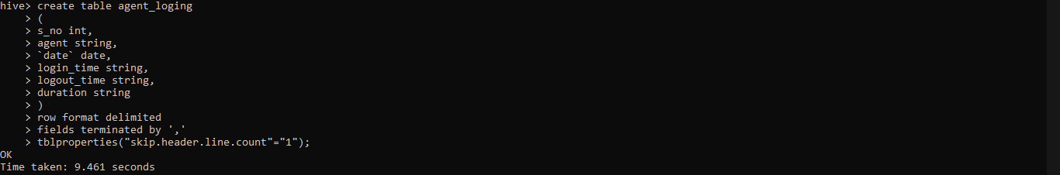

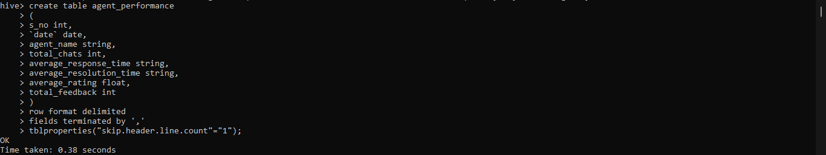

Q2) Dump the data inside the hdfs in the given schema location.

Use the following commands to load data from Hadoop to tables

* LOAD DATA LOCAL INPATH '/home/AgentLogingReport' INTO TABLE agent_loging;
* LOAD DATA LOCAL INPATH '/home/AgentPerformance.csv' INTO TABLE agent_performance;

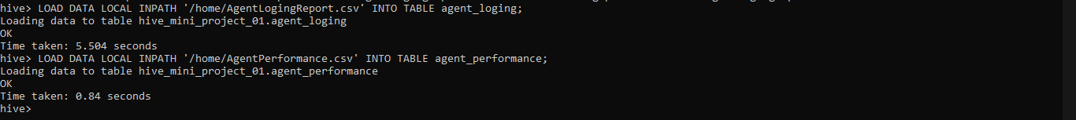

In order to get information about tables, we can use following:

* describe formatted agent_loging
* describe formatted agent_performance

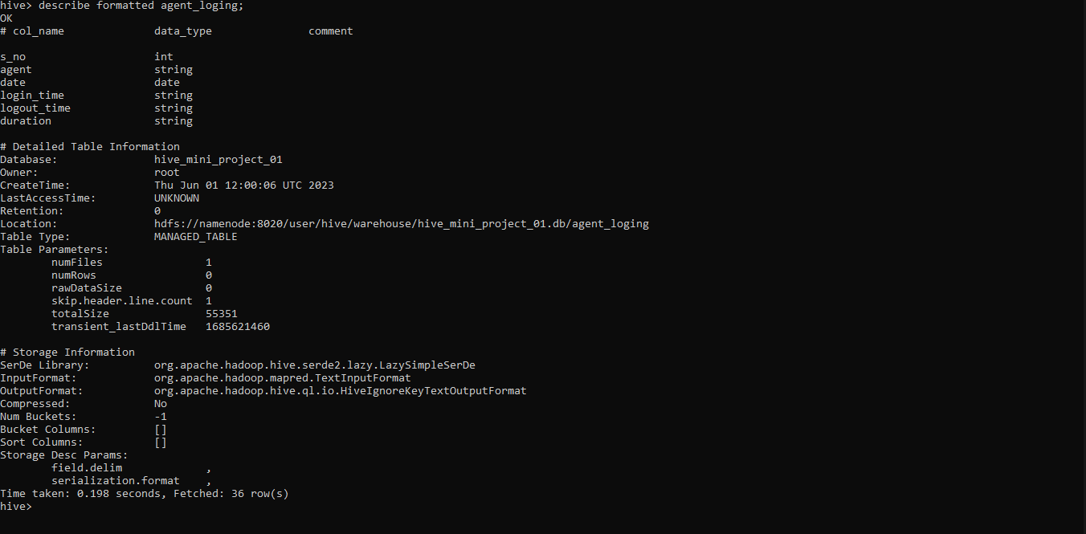

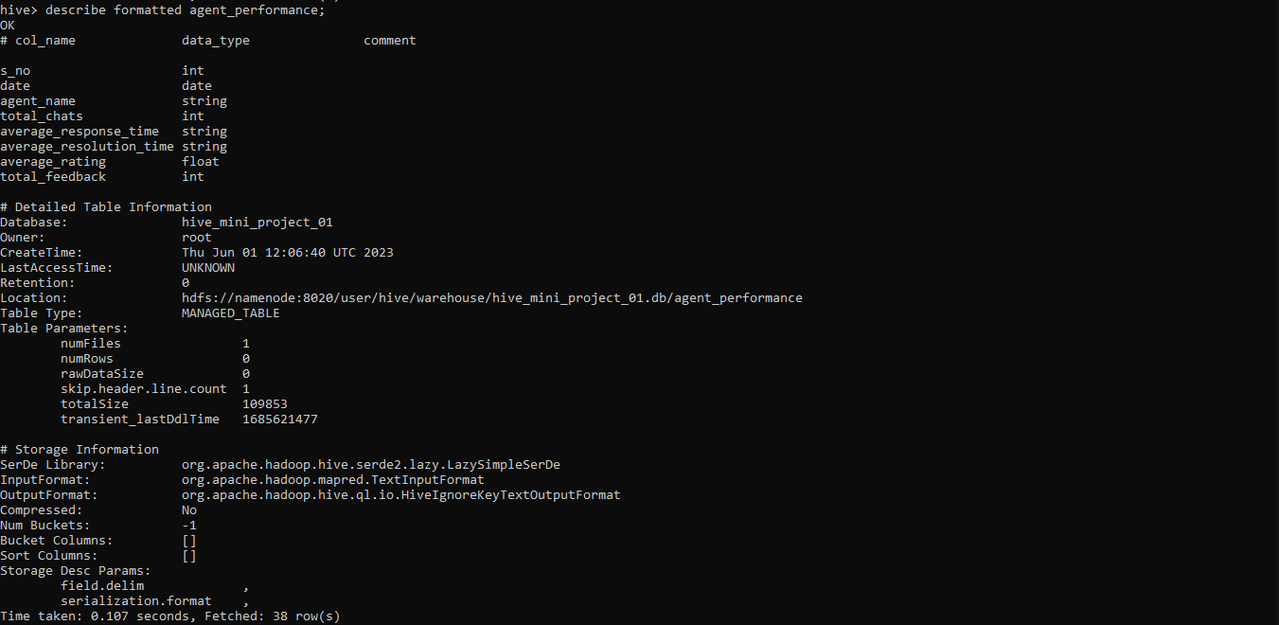

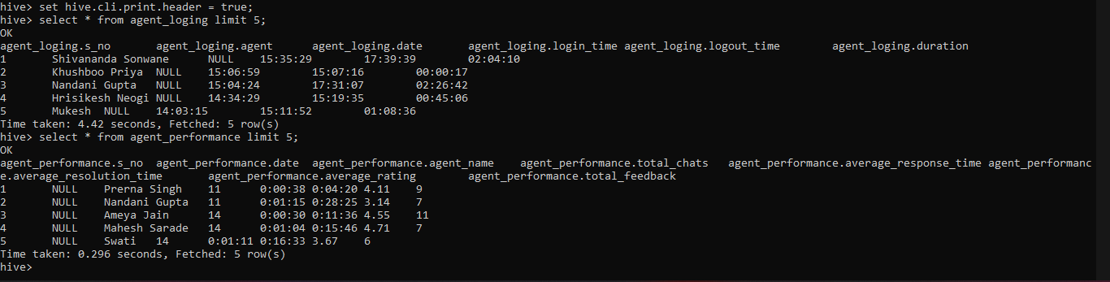

3. List of all agents' names.

* select distinct agent from agent_loging;

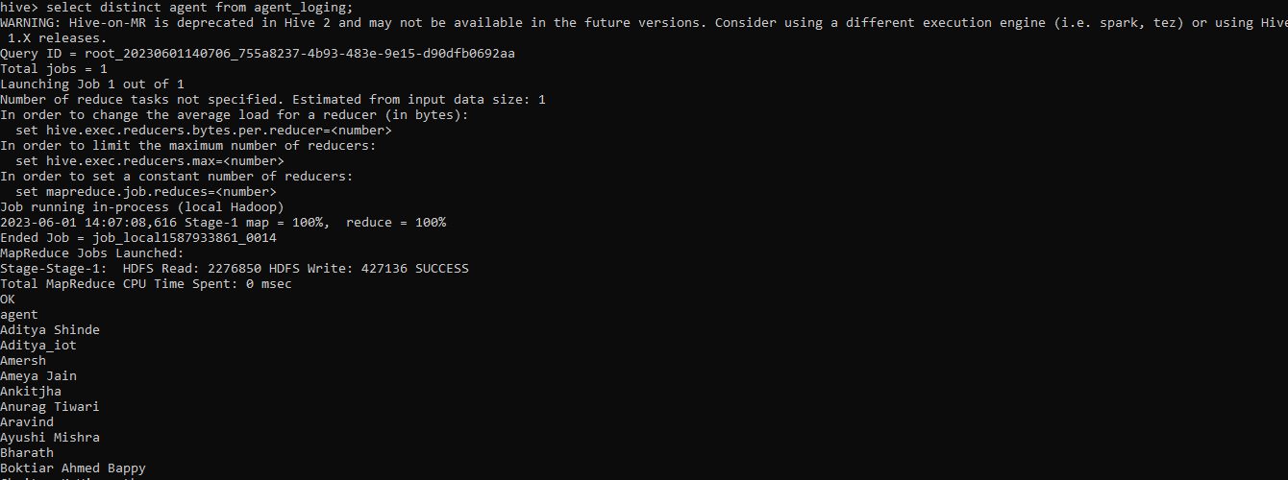

4. Find out agent average rating.

* select agent_name as agent, avg(average_rating) as average_rating from agent_performance group by agent_name;

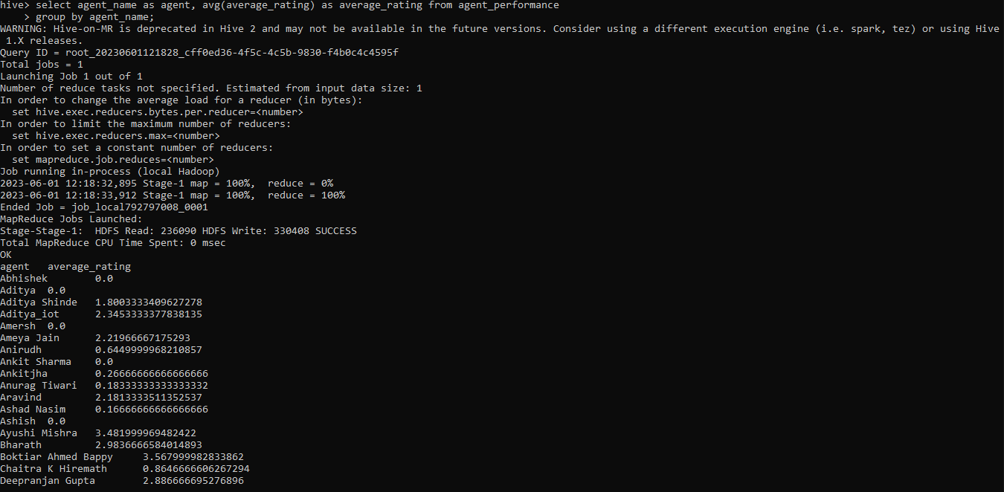

5. Total working days for each agent.

* select agent_name as agent, count(distinct date) as number_of_working_days from agent_performance group by agent_name;

6. Total query that each agent has taken

* select agent_name as agent, sum(total_chats) as queries_taken from agent_performance group by agent_name;

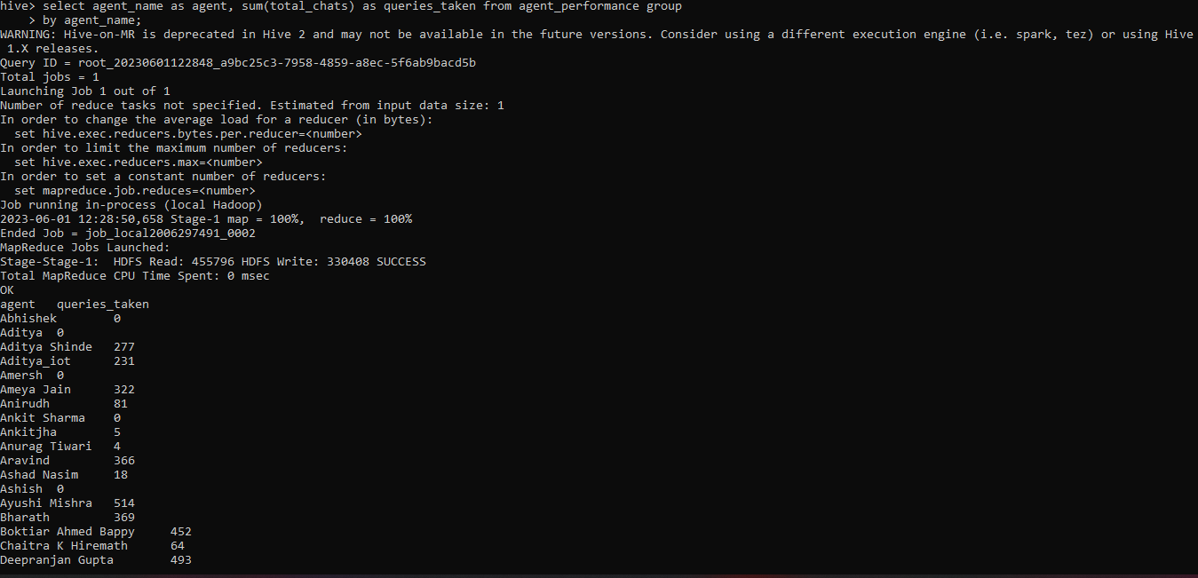

7. Total Feedback that each agent has received Solution

* select agent_name as agent, sum(total_feedback) as feedbacks_received from agent_performance group by agent_name;

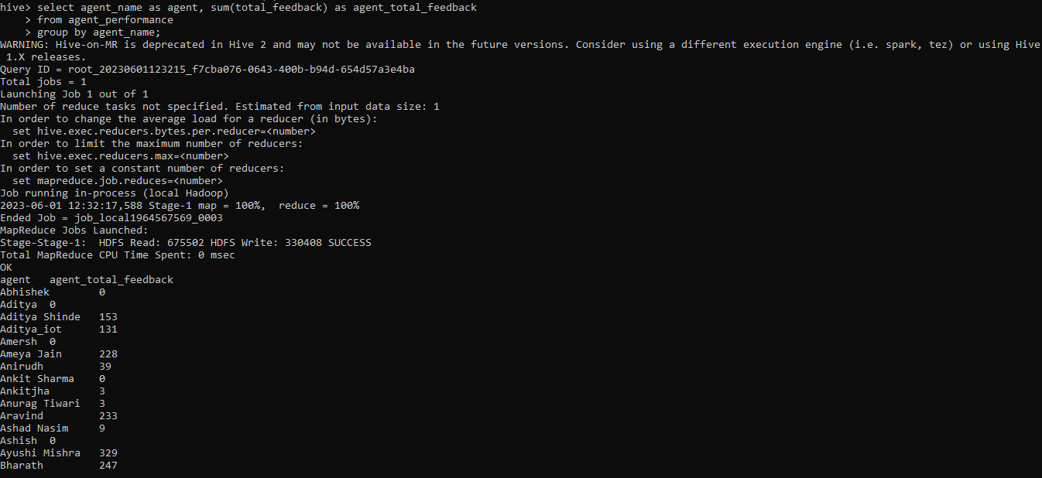

8. Agent name who have average rating between 3.5 to 4

* select agent_name as agent

from agent_performance

where average_rating between 3.5 and 4;

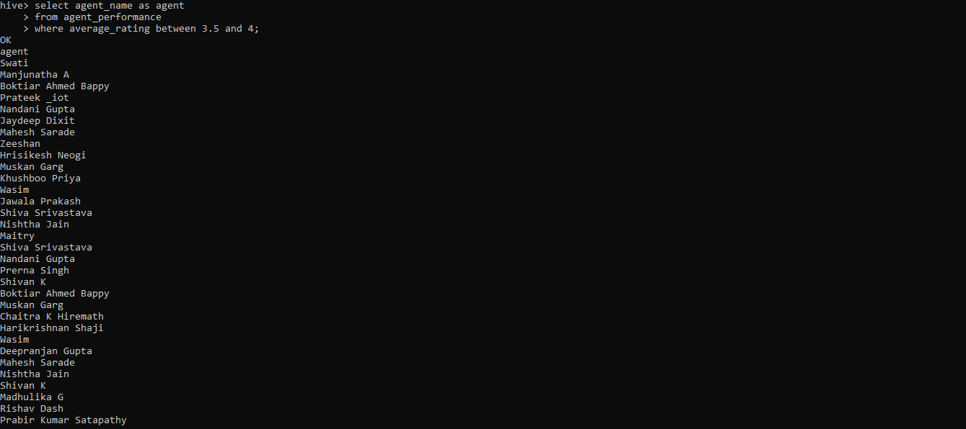

9. Agent name who have rating less than 3.5

* select agent_name as agent from agent_performance where average_rating < 3.5;

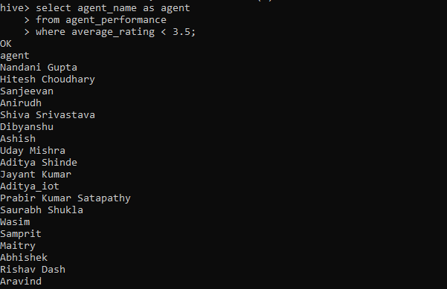

10. Agent name who have rating more than 4.5

* select agent_name as agent from agent_performance where average_rating > 4.5;

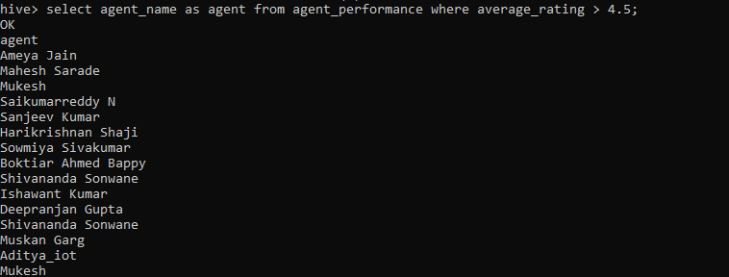

11. How many feedback agents have received more than 4.5 average

* select count(*) from(select agent_name as agent, avg(total_feedback) as average_feedback from agent_performance group by agent_name having average_feedback > 4.5)s;

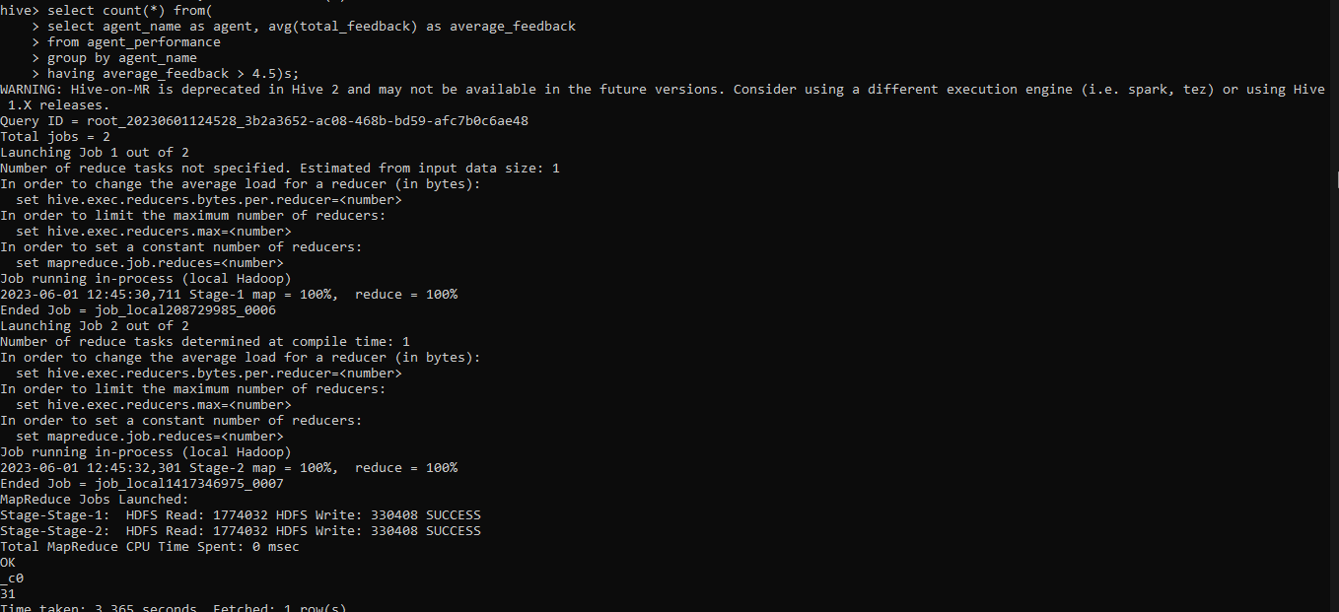

12. Average weekly response time for each agent.

* select agent, avg(weekly_response_time_in_sec) as avg_weekly_response_time_in_sec from (select week, agent, sum((time[0]*3600+time[1]*60+time[2])) as weekly_response_time_in_sec from(select agent_name as agent, weekofyear(date) as week, split(average_response_time,':') as time from agent_performance) t group by agent, week)s group by agent;

13. average weekly resolution time for each agents.

* select agent, avg(weekly_resolution_time_in_sec) as avg_weekly_resolution_time_in_sec from (select week, agent, sum((time[0]*3600+time[1]*60+time[2])) as weekly_resolution_time_in_sec from(select agent_name as agent, weekofyear(date) as week, split(average_resolution_time,':') as time from agent_performance) t group by agent, week)s group by agent;

14. Find the number of chats on which they have received a feedback

* select agent_name as agent, sum(total_chats) as chats, sum(total_feedback) as chats_with_feedback_received from agent_performance group by agent_name;

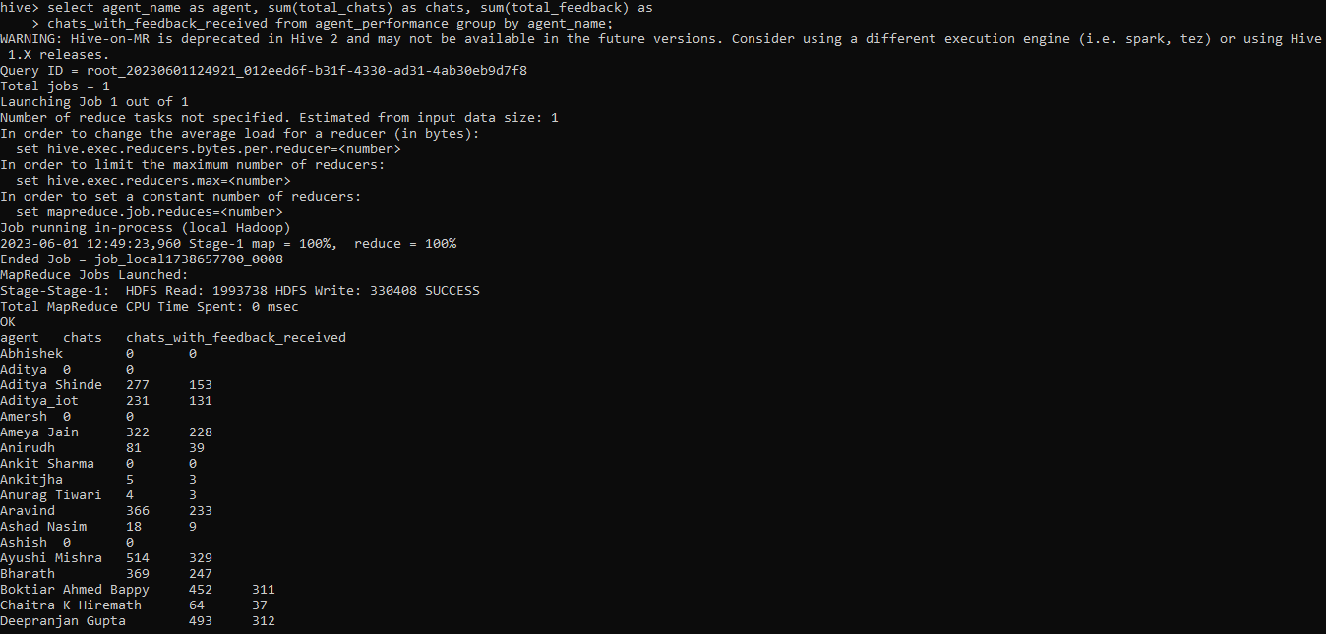

15. Total contribution hour for each and every agents weekly basis.

* select week, agent, sum((time[0]*3600+time[1]*60+time[2])/3600) as total_hrs_contributed from(select agent, weekofyear(date) as week, split(duration,':') as time from agent_loging) t group by agent, week;

16. Perform inner join, left join and right join based on the agent column and after joining the table export that data into your local system.

a. inner join

* INSERT OVERWRITE DIRECTORY '/tmp/agent_data'
* ROW FORMAT DELIMITED
* FIELDS TERMINATED BY ','
* select a_l.*, a_p.*
* from
* agent_loging as a_l
* inner join
* agent_performance a_p
* on a_l.agent = a_p.agent_name
* limit 5

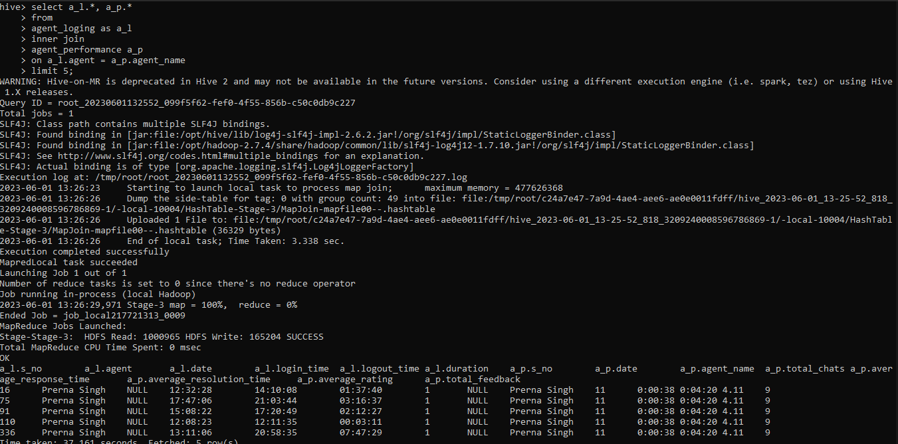

* hadoop fs -getmerge /tmp/agent_data result.csv



b. left join

* INSERT OVERWRITE DIRECTORY '/tmp/agent_data'
* ROW FORMAT DELIMITED
* FIELDS TERMINATED BY ','
* select a_l.*, a_p.*
* from
* agent_loging as a_l
* inner join
* agent_performance a_p
* on a_l.agent = a_p.agent_name
* limit 10

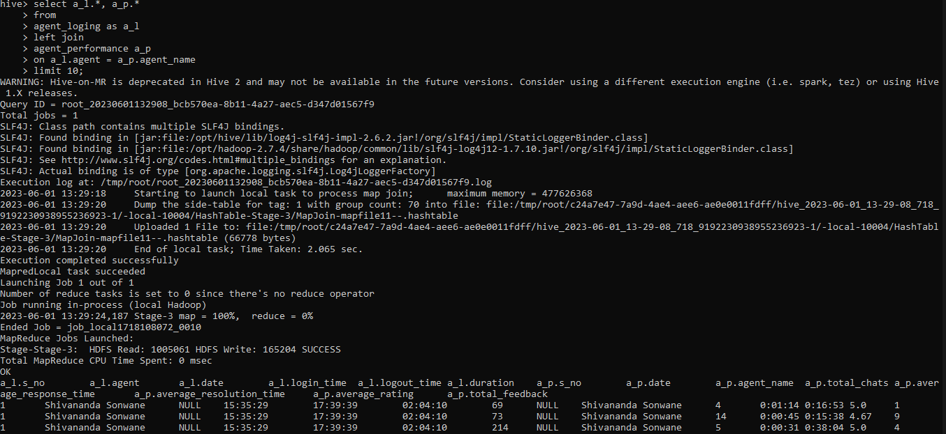

c. Right join

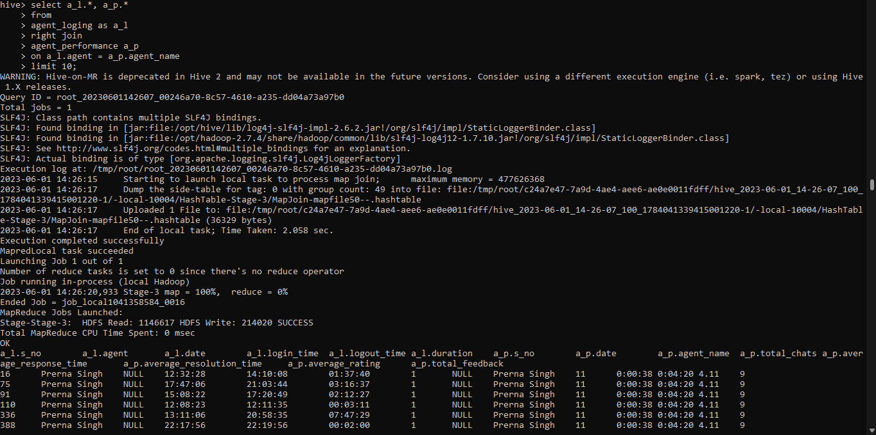

17. Perform partitioning on top of the agent column and then on top of that perform bucketing for each partitioning.

* set the below mentioned properties to be true.
* hive> set hive.exec.dynamic.partition=true;
* hive> set hive.exec.dynamic.patition.mode=nonstrict;
* Create partition bucket table with same columns in agent_loging table

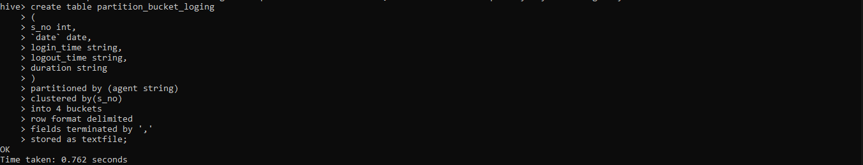

Load the data from agent_loging to packet_bucket_loging table using following command.

* insert overwrite table partition_bucket_loging partition(agent) select s_no, `date`, login_time, logout_time, duration, agent from agent_loging;



