

Department of Artificial Intelligence and Data Science

Image Processing
BAD24406a

Mini Project Report
on
TOPIC: Make use of the given Image Segmentation Dataset and segment the images in the dataset using Edge-Based Segmentation (Canny) and estimate the quality of the segmented images using Dice Coefficient (F1 Score), IoU (Jaccard Index), Pixel Accuracy, Precision & Recall and provide a visual representation of results.

Submitted By
Name 1: Yashas BT USN1 :1GA24AD114
Name 2: Vadiraj Joshi USN2: 1GA24AD104
Name 3: Sujan G USN3:1GA24AD092
Name 4: Zeeshan Ahmed USN4:1GA24AD115

Under the Guidance
of
Dr. Pooja S.
Associate Professor
Department of AI & DS

CONTENTS

Sl No. | Topic | Page No
1 | Introduction | 3
2 | Code | 4
3 | Results | 10
4 | Conclusion | 15

INTRODUCTION
Image segmentation is a fundamental and widely studied task in the field of digital image processing and computer vision. It involves partitioning an image into multiple meaningful and homogeneous regions so that objects of interest can be identified, analyzed, and interpreted effectively. Segmentation plays a crucial role in numerous real-world applications such as medical imaging (tumor detection), autonomous driving (road and obstacle detection), satellite image analysis, and object recognition systems.
Among various segmentation approaches, edge-based segmentation is one of the classical and intuitive techniques. This method focuses on detecting significant intensity changes in an image, which typically correspond to object boundaries. By identifying these discontinuities, edge-based methods attempt to outline the structure and shape of objects present in the scene.
In this project, we employ the Canny Edge Detection algorithm, a widely used and robust edge detection technique known for its accuracy and noise resilience. The Canny algorithm operates through a multi-stage pipeline designed to produce thin, well-connected edges while minimizing false detections. The major stages include:
- Noise Reduction: The image is first smoothed using a Gaussian filter to suppress noise and avoid spurious edge detection.
- Gradient Computation: Intensity gradients are calculated to identify regions with high spatial derivatives, indicating potential edges.
- Non-Maximum Suppression: This step refines the detected edges by preserving only the local maxima, resulting in thin edge lines.
- Double Thresholding and Edge Tracking: Strong and weak edges are identified, and connectivity analysis is performed to retain only meaningful edges while discarding noise.
To quantitatively evaluate the effectiveness of the segmentation, the detected edges are compared against the provided ground truth annotations. Several standard performance metrics are used to assess the quality of segmentation:
- Dice Coefficient (F1 Score): Measures the overlap between predicted and ground truth edges.
- Intersection over Union (IoU / Jaccard Index): Evaluates the similarity between predicted and actual segmentation.
- Pixel Accuracy: Indicates the proportion of correctly classified pixels.
- Precision: Reflects the correctness of predicted edge pixels.
- Recall: Measures the ability of the method to detect all relevant edges.
These metrics collectively provide a comprehensive evaluation of the segmentation performance, highlighting both the strengths and limitations of edge-based methods such as Canny when applied to complex natural images.

CODE
import os
import cv2
import numpy as np
import matplotlib.pyplot as plt
from scipy.io import loadmat
import pandas as pd

# PATHS

IMAGE_DIR = "Images"
GT_DIR = "Groundtruth"
OUTPUT_DIR = "outputs"

os.makedirs(OUTPUT_DIR, exist_ok=True)

# LOAD GROUND TRUTH

def load_ground_truth(mat_path):
mat = loadmat(mat_path)
gts = mat['groundTruth']

combined = None

for i in range(gts.shape[1]):
boundary = gts[0][i]['Boundaries'][0][0]

if combined is None:
combined = boundary.astype(float)
else:
combined += boundary

combined = combined / gts.shape[1]
combined = combined > 0.05

return combined.astype(np.uint8)

# METRICS
def compute_metrics(pred, gt):
pred = pred.astype(bool)
gt = gt.astype(bool)

TP = np.logical_and(pred, gt).sum()
FP = np.logical_and(pred, ~gt).sum()
FN = np.logical_and(~pred, gt).sum()
TN = np.logical_and(~pred, ~gt).sum()

dice = (2 * TP) / (2 * TP + FP + FN + 1e-6)
iou = TP / (TP + FP + FN + 1e-6)
accuracy = (TP + TN) / (TP + TN + FP + FN + 1e-6)
precision = TP / (TP + FP + 1e-6)
recall = TP / (TP + FN + 1e-6)

return dice, iou, accuracy, precision, recall

# STORAGE

dice_scores, iou_scores = [], []
accuracies, precisions, recalls = [], [], []

results = []

# MAIN LOOP

for file in os.listdir(IMAGE_DIR):

if not file.endswith(".jpg"):
continue

img_path = os.path.join(IMAGE_DIR, file)
mat_path = os.path.join(GT_DIR, file.replace(".jpg", ".mat"))

if not os.path.exists(mat_path):
print(f"Skipping {file}")
continue

# Load image
image = cv2.imread(img_path)
gray = cv2.cvtColor(image, cv2.COLOR_BGR2GRAY)

# Load GT
gt = load_ground_truth(mat_path)
gt = cv2.resize(gt, (gray.shape[1], gray.shape[0]))

# CANNY + MORPHOLOGY

edges = cv2.Canny(gray, 50, 150)

kernel = np.ones((3,3), np.uint8)
edges = cv2.morphologyEx(edges, cv2.MORPH_CLOSE, kernel)
edges = cv2.dilate(edges, kernel, iterations=1)

pred = edges > 0

gt = cv2.dilate(gt.astype(np.uint8), kernel, iterations=2)
gt = gt > 0

# METRICS

d, i, a, p, r = compute_metrics(pred, gt)

dice_scores.append(d)
iou_scores.append(i)
accuracies.append(a)
precisions.append(p)
recalls.append(r)

results.append([file, d, i, a, p, r])

# VISUALIZATION

overlay = image.copy()
overlay[pred] = [255, 0, 0]
overlay[gt] = [0, 255, 0]

fig, axs = plt.subplots(1, 4, figsize=(15,4))

axs[0].imshow(cv2.cvtColor(image, cv2.COLOR_BGR2RGB))
axs[0].set_title("Original")
axs[0].axis("off")

axs[1].imshow(gt, cmap='gray')
axs[1].set_title("Ground Truth")
axs[1].axis("off")

axs[2].imshow(pred, cmap='gray')
axs[2].set_title("Improved Canny")
axs[2].axis("off")

axs[3].imshow(cv2.cvtColor(overlay, cv2.COLOR_BGR2RGB))
axs[3].set_title("Overlay")
axs[3].axis("off")

plt.tight_layout()
plt.savefig(os.path.join(OUTPUT_DIR, f"result_{file}"))
plt.close()

print(f"Processed: {file}")

# FINAL METRICS

print("\n===== FINAL RESULTS =====")
print(f"Dice Coefficient : {np.mean(dice_scores):.4f}")
print(f"IoU (Jaccard) : {np.mean(iou_scores):.4f}")
print(f"Pixel Accuracy : {np.mean(accuracies):.4f}")
print(f"Precision : {np.mean(precisions):.4f}")
print(f"Recall : {np.mean(recalls):.4f}")

# RESULTS TABLE (NEW)

df = pd.DataFrame(results, columns=[
"Image", "Dice", "IoU", "Accuracy", "Precision", "Recall"
])

# serial number
df.insert(0, "Sl No.", range(1, len(df)+1))

# average row
avg = df.mean(numeric_only=True)
avg["Image"] = "Average"
df = pd.concat([df, pd.DataFrame([avg])], ignore_index=True)

# Save CSV
df.to_csv("results_table.csv", index=False)

print("\n===== RESULTS TABLE =====")
print(df.to_string(index=False))

# GRAPH

metrics = ['Dice', 'IoU', 'Accuracy', 'Precision', 'Recall']
values = [
np.mean(dice_scores),
np.mean(iou_scores),
np.mean(accuracies),
np.mean(precisions),
np.mean(recalls)
]

plt.figure(figsize=(8,5))
plt.bar(metrics, values)
plt.title("Segmentation Performance Metrics")
plt.xlabel("Metrics")
plt.ylabel("Score")
plt.grid()

plt.savefig(os.path.join(OUTPUT_DIR, "final_metrics.png"))
plt.show()

RESULTS
Results Table
Sl No. | Image | Dice | IoU | Accuracy | Precision | Recall
1 | 12084.jpg | 0.353276 | 0.214532 | 0.463993 | 0.228577 | 0.777357
2 | 14037.jpg | 0.376744 | 0.232091 | 0.741867 | 0.338361 | 0.424948
3 | 16077.jpg | 0.358189 | 0.218167 | 0.49444 | 0.242513 | 0.684861
4 | 19021.jpg | 0.456001 | 0.295338 | 0.537399 | 0.326107 | 0.757873
5 | 21077.jpg | 0.475504 | 0.311909 | 0.677308 | 0.352632 | 0.729796
6 | 24077.jpg | 0.515212 | 0.346994 | 0.644063 | 0.445868 | 0.610099
7 | 3096.jpg | 0.372457 | 0.228846 | 0.896115 | 0.785997 | 0.244053
8 | 33039.jpg | 0.394225 | 0.245504 | 0.289396 | 0.253438 | 0.886915
9 | 37073.jpg | 0.706076 | 0.545685 | 0.855118 | 0.74661 | 0.669716
10 | 38082.jpg | 0.486872 | 0.321766 | 0.397996 | 0.334261 | 0.895916
11 | 38092.jpg | 0.393051 | 0.244595 | 0.479777 | 0.271706 | 0.710252
12 | 41033.jpg | 0.316817 | 0.188225 | 0.649504 | 0.215427 | 0.598493
13 | 41069.jpg | 0.216301 | 0.121265 | 0.209707 | 0.124661 | 0.816555
14 | 42012.jpg | 0.471723 | 0.308663 | 0.592477 | 0.400316 | 0.574135
15 | 42049.jpg | 0.627314 | 0.456997 | 0.875079 | 0.631069 | 0.623603
16 | 43074.jpg | 0.322298 | 0.192107 | 0.688027 | 0.247574 | 0.461631
17 | 45096.jpg | 0.450489 | 0.29073 | 0.845992 | 0.572915 | 0.371173
18 | 54082.jpg | 0.554241 | 0.383357 | 0.646103 | 0.465298 | 0.685224
19 | 55073.jpg | 0.438562 | 0.280871 | 0.360645 | 0.292437 | 0.876572
20 | 8023.jpg | 0.326019 | 0.194757 | 0.711945 | 0.202943 | 0.828417
10.5 | Average | 0.430569 | 0.28112 | 0.602847 | 0.373936 | 0.661379

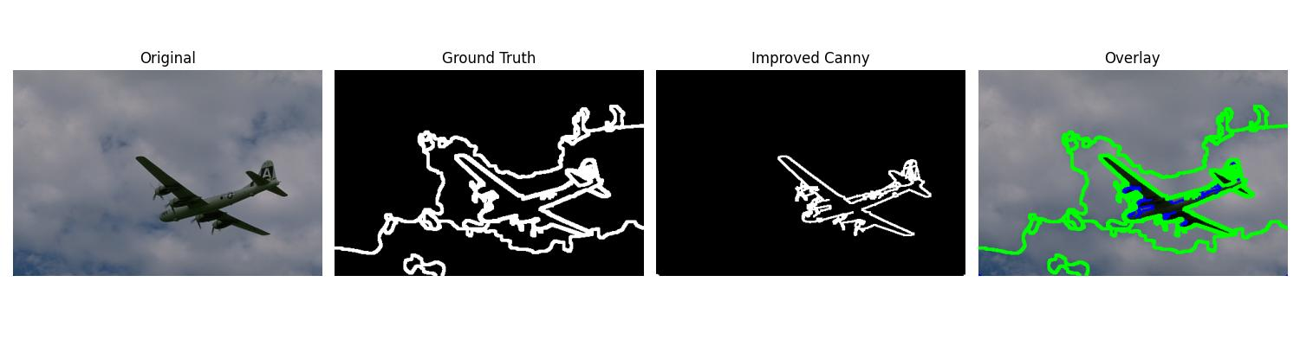
Sample Original and Resulting Images
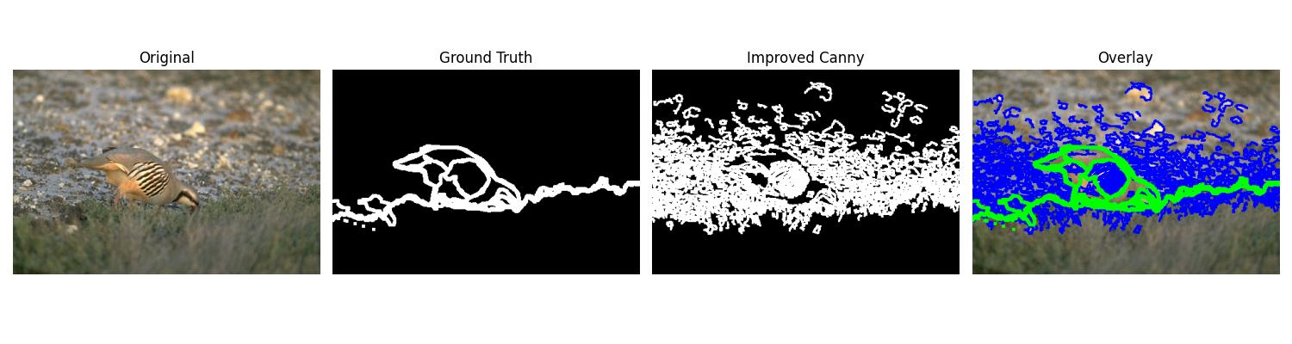
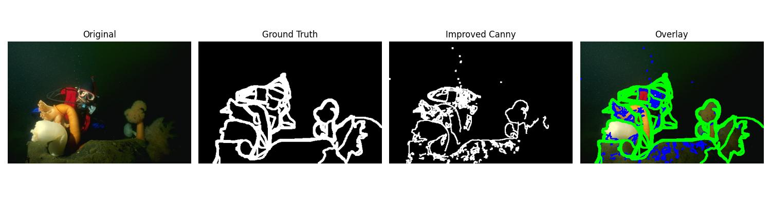
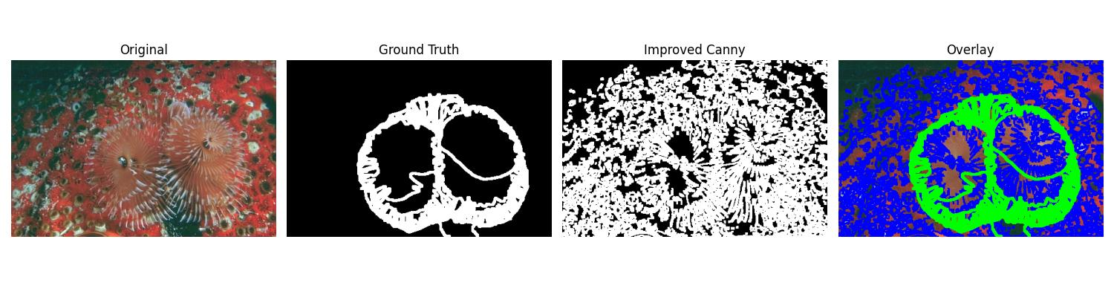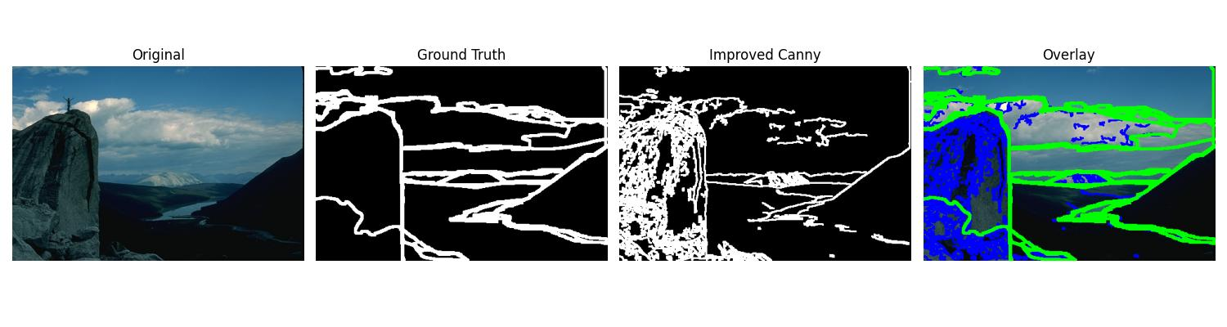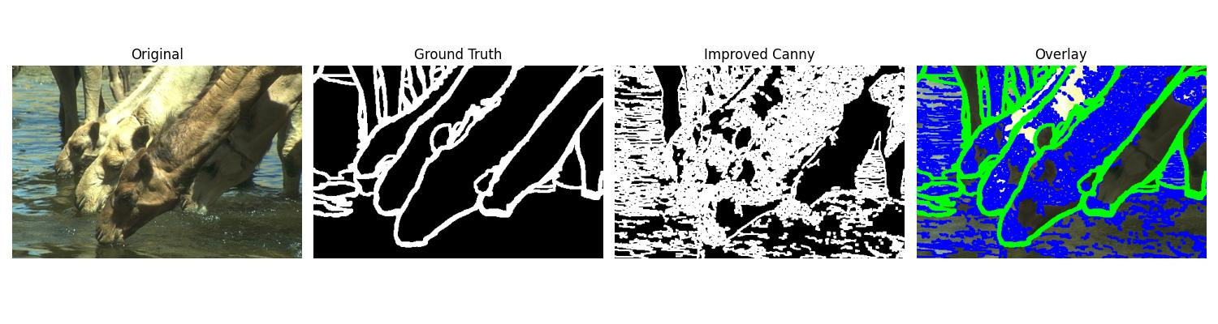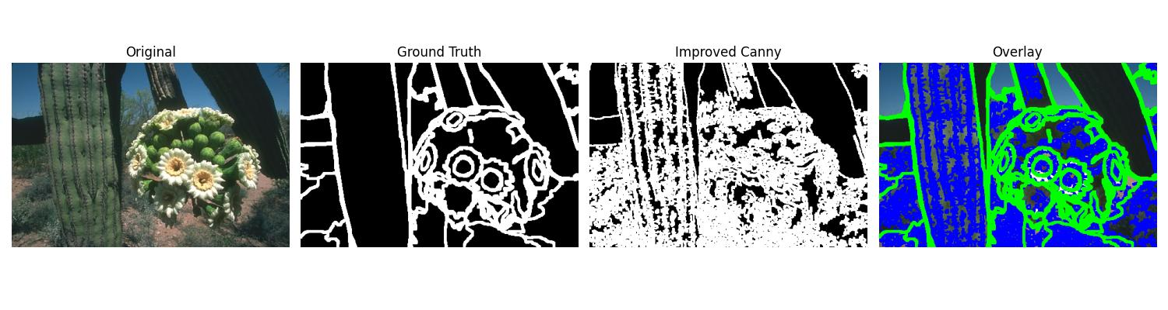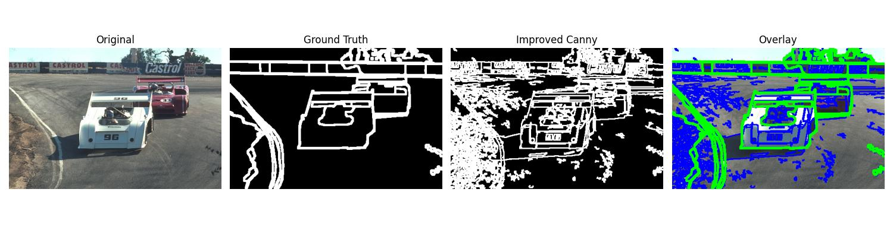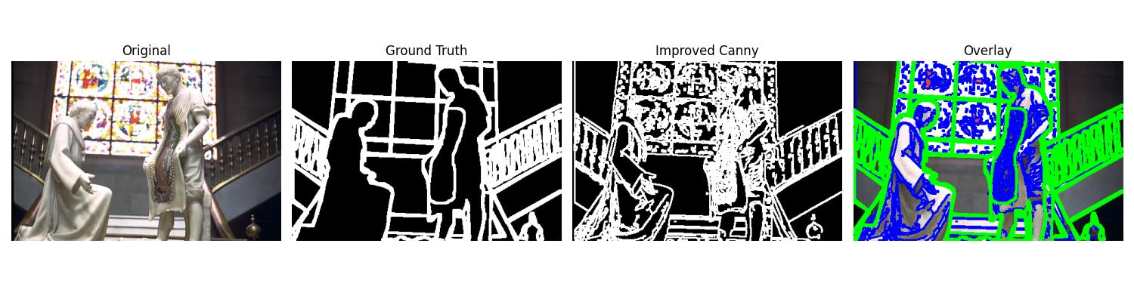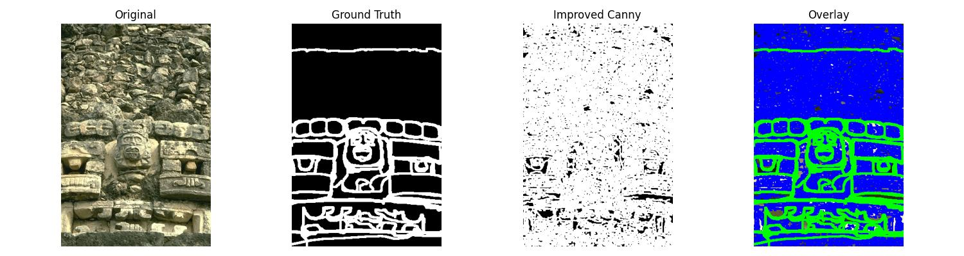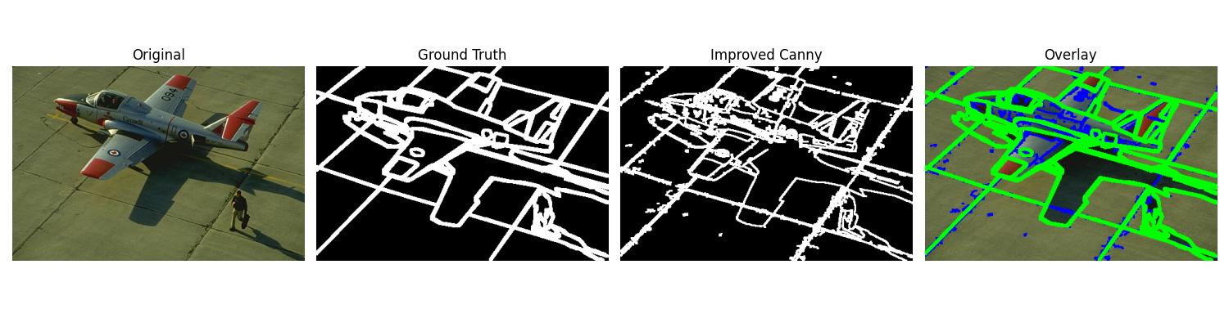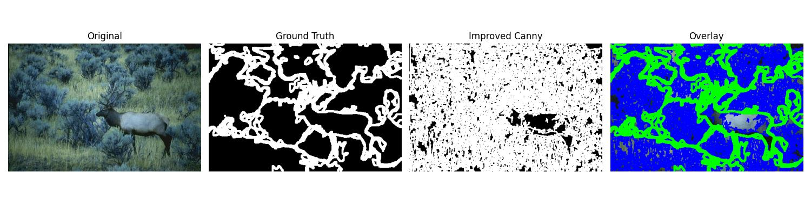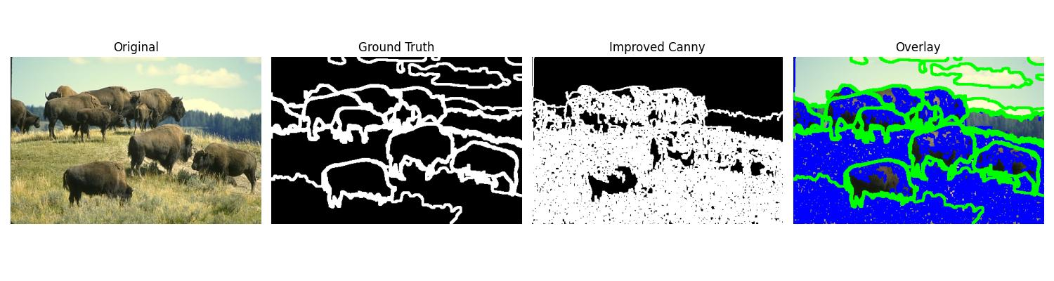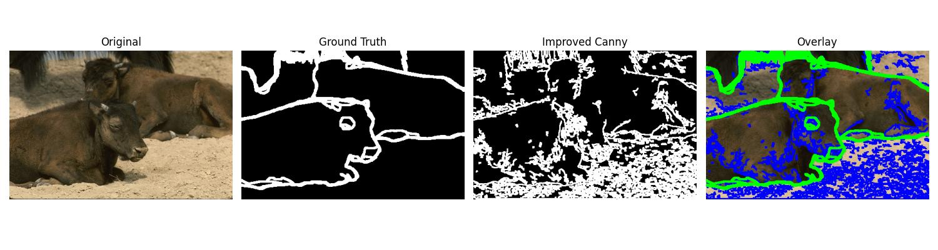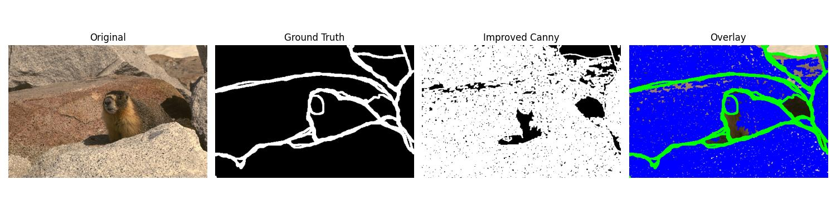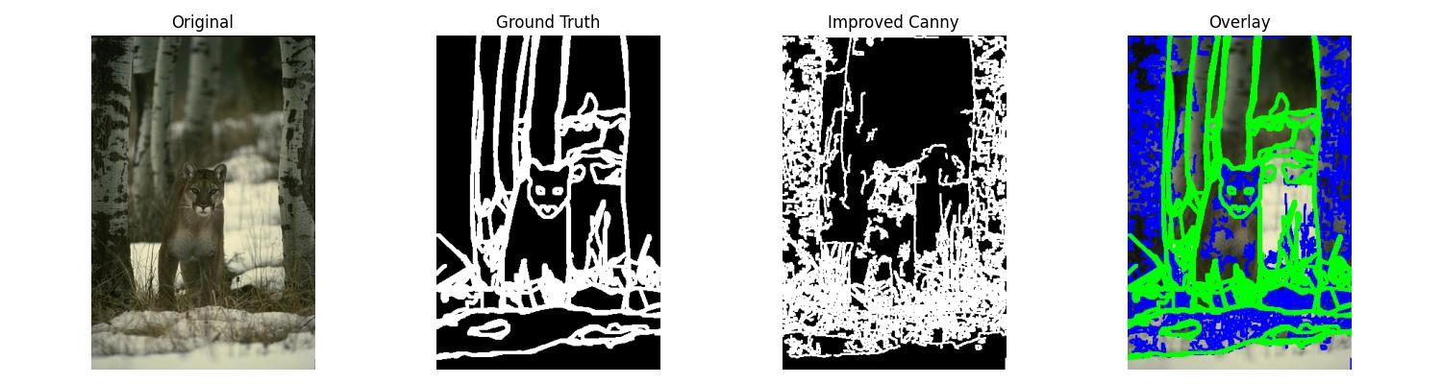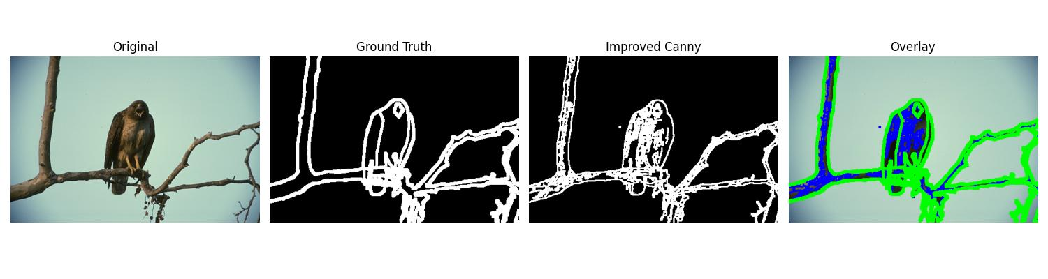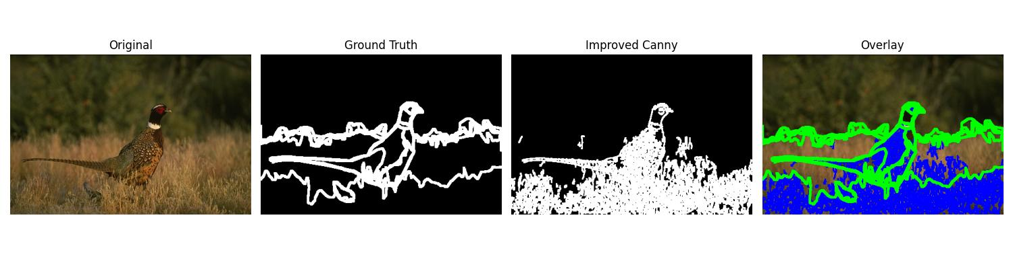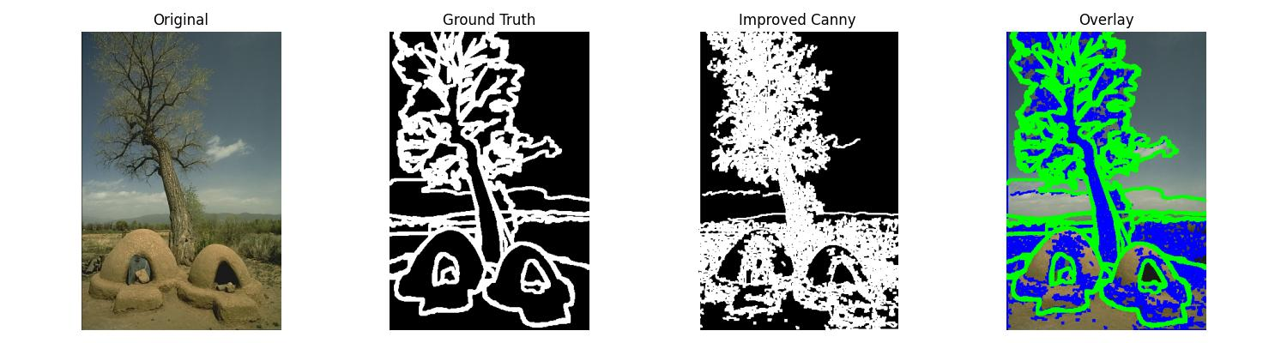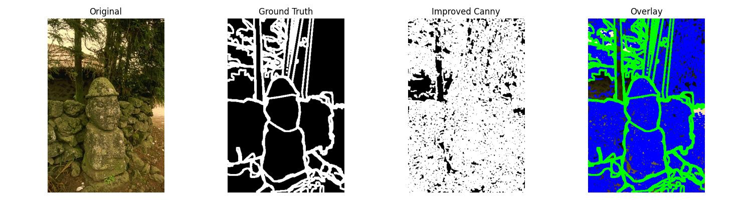

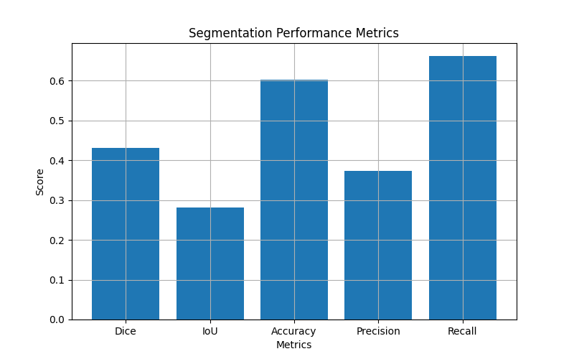
Visualizations (graph and charts)
CONCLUSION
- Edge-based image segmentation was successfully implemented using the Canny Edge Detection algorithm.
- The method effectively detected prominent edges while maintaining low computational complexity.
- Evaluation using Dice, IoU, Precision, Recall, and Accuracy revealed moderate performance due to differences between predicted edges and ground truth boundaries.
- Canny detects intensity variations, making it less effective in capturing all semantic and textured regions.
- Morphological operations such as dilation and closing improved edge continuity and overlap with ground truth.
- The approach highlights the strengths and limitations of classical segmentation techniques.
- Overall, it provides a strong foundation for understanding and advancing toward modern learning-based segmentation methods.

