Andaman & Nicobar

Port-Blair

Here's a more detailed itinerary with suggested timings for your 7-day trip to Andaman and Nicobar Islands:

**Day 1: Arrival in Port Blair**

* Morning/Afternoon: Arrive in Port Blair
* Afternoon: Check-in to your hotel
* Evening: Rest and relax after your journey
* 

**Day 2: Port Blair - City Tour**

* Morning: Visit Cellular Jail
* Afternoon: Explore Corbyn's Cove Beach
* Evening: Anthropological Museum and Fisheries Museum
* Night: Cellular Jail light and sound show

**Day 3: Port Blair to Havelock Island**

* Morning: Take a ferry to Havelock Island
* Afternoon: Check-in to your hotel
* Evening: Relax at Radhanagar Beach

**Day 4: Havelock Island - Elephanta Beach**

* Morning: Visit Elephanta Beach for water activities
* Afternoon: Relax on the beach
* Evening: Leisure time

**Day 5: Havelock Island - Kalapathar Beach**

* Morning: Enjoy leisure time
* Afternoon: Visit Kalapathar Beach
* Evening: Sunset at Kalapathar Beach
* 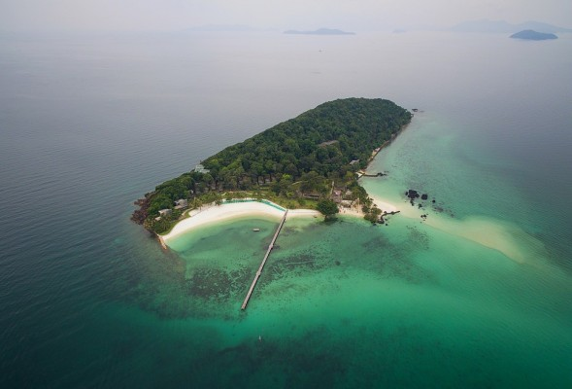

**Day 6: Havelock Island to Neil Island**

* Morning: Take a ferry to Neil Island
* Afternoon: Visit Laxmanpur Beach and Natural Bridge
* Evening: Sunset at Bharatpur Beach

**Day 7: Neil Island to Port Blair**

* Morning: Ferry back to Port Blair
* Afternoon: Visit Chidiya Tapu for bird watching
* Evening: Explore local markets and do some shopping
* Night: Depart from Port Blair

Please note that actual timings may vary based on ferry schedules, weather conditions, and personal preferences. It's advisable to check local timings and conditions during your trip.

Top of Form