**Delhi-Agra Itinerary**

**Day 1: Delhi Arrival**

* Morning: Arrival in Delhi
* Afternoon: Check-in to your hotel, rest, and freshen up
* Evening: Explore Connaught Place or India Gate
* Dinner: Local restaurant in Connaught Place
* 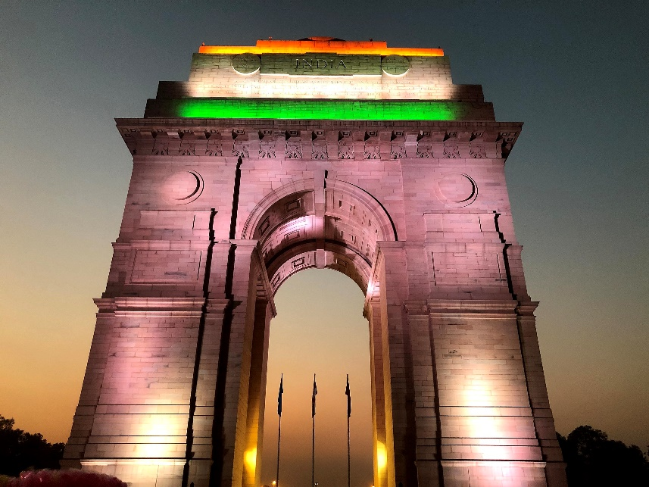

**Day 2: Delhi Sightseeing**

* Morning: Visit Qutub Minar and Humayun's Tomb
* Afternoon: Explore Lotus Temple and India Gate
* Evening: Visit Akshardham Temple (Note: Closed on Mondays)
* Dinner: Local restaurant or back to Connaught Place

**Day 3: Delhi to Agra (via Taj Expressway)**

* Morning: Drive to Agra (approximately 3-4 hours)
* Afternoon: Check-in to your hotel in Agra
* Evening: Visit Mehtab Bagh for a view of the Taj Mahal at sunset
* Dinner: Local restaurant in Agra

**Day 4: Agra Sightseeing**

* Morning: Sunrise visit to the Taj Mahal
* Late morning: Explore Agra Fort
* Afternoon: Visit Itmad-ud-Daulah's Tomb
* Evening: Leisure time or shopping in local markets
* Dinner: Local restaurant or at your hotel

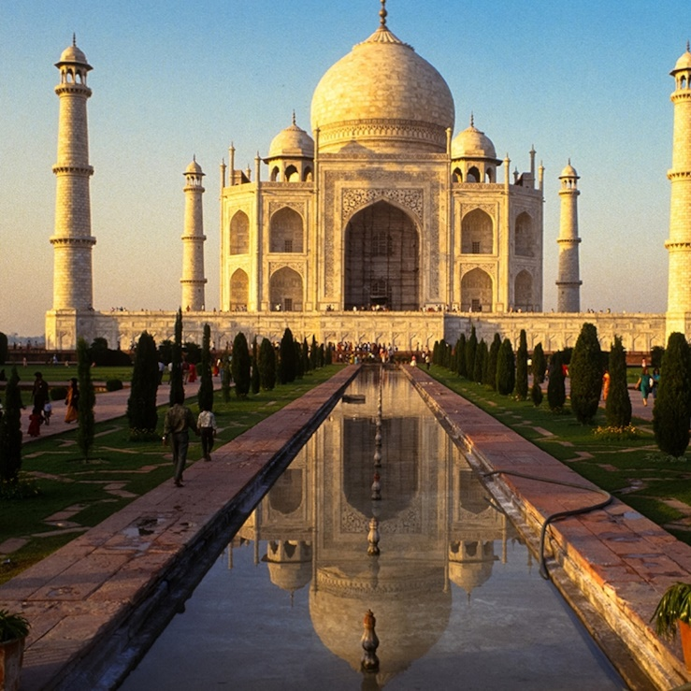

**Day 5: Agra to Fatehpur Sikri and return**

* Morning: Visit Fatehpur Sikri (approximately 1 hour from Agra)
* Afternoon: Explore Fatehpur Sikri and return to Agra
* Evening: Leisure time or optional visit to local markets
* Dinner: Local restaurant or at your hotel

**Day 6: Agra to Delhi Departure**

* Morning: Check out from the hotel and visit the Agra Red Fort if not done earlier
* Afternoon: Drive back to Delhi
* Evening: Free time for last-minute shopping or relaxation
* Dinner: Local restaurant or as per your preference