**GOA-MUMBAI-PUNE**

**Day 1: Arrival in Goa**

* **Morning (Arrival):** Arrive in Goa.
* **Afternoon (12:00 PM - 2:00 PM):** Check-in at the hotel and freshen up.
* **Afternoon (2:30 PM - 6:00 PM):** Relax on a nearby beach (e.g., Baga Beach).
* **Evening (7:00 PM onwards):** Explore the local markets and enjoy dinner.
* 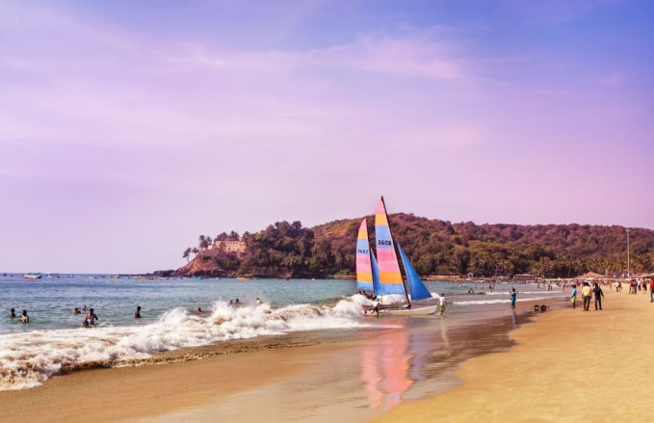

**Day 2: Explore North Goa**

* **Morning (9:00 AM - 12:00 PM):** Visit Aguada Fort and Sinquerim Beach.
* **Lunch (12:30 PM - 2:00 PM):** Lunch at a beachside shack.
* **Afternoon (2:30 PM - 6:00 PM):** Explore Calangute and Candolim Beaches.
* **Evening (7:00 PM onwards):** Enjoy the nightlife in North Goa.

**Day 3: South Goa Relaxation**

* **Morning (9:00 AM - 12:00 PM):** Visit Colva Beach and Benaulim Beach.
* **Lunch (12:30 PM - 2:00 PM):** Lunch at a beachfront restaurant.
* **Afternoon (2:30 PM - 6:00 PM):** Relax at Palolem Beach.
* **Evening (7:00 PM onwards):** Enjoy a beachside dinner.

**Day 4: Depart to Mumbai**

* **Morning (9:00 AM - 12:00 PM):** Check-out from the hotel and depart for Goa Airport.
* **Afternoon (1:00 PM - 2:30 PM):** Flight to Mumbai.
* **Afternoon (3:00 PM - 5:00 PM):** Arrival in Mumbai.
* **Evening (6:00 PM onwards):** Check-in at the hotel, freshen up, and explore local markets.

**Day 5: Mumbai Sightseeing**

* **Morning (9:00 AM - 12:00 PM):** Visit Gateway of India and Elephanta Caves (if time permits).
* **Lunch (12:30 PM - 2:00 PM):** Lunch at a local restaurant.
* **Afternoon (2:30 PM - 6:00 PM):** Explore Chhatrapati Shivaji Maharaj Terminus and Marine Drive.
* **Evening (7:00 PM onwards):** Dinner and relaxation.
* 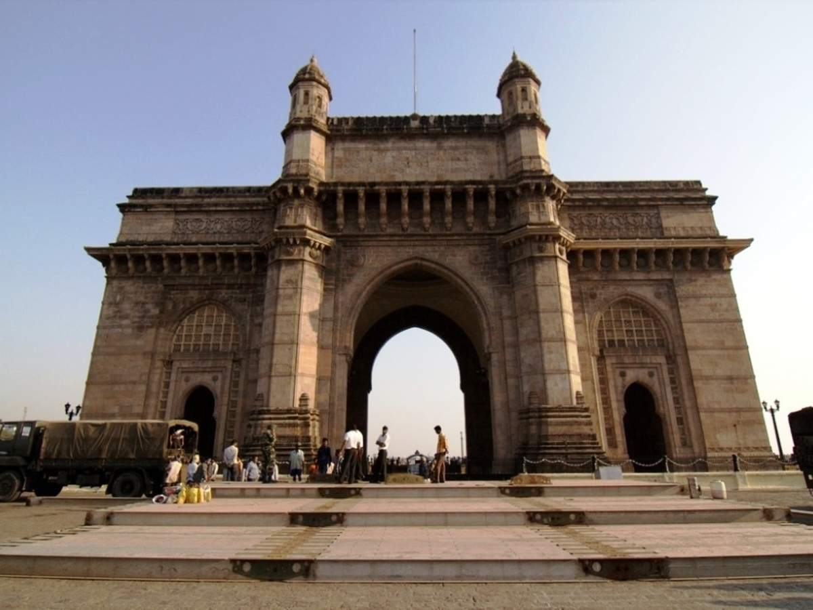

**Day 6: Explore South Mumbai**

* **Morning (9:00 AM - 12:00 PM):** Visit the Prince of Wales Museum and Hanging Gardens.
* **Lunch (12:30 PM - 2:00 PM):** Lunch at a Parsi or Irani café.
* **Afternoon (2:30 PM - 6:00 PM):** Explore Colaba Causeway for shopping.
* **Evening (7:00 PM onwards):** Dinner at a local eatery.

**Day 7: Depart to Pune**

* **Morning (9:00 AM - 12:00 PM):** Check-out from the hotel and depart for Pune.
* **Afternoon (1:00 PM - 2:30 PM):** Arrival in Pune.
* **Afternoon (3:00 PM - 6:00 PM):** Check-in at the hotel and freshen up.
* **Evening (7:00 PM onwards):** Explore local markets and enjoy dinner.

**Day 8: Pune City Exploration**

* **Morning (9:00 AM - 12:00 PM):** Visit Shaniwar Wada and Aga Khan Palace.
* **Lunch (12:30 PM - 2:00 PM):** Lunch at a local restaurant.
* **Afternoon (2:30 PM - 6:00 PM):** Explore Osho International Meditation Resort.
* **Evening (7:00 PM onwards):** Dinner and relaxation.
* 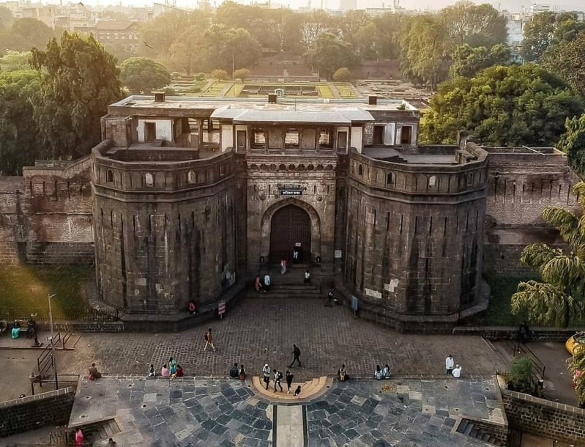

**Day 9: Departure**

* **Morning (9:00 AM - 12:00 PM):** Check-out from the hotel.
* **Afternoon (1:00 PM - 3:00 PM):** Depart for Pune Airport.
* **Afternoon (4:00 PM - 6:00 PM):** Flight back to the home destination.

This itinerary offers a blend of beach relaxation, cultural exploration, and city sightseeing. Adjustments can be made based on specific interests and travel preferences. Please check for any travel restrictions or guidelines before planning your trip.