BUSINESS REVENUE, EXPENSE & PROFIT ANALYSIS DASHBOARD
Microsoft Excel Data Analytics Project Documentation
Updated according to the final dashboard layout
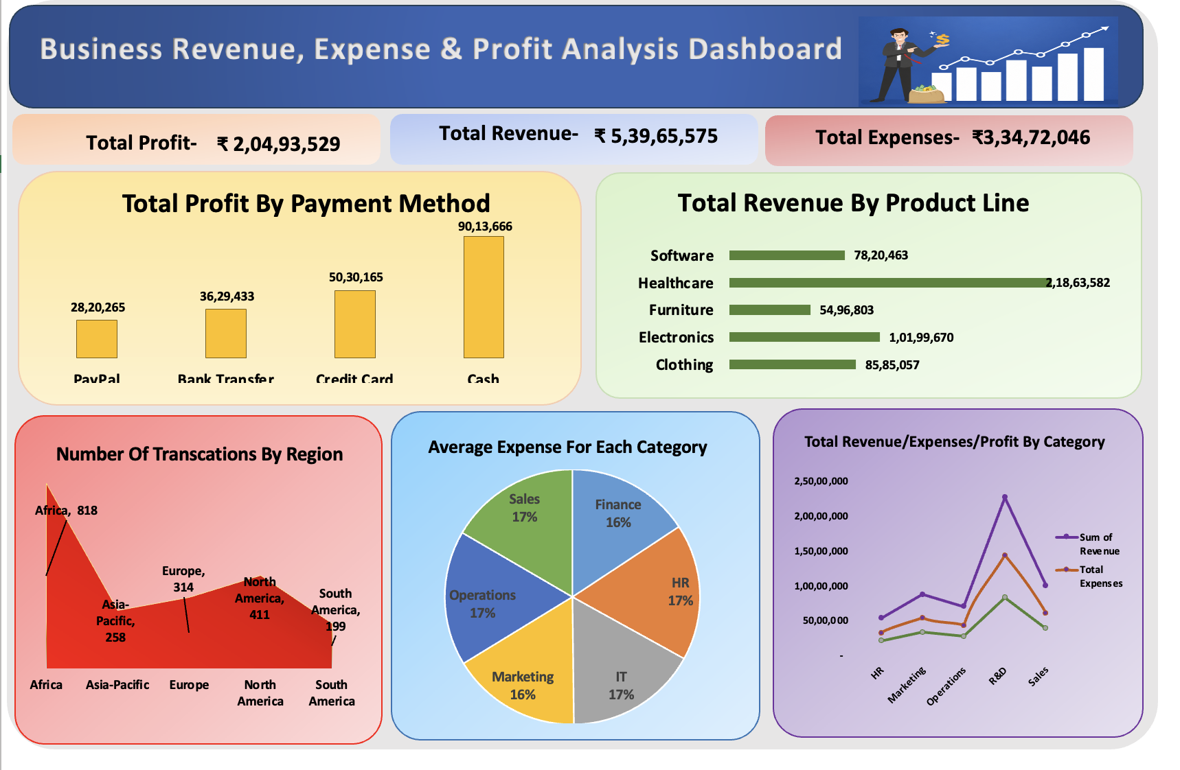

1. Project Overview
The Business Revenue, Expense & Profit Analysis Dashboard is an Excel-based data analytics project developed to transform 2,000 business transactions into a visual business report. The dashboard focuses on revenue, expenses, profit, payment methods, product lines, regional transaction volume, departmental expenses, and category-level financial performance.

2. Dataset at a Glance
Dataset at a Glance means a quick overview of what is contained in the dataset before analysis begins.
Metric | Value
Transaction Records | 2,000
Columns | 12
Categories | 5
Departments | 6
Product Lines | 5
Regions | 5
Customer Segments | 4
Payment Methods | 4

3. Raw Data Structure
Column | Business Meaning
Transaction_ID | Unique ID for each transaction.
Transaction_Date | Date of the transaction.
Revenue | Revenue generated by the transaction.
Expenses | Expenses associated with the transaction.
Profit | Profit or loss generated by the transaction.
Category | Business category used for financial comparison.
Region | Geographical region of the transaction.
Department | Department associated with the transaction.
Product_Line | Product line associated with the transaction.
Customer_Segment | Customer segment associated with the transaction.
Payment_Method | Payment method used.
Discount | Discount applied to the transaction.

4. Step-by-Step Procedure

Step 1 - Understand the raw dataset
Identify dimensions such as region, department, product line, category, payment method and date, along with measures such as revenue, expenses and profit.

Step 2 - Check data readiness
Check dates, numeric fields, category labels and missing values so Pivot Table calculations are reliable.

Step 3 - Prepare the data
Keep one header row and transaction-level records in a consistent tabular structure.

Step 4 - Create KPI calculations
Calculate Total Profit, Total Revenue and Total Expenses using SUM. These values are displayed as KPI cards directly below the dashboard title.

Step 5 - Analyze profit by payment method
Use Payment_Method with Profit and Sum of Profit to create the Total Profit by Payment Method column chart.

Step 6 - Analyze revenue by product line
Use Product_Line with Revenue and Sum of Revenue to create the Total Revenue by Product Line horizontal bar chart.

Step 7 - Analyze transactions by region
Count Transaction_ID by Region and display the results using the regional area chart.

Step 8 - Analyze average expenses
Calculate Average of Expenses by Department. The dashboard section is titled 'Average Expense For Each Category', while the visible slices represent departments.

Step 9 - Analyze category-level financial performance
Compare Revenue, Expenses and Profit by Category using aggregated values.

Step 10 - Build the dashboard
Arrange KPI cards at the top and five supporting visualizations underneath them.

Step 11 - Validate the dashboard
Cross-check KPI totals and chart values against the source transaction data.

Step 12 - Interpret the results
Use the dashboard to understand major revenue contributors, profit contribution, regional activity and expense patterns.

5. KPI Cards in the Dashboard
The updated dashboard contains three KPI cards immediately below the main title. A KPI (Key Performance Indicator) is a high-level number used to quickly understand business performance.
KPI | Dashboard Value | Meaning
Total Profit | ₹ 20,493,529 | Total profit generated after considering expenses.
Total Revenue | ₹ 53,965,575 | Total revenue generated from all transactions.
Total Expenses | ₹ 33,472,046 | Total expenses incurred across all transactions.

The KPI cards are the three large colored boxes directly below the blue dashboard header. The numbers printed above individual chart bars are data labels, not KPI cards.

6. Analysis Map
The Analysis Map explains how each business question was converted into an Excel analysis and then into a dashboard visual.
Business Question | Fields Used | Excel Output
What is total profit? | Profit | Total Profit KPI
What is total revenue? | Revenue | Total Revenue KPI
What are total expenses? | Expenses | Total Expenses KPI
Which payment method contributes most profit? | Payment_Method, Profit | Total Profit by Payment Method – Column Chart
Which product line generates the most revenue? | Product_Line, Revenue | Total Revenue by Product Line – Bar Chart
Which region has the most transactions? | Region, Transaction_ID | Number of Transactions by Region – Area Chart
How are average expenses distributed? | Department, Expenses | Average Expense For Each Category – Pie Chart
How do financial measures compare by category? | Category, Revenue, Expenses, Profit | Total Revenue/Expenses/Profit by Category – Line Chart

7. Verified KPI Results
KPI | Result
Total Profit | ₹ 20,493,529
Total Revenue | ₹ 53,965,575
Total Expenses | ₹ 33,472,046
Profit Margin | 38.0%
Transaction Records | 2,000

8. Total Profit by Payment Method
Payment Method | Total Profit
PayPal | ₹ 2,820,265
Bank Transfer | ₹ 3,629,433
Credit Card | ₹ 5,030,165
Cash | ₹ 9,013,666

The column chart compares the total profit associated with each payment method. Cash has the largest profit contribution in the dataset.

9. Total Revenue by Product Line
Product Line | Total Revenue
Furniture | ₹ 5,496,803
Software | ₹ 7,820,463
Clothing | ₹ 8,585,057
Electronics | ₹ 10,199,670
Healthcare | ₹ 21,863,582

The horizontal bar chart compares revenue generated by each product line. Healthcare has the largest revenue contribution in the dataset.

10. Number of Transactions by Region
Region | Transactions
Africa | 818
North America | 411
Europe | 314
Asia-Pacific | 258
South America | 199

The regional chart shows transaction activity across the five regions. Africa records the highest transaction count in the dataset.

11. Average Expense For Each Category
Department Shown in Pie Chart | Average Expense
Finance | ₹ 15,749.48
Marketing | ₹ 16,478.30
Sales | ₹ 16,627.72
IT | ₹ 16,810.53
Operations | ₹ 17,174.34
HR | ₹ 17,351.54

The dashboard title uses the word 'Category', but the visible pie-chart slices are Finance, HR, IT, Marketing, Operations and Sales, which are departments in the source dataset. The chart therefore represents average expense by department.

12. Total Revenue / Expenses / Profit by Category
Category | Revenue | Expenses | Profit
HR | ₹ 5,399,448 | ₹ 3,247,742 | ₹ 2,151,706
Marketing | ₹ 8,755,912 | ₹ 5,417,002 | ₹ 3,338,910
Operations | ₹ 7,058,076 | ₹ 4,291,785 | ₹ 2,766,291
R&D | ₹ 22,711,986 | ₹ 14,381,610 | ₹ 8,330,376
Sales | ₹ 10,040,153 | ₹ 6,133,907 | ₹ 3,906,246

The line-chart section compares financial measures across business categories. In the final dashboard image, the visible legend shows Revenue and Total Expenses; the section title also references Profit.

13. Dashboard Layout
- Header: Business Revenue, Expense & Profit Analysis Dashboard.
- KPI row: Total Profit, Total Revenue and Total Expenses.
- Top analytical row: Total Profit by Payment Method and Total Revenue by Product Line.
- Bottom analytical row: Number of Transactions by Region, Average Expense For Each Category, and Total Revenue/Expenses/Profit by Category.
- Color-coded panels are used to visually separate the five analytical sections.

14. Excel Techniques Used
- Data preparation and validation
- Pivot Tables
- Pivot Charts
- SUM aggregation
- COUNT aggregation
- AVERAGE aggregation
- Data labels
- Chart formatting
- KPI card design
- Dashboard layout and visual presentation

15. Key Business Insights
- Total revenue is ₹ 53,965,575, total expenses are ₹ 33,472,046, and total profit is ₹ 20,493,529.
- The calculated overall profit margin is 38.0%.
- Cash contributes the highest total profit among the payment methods.
- Healthcare contributes the highest revenue among the product lines.
- Africa has the highest transaction count among the regions.
- The pie chart compares average expenses across six departments.
- Category-level analysis compares revenue, expenses and profit together rather than looking at revenue alone.

16. Project Outcome
The final Excel dashboard converts raw transaction-level data into a single visual report. It combines three KPI cards with five supporting charts so that users can quickly monitor financial performance and investigate payment, product, regional, departmental and category-level patterns.

17. Skills Demonstrated
Technical Skills | Analytical Skills
Microsoft Excel | KPI Analysis
Data Preparation | Revenue Analysis
Pivot Tables | Profitability Analysis
Pivot Charts | Expense Analysis
Data Aggregation | Regional Analysis
Dashboard Design | Comparative Analysis
Data Visualization | Business Insight Generation
Business Reporting | Data Interpretation

