Production Performance & Cost Analysis Dashboard
Excel Dashboard Project Documentation
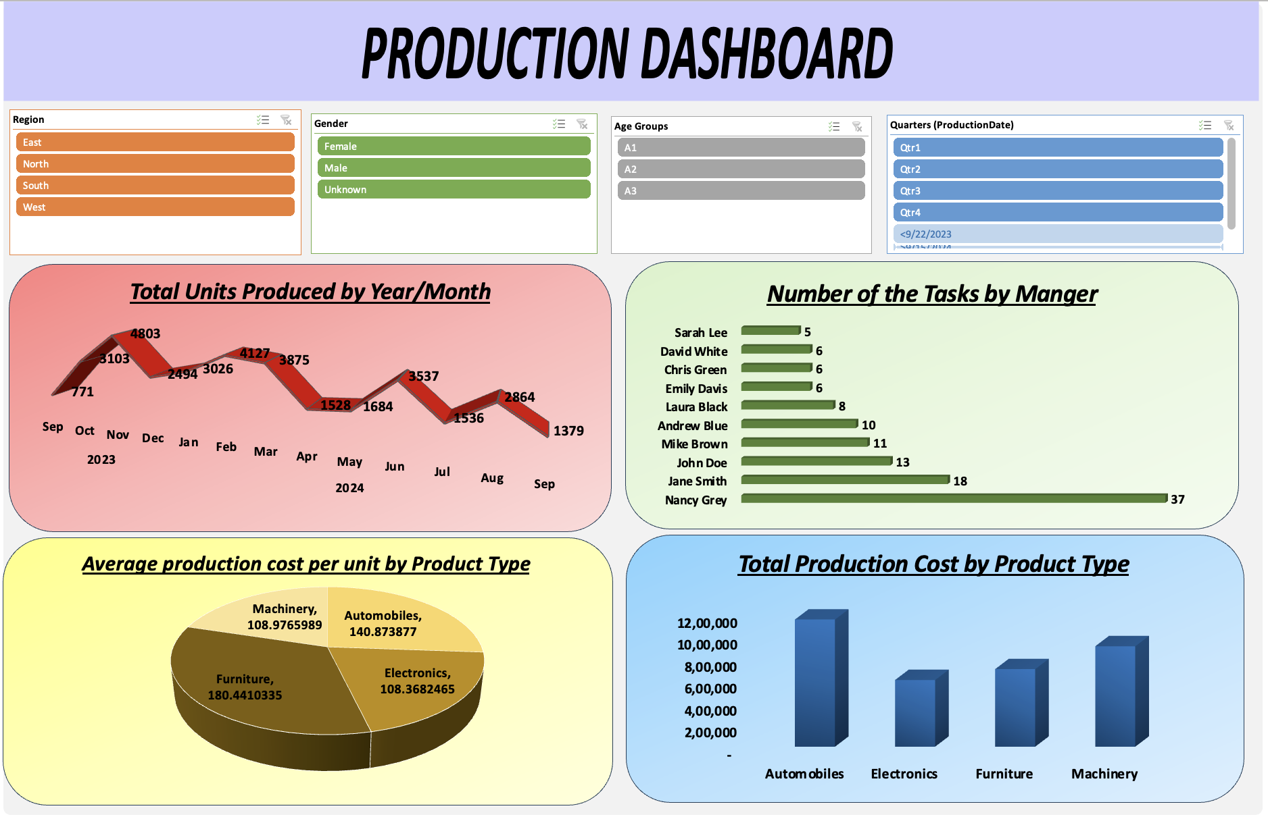

1. Project Overview
This project is an Excel-based Production Dashboard created to analyze production volume, production cost, manager task distribution, and product-type performance. The dashboard uses interactive slicers to filter the analysis by Region, Gender, Age Group, and Quarter.

2. Project Objectives
- Monitor the number of units produced over time.
- Compare the number of tasks handled by each manager.
- Analyze average production cost per unit for each product type.
- Compare total production cost across product types.
- Provide interactive filtering by region, gender, age group, and quarter.
- Present production information in a clear visual dashboard for business reporting.

3. Dataset at a Glance
- Source worksheet: Production Dataset
- Records: 120 production records
- Date range: 22 September 2023 to 14 September 2024
- Columns in the dashboard dataset: 11
- Product types: Automobiles, Electronics, Furniture, Machinery
- Regions: East, North, South, West
- Managers: 10
- Gender values: Female, Male, Unknown
- Age groups: A1, A2, A3

4. Raw Data Structure
Column | Purpose
ProductionID | Unique production record identifier
ProductionDate | Date on which production was recorded
Region | Geographical region
Manager | Manager associated with the production/task record
ProductType | Type of product produced
UnitsProduced | Number of units produced
TotalCost | Total production cost for the record
Gender | Gender value recorded for the record
True Age | Age value used to create age groups
Age Groups | Derived age classification: A1, A2, or A3
Production Cost Per Unit | Derived cost-per-unit measure

5. Data Preparation and Calculations
The workbook contains two derived fields used by the dashboard:
- Age Groups: =IF(I2<=35,"A1",IF(I2<=45,"A2","A3"))
- Production Cost Per Unit: =G2/F2
These calculated fields support segmentation by age group and comparison of production cost efficiency.

6. Dashboard Filters / Slicers
Filter | Available values
Region | East, North, South, West
Gender | Female, Male, Unknown
Age Groups | A1, A2, A3
Quarters (ProductionDate) | Qtr1, Qtr2, Qtr3, Qtr4

7. Key Dashboard Metrics
- Total Units Produced: 34,727
- Total Production Cost: ₹33,71,078
- Overall Average Production Cost Per Unit: 132.3923509

8. Total Production Cost by Product Type
Product Type | Total Cost | Units Produced | Records
Automobiles | ₹11,52,805 | 13,137 | 46
Machinery | ₹9,10,416 | 9,409 | 30
Furniture | ₹7,03,282 | 5,274 | 19
Electronics | ₹6,04,575 | 6,907 | 25
The dashboard's Total Production Cost by Product Type chart compares these four product categories. Automobiles has the highest total production cost in the source Pivot Table.

9. Number of Tasks by Manager
Manager | Number of Tasks
Nancy Grey | 37
Jane Smith | 18
John Doe | 13
Mike Brown | 11
Andrew Blue | 10
Laura Black | 8
Emily Davis | 6
Chris Green | 6
David White | 6
Sarah Lee | 5
Total tasks represented in the Pivot Table: 120.

10. Total Units Produced by Year / Month
Period | Units Produced
2023 Total | 11,171
Sep 2023 | 771
Oct 2023 | 3,103
Nov 2023 | 4,803
Dec 2023 | 2,494
2024 Total | 23,556
Jan 2024 | 3,026
Feb 2024 | 4,127
Mar 2024 | 3,875
Apr 2024 | 1,528
May 2024 | 1,684
Jun 2024 | 3,537
Jul 2024 | 1,536
Aug 2024 | 2,864
Sep 2024 | 1,379
Grand Total | 34,727

11. Average Production Cost per Unit by Product Type
Product Type | Average Cost per Unit
Automobiles | 140.8738769541
Electronics | 108.3682465167
Furniture | 180.4410334878
Machinery | 108.9765989464
Grand Total / Overall Average | 132.3923508956

12. Supporting Data Distribution
Dimension | Record Count
Region | West 55; North 28; East 19; South 18
Gender | Female 56; Male 53; Unknown 11
Age Groups | A1 53; A2 42; A3 25
Quarter | Qtr1 40; Qtr4 34; Qtr2 25; Qtr3 21

13. Analysis Map
Business Question | Fields / Dimension | Calculation / Output | Visualization
How many units are produced over time? | ProductionDate, UnitsProduced | Sum of UnitsProduced by year/month | Line chart
How are tasks distributed among managers? | Manager | Count of tasks/records by manager | Horizontal bar chart
Which product type has the highest average unit cost? | ProductType, Production Cost Per Unit | Average production cost per unit | Pie chart
How does total production cost vary by product type? | ProductType, TotalCost | Sum of TotalCost | Column chart
How can results be segmented? | Region, Gender, Age Groups, ProductionDate | Interactive filtering | Slicers

14. Excel Techniques Used
- Data preparation and derived columns
- IF formula for age-group classification
- Division formula for production cost per unit
- Pivot Tables
- Pivot Charts
- Slicers
- Date grouping by year, month, and quarter
- Sum, Count, and Average aggregations
- Dashboard layout and chart formatting

15. Key Insights
- Total production across the source data is 34,727 units.
- Total production cost is ₹33,71,078.
- Automobiles has the highest total production cost at ₹11,52,805.
- Furniture has the highest average production cost per unit at 180.4410335.
- Electronics has the lowest average production cost per unit at 108.3682465.
- November 2023 has the highest monthly production shown in the Pivot Table at 4,803 units.
- Nancy Grey has the highest task count at 37.
- The West region contains the largest number of records, with 55 out of 120 records.
- Qtr1 contains the largest number of records among the displayed quarter groups, with 40 records.

16. Project Outcome
The completed Production Dashboard transforms the production dataset into an interactive management report. It combines production trends, task distribution, cost analysis, and slicer-based filtering in a single Excel dashboard. The project demonstrates practical Excel data-analysis and reporting skills.

17. Skills Demonstrated
Microsoft Excel | Data Cleaning & Preparation | Pivot Tables | Pivot Charts | Slicers | Data Visualization | Dashboard Design | Business Reporting | Basic Excel Formulas | Data Analysis

